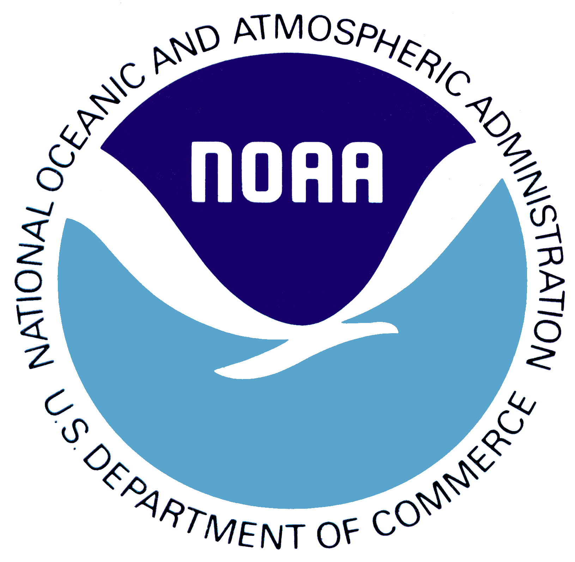
CURRICULUM VITAE - ELIZABETH M. JOHNS

Atlantic Oceanographic and Meteorological Laboratory

RESEARCH INTERESTS
Climate and ecosystem variability of south Florida, the Gulf of Mexico, the Caribbean Sea, and the North Atlantic; interdisciplinary studies of Caribbean reef fish larval abundance, distribution and diversity; large-scale oceanographic and meteorological events and their effect on marine ecosystems.

EDUCATION
BA in English Literature from Mount Holyoke College, 1976

PhD in Oceanography from University of Rhode Island, 1984

DISSERTATION
Johns, E. M. (1984). Geostrophy and potential vorticity in the Gulf Stream off Cape Hatteras, Ph.D. Dissertation, University of Rhode Island, 224 pp.

RECENT PUBLICATIONS
Johns, E. M., R. Lumpkin, N. F. Putman, R. H. Smith, F. E. Muller-Karger, D. T. Rueda-Roa, C. Hu, M. Wang, M. T. Brooks, L. J. Gramer, and F. E. Werner (2020). The establishment of a pelagic Sargassum population in the tropical Atlantic: Biological consequences of a basin-scale long distance dispersal event. Progress in Oceanography, vol. 182, 102269.

Meinen, C. S., W. E. Johns, B. I. Moat, R. H. Smith, E. M. Johns, D. Rayner, E. Frajka-Williams, R. F. Garcia, and S. L. Garzoli (2019). Structure and variability of the Antilles Current at 26.5ºN. Journal of Geophysical Research, vol. 124, 3700-3723.

Putman, N. F., G. J. Goni, L. J. Gramer, C. Hu, E. M. Johns, J. Trinanes, and M. Wang (2018). Simulating transport pathways of pelagic Sargassum from the equatorial Atlantic into the Caribbean Sea. Progress in Oceanography, vol. 165, 205-214.

Carrillo, L., E. M. Johns, R. H. Smith, and J. T. Lamkin (2016). Pathways and hydrography in the Mesoamerican Barrier Reef System Part 2: Thermohaline structure. Continental Shelf Research, vol. 120, 41-58.

Lee, T. N., N. Melo, N. Smith, E. M. Johns, C. R. Kelble, R. H. Smith, and P. B. Ortner (2016). Circulation and water renewal of Florida Bay. Bulletin of Marine Science, vol. 92(2), 153-180.

Carrillo, L., E. M. Johns, R. H. Smith, J. T. Lamkin, and J. L. Largier (2015). Pathways and hydrography in the Mesoamerican Barrier Reef System Part 1: Circulation. Continental Shelf Research, vol. 109, 164-176, 2015.

Johns, E. M., B. A. Muhling, R. C. Perez, F. E. Muller-Karger, N. Melo, R. H. Smith, J. T. Lamkin, T. L. Gerard, and E. Malca (2014). Amazon River water in the northeastern Caribbean Sea and its effect on larval reef fish assemblages during April 2009. Fisheries Oceanogr., 23(6), 472-494.

Smith, R. H., E. M. Johns, G. J. Goni, J. Trinanes, R. Lumpkin, A. M. Wood, C. R. Kelble, S.R. Cummings, J. T. Lamkin, and S. Privoznik (2014). Oceanographic conditions in the Gulf of Mexico in July 2010, during the Deepwater Horizon oil spill. Continental Shelf Research, 77:118-131, doi:10.1016/j.csr.2013.12.009.

