MISSION PLAN
FLIGHT ID | 20210702H1 | STORM | AL05/ELSA
MISSION ID | 0205A | TAIL NUMBER | NOAA42
TASKING | EMC | PLANNED PATTERN | Butterfly
MISSION SUMMARY
TAKEOFF [UTC] | 1431 | LANDING [UTC] | 2049
TAKEOFF LOCATION | Aruba | LANDING LOCATION | Aruba
FLIGHT TIME | 6.3 | BLOCK TIME | 6.6
TOTAL REAL-TIME RADAR ANALYSES  (Transmitted) | 3 (3) | TOTAL DROPSONDES (Good/Transmitted) | 16 (15/15)
OCEAN EXPENDABLES (Type) | None | sUAS (Type) | None
APHEX EXPERIMENTS / MODULES | None planned
HRD CREW MANIFEST
LPS ONBOARD | NA | LPS GROUND | Zawislak
TDR ONBOARD | NA | TDR GROUND | Gamache/Reasor/Alvey/  Fischer
ASPEN ONBOARD | NA | ASPEN GROUND | Sellwood/Wadler
NESDIS SCIENTISTS | NA
GUESTS (Affiliation) | NA
AOC CREW MANIFEST
PILOTS | Abitbol (Aircraft Commander), Shaw, Stateler
NAVIGATOR | Urato
FLIGHT ENGINEERS | Darby / Heysteck
FLIGHT DIRECTOR | Parrish / Hathaway
DATA TECHNICIAN | Mascaro
AVAPS | Warnecke

PRE-FLIGHT
Flight Plan | 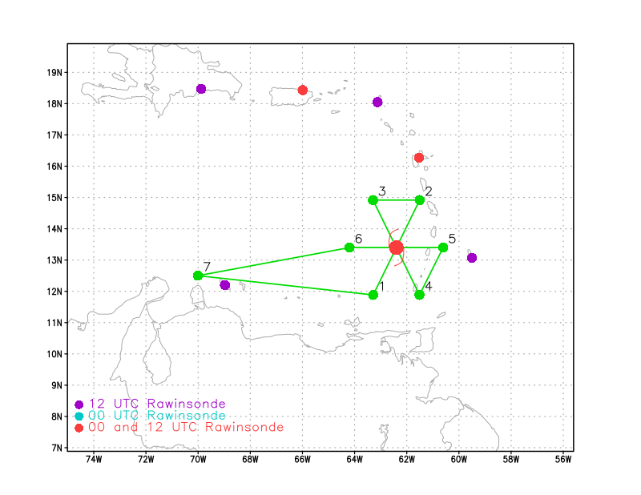
Expendable Distribution | Dropsondes released at the endpoint and midpoint of each leg, as well as at the center of each pass.
Preflight Weather Briefing | Elsa has intensified to a minimal, 65-kt hurricane as the storm surprisingly gained organization overnight, showing extensive banding and even perhaps a developing partial eyewall that, as of the pre-flight brief, is located in very close proximity to Barbados. The storm is still embedded in strong easterly flow, which is contributing to the fairly fast propagation speed of WNW at 24 kt, but also the stronger winds located on the north side of the storm. The international airport at Barbados reported 67 kt gusts this morning.  The storm is expected to maintain it’s fast WNW trajectory into the Caribbean, skirting Hispaniola and Cuba before passing over Cuba to the north, into the eastern Gulf. NHC expects it to maintain hurricane intensity while in the Caribbean.  The plan calls for a butterfly pattern flown at a pressure altitude of 10,000 ft. It’s likely that 42 will need to fly an official fix for NHC for 1730Z, which will also be flown at 10 kft. We’ve requested a fix on each pass.
Instrument Notes | There were issues with the IWG (flight level) datastream on the ferry flight yesterday, and a solution was applied today to correct that issue. The Compact Raman Lidar is not operational, and the WSRA and cloud physics probes are not yet installed. THOR is installed and operational.

IN-FLIGHT
Time [UTC] | Event
1431 | Takeoff from Aruba
1500 | While the IWG1 issue was resolved, AOC is still working on issues related to the ingestion of the IWG1 into MTS2.  The storm is now passing the Leeward Islands. The visible imagery indicates that inner core precipitation is still wrapping all the way around the center and the Barbados radar still shows a fairly complete and organized eyewall with some fairly intense precipitation on the east to north side of the eyewall.
1600 | Approaching the IP to the SW of the center. There is still a healthy amount of convective band both in the outer and inner regions of the storm.
1609 | Arrived IP, released Sonde #1, been set up on the 210 deg. azimuth track for a couple minutes
1622 | Released Sonde #2, midpoint on SW inbound  Winds are surprisingly light at their flight altitude (10 kft), with even southeasterly winds through the first half of the inbound, which is opposite of what would be expected based on being SW of the center. Even a circulation observed just before the midpoint of the inbound leg.
1633 | Released Sonde #3, center on first pass
1647 | Released Sonde #4, midpoint on outbound to NE  So sure enough, flight-level winds got up to 75+ kt to the NE of the center and 70 kt 10-sec SFMR at the surface.  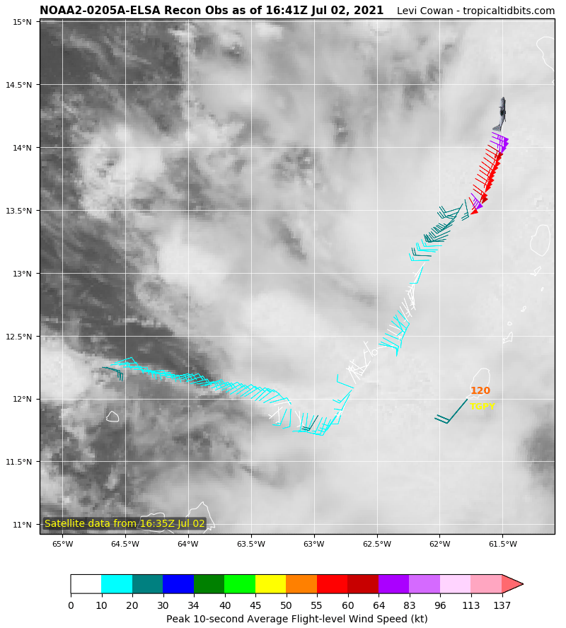  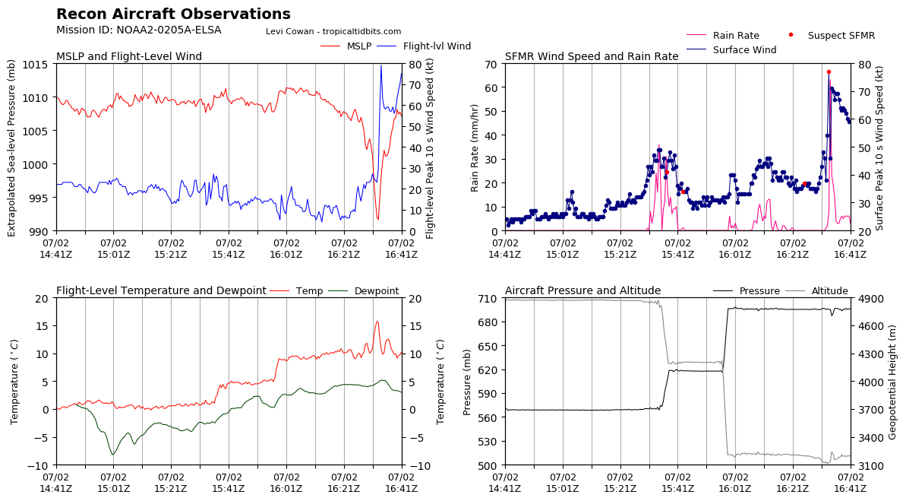
1657 | Turning downwind to position for the next pass from NW to SE  The “center” sonde reported 77 kt sfc wind and a 996 mb surface pressure, so definitely missed the center with the sonde; it was in heavier precipitation just to the NNE of the center. Sonde actually reported 103 kt at 944 mb. The winds at 10 kft are different than at the surface, suggesting still some complexity in the inner core circulation.
1659 | Released Sonde #5, endpoint sonde to the NE
1721 | Released Sonde #6, IP sonde to the NW, now inbound to the center.  Deep convection continues to develop near the center with some lightning indicated in GLM. The intense outer bands observed earlier have dissipated some, particularly to the west and northwest (was this a diurnal pulse?)  The first radar analysis is available and it shows a very fascinating structure. At 2 km, there is a circulation well to the SW of the fixed center -- this was clear at flight level too, as seen in an earlier noted event. But they also were able to sample a small circulation in the vicinity of the deep convection near the fixed center. Fairly disorganized. But at 5 km, there is a much more coherent circulation about where they fixed the center. Hard to say if this is a tilted structure without understanding what is producing the circulation in the low levels.  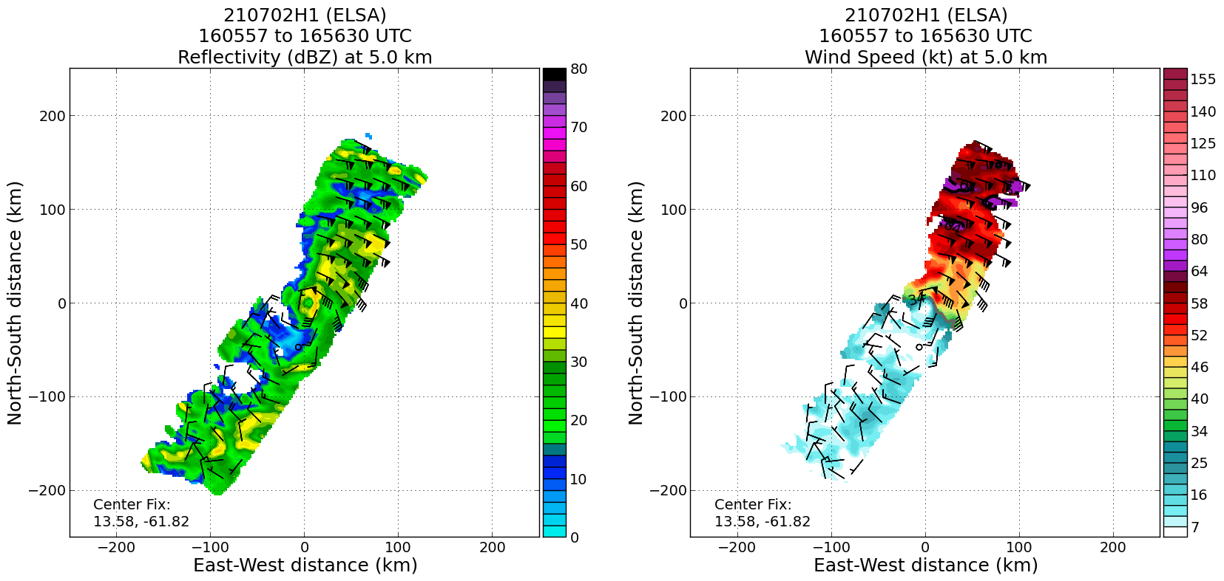  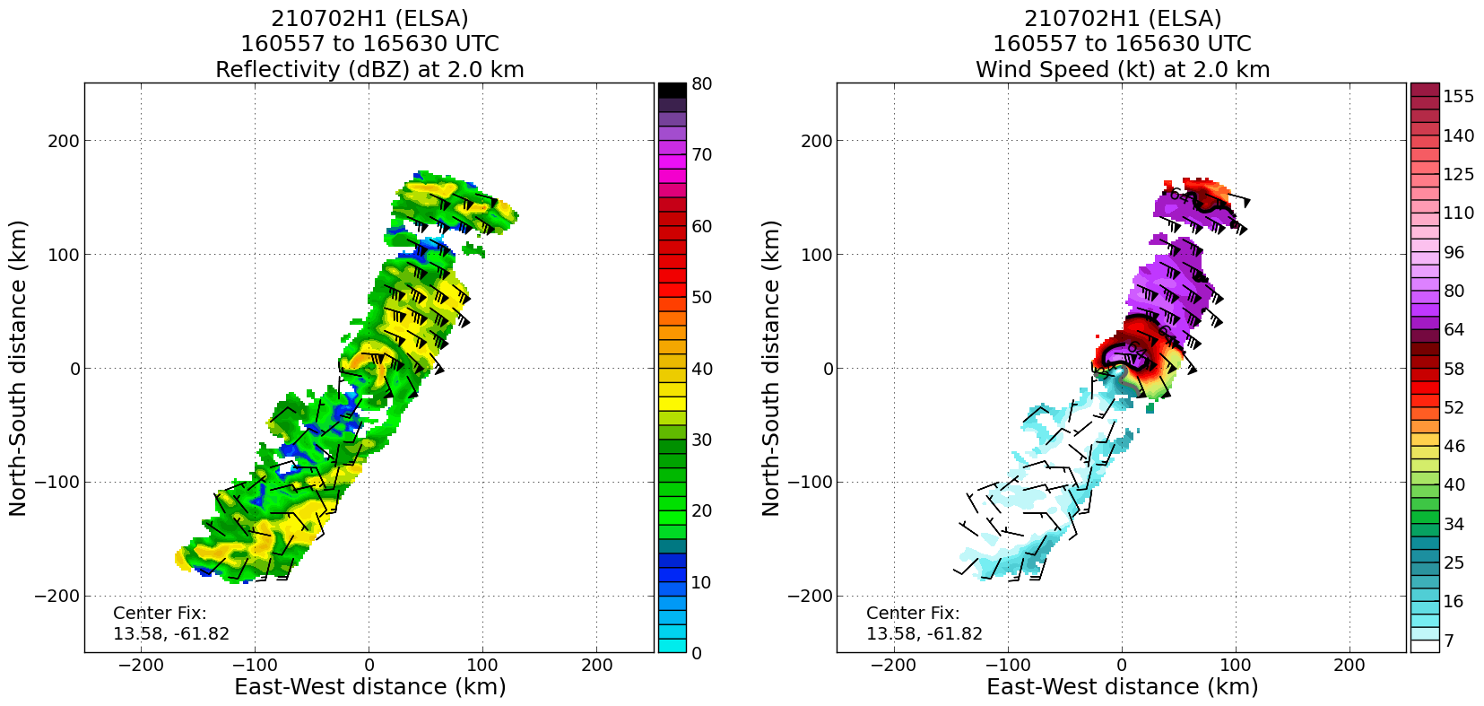
1734 | Released Sonde #7 at the midpoint of the inbound leg to the NW
1751 | Released Sonde #8 at the center for the 2nd pass; bad sonde; going back around to release another sonde at the marked center
1755 | Released Sonde #9 at the center as a backup; sonde splashed at 992 mb with 28 kt wind from the SSE
1809 | Released Sonde #10 at the midpoint of the outbound leg to the SE
1823 | Released Sonde #11 at the endpoint of the outbound leg to the SE; now going downwind for the final pass.  On this 2nd pass, again a very asymmetric structure was observed in the windfield. Once again a peak flight-level wind near 80 kt, and surface wind near 70 kt were observed.  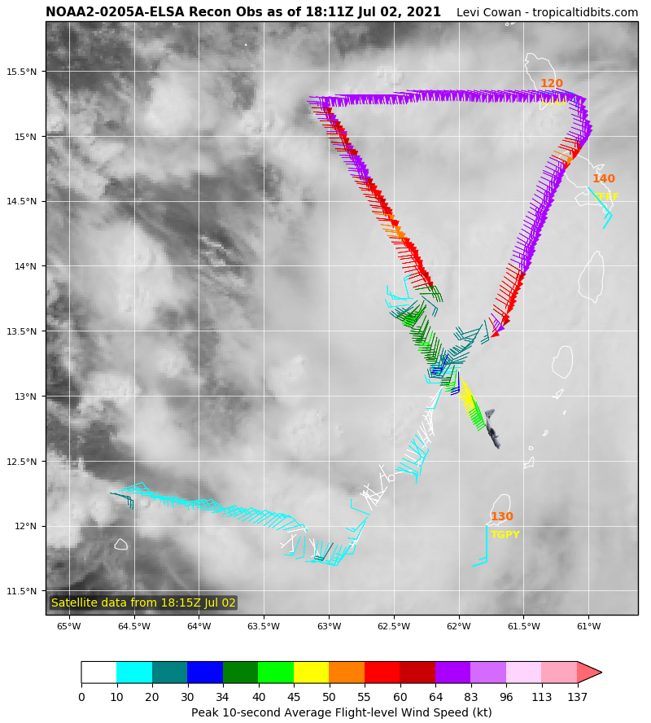  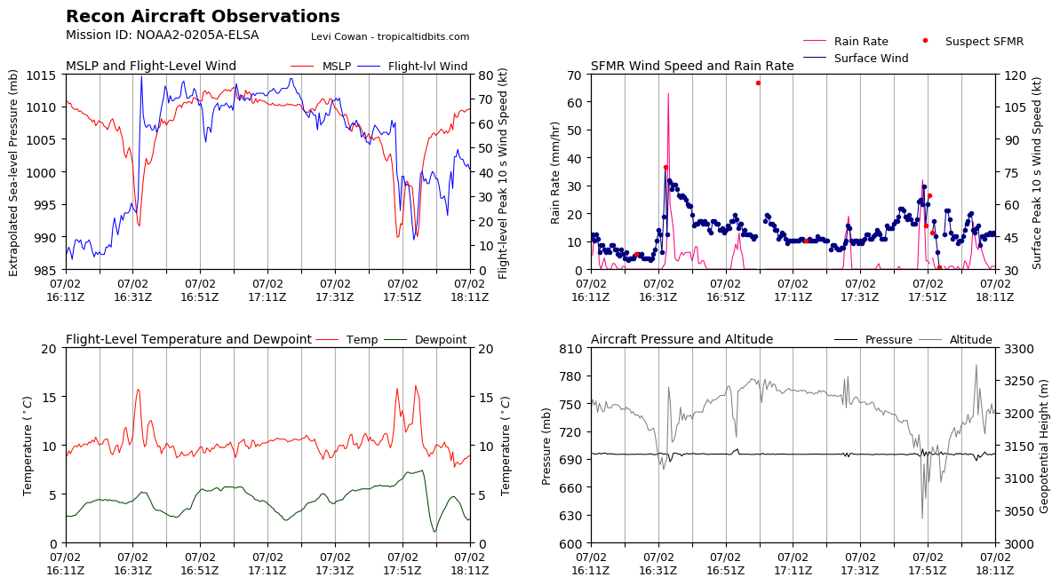
1846 | Released Sonde #12 at IP of inbound from the east for pass #3.  IR and visible satellite imagery suggests that inner core convective organization hasn’t changed much in terms of distribution, but perhaps has weakened some, evidenced by the slightly warming cloud tops and less inner core lightning.
1857 | Released Sonde #13 at midpoint of inbound leg from the east;  The 2nd radar analysis is in and once again showed a robust circulation at least at flight level and above; but below our flight level of ~3km, the circulation is more defuse, potentially even closer to being an open wave.  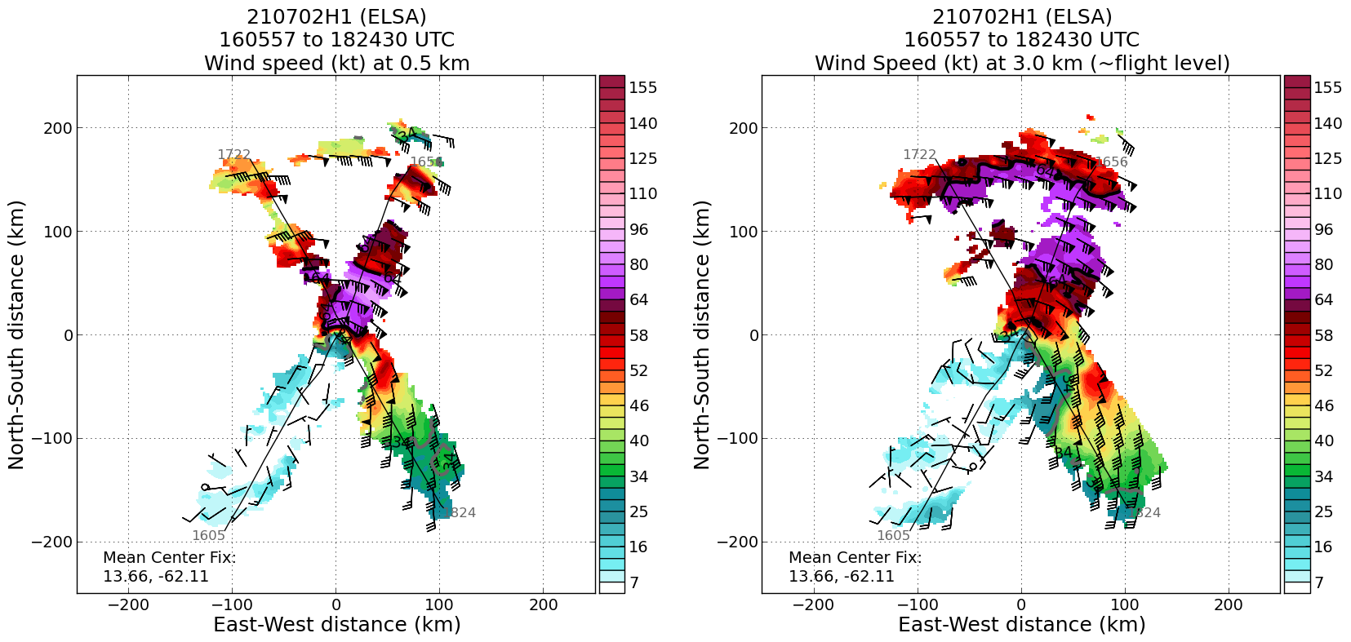  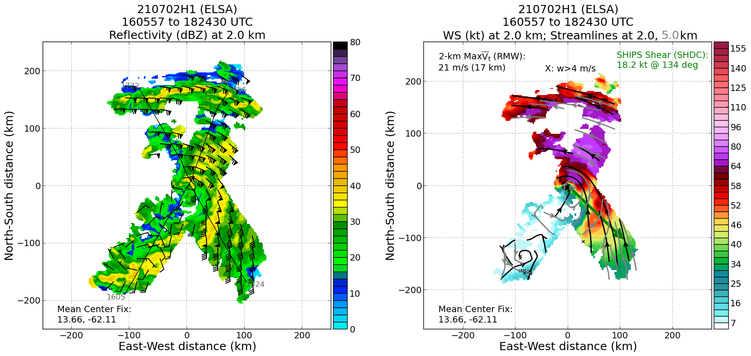
1910 | Released Sonde #14 at the center of pass #3.  Sonde splashed with 998 mb surface pressure and 46 kt of wind with a wind direction at 175 degrees (southerly winds). Pretty challenging to get center sondes in this flight, given that there is likely a tilt between the surface and flight level.
1919 | Released Sonde #15 at the midpoint of the outbound to the west
1932 | Released Sonde #16 at the endpoint of the outbound to the west; this completes the pattern.  The final satellite loops from the duration of the flight:

POST-FLIGHT
Mission Summary | Overall, this flight was successfully flown for EMC as all planned sonde releases and tail Doppler radar analyses were transmitted off the airplane. The data indicated that Elsa has a very complicated vortex structure -- below the flight-level, in the lower levels, the circulation was rather diffuse (almost an open wave) with even a separate circulation observed well south of the fixed center on the first pass. Above the flight-level, the radar analyses indicated a much more coherent circulation (though even a bit elongated above 7 km). While the data indicated the storm had strengthened from the initial estimate of the storm’s intensity when NOAA42 entered the storm, it remained in a fairly steady state during the mission. The strongest winds were observed to the north and east, with a pretty significant asymmetry as the wind field was much weaker to the west and south; this is indicative of the storm being superimposed on the strong easterly steering flow.  16 total dropsondes were released, 15 transmitted (1 bad center sonde not transmitted)  The HRD crew was able to overcome challenges of not having NASA’s Mission Tools Suite for situational awareness; they used a number of other tools, as well as direct communication with the aircraft crew to get the pertinent information.
Actual Standard Pattern Flown | Butterfly
APHEX Experiments / Modules Flown | AIPEX (not specifically flown, but given the intensification of the storm, this data would be useful to the experiment)
Plain Language Summary | - The NOAA P-3 flew this mission in support of data ingestion into NOAA/National Centers for Environmental Prediction/ Environmental Modeling Center’s Hurricane Weather Research and Forecasting (HWRF) forecast model.  - The aircraft data collected indicated that the storm had strengthened to 75 kt, but also exhibited a highly asymmetric wind field such that the winds on the south and west sides were significantly weaker than the hurricane-force winds on the north and east sides.  - The circulation was observed to be fairly disorganized such that below the altitude the P-3 was flying (~3 km), the circulation was tilted away from the center seen above the flight level.
Instrument Notes | No reported issues from instrumentation operating onboard.
Final Mission Track | 