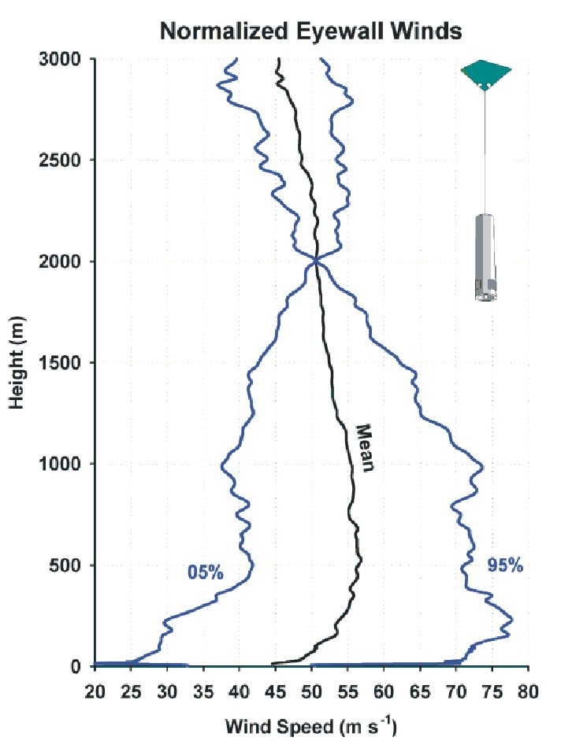
Figure 30. Mean of 61 eyewall GPS soundings, normalized to the same speed at 2 km, illustrating the large variability about the mean, which approximates a logarithmic profile.

