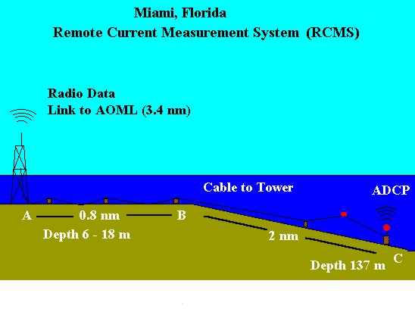
Figure 23. Discharge monitoring at the Port of Miami.

