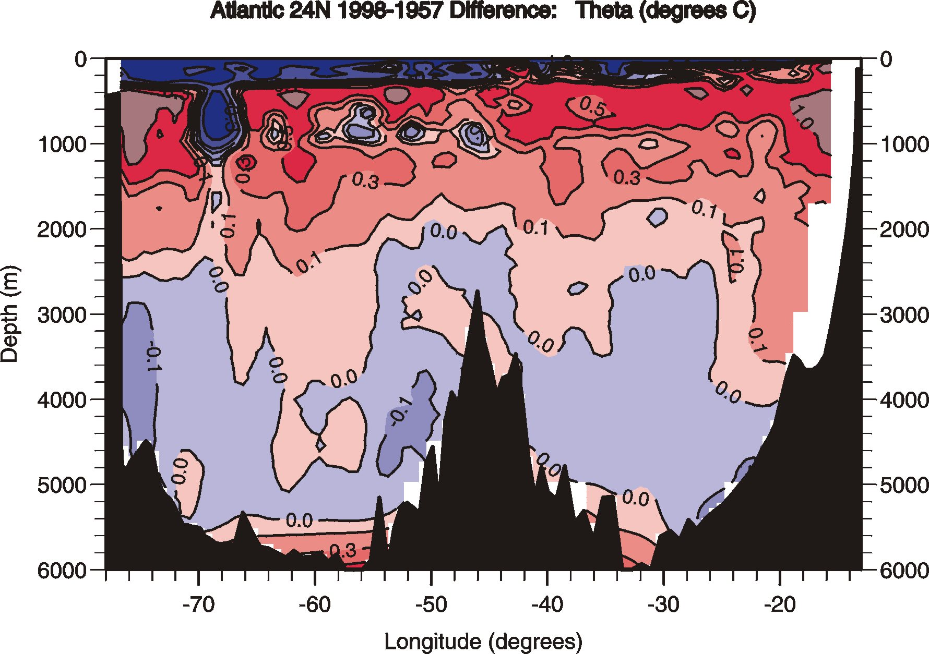
Figure 11. Decadal variability in surface heat fluxes can most clearly be seen from high quality hydrographic sections sufficiently accurate enough to measure the small changes in temperature seen between sections taken during different epochs. The ocean effectively integrates small changes in surface heat flux that result in small biases in SST which become subducted and overturned into the deep water. Repeat hydrographic measurements taken at the same location through time can then be differenced to get indicators of climate change. Shown here is the temperature difference along pressure surfaces between the Ronald H. Brown (1998) and Discoverer (1957) hydrographic sections. Large warming of the water column from 300-2500 m is seen, suggesting increased surface heating in the northern North Atlantic over these decades. The strong negative temperature difference above 300 m is due to the fact that the 1957 data was taken during summer and the 1998 data was taken during winter.

