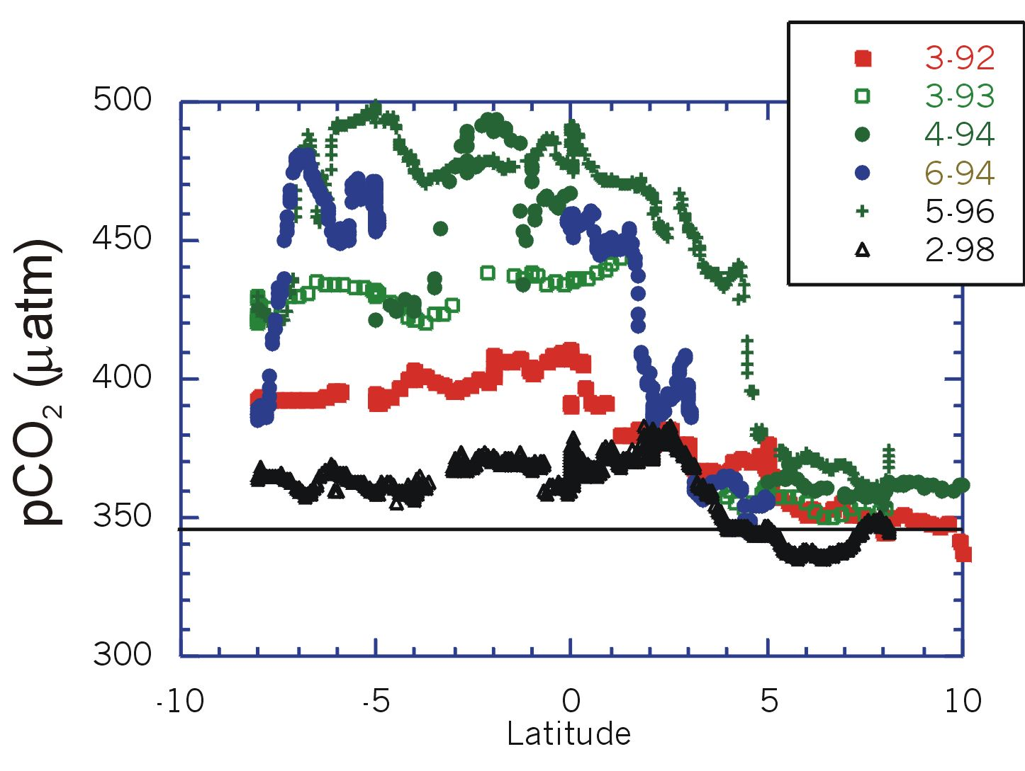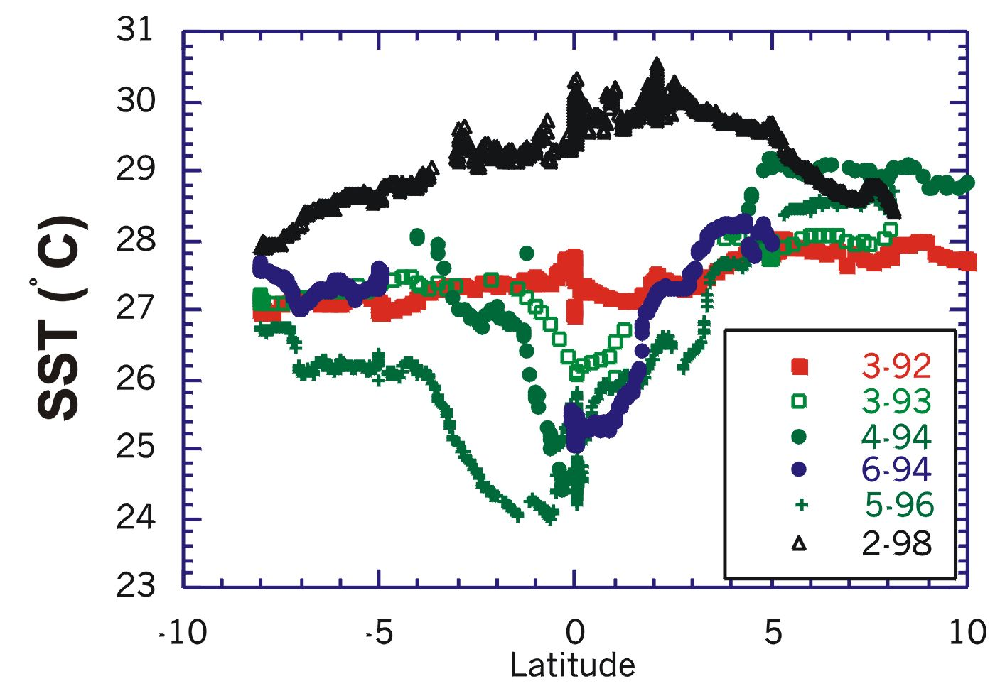
Figure 10. Changes of pCO₂ (left) and SST (right) over time along 110W in response to the ENSO cycle. During El Niños, the efflux of CO₂ is depressed. The dates in the panel, denoted by the month followed by the year (e.g., 6-94), give the dates when the data were collected

