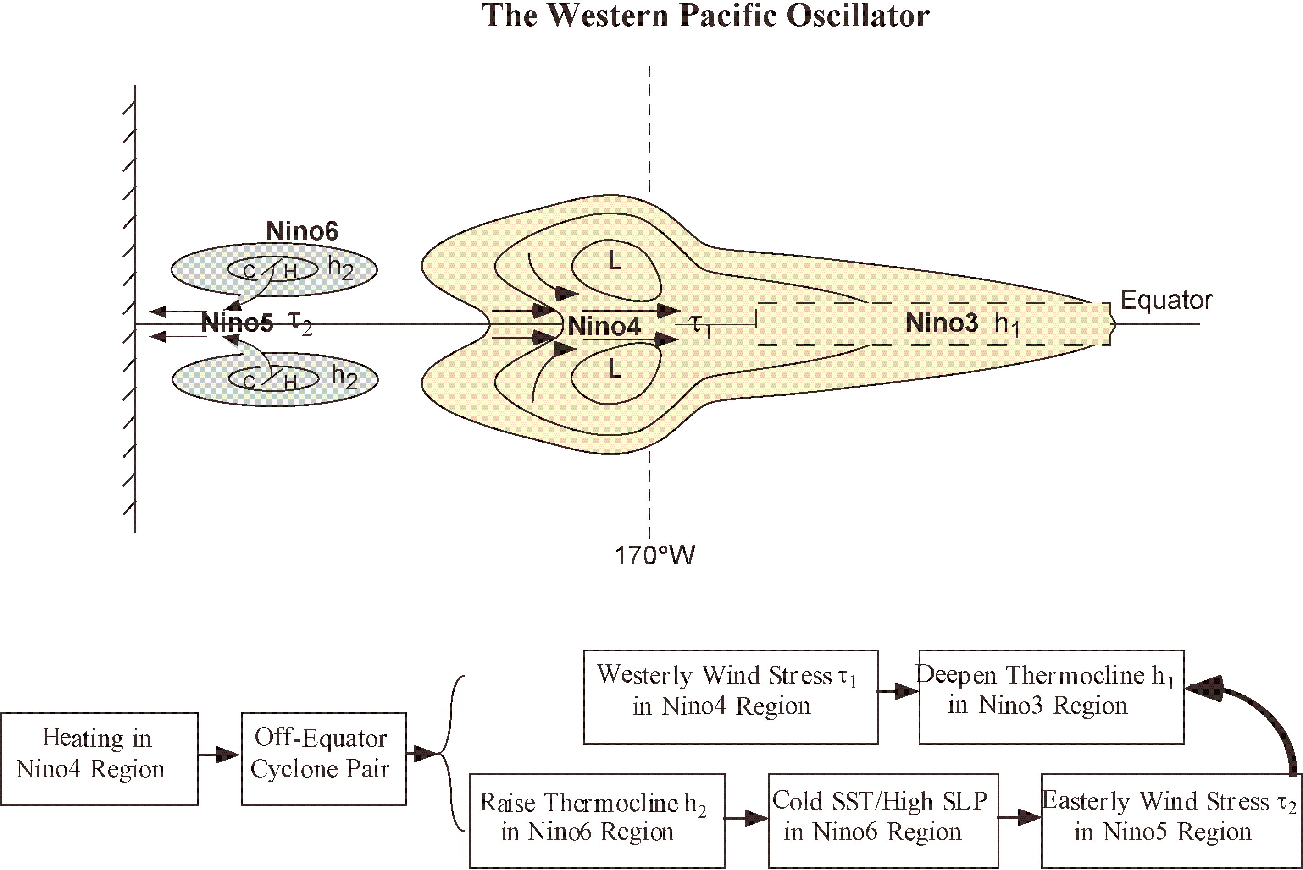

Figure 9. Schematic diagram of the western Pacific oscillator for ENSO. Condensation heating in the western central Pacific induces a pair of off-equatorial cyclones with westerly wind anomalies on the equator. These equatorial westerly wind anomalies act to deepen the thermocline and increase SST in the equatorial eastern Pacific, thereby providing a positive feedback for anomaly growth. On the other hand, the off-equatorial cyclones raise the thermocline there via Ekman pumping. Thus, a shallow off-equatorial thermocline anomaly expands over the western Pacific, leading to a decrease in SST and an increase in SLP in the off-equatorial western Pacific. During the mature phase of El Niño, this off-equatorial high SLP initiates equatorial easterly wind anomalies in the western Pacific. These equatorial easterly wind anomalies cause upwelling and cooling that proceed eastward as a forced ocean response providing a negative feedback for the coupled ocean-atmosphere system to oscillate. Scientists at AOML are continuing to work on ENSO mechanisms by developing a unified ENSO oscillator model that includes the delayed oscillator, the western Pacific oscillator, the recharge-discharge oscillator, and the advective-reflective oscillator.

