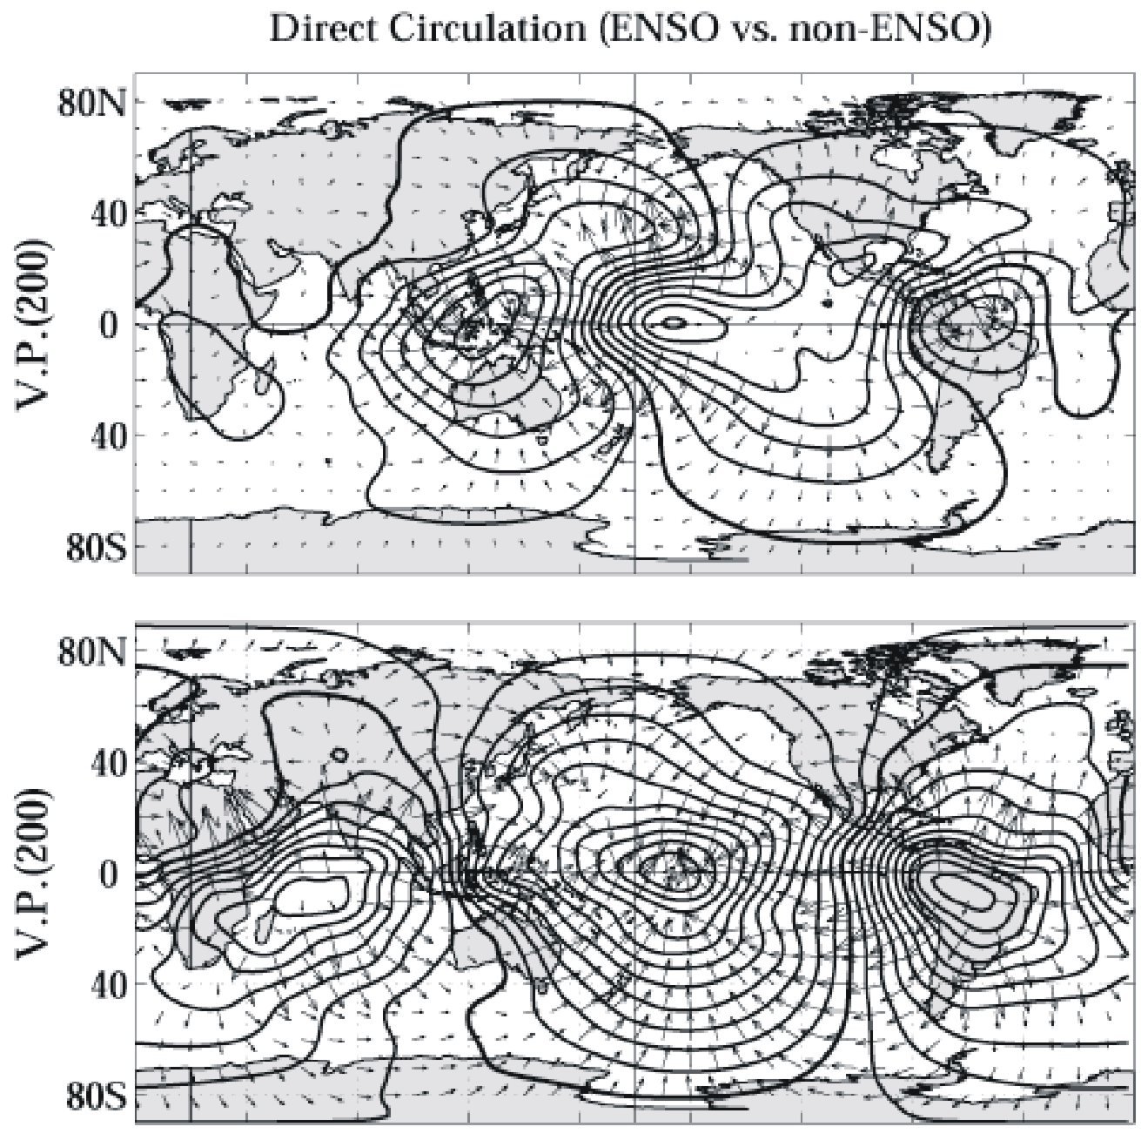
Figure 4. Anomalous distributions of the tropospheric direct circulation associated with the global ENSO (top) and non-ENSO (residual) variabilities in the equatorial Pacific. Top Panel: Composite average of 200 hPa velocity potential and irrotational velocity associated with positive-minus-negative phases of the global ENSO variability in the NINO3 region (see Figure 3, middle panel). Features to note are: (1) the lateral convergence and implied suppressed convection west of the dateline and over northern South America; plus (2) the enhanced (suppressed) Hadley circulation in the central North Pacific (North Atlantic). Bottom Panel: Composite average of 200 hPa velocity potential and irrotational velocity associated with the change in the residual NINO3 SST between two multidecadal periods: 1978-1999 minus 1950-1977 (see Figure 3, bottom panel). Features to note include: (1) convergence (divergence) just east of the dateline (over South America), where the global ENSO shows divergence (convergence); and (2) anomalous Hadley circulations in the central North Pacific and North Atlantic that are opposite to those of the global ENSO mode

