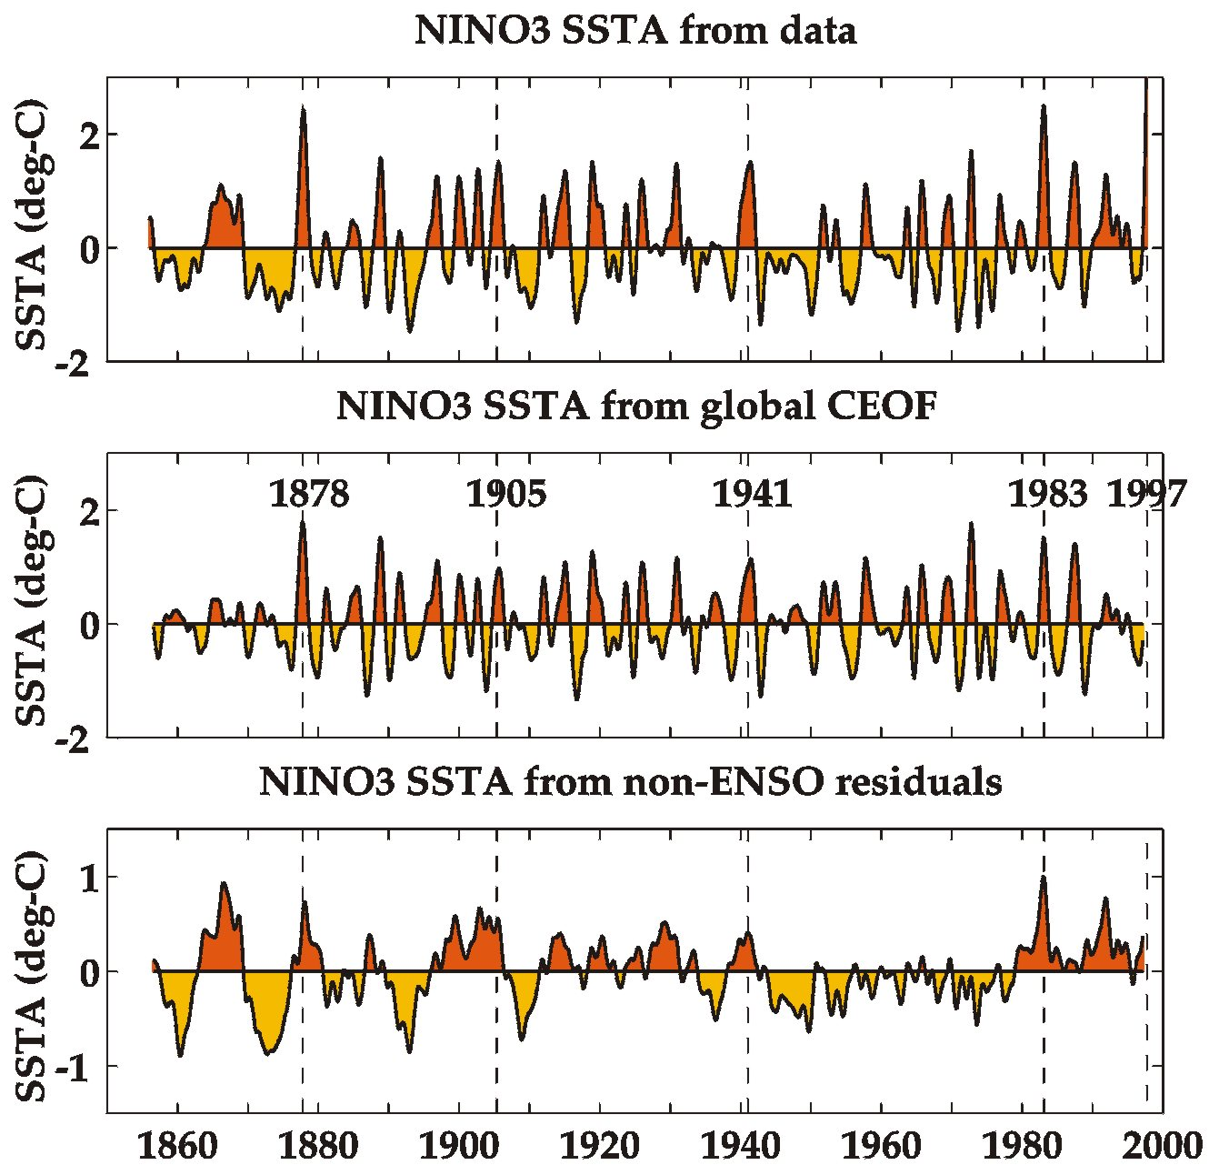
Figure 3. Top Panel: Monthly averages of sea surface temperature (SST) data for the NINO3 region in the equatorial Pacific. Note that 1997-1998, 1982-1983, and 1878-1879 have the largest peaks in the record and that they are all larger than the peak of 1972-1973. Middle Panel: Monthly averages of the global ENSO mode projected onto the NINO3 region. Note that peaks are generally smaller than in the data index and that 1972-1973 is now the largest peak in the series. Bottom Panel: Monthly averages of the residual SST variability in the NINO3 region after removing the global ENSO component from the data. Note that the series is predominantly decadal-to-multidecadal in character and accounts for the differences in the above two series.

