Instructions for launching APEX ARGO floats

When deploying APEX ARGO floats off ships with high freeboards, it will be necessary to drop the float from a considerable height. The impact with the water due to the height and movement of the ship may damage the sensitive antenna, so a cardboard box is constructed in which to place the float during deployment. These boxes are designed to hold the float in place, giving protection to the antenna during the impact of deployment. The box is constructed such that it will open after a few minutes in the water, and all the components of the box are biodegradable.
The float must be deployed off either the port or starboard side (whichever is on the lee) of the lowest possible aft deck. Key elements during deployment are that the float impacts the water horizontally, and that the base of the float is facing forwards. This is to give maximum protection to the antenna, ensuring that any movement of the float within the box due to the inertia of the impact affects the base rather than the antenna of the float.

Equipment:
APEX ARGO Float
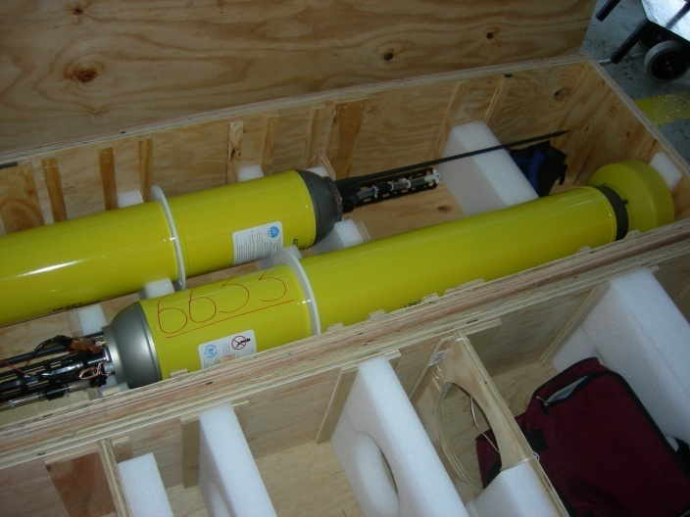

Deployment ropes (x2)
Cardboard casing consisting of:
- 5-panel (85”x17”) box
- 24”x24” squares with slits (x2)
- 36”x17” rectangles with oval hole (x4)
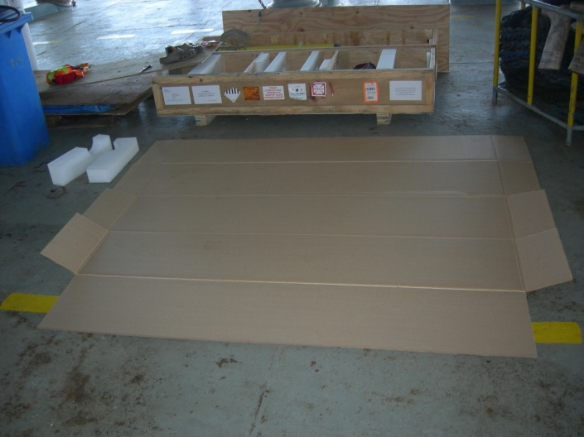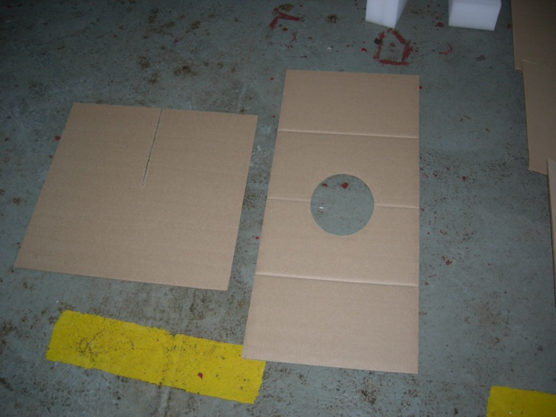
- Wooden plates with ropes (x2)
-Wax thread
- ‘Lifesaver’ candies (x4)
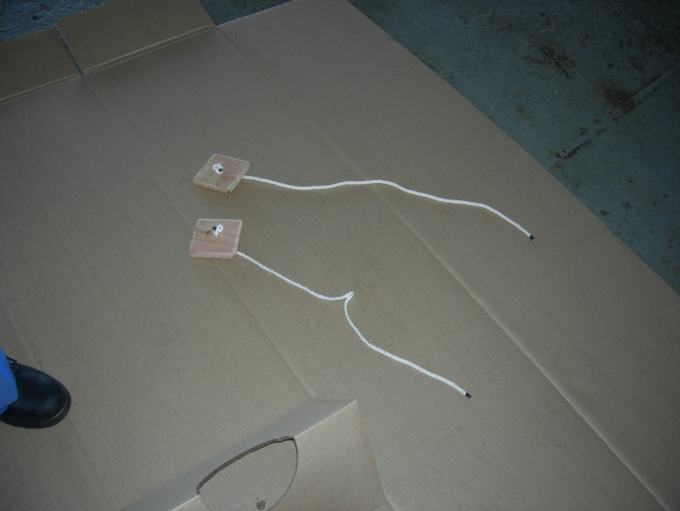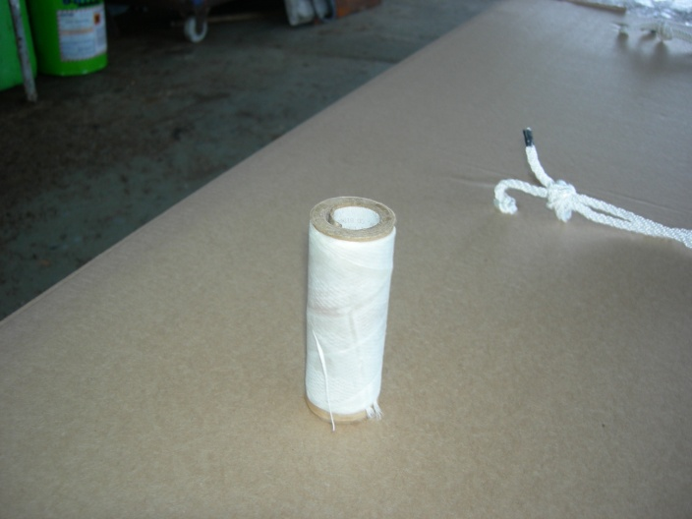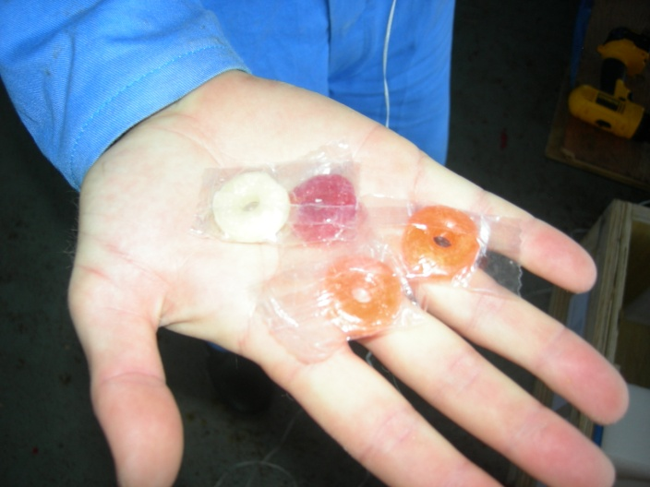

Construction of box:
- Measure and mark 3” and 30.5” from the bottom fold on the inside of panels 1 and 3 of the box.
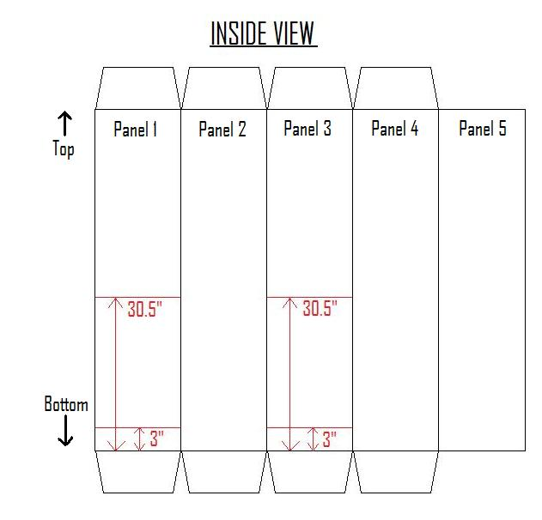
- Fold rectangular panels to form “pyramids”. Glue overlapping panels securely. Overlapping panels are not equal so ensure overlap is correct!
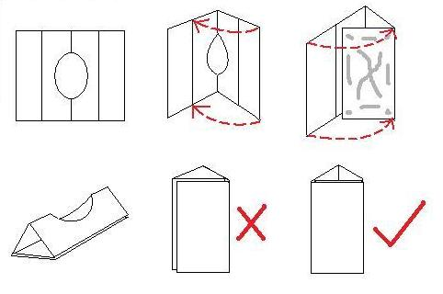
- Glue “pyramids” along upper side of 3” and 30.5” lines on panels 1 and 3 of the box, with the oval holes facing up.
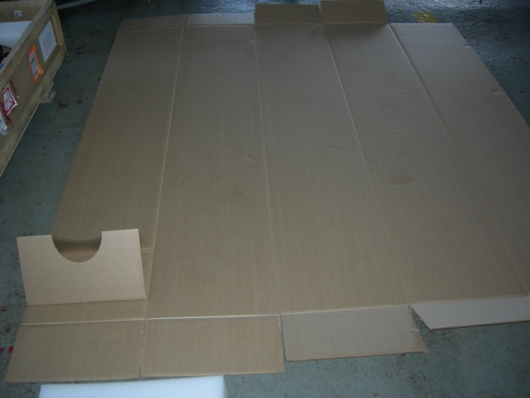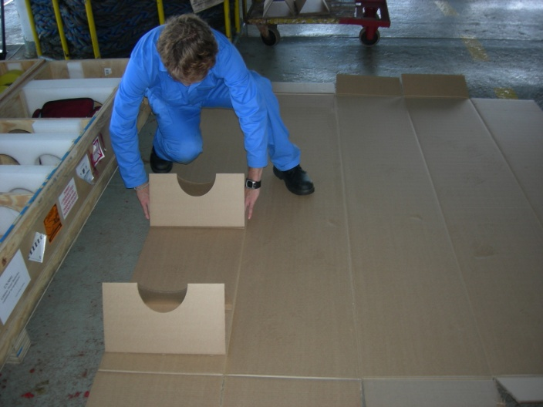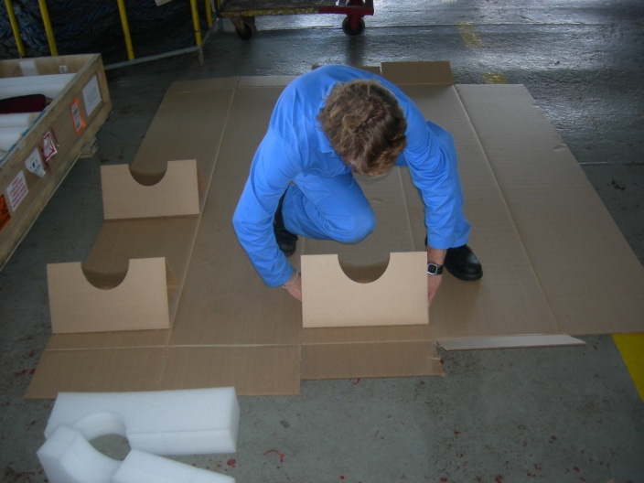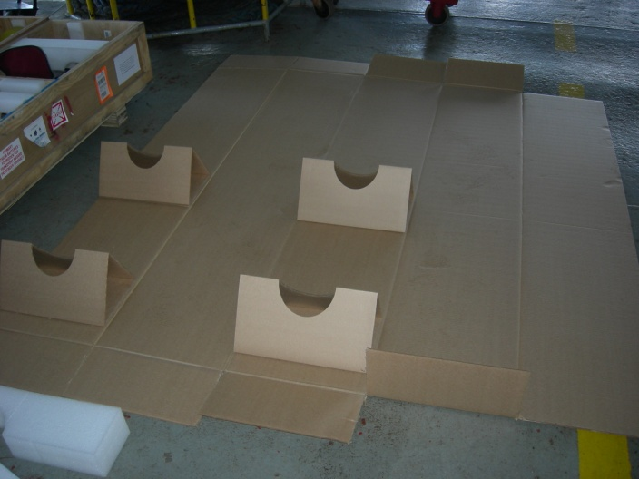
- Drill holes through base of pyramids and box on panel 3, roughly in centre of base of pyramid. Ensure holes large enough to thread rope attached to wooden plates.
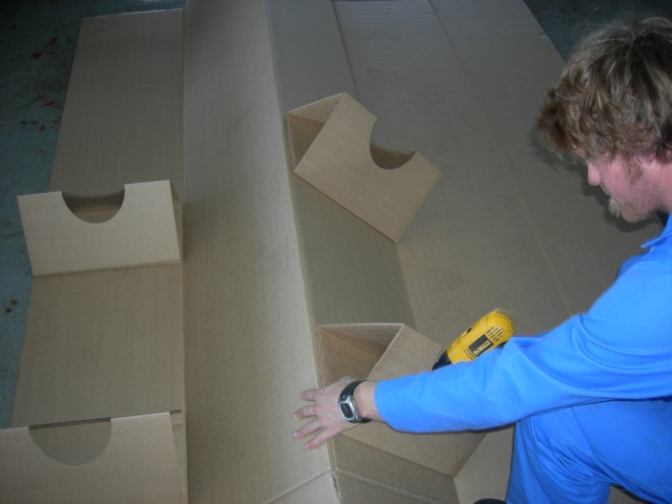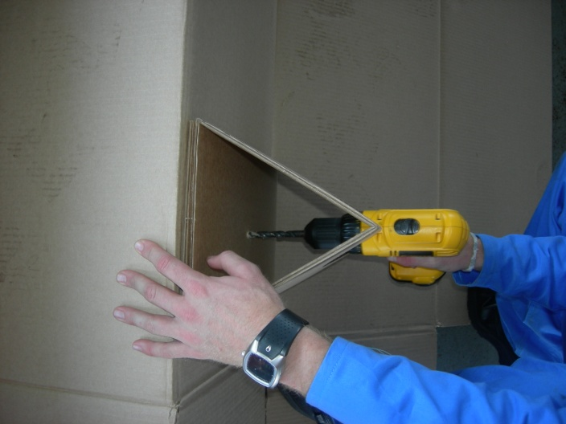

- Thread ropes through holes with wooden plates inside “pyramids”, flush up to the “pyramid” base.
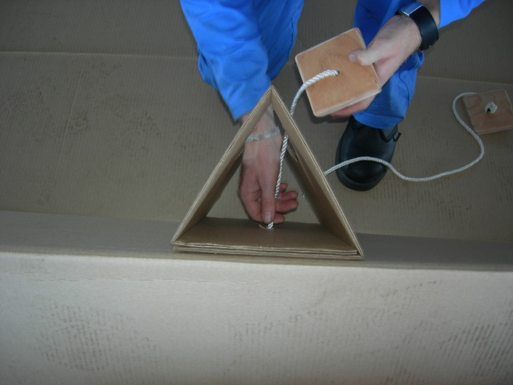

- Tie knots in ropes on outside of box so that plates sit flush with base of “pyramid” inside box.
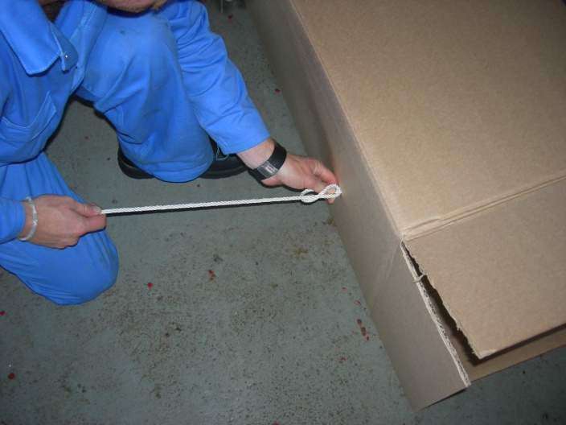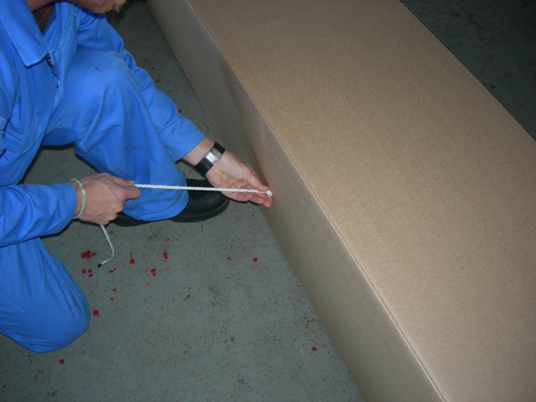

- Tie loops into ropes on outside of box to act as handles. Ensure handles are big enough to fit hands and are of equal length.
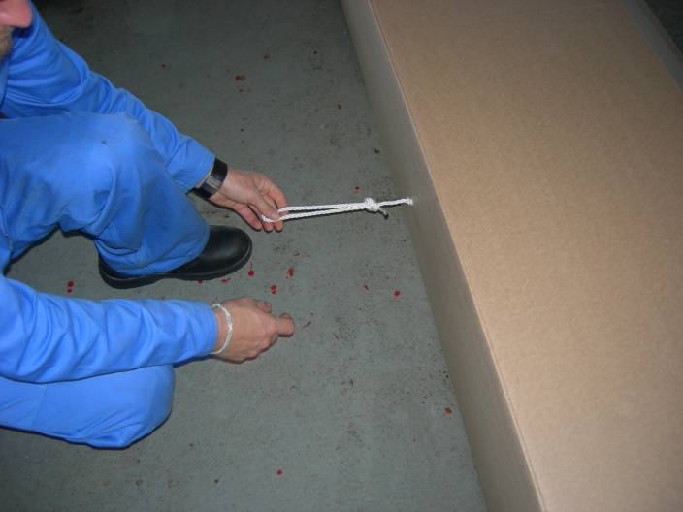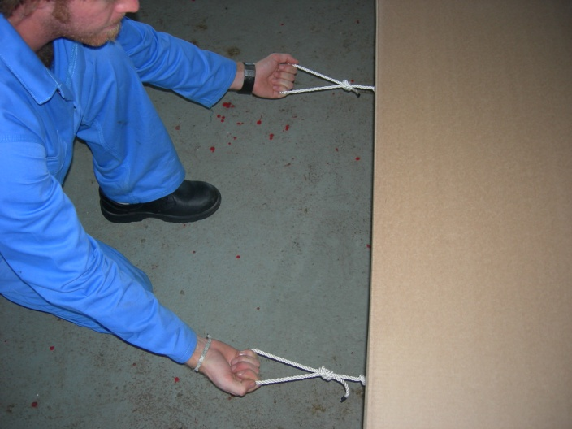

- Remove float from shipping crate. Always ensure rubber plug is inserted into base of float and that plugs are removed from CTD!
- Place float onto panel 3 “pyramid” holders in the oval openings such that the antenna points to the top of the box. Float should lie with base of float on bottom side of lower “pyramid” and the deployment ring on top side of upper “pyramid” in order to restrict movement.
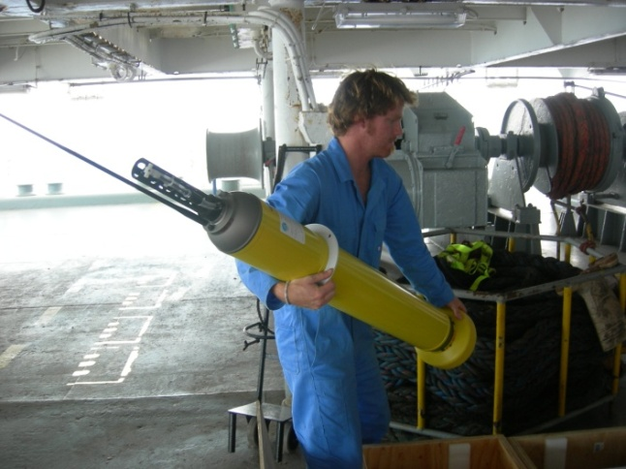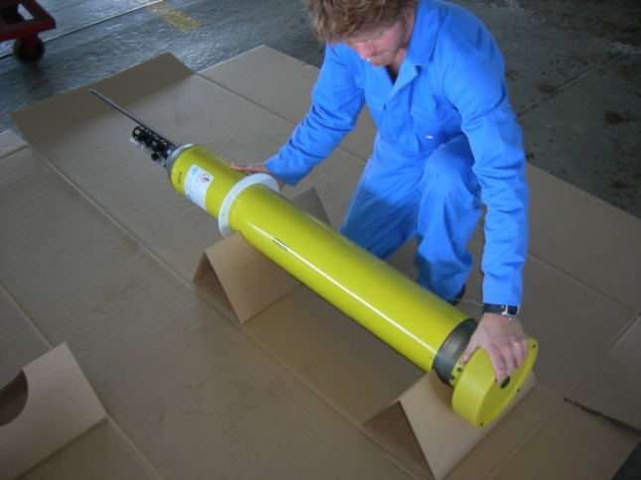

- Slide the two 24”x24” panels into an x-shape such that they are at a 90˚ angle with one another and their slits interlock.
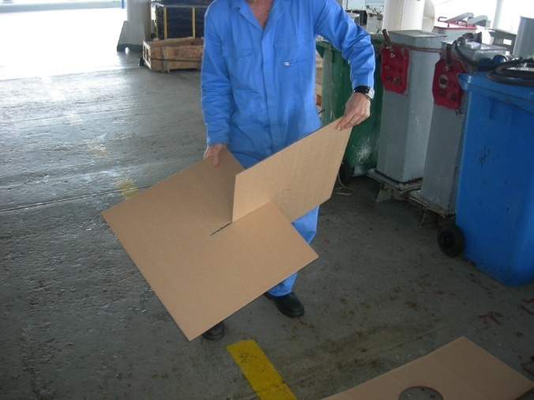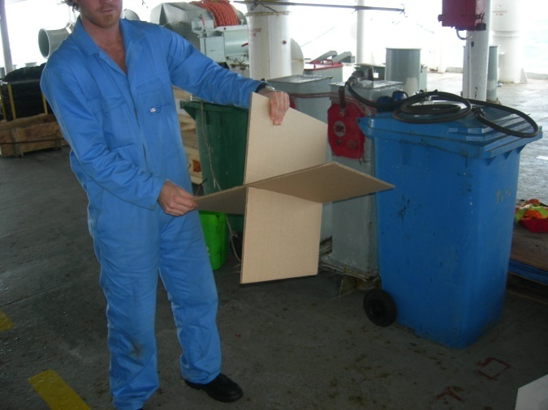
- In the case of ARGOS antennae, place x in panel 3 on the top side of the float such that antenna lies beneath the x. This will ensure that movement of the antenna is cushioned by the x on impact.
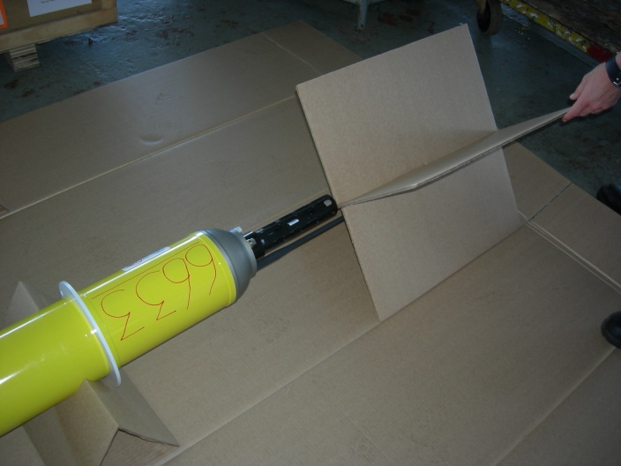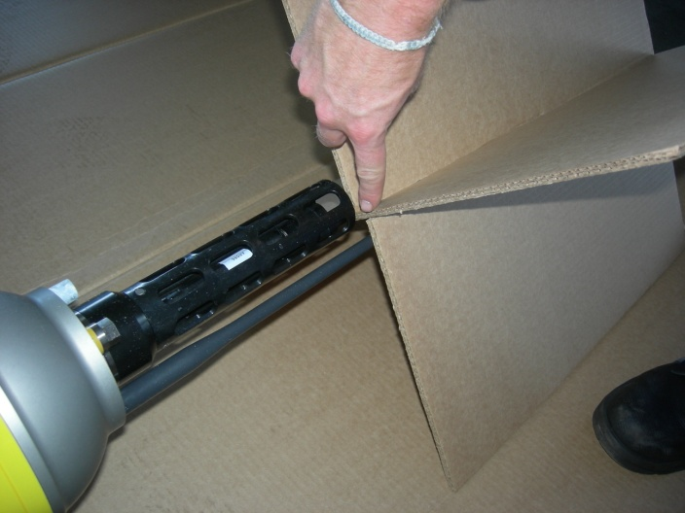

- In the case of the Iridium antennae (not pictured), place x in panel 3 on the top side of the float such that the antenna butts up against the x, restricting movement.
- Fold panel 1 over so it is opposite panel 3 and the “pyramids” now surround the float from opposite sides.
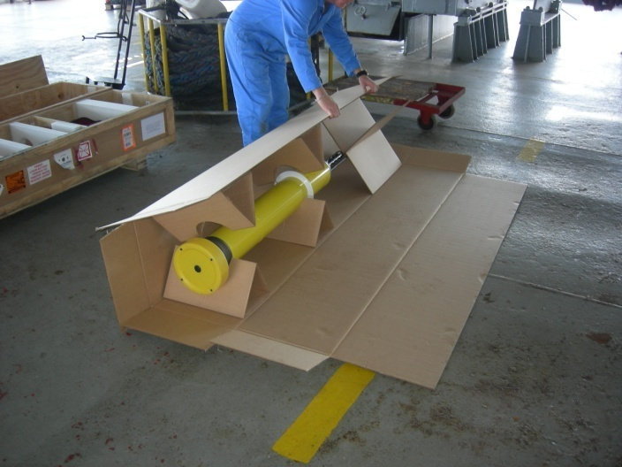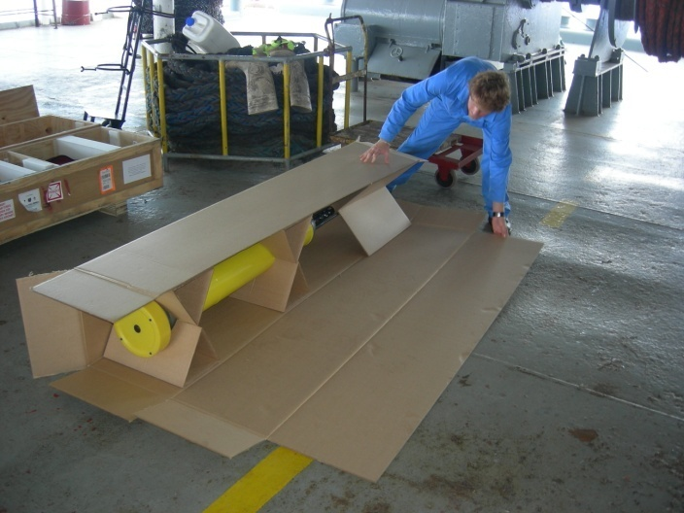

- Now fold panels 4 and 5 toward the float such that panel 5 overlaps panel 1.
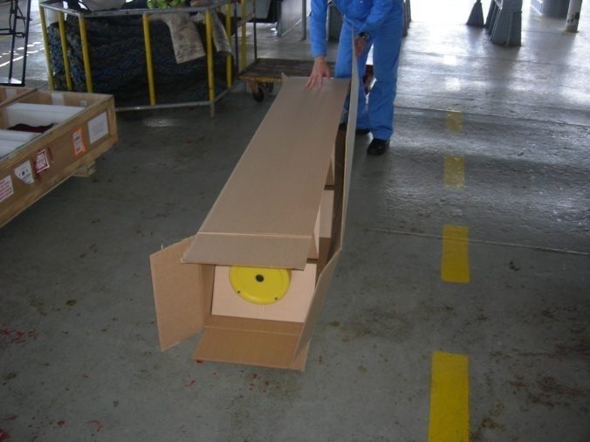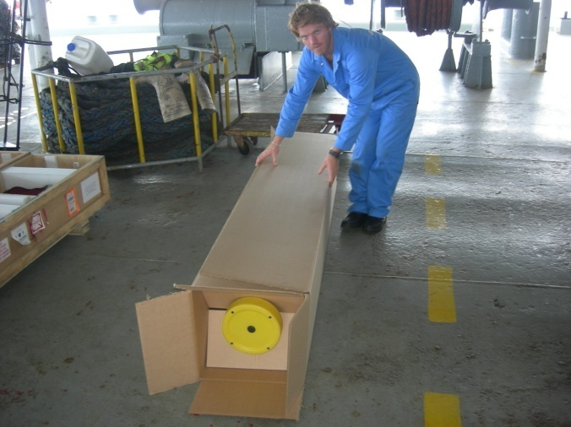
- Fold the end flaps at the top and bottom of the box in a cross-shape.
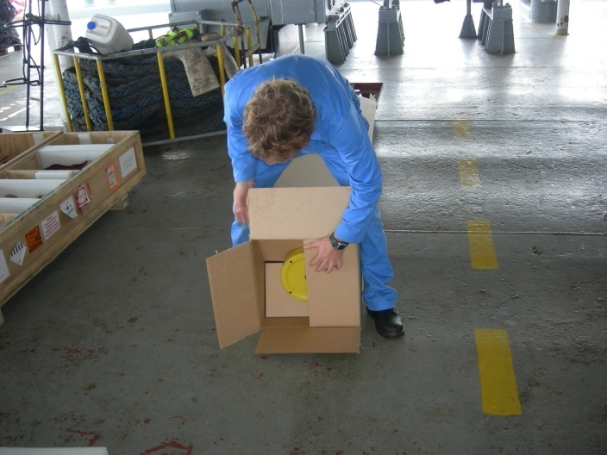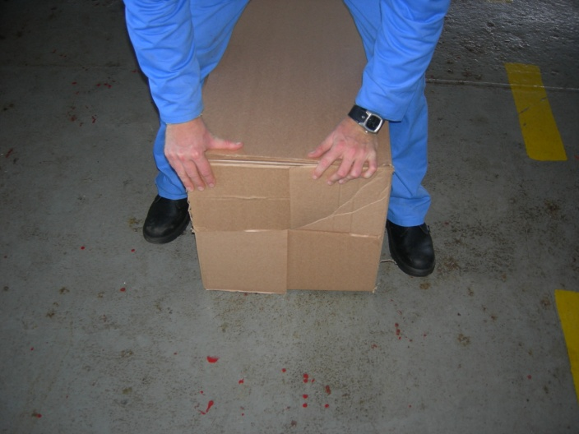

- Roll the box through 180˚ onto bearers, such that the box now lies on the open side with the handles facing upwards. The box is off the ground to make tying it in the next few steps easier.
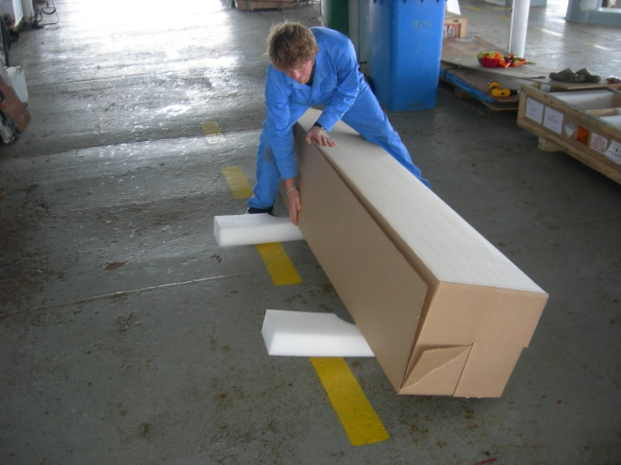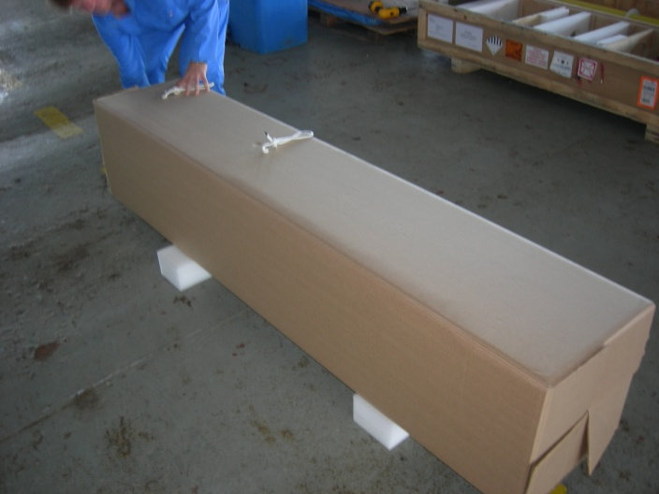

- Cut 2 lengths of the wax thread each ~8’ long.
- Tie a loop in one end of the thread, feeding this through 2 “Lifesaver” candies. Pull loop back over candies and tighten. Repeat for other thread and candies.
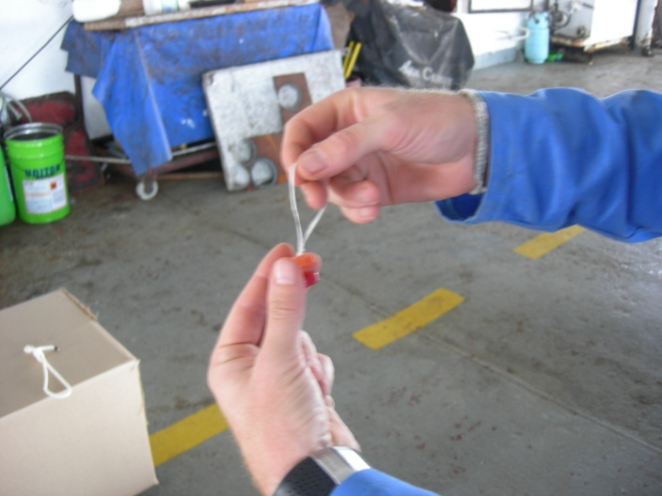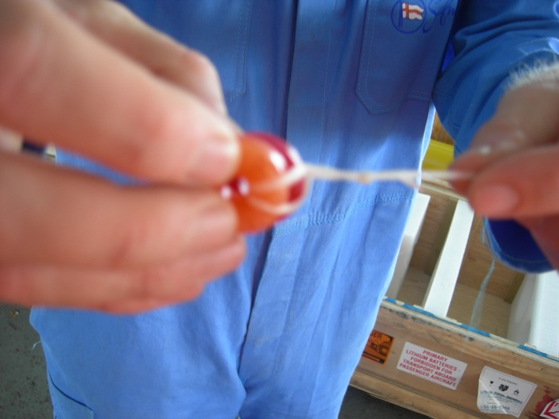

- Wrap the thread around the box once, feeding through the candies on the other end of the thread.
- Be careful to feed through candies only and not the loop in the other end of the thread.
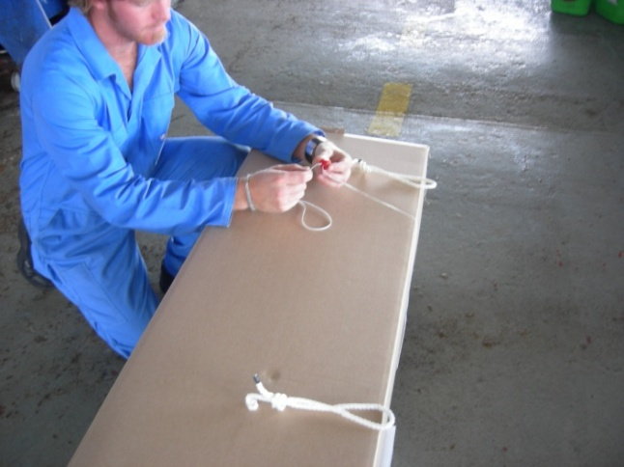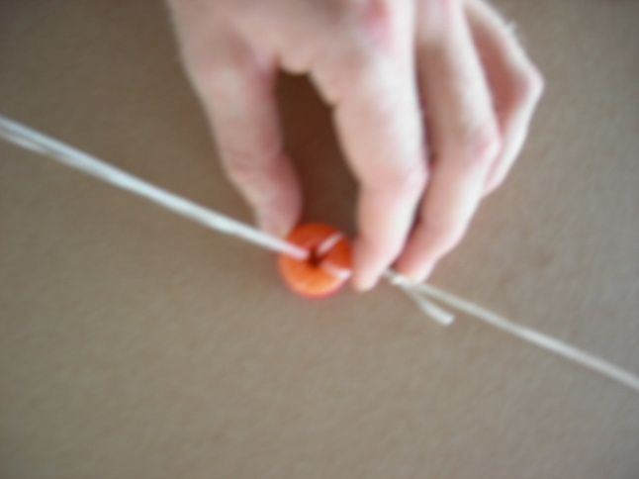

- Do a trucker’s hitch to tighten thread around box.
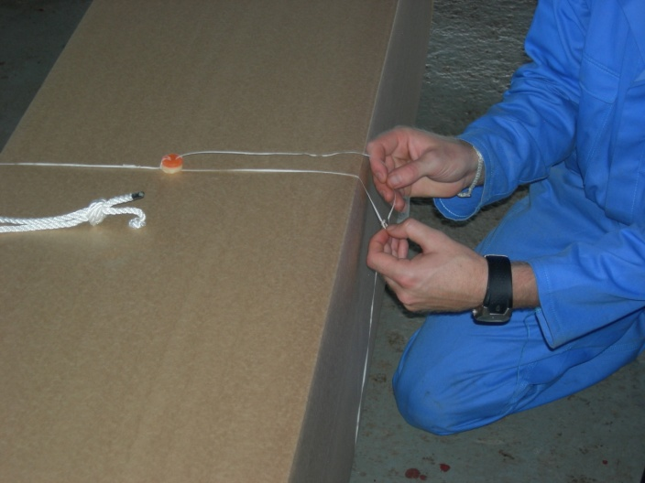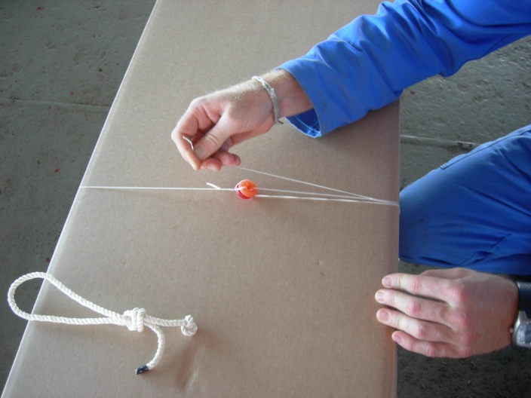

- Repeat for the other thread. The threads should be positioned near the rope handles for maximum strength. Be careful of the candies, they have good tensile strength but are brittle and crush easily.
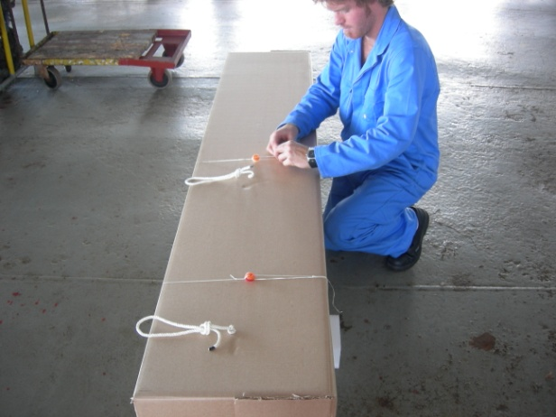
- The box should now be secured shut.
- Write “forward” on the end of the box with the base of the float and “aft” on the antenna end of the box. This will be the direction the box must face when deploying whether off the port or starboard side of the ship.

Deploying Float:
- NOTE: METHOD OF DEPLOYMENT WILL DEPEND ON WEATHER CONDITIONS AS WELL AS THE SHIP
- Float should not be dropped more than ~6m. If freeboard >~6m ropes should be used.
- If freeboard >~6m but heave of the ship allows drops <6m then a properly timed drop will not require ropes.
- Method of deployment must be judged by technician according to specific circumstances.
- Depending on which side of the ship you are going to deploy from, shift the candies on the box so that they face away from the hull to avoid damage when deploying. Remember that handles will be facing up, base of float facing forward and antenna facing aft.

Using ropes:
- Measure lengths of deployment ropes such that they just reach the sea surface from the guard rail (ie height of the freeboard).
- Tie the two ropes to the guard rail roughly 10’ apart, such that loose ends reach sea surface when hanging overboard. (Ropes are placed further apart than the width of the box to provide stability while lowering and reduce swinging).
- With the float box on the deck next to guard rail; feed the ropes through the rope handles on the box with the loose ends on deck.
- Lift box onto guard rail pulling deployment ropes taught. Ensure ropes are on the boat side of the box not the sea side.
- Holding deployment ropes one in each hand, lower box overboard off guard rail being very careful to keep the box horizontal. Remember the box is lop-sided towards the base of the float.
- Continue to lower box. Always be aware of keeping box horizontal as well as how much rope you have left to lower.
- Once end of ropes (or the shorter rope if unequal in length) is reached, throw end of ropes overboard away from the ship. Ensure that ropes are thrown simultaneously to allow box to hit water horizontally.

Without Ropes:
- Lift box onto guard rail making sure float is parallel to the ship with the base facing forward and the antenna facing aft.
- Holding rope handles on box, lower over board off the guard rail making sure to keep box horizontal.
- Wait for heave of ship so that drop is minimized. Drop is minimized release both handles simultaneously so that box hits water horizontally.

Be sure to log the float ID (found on the float casing), the date (mm/dd/yyyy), time (GMT), latitude and longitude of deployment.

