High Density XBT run and Argos float deployments
05 February 2010 – 28 February 2010
Valparaiso (Chile) to Cape Town
Report by: Gus Mckay
_____________________________________________________________________________________
Background
I have been collaborating with the United States Department of Commerce's Atlantic Oceanographic and Atmospheric Administrations’ Laboratory since the implementation of the South Africa to New York transect in Sep 2001. In order to further my training and strengthen the SAWS’s relationships with NOAA , I agreed to do a High Density XBT run for NOAA between Valparaiso(Chile) and Cape Town on NOAA’s research ship the Ronald Brown (AX180210) during February 2010.
The Atlantic Oceanographic and Atmospheric Laboratory is located in Miami, Florida and is one of twelve laboratories of the National Oceanographic and Atmospheric Administration (NOAA). The Physical Oceanography Division of this laboratory has the mission to investigate the effect of the ocean on climate. To accomplish this they maintain an oceanographic and climate observing system to measure the upper ocean thermal structure and currents. Several data sets are obtained and developed by our laboratory's staff of scientific and technical personnel to investigate the ocean processes and their link to climate variability and environmental changes.
Some of these observations are made by hydrographic measurements including the acquisition of temperature sections across long oceanic sections. The ship tracks used to deploy eXpendable BathyThermographs (XBTs) to obtain these temperature sections are usually referred to as lines. The line between Cape Town and Brazil is known as AX18. Hamburg SUD shipping company has volunteered space aboard their ships along this line. Moreover, other instruments such as drifters and floats are sometimes also deployed to help investigate ocean currents. Remote sensing procedures are also used, including satellite observations, to monitor surface ocean currents, wind fields, and sea surface temperatures.
Many of the results obtained from our research can be viewed in real or near-real time on our laboratory's web pages. As we obtain the data we place updates on the progress of our research. This information can be accessed through our web pages at www.aoml.noaa.gov or www.aoml.noaa.gov/phod. The web pages where we show results obtained from high density (www.aoml.noaa.gov/phod/hdenxbt) or low density(www.aoml.noaa.gov/phod/uot/seasxbt.html) deployments from ships that join the Voluntary Observing Ships program might be of special interest to you since this is where the data obtained will be recorded. Moreover, results from satellite-derived ocean surface currents (www.cwcaribbean.aoml.noaa.gov, click on 'Access CoastWatch Data', and then on 'Altimeter and GTS Data') and surface winds (www.cwcaribbean.aoml.noaa.gov, click in 'Access CoastWatch Data', and then click on 'Near Real-Time Wind Data’) can also be accessed through our web pages.
Results obtained from observations and instrument deployments from volunteer ships are transmitted in real-time to our laboratory and then used by the National Weather Service to produce their marine, and atmospheric forecasts. Shipping companies then use this information as an aid for their operations.

Cruise Plan
Implementation of High-Density XBT Line AX18.

National Oceanic and Atmospheric Administration
Atlantic Oceanographic and Meteorological Laboratory
Physical Oceanography Division
4301 Rickenbacker Causeway
Miami, Florida 33149

Principal Investigators:
Gustavo Goni and Molly Baringer

Date: Departing Durban, South Africa February 05, 2010; arriving in Cape Town
February 28, 2010.

Ship Name: Ronald H .Brown (NOAA)

Scientific Party: Mr. Gus McKay (South African Weather Service)

Description of the Program:

The Atlantic Ocean plays an important role within the global ocean thermohaline circulation, through the interocean and interhemispheric exchanges of water, heat, salt and vorticity. The Meridional Overturning Circulation (MOC) in the subpolar North Atlantic is driven by the formation of the North Atlantic Deep Water (NADW), with a formation rate and properties that are highly influenced by climate changes on the decadal and interdecadal time scales. These climate changes affect the air-sea buoyancy flux in the subpolar basin, where warm-to-cold water transformation processes take place. Recent results indicate that the formation of the NADW is the cause of strong traces of the North Atlantic Oscillation (NAO), a leading signal in decadal time scale climate changes in the Atlantic. The MOC in the subtropical North Atlantic is mostly affected by changes in momentum, air-sea fluxes and salinity. However, the processes by which they cause changes in the ocean dynamics are not completely known, particularly at decadal and longer time scales.

The upper limb of the MOC carries warm waters from the South Atlantic into the North Atlantic subtropical gyre through pathways and mechanisms that are not completely understood and need to be investigated further. This connection between the upper limbs of the gyres in the southern and northern hemispheres in the tropical Atlantic is primarily composed by zonal currents, which are forced by the wind field, primarily by the position and intensity of the Inter-Tropical Convergence Zone (ITCZ). Therefore, the tropical Atlantic is of critical interest for the large-scale ocean circulation since it is where strong western boundary currents contribute to inter-hemispheric transport of properties. The MOC carries warm water from the South Atlantic to the North Atlantic off the coast of Brazil within a western boundary current, the North Brazil Current (NBC). Below the NBC, colder, fresher Antarctic Intermediate water flows north in the North Brazil Undercurrent
In addition to the northward flow of the NBC a shallow Subtropical Cell (STC) carries subducted surface water from the southern subtropics to the equator, where it is upwelled to the surface.

While time scales of decades or more characterize the deep flows, the time scales of the boundary currents and STCs are of months to several years. Monitoring water mass properties as well as the velocity structure of the hypothesized pathways between the subtropics and the tropics provides the tools to characterize both the mean and the time-dependent properties of the tropical portion of the MOC and the Atlantic STC. The role of the South Atlantic in the Meridional Overturning Circulation (MOC) can be better understood by reducing the uncertainty in the meridional heat flux through the subtropical band.

This program is designed to measure the upper ocean thermal structure in key regions of the Atlantic Ocean. The seasonal to interannual variability in upper ocean heat content and transport is monitored to understand how the ocean responds to changes in atmospheric and oceanic conditions and how the ocean response may feedback to the important climate fluctuations such as the NAO. This increased understanding is crucial to improving climate prediction models. Within this context, four XBT lines have been chosen to monitor properties in the upper layers of the Atlantic Ocean.
The key objective of this program is to implement the high density XBT line AX18 to improve the existing climate observing system in the tropical Atlantic. These observations will allow improving our knowledge of the spatial and temporal variability of the surface currents in the South and tropical Atlantic and to estimate the meridional heat transport in the South Atlantic

This will be the 20th realization of a five-year program to survey this line four times a year (Figure 1). Additional information on this project may be obtained from http://www.aoml.noaa.gov/phod/hdenxbt/
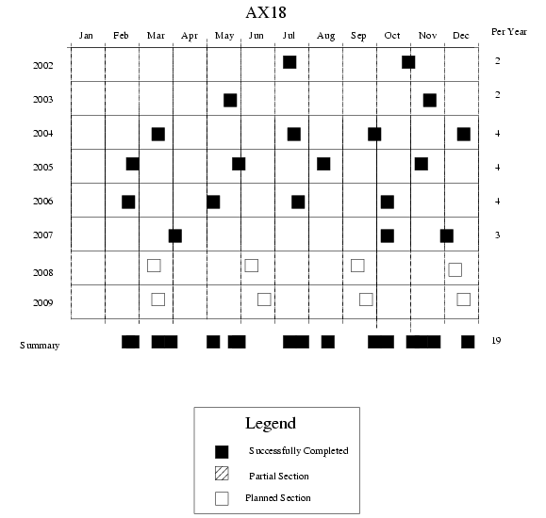

Figure 1. Deployment schedule for AX18.

Figure 2. The location of XBT deployments for the previous AX18 XBT transects. The key objective of this project is to improve the existing climate observing system in the tropical Atlantic.

Based on recommendations from the Climate Observing System for the Tropical Atlantic (COSTA) Workshop (Miami, May 1999) this program will increase data collection on the AX18 low density XBT VOS line between Durban and Santos traversing key regions in the tropical Atlantic four times a year. These observations will allow to improve our knowledge of the spatial and temporal variability of the zonal surface currents in the tropical Atlantic Ocean.
Implementation:

Implementation:
Two types of instruments will be deployed:

(a) EXpendable BathyThermographs, XBTs.

The XBTs were already loaded on the ship. The XBTs will be launched from a hand launcher in two modes, High Density (every 20 km) and Intermediate Density (every 50 km), performed between the Strait of Magellan and Cape Town

1. Intermediate Density: Between the coast of South America once the ship enters waters deeper than 200m (approx. 52.5 S,65 W)and southeast of the Malvinas (approx. 52.3 , 58W). Approximately 10 XBT’s.
2. High Density : Between 52.3 S,58W and 45ºW.Approximately 48 XBTs.
3. Intermediate Density: Between 45º W and 10º E. Approximately 62 XBT’s
4.High Density: Between 10º E and approx. 200m depth off South Africa. Approximately 50 XBTs.

Total : Approx. 170 XBT’s

The time spacing between drops will be determined by the ship speed (Table I).

(b) Profiling Floats.

8 profiling floats will be deployed during this crossing.

(c) Surface Drifters.

No surface drifters will be deployed during this crossing.

High-density XBT cruise AX180210 report

Ship Rider: Fergus Mckay

a) XBTs deployed: 196

b) Drifters deployed: No drifters were deployed.

c) Profiling floats deployed: 8 floats were deployed.

No. | Float  S/N | Start Date/Time  MM/DD/YYYY | Deploy Date/Time  MM/DD/YYYY | Lat  Deg Min X | Long  Deg Min X
1. | 931/9194 | 02/15/2010 – 13:00 | 02/16/2010 – 12:33 | 49⁰ 24.94' S | 046⁰ 51.30' W
2. | 946/0680 | 02/17/2010 – 13:20 | 02/18/2010 – 11:05 | 49⁰ 45.10' S | 033⁰ 01.01' W
3. | 819/71623 | 02/19/2010 – 09:43 | 02/19/2010 – 18:30 | 48⁰ 57.67' S | 023⁰ 00.01' W
4. | 923/84846 | 02/20/2010 – 07:50 | 02/20/2010 – 13:37 | 48⁰ 04.45' S | 017⁰ 00.10' W
5. | 811/71619 | 02/21/2010 – 08:08 | 02/22/2010 – 15:04 | 43⁰ 03.19' S | 010⁰ 00.31' W
6. | 921/84844 | 02/22/2010 – 14:50 | 02/23/2010 – 06:14 | 42⁰ 18.06' S | 006⁰ 00.01' W
7. | 921/84844 | 02/23/2010 – 13:45 | 02/23/2010 – 21:05 | 41⁰ 23.91' S | 002⁰ 01.00' W
8. | 927/84850 | 02/25/2010 – 05:50 | 02/25/2010 – 13:16 | 38⁰ 22.79' S | 007⁰ 58.55' E

d) All data was sent via e-mail on a daily basis. The Binary files were sent.

e) Equipment tools and supplies needed: A shifting spanner for the launcher and a Stanley
knife to remove the wrapping from the profiling floats.

f) Problems: The main problem we had was that this transect will invariably be influenced by bad weather. On two occasions the Captain gave the order to baton down the hatches due to storm sea and above gale force wind conditions, hence resulting in me having to stop XBT operations. The bad weather also caused some heavy equipment to roll over the launcher cable during an attempted launch damaging it. Fortunately there was a spare launcher, so the damaged one was replaced. On our last two days we had quite a large swell from directly behind the stern, causing quite a lot of turbulence at the launch sites, resulting in a slight impedance of the data collected.

g) Recommendations: If any more XBT runs are done on this route an automatic launcher should be provided to solve the problem of trying to launch in the storm sea conditions on this transect.

g) Other narrative: Other than the inclement weather and sea conditions, I still found the trip to be enlightening and Captain Blake, officers and crew were also very hospitable making for a pleasant voyage. I was also ably assisted with XBT drops and profiling float deployments by Shawn Gendron.

h) Ship contact: Captain Wade Blake
email: CO.Ronald.Brown@noaa.com

Summary of cruise AX180210 between Valpariso and Cape Town

AX180210 was conducted aboard the M/V Ronald Brown. I boarded the ship during the morning of the 5th of February and the ship left Valpariso during the morning of the 06th February. The ship birthed at Cape Town on the 27th of February 2010.
In total 196 XBTs were deployed. High density deployments at a rate of one per 20 km were started at 32.58 S and 71.45 W. Intermediate density deployments at a rate of one per 50km commenced from 45° W until 10° E. High density measurements commenced again from 10° E until 41.3°W.
8 profiling floats were deployed .
The weather wasn't too kind this cruise, with storm seas and gale force winds making life a bit difficult for
us. On two occasions Captain Blake gave the order to baton down the hatches due to storm seas and
gale force winds. This resulted in a delay in XBT operations. On the 17th some heavy equipment rolled
over the launcher cable due to the rough seas, damaging it. I therefore replaced the launcher with our
spare one, and commenced operations again once getting permission to go out on the deck. The only
other problem we experienced was on the 24th and 25th , when we had a large swell catching up to the
stern of the boat, causing a lot of turbulence at our launch sites, therefore affecting the data acquisition a
bit negatively. There was only one XBT that was found to be faulty before the launch stage.

F.Mckay

Port Meteorological Officer
Durban

Reports and Feedback from the National Ocean and Atmospheric Administration(NOAA) of the United States of America.
UNITED STATES DEPARTMENT OF COMMERCE
National Oceanic and Atmospheric Administration
OFFICE OF MARINE AND AIRCRAFT OPERATIONS
NOAA Ship RONALD H. BROWN
439 West York Street
Norfolk, VA 23510
Friday, February 26,2010
To whom it may concern:
It was a pleasure having Gus McKay of the South African Weather Service aboard
NOAA Ship Ronald H Brown during NOAA's CLIVAR project voyage from
Valparaiso, Chile to Cape Town, South Africa, 6-27 February 2010.
We experienced several periods of very rough weather and Gus was very helpful to both
me on the ship and was clearly dedicated to the scientific mission for NOAA-AOML. He
continued the data collection (XBT launches and deploying drifting floats) in some very
challenging conditions throughout the day and night. He was always in high spirits and
the officers and crew enjoyed having him aboard.
We would gladly welcome Gus back anytime his services are needed by any project.
Thanks for sharing Gus with NOAA and the NOAA Ship Ronald H Brown.
Sincerely,
Wade J. Blake
Captain, NOAA
Commanding Officer
From: Robert J. Roddy [Robert.J.Roddy@noaa.gov]
Sent: 19 February 2010 09:33 PM
To: Gus Mckay
Subject: Re: FW: WHOI Argo float deployment 819/71623

Hi Gus,
Thanks for your very professional work!
Perhaps if the officers on watch can do the meteorology readings for each ARGO
deployment, that may make it easier for you.
Question: When you say slip line, are you taking the floats out of their
boxes, and deploying them through the hole in their skirt disk?
Or, are you lowering the whole box in until the release touches water, and
releases the straps, as we do in normal container ship deployments?

Cheers, Robert.
From: P.Robbins [probbins@whoi.edu]
Sent: 25 February 2010 06:27 PM
To: Gus Mckay
Subject: Re: WHOI Argo float deployment 927/84850
Gus,
Thanks for all deployment work and especially for the detailed meteorology reports and the
photos.
Are you South African? Are you headed home after the ship docks in Cape Town?

Paul Robbins
From: Robert.J.Roddy@noaa.gov
Sent: 24 February 2010 09:34 PM
To: Adrian Webb; Fergus Mckay; Gus Mckay
Gus... Happy landings into Cape Town!
Thanks for all you did out there, under not the best conditions!
You can book your own flight to DUR, or if you know when you want to fly up, I
can have KBTravel book it- your choice.

Thanks for everything... You guys are the BEST!!
Ciao, Robert.
Photos

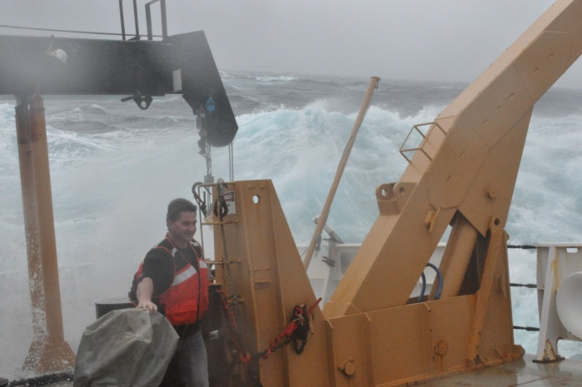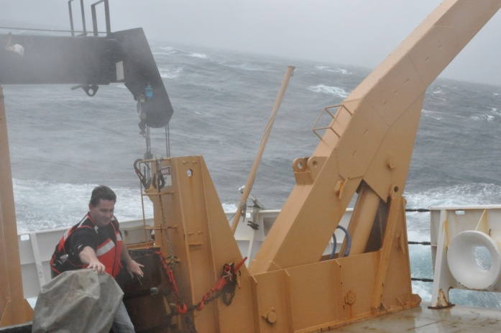
Dropping XBT’s in gale force winds (Gus Mckay)

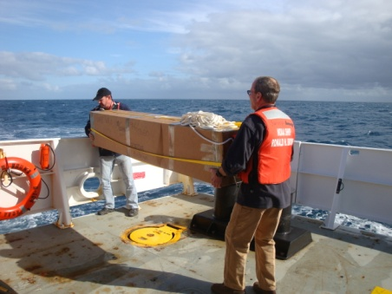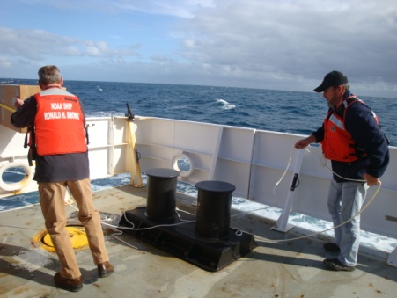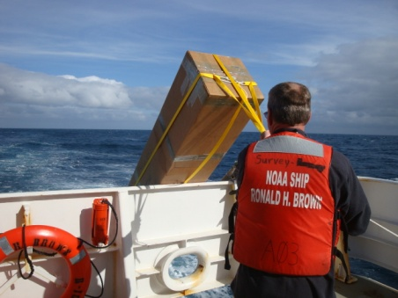

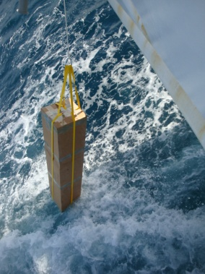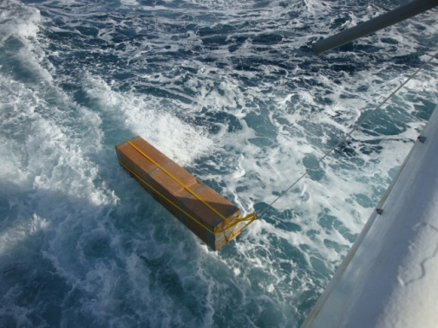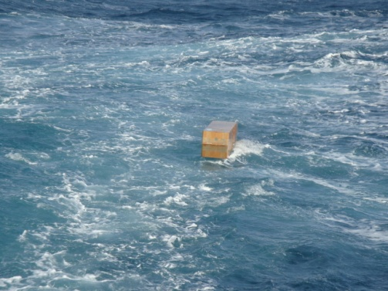
Deploying an Argos float(Myself and Jonathon Shannahoff)

