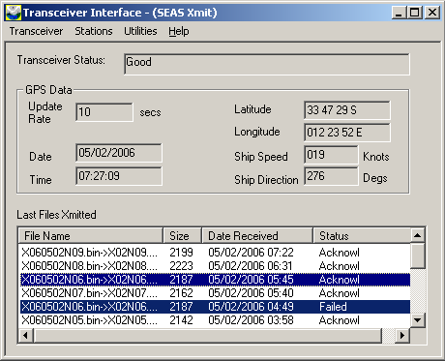
X060502N06.bin file failed in automatic tx, so it was transmitted using XBT/Transmit/Selected profile.

X060502N16.bin status “View log” same in Tx log... was it transmitted or not?
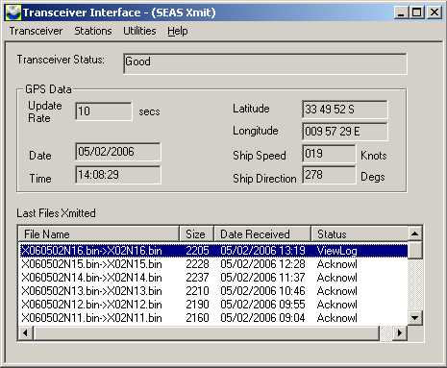
Same happened for next (N17)

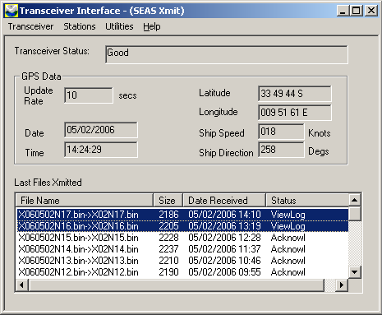
Both transmitted using XBT/Transmit/Selected profile.
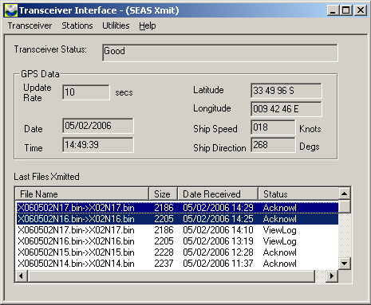

Requesting mails from Capsat on 02MAY1704Z, this msg appeared many times

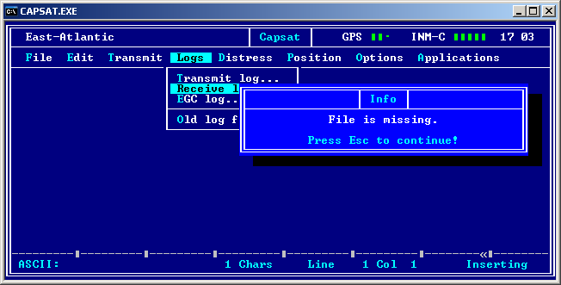
- And sometimes was necessary to kill capsat with control+alt+delet because it freezes.... but then works ok.

X060502N24.bin failed. Tx in manual mode.

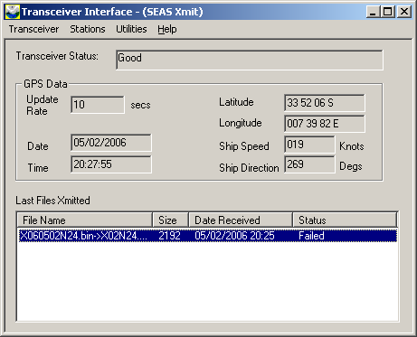

launch im #6 tube with probe aparently good (resistance arround 20000) gave MK21 error as seen on screen. Reloaded, reset tubes and launched again...

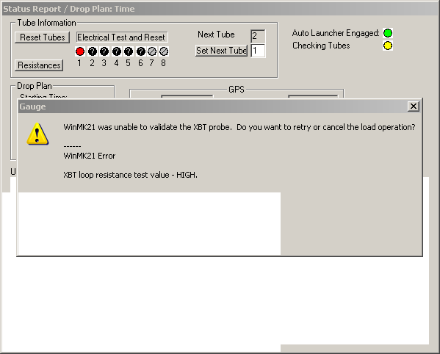

cannot transmit X050609N10.bin
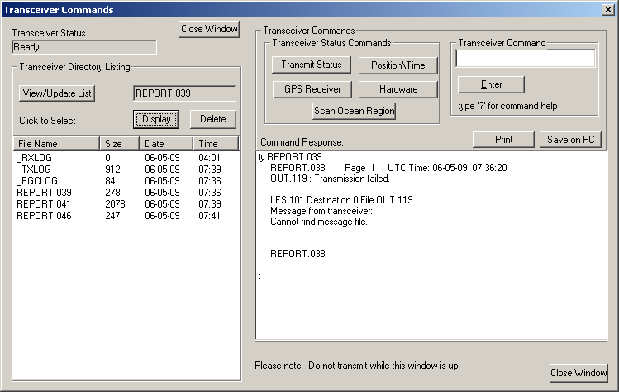

I understand the system received the .bin at 0732 and gave up at 0736...

it was sent manually by transmit last profile
