

Physical Oceanography Division Phone: 305-361-4345
4301 Rickenbacker Cswy Fax: 305-361-4412
Miami, Florida 33149-1097
October 2018

Cruise Plan – AX18

Ship Name: M/V Mercury Ace

Call Sign: 3FNS7

IMO: 9591052

Project Title: Ship Of Opportunity Program
High Density XBT Transect AX18

Beginning date: Departing Zarate, Argentina, 22 October, 2018.

Ending date: Arriving Durban, South Africa, 8 October, 2018

Scientific Ship Riders: Javier Pardinhas - NOAA AOML,

If you encounter an issue that may cause the cruise to need to be canceled, or cause the cruise to fail, or are missing equipment, please contact the following people as soon as possible by phone or by what's app.
Zach Barton – 305-721-7100 (Phone and whatsapp)
Pedro Pena – 786-380-9192 (Phone only)
Ulises Rivero – 305-962-7446 (Phone and whatsapp)
Gustavo Goni – hereisgustavo (skype)

Description of the Scientific Program:

The Atlantic Ocean plays an important role within the global ocean thermohaline circulation, through the interocean and interhemispheric exchanges of water, heat, salt and vorticity. The Meridional Overturning Circulation (MOC) in the subpolar North Atlantic is driven by the formation of the North Atlantic Deep Water (NADW), with a formation rate and properties that are highly influenced by climate changes on the decadal and interdecadal time scales. These climate changes affect the air-sea buoyancy flux in the subpolar basin, where warm-to-cold water transformation processes take place. Recent results indicate that the formation of the NADW is the cause of strong traces of the North Atlantic Oscillation (NAO), a leading signal in decadal time scale climate changes in the Atlantic. The MOC in the subtropical North Atlantic is mostly affected by changes in momentum, air-sea fluxes and salinity. However, the processes by which they cause changes in the ocean dynamics are not completely known, particularly at decadal and longer time scales.

The upper limb of the MOC carries warm waters from the South Atlantic into the North Atlantic subtropical gyre through pathways and mechanisms that are not completely understood and need to be investigated further. This connection between the upper limbs of the gyres in the southern and northern hemispheres in the tropical Atlantic is primarily composed by zonal currents, which are forced by the wind field, primarily by the position and intensity of the Inter-Tropical Convergence Zone (ITCZ). Therefore, the tropical Atlantic is of critical interest for the large-scale ocean circulation since it is where strong western boundary currents contribute to inter-hemispheric transport of properties. The MOC carries warm water from the South Atlantic to the North Atlantic off the coast of Brazil within a western boundary current, the North Brazil Current (NBC). Below the NBC, colder, fresher Antarctic Intermediate water flows north in the North Brazil Undercurrent. In addition to the northward flow of the NBC a shallow Subtropical Cell (STC) carries subducted surface water from the southern subtropics to the equator, where it is upwelled to the surface.

While time scales of decades or more characterize the deep flows, the time scales of the boundary currents and STCs are of months to several years. Monitoring water mass properties as well as the velocity structure of the hypothesized pathways between the subtropics and the tropics provides the tools to characterize both the mean and the time-dependent properties of the tropical portion of the MOC and the Atlantic STC. The role of the South Atlantic in the Meridional Overturning Circulation (MOC) can be better understood by reducing the uncertainty in the meridional heat flux through the subtropical band.

This program is designed to measure the upper ocean thermal structure in key regions of the Atlantic Ocean. The seasonal to interannual variability in upper ocean heat content and transport is monitored to understand how the ocean responds to changes in atmospheric and oceanic conditions and how the ocean response may feedback to the important climate fluctuations such as the NAO. This increased understanding is crucial to improving climate prediction models. Within this context, four XBT lines have been chosen to monitor properties in the upper layers of the Atlantic Ocean.

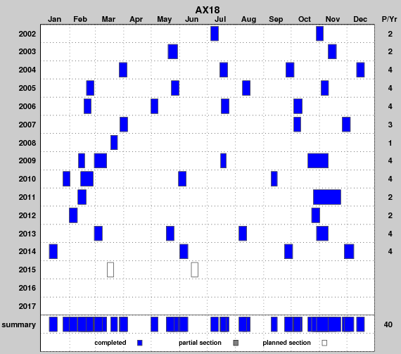
The key objective of this program is to implement the high density XBT line AX18 to improve the existing climate observing system in the tropical Atlantic. These observations will allow improving our knowledge of the spatial and temporal variability of the surface currents in the South Atlantic and to estimate the meridional heat transport in the South Atlantic.

Figure 1. Deployment schedule for AX18.
Based on recommendations from the Climate Observing System for the Tropical Atlantic (COSTA) Workshop (Miami, May 1999) this program will increase data collection on the AX18 high density XBT transect between Argentina and South Africa traversing key regions in the tropical Atlantic four times a year. These observations will allow us to improve our knowledge of the spatial and temporal variability of the zonal surface currents in the tropical Atlantic Ocean.

Implementation:
Three types of instruments will be deployed:

XBT deployment plan
The XBTs will be launched from an autolauncher in two modes, High Density and Intermediate Density, performed between South Africa and South America.

- High Density (every 10 Km): Off the coast of Argentina, once the ship enters water deeper than 200m (approx 53ºW) continuing to 40ºW. Approximately 83 XBTs.
- Intermediate Density (every 30 Km): Between 40ºW and 0º. Approximately 124 XBTs.
- High Density (every 10 Km): Between 0º and coast of South Africa, once the ship enters waters deeper than 200m (approx. 18.5 ºE). Approximately 183 XBTs.

Total: approx 390 XBT’s.

If the Ship is going from South Africa to South America, simply reverse these directions.
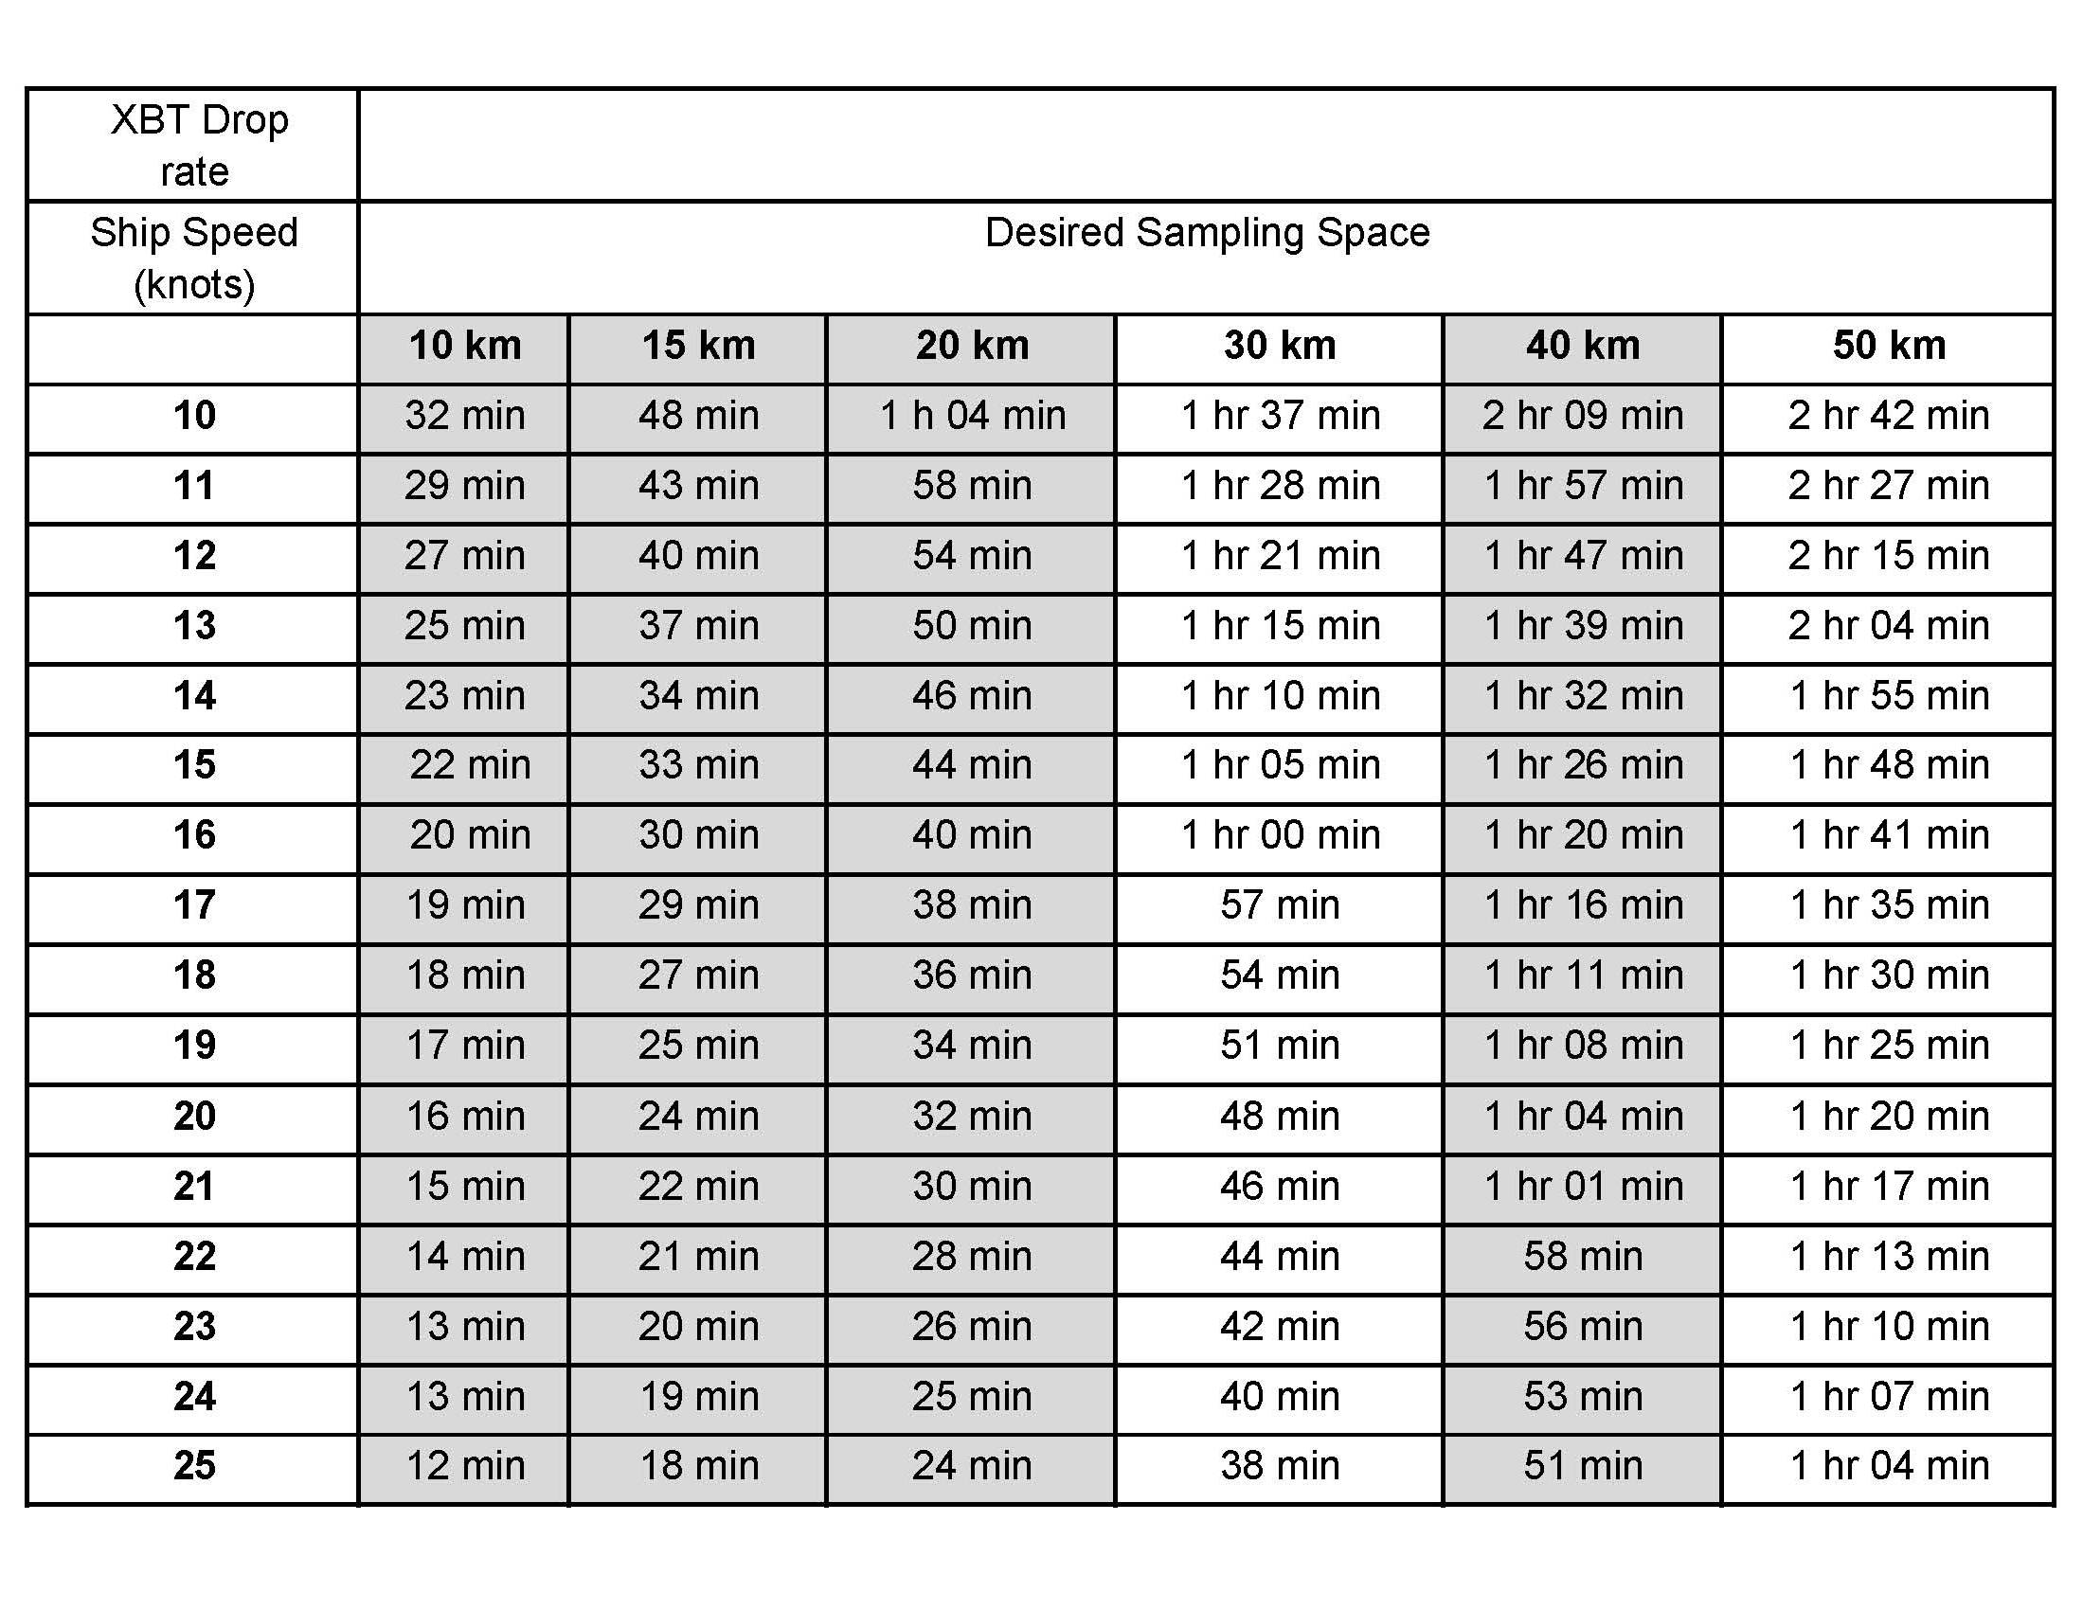
The time spacing between drops will be determined by the ship speed (Table I).

Table I. Time interval between XBT launches based on ship speed and desired sampling spacing.

If the planned sampling is interrupted for any reason (such as an autolauncher failure) the procedure will be to drop another probe as close as possible to the planned drop and continue with the desired spacing of the XBTs for that section of the cruise track (according to the above guide). If a serious malfunction of the autolauncher occurs then manually deploy the XBTs from the stern of the ship using the hand launcher. While this happens, please be troubleshooting the problems and be in contact with Zach Barton, Ulises Rivero (Ulises.Rivero@noaa.gov), Andy Stefanick (Andrew.Stefanick@noaa.gov), or Pedro Pena (pedro.pena@noaa.gov).

The ship-rider will work as needed around the clock to:
1) check and load the auto-launcher;
2) check that the system is logging data correctly;
3) keep a log of problems, repeated casts due to suspected XBT errors and weather conditions;
4) inform NOAA personnel of any difficulties; and,
5) deploy ARGO profiling floats and surface drifting buoys as necessary.

ARGO float deployment

No Argo floats will be deployed.

Drifter deployments

No drifters will be deployed during this cruise
Summary

This high resolution XBT transect will require 390 probes plus an anticipated 10% failure rate of 40 probes. This typically requires a total of 430 probes per crossing.
Temperature sections and surface conditions:

The two temperature sections obtained during the February 2006 and March 2007 transects reveal the main surface currents in the region that can be detected from the slope of the isotherms (Figure 2).

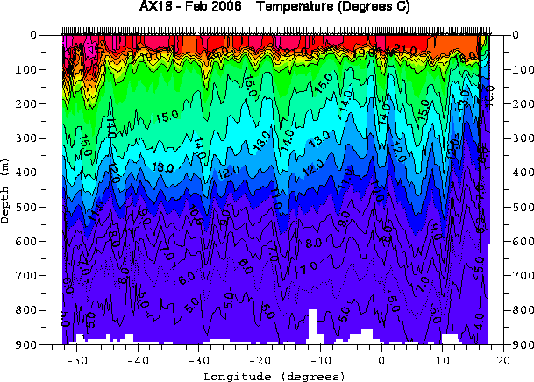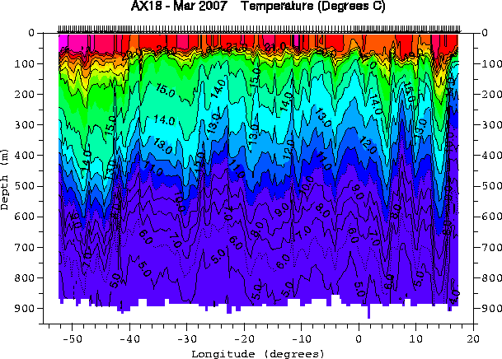

Figure 2. Temperature sections obtained from the February 2006 and March 2007 transects.

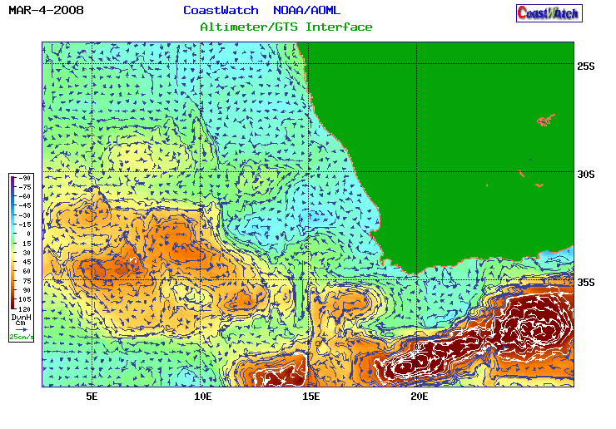
The satellite altimetry derived surface currents (Figure 3) in the region indicate that there is a warm ring centered approximately 8E 33S.
Figure 3. Altimetry-derived geostrophic currents for March 4, 2008
High Density Check-in list for the Ship Rider Date Completed

The ship rider is the primary person responsible for ensuring the success of the cruise. This includes checking that all the necessary equipment has been tested and loaded in the ship, verifying weather conditions, ship schedules, possible ship delays etc. Before traveling the rider must have all documents and contact information required for the cruise.

Equipment testing: ____________
- Verify that all equipment to be sent from AOML has been thoroughly tested before shipping.
- Comment if not testing was performed:
______________________________________________________________________________________________________________________________________________________________________________________________________

Check equipment shipping and loading: ____________
- Contact Zach Barton (Zach.Barton@noaa.gov, 305-361-4548) to confirm the status of equipment shipment and loading.

Check ship route ____________
- Contact Zach Barton (Zach.Barton@noaa.gov, 305-361-4548) to confirm that the ship is on the scheduled route two days in advance of the cruise’s planned date as well as the day before of your travel. Also communicate with Robert and Zach to inform them of your travel arrangements for the cruise.

Contact support at AOML ____________
- Contact Zach Barton (Zach.Barton@noaa.gov, 305-361-4548) at least a week in advance of the cruise’s planned date, and again at least two days before to coordinate airport pick up, ship access, etc.

Record height of deployments: ______________
- Please take note of and put in your report the approximate height that the deployments were made from. (Top of the water to where the probe was launched from.)
High Density Check-out list for the Ship Rider Date Completed

Data submission to AOML after the cruise __________________

The following files should be sent to AOML after the cruise, regardless of data transmissions during the cruise:
1. All XBT data in .BIN (c:\users\public\Documents\AMVERSEAS_V9\Archive\XbtDataRecorder\), and electronic XBT drop log sheet.
2. HistoryAllAttempts.txt – found at: c:\users\public\Documents\AMVERSEAS_V9\Archive\Reports\
3. The cruise data (including the above items) can be easily compressed with the “compress cruise data” button in the “utilities” menu in the XBT program.
3. Cruise summary for the web page
4. Cruise Report (Generated by amverseas in the “tools” menu in the XBT window
5. Drifting buoy log sheet and ARGO float log sheet in case of deployments of these instruments

The data can be submitted in a CD, memory stick or in a zip file as an email attachment.

Sent the XBT data and HistoryAllAttempts.txt to each of the following:
Yeun-Ho Daneshzadeh Yeun-Ho.Chong@noaa.gov __________________
Francis Bringas Francis.Bringas@noaa.gov __________________
Zach Barton Zach.Barton@noaa.gov __________________

Argo deployment information while underway:
e-mailed to: aoml.argo@noaa.gov and deploymentinfo@whoi.edu _____________________

Drifting buoy deployment information while underway:
Shaun Dolk Shaun.Dolk@noaa.gov __________________

Cruise summary for the webpage. This information goes on the webpage and includes the number of XBTs deployed, drifters/floats deployed, any data affecting issues, etc. Send an email to each of the following with your summary:
Gustavo Goni Gustavo.Goni@noaa.gov __________________
Shenfu Dong Shenfu.Dong@noaa.gov __________________
Molly Baringer Molly.Baringer@noaa.gov __________________
Yeun-Ho Daneshzadeh Yeun-Ho.Chong@noaa.gov __________________
Francis Bringas Francis.Bringas@noaa.gov __________________
Zach Barton Zach.barton@noaa.gov __________________

Please email a Cruise Report to Shenfu Dong, Gustavo Goni, Zach Barton, and Francis Bringas stating the following:
  - XBTs deployed
  - Drifters deployed (ID, date, time, latitude, longitude)
  - Profiling floats deployed (start time, deployment time, latitude, longitude)
  - GTS transmission (Real-time, twice a day, problems)
  - Additional equipment, tools, supplies needed
  - Problems
  - Recommendations
  - Other narrative

