 Physical Oceanography Division Phone: 305-361-4345
4301 Rickenbacker Cswy Fax: 305-361-4412
Miami, Florida 33149-1097
March 2019

Cruise Plan – AX08

Ship Name: M/V Maersk Vilnius

Call Sign: 9V8503

IMO: 9408956

Project Title: Ship Of Opportunity Program
High Density XBT Transect AX08

Beginning date: Departing Durban, South Africa, March 24, 2019

Ending date: Arriving Newark, New Jersey, April 17 , 2019.

Scientific Ship Riders: Mr. Fergus Mckay

If you encounter an issue that may cause the cruise to need to be canceled, or cause the cruise to fail, or are missing equipment, please contact the following people as soon as possible by phone or by what's app.
Zach Barton – 305-721-7100 (Phone and whatsapp)
Pedro Pena – 786-380-9192 (Phone only)
Ulises Rivero – 305-962-7446 (Phone and whatsapp)
Gustavo Goni – hereisgustavo (skype)

Description of the Scientific Program

The Atlantic Ocean plays an important role within the global ocean thermohaline circulation, through the interocean and interhemispheric exchanges of water, heat, salt and vorticity. The Meridional Overturning Circulation (MOC) in the subpolar North Atlantic is driven by the formation of the North Atlantic Deep Water (NADW), with a formation rate and properties that are highly influenced by climate changes on the decadal and interdecadal time scales. These climate changes affect the air-sea buoyancy flux in the subpolar basin, where warm-to-cold water transformation processes take place. Recent results indicate that the formation of the NADW is the cause of strong traces of the North Atlantic Oscillation (NAO), a leading signal in decadal time scale climate changes in the Atlantic. The MOC in the subtropical North Atlantic is mostly affected by changes in momentum, air-sea fluxes and salinity. However, the processes by which they cause changes in the ocean dynamics are not completely known, particularly at decadal and longer time scales.

The upper limb of the MOC carries warm waters from the South Atlantic into the North Atlantic subtropical gyre through pathways and mechanisms that are not completely understood and need to be investigated further. This connection between the upper limbs of the gyres in the southern and northern hemispheres in the tropical Atlantic is primarily composed by zonal currents, which are forced by the wind field, primarily by the position and intensity of the Inter-Tropical Convergence Zone (ITCZ). Therefore, the tropical Atlantic is of critical interest for the large-scale ocean circulation since it is where strong western boundary currents contribute to inter-hemispheric transport of properties. The MOC carries warm water from the South Atlantic to the North Atlantic off the coast of Brazil within a western boundary current, the North Brazil Current (NBC). Below the NBC, colder, fresher Antarctic Intermediate water flows north in the North Brazil Undercurrent. In addition to the northward flow of the NBC a shallow Subtropical Cell (STC) carries subducted surface water from the southern subtropics to the equator, where it is upwelled to the surface.

While time scales of decades or more characterize the deep flows, the time scales of the boundary currents and STCs are of months to several years. Monitoring water mass properties as well as the velocity structure of the hypothesized pathways between the subtropics and the tropics provides the tools to characterize both the mean and the time-dependent properties of the tropical portion of the MOC and the Atlantic STC. The role of the South Atlantic in the Meridional Overturning Circulation (MOC) can be better understood by reducing the uncertainty in the meridional heat flux through the subtropical band.

This program is designed to measure the upper ocean thermal structure in key regions of the Atlantic Ocean. The seasonal to interannual variability in upper ocean heat content and transport is monitored to understand how the ocean responds to changes in atmospheric and oceanic conditions and how the ocean response may feedback to the important climate fluctuations such as the NAO. This increased understanding is crucial to improving climate prediction models. Within this context, four XBT transects have been chosen to monitor properties in the upper layers of the Atlantic Ocean.

The key objective of this program is to implement the high density XBT transect AX08 to improve the existing climate observing system in the tropical Atlantic. These observations will allow improving our knowledge of the spatial and temporal variability of the surface currents in the South and tropical Atlantic and to estimate the meridional heat transport in the South Atlantic.

Additional information on this project may be obtained from http://www.aoml.noaa.gov/phod/hdenxbt/

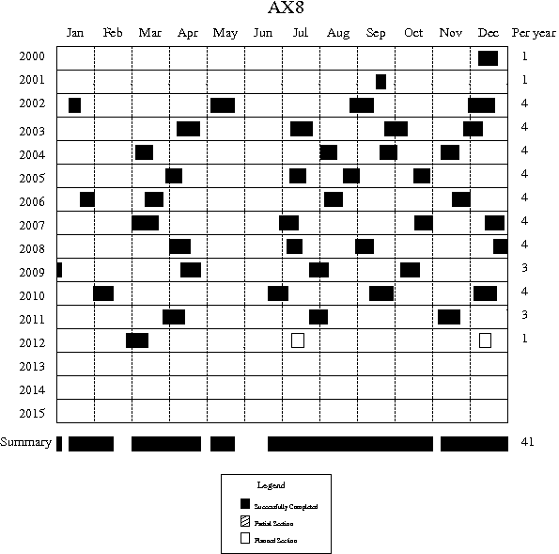

Figure 1. Deployment schedule for AX08.
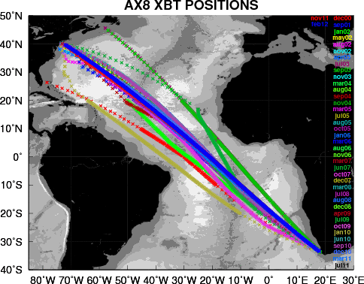
Figure 2. The location of XBT deployments for the previous AX08 XBT transects since 2000. The key objective of this project is to improve the existing climate observing system in the tropical Atlantic.
Based on recommendations from the Climate Observing System for the Tropical Atlantic (COSTA) Workshop (Miami, May 1999) this program will increase data collection on the AX08 low density XBT Transect between Cape Town and New York City traversing key regions in the tropical Atlantic four times a year. These observations will allow to improve our knowledge of the spatial and temporal variability of the zonal surface currents in the tropical Atlantic Ocean.

XBT Deployment Plan

*****IT IS THE RESPONSIBILITY OF THE RIDER TO ENTER THE SHIP’S IMO NUMBER AND CALLSIGN INTO THE SEAS METADATA SETUP. ****
Also insure that the check out list in section I. gets done once the transect voyage is completed.

1. High Density: One XBT every 25 km- between Cape Town (200m depth or more-approx 33.5°S), and 25 South. (about 60 XBTs)

2. High Density: one XBT every 25 km- between 25°S and 10°S (approximately 112 XBTs).

3. High Density: one XBT every 25 km- between 10°S and 15°N (approximately 174 XBTs).

4. High Density: one XBT every 25 km- between 15°N and Newark (until 200m depth-approx 39.5°N) (approximately 184 XBTs).

The time spacing between drops will be determined by the ship speed (Table I). If the ship is traveling at a different speed it will be necessary to adjust the launch times (see Table 1 as a quick guide).
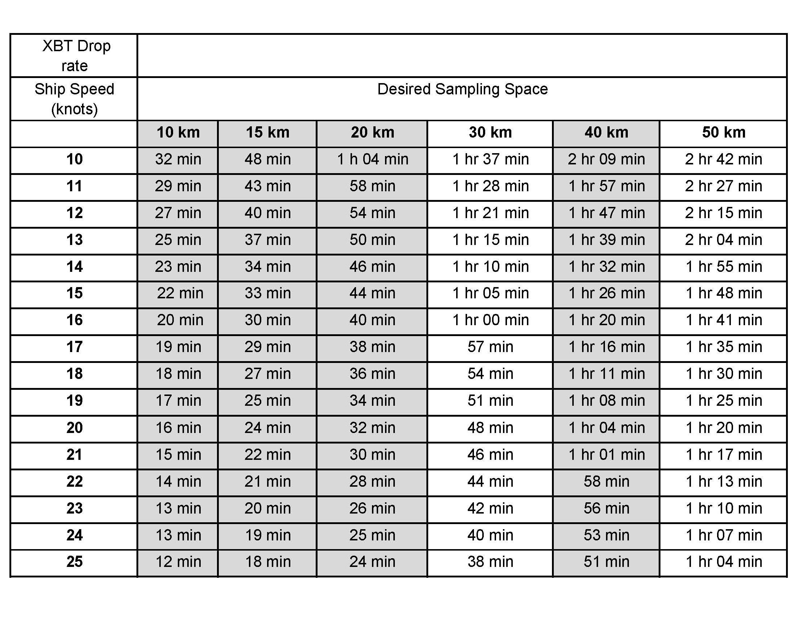
Table I. Time interval between XBT launches based on ship speed and desired sampling spacing.

If the planned sampling is interrupted for any reason (such as an autolauncher failure) the procedure will be to drop another probe as close as possible to the planned drop and continue with the desired spacing of the XBTs for that section of the cruise track (according to the above guide). If a serious malfunction of the autolauncher occurs then manually deploy the XBTs from the stern of the ship using the hand launcher. While this happens, please be troubleshooting the problems and be in contact with Zach Barton, Ulises Rivero (Ulises.Rivero@noaa.gov), Kyle Seaton (Kyle.Seaton@noaa.gov), Andy Stefanick (Andrew.Stefanick@noaa.gov), or Pedro Pena (pedro.pena@noaa.gov).

The ship-rider will work as needed around the clock to:
1) check and load the auto-launcher;
2) check that the system is logging data correctly;
3) keep a log of problems, repeated casts due to suspected XBT errors and weather conditions;
4) inform NOAA personnel of any difficulties; and,
5) deploy ARGO profiling floats and surface drifting buoys as necessary.

ARGO float deployments
0 Argo floats will be deployed at the locations below:

Drifter deployments
0 Atlantic surface drifters will be deployed at locations to be determined later.

Summary

This high resolution XBT transect will require 530 probes plus an anticipated 10% failure rate of 53 probes for each Atlantic crossing. This requires a total of 583 probes per crossing. Drifting buoys and ARGO floats may be deployed as deemed necessary.

Temperature sections and surface conditions:

The two temperature sections obtained during the September 2001 and August 2002 transects reveal the main surface currents in the region that can be detected from the slope of the isotherms (Figure 3).

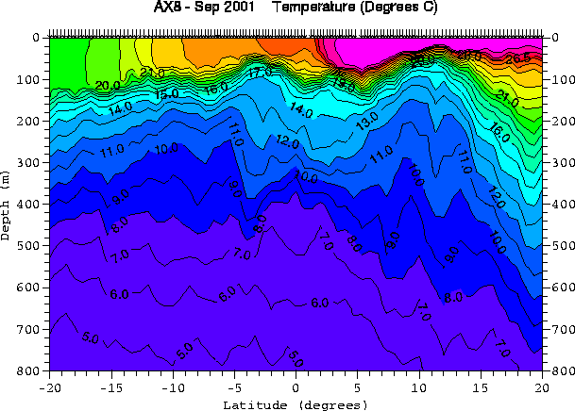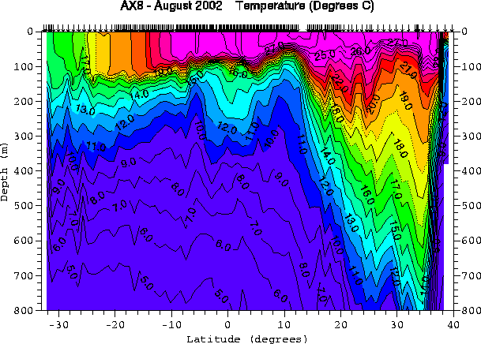

Figure 3. Temperature sections obtained from the September 2001 and August 2002 transects.
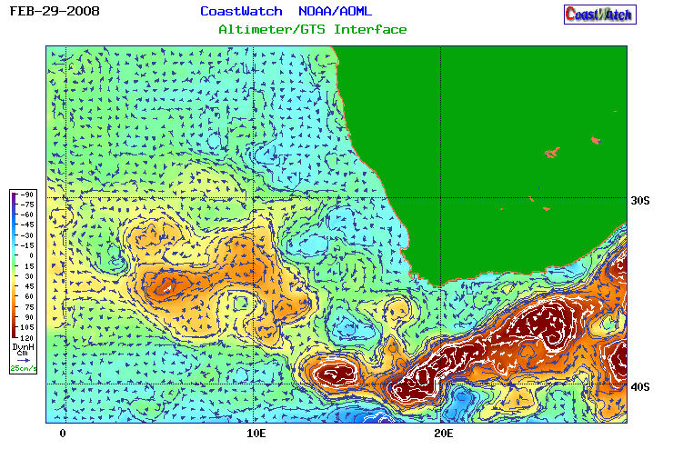

Figure 4. Altimetry-derived geostrophic currents for February 29, 2008

The satellite altimetry derived surface currents (Figure 4) in the region indicate that there is a warm ring centered approximately 10E 34S.

Basic Ship Visit and Rider Rules – courtesy of Steve Cook et al
The following guidelines pertain to any person who might have occasion to visit, install, repair or replace equipment, or ride on any Ship of Opportunity Program (SOOP) ship participating in any program to collect scientific observations. Most of these guidelines are based upon common sense and respect for those who “live” on the vessel. Visitors are essentially being invited into their home as a guest and, as a guest, desire to be invited back. A goal within the SOOP Program has always been to minimize the shipboard impact as much as possible. These are not “Cruise Ships” or “Research Vessels” and therefore ship riders strive for self-sufficiency. There are times, like departing or arriving in port or navigating congested waters that the bridge officers and crew have to concentrate on their own responsibilities and not the rider’s. Please leave them alone during this time. It is always a good idea to brief the Captain and Chief Engineer prior to departure as to the plans and scope of the work and exactly what will be needed from the bridge officers or any other assistance.
These guidelines are not just for the novitiate “first timer”, but also for those who have often visited or ridden the same ship many times. It is certainly acceptable and beneficial to be knowledgeable about the ship’s standard operation but don’t become familiar to the point of complacency and forget the basic rules of respect. Ship riders should always remember that they are professionals involved in the collection of important scientific information and they not only represent themselves but also Scripps and the SOOP program.
Following is a list of basic guidelines that should be observed.
- Always see the Captain and/or Chief Officer when first boarding the ship.
- If riding the ship, then learn the ship’s daily watch schedule. Know when meal times and coffee breaks are scheduled and plan activities accordingly.
- Be in good health, as this work can be very exhausting and the hours long.
- If alcohol is allowed on board, limit consumption in order to use good judgment in regards to personal interactions and because it may be necessary at any time to go to work
- Be cognizant of ship customs and protocol.
  - For instance, if people wait for the Captain to sit down, then don’t sit down before he does.
  - Wait to be invited or ask permission to enter special places like the bridge, engine room or lounge area.
  - If the officers remove their shoes before entering their lounge area or stateroom, then follow the example
- Wear appropriate clothing and shoes. Ragged shorts, bathing suits or sandals are inappropriate.
- Don’t sleep in a public space or prop feet up on any table or desk and “kick back”.
- Don't bring food out on deck, especially in port, and especially in Australia. Instant $1000 fine!
- If it is necessary to conduct a meeting in a stateroom leave the door open.
- Clean up messes and keep gear stowed away when not in use. Work areas should be kept tidy so ship’s personnel don’t have to “step over” the equipment or supplies to conduct their own jobs.
- When there is a lot of activity on the bridge, limit questions and conversations. A detailed briefing of what is required from the bridge officers conducted prior to departure should minimize confusion and stress.
- Bring all necessary tools. Don’t ask to borrow ship’s tools if possible.
- Use email or telephone whenever possible to keep the ship and agents apprised of schedule and plans.

Some of the participating SOOP support several different scientific projects and, as such, the combined impacts of those projects become cumulative and can increase the stress on the officers and crews. It is essential that all projects coordinate their ship support activities so they don’t overburden the system and are asked to leave the ship entirely. There are real-time operational requirements that contribute to safety at sea issues and there are special scientific projects that support science. Both can be accommodated but it is incumbent on those who meet and greet these ships to take the time and effort to accommodate the basic needs of the mariners who contribute so much to the program’s success.

High Density Check-in list for the Ship Rider Date Completed

The ship rider is the primary person responsible for ensuring the success of the cruise. This includes checking that all the necessary equipment has been tested and loaded in the ship, verifying weather conditions, ship schedules, possible ship delays etc. Before traveling the rider must have all documents and contact information required for the cruise.

Equipment testing: ____________
- Verify that all equipment to be sent from AOML has been thoroughly tested before shipping.
- Comment if not testing was performed:
______________________________________________________________________________________________________________________________________________________________________________________________________

Check equipment shipping and loading: ____________
- Contact Zach Barton (Zach.Barton@noaa.gov, 305-361-4548) to confirm the status of equipment shipment and loading.

Check ship route ____________
- Contact Zach Barton (Zach.Barton@noaa.gov, 305-361-4548) to confirm that the ship is on the scheduled route two days in advance of the cruise’s planned date as well as the day before of your travel. Also communicate with Robert and Zach to inform them of your travel arrangements for the cruise.

Contact support at Newark ____________
- Contact James Farrington and Zach Barton at least two days in advance of the cruise’s planned date (James.W.Farrington@noaa.gov, 757 651-3794) to coordinate airport pick up, ship access, etc.

Record height of deployments: ______________
- Please take note of and put in your report the approximate height that the deployments were made from. (Top of the water to where the probe was launched from.)

High Density Check-out list for the Ship Rider Date Completed

Data submission to AOML after the cruise __________________

The following files should be sent to AOML after the cruise, regardless of data transmissions during the cruise:
1. All XBT data in .BIN (c:\users\public\Documents\AMVERSEAS_V9\Archive\XbtDataRecorder\), and electronic XBT drop log sheet.
2. HistoryAllAttempts.txt – found at: c:\users\public\Documents\AMVERSEAS_V9\Archive\Reports\
3. The cruise data (including the above items) can be easily compressed with the “compress cruise data” button in the “utilities” menu in the XBT program.
3. Cruise summary for the web page
4. Cruise Report (Generated by amverseas in the “tools” menu in the XBT window
5. Drifting buoy log sheet and ARGO float log sheet in case of deployments of these instruments

The data can be submitted in a CD, memory stick or in a zip file as an email attachment.

Sent the XBT data and HistoryAllAttempts.txt to each of the following:
Yeun-Ho Daneshzadeh Yeun-Ho.Chong@noaa.gov __________________
Francis Bringas Francis.Bringas@noaa.gov __________________
Zach Barton Zach.Barton@noaa.gov __________________

Argo deployment information while underway:
e-mailed to: aoml.argo@noaa.gov and deploymentinfo@whoi.edu _____________________

Drifting buoy deployment information while underway:
Shaun Dolk Shaun.Dolk@noaa.gov __________________

Cruise summary for the webpage. This information goes on the webpage and includes the number of XBTs deployed, drifters/floats deployed, any data affecting issues, etc. Send an email to each of the following with your summary:
Gustavo Goni Gustavo.Goni@noaa.gov __________________
Shenfu Dong Shenfu.Dong@noaa.gov __________________
Molly Baringer Molly.Baringer@noaa.gov __________________
Yeun-Ho Daneshzadeh Yeun-Ho.Chong@noaa.gov __________________
Francis Bringas Francis.Bringas@noaa.gov __________________
Zach Barton Zach.barton@noaa.gov __________________

Please email a Cruise Report to Shenfu Dong, Gustavo Goni, Zach Barton, and Francis Bringas stating the following:
XBTs deployed
Drifters deployed (ID, date, time, latitude, longitude)
Profiling floats deployed (start time, deployment time, latitude, longitude)
GTS transmission (Real-time, twice a day, problems)
Additional equipment, tools, supplies needed
Problems
Recommendations
Other narrative

