Stepped Frequency Microwave Radiometer
(SFMR)

The SFMR consists of a pyramid-shaped feedhorn antenna and an electronics unit (see SFMR graphic below). Total weight for both units will be less than 40 lbs.
The feedhorn is notional at this time, but the Government expects it to be approx 24" high, with a 12" by 12" square base. The bottom of the feedhorn has a flat fiberglass cover designed to be transparent across the range of SFMR frequencies (4.6 - 7.2 GHz). The feedhorn has a transition fitting and SMA connector at the top of the pyramid. The feedhorn shall be mounted in a manner that it faces downwards.
The electronics package is a cylindrical metal container with square end plates. It is about 1 ft long and the cylinder is about 1 ft in diameter. The end plates have mounting holes in the corners. One of the end plates has all connectors required to interface with the feedhorn and the aircraft systems.
The cylinder is sealed and pressurized. The feedhorn is not pressurized and has no environmental requirements. The system (feedhorn and electronics) will need to be removed for calibration and maintenance approx twice each year. There are no access requirements while the system is mounted in the aircraft.
The Government will provide all wiring to the SFMR system. It is desired that a wire route be identified between the SFMR unit and the nearest LDSN panel. It is desired that the distance from the center of the electronics unit side plate to the SMA fitting on the top of the feedhorn be minimized.
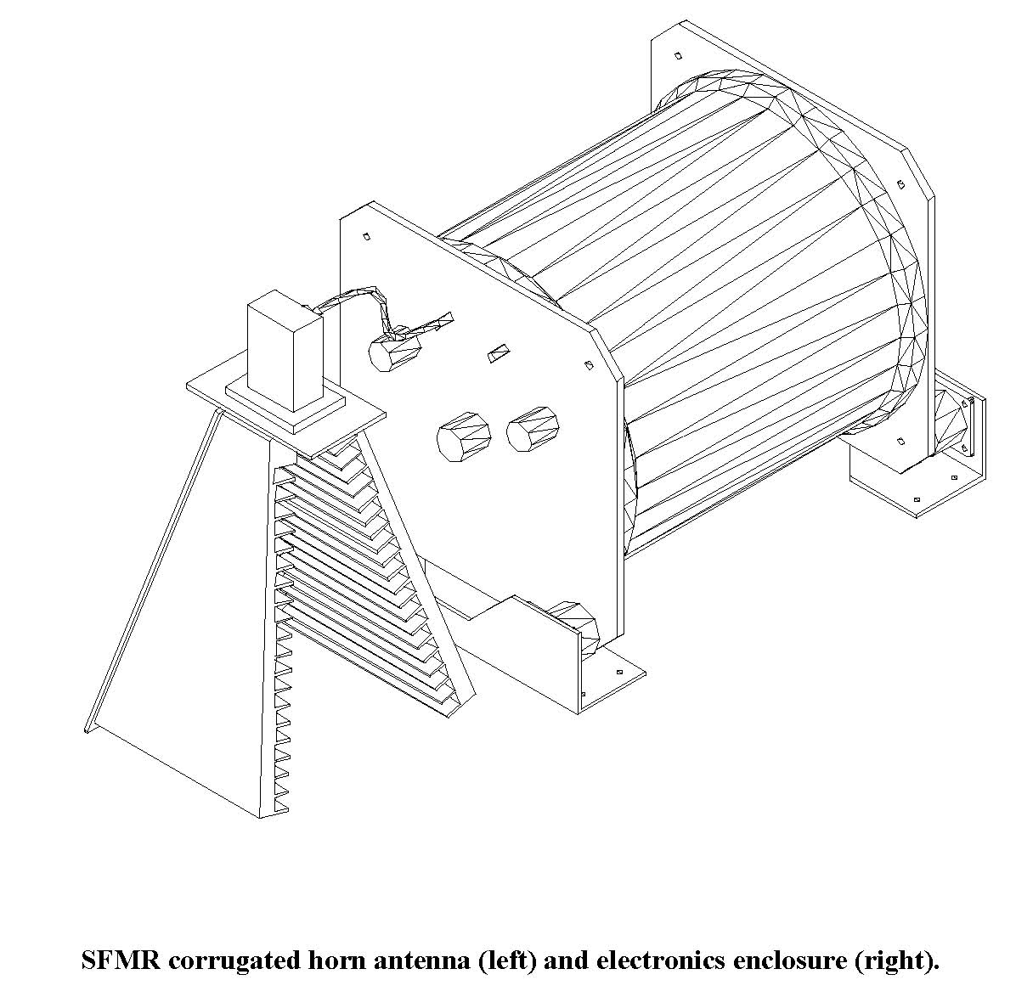

Note that one side of the feedhorn has been cut away for illustrative purposes; also that the feedhorn is not to scale (this is a smaller feedhorn used in AOC's P-3 Orion installation).

