Best Track Committee Re-Analysis Comments for 1965
(Replies to the Committee are given in bold face and indented – October 2019)

General comments:

1. While there are not as many satellite and radar images available for the 1965 systems as in subsequent years, could they please be gathered into one directory? The write-ups mention several such images that the committee members cannot locate. There is a chance some images could be found online either through a Google search of through the EV2 web site.

All of the satellite images that we can locate have been put directly into the metadata writeup for 1965.

2. Adjusting the intensity estimate of the wind-pressure by the size of the RMW is standard practice during the re-analysis. However, some of the aircraft-reported RMWs seem to lack pass-to-pass consistency, and in some cases it is unclear whether the RMW size is based on actual wind measurements, radar eye diameter, or calm wind diameter. Please check these as much as possible, and if necessary smooth out any bumps the RMW inconsistencies may have put into the best tracks.

The inner core size from the aircraft of the 1960s was an estimate of eye diameter. We estimate an RMW from this information. We have now gone through all large inconsistencies in the obtained RMW values.

1965 Storm #1, Unnamed:

1. The Committee concurs with the proposed delayed genesis. It is noted, though, that a low pressure area that presumably was the precursor disturbance appeared at least intermittently on the microfilm maps prior to the genesis time, and thus the original track makes at least some sense.

Agreed. This point is added to the metadata writeup.

2. Please re-examine the use of the wind-pressure relationships for this system. Despite the original claim in the seasonal write-up that the system was not cold core, the 500-mb chart on the Historical Weather Maps suggests an upper-level trough with a temperature gradient was located over the surface center. This suggests that the cyclone had at least some subtropical characteristics, and thus the wind-pressure relationships may not be fully applicable.

Agreed. This point is added to the metadata writeup.

2a. On a related noted, please better justify why the observations from the NOMAD buoy (see below), Alligator Point, and Dog Island were discarded in favor of the intensity from the wind-pressure relationships.

After further review, an intensity of 40 kt is assessed at 06Z on the 14th consistent with the NOMAD observation. Also an intensity of 50 kt is now assessed at 06Z, at 11Z at landfall, and at 12Z on the 15th based upon the Alligator Point and Dog Island observations.

2b. An article in the January 1966 Mariners Weather Log describing the NOMAD buoys states that the anemometer height is 4 m, but it also suggests that the buoys reported a peak gust rather than a sustained wind. The Committee suggests contacting the National Data Buoy Center to see if they can verify these specifications.

Unfortunately, these details could not be confirmed regarding the NOMAD buoys.

2c. Unless there is strong evidence to show why the surface obs should be discounted in favor of the wind-pressure relationships, please adjust the intensities to better match the surface obs. A 50 kt landfall intensity may be better given the Alligator Point and Dog Island obs of 45-50 kt.

Agreed.

3. What were the minimum pressures in the landfall area? Were there any lower pressures than what appears on the microfilm maps?

The lowest observed pressure over land was 1006 mb at Panacea, FL at 1230Z, which was in the Land Highlights sections.

4. The Committee concurs with the extended track as an extratropical cyclone. However, it has a question about the 30-kt intensity on 20 June. Is this based on the 35-kt ship in the write-up? If so, why isn’t the intensity higher? If there is reason to think that ob is not good, please keep the intensity at 25 kt after 1800 UTC 19 June.

Agreed to keep the intensity at 35 kt through early on the 20th.

1965 Storm #2, Anna:

1. Please better justify the longitude of the track on 22 August. First, it is unclear how appropriate this shift to the east is given the lack of data near the center and apparent lack of satellite imagery. Second, the 1200 UTC longitude being tweaked 0.1 deg east of the 0600 UTC and 1800 UTC longitudes looks strange give the lack of observations.

Agreed to retain original longitudes on the 22nd.

2. Is it possible based on the winds and pressures reported by the SS Excelsior that the peak intensity could be higher than 85 kt – perhaps 90 kt?

Agreed.

3. In the 21 August write-up, is “past of Bermuda” supposed to be “east of Bermuda”?

Yes. So changed.

1965 Storm #3, Betsy:

1. Please re-consider the early upgrade to a tropical storm on 27 August. It seems to be based on a ship report 250 n mi from the center, whose representativeness is thus suspect. The Committee also notes that the proposed intensities reduce the intensity to 30 kt at 1800 UTC 28 August despite a 35 kt ship report at that time. Why the inconsistency?

Agreed to retain the system as a tropical depression on the 27th.

2. Were there any pressure reports from the Lesser Antilles that may help to estimate the intensity on 28 August?

The lowest reported pressure in the Lesser Antilles was only 1010 mb at 18Z on the
28th, consistent with the system being a tropical depression.

3. Where in the storm wallet is the 1002 mb reconnaissance fix for 1300 UTC? The fix log in the wallet says that the pressure was 1007 mb from a dropsonde, and the 700 mb height is more consistent with 1012 mb. Coded forms for both of these obs are in the wallet. Please provide the coded message with the 1002 mb, or use the original HURDAT pressure and intensity for 1200 UTC 29 August.

Agreed to use the 1007 mb central pressure for the 12Z August 29th entry. However, given the fast forward motion and visual estimates of 55 kt, a slightly higher intensity – 40 kt – is selected at that time.

4. The Committee concurs with the proposed later upgrade to a hurricane.

Agreed.

5. The Committee notes an inconsistency for the aircraft fixes early on 1 September. The fix log in the storm wallet says the 984 mb fix was at 0834 UTC, while the vortex message suggests it was at 0610 UTC.

This inconsistency is noted in the metadata writeup. It does not affect the reanalysis, given that both would be relevant for 06Z.

6. Please re-examine the intensities on 3-4 September. First, there may be an error in the assessment for the 1800 UTC 3 September intensity, where the write-up states the central pressure was 950 mb, but apparently gives wind values for 959 mb (a typo?). Second, reconnaissance reports strongly suggest the hurricane underwent an eyewall replacement near 0000 UTC 4 September. Third, it is noted that the currently proposed intensities during this time show a lot of short-term varying between 100-105 kt. If a re-assessment caused by the eyewall replacement does not lead to significant changes in the proposed intensities, can some of these 5 kt changes be smoothed through?

The 959 mb value discussed was indeed a typo, which has been corrected. The possible eyewall replace around 00Z on the 4th has now been mentioned in the metadata writeup. The intensities on the 4th have been smoothed to show 105 kt for the whole day.

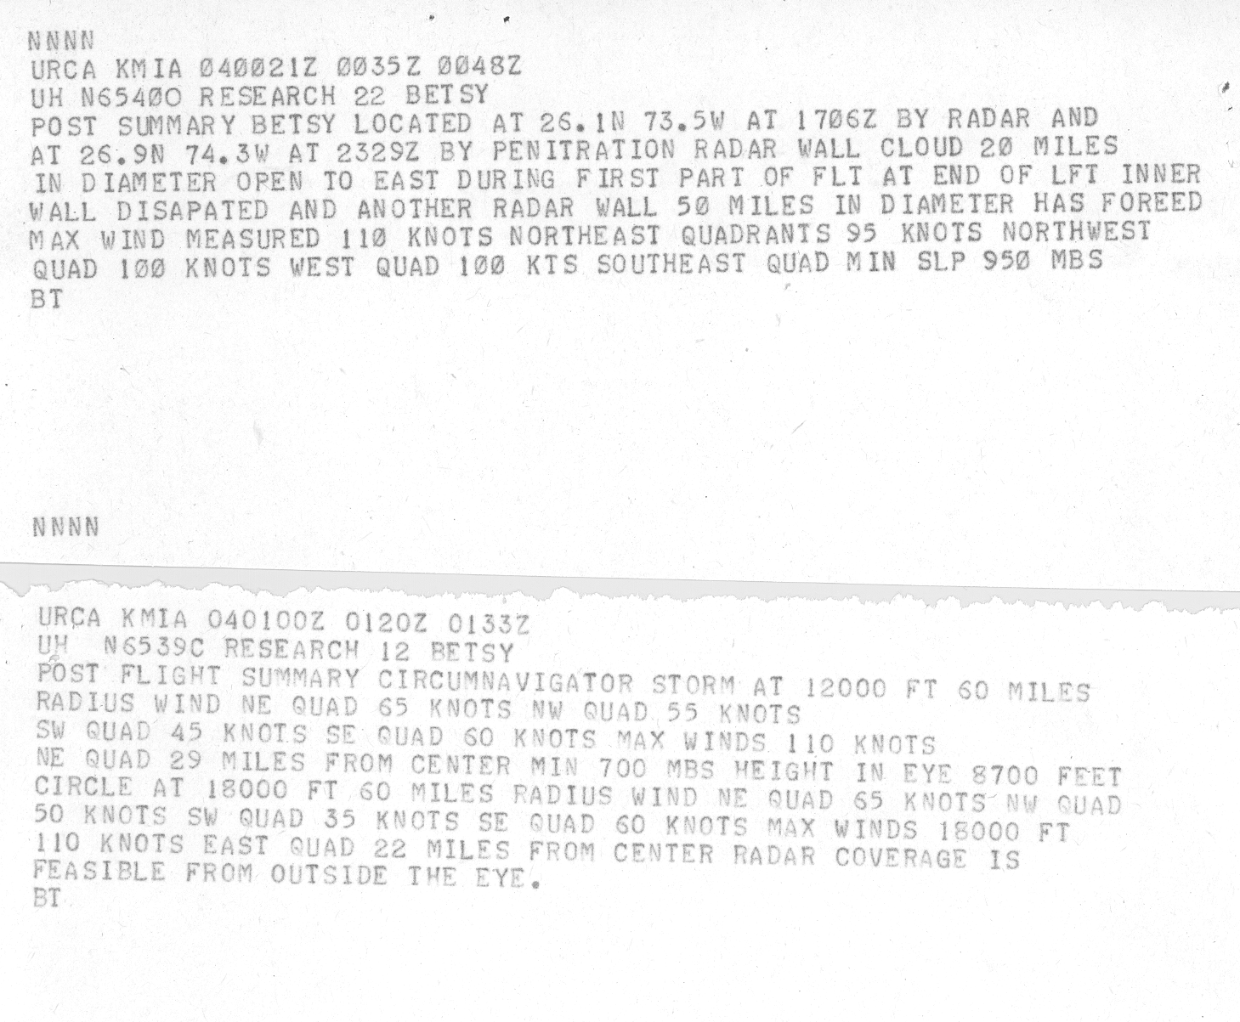
7. Please contact the Meteorological Service of the Bahamas to obtain more information on the 131 kt at Green Turtle Cay and the 155 kt wind at Hope Town. Since Hope Town is in the Abaco Island group, it may be that these are two different reports from the same station.

7a. While these reports look suspect when compared to the estimates from the wind-pressure relationships, unless they are totally wrong they suggest a need for a higher intensity than indicated by the relationships. For example, a 100 kt intensity may be more appropriate for 1800 UTC 6 September.

This value for Hope Town may have come from the Hope Town Lighthouse (26.5N 77.0W). The location for Green Turtle Cay measurement cannot be precisely located (26.8N 77.3W). These values are supposedly fastest mile readings. A 155 kt fastest mile converts to about 145 kt 1 min sustained wind. Such a value appears to be extremely high compared with what the aircraft reconnaissance suggests from the central pressure and eye diameter (only 95 kt).

We contacted the Bahamian Weather Service about these records for Betsy. They had no records for the Hope Town measurements, but did confirm that the Green Turtle Cay were unofficial observations. “On September 6th the winds recorded at Green Turtle Cay was 125 mph at 8pm and by 5am the next morning the winds were measured between 135-150 mph the peak winds of the storm there were measured at 150 mph at 5am Tuesday.” They also provided additional official observations: “147 mph winds were official winds measured in Abaco and were taken from the Department of Meteorology Hurricane Betsy's official report to the Bahamas Cabinet. It was also reported in the Abaco's Commissioner's report and yes it was sustained winds and it was measured at 2pm [on the 6th] at Marsh Harbour.” This value was measured at Marsh Harbour Airport (26.5N 77.1W). The 147 mph report is consistent with what Mr. Wayne Neely's published in his book "The Major Hurricanes to Affect the Bahamas", he states that the "highest winds were measured in Abaco of 147 miles per hour". 147 mph is 127 kt fastest mile, which converts to about 121 kt 1 min sustained, which is still inconsistent with what was being reported by the aircraft.

Taking a blend of what is suggested by aircraft reconnaissance (around 95 to 100 kt) with these measurements, an intensity of 100 kt is analyzed at 18Z on the 6th and 105 kt is analyzed from 00Z through 18Z on the 7th. This is very close to what was in HURDAT originally.

8. The Committee notes that the 948 mb aircraft pressure at 1800 UTC 8 September looks suspect. First, this pressures is 6 mb lower than the pressures measured before and after it. Second, the recorded 700 mb height is 40-50 m higher than those other fixes.

Agreed to remove this as central pressure for 18Z September 8th.

9. The Committee notes that Ho’s Louisiana landfall pressure of 941 mb is the same as that currently in HURDAT for 0000 UTC 10 September. This seems to have come from the vortex message for the fix at 0000 UTC 10 September, which reports a 941 mb pressure that was not put into the fix log. The dropsonde for this fix was 946 mb, while the extrapolation using current formulas is 945 mb.

Agreed to add this note to the discussion.

10. The Committee does not concur with reducing the intensity at the Louisiana landfall to 110 kt. While it agrees that the 135 kt value currently in HURDAT is too high, the 948 mb landfall pressure, the faster than average northwestward motion at landfall, and the 112-kt 1-min average wind at Port Sulphur support a landfall intensity of 115 kt even though the eye was larger than average. Please use 115 kt for the landfall intensity and subsequent inland decay calculations.

Agreed.

11. The Committee concurs with the proposed earlier extratropical transition.

Agreed.

1965 Storm #4, (new):

1. Please provide the appropriate upper-level maps from the Historical Weather Map series for this system. Please also locate and provide any available satellite imagery for this system.

The upper-level maps have been added into the binder. We have not been able to locate any satellite images for this system.

2. The Committee concurs with the addition of this system to HURDAT.

Agreed.

3. Is it possible that the system transitioned to a tropical cyclone closer to 1200 UTC 7 September? The associated temperature gradients look fairly weak by that time.

Agreed.

4. Please re-examine the proposed time of extratropical transition at 1200 UTC 9 September. On one side, the observations suggest a temperature gradient was developing across the system. On the other side, this gradient may be due to the background sea surface temperature patterns, and the Historical Weather Maps show that the approaching cold front was well northwest of the center at 1200 UTC. Would 1800 UTC 9 September or 0000 UTC 10 September be a better time?
Agreed to indicate extratropical transition at 00Z September 10th.

1965 Storm #5, Carol:

1. Please better justify the southward shift on 16-17 September. The data does not appear to be good enough to justify this.

Agreed. Positions adjusted back to original HURDAT.

2. The Committee notes that the aircraft fix near 2315 UTC 20 September was made at 300 mb, and there is no way to quality control the estimated central pressure. Also, given the normal outward slant of the eyewall with height, the surface eye was likely smaller than 60 mi diameter.

Agreed that the central pressure estimate from 300 mb is highly uncertain. It’s retained, given that it’s consistent with what was observed by dropsonde about 12 hours later. A note has also been added that the surface eye would likely be smaller than 60 nm diameter at 300 mb.

3. The Committee also notes that the fix at 1130 UTC 21 September should be used with caution. First, the fix was again made at 300 mb, which may lead to an inflated RMW size. Second, the assessed 974 mb pressure apparently comes from a dropsonde for which there is no record. The pressure extrapolated from 300 mb was 990 mb. It should be noted that some Committee members think the data support an 85 kt intensity near this time. However, a lower intensity may be better given the uncertainties in the central pressure and the eye size.

These issues about the central pressure and eye size are now mentioned in the writeup. An 80 kt intensity is analyzed, which is 15 kt higher than in HURDAT2 originally.

4. Is the best track position at 1200 UTC 21 September compatible with the satellite fix at 1324 UTC that day?

The best track position at 12Z September 21st is compatible with the recon position and ship observations, but substantially south of the satellite fix. Given the uncertainties in correctly geo-locating the satellite pictures way out over the open ocean, such an inconsistency with the recon and the ships is not surprising.

5. Please better state why the 989 mb central pressure from the fix at 0035 UTC 22 September is “not considered a central pressure operationally”. It is noted that the 700 mb height of 2984 m and temperature of 15C at 11,000 ft would yield a central pressure of near 988 mb using today’s formulas.

This central pressure is not consistent with values on the 21st or later on the 22nd and is thus not considered to be reliable.

6. In the reanalysis write-ups for 22-23 September, it may be worthwhile to add the influence of Additional System #4 to the discussion of Carol’s motion.

Agreed.

7. The Committee recommends keeping the intensity 65 kt at 1200 UTC 23 September as the data from the 0945 UTC aircraft fix does not definitively support a downgrade to a tropical storm. However, the proposed 60-kt intensity at 1800 UTC that day looks good.

Agreed.

8. Please re-examine the aircraft pressures and the associated proposed intensity near 1200 UTC 26 September. The fix log has an extrapolated pressure of 998 mb, followed by a note that the observed 700 mb height of 2972 m would support a 986 mb pressure. Based on that height and the observed temperature of 8.5C, today’s extrapolation formulas give a pressure of 992 mb. In addition, there was a dropsonde with an apparent splash pressure of 992 mb, although the drop has a different 700 mb height than the value in the fix log. It is suggested that 992 mb be used for the intensity estimate at this time.

Agreed. This brings the intensity down to 60 kt.

9. While the Committee generally concurs with the proposed earlier extratropical transition, 0000 UTC 30 September is probably too soon. 1200 UTC 30 September is probably better.

Agreed to adjust extratropical transition to 12Z on September 30th.

9a. Given the uncertainty as to how far Carol went in extratropical transition, particularly the weakening of the temperature gradient on 1 October, please see if any satellite imagery is can be located for that day to help clarify the situation.

No additional satellite imagery is available.

10. The Committee concurs with the extension of the track to 3 October.

Agreed.

1965 Storm #6, Debby:

1. The satellite images of the cyclone available in the storm wallet (see below) indicate that Debbie was not a classical tropical cyclone, and subtropical cyclone characteristics are a possibility. Please include the appropriate upper-level maps from the Historical Weather Maps series.

Done.
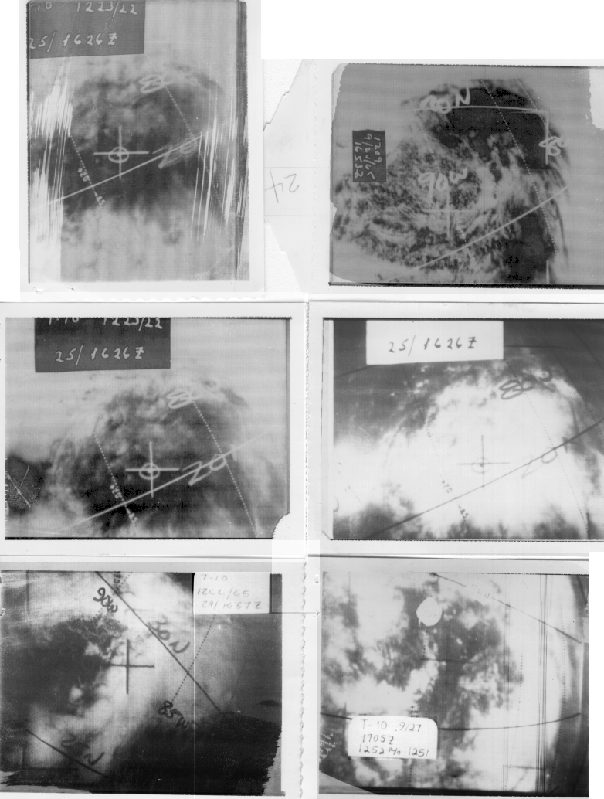

2. If possible, please find information on the elevation of the anemometers on the lightships and any oil rig observations.

Unfortunately, such important metadata has not been recorded from what we can determine.
3. The Committee concurs with the proposed track changes near the end of the cyclone’s life.

Agreed.

1965 Storm #7, (new):

1. Please provide the appropriate upper-level maps for this system. Also, please find whatever satellite imagery may be available.

The 500 mb maps have been added to the binder. Unfortunately, no satellite images can be located for this system.

2. The Committee concurs with the addition of this system, and given the characteristics it would prefer that it be added as a subtropical storm. The data suggests that it never consolidated into a classical tropical cyclone.

The definition of subtropical cyclone includes a description of the character of the convection: “they have organized moderate to deep convection, but lack a central dense overcast”. Without satellite imagery to confirm, it would be best to keep this system officially as a tropical storm and to enhance the wording that it may very well have been a subtropical storm in reality. The first official subtropical storms in HURDAT2 are in 1968 at the advent of routine satellite imagery for the Atlantic basin.

1965 Storm #8, Elena:

1. The Committee does not concur with delaying genesis 12 hours. There is insufficient data on the provided maps to justify the change.

Agreed to not delay genesis.

2. In the 15 October Reanalysis section, should “eye diameter of 20 kt” be “eye diameter of 20 nm”?

Corrected.

3. It should be noted in the reanalysis section for 16 October that the Aircraft Weather Officer reported that Elena was tilted with the 500 mb center located 20 miles northeast of the surface center.

Agreed.

4. The Committee concurs with the revised time of extratropical transition and the extended track as an extratropical cyclone.

Agreed.

1965 Storm #9, (new):

1. Please provide the appropriate upper-level maps and any available satellite imagery for this case.

The 500 mb maps have been added to the binder. Unfortunately, no satellite imagery can be obtained for this system.

2. The Committee concurs with the addition of this system, albeit with some reservations. On one side, the evolution is more consistent with that of a decaying baroclinic low. On the other side, it was interesting enough to the forecasters of the time that aircraft were sent to it.

Agreed.

1965 Additional Notes:

1. Please re-examine the October 15-20 system, including gathering all of the available upper-level maps and satellite imagery. There is storm wallet material for this system, including a reconnaissance mission near 1230 UTC 18 October that reported 1004 mb and estimated 55 kt surface winds about 50 miles from the center (see below) just before the center made landfall between Daytona Beach and Jacksonville. It is recommended that this system be submitted to the committee as a possible short-lived subtropical or tropical storm, similar to the Brevard County storm in 2011.

Agreed. This is now added in as a new tropical storm (but likely subtropical).

2. The Committee concurs with leaving the other possible systems out of HURDAT.

Agreed.
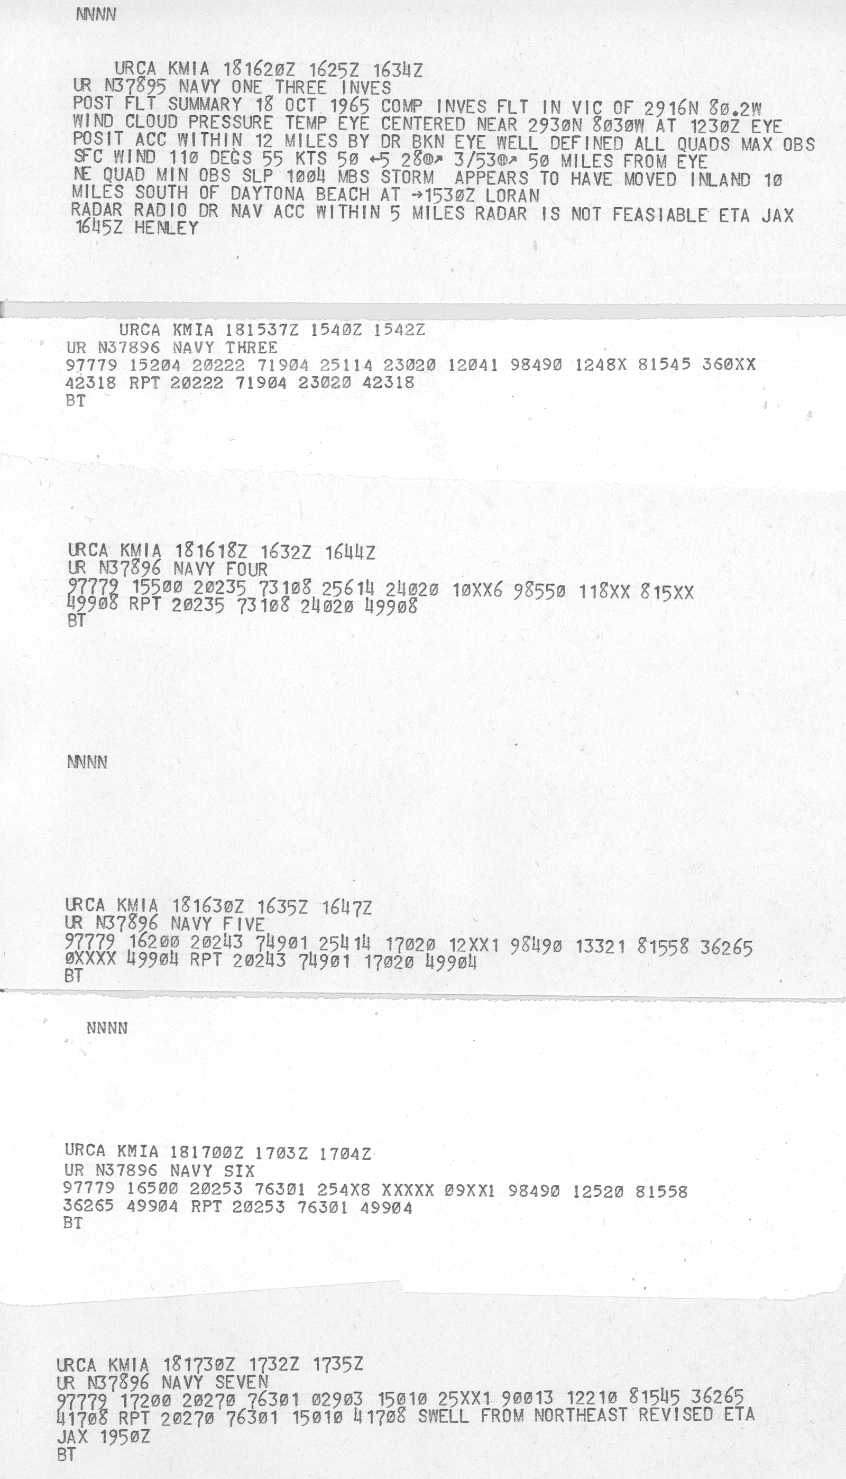

2. The Committee concurs with leaving the other possible systems out of HURDAT.

Agreed.

