Best Track Committee Re-Analysis Comments for 1961
(Responses in boldface by Chris Landsea and Sandy Delgado – September 2016)

General comments:

1. Several storms had pressures in HURDAT that were apparently ‘analyzed’ instead of measured. In the past, the practice has been to remove such pressures unless they could be linked to a specific measurement close to the synoptic time. However, in the aircraft era there may be enough data to justify the use of such ‘analyzed’ pressures as long as the gaps between the data points are not too long. Also, the Committee notes that the National Hurricane Center (NHC) or National Hurricane Research Project (NHRP) constructed pressure vs. time curves for several cyclones in the late 1950’s and early 1960’s, including Carla and Esther of 1961.

In the cases where these analyzed pressure curves exist, the HURDAT pressures should not be summarily removed if they look reasonable compared to the analyzed curve and the data – with the caveat that the data can be quite problematic. Other pressures found in HURDAT should be checked to see corresponding observations are present and removed if such obs cannot be found.

Agreed to retain reasonable, existing HURDAT central pressures that may not be based upon specific observations.

2. There are some places in the submission where 5 kt fluctuations in intensity are introduced into due to small variations in central pressure, particularly in storms such as Carla and Esther. Please try to smooth these out unless there is some physical reason for such fluctuations to occur, such as an eyewall replacement cycle.

Agreed to smooth through small variations in intensity, unless these are based upon sound physical reasoning.

1961 Storm #1, Ana:

1. The Committee would like to see an earlier genesis for Ana based on the satellite imagery at 1449 UTC 17 July referenced by Fitz and Dunn, as well as the westerly wind ship report at 1800 UTC 17 July. It is suggested that the system be started as a 30-kt depression near 10N-11N 46W at 1800 UTC 17 July and then moved just north of west at 6-7 degrees a day to the 11.7N 60.2W at 0000 UTC 20 July. The intensity should gradually increase from 30 kt to 50 kt.

Agreed to introduce genesis at 18Z on the 17th and gradually ramp up the intensity to 50 kt by 00Z on the 20th.

2. What obs are available from Trinidad and Tobago to help refine the track and intensity as the cyclone passed to the north?
The synoptic six-hourly observations from Port of Prince, Trinidad are consistent with a tropical storm passing north of the island, but no tropical storm force were observed. No observations were taken at Tobago.

3. The Annual Tropical Storm Report (ATSR) states that the plane that made the 1130 UTC fix on 20 July had an 850 mb height of 1353 m, which yields an extrapolated pressure of 993 mb using today’s formulas. However, the fact that it is so much lower than the other reported pressures during this part of Ana’s life makes its accuracy uncertain.

This observation is now mentioned in the writeup, but is discounted.

4. There are three typos in the submission. First, in the second bullet point for the aircraft highlights on 21 July, there is an extra word “have”. Second, in the metadata discussion for 25 July, please change “sport low” to “spot low”. Third in the 22 July re-analysis section, should “entered the central Caribbean” be “entered the western Caribbean” based on the observed longitude?

Corrected.

5. The Committee notes that for the aircraft fix at 0700 UTC 21 July, the extrapolation of the 700 mb data using today’s formulas yields 995 mb

As was already included in the writeup “The coded drop shows 992 mb surface pressure, which is consistent with the 700 mb temp/height.” Three millibars is within the typical uncertainty for these types of measurements.

6. The National Hurricane Research Project (NHRP) flights on 21 July made a series of fixes, and the central pressures based on the observed D-values at 9880 ft and Jordan’s nomograph differ some from the pressures in the metadata. These fixes include 1) 1407Z, with flight-level winds of 77 kt and a pressure of 980 mb based on D-values, 2) 1510Z, flight-level winds 79 kt and a pressure of 979 mb, 3) 1718Z, 90 kt flight-level winds and a pressure of 976 mb. It should be noted that these pressures are based on D-values that are not at the center of the eye, and thus the pressures could be a little lower.

These have been added into the database and included in the daily summary, where applicable.

7. The ATSR indicates that the aircraft fix at 0700 UTC 22 July had a 700 mb height of 2930 m and a temperature of 13C in the eye. This extrapolates to a central pressure of 983 mb.

This has been added into the database and included in the daily summary.

8. Please contact the meteorological services of Honduras and Belize for any data they can provide about the passage of Ana.

The Meteorological Services of Honduras and Belize have been contacted to obtain additional information about Hurricane Ana. Unfortunately, they do not have any more observations.

9. Please re-examine all of the aircraft data from the ATSR on 23 July. Amongst many issues, the 700 mb data for the 1600Z fix yields an extrapolated pressure of 977 mb, which is lower than any of the dropsondes for that flight. Also, the positions and data of several of the drops match poorly with the fix data reports. Finally, were there any issues with the proximity of the center to land? Please revise the pressures and the associated intensities after the re-examination.

The 977 mb obtained from the flight-level data for the 16Z is four millibars lower than that obtained from the dropsonde, which is within the errors and uncertainties expected from both techniques. 981 mb is retained as the central pressure at that time, as it consistent with the surface pressure directly obtained as well as the 850 mb heights/temperature derived value. The proximity to land, given that the system was straddling the coast, could contribute toward the uncertainty in the positions from dropsonde/flight level. This is now mentioned in the metadata writeup.

1961 Storm #2, Betsy:

1. Please re-examine the proposed intensities on 2-3 September. While the 55 kt at 0600 UTC 2 September and the 90 kt at 1200 UTC 3 September look reasonable, the 90 kt at 0600 UTC 3 September might be too high.

Agreed to reduce the intensity at 06Z on the 3rd to 85 kt.

2. Please re-examine the pressure for the fix at 0100 UTC 4 September and, if necessary, adjust the intensity at that and adjacent time. The fix forms state that the pressure was 989 mb via a dropsonde, and they also state that the 700 mb height was 2988m. However, the fix form states that the maximum temperature in the eye was 19C, while the dropsonde reports 11C. The former would yield an extrapolated pressure of 981 mb (consistent with the previous and later pressure reports), while the latter yields 991 mb (consistent with the dropsonde pressure).

Agreed to use the 981 mb for the fix at 01Z based upon consistency with the previous and later reports.

3. In regards to the 986 mb pressure in HURDAT at 1200 UTC 4 September, the ATSR shows a penetration fix at 1300 UTC that day. This is presumably an Air Force mission since the data is not in the ATSR. Please try to find the data from this mission, and for the time being please do not remove this pressure.

This value is retained in HURDAT, but it could not be confirmed as being an Air Force mission.
4. Please re-examine the proposed intensity at 1800 UTC 10 September and the adjacent times. A close fit to the wind-pressure relationship is probably not justified to a system that was nearly extratropical. Is there any other data to support a 90-kt intensity at that time?

Agreed to retain the system as 85 kt at 18Z on the 10th.

5. Please re-examine the dissipation time for the extratropical portion of Betsy, as it may have lasted longer that proposed. Possible positions and pressures for the extratropical phase include:

9/12 06z 956 mb
9/12z 12z 952 mb
9/12 18z 946 mb
9/13 00z 946 mb
9/13 06z 947 mb
9/13 12z 948 mb
9/13 18z 952 mb
9/14 00z 954 mb
9/14 06z 955 mb
9/14 12z 956 mb
9/14 18z 62n 27w 960 mb
9/15 00z 62.5n 30w 964 mb
9/15 06z 61.5n 30w 968 mb
9/15 12z 60n 30w 972 mb
9/15 18z 57N 29W 976 mb 45 kt
9/16 00z 55n 27w 980 mb 40 kt
9/16 06z 52.5n 26w 986 mb 35 kt
9/16 12z 51n 23w 992 mb 30 kt
9/16 18z Low absorbed by larger cyclone north of Great Britain (Debbie)

Agreed to incorporate a smoothed version of these positions/central pressures/intensities into HURDAT.

1961 Storm #3, Carla:

1. Please provide the microfilm maps for 1-2 September.

These have now been added in.

2. Is the ship HJNE reporting southeast winds 55 kt on the 1800 UTC 4 September microfilm map?

This ship is reported in COADS as having 20 kt, which would be much more consistent with the surrounding observations.

3. Regarding the 1002 mb pressure indicated by the Monthly Weather Review (MWR) near 0000 UTC 5 September, the ATSR indicates a penetration fix at 0100 UTC 5 September. This was likely an Air Force mission since no Navy data is in the ATSR.

This is now so mentioned and retained in HURDAT.

4. Are any additional observations available from Swan Island to see if the minimum pressure was documented?

Unfortunately, no additional observations from Swan Island are available.

5. On 6 September, the Navy plane made a fix around 2130-2200 UTC with a dropsonde pressure of 978 mb, a pressure extrapolated form 700 mb of 978 mb, and a pressure extrapolated from 850 mb of 981 mb. This might be the fix mentioned in the MWR article.

Agreed and now so clarified.

6. There are issues with the pressures on the Navy recon flight late on 7 September. The fix at 1900 UTC reports a 971 mb pressure. However, an associated dropsonde reports 976 mb, and modern extrapolation formulas suggest 975 mb. The fix at 2230 UTC reported a 967 mb pressure. However, extrapolated data from both the fix and the dropsonde suggest a 972 mb pressure.

Agreed and reanalysis adjusted accordingly.

7. Recon issues for 8 September:

7a. The NHRP actually had two flights this day, one at 850 mb and one at 700 mb. One pass through the center at 1805 UTC has a central pressure of 961 mb based on the D-value in the NHRP report and Jordan’s nomograph.

Agreed and reanalysis adjusted accordingly.

7b. A Navy fix at 1900 UTC has an extrapolated pressure of 959 mb based on the fix data and modern formulas. The plane subsequently orbited in the eye and reported several more pressures, including a 959 mb dropsonde (apparently at 2000 UTC), the 2200 UTC fix with the 954 mb dropsonde mentioned in the metadata, and a 2330 UTC fix with no pressure data.

Agreed, these are added to the fix database.

8. Recon issues for 9 September:

8a. The first fix mentioned in the aircraft data for this day was at 0700 UTC, and while the estimated pressure is 955 mb there is a 958 mb drop that passes quality control checks.

Three millibars is within the errors and uncertainty expected from flight-level reductions and dropsonde observations. Thus 955 mb is retained.

8b. The NHRP planes made several fixes from 850 and 700 mb, and some of the central pressures derived from the D-values and Jordan’s nomograph do not match the 948 mb list in the metadata at 2100 UTC. These fixes include 1838 UTC/947 mb, 2103 UTC/936 mb, 2232 UTC/935 mb, and 2316 UTC/945 mb.

Agreed. The 947 mb at 1838Z is added to the metadata and used in the reanalysis. The other fixes are added to the excel spreadsheet.

9. Recon issues for 10 September:

9a. There was a Navy penetration fix at 1006 UTC with a dropsonde pressure of 942 mb and a pressure extrapolated from 700 mb of 939 mb.

This was already in the excel spreadsheet.

9b.The ATSR suggest that the 1245 UTC fix had a press of 937 mb extrapolated during a low-level penetration.

This was already described in the metadata.

9c. There was a Navy fix at 1600 UTC with a dropsonde pressure of 942 mb, which also matches the pressure extrapolated from 700 mb.

This was already in the excel spreadsheet.

9d. The NHRP plane made three fixes from 13800 ft/618 mb with the D-values extrapolating to pressures of 937 mb at 1837 UTC, 934 mb at 2104 UTC, and 933 mb at 2214 UTC. This is from the data in the NHRP report and Jordan’s nomograph.

The 937 mb at 1837Z is now used at the 18Z slot in HURDAT. This and the other fixes have now been added to the excel spreadsheet.

10. Recon issues for 11 September:
10. There are also numerous Navy and NHRP fixes missing from the 11 September metadata. The most significant is that the Navy plane that made the 0430 UTC fix orbited the eye until 0700 UTC. At that time, it reported a 700 mb height of 2478 m, which was the lowest height observed during Carla. Combined with a temperature of 19C, this yields an extrapolated pressure of 927 mb using today’s formulas.

The 07Z fix with the 927 mb central pressure is now added in and used to provide the peak intensity of Carla at 125 kt. These other fixes were already included in full in the excel database. The metadata summary typically only provide six hour highlights.

10a. The pressure derived from the D-values on the NHRP flight of 11 September range from 933-938 mb, which is lower than the value for the 2100 UTC fix mentioned in the metadata. However, several fixes may have issues with the eye being over land.

940 mb central pressure is the value for 21Z, based upon the NHRP report. However, the range of pressures from the D-values is now mentioned in the writeup as well as the issue of the eye being over land.

11. The NHC wallet has a port-storm report that includes a pressure observation of 931.3 mb from a barge in the Victoria Channel at 1415 CST (see the image below). This is likely the source of the 931 mb landfall pressure. Please use this report and remove the speculation on the pressure from the metadata.

Agreed. This observation has been added into the writeup and the excel database and the speculation has been removed.

12. The Committee does not concur with the majority of the proposed intensity changes when Carla is over the Gulf of Mexico, including the landfall intensity. While the Committee recognizes that the 150 kt currently in HURDAT is too high, the proposed 115 kt landfall intensity looks too low given the 931 mb central pressure and the two reports of 126 kt fastest mile winds. Pending any revisions in the central pressures due to the aircraft issues described above, the Committee would recommend the following intensities:

9/8/1200 UTC – 100 kt
9/8/1800 UTC – 100 kt
9/9/0000 UTC – 110 kt
9/9/0600 UTC – 110 kt
9/9/1200 UTC – 110 kt
9/9/1800 UTC – 110 kt
9/10/0000 UTC - 110 kt
9/10/0600 UTC – 115 kt
9/10/1200 UTC – 120 kt
9/10/1800 UTC – 120 kt
9/11/0000 UTC – 120 kt
9/11/0600 UTC – 120 kt
9/11/1200 UTC – 125 kt
9/11/1800 UTC – 125 kt
9/11/2000 UTC (landfall) – 125 kt

Agreed to incorporate these intensities into HURDAT’s revisions with the small decrease of going 105 kt at 9th 00-12Z and a small increase to 115 kt at 10th 00Z for a smoother intensification, which better fits the central pressure revisions. Also intensity is boosted to 125 kt at 06Z on the 10th based upon the 927 mb central pressure value from aircraft at 07Z.

13. Since many surface observations were available after landfall, it may be possible to use analyzed locations and pressures for HURDAT. A possible list of these includes:

Sep 12 18z – 977 mb
Sep 13 06z – 985 mb
Sep 13 12z – 988 mb – the proposed reanalysis longitude is a bit closer to the NA map position than HURDAT, so it is preferred
Sep 13 18z – 991 mb
Sep 14 00z – 992 mb
Sep 14 06z – 993 mb
Sep 14 12z – 993 mb
Sep 14 18z – 992 mb
Sep 15 00z – 991 mb
Sep 15 06z – 990 mb
Sep 15 12z – 986 mb – The NA and NH map series disagree concerning this cyclone’s longitude, ranging between the original HURDAT longitude and the reanalysis longitude – between 67 and 69W. Since there are no Canadian observations in this region, suggest a compromise longitude of 68W
Sep 15 18z – 983 mb
Sep 16 00z – 980 mb

Beyond HURDAT (same low, no confusion at all):
Sep 16 06z – 61N 65W 976 mb 35 kt
Sep 16 12z – 62N 63W 974 mb 35 kt
Sep 16 18z – 63N 61.5W 972 mb 40 kt
Sep 17 00z – 65N 60W 974 mb 40 kt
Sep 17 06z – 66N 60W 976 mb 35 kt
Sep 17 12z – 67N 60W 980 mb 30 kt
Sep 17 18z – 68N 58W 984 mb 25 kt
Sep 18 00z – 68N 54W 988 mb 20 kt
Sep 18 06z – Dissipated

Agreed to incorporate all of these into HURDAT with some smoothing introduced.

14. In the MWR excerpt on 6 September, “hurricane forced” should be “hurricane force”.

Corrected.
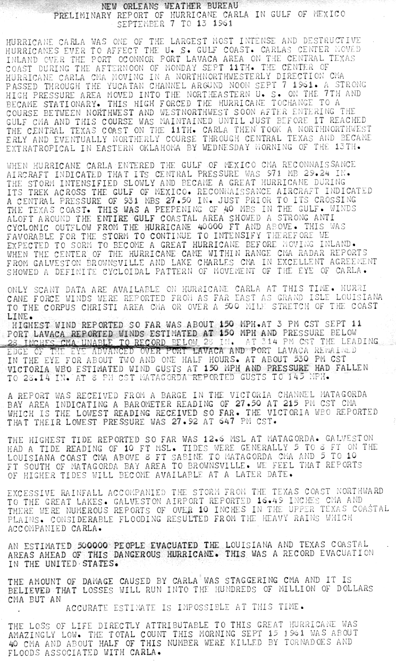
1961 Storm #4, Debby:

1. The Committee concurs with the earlier genesis time.

Agreed.

2. Please contact the Meteorological Services of the Cape Verde Islands and Portugal for any data they have on Debby. Also, is more detailed data available for Debbie’s impact in the British Isles?

The Meteorological Services of the Cape Verde Islands/Portugal and the British Met Office have been contacted for more information regarding Debbie. However, neither have additional significant observations available.

3. The Committee concurs with reducing the peak intensity of Debby below 100 kt.

Agreed.

4. Given the 75 kt ship report at 1200 UTC 12 September, wouldn’t this support keeping the intensity 80 kt through that time?

Agreed.

5. What is the basis for rejecting the 95 kt ship observation on 14 September? The Committee notes that this ob was not used in the original HURDAT intensities.

This observation appears to be substantially high biased and was disregarded.

6. The Committee concurs with the earlier time of extratropical transition.
Agreed.

1961 Storm #5, Esther:

1. The Committee concurs with the earlier genesis time. Given the well-defined appearance in the 1912 UTC 10 September satellite image, the Committee suggests adding a position at 1200 UTC with an intensity of 30 kt.

Agreed.

2. If possible, please smooth through the 5 kt fluctuations in intensity on 14-15 September.

Agreed, these fluctuations have been smoothed.
3. The Committee notes that the 700 mb data in the ATSR for the 0700 UTC fix on 16 September extrapolates to a central pressure of 954 mb using today’s formulas.

ADD TO EXCEL

4. Is there any known reason why “HANNAH” is written on the microfilm maps for 0000 UTC 16 September and 0000 UTC 17 September?

It is unknown why this is written on the maps. Very odd!

5. Please highlight the changes in central pressure in the HURDAT from 17 September onward.

Agreed.

6. Please re-examine all of the aircraft-reported pressures on 17 September. The accepted minimum central pressure for Esther is 927 mb based on the dropsonde fix near 1900 UTC that day. However, the extrapolation of the pressure from the flight-level data for that fix yields 924 mb, while the extrapolation of the dropsonde data yields 928 mb. Also, numerous other fixes this day have extrapolated pressures below 927 mb, including 0700 UTC (924 mb), 1635 UTC (922 mb from D-values not in center extrapolated from 811 mb), and 1914 UTC (919 mb from D-values not in center extrapolated from 811 mb). After this re-examination, please make any appropriate changes to the proposed intensities.

The 927 mb from the dropsonde fix near 19Z is within the noise level of the extrapolation of the dropsonde data (928 mb) and extrapolation from flight-level data (924 mb). The other three central pressures have been added into the database and the writeup. 919 mb now accepted as lowest central pressure for Esther. Based upon this, it is analyzed that Esther reached 140 kt (Category 5).

6a. On a related note, the NHRP aircraft measured detailed flight-level winds on multiple passes through the eye, with these data being published in several NHRP reports. Please examine this data to see if there is anything useful for an intensity analysis.

Aircraft flight level winds of this era are extremely unreliable and cannot be used quantitatively for intensity analysis.

7. The radar information about the eye size on 18 September indeed suggests that Esther underwent an eyewall replacement cycle. Has this been taken into account in the proposed intensities?

Given the rather sudden increase in size and moderate filling of the central pressure, Esther may have undergone through a concentric eyewall cycle. This is taken into account for the proposed intensities: A penetration fix at 19Z on the 18th measured a central pressure of 943 mb. At 16Z, a reconnaissance aircraft estimated an eye diameter of 40 nm. A central pressure of 943 mb suggests maximum sustained winds of 107 kt from the north of 25N weakening pressure-wind relationship. An eye diameter of 40 nm suggests an RMW of 30 nm and climatology indicates 17 nm. Based on a forward speed of 13 kt and an RMW larger than climatology, an intensity of 105 kt is selected for 18Z on the 18th, down from 125 kt originally in HURDAT, a major intensity change.

7a. Please re-examine the aircraft pressures at 0100 UTC and 0700 UTC 18 September. In a reversal of the previous day, the extrapolated pressures from the fix and dropsonde data are higher than those on the fixes by 3-6 mb.

At 01Z the drop reported 928 mb at the surface, 700 mb drop temp-heights gives 931 mb, and extrapolated flight-level is 933 mb. At 07Z the drop reported 933 mb at the surface, 700 mb drop temp-heights gives 936 mb, and extrapolated flight-level is 935 mb. For an extreme hurricane, such variations are in the noise level. Surface pressure values from the drops are retained.

8. If possible, please smooth through the 5 kt fluctuations in intensity on 19-20 September.

Agreed to smooth through these fluctuations.

9. Please double check the pressures on the fixes for 1030 UTC and 1300 UTC 19 September. These pressures are significantly lower than the other pressures observed that day.

It is noted in the writeup that these pressures are questionable given that they are somewhat lower than those measured earlier and subsequent in the day. However, the raw aircraft/dropsonde data from these Air Force fixes cannot be obtained. As noted above, the intensities on the 19th have been smoothed.

10. The 700 mb data for the fix at 2300 UTC 20 September extrapolates to a central pressure of 962 mb using today’s formulas.

This value has been added to the writeup and the fix database.

11. Please re-examine the pressure of the 0355 UTC 21 September fix. The 700 mb height (8950 ft) and temperature on the fix form would extrapolated to a pressure of 954 mb using today’s formulas. However, the 700 mb height on the associated dropsonde was 9240 ft, with the sonde reporting a splash pressure of 967 mb. The Committee notes that the 700 mb height on the sonde is in good agreement with the heights reported at other times during this mission. However, the 8950 ft height matches what is written on the form in the ATSR.

The fix form values suggesting 954 mb are quite likely erroneous. 967 mb accepted as the central pressure at this time.

12. In the 21 September re-analysis write-up, “970 kt” should be “970 mb”.

Corrected.

13. Please re-examine the track during Esther’s second approach to Massachusetts on 26 September, as the Committee does not concur with the proposed westward shift. The original HURDAT track matches that proposed by the post-storm report from Boston (http://www.nhc.noaa.gov/archive/storm_wallets/atlantic/atl1961/esther/preloc/pshbos2a.gif). This track is supported by surface observations from Nantucket, which indicate the center went near or east of that island at around 0500 UTC 26 September.

Agreed to retain original track, but with track positions adjusted in time to have Nantucket landfall around 05Z.

14. The Committee does not concur with the removal of 27 September from HURDAT, as the data suggests that Esther remained a separate system from the other baroclinic low.

Agreed to retain Esther at 00 and 06Z on the 27th with dissipation thereafter.

1961 Storm #6, Unnamed:

1. There are three apparent typos in the metadata. In the 11 September discussion, “slowly a well-defined low-level center” appears to be missing something. In the 13 September discussion. “but wide the clouds appear quite dense,” should probably be “but while the clouds appear quite dense,”. Finally, in the 15 September discussion, “reported winds dropped off alter it pressed Cape Hatteras” should likely read “reported winds dropped off after it passed Cape Hatteras.”

These typos are corrected.

2. Please re-examine the proposed intensities at 1800 UTC 13 September and 0000 UTC 14 September. At the former time, the presence of 30 kt winds over 100 n mi from the center suggests the possibility of stronger winds close to the center. At the latter time, the 35 kt ship report suggest the possibility of stronger winds as well. It is noted that while the central pressure was high at these times (1008-1009 mb), the pressures to the east were also very high (1016-1020 mb).

Agreed to boost intensities at 18Z on the 13th to 35 kt and at 00Z on the 14th to 40 kt.

3. The track (and possibly the intensity) of this system from landfall is North Carolina northward essentially needs to be re-done from the beginning, as all of the available tracks (old HURDAT, proposed HURDAT, and that of Fay in 1962) appear to be at least somewhat flawed. On a state by state basis, the issues include:

3a. North Carolina: First, Wilmington reported a pressure of 1008 mb as the center passed to the east according to the Local Climate Data for September 1961. Second, Elizabeth City reported a pressure of 1002.4 mb and south winds 18 kt as the center passed near the station. The current and proposed HURDAT tracks have the center passing 40-50 n mi west-northwest of Elizabeth City, which seems a little unlikely given the low pressure there. The Committee thus recommends moving the track closer to Elizabeth City. Also, the Elizabeth City pressure suggests that the 1008 mb pressure in Wilmington was not representative of the landfall pressure. Please find data from the other stations south and southwest of Elizabeth City and northeast of Wilmington to better refine the landfall intensity and track across North Carolina.

Observations were obtained for additional North Carolina stations including Wilmington, Jacksonville, and New Bern which indicate a landfall position northeast of Wilmington with about 1006 mb central pressure. It appears likely that the system was deepening AFTER landfall, due in part because of baroclinic forcing. The position is shifted south-southeastward at 18Z, so as to make its closest approach to Elizabeth City at 19Z.

3b. Virginia: The current tracks show the tracking across southeastern Virginia and part of the lower Chesapeake Bay. This does not agree well with the data from the stations in the Hampton Roads area, which suggest the center passed over Norfolk and/or Virginia Beach. The Oceana Naval Air Station in Virginia Beach reported a minimum pressure near 1002 mb and calm winds, while the Norfolk Airport and the Naval Station Norfolk show winds consistent with a center passage and pressures of 1002-1004 mb. In addition, the obs from the Langley Air Force Base near Hampton/Newport News shows a wind shift from northeast to northwest at the time of lowest pressure (1005 mb), suggesting the center was southeast or east of that station. As with northeastern North Carolina, it is recommended that the track be shifted eastward. It is also recommended that data from the other stations in southeastern Virginia be checked to make sure they are consistent with a passage over Norfolk. This would include Wallops Island if a weather station was present in the area at the time.

While no other station data was available from southeastern Virginia or DelMarVa, the available observations are indeed consistent with a significant eastward shift of the track taking the system over Norfolk. No observations were taken at Wallops Island during this era.

3c. Maryland: The observations from Salisbury show a wind shift from southeast to east to north to northwest around the time of minimum pressure (1004 mb near 0000 UTC 15 September), suggesting the center passed east of that station. The Committee notes that the 6-hourly obs from Ocean City included in the binder are not sufficient temporally to resolve the center passage.

Agreed that the data from Salisbury and Ocean City (assuming that the ob listed at 06Z was actually the 00Z value) show the center of the tropical storm between the two stations at 00Z on the 15th. Unfortunately, Ocean City only took observations once every 6 hours (and these appear to be offset by six hours from the correct time).

3d. Delaware: Please obtain whatever data is available from coastal stations in Delaware for this system.

Observations from Dover and Wilmington, DE were obtained. These are consistent with the system passing through extreme southeastern Delaware.

3e. New Jersey: The Atlantic City radar image in Fay’s paper shows the center to the east-northeast of the radar site at a bearing of 075 degrees. (The distance cannot be determined as there is no description of the interval of the range rings). Assuming that the radar was near the Atlantic City airport, none of the current tracks are consistent with the radar image, which suggests the center was over water east of the New Jersey coast. This at the very least casts doubt on whether the pressure measured in Atlantic City can be considered a central pressure, and it may require another eastward adjustment of the track. Fay mentions that several of the old coded radar data messages (SDs) from Atlantic City, New York, and Nantucket mentioned an “open center”. Please try to locate these reports to see if there is enough position information to refine the track.

Agree to adjust the track eastward. At the time of the radar image – 0338Z on the 16th – the system is now shown to be about 20 nm northeast of Atlantic City, just off of the coast. The coded radar messages could not be located.

3f. New York/Long Island: Fay shows several pressure traces along the path of the cyclone, including two from Long Island – Idlewild (modern day Kennedy International Airport) and Suffolk County Air Force Base (modern day Westhampton airport). The latter is shown to have a lower pressure and a steeper pressure fall, suggesting the center was closer to eastern Long Island than to the New York City area. The Suffolk County station data is in the binder, and the reported altimeter settings suggest a 997 mb pressure at 0700 UTC 15 September. This agrees with the central pressure used by Fay, as well as being lower than the pressures in New York City. This information suggests that the center passed over Long Island to the east of the New York City metro area. Please obtain the data from other stations on Long Island to better refine the track, which again may require an eastward adjustment. Also, please include the Suffolk County observation in the write-up.

Agreed to adjust the track to show landfall in central Long Island. Unfortunately, Idlewood and Suffolk were the only observations regularly taken in Long Island.

3g. Connecticut/Rhode Island: Providence, Rhode Island reported a 997 mb pressure near 0900 UTC 15 September. Please include this data in the write-up along with the observed winds. Also, this pressure is a couple of millibars lower than that observed in Hartford, Connecticut, again suggesting that an eastward adjustment of the track may be required.

Providence’s observation is now included. The track is adjusted eastward near the time of this observation.

3h. Farther North/Final Dissipation: One issue with the system as it moved into New England was the fast forward motion, which suggests that at some point the circulation broke open into a trough and that the wind and pressure centers may not have been co-located. Please look at the data at as high of a temporal frequency as possible and determine 1) the track of the pressure center and when it dissipated, and 2) the track of the wind center and when it dissipated. Pending this study, the Committee tentatively concurs with removing the 1800 UTC 15 September point from HURDAT.

An analysis of the system at 12Z September 15th leaves it ambiguous as to whether the system still maintained a closed low level circulation. There are no northerly winds in the western semicircle, but the data is somewhat sparse. The observations around 18Z are suggestive that the system had dissipated by that point.

4. In the 14 September re-analysis section, there is a mention of the radar image from Hatteras that includes “weak low pressure”. Please delete “weak” from the description.

This is removed.

1961 Storm #7, Frances:

1. On 30 September, it is likely that the radius of maximum wind (RMW) is not 6 n mi even though the aircraft report a wind center that was 8 n mi across. The ATSR has other comments about that mission, which include “calm area in center very large”, “pressure gradient flat”, and “light winds all quadrants near center”. This suggests that the reported 70 kt winds might be unrepresentative of the strength of the cyclone. On the other hand, the external pressures are high, which argues for a stronger system that the 37 kt suggested by the wind pressure-relationship. It would probably be best to use the original HURDAT intensities at 1800 UTC 30 September and 0000 UTC 1 October.

Agreed that this wind center diameter cannot be converted to an RMW. Agreed to retain 45 kt as intensity at 18Z on the 30th and 00Z on the 1st.

2. Are there any land station highlights or data other than that on the microfilm maps for Frances’ passage through the Lesser Antilles?

There are no significant surface observations on the 30th or 1st in connection with this small tropical storm.

3. On the 0600 UTC 2 October microfilm map, there appears to be a hand-plotted ship report of 1008 mb. Is this correct? If so, it should probably be mentioned in the write-up as evidence that Frances still had a closed low pressure area.

Agreed to mention in the writeup.

4. The 3 October write-up should probably include a note that the aircraft found 1010 mb and simultaneous 25 kt winds at 1300 UTC.

Agreed.

5. On 4 October, the Northern Hemisphere maps have a reference to recon data near 1900 UTC that is not included in the ATSR. Please examine this and use it in the re-analysis if it looks reasonable.
Agreed to include these radar center fixes. They agree with the proposed position of Frances.

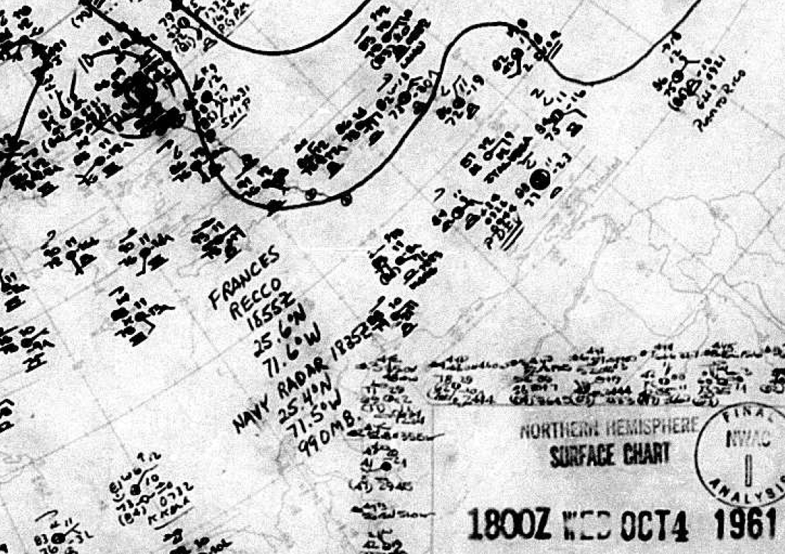

6. The Committee concurs with the proposed increase in peak intensity to 115 kt.

Agreed.

7. On 8 October, the Northern Hemisphere maps have a reference to a radar fix by a ship. Please examine this and use it in the re-analysis if it looks reasonable.

Agreed to include in this ship based radar fix. It concurs with our proposed track.
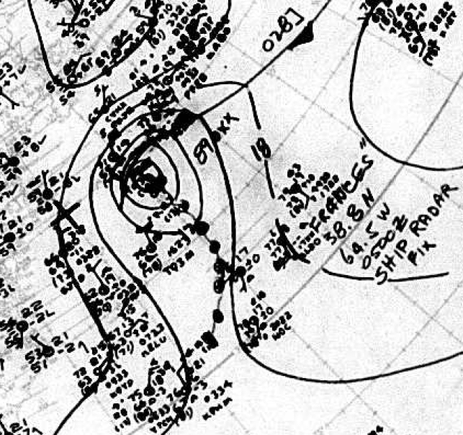

8. Is any detailed data available form Nova Scotia for Frances’ passage? This could help determine whether the cyclone dissipated over the area as stated by the MWR.

No other observations are available from Nova Scotia beyond the six hourly measurements contained in the microfilm maps.

9. Please re-examine the proposed extratropical transition. First, the proposed time on 8 October does not look viable, as even the 8 October write-up says no frontal features were discernable. Second, as Frances passed over Nova Scotia it appeared to be in close proximity to a developing baroclinic low to the north. While the data is ambiguous, the microfilm maps suggest that Frances was absorbed into this system, which then had a several day lifespan over the North Atlantic. However, there is a need to see if Frances became the predominant low and if the best track thus might need to be extended.
Agreed to not show extratropical transition on the 8th. Transition to an extratropical cyclone is analyzed at 00Z on the 9th, twelve hours earlier than originally shown in HURDAT. A warm frontal boundary can be analyzed east of the system reaching toward the center of Frances at that time. If Frances had continued until 12Z on the 10th, the system would have been in the vicinity of 46-47N, 54-56W. Observations from Newfoundland show substantially higher pressures and no evidence of a closed circulation in that vicinity. Instead, a more dominant extratropical low is clearly forming well west-northwest near 50N 63W. Thus Frances is shown as dissipating after 06Z on the 10th.

1961 Storm #8, Gerda:

1. Please provide upper-air maps covering the period of Gerda’s extratropical transition.

So provided.

2. In the discussion for 22 October, there is a reference on how the early stages of Gerda resembled Tropical Storm Nicole in 2010. This might be better made in the discussion for 16 or 17 October.

This has been moved.

3. Please re-examine the genesis time for this system. The original HURDAT started it at 0000 UTC 16 October, and the pressures on 16-17 October would certainly support a depression or minimal tropical storm. However, during that time the cyclone is large and lack an inner core. Also, the microfilm map for 1200 UTC 17 October suggests an elongated system with possible multiple vorticity centers. Finally, except for the suspect winds at Santiago de Cuba, there are no significant wind reports on until 1800 UTC 17 October at the earliest. As of this writing, the Committee would be in favor of dropping 16 October from the track unless additional evidence of 25-30 kt winds can be found.

Agreed to remove the 16th from HURDAT.

3a. Pending the resolution of above, would the following central pressures look reasonable?

Oct 16 00z: 1004 mb based on an observation in southeast Jamaica of 1006 mb and 15 kt winds from the ESE
Oct 16 06z: 1005 mb based on the observation in southeast Jamaica of 1005 mb and light wind
Oct 16 18z: 1002 mb based on a ship at 20N 77.5W with a 1004 mb pressure and a SE 20 kt wind
Oct 17 06z: 1002 mb based on a ship near 20.3N 80W with a 1003 mb pressure and a NE 10 kt wind
Oct 17 18z: land observation from Cuba confirms the recon value in HURDAT/the reanalysis
Oct 18 00z: 1002 mb based on an observation in southeast Cuba with 1004 mb and a SW 20 kt wind
Oct 18 12z: 1003 mb due to observations over Cuba

All of these central pressures (from 17th 06Z onward) have been added into HURDAT.

4. Does the microfilm map for 0300 UTC 18 October show a 35-kt ship over the Straits of Florida? Does the microfilm map for 1500 UTC 18 October show a 40-kt ship report over the Straits of Florida? If so, were these factored into the re-analysis?

These are now added into the reanalysis and indicate that the system reached 35 kt around 06Z and 40 kt around 18Z on the 18th.

5. Pending the resolution of point 4, please better explain the reasoning for making the cyclone a tropical storm at 1800 UTC 18 October. It should be more explicit than “data early on the 19th”.

See above response to point #4.

6. The microfilm maps for 1200 and 1500 UTC 19 October show data from a Navy aircraft mission into Gerda. This mission is not documented in either the ATSR or the NHC storm wallet. Please locate the data from this flight.

An aircraft reconnaissance mission flew into Gerda around 12-15Z. While no tropical storm force winds were measured (perhaps because they stayed near the large light-wind center), an observation around 12Z allowed for a determination of a central pressure around 999 mb. This replaces the 1001 mb in HURDAT originally. (These data are only available on the microfilm.)

7. Was the ship report of 993 mb and 40 kt at 2100 UTC factored into the peak intensity? If the pressure is correct, it implies a central pressure near 990 mb, which would support the original 60 kt peak intensity in HURDAT. The Committee notes there are also two observations of 55 kt winds, which would also support the original 60 kt peak intensity.

Agreed to add in a 989 mb central pressure at 18Z on the 19th. Agreed to retain peak intensity as 60 kt.

8. Pending examination of the requested upper-air maps, the Committee tentatively concurs with the earlier proposed time of extratropical transition. Could the transition have occurred as early as 1200 UTC 20 October?

Agreed to indicate extratropical transition at 12Z on the 20th, as a strong E-W temperature gradient had developed by that time.

9. Are maps available for 22-23 October? The Committee would like to see them to determine the fate of Gerda after extratropical transition, as the Northern Hemisphere map series suggest the possibility the cyclone crossed the Atlantic and wound up near the British Isles on 27 October.

The six hourly microfilm maps are now available through 18Z on the 23rd. They indicate that the Gerda vortex became absorbed in a frontal boundary around 18Z on the 22nd. A subsequent baroclinic development along the front was responsible for the cyclone that crossed the Atlantic and would up near the British Isles on the 27th.

1961 Storm #9, Hattie:

1. Please see below for comments on the resolution of the Hattie-Simone-Inga issue.

These are now so resolved.

2. The Committee concurs with the earlier genesis time. Indeed, it is wondering if the genesis could be moved up to sometime on 26 October give the evidence of a low as early as 0000 UTC that day and 35 kt winds as early as 1200 UTC that day.

Agreed to show genesis at 00Z on the 26th, 36 hours earlier than in HURDAT originally.

3. Issues and comments regarding aircraft data on 28 October:

3a. The pressure for the 0700 UTC fix is problematic. The actual fix says 998 mb. However, the extrapolation of the fix 700 mb data is 990 mb, while the extrapolation from the dropsonde data is 1001-1004 mb.

This fix is problematic. As none of these values appear realistic given the preceding and subsequent observations, no central pressure is indicated at the 06Z position.

3b. The pressure for the 1500 UTC fix is also problematic. The fix reports an extrapolated pressure of 963 mb. However, the 700 mb data suggests an extrapolated pressure of 969 mb. In addition, the associated dropsonde reported 969 mb, but it has an apparent serious error in the 700 mb height. The extrapolated 850 mb data from the drop is 970 mb.

Agreed that this 15Z pressure is problematic. Fortunately, the 12Z and 18Z central pressures in HURDAT do not use this fix.

3c. The 1935 UTC fix reported a pressure of 964 mb, which may have been at low level according to the ATSR.

So noted.

4. Please better justify the decrease in intensity to 95 kt at 1200 UTC 29 October. While it is clear that Hattie was undergoing an eyewall replacement with a rising central pressure, is the proposed 5 kt decrease from 0600 to 1200 UTC getting too precise?
Agreed, 100 kt instead of 95 kt used at 12Z.

5. For the 0000 UTC 30 October intensity, what does the intensifying subset of the wind pressure relationship give for an estimate? The value quoted in the write-up is 103 kt, but it does not explicitly state it is from the intensifying subset. If the subset intensity is higher, does the 100 kt intensity need to be revise upward?

The intensifying subset gives 105 kt. Given the large circulation and forward speed of about 10 kt for Hattie at that time, 100 kt remains an appropriate intensity.

6. The 30 October write-up states that the peak intensity was 135 kt based on the 914 mb central pressure and the RMW. First, this does not match what is in the proposed HURDAT extract, which says 140 kt. Second, the Committee would favor a peak intensity 145 kt in better agreement with the wind-pressure relationship.

The wording is corrected and a peak intensity of 145 kt is used for Hattie.

7. There is a typo in the 31 October write-up: “has been replace with 914 mb” should be “has been replaced with 914 mb”.

Corrected.

8. Please re-check the time of the 924 mb ship report just before landfall against the landfall time. Was the ship far enough offshore that it took two hours for the center to get to the coast?

Agreed that given the likely location of the ship, that landfall would have been sooner, around 12Z. The positions are adjust slightly to make this change for Hattie.

1961 Storm #10, Jenny:

1. The following set of Northern Hemispheric maps should be added to the electronic archive for this system:

Done.

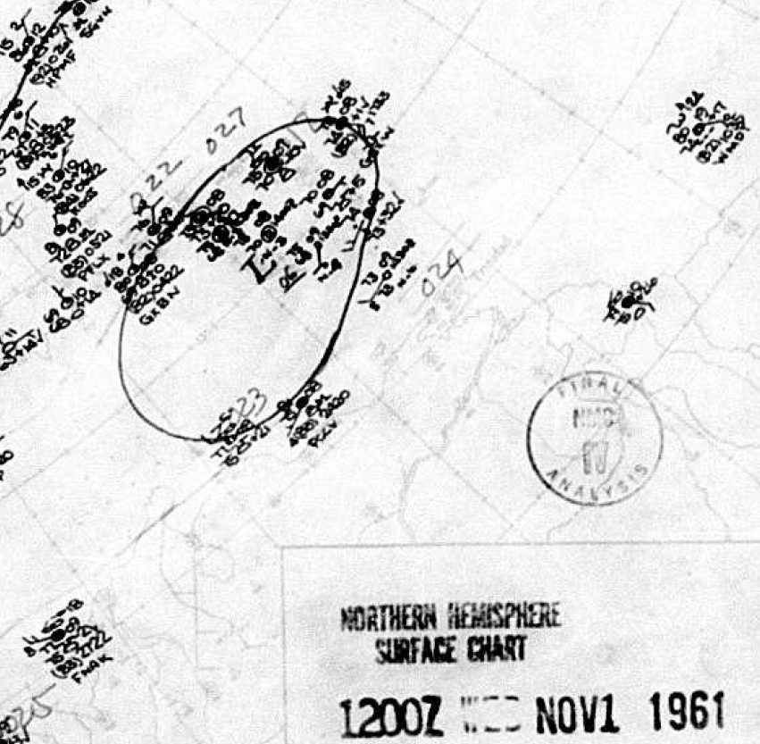

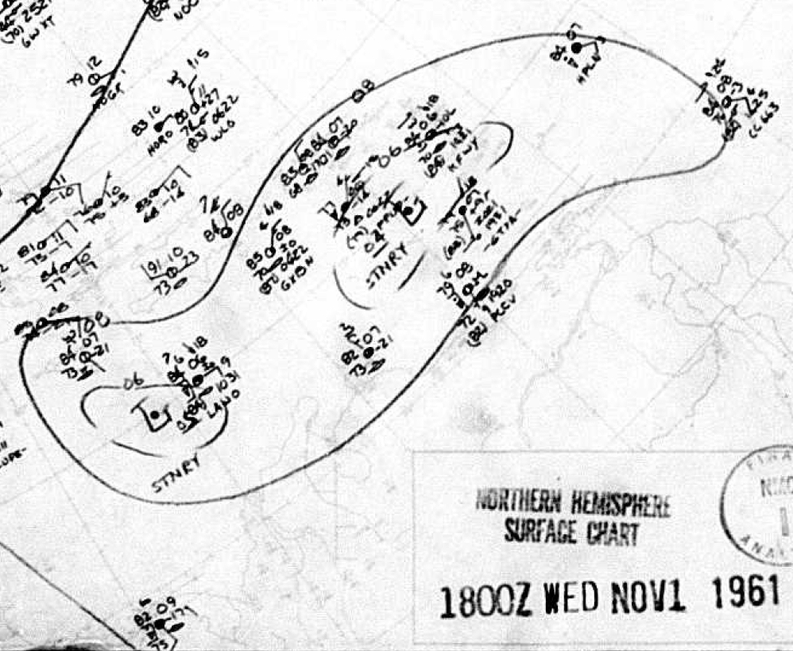

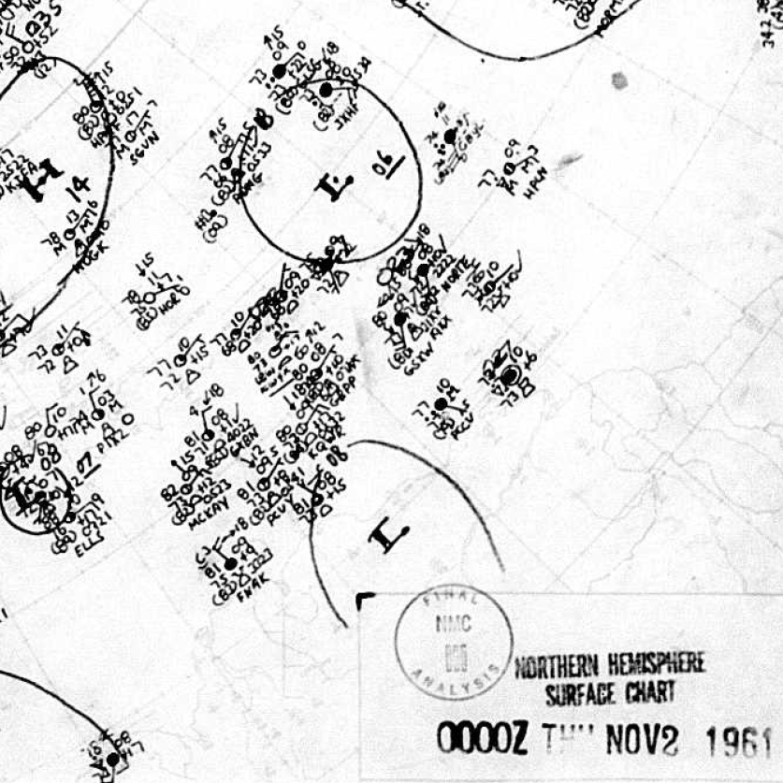

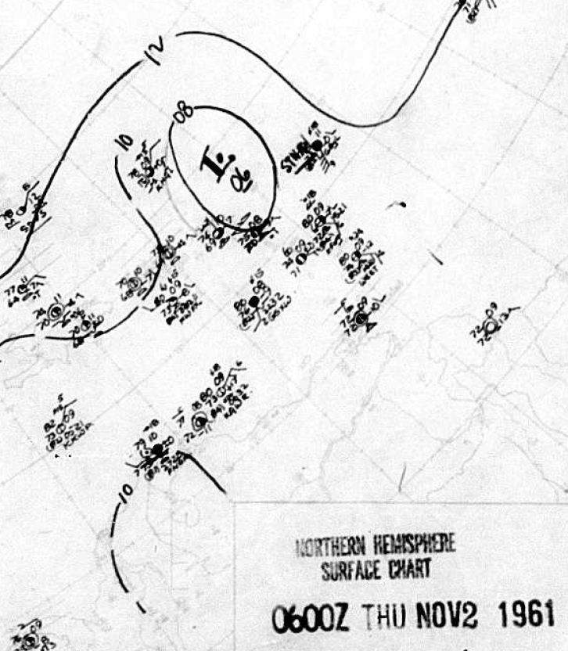

2. Please re-examine the earlier genesis time. While the pressures were quite low over the Leeward Islands at 1800 UTC 1 November, it is unclear whether there were strong enough winds anywhere in the circulation to justify calling it a tropical/subtropical cyclone. Please check with the COADS database to see what observations are available northeast of the center at that time.

Agreed that genesis began early on November 2nd. No additional COADS observations were available northeast of the original HURDAT position at 18Z on the 1st.

2a. Pending the resolution of point 2, the Committee would favor a genesis time of 0000 UTC 2 November, when there was a 30 kt ship report.

Agreed to indicate genesis at 00Z on the 2nd.

3. There were several reports of gale- to storm-force winds northwest of the center on 4 November that were judged to be not representative of the strength of the system due to the distance from the center. Please re-examine these data with two extra criteria to consider: 1) The system was more subtropical than tropical, and thus stronger winds could exist farther from the center, and 2) whether the pressures on these ships were low enough that they were in the circulation rather than in the adjacent high pressure ridge.

These reports of gale- to storm-force winds northwest and north of the center were 300 to 500 nm away from the center of the system. Even considering that the system was perhaps subtropical in nature, these are too large for an RMW for a tropical or subtropical cyclone. Additionally, these observations were outside of the outer closed isobar and outside of the circulation of the system. Thus they are not considered to be representative of the intensity of this system on the 4th.

4. Is the 991 mb observation at 1800 UTC 5 November close enough to the center that it can be used to analyze a central pressure?

Agreed.

5. The Committee concurs with the proposed earlier extratropical transition.

Agreed.

1961 Storm #11, Inga:

1. Please see below for comments on the resolution of the Hattie-Simone-Inga issue.

This has now been resolved successfully.

2. The 3 November metadata appears to have a quote regarding the unique origin of Inga. Where is this quote from?

This statement is not a quote. It was our original assessment, which is now revised somewhat.

3. The Committee concurs with the earlier genesis time.

Agreed.

4. Please re-examine the proposed intensities on 4-5 November. If the 70 kt ship is taken at face value, then the higher intensities are correct. However, Inga was located in a part of the Gulf of Mexico that is notorious for high winds associated with funneled cold air surges along the east coast of Mexico, and all indications are such a surge was in progress on 4-5 November. Please examine each ship report in the western semicircle to see if it can be determined which of them had strong wind due to the cold surge and which of them had strong winds due to the tropical cyclone.

Unfortunately, it is difficult – if not impossible – to separate those strong wind observations from that due to the cold air funneling that occurs along the east coast of Mexico versus those that are due primarily to the tropical cyclone. Morever, the very low pressures – 1005 mb (with 45 kt) and 1001 mb (with 70 kt) – from two separate ships around 12Z argue strongly for a tropical cyclone or – at the very least a hybrid – on this date worthy of inclusion into HURDAT.

4a. Pending the resolution of point 4, the Committee would be in favor of keeping the intensities on 4-5 November closer to 50 kt.

Thus it is preferred to keep HURDAT showing a peak of 60 kt late on the 4th and early on the 5th.

5. In the 5 November write-up, please remove the sentence regarding the diurnal convective minimum unless there is a satellite image to support it.

Agreed.

1961 Storm #12 (new):

1. Please provide whatever upper-air maps are available for this system.

These are now provided from the 18th through the 20th.

2. The Committee does not concur with adding this system to HURDAT at this time, as it is not clear enough that the cyclone was non-frontal. One of the 1200 UTC 19 November microfilm maps shows a warm front extending east from the center, and this looks reasonable in light of the wind shifts and dewpoint gradients seen in the data. There is an issue that the system is at the edge of the coverage of some of the microfilm maps, and thus there is trouble seeing the complete picture. The Committee therefore requests that additional storm-centered analyses of the temperatures and dewpoints be created to help the Committee see the thermal structure of the system.

These additional analyses have been created. They suggest that the system was non-frontal from early on the 18th to late on the 20th. It is recommended to include the system in as a new tropical cyclone.

3. Regardless of the final determination of this system, there are a couple of places in the write-up where the decision making needs clarification. The first is the analysis of a depression forming on 17 November, and the second is the upgrading of the system to a tropical storm on 19 November six hours before the first gales were reported.

The wording has been improved as requested.

4. If the cyclone is accepted into HURDAT, there may be a need to re-evaluate the extratropical portion of the life cycle, as the Northern Hemisphere maps suggests the possibility that this cyclone was the predominant circulation in the area and lasted several more days.

Ship observations at 12Z on the 21st indicate that the system had merged with a developing extratropical cyclone associated with the frontal boundary. The last position is analyzed at 06Z on the 21st.

Comments on the Hattie-Simone-Inga Issue:

1. After an assessment by both the Atlantic and Pacific Re-Analysis projects, the proposal is to delete eastern Pacific Tropical Storm Simone from HURDAT on the basis that it was more of a Central American Gyre system and not a tropical cyclone. However, this brings up several concerns, as this proposal seems to be in conflict with the available data.

These are addressed below.

2. There are observations available from Tapachula, Mexico (southeastern Mexico near the Guatemala border) on several of the microfilm maps. The two most striking observations that are a) 1008.3 mb and light east winds at 0600 UTC 1 November, and b) 1001.4 mb and light east winds at 1200 UTC 1 November. The 6-h pressure falls suggest that a significant low pressure area either passed near or formed near the station.
3. There are other observations on the microfilm map for 1200 UTC 1 November showing a sub-1000 mb low was located off the coast of southeastern Mexico. These include the Tapachula observation mentioned above and a report of 1000.3 mb and 35 kt westerly winds from a ship offshore. In addition, the Historical Weather Map for 1200 UTC 1 November shows a 999 mb pressure just off of the southeastern coast of Mexico. The pressures over land are higher than 1000 mb on both maps, suggesting that the center of the low was over water.
3a. Assuming these data are correct (have they been quality controlled?), there was a low over water at 1200 UTC 1 November. So, was this the remains of Hattie? Was it Simone? Was it a monsoon low/gyre system that did not meet the requirements of being a tropical cyclone? If so, what is the basis for saying this?

Correct, the remnants of Hattie, which at 12Z on the 1st have evolved into a Central American Gyre, are located just offshore as a trough roughly from 14N91W to 16N96W. No inner core remains of Hattie, as the straightline WNW to W winds all along the Mexican coast attest. The data do indeed look accurate in that gale force winds were occurring south of the trough axis.

4. The subsequent data suggests this low moved generally west-northwestward across the Pacific. The 0000 UTC 2 November microfilm map is rather striking with an observation of 1001 mb and 40 kt over the water and apparent pressures of 1007 to 1009 mb near Salina Cruz, Mexico. (Are there two obs plotted there, one on top of the other? Have the Salina Cruz data been quality controlled?)
4a. However, the 0000 UTC 2 November microfilm map also suggests a low pressure area over southeastern Mexico just southeast of the Bay of Campeche. One station reports 1000.6 mb and a light easterly wind. Another station to the west reports 1003.5 mb and northerly winds, while a third station to the northeast reports 1002.8 mb and east-northeasterly winds. Additional evidence for a low pressure area over land is seen on the 1800 UTC 1 November microfilm map, where a station in southeastern Mexico reported 1000.8 mb and northerly winds. If this is a separate low pressure area, is it the remains of Hattie? Is it the center of the Central American gyre?

It appears that the Salina Cruz observation at 00Z is 1002 mb and not 1007 or 1009 mb (it is difficult to read). At this time, the lowest pressure with the Central American Gyre extended from the southern coast of Mexico eastward to overland in near the southeastern Mexico-Guatemala border. Gale force westerly winds continued to occur on the 2nd south of the trough axis.

5. The 0600 UTC and 1200 UTC 2 November microfilm maps suggest that a low pressure area moved near and west of Salina Cruz, which reported northeast winds and 1002.5 mb at 0600 UTC and 1007.7 mb at 1200 UTC.
5a. A striking feature of the 1200 UTC 2 November microfilm map are the low pressures near the southern end of the Bay of Campeche, with two stations reporting pressures below 1000 mb. This is additional evidence for a system over that part of Mexico.
6. While a lack of data makes it difficult to see the evolution of features over the Gulf of Mexico on 2-4 November, the 0000 UTC 3 November microfilm map shows a pressure of 996.3 mb at Veracruz, Mexico. That suggests some low pressure area was near the station. However, how does this relate to the other features seen earlier?

By late on the 2nd and during the 3rd, an extratropical low pressure center had formed over the Bay of Campeche with a front extending from the low north-northeastward over the Gulf of Mexico to the southeastern United States while low pressure with the Gyre continued in existence along the southern Mexico coast. By late on the 3rd, it appears that the Central American Gyre had dissipated, leaving only a broad, extratropical low pressure system in the Gulf of Mexico. This latter system evolved into Inga on the 4th of November.

7. For the moment, the Committee does not concur with removing Simone, as the case for this Pacific low pressure area not being a tropical cyclone is not strong enough. Please re-state the case as best as can be done. It should be noted that the case that the three systems were one cyclone is in the published literature (in this case in Weatherwise in 1963), so the case needs to have something close to publication-quality rigor.

The case has been restated to remove Simone. We have also contacted SUNY-Albany experts on the Central America Gyre for their feedback. We have also referenced and quoted portions from Randerson’s paper in Weatherwise. In addition, we have included every 12 hours from 12Z October 31st until 00Z November 5th the NCAR/NCEP reanalysis sea level pressures. These new analyses are consistent with the interpretation of Hattie evolving into a large, strong Central American Gyre from the 1st through the 3rd.

8. The Northern Hemisphere maps suggest the possibility that a frontal wave moved southward through the western Gulf of Mexico on 2-3 November, which may (or may not) have contributed to the development of Inga. Please check these maps (available from David Roth) to see if they add to the knowledge of what happened.

Agreed. The upper-level maps from the 31st through the 4th are now added into the reanalysis.

1961 Additional Notes:

1. The Committee concurs that the June suspect (#2) may have been a tropical storm, but that the evidence is insufficient to add it to HURDAT at this time.

Agreed.

2. The Committee concurs with leaving the other systems out of HURDAT.

Agreed.

