Best Track Committee Re-Analysis Comments for 1960

(Responses provided in boldface by Chris Landsea and Sandy Delgado – June 2016)

General comments:

1. The Committee appreciates the effort to convert the 1960 submission to the new format and to try to reconcile some of the versions of the Hurricane Donna re-analysis. However, it is noted that this submission is not as well documented as it needs to be. Most notably, there are no surface data printouts available in the binder for Donna for any place north of south Florida. These are needed to resolve the issue of Donna’s intensity over the Florida Peninsula, as well as the landfall intensities and structures farther north. Also notably, the lowest pressure during the landfall of Hurricane Ethel was at the Gulfport Airport, and the binder does not include the detailed record for that station. Please provide the Committee with these and other appropriate surface observations.

1a. Due to the above and a long list of issues found for Donna, the Committee’s comments on Donna are incomplete. The Committee will need to make a second round of comments after the data is provided.

These additional original forms have now been provided.

2. The submission contains some examples of what appears to be speculation, including statements along the lines of ‘it is possible genesis could have occurred earlier’ as well as comments about which reported pressures seem to have been accepted as central pressures. Most of these are probably unnecessary and should be removed from the write-up.

The speculation has now been removed.

3. Please make sure the scanned images archive includes the appropriate upper air maps for the cases where there is a question about the tropical character of the system or when extratropical transition occurred. This would include cases such as Brenda and Donna.

These upper-level maps have now been included with filenames “19600727.pdf”, for example, for Brenda and Donna.

1960 Storm #1, Unnamed:

1. Please better document the 1006 mb pressure “measured” by the Navy aircraft on 23 June, as no aircraft highlight is mentioned in the daily summary. Such an ob is present on the 0000 UTC 24 June microfilm map. However, it appears to have a time of 2320 UTC(?), which would make in inappropriate for a central pressure at 1200 UTC 23 June. In addition, it is not clear that this measurement was in the center. Please find the other data from this mission. In addition, please remove the central pressure at 1200 UTC 23 June unless an ob is found near that time to support it.

Agreed that this aircraft reconnaissance ob from 2320Z is not a central pressure. Unfortunately, no further information is available from this flight. The 12Z 1006 mb central pressure has been removed.

2. What is the location of the “Naval Base, Texas” mentioned in the 24 June land station highlights?

Corpus Christi Naval Base.

3. There appear to be two strange ship reports in the spreadsheet, one at 20-Jun 16Z with data 998 105 W 82 SHIP 228 847 COA and one at 25-Jun 1Z with data 1000 25 E 82 SHIP 200 860 COA. Please remove these if they are not relevant to the storm.

Agreed to remove these erroneous COADS observations.

4. Since the Padre Island Park reported sustained winds of 45 kt, is it possible that the landfall/peak intensity could be 50 kt instead of 45 kt?

Agreed to have landfall/peak intensity be 50 kt.

5. In regards to the Kingsville, TX minimum pressure and simultaneous wind, shouldn’t the inferred pressure from 12 kt and 1002 mb be 1001 mb instead of 1002?

The “10 kt for 1 mb” rule is typically valid over water. Because of increased friction over land and reduced wind for the same pressure gradient, we use a “5 kt for 1 mb” rule for over land exposure. Thus a central pressure of 1001 mb would be valid here.

6. While the available data suggests this storm did not have a great radar presentation, there were some apparent center fixes made from the Victoria and Kelly Air Force Base radars. Please add these to the spreadsheet if they can be found.

These were located in the storm wallet and have been added into the metadata file and the excel database.

7. Please re-examine the proposed positions for the after-landfall times from 1200 UTC 26 June to 1800 UTC 27 June. The original HURDAT positions are also a good fit for the observed surface data, so some compromise between the old and proposed new positions may be necessary.

Agreed to compromise on the positions from 12Z 26th to 18Z 27th.

8. The synoptic maps for the United States suggest the following central pressures could be added to HURDAT after landfall:

June 24 12z 1002 mb
June 24 18z 1003 mb
June 25 00z 1004 mb
June 25 06z 1005 mb
June 25 12z 1006 mb
June 25 18z 1006 mb
June 26 00z 1005 mb
June 26 06z 1006 mb
June 26 12z 1007 mb
June 26 18z 1008 mb
June 27 00z 1008 mb
June 27 06z 1009 mb
June 27 12z 1010 mb
June 27 18z 1011 mb
June 28 00z 1011 mb
June 28 06z 1012 mb
June 28 12z 1013 mb

Agreed to add these central pressures in.

9. The references should include the write-up on this system in the June 1960 Climatological Data National Summary.

Agreed to include this reference.

1960 Storm #2, Abby:

1. The Committee concurs with the proposed earlier time of genesis. However, the write-up should include a statement that the positions on 9 July are more uncertain than normal.

Agreed to indicate a statement about the position uncertainty on the 9th.

2. There is a ship in the spreadsheet at 2100 UTC 9 July with 997 mb and winds E 15 kt near 14.5N 61.3W. First, is this report actually at the right time? It would be close to the center if it were at 2100 UTC 10 July, but would be totally wrong for 9 July. Second, is there any history from this ship that would allow any quality control of this data? Please examine this and make use of it in the re-analysis if it turns out the ship was near the center on 11 July.

There is no ship id for this observation from COADS, so no history can be obtained. The observation also had an odd SST of 57F. It is likely that this observation is corrupted and it thus ignored in the reanalysis.

2a. On a related note, there is a ship report of 55 kt winds at 1200 UTC 10 July that is in the spreadsheet, but is not mentioned in the ship highlights or anywhere else in the write-up. Was this ship used in the re-analysis? If not, why not? It should be mentioned in the write-up at the very least even if the data looks bad.

It appears that the observation is 15 kt instead of 55 kt, though it is unclear in how it is plotted on the microfilm. The value is changed in the spreadsheet.

3. Please note in the land highlights section that the lowest pressure at the St. Lucia station was 1009.1 mb according to the San Juan Weather Service Office report in the storm wallet. Also, please obtain more detailed observations from St. Lucia if they are available.

This highlight is added in on the 10th. No additional observations were available from St. Lucia.

4. Please re-examine the landfall time on St. Lucia. An aircraft radar fix suggests the center was over the southern end of St. Lucia near 1200-1300 UTC 10 July instead of the 1100 UTC stated in the write-up. Please correct this and adjust the track if necessary.

Agreed to indicate landfall time on St. Lucia to 12Z on the 10th.

5. The Committee concurs with the proposed changes in intensity, although with a sense of caution (especially in light of the similar issues that occur with Hurricane Cleo). The main reason for calling this system a hurricane in real time seems to have been the surface winds estimates from the aircraft. The Committee notes that the observed pressures do not seem to justify hurricane strength through 14 July. In addition, the maximum flight-level winds mentioned in any of the aircraft observations is 65 kt, which would not support hurricane strength (with the caveat that these winds were not always reported in detail). However, the last flight into the storm reported a well-defined 20 n mi wide eye at landfall, and a radar image in the Monthly Weather Review (MWR) season article shows an excellent structure. This at least qualitatively supports hurricane status at that time.

Agreed to keep Abby below hurricane force through the 14th. Agreed to indicate that the radar image supports hurricane status on the 15th.

5a. Please contact the Meteorological Service of Belize to see if they have any data from the landfall area. Please also contact the Meteorological Service of Honduras to see if they have any data from the Bay Islands that were near the center, including any pressures that might have been measured. It is noted that coded messages from Guanaja are available in the NHC wallet, although they do not seem to have included pressure observations.

Neither the Meteorological Service of Belize nor Honduras have any additional observations available for Abby.

6. It is noted that Veracruz, Mexico reported west winds at 0600 UTC 17 July, with two observations of 30 kt east winds to the north of that station. Please examine the possibility that the center of Abby (or its remnants) passed north of Veracruz.

Agreed to extend Abby’s track through 12Z on the 17th, passing north of Veracruz around 06Z.

1960 Storm #3, Brenda:

1. While the Committee concurs with the proposed earlier genesis time of 1800 UTC 27 July, there is a need for a better explanation of why the system would be a tropical or subtropical cyclone at that time as opposed to a broad low. In addition, since there is a 50-kt ship report and two 30-kt ship reports at that time, was the system already at tropical-storm strength?

The strongest winds at that time were about 100-200 nm from the center. Additionally, the HWM 500 mb map indicates an upper-low co-located over Brenda’s center. The large RMW and upper-low suggest that the system may have been a subtropical cyclone, but without satellite images to confirm the convective structure, this classification is not formally used. The 50 kt ship report appears to be erroneous and is not used. There is one 30 kt ship report observation at 18Z on the 27th.

1a. Have any quality control checks been made on the three key ship at 1800 UTC 27 July?

The 50 kt ship report appears to be erroneous and is not used. There is one 30 kt ship report at 18Z on the 27th - #5822 in COADS. This ship has a long history of reporting and the wind reports appear to be reasonable compared to its neighbors.

2. Are any observations available in the landfall from Cross City or Cedar Key, Florida?

Unfortunately, a search of the EV2 website does not provide any observations from Cross City of Cedar Key on the 28th or 29th of July.

3. Since there are multiple observations of 55 kt on 29 July, is it possible that the peak intensity was higher? Please better explain why 55 kt was selected as the peak intensity.

Agreed to go to 60 kt for peak intensity (at 18Z on the 29th) and intensity at landfall in North Carolina (at 21Z on the 29th) based upon the two ship observations.

4. The Committee does not concur with the proposed earlier time of extratropical transition. Observations from several stations from Maryland to Massachusetts show that the dewpoints near the center dropped from the upper 60’s or low 70’s Fahrenheit to the lower 60’s shortly after the center passed. However, in every case, the dewpoints increased again a few hours later. This suggests that although a small tongue of cooler and drier air was near the center, Brenda did not develop the well-defined frontal systems characteristic of an extratropical low on 30 July. Please use the original time of transition in HURDAT.

Agreed to retain the original extratropical transition time of 06Z on the 31st.

4a. The Committee also does not concur with removing 31 July and 1 August from HURDAT. The series of microfilm maps suggest that Brenda was the dominant system in the merger with the extratropical low, and this is supported by analyses in the North American map series. Indeed, the North American maps suggest that track could be continued possibly through 8 August (possible positions provided below). Please re-examine the post-tropical part of the track and make whatever modifications are necessary to the track and to the metadata.

July 31 12z: 50N 69W 30 kt 990 mb
July 31 18z: 54N 68W 35 kt 986 mb
August 1 00z: 58N 69W 40 kt 977 mb
August 1 06z: 60.5N 69.5W 45 kt 976 mb
August 1 12z: 61.0N 71.5W 40 kt 977 mb
August 1 18z: 61.5N 75.0W 40 kt 980 mb
August 2 00z: 60.5N 77.5W 35 kt 982 mb
August 2 06z: 58N 79.5W 35 kt 983 mb
August 2 12z: 56N 80W 35 kt 983 mb
August 2 18z: 55.5N 76W 30 kt 984 mb
August 3 00z: 55.5N 71W 30 kt 984 mb
August 3 06z: 56N 68W 30 kt 983 mb
August 3 12z: 56N 67W 30 kt 984 mb
August 3 18z: 56.5N 66W 30 kt 985 mb
August 4 00z: 57N 66W 30 kt 986 mb
August 4 06z: 57N 66W 30 kt 986 mb
August 4 12z: 57N 66W 30 kt 987 mb
August 4 18z: 57.5N 66W 25 kt 989 mb
August 5 00z: 58N 66W 25 kt 992 mb
August 5 06z: 59N 66W 25 kt 995 mb
August 5 12z: 59.5N 67W 20 kt 998 mb
August 5 18z: 60N 70W 20 kt 1000 mb
August 6 00z: 59.5N 72W 20 kt 1003 mb
August 6 06z: 59N 74W 15 kt 1005 mb
August 6 12z: 58N 72W 15 kt 1006 mb
August 6 18z: 58N 69W 15 kt 1006 mb
August 7 00z: 57.5N 66W 15 kt 1007 mb
August 7 06z: 57N 64W 15 kt 1007 mb
August 7 12z: 56N 62W 15 kt 1006 mb
August 7 18z: 56N 60W 20 kt 1005 mb
August 8 0z: Merged with a low to its west

Agreed to retain Brenda as an extratropical cyclone through 18Z on the 7th.

1960 Storm #4, Cleo:

1. The Committee concurs with the proposed new genesis location.

Agreed regarding new genesis location.

2. The Committee notes that the aircraft fix at 0000 UTC 19 August included an 850 mb height of 4800 ft/1463 m, which would yield a pressure of 1006 mb using today’s extrapolation formulas. However, this seems to be at odds with other measured pressures near that time.

This value is added into the metadata and excel database, but is not used as a reliable central pressure.

3. What is the level of the 122 kt wind reported by the aircraft on 19 August? The plain text center message mentions a 500 mb height, suggesting that the wind was measured at that level. Do the other coded observations in the wallet support this? If, so, could the surface winds be stronger than 75 kt?

Aircraft flight level winds of this era are extremely unreliable and cannot be used quantitatively for intensity analysis.

3a. The 500 mb height for the 2319 UTC fix is given is 18970 ft, which yields a central pressure near 996 mb using Jordan’s 1957 nomograph.

Surface pressures cannot be reliably calculated from a 500 mb flight level, as half of the atmosphere is below this altitude.

3b. It is noted that the research aircraft made radar fixes from outside the eye at 2130 UTC and 2216 UTC 19 August. Please include these fixes in the metadata and the spreadsheet.

These were already in the excel database. They were not in the daily metadata, as only a few of the fixes are included here, typically near synoptic time.

4. It is noted that the aircraft fix at 0132 UTC 20 August reported a 700 mb height in the eye of 10050 ft/3063 m, along with a temperature of 13C. This yields a central pressure of 997 mb using today’s extrapolation formulas.

This value is added into the excel database and the daily metadata as well as being used to adjust the intensity downward at 00 and 06Z on the 20th.

4a. It is also noted that this aircraft reported 100-kt flight-level winds at 700 mb in the south quadrant, with the rest of the quadrants reported as “unknown”. Could the intensity at this time be stronger than 80 kt, especially since the maximum flight-level winds may have been missed?

Aircraft flight level winds of this era are extremely unreliable and cannot be used quantitatively for intensity analysis.

5. It is noted that the forecasters at the time also struggled with the apparent violation of wind-pressure relationships in Cleo. Included below for both the Re-Analysis Project and the Committee are two entries from the NHC storm wallet discussing the issue:

This interesting discussion has now been included in the metadata writeup.

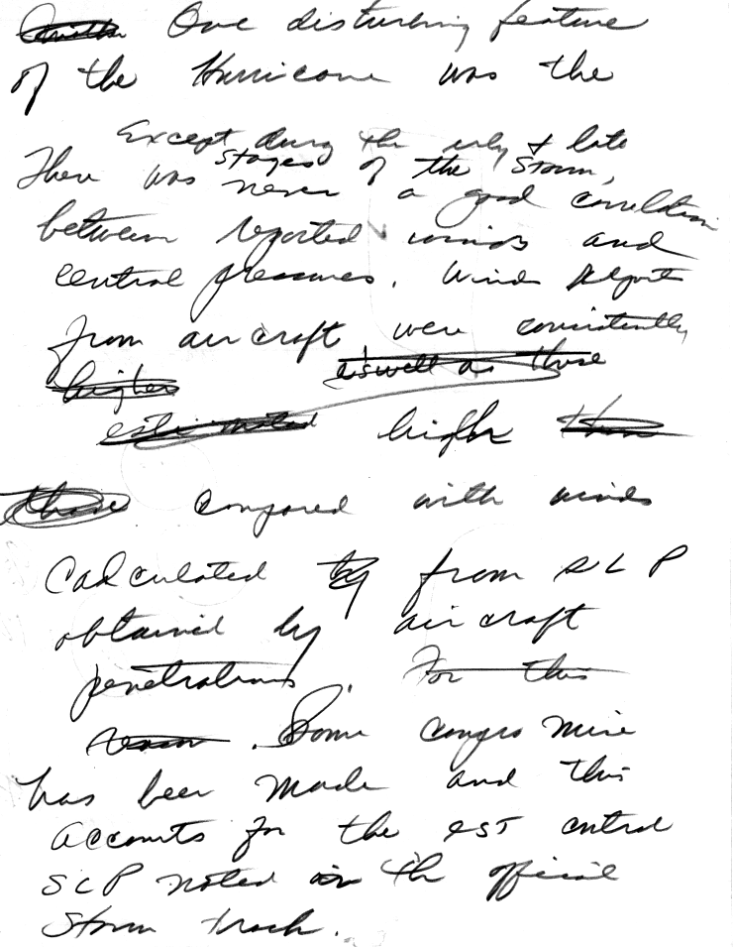

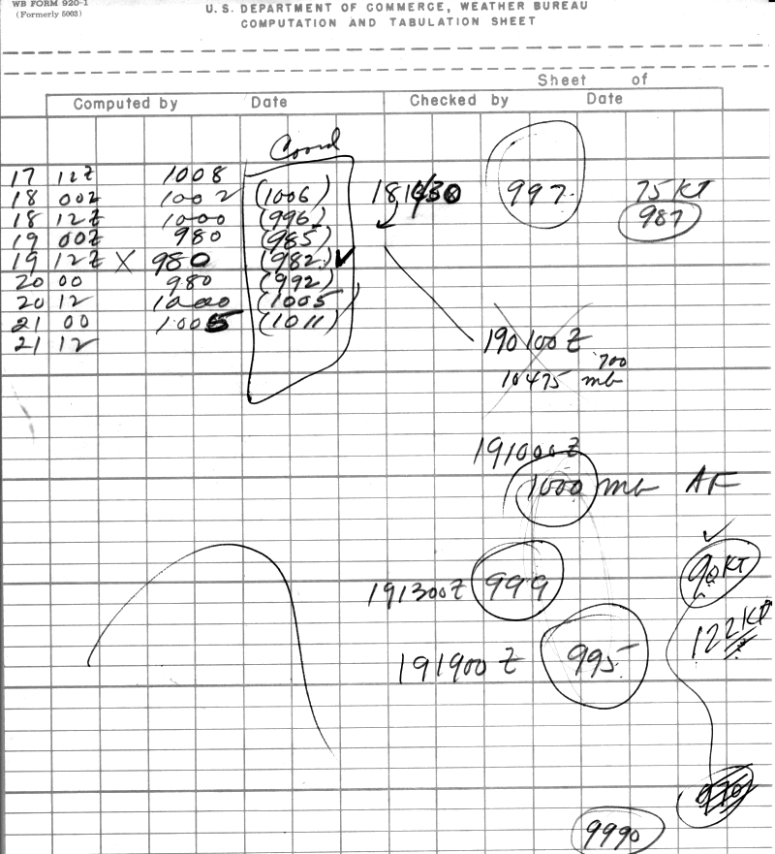

1960 Storm #5, Donna:

1. A major issue in this write-up is that the aircraft fixes are poorly documented. Some of them are in the spreadsheet but not in the write-up. There are some that are in the write-up, but not in the spreadsheet, or vice versa. There are many that seem to be logged with incorrect pressure and height data. There are also some that do not seem to be in either the write-up or the spreadsheet, yet they can easily be found in the NHC online wallet and other sources. Please make sure all of the aircraft fixes with central pressures are properly documented in both the write-up and the spreadsheet, including making sure that the pressures are quality controlled.

Extensive revisions and consistency checking has now been done between the original sources, the excel database, and the metadata writeup.

2. The Committee does not concur with the removal of 29 and 30 August from HURDAT. Although it is appreciated that there is little evidence of the existence of a tropical cyclone on these days, the data is far too sparse to justify removing the current HURDAT entries.

Agreed to retain the 29th and 30th with a statement that it is ambiguous whether Donna existed as a tropical cyclone on those dates.

3. Please better explain the rationale for removing the “estimated” central pressure. Is there a chance that these were based on data that was not available to the Re-Analysis project and the Committee? If so, great care should be exercised in removing them.

Unlike most tropical cyclones of the late 1950s and 1960s, central pressure values were provided in HURDAT for the 12 UTC times from the 1st until the 12th. The ones that were not based upon an observation, but instead were likely estimated, have been removed. However, central pressures mentioned in HURDAT with no explicit documentation of a measured value yet aircraft were present are not removed.

4. There are observations near Donna on the microfilm map for 1200 UTC 2 September that are not mentioned in the metadata. Please clarify what these observations are.

The observation was a poorly plotted 5 kt SW wind from COADS, that resembled 50 kt. This is now corrected.

5. The proposed intensity for 1800 UTC 2 September is 95 kt, based partly on the southern wind-pressure relationship yielding an 86 kt estimate for a central pressure of 973 mb. What is the intensity estimate for 973 mb using the intensifying subset of the southern wind-pressure relationship?

The intensifying subset of the southern wind-pressure relationship suggests 87 kt. This is now used instead of 86 kt.

6. For the aircraft fix at 1255 UTC 3 September, it should be noted that the aircraft reported 120 kt flight-level winds in the southeastern quadrant. These winds were apparently at low level (below 850 mb).

These have now been included in the excel database and the daily summary.
7. The Committee concurs with the disregarding of the 942/952 mb pressures on the dropsonde at 1317 UTC 4 September. The Committee notes that this aircraft also reported 150 kt flight-level winds (apparently at 1000 ft), but these are called ‘estimated’ in the text message.

Agreed to disregard the 942/952 mb dropsonde values. The 150 kt flight-level winds have now been added into the excel database and the daily summary. Note that flight-level winds in this era are all semi-quantitative and estimated.

8. The NHRP flight summary put together by Gray shows that an NHRP research aircraft passed through the eye around 2045 UTC 4 September at an altitude of 13800 ft. The plane measured flight-level winds of 120 kt 12.5 n mi from the center, and the D-values suggest the central pressure was 960-961 mb using Jordan’s nomograph. Please note this in the metadata and use this in the re-analysis if necessary.

This has now been added to the excel database. However, extrapolating sea level pressure from a flight level near 600 mb is problematic and is not included into HURDAT.

9. Please contact the various meteorological services of the Leeward Islands for more information on the passage of Donna. Some of the data is available in a report from the San Juan office in the NHC storm wallet (see below), which includes that the 952 mb lowest pressure on Sint Maarten was in the eye. However, it needs to be determined whether the 110 kt southwesterly sustained winds on Sint Maarten were measured or estimated, as well as what was the height of the anemometer. If they were measured, this suggests the intensity at that time may need to be higher than 110 kt.

The reference of the 952 mb being in the eye from the San Juan office report has now been added in. MeteoFrance has been contacted with regards to these observations. However, they have no information regarding the anemometer height nor whether the 110 kt was estimated or observed.

9a. The NHC wallet also includes a report of a lowest pressure of 29.14 in on Anguilla, which is just north of Sint Maarten and also in the eye. This pressure looks too high compared to the other data.

Agreed that this pressure looks too high given that the station was in the eye and in comparison with other data.

9b. It is noted that the Navy radar fixes showed the center of the eye passing north of Sint Maarten, suggesting the possibility that the central pressure was a little lower than 952 mb.

All of the aircraft fixes have been plotted up over the Lesser Antilles. The fixes overall are consistent with a direct hit on Sint Maarten.

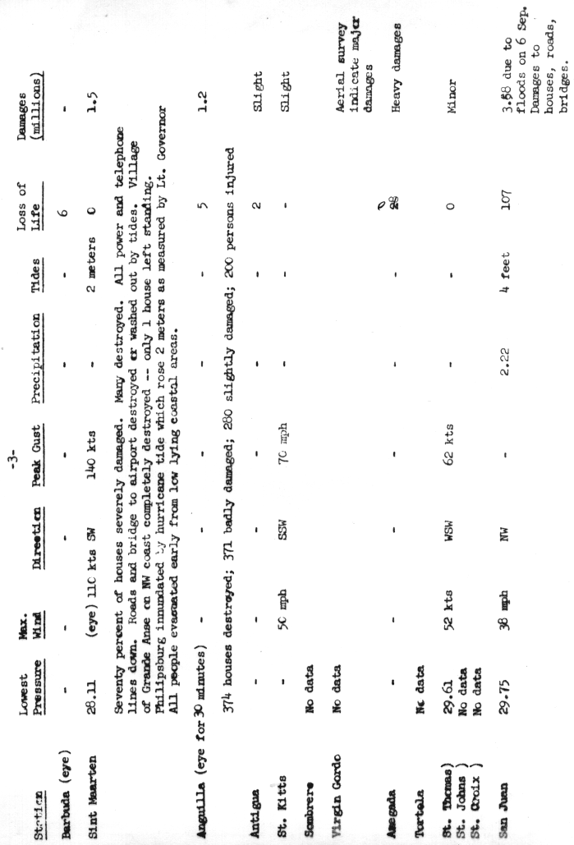
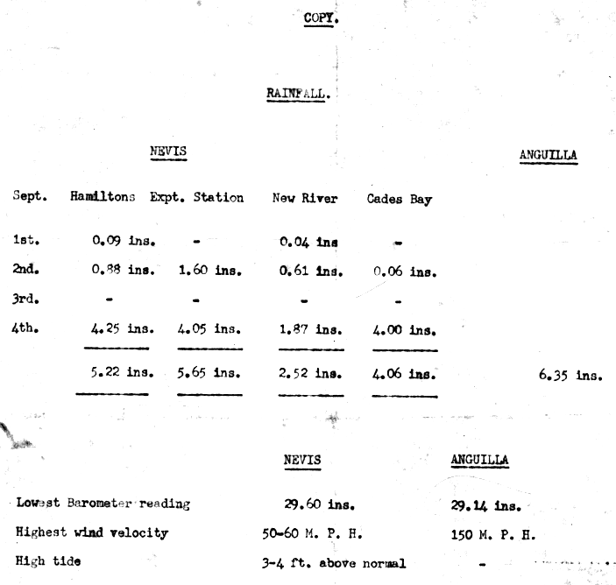

10. Issues with the aircraft data on 5 September:

10a. The Navy aircraft that made the 0130 UTC fix made a second penetration fix at 0700 UTC after the center had passed Sint Maarten. The 700 mb height was 9168 ft/2794 m with a temperature of 18.1C, which yields a central pressure of 962 mb using today’s formulas.

This is now included in the excel database and the daily summary. It appears that Donna peaked in intensity with 952 mb as it passed over Sint Maarten around 04Z, weakening to 962 mb by this 07Z fix, then steadily deepened thereafter.

10b. The metadata write-up of the 1245 UTC fix has a bad latitude and longitude.

This position typo has been corrected.
10c. The NHC wallet has reports from an Air Force aircraft that fixed Donna at 1345 UTC and 1555 UTC. On the first fix, the aircraft reported an estimated surface pressure of 960 mb. However, a drop measured 965 mb, and the 500 mb height of 18360 ft yields a 967 mb central pressure from Jordan’s nomograph. On the second fix, the aircraft report a 500 mb height of 18260 ft, which yields a 964 mb central pressure from Jordan’s nomograph. (This is one of the missions that is in the spreadsheet but not in the write-up.)

The writeup provides highlights, not every single fix. Note that central pressures derived from 500 mb flight-level data are not accurate enough for use here.

10d. Please note that the 956 mb pressure from the NHRP aircraft at 1943 UTC was extrapolated.

Agreed to indicate that this value was extrapolated.

11. Please re-evaluate the intensity on 4-5 September based on the information from points 8 and 9. At the very least, there may need to be some smoothing of the 5 kt fluctuations that are currently proposed.

With this information, the 06Z 5th intensity has been adjusted to 110 kt. All of the best track intensities on the 4th and 5th are 110 kt.

12. Issues with aircraft data on 6 September:

12a. Please re-examine the aircraft fix at 0130 UTC. The ATSR first mentions the plane entering the center at 0130 UTC, then it makes a formal fix at 0200 UTC. This fix mentions an “uncorrected” dropsonde pressure of 946 mb. The minimum 700 mb height in the eye is 8755 ft/2669 m, which along with a temperature of 16C yields an extrapolated pressure of 951 mb using today’s formulas. There is a subsequent dropsonde with a splash pressure of 960 mb. However, the 700 mb height on the sonde is 9200 ft, suggesting it was not released in the center of the eye. It is not clear where the 941 mb pressure mentioned in the post-flight summary comes from.

It appears that there was a second drop – not transmitted – which obtained the 941 mb (“MIN OBSD SFC PRES 941 MB BY DROP”), which is consistent with the central pressures obtained several hours subsequently.

12b. Please re-examine the central pressure and the associated best track intensity from the Air force fix at 1835 UTC. The aircraft reported an extrapolated pressure of 932 mb. It also reported a 500 mb height of 17600 ft, which yields a pressure of 933 mb using Jordan’s nomograph. However, the associated dropsonde reported a splash pressure of 940 mb, and the 700-mb data on the drop would yield an extrapolated pressure of 938 mb. The post-flight summary noted that on this fix that the 500 mb and surface centers did not seem to be quite vertically aligned.

Agreed to use the 940 mb from the dropsonde as the central pressure at 1835Z. Sea level pressure extrapolation from 500 mb is not accurate enough for use as a central pressure.
12c. For the aircraft fix at 2230 UTC, the minimum 700 mb height was 8300 ft/2530 m, and a temperature of 16.8C was reported at 671 mb. This would extrapolated to a pressure of about 935 mb using today’s formulas.

Agreed to use this 935 mb as the central pressure around 00Z on the 7th.

13. Please add a reference for the 1961 MWR article by Jordan and Schatzle (pp 354-356) that documents the concentric eyewall structure of Donna on 6 September.

Agreed to reference Jordan and Schatzle (1961).

14. On 7 September, the NHC wallet has data for a research aircraft making penetration fixes at 1818 UTC and 2152 UTC. On the first fix, the 500 mb height was reported to be 17670 ft, which yields a central pressure of 938 mb using Jordan’s nomograph. On the second fix, the plane reported a pressure of 941 mb. The minimum observed 700 mb height was 8430 ft/2570 m, Unfortunately, no temperature was reported.

The 941 mb central pressure is now included in the excel database. Sea level pressure extrapolation from 500 mb is not accurate enough for use as a central pressure.

14a. The NHRP flight summary has data for a mission on 7 September, but it is unclear whether this is the same research flight as the one in the NHC wallet. The plane penetrated the center at 8200 ft near 1655 UTC, and the minimum observed D-values would support a surface pressure near 950 mb using Jordan’s nomograph. However, the flight-level winds at those D-values were about 35 kt, suggesting a lower pressure. During this penetration, the aircraft reported 150 kt flight-level winds 15 n mi from the center. The plane again penetrated the center at 8200 ft near 1758 UTC, and the minimum observed D-values would support a surface pressure near 946 mb. However, the flight-level winds at those D-values were 40-50 kt, again suggesting a lower pressure. Two additional penetrations were made at 13000 ft near 2010 UTC and 2117 UTC. The minimum observed D-values on these fixes would support central pressure nears 940 mb. The observed winds for these D-value measurements were less than 30 kt.

These near-central pressure values have been added into the excel database and daily summary. However, it is not clear how these can be converted to a central pressure and thus are not included as a central pressure. Sea level pressure extrapolations obtained at 13,000 ft (~600 mb) are not accurate enough to be included as central pressures.

15. Issues for aircraft data on 8 September:

15a. On the fix at 0400 UTC, the aircraft reported a dropsonde pressure of 947 mb. The drop has a 700 mb height of 8640 ft/2633 m and a temperature of 16C, which using today’s formulas would yield a pressure of 947 mb that matches the splash pressure. However, on the text fix form where the drop is first mentioned, it states that the minimum 700 mb height in the eye was 8711 ft/2655 m with a temperature of 15C. This combination give a surface pressure of 950-951 mb.

A 3-4 mb difference between 700 mb height/temperature obtained pressure versus the dropsonde pressure is in the noise level for the instrumental accuracies of this era.

15b. The same aircraft made a third fix at 0700 UTC with a minimum 700 mb height of 8593 ft and an eye temperature of 14C. This would extrapolate to a central pressure of 947-948 mb. (None of the fixes from this aircraft are in the spreadsheet.)

These are now included within the excel database and daily summary.

15c. The NHC wallet has data for an Air Force mission with a fix at 1020 UTC. The aircraft reported a 500 mb height of 17830 ft, which produces a surface pressure of 945 mb using Jordan’s nomograph. A dropsonde reported a 951 mb splash pressure, while the extrapolated pressures from the drop’s 850 and 700 mb data are 950-951 mb. This is the same aircraft that made the fix at 1300 UTC. (It should be noted that there was a splash pressure of 949 mb for this sonde that was apparently corrected to 951 mb.)

This 951 mb central pressure from dropsonde is now included in the excel database. Sea level pressure extrapolation from 500 mb is not accurate enough for use as a central pressure. This provides a good example of where the 500 mb-derived central pressure was several mb (in this case six) lower than that observed by dropsonde.

16. The NHC Wallet has some information from the Bahamas that is not logged in either the metadata write-up or the spreadsheet. One significant ob (see below) is that the eye of Donna passed over Ragged Island at 0940 local time 8 September, and that a pressure of 27.90 in/944.8 mb was measured at about that time. A second significant ob (see below) is that the anemometer at Long Cay, Fortune Island, was reporting 138 mph at 0300 local time 8 September when the instrument was blown down. The observer estimated that the winds continued to increase for over an hour after the anemometer failed.

These have now been incorporated into the excel database and the daily summary.

16a. Please contact the Meteorological service of the Bahamas for more information on these and other data from the affected islands.

The Meteorological service of the Bahamas has been contacted but they have no additional information about this or other observations during Donna.

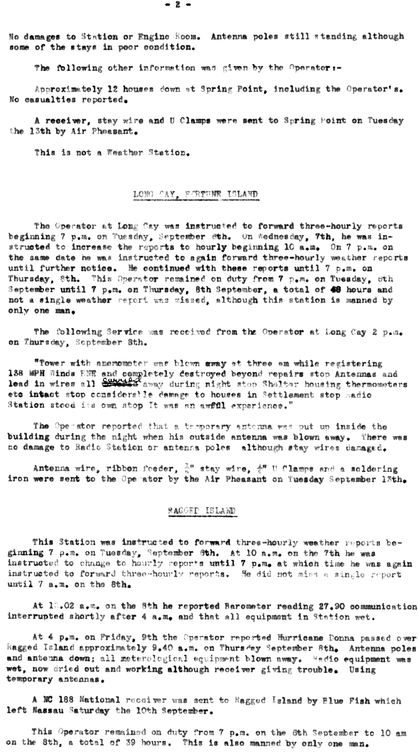
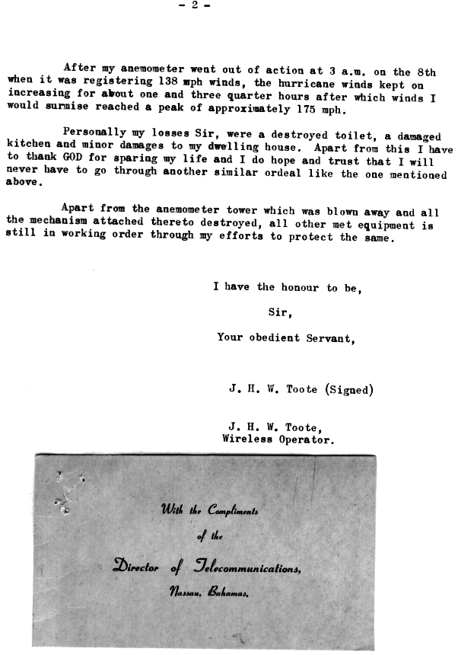

17. Issues with aircraft data on 9 September:

17a. Please re-examine the fixes and pressure near 0000 UTC. The aircraft fixed the center at 0030 UTC and reported a 939 mb central pressure via dropsonde. However, the plane also reported a minimum 700 mb height of 8691 ft/2649 m and an eye temperature of 14C. This yields an extrapolated pressure of 951 mb using today’s formulas. The 946 mb dropsonde included in the ATSR has a position that does not correspond to the aircraft-reported storm center. It may be that this was a peripheral sonde with a bad calibration.

The discrepancy between the dropsonde and the flight-level extrapolation is noted in the metadata daily summary.

17b. A Navy fix at 0400 UTC has a dropsonde pressure of 944 mb. The aircraft also reported a 700 mb height of 8650 ft/2637 m and a temperature, of 17C which produces an extrapolated pressure of 947 mb.

Agreed to add this value into the excel database.

17c. For the Navy fix at 0700 UTC, the reported pressure of 943 mb was extrapolated. The reported 700 mb height and temperature would yield 942 mb using today’s formulas. However, there is also a dropsonde associated with the fix that reported 946 mb, which was consistent with the 700 mb data on the drop. This fix was not was properly documented in the ATSR, but is available in the NHC wallet.

Agreed to add 942 mb into the excel database and daily summary. The 946 mb pressure from the drop appears to be too high compared to previous and subsequent pressures.

17d. The Navy fix at 0920 UTC reported an extrapolated pressure of 933 mb. Using today’s formulas, the reported 700 mb height (8500 ft/2590 m) and temperature (20C) would yield an extrapolated pressure of 938 mb. This is consistent with the 938 mb eye dropsonde.

Agreed to correct the 933 mb to 938 mb.

17e. The Navy flight from 1300 UTC to 1700 UTC apparently spent much of its time orbiting the eye, and it provided many fixes. The times and reported pressures include: 1300 UTC old extrapolation 936 mb/modern extrapolation 943 mb/dropsonde 942 mb; 1400 UTC modern extrapolation 937 mb; 1600 UTC old extrapolation 942 mb/modern extrapolation 938 mb/dropsonde 939/940 mb. It should be noted that for that last fix, the NHC wallet has the drop with a 940 mb splash pressure while the ATSR has the same message with a 939 mb splash pressure. Since 940 mb was used in the post-flight summary, it is probably the better pressure. Please make sure these fixes are properly logged in the write-up and the spreadsheet.

These values have now been included in the excel database and (for the 13Z fix) the daily summary.

17f. A research mission documented in the NHRP flight summary reported D-values supporting a pressure of 942 mb at 1638 UTC. However, these D-values were measured in a part of the eye where the winds were 30+ kt, suggesting the central pressure was lower. The NHRP flight summary indicates the plane measured 131 kt winds 15 n mi from the center. However, this does not agree with the fix message in the NHC wallet, which has a maximum flight-level wind of 122 kt.

The 131 kt flight level winds have been added into the excel database.

17g. A second research mission in the NHC wallet (but not in the NHRP summary) fixed the center at 1958 UTC and reported a 700 mb height of 8340 ft/2542 m. It is unclear if this is correct, as it is different than those of the simultaneous Navy flight. However, if it is correct, please correct the value for this fix on the spreadsheet. Unfortunately, no temperature seems to be available to calculate a central pressure.

Agreed to adjust the 700 mb heights for the research mission in the excel database.

17h. In regards to the to the Navy fix at 1900 UTC, the fix for reports an extrapolated pressure of 940 mb. The 700 mb data and the modern extrapolation formulas give 946 mb, while the eye dropsonde reported 944 mb. Based on this, the 940 mb used in the write-up may be too low. The Committee notes that the NHC wallet has a version of this fix with incorrect pressure and height information.

Agreed to use the 944 mb pressure from dropsonde as the central pressure.

18. Issues with aircraft data on 10 September:

18a. For the 0050 Navy fix, the reported pressure was 938 mb. The 700 mb data yields a pressure of 940 mb using modern extrapolation formulas. The 938 mb reading appears to come from a dropsonde which has reasonable-looking and height data, but has a drop location well outside of the eye.

It is likely that the reported drop location is in error. This is now noted in the daily summary.

18b. The Navy plane that was in the storm as Donna moved through the Florida Keys reported the following pressures: 0400 UTC uncorrected dropsonde 937 mb/modern extrapolation 940 mb/dropsonde 939 mb; 0430 UTC modern extrapolation 943 mb; 0530 dropsonde 942 mb? There is a question about when the 942 mb dropsonde was made, as the position better matches that of the 0430 UTC fix than the 0530 UTC fix. Also, the version of the drop in the NHC wallet says it was made near the north wall cloud.

Agreed to include these values into the excel database.

18c. The last Navy plane before landfall in southwestern Florida made a low-level penetration near 1125 UTC (time from the ATSR). The observed central pressure was 940 mb. The 1300 UTC fix reported 940 mb from the old 700 mb extrapolation/939 mb modern extrapolation/944 mb from a dropsonde with a 700 mb height about 90 ft higher than the lowest in the eye. Finally, the fix with the 953 mb pressure was actually made at 1600 UTC instead of 1700 UTC as shown in the write-up, and the aircraft said the pressure could be wrong due to the eye making landfall.

The 939 mb extrapolated pressure is now used as the central pressure at the 12Z slot, as the 944 mb from dropsonde may have not been in the center of the eye. The 17Z 953 mb pressure is now not considered to be a central pressure, due to the uncertainty of the validity of the pressure measurement at or after landfall.

19. The Committee has many issues with the proposed revisions across the Florida Peninsula:

19a. Please make sure that the RMW used in the intensity calculations matches that based on the available surface data.

This has now been analyzed and confirmed. See below.

19b. What is the basis for making the Keys landfall pressure 930 mb based on the Conch Key pressure of 933 mb? The 930 mb value is not necessarily wrong, given that the lowest pressure could have easily slipped between the various islands in the Keys. However, some additional background information on this would be helpful.

A pressure of 933 mb observed from a calibrated barometer on Conch Key is the basis for the estimated 930 mb central pressure at landfall, assuming that this single instrument may not have measured the exact central pressure of Donna. 930 mb central pressure was also that assessed by Ho et al. and Jarrell et al.

19c. The Committee has concerns about the proposed 120 kt landfall intensity in the Keys. First, this may be too far below the values given by the wind-pressure relationships. Second, Sombrero Key reported 111 kt fastest mile winds on the west of the center, while Tavernier reported 104 kt (the limit of the anemometer) for 45 minutes. There is a need for more information on these stations. What is the 1-minute winds for a 111 kt fastest mile wind? What were the elevations of the two stations? Where were they in relation to the radius of maximum winds (RMW)?

The 111 kt fastest mile wind converts roughly to a peak 1 minute wind of 106 kt. The NOAA technical catalog of station metadata indicates “Unknown” for the anemometer height for both the Sombrero Key Lighthouse station and the Tavernier cooperative station. It is possible that the Sombrero Key (and the Tavernier) anemometer observations were above the standard 10 m above ground/water. The 20 nm RMW arrived at from the aircraft reconnaissance eye diameter (and also arrived at by Ho et al. and Dunion et al.) can be compared with the peak winds from Sombrero Key Light and Tavernier. A 20 nm RMW would place Sombrero Key Light nearly at the RMW and Tavernier just outside of the RMW at the times of closest approach. Thus these observations are consistent with a 20 nm RMW.

19d. Given the path of the storm, Naples is probably not a good landfall point. Would Cape Romano or Marco Island be a better point at a slightly earlier time?

Agreed. A landfall at 16Z near 25.9N 81.6W just east of Marco Island is now indicated.

19e. The Committee does not concur with the proposed downgrade to Category 2 at landfall in southwestern Florida. First, there are indications that the central pressure might have been lower than the formal 950 mb measurements in Naples and Fort Myers. The reports from Naples state it was not completely calm in the city during the eye passage as shown in the Florida Climatological Data table below. The table entry for Fort Myers states another barometer in the area measured 27.75 inches/940 mb. While that sounds unlikely, it suggests the possibility that the Fort Myers station (as well as the Naples station) might not have measured the lowest pressure. Third, Everglades City was in the eastern RMW, and the description in the table suggest that major hurricane conditions occurred there. Fourth, there was a report of a 113 kt fastest mile wind in Punta Gorda that is not mentioned anywhere in the write-up. Various accounts say that the instrument in Punta Gorda failed, and it cannot be ruled out that this was an estimate. However, nowhere is the value explicitly stated as estimated, and if it is not an estimate, what does this mean for the intensity? Finally, Hurricane Wilma of 2005 made landfall as a 950 mb Category 3 with a much larger RMW (and environmental pressure?) than Donna, albeit with a faster forward speed. This suggests that Donna could have been a major hurricane with its RMW and forward speed.

Based on the above, the Committee recommends that the landfall intensity at whatever the revised landfall point turns out to be set to at least 100 kt, if not higher. The Committee would also like to see all of the detailed observations from the stations in southwestern Florida, especially those near the path of the RMW.

These observations have been added into the excel database and the daily summary. Donna then made landfall just east of Marco Island around 16 UTC on the 10th at 25.9N 81.6W. A pressure of 950 mb observed at Naples at 17 UTC, but the center of the hurricane passed to the east of the city, so this is a peripheral pressure value. Runs of the Schloemer model give a central pressure of about 945 mb, assuming that the distance from Naples to the center of the eye was 5-10 nm. Given that some filling occurred after landfall until the Naples observation was taken, central pressure at landfall near Marco Island is analyzed to be 942 mb, which is consistent with some filling measured by aircraft a few hours earlier. This pressure suggests maximum winds of 108 kt from the weakening subset of the north of 25N pressure-wind relationship. The forward speed of Donna had increased to about 12 kt but the outer closed isobar remained low (1009 mb). Intensity at this landfall is thus analyzed to be 105 kt. Note that there was a 113 kt fastest mile report (reduces to 108 kt peak 1 min wind) from Punta Gorda at 20 UTC, though it is unclear if this was observed or was visually estimated.

A search of NCDC’s EV2 website was successful in getting the original Surface Weather Observations from Fort Myers, but Everglades City, Naples, and Punta Corda were not available.

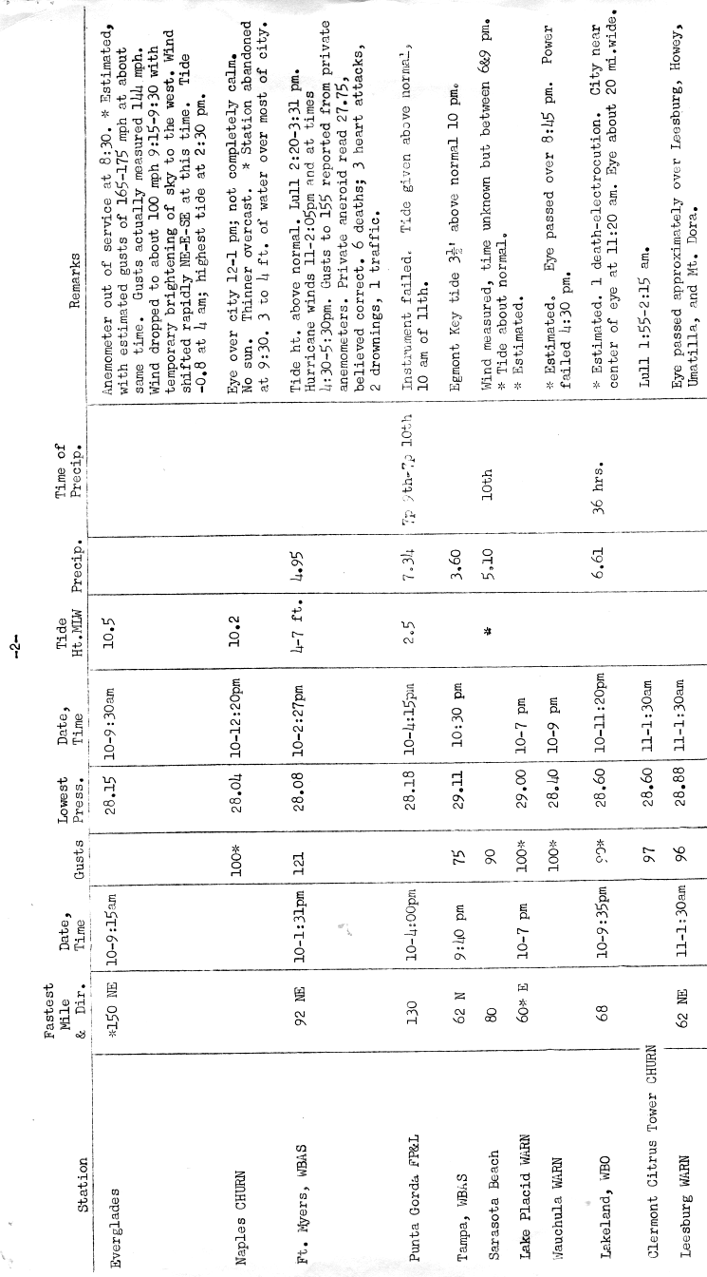
19f. The Committee does not concur with the proposed downgrade of Donna to a tropical storm over central Florida. First, this reduction seems to be based on H*WIND analyses of Dunion et al, which the Committee believes has a low bias. (Question: Was the Dunion analysis using one of the older versions of H*WIND?) Second, the 59 kt wind at Lakeland at 0235 UTC was likely not in the strongest part of the storm, suggesting that Donna remained a hurricane at that time. Third, the Florida Climatological Data reports a 64-kt fastest mile wind at Ponce de Leon Inlet (New Smyrna Beach) at 0823 UTC 11 September, which suggests that Donna was at or near hurricane strength at that time. (This observation from the table below is not in either the spreadsheet or the write-up.) The Committee recommends keeping Donna a hurricane all of the way across Florida.

Agreed to retain Donna as a hurricane all of the way across Florida. The Dunion analysis was using the version of H*WIND that was available in 2001, which has certainly evolved significantly to that used today. The version today does not employ (nor was the real-time version in 2001) the Kaplan-DeMaria inland decay model, which was used in the Dunion paper. However, because the Dunion analysis began with a 98 kt maximum wind at landfall near Marco Island, the subsequent intensities after landfall may be low biased as well. Given that the intensity assessed here is higher (105 kt), the Kaplan-DeMaria inland decay model gives 82, 56, and 62 kt for 00, 06, and 12 (just offshore) UTC. Peak observed winds after landfall were 59 kt at 0235 UTC in Lakeland and 64 kt at 0823 UTC at Ponce de Leon Inlet lighthouse. Intensities in HURDAT are reanalyzed to be 85, 65, and 70 kt, down from 105, 100, and 90 kt originally in HURDAT.
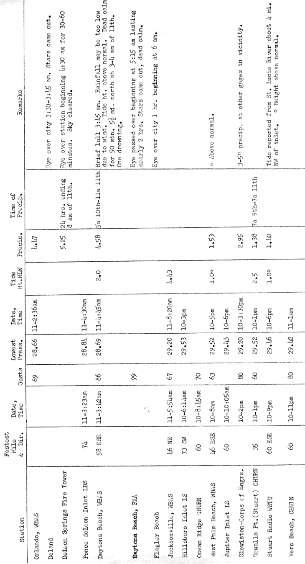
20. The Committee notes that there is a post-storm report from the Daytona Beach weather Bureau office in the NHC Wallet. One part of it includes a report of 50 minutes of calm 5.5 miles north of Daytona Beach with a minimum pressure of 28.60 inches/968.5 mb. The pressure is at least consistent with the later aircraft reports.

Agreed to add in this into the excel database, daily summary, and include as a central pressure at 12Z on the 11th.

21. For the first aircraft mission after Donna emerged into the Atlantic, there is an eye dropsonde at about 1830 UTC 11 September with a splash pressure of 970 mb. The 850 mb data extrapolates to a pressure of 974 mb. In addition, another eye dropsonde near 2200 UTC had a splash pressure of 968 mb, with pressures 968-970 mb extrapolated from the 850 and 700 mb data.

Agreed to add in these observations and have now used the 970 mb at the 18Z 11th central pressure in HURDAT.

22. The Committee does not concur with proposed 955 mb landfall pressure for the North Carolina coast. While working backward from the 958 mb pressure at Belhaven supports this, some part of the eye passed over three stations – Wilmington, New Bern, and Cherry Point – before reaching Belhaven, and these stations all reported minimum pressures near 962 mb. Also, there is nothing in the data from the last recon mission to support a 955 mb pressure, although the pressure data is a little problematic as the eye made landfall. The Committee recommends using 958 mb as the landfall pressure based on the extrapolated value in the last aircraft fix – and even that might be a little low. If possible, please make a quality control check on the Belhaven pressure data.

Agreed to use a 958 mb central pressure at landfall in North Carolina. Unfortunately, a time series of the Belhaven pressure is not available. Lowest observed pressure was 958 mb in the eye at Belhaven in eastern North Carolina a couple hours after landfall. However, the eye of Donna also passed over or very close to Wilmington, New Bern, and Cherry point before reaching Belhaven and all three of these stations reported minimum pressures near 962 mb. Thus it is likely that Belhaven’s observation was biased slightly high. This along with the aircraft reconnaissance measurement three hours before landfall, the analyzed central pressure at landfall in North Carolina is around 958 mb.

23. Please state more clearly that the Long Branch mentioned in the 12 September land highlights is in New Jersey.

Done.

24. Please make a more extensive search for data on Long Island and in southeastern New England, as the New York and New England Climatological Data publications show there is more than made it into either the data tabulation at the time or the re-analysis submission. For example, the New York CD mentions “several wind towers on Long Island” where the winds reached 100 mph, and it explicitly states that the anemometer at the Montauk Point Lighthouse blew away at 100 mph winds. The New England CD mentions a pressure of 28.58 inches/967.8 mb at Noank, Connecticut (near Groton), which does not appear in any other literature on Donna.

Agreed to add in the Long Island tower, Montauk Point Lighthouse, Noank observations into the daily summary and the excel database. Unfortunately, no further information is available on these observations.

24a. The Committee notes that the New England CD has a map showing the track of the area of lowest pressure. Please check this against the proposed track across the area.

This map has been obtained and compared against the proposed track. No alterations to Donna’s proposed track appears necessary.

24b. Please note in the in the land station highlights that New York Kennedy airport had a minimum pressure of 967.2 mb.

Agreed to add this into the excel database.

24c. Amongst possible missing stations, Islip and Republic airports on Long Island (between Brookhaven and New York City) were also in operation in 1960, and the eye likely passed over both of them.

The Surface Weather Observations from Islip were obtained from the NCDC EV2 website. Unfortunately, no observations were taken between 1558Z and 2200Z when Donna went over the airport. No observations were available from Republic airport.

25. The eye passed over the Suffolk County Air Force Base (modern day Westhampton) on Long island with a good SWO record available. Can an RMW be estimated from these data?

The peak winds at the Suffolk County Air Force Base occurred at 1838Z and the lowest pressure (and minimum winds) occurred at 2045Z. Given the motion of Donna of about 30 kt, this would suggest an RMW of about 60 nm. This is now also added to the metadata writeup.

25a. The estimated landfall pressure on Long Island is 959 mb based on the premise that the center passed just east of Brookhaven and its 961 mb pressure. However, the Suffolk County AFB to the east of Brookhaven reported a minimum pressure of 965 mb, and the Calverton airport reported about the same altimeter setting (with the caveat that Calverton data are incomplete and appear to be marked as estimated in the SWO). Is it possible that the pressure minimum passed over Brookhaven? Are there more detailed observations available from Brookhaven?

Unfortunately, no additional observations are available from Brookhaven. The 965 mb minimum pressure at Suffolk County occurred with 23 kt winds and the wind shift at that location went from east to south to west, indicating that Donna’s center went west of that location. Brookhaven and Suffolk County are about 20 nm distant, so having a slightly lower pressure just east of Brookhaven is consistent with the available observations. 959 mb central pressure at landfall in New York is retained.

26. The Committee has issues with the reduction of the landfall intensity in New York from 90 kt to 85 kt. Pending the resolution of points 24 and 25, wouldn’t 90 kt be a better landfall intensity in light of the 83 kt at Block Island and the original 90 kt HURDAT value?

Given the RMW calculation of 50 nm, it appears quite possible that Block Island received nearly the strongest winds present in Donna. 959 mb suggests maximum winds of 90 kt from the Landsea et al. north of 35N pressure-wind relationship. Given the large size (climatology is 35 nmi for this central pressure and latitude), low (1004 mb) environmental pressure, but fast (32 kt) forward speed, some reduction from the value suggested from the pressure-wind relationship is appropriate. Thus maximum sustained surface winds are estimated to be 85 kt at landfall in New York.

1960 Storm #6, Ethel:

1. Please provide whatever microfilm maps are available for 11 September.

These have now been made available in the binder and the w: drive.

2. The dates on the track map appear to be in error by one day, For example, the point labelled as the 12th should be the 13th.

Thank you for catching that error.

3. While there is evidence that a low pressure area existed in the southwestern Gulf of Mexico at 1800 UTC 12 September, the Committee has two questions. First, what is the evidence that this was a tropical cyclone instead of a low pressure area? Second, how much was the front over the western Gulf of Mexico involved in the system? The Committee agrees that genesis likely occurred prior to 0000 UTC 14 September, but it needs a stronger argument to add earlier times to HURDAT.

Evidence that this was a tropical cyclone at 18Z on the 12th rather than a trough are the two ships in the southwestern Gulf of Mexico showing 25 kt winds out of the southeast north of the system and 20 kt winds out of the southwest south of the system. If the system were only a trough, then it is unlikely that there would be 25 kt SE winds present. A significant frontal boundary was present on the 12th and 13th, but this was primarily affecting the northeastern Gulf.

3a. It is noted in particular that the proposed position of 23N 92W at 1800 UTC 13 September is difficult to reconcile with the other data on the microfilm map.

The position at this time is mainly interpolated from earlier and later times when data is more plentiful near the center of the system. The proposed position is consistent with the few observations available between 19-26N 89.5W-97W. The weak winds east of 89.5W represent mainly the effect of the cold front.

4. It should be noted somewhere in the write-up that the reports from the MAMOS buoy were the first time an automated weather buoy successfully transmitted observations from an Atlantic tropical cyclone. There is an article on it in the 1960 Mariners Weather Log on pages 191-194. If possible please locate the remainder of the observations from the buoy, which seems to have been reporting every three hours.

This important milestone was added into the metadata writeup. Unfortunately, no additional observations were available.

5. The Committee notes that on the pressure for the 1900 UTC 14 September aircraft fix, the aircraft reported 972 mb from the low-level penetration. It then extrapolated 974 mb using the 700 mb data, which would yield 976 mb using today’s formulas. Finally, a dropsonde that passes QC checks reported 974 mb. Based on this, 974 mb looks like the best pressure for this fix.

974 mb central pressure was already being used in the reanalysis.

6. The Committee notes that one of the aircraft text messages for the 2212 UTC 14 September fix states “four ships near eye”.

Several ships were indeed noted near the eye from the microfilm and COADS observations near that time.

7. The aircraft fix for 0000 UTC 15 September has a 700 mb height of 9610 ft/2929 m and temperature of 18C. This yields a modern extrapolated pressure of 976 mb.

This has been added into the excel database and the daily metadata as well as replacing the 975 mb value from late on the 14th.

8. The Committee concurs with the reduction in the peak intensity to 100 kt, and it asks for a note to be added that this value has greater than normal uncertainty. It should be noted that this system has similarities with Hurricane Danny of 2015, which was a major hurricane with a central pressure near or above 970 mb.

Agreed to add in the statement about the uncertainty and comparison with Hurricane Danny.

9. The aircraft pressures early on 15 September are very problematic. The Navy aircraft that monitored Ethel early in 15 September made a fix at 0300 UTC and reported a 700 mb height of 9600 ft/2926 m. However, that fix did not report an eye temperature. After that, the reports become more confusing due to the apparent dissipation of the eyewall convection. At 0608 UTC, the plane reported a minimum 700 mb height of 9590 ft/2923 m along with a temperature of 21C at 28.4N 88.6W, which would yield a 972 mb pressure using today’s formulas. The plane later reported a dropsonde at that position with a splash pressure of 981 mb. However, the 700 mb height for the sonde is 150 ft higher and the 700 mb temperature 2C cooler than that for the ‘fix’, so the relationship between the two is unclear. (Note: The version of this sonde in the ATSR is different from the one in the NHC wallet, which has a splash pressure of 982 mb.) At 0830 UTC the plane reported a 700 mb height of 9620 ft/2932 m with a temperature of 16C, which would extrapolate to a pressure of 979 mb. The plane dropped a sonde near the location of a center fix at 0900 UTC that reported 986 mb. However, this sonde has a 700 mb height 120 ft higher and a 700 mb temperatures 3C cooler than those reported at 0830 UTC. Complicating matters further is that the post-flight summary indicated a minimum (old) extrapolated pressure of 982 mb, but this is no information as to when this occurred.

Discussing the issue with Hugh Willoughby, he indicates that the aircraft temperatures from this era mere not well-calibrated. (One had to account for the fact that the aircraft was flying through the air, causing artificial heating of the airborne thermometer. Such corrections in that era were crude at best, if they were employed.) In cases of discrepancy between aircraft and dropsonde estimated surface pressures, preference should be given to dropsondes. This assumes, of course, that the drop remained in the eye, which was not always the case. Based upon the dropsonde closest to 06Z which appears to have landed in the eye, a 981 mb central pressure is used for HURDAT.

9. Please re-examine the intensity at 1200 UTC 15 September. If the 78 kt fastest-mile wind at Venice, Louisiana at 1015 UTC (west of the center) is taken at face value, it suggests that the proposed intensity is too low. Please find out more about this observation, especially if the anemometer was elevated.

The anemometer height was not available in the NOAA technical catalog of weather station metadata. Agreed to boost the 12Z September 15th intensity up to 75 kt, 5 kt less than HURDAT.

10. Data in the NHC wallet indicate there were two research flights into Ethel on the morning of 15 September that were noted in the spreadsheet, but not in the write-up. The flight labelled “ALPHA” made a fix at 1525 UTC apparently flying at 13000 ft, where it reported 105 kt flight level winds northwest of the center of the 40 n mi wide eye. The plane “computed” a surface pressure of 986 mb. It also reported a 700 mb height of 9680 ft/2950 m, but no 700 mb temperature. The flight labelled “BRAVO” made two fixes at 1425 UTC and 1526 UTC, and on one of them (which one is unknown) is reported an 850 mb height of 4120 ft/1256 m. This would extrapolated to 982 mb. However, this plane reported a maximum flight-level wind of only 55 kt. Please try to find whatever other data might be available from these flights, which are not in the NHRP flight summary.

Again, not every fix is included into the daily summary. Only those closest to the synoptic time are generally provided, as long as that has central pressure/size information available for the relevant synoptic time highlight. The 982 mb is now added into the excel database.

11. On the fix at 1312 UTC 15 September, the combination of the 700 mb height of 9740 ft/2969 m and a temperature of 17C extrapolates to 981 mb using today’s formulas. This is notably lower than either the value on the fix form or on the corresponding dropsonde.

Again, the flight-level temperature calibrations were not well crafted (or even used), so some spurious warming may occur. Preference is given to drops, if it’s fairly certain that it landed in the eye.

12. Please provide whatever detailed observations are available from Gulfport, Mississippi. While the report in the NHC wallet indicates that the 50 kt sustained winds were estimated, they apparently occurred at the same time as the lowest pressure of 979 mb.

Unfortunately, this station is not available at NCDC via the EV2 website.

13. Given the imprecision of the central pressure measurements, it may be a good idea to smooth both the pressures and the intensities between 0600 UTC 15 September and landfall. In particular, there probably should be no change in strength between 1800 UTC and landfall.

Agreed to smooth the intensity values between 06Z and landfall at 21Z on the 15th with the same value (70 kt) at both 18Z and 21Z.

14. Please consider incorporating the following central pressures after landfall based on the North American map series:

9/16 18z 1010 mb
9/17 00z 1011 mb
9/17 06z 1012 mb
9/17 12z 1013 mb
9/17 18z 1015 mb
9/18 00z 37N 85W 15kt 1017 mb
9/18 06z degenerates into open trough

These central pressures are added in. However, available observations indicate that the system had degenerated into an open trough by 00Z on the 18th.

1960 Storm #7, Florence:

1. On the microfilm map for 0000 UTC 18 September, there appears to be an observation of 35 kt northeast winds near the hand drawn ob of 35 kt north winds. What is this observation?

It’s either 35 or 30 kt, as it’s difficult to determine if the analyst in 1960 meant to put a half barb on the observation of not. Looking at the other 5 kt increment observations plotted, this does appear at closer look to be 35 kt. We have now added it into the excel database.

2. Please add an appropriate re-analysis discussion for 21 September.

There is very little to mention on this date with regards to observations with minimal changes to the best track. The 21st is briefly mentioned the on the 20th summary.

3. The Committee concurs with including a disturbance or wave phase for part of the track. Based on the data, is it possible Florence degenerated to a trough 6-12 hours earlier than currently proposed?

Agreed to indicate a disturbance phase for 12 and 18Z on the 21st as well. (Now we do have to include a reanalysis discussion on the 21st…)

4. Please mention the 1004 mb observation at Moore Haven, Florida in the land station highlights for 24 September. Also, please see if other observations of low pressure are available from the area around Lake Okeechobee.

A search of the NCDC EV2 site indicated that the station was actually Clewiston, though it only provided observations three times a day. This is now indicated in the daily highlights. No other observation was available for extreme southwestern Florida or the Lake Okeechobee.

5. Please provide the detailed surface observations for Vero Beach (and possible other south Florida stations) for 24-25 September. The 0000 UTC 25 September microfilm map shows a west wind at what looks like Vero Beach, suggests the possibility that the center of the Florence reached the east coast.

The detailed Surface Weather Observations were obtained for Vero Beach from the NCDC EV2 website. These indicate that the lowest pressure for that location occurred at 22Z on the 24th with 1006 mb and WSW winds of 9 kt. This, along with the numerous other observations, suggest that the center of Florence reached the coast, earlier around 06-12Z on the 24th, but the system did not clearly move over the Atlantic.

6. The Committee concurs with the proposed increase to tropical storm strength on 24 September.

Agreed to indicate a tropical storm stage on the 24th.

7. Given how weak the system seems to be on 26-27 September, perhaps a status of low would be better than that of tropical depression?

Such a status would not be appropriate until later in the 1960s when regular satellite imagery becomes available.

8. Please re-examine the last couple of positions on 26-27 September, as the proposed track apparently crosses a frontal system in the North American analyses.

Agreed that this is not a reasonable solution. Upon further examination, the system dissipated by 00Z on the 27th. Thus both the 00Z and 06Z positions on the 27th are eliminated.

1960 Additional Notes:

1. Suspect #1, the first May system: Please re-examine the data for 0000 UTC and 0600 UTC 6 May. First, a ship report of 55 kt and 1000.0 mb northwest of the center at 0000 UTC suggests the possibility the cyclone developed a tropical-cyclone-like inner core. Second, there is a ship just east of the center on the 0600 UTC map that does not appear in the spreadsheet. Is it reporting 10 kt or 50 kt, and what is the pressure? Given the data at subsequent times, it is not likely that the low transitioned to a subtropical cyclone, but this part of the life cycle needs more investigation.

Agreed that the 55 kt/1000 mb ships indicates that the system developed an inner core with strong winds but remained baroclinic with a 15F temperature gradient across the system north-south at that time. That “ship” at 06Z on May 6th is Bermuda and it reported 10 kt and 1005 mb.

2. Suspect #2, the second May system: A position of 36N 73W is probably better than “Northwest Atlantic” on 26 May.

Agreed to provide a specific point for this system on May 26th.

3. Suspect #6, late August to early September: Please prepare a full write-up on this system as a potential new tropical cyclone, including obtaining any COADS data that might be available and (if possible) data from the routine reconnaissance missions. The 0000 UTC 1 September microfilm map has a ship with wind northeast 25 kt and pressure 1010.4 mb near 23.5N 49.5W. If the ob is correct, it implies a low of near 1008 mb with pressures of 1016 mb reported to the south, which in turn implies a closed circulation. On the 0600 UTC 1 September map, there is an ob of wind southeast 30 kt and 1009 mb, which if correct implies about a 1006 mb low embedded in rather high surrounding pressures. It is unclear if a closed circulation was present before that time. However, the routine reconnaissance mission on 31 August found light winds near 20.5N 49W, which allows for the possibility of a circulation to the north. Another reconnaissance mission apparently flew near or through the system later on 1 September, and between it and the nearby ships the circulation looks poorly defined. However, the pressures are mostly illegible on the microfilm map.

Agreed to add this system as a new tropical storm. See new HURDAT/daily summary/discussion/excel database.

4. Suspect #8 (now #7), late September western Atlantic: The Committee concurs with leaving this system out of HURDAT. The two ship reports of tropical-storm-force winds not far from the center at 1800 UTC 25 September suggest the possibility that the system had a tropical-cyclone-like inner core. However, there are several other time where ships were near the center (notably 1200 UTC 25 September) and showed that no such feature existed. Based on this, there is insufficient evidence to call this a subtropical or tropical storm.

Agreed to leave this system out of HURDAT. Some of this discussion is added into the writeup.

5. Suspect #9 (now #8), late September eastern and central Atlantic: Please provide any available microfilm maps for this system for 25-26 September, and also please try to obtain whatever routine reconnaissance data may be available. The 1200 UTC 27 September microfilm maps map has a ship with wind southeast 25 kt and 1009 mb near what might be a small center. The 0000 UTC 28 September map has three tropical-storm-force wind reports (including the two that are reported as suspect in the write-up) near what could be a small center. After that time, this feature is not seen in the data. This system is not likely to have been a tropical storm, but there is enough happening in that 12-hour interval to warrant a closer look.

The microfilm have been obtained for the 25th and 26th of September. However, these have no observations available anywhere near the center of the system. No aircraft reconnaissance was conducted on it. It is agreed to leave the system out of HURDAT.

6. The Committee concurs with leaving the other systems out of HURDAT.

Agreed to leave out the remaining systems out of HURDAT.

