Best Track Committee Re-Analysis Comments for 1959
Responses by Sandy Delgado and Chris Landsea given in bold face – March 2016

General comments:

1. The NHC storm wallet for Gracie includes an “Index of Assembled Meteorological Data Related to Hurricane Gracie” put together by the National Climatic Data Center (NCDC), or the National Weather Records Center as it was known at the time. The wallet contains 40 pages of catalog and no useful data. However, it suggests that additional data for this storm was assembled into some readily accessible form at NCDC. In addition, at the end of the catalog is a list of other Atlantic hurricane for which such packages were created (see the image below). Please try to obtain these packages from NCDC, as they may contain data that so far the re-analysis project has not had access to.

We too had seen this in the Storm Wallet and had followed up at NCDC to see if additional observations would be available. However, the only information they had today were the catalog listing like what you had uncovered and not any new observations.

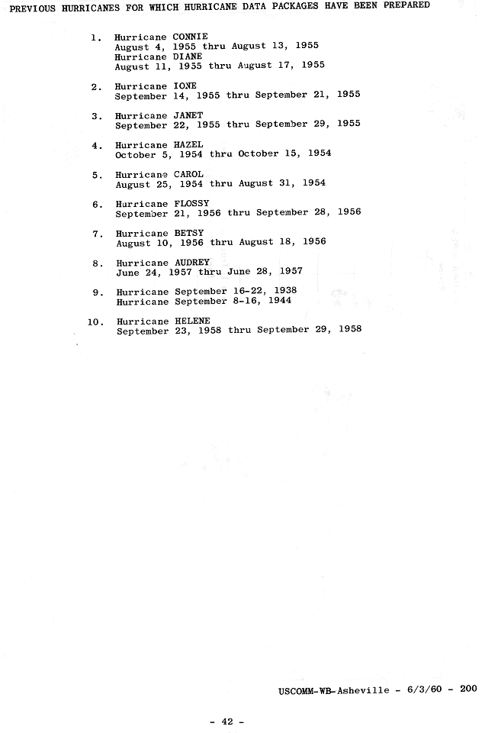
2. One data set that is very problematic is the reconnaissance data from the Air Force flights. There are many occasions where these flights were made based on references in the Annual Tropical Storm Report (ASTR), but only there only a few records available in the storm wallets and on the microfilm maps. Please make an effort to find these data, which likely need quality control checking based on what has been seen with the Navy and NHRP data.

We acknowledge that the depth of information available for the Air Force flights in this era is less comprehensive and somewhat incomplete compared with what is found for the Navy and NHRP missions. We have checked again with NCDC and the Air Force for more information on these flights. However, there does not appear to be any source for additional information about these.

3. Another data that seems to be absent is observations from oil rigs in the northwestern Gulf of Mexico. There were some occasions (Arlene, Debra, Irene, and the August disturbance) where these data could have been useful. Please try to find these data as well.

NCDC has on the EV2 website Offshore Platform data from 1980 onward, but from 1956 onward on hardcopy in Asheville. I sent the NCDC folks a request for data. Unfortunately, they had no observations available for the NW Gulf of Mexico for the dates of Arlene, Debra, Irene, and the August disturbance.

4. Some of the reports in 1959 come from the Cooperative Hurricane Reporting Network or CHURN. There are some of the CHURN reports in the storm wallets, although the records seem to be incomplete. More are apparently available online at the EV2 web site for the period 1957 to 2000. Please make sure that are of the available CHURN obs have been found and used in the re-analysis.

We have now obtained all of the CHURN observations for the 1959 hurricane season. (These observations were typically taken once a day.) Most of the landfalling systems did not have any observations of note. However, for Cindy CHURN stations at Point Judith, RI and Race Point, MA did have notably low pressures, which have now been added into the spreadsheet database. These did not make it to the daily highlights or necessitate a change in the reanalysis.

5. There are a lot of radar fixes in various parts of the 1959 storm wallets, as well as fixes that can be made from the radar picture book of Hurricane Debra. Please make sure that all of these are entered into the spreadsheets for eventual inclusion in the fix files.

Most of the radar fixes were already included into the spreadsheet database. Additional ones for Cindy, Debra, Irene, and Judith were added into the database.

6. Please make sure the scanned images archive includes the appropriate upper air maps for the cases where there is a question about the tropical character of the system or when extratropical transition occurred. This would include a case such the unnamed storm #3, Cindy, and the proposed new storms #6, #8, and #9 amongst others.

1959 Storm #1, Arlene:

1. Is this the earliest tropical cyclone/tropical storm of record to make landfall in Louisiana? If so, please make a mention of this in the write-up.

Yes, Arlene is the earliest tropical storm to make landfall in Louisiana.

2. In the 28 May write-up, please mention the ship with west winds 20 mph south of the center. Given the strength of the vortex at that time, is it possible that genesis occurred earlier (with the caveat that the 0600 UTC microfilm map has no evidence of a closed circulation)?

Agreed to mention the 20 kt W ship and to begin genesis at 06Z on the 28th.

3. Please re-examine the central pressures and the estimated intensities from the recon flight on the morning of 29 May. The text message in the ATSR for the 1200 UTC fix (coded Navy Seven) says that the minimum observed pressure was 1008 mb. However, the text coding sheet and the plotted map show what looks like a pressure of 1000 mb (ob #8) at 1230 UTC. The lower pressure is supported by the subsequent ob #9, which appears to show a 1005 mb pressure and estimated winds of 45 kt. If the lower pressure are correct, the intensity for 1200 UTC 29 May needs to be re-evaluated.

Agreed that 1000 mb is likely to be the central pressure around 12Z. This is now included into HURDAT and a 45 kt intensity is analyzed at that time (up from 40 kt in HURDAT originally).

4. Please also re-examine the central pressure and estimated intensity near 0000 UTC 30 May. The post-flight summary of the navy flight mentions a fix at 0100 UTC 30 May and says that the minimum observed pressure was 1000 mb via dropsonde. However, the rest of the flight data suggests this dropsonde was actually at 2100 UTC 29 May. Another complication is that the drop location does not match well with the other reported eye positions. It should be noted, though, that the 1000 mb surface pressure agrees well with the values computed using the sonde’s 850- and 700-mb data and modern formulas.

Agreed to indicate that the 1000 mb drop was likely taken at 21Z on the 29th, but that its surface pressure value is consistent with information from 700 and 850 mb. Agreed to note that the drop location does not match well with the other reported center positions.

4a. Given the issues with the aircraft data mentioned above, can the kink in the track at 0000 UTC 30 May be smoothed out?

Agreed to smooth out the kink in the track around 00Z 30th.

5. While there was no formal fix, a Navy plane reported an 850 mb height of 4600 ft near the center at 0710 UTC 30 May. This yields an estimated surface pressure of 999 mb using modern extrapolation formulas. Please work this in to the intensity analysis if possible.

Agreed to add this central pressure into the reanalysis, but it does not alter the intensity at 06Z.

6. While again there was no formal fix, a Navy plane near the center measured a 700 mb height of 9850 ft and a temperature of 9C at 1640 UTC 30 May. This extrapolates to a pressure of 995 mb using modern formulas.

Agreed to add this fix into the excel database, but we already have 993 mb at 1917Z.

7. The Committee notes that while it is not obviously wrong, the 993 mb dropsonde surface pressure at 1950 UTC 30 May is a little lower that the values (995-996 mb) calculated from the sonde’s 850- and 700-mb data.

Such differences are in the noise level of the accuracy of the instrument and are relatively common.

8. The summary of Arlene in the Louisiana Climate Data states that the center passed near or over Franklin, Louisiana, which had a 10-minute calm near 6:25 PM local time 30 May and a wind shift from east to west. The summary also states the wind damage was greatest near Franklin. In addition, detailed data from Baton Rouge clearly shows the center passed west of the station. Please make sure the track reflects these data.

Agreed to add in this information from the Climatological Data and have slightly adjusted track accordingly.

9. Given the original track and the available data, would it be better to show Arlene as a remnant low on 1-2 June rather than dissipated? Otherwise, please better state the rationale for saying the cyclone had dissipated.

Agreed to retain original HURDAT and show dissipation after 18Z on the 2nd.

1959 Storm #2, Beulah:

1. Please re-examine the time of genesis on 15 June. There is nothing obviously wrong with the current and proposed time of 1800 UTC. However, the Historical Weather Map (HWM) for 1200 UTC shows a west wind of 20 kt and a pressure of 1004.8 mb. This suggests the possibility the cyclone already existed at that time.

Agreed. This possibility is now so noted in the reanalysis.

1a. Please provide additional detailed observations from Tampico, particularly on 15 June. The Committee notes that the binder contains such observations from Veracruz, Mexico for this system, and the Tampico obs may help refine the genesis time.

A search of the NCDC EV2 site provides many Mexican observations in June 1959, but Tampico is missing. No other station is available nearby.

2. The proposed reduction in intensity early on 16 June look strange. The report from the ship Hondo of 50 kt winds and 997 mb at 0900 UTC suggests that the system was at least 50 kt intensity at that time – and possibly stronger given that the central pressure was in the low 990’s. This makes the proposed 40 kt at 0600 UTC look too low. Please either better justify the proposed intensities, or revise them to better fit the Hondo observation.

Agreed to boost up the intensity to 50 kt at 06Z and adjust earlier (18Z on 15th and 00Z on 16th) and later times (12Z on 16th) accordingly.

3. The ATSR shows an “uncorrected dropsonde” pressure of 985 mb near 0900 UTC 17 June. This value is included in the spreadsheet, but is not mentioned anywhere in the write-up. Please comment on this and why it was not used in the re-analysis. The Committee notes that at that time, the airplane reported a 700 mb height of 9850 ft/3002 m and a temperature of 15C. This would extrapolated to a pressure of 987 mb using modern formulas. It is unknown whether these were the extreme values recorded as the plane orbited inside the eye.

Agreed to use this dropsonde value as the central pressure and include in the 06Z slot. This allows the intensity to be boosted from 55 to 60 kt at this time.

4. Please better explain why the intensities were raised on 18-19 June as Beulah made landfall. While the last reported recon pressure was 1001 mb, the there are no estimates of tropical-storm winds from the aircraft, and no reported tropical storm winds from the nearby land stations. Are there any accounts from Mexico to suggest Beulah was still a tropical storm at landfall? Please provide better evidence of the tropical storm winds, or reduce the intensity at landfall to a depression.

Agreed to indicate steady weakening of Beulah on the 18th with landfall as a tropical depression.

1959 Storm #3, Unnamed:

1. Please better explain the proposed earlier genesis time. The data does suggest that at least closed isobars were present by 1800 UTC 17 June. However, there do not seem to be any reports west of the developing center that conclusively close the circulation.

Agreed to retain the original genesis time of 00Z 18th.

2. Please re-examine both the track and intensity of the cyclone as it crossed the Florida Peninsula. There are three issues that need addressing.

2a. The landfall location is given as 10 n mi southwest of St. Petersburg. However, the data from MacDill Air Force Base and Tampa International Airport showed that the winds shifted from south to southwest to northwest, suggesting the center passed north of those locations. This is not consistent with a landfall southwest of St. Petersburg.

Agreed to adjust the landfall point to 28.0N 82.8W (first draft had 27.6N 82.7W) at Clearwater. This track takes the tropical storm just north of the MacDill and Tampa airports.

2b. The center apparently passed over or just south of McCoy Air Force Base (Orlando International Airport) near 1000-1100 UTC, with the wind going from east to calm to north along with a minimum pressure of 1002-1003 mb. Please note this in the write-up.

Agreed to include this in the daily writeup.

2c. The Committee has some issues with the extrapolated pressure of 998 mb at 1200 UTC using the Cape Canaveral data. While the Committee generally agrees with the use of a 1 mb per 10 kt of wind extrapolation for observations inside the radius of maximum winds (RMW), it has concerns using a higher wind than observed (20 kt) on the premise that the wind was blowing offshore. In addition, the tight pressure center implied by a 998 mb central pressure is not compatible with other surface observations.

Agreed to not add a central pressure estimate based upon the Cape Canaveral observation.

3. The 500 mb map in the HWM shows data from Florida suggesting that the cyclone had a warm core at that level, but no closed circulation. Does this suggest that the cyclone continued to have hybrid characteristics as it crossed the Florida Peninsula?

The warm core at the 12Z 18th HWM 500 mb map would suggest, by itself, that the system was a tropical cyclone. The other characteristics – the system elongated NE-SW and a moderate temperature gradient starting to develop between the northeastern and southeastern quadrants – suggest that it had some hybrid structure.

4. Please re-examine the use of the 974 mb minimum pressure mentioned in the Monthly Weather Review (MWR) for 19 June. First, what is the basis of stating that it is likely around 1200 UTC that day? Second, what is the basis for stating it is “reasonable” given that there are no other reliable observed pressures within 10 mb of that pressure?

The reanalysis did not assign the 974 mb at 12Z on the 19th. This value was already in HURDT. The pressure report is reasonable given that there were two ships reporting hurricane force winds on the same date.

5. The Committee does not concur with the proposed earlier extratropical transition. While the data show that the cyclone was becoming involved in a frontal system before 1800 UTC 19 June, the two ship reports of 65 kt at 1200 UTC that day are both close to the center. This suggests that the cyclone had [not] fully lost its tropical characteristics at that time. (This is even more true if the central pressure was actually 974 mb, as this would require a strong inner core pressure gradient.) Please use the original transition time of 1800 UTC.

Agreed to retain extratropical transition at 18Z on the 19th.

5a. If possible, please find the temperature data for the two ships with 65 kt winds at 1200 UTC 19 June. This might help better resolve the time of extratropical transition.

Unfortunately, the temperatures were not plotted on the microfilm maps for these ships, nor are the ships within the COADS database.

6. Is any detailed information available from Canada on the part of the track that passed over Nova Scotia, Newfoundland, and the adjacent waters?

Unfortunately, no additional observations are available from Canada for this system.

1959 Storm #4, Cindy:

1. While the MWR summary for 5 July summarizes the upper-level pattern over the developing Cindy quite well, there is a need to include the appropriate upper air charts as part of the scanned images. Please note somewhere in the write-up that the initial development of Cindy may have been subtropical due to the influence of the large upper-level low.

The upper level charts have been included from July 4th to 6th. Agreed to indicate that the initial development of Cindy may have been subtropical.

1a. On a related note, please better explain why the proposed track has the system shown as extratropical from 1800 UTC 4 July to 0600 UTC 5 July. While the various analyses suggest a front was near the cyclone during this time, the surface temperature gradient is weak even at 1800 UTC 4 July. Please examine if an earlier time of tropical transition would be better.

Agreed to indicate tropical cyclone stage at the initial position at 12Z on the 4th.

2. The data in the Charleston Surface Weather Observations (SWO) for 8-9 July does not match the 1005 mb and 41 kt winds mentioned in the metadata summary for 8 July. Is it possible that the Climatological Data publication is referring to a different station in the Charleston area?

The data in the SWO only provide the hourly observations. The 41 kt occurred between hourly observations late on the 8th.

3. The aircraft data in the spreadsheet for 8 July does not match the information given in the 8 July metadata summary. Please correct whichever set of data that is wrong.

The excel database has been corrected.

4. The 56 kt observation early on 9 July in McClellanville was from a CHURN station, and there is a need to obtain the complete data record if it is available. (There is also a need to add it to the spreadsheet.) In the NHC wallet for Cindy, there is the following describing the McClellanville CHURN station courtesy of the Meteorologist in Charge of the Charleston WBO:

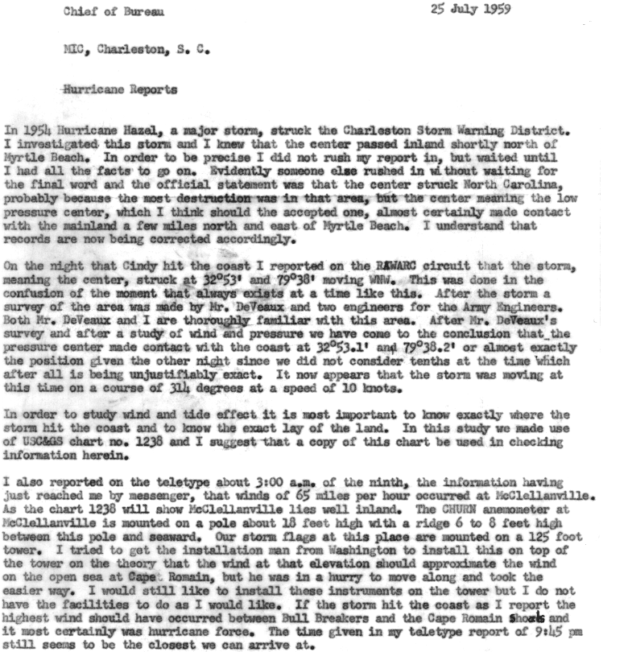

The CHURN reports are available on the EV2 website and observations from Point Judith, RI and Race Point, MA were obtained for Cindy. However, no reports from South Carolina were archived.

5. The Committee is not in favor in downgrading Cindy to a tropical storm at landfall at this time. The Committee recognizes that there is no conclusive evidence that Cindy was actually a hurricane, and if this was a new system being added we would probably call it a tropical storm. However, given all that is unknown about the data from McClellanville, including where it was in relation to the RMW, there is not yet enough evidence to overturn the operational and earlier post-analysis decision to make Cindy a hurricane. This could change after additional analysis of the McClellanville data.

Agreed to retain Cindy a hurricane at landfall in South Carolina.

6. Has there been any quality control done on the ship that reported 35 kt winds at 0600 UTC 10 July? The Committee notes that other ships a similar distance east and southeast of the center reported lighter winds.

The ship - #14142 – also reported at 18Z on the 10th and it again appears to be biased high relative to its neighboring observations. This ship observation has now been removed from the daily highlights.

7. Examination of the Charlotte, NC SWO indicates that the 42 kt wind on 10 July was in a severe thunderstorm and appears to be unrepresentative of the strength of the tropical cyclone. The winds outside of the thunderstorm were less than 15 kt. Please re-examine that proposed intensities for that day leaving that datum out.

40 and 45 kt ship reports that do appear to be more reliable were observed late on the 10th. It is estimated that Cindy regained tropical storm intensity at 12Z (six hours earlier than HURDAT), while still overland but approaching the coast.

8. In regards to the 65-kt report from the ship Ocean Monarch at 0600 UTC 11 July, please better explain the basis for accepting the Mariners Weather Log value of 44 kt instead of the 65 kt available from the other sources. It is impossible for the Committee to tell which value is correct, but there seems to be little doubt that the report was received as hurricane force in real time.

The Mariners Weather Log post-storm analysis indicates that the intensity of the wind from that ship was 45 kt, which appears more reasonable with the reports of ships nearby.

9. Please re-examine the track of the center across southeastern Massachusetts. While Nantucket reported the lowest pressure, the Otis Air Force Base near Mashpee reported winds shifting from southeast to south to southwest as the center passed near the station. This suggests the possibility that the center went a little west of the proposed positions. Please obtain whatever additional data is available from Martha’s Vineyard and Cape Cod to better refine the track.

Observations via the EV2 website were obtained for East Boston, South Weymouth, Otis, Martha’s Vineyard, Nantucket, and Barnstable. These do indicate a landfall position farther west at 12Z at 41.7N 70.7W along Buzzards Bay east of New Bedford.

1959 Storm #5, Debra:

1. Please better justify the earlier genesis. In regards to the ship with west-northwest winds at 1800 UTC 22 July, has any quality control check been made on it?

This ship is only found in HWM, not in COADS. A history of its observations is not available. However, the observation looks consistent with other available ships in the vicinity.

2. Please re-examine the intensity at 1200 UTC 24 July. First, reconnaissance data suggests that Debra was at or near hurricane strength just a few hours later. Second, how close was the report from the ship Mexican Trader to the RMW and the maximum winds? If this ship was some distance from the center (which would fit the 1009 mb reported pressure), the intensity could be higher than proposed. Third, based on the radar presentation, the MWR states the system was at full hurricane strength by 1200 UTC. If necessary, please adjust the 0600 UTC intensity to better match what has been determined for 1200 UTC.

Agreed to indicate hurricane intensity (65 kt) at 12Z and to boost the 06Z intensity from 40 to 50 kt. As best one can tell, the Mexican Trader was about 20-25 nm from the center of Debra, perhaps near or just outside the RMW.

3. Please clarify the actual minimum pressure at the Brazos River Floodgates. The SWO shows 29.36 inches, while the Galveston post storm report and real-time data in the NHC wallet shows 29.21 inches.

The SWO only indicates hourly observations, while the storm report/real-time data obtained the minimum pressure that occurred between the hourly observations.

4. What would the 70 kt and 73 kt fastest mile winds at the Brazos River Floodgates and Freeport convert to in terms of a 1-minute average? In addition, what is the source of the 78 kt wind mentioned in the MWR excerpt? Is this a typo?

70 and 73 kt fastest mile winds convert to 69 and 72 kt 1 min winds, respectively. It is likely that the 78 kt in the MWR except is a typo.

5. Please re-examine the use of the Ho et. al. Inland Decay Pressure model to determine the pressure at 0600 UTC 25 July. While the need to estimate a landfall pressure is appreciated, the Committee is concerned about the lack of observations near the center at the time of landfall. Perhaps an application of Schloemer’s or Holland’s formulas using the peripheral data might help support the Ho model?

Using the 987 mb at the Freeport Coast Guard Station (~12 nm from the center) and assuming an RMW of 20 nm, a central pressure of 981 mb is obtained from the Schloemer equation. Using an RMW of 15 nm, a central pressure of 977 mb is obtained. These support a 980 mb central pressure at landfall.

6. The Committee concurs with the proposed earlier dissipation.

Agreed.

1959 Storm #6, (new):

1. The Committee concurs with adding this system to HURDAT.

Agreed.

2. Please add data for 1 August to the spreadsheet.

Agreed.

3. Since a low pressure area existed prior to the proposed genesis time, could the genesis time perhaps be moved up? It looks awkward for the first point to be at tropical storm strength for a system with a prior existing circulation.

Agreed to indicate genesis six hours earlier at 00Z on the 2nd as a tropical depression.

4. Is any coastal radar data available during the genesis period? If so, it might help refine the track.

Unfortunately, there are not any coastal radar data available for this system.

5. On a similar note, is any coastal rawinsonde data available that might help analyze the structure?

Yes, the individual rawindsonde observations at 12Z for the 500 mb level are available on the Historical Weather Maps and are now included in the binder.

6. The Committee has concerns that the proposed time of extratropical transition is too early, although there is no data to conclusively show the proposed time of 0000 UTC 4 August is wrong. Please add a note to the write-up that better highlights the uncertainty.

Agreed to indicate extratropical transition at 00Z on the 4th and to note the timing uncertainty could be as much as 12 hours.

1959 Storm #7, Edith:

1. What is the basis for saying in the 17 August summary that a tropical wave became “better organized”? Is enough known about the structure to say this with any certainty?

Agreed to remove this statement.
2. Please re-examine the track of this system as it moved through the Lesser Antilles. He current and proposed new tracks both take the center near Guadeloupe. However, data from the Navy reconnaissance mission in the ATSR shows that near 1100 UTC 18 August the lowest pressures (1010-1011 mb) and the best wind shift were farther south, located west of Dominica. Please obtain as detailed data as possible from Martinique, Dominica, and Guadeloupe to better refine the track.

Agreed to shift the track even farther southwest than proposed. This indicates a landfall around 10Z over Dominica. No other additional information are available for these islands, beyond the synoptic times maps within the microfilm archive.

3. Please re-examine the proposed reduction in peak intensity, especially after obtaining the island data mentioned above. While there is reason not to take the 50 kt surface wind estimate from the Navy aircraft at face value, the 35-kt ship reports used to help justify the reduction in intensity are far enough from the center that the likely were not in the maximum winds.

Agreed to retain the 50 kt peak intensity on the 18th.

4. The Committee concurs with the proposed later genesis and earlier dissipation.

Agreed.

1959 Storm #8, (new):

1. The Committee concurs with adding this system to HURDAT. Please examine the HWM upper-level maps for this case to see if it should be referred to as subtropical for the early part of its life cycle.

The 500 mb maps do support the concept of the system being a subtropical storm, as there was an upper-level low over the system on the 28th and 29th.

2. The track of this system is a bit choppy, particularly near the turn on 29 August and the decrease in forward motion on 1 September. Can it be smoothed out?

Agreed, the track has been smoothed around these two points.

3. The microfilm maps for 1800 UTC 27 August and 0000 UTC 28 August appears to have data from an Air Force reconnaissance mission on it. Unfortunately, the plot is does not have enough data to determine the flight level of the aircraft or any surface pressure. However, there are multiple observations of “wind variable 10 kt” spread out over a 120-180 n mi wide area near the center. If these are actually low-level winds, it calls into doubt that a “well defined” center existed by 0000 UTC 28 August. Please located more detailed data from this flight and, if necessary, modify the genesis time.

No additional information was available for these flights. Agreed to delay genesis until 06Z on the 28th.

4. At 0600 UTC 31 August, there is a ship report of 40 kt and 996 mb. The proposed best track intensity is 50 kt based on the wind pressure relationship and the observed slow motion. However, this combination of wind and pressure a central pressure in the lower 990’s, which could support an intensity greater than 50 kt. Please re-examine this.

Agreed to indicate 55 kt at 06Z on the 31st for the intensity.

5. On the microfilm map for 1200 UTC 1 September, there is a hand-plotted ship report with a 1002 mb pressure. This report is present in the spreadsheet, but is not included in the daily summary. Is this pressure correct, as it seems low compared to the other data? If it is, please note this ob in the daily summary, as it is a significant low pressure reading.

This observation was from COADS but without ship ID. It does appear to be unrealistically low, given its location relative to other observations and thus is not mentioned in the daily summary.

6. The Committee accepts the proposed time of extratropical transition. However, there should be a note in the write-up that the time of extratropical transition of this system is highly uncertain and could have occurred earlier. The circulation became somewhat elongated on 1 September, and the track changes that day could be consistent with the merging of the cyclone with an upper-level low. Subsequently, the surface observations on 2 September do not suggest surface fronts. It may be that the system had an aborted transition on 1 September and then recovered some if its tropical characteristics.

Agreed, this discussion is now included within the reanalysis.

7. In the 4 September summary, there is a typo: “extropical”.

Corrected.

1959 Storm #9, (new):

1. The Committee concurs with adding this system to HURDAT.

Agreed.

1a. Please provide a better explanation of why this system might be considered subtropical. Would the 500 mb pattern shown in the HWM support this? Would the lack of an inner wind core through the life of the cyclone support this?

Unfortunately, the 500 mb pattern in HWM has no observations over or near the system, so it is difficult to determine if it had an upper level low/trough associated with it. However, the lack of an inner wind core (i.e., large 100-200 nm RMW) would support that the system may have been a subtropical cyclone.

2. Please re-examine the time of genesis. While a surface low was present on 7-8 September, the reported pressures were high and the reported winds were relatively low. This suggests that part of the life cycle would better be described as a low pressure area instead of a subtropical or tropical cyclone.

Agreed to indicate tropical cyclogenesis at 00Z on the 9th with the 7th and 8th described as a broad low.

2a. On a related note, please try to smooth the best track positions on 7-9 September. The center appears to be too broad to be tracked this precisely.

Agreed to smooth out the best track positions.

3. Please mention the ship report of 1008 mb at 0600 UTC 9 September in the daily write-up. It suggests that the central pressure had fallen to near 1007 mb by this time.

Agreed.

4. On the 1800 UTC 10 September microfilm map, there is a ship report with 1008 mb and 20 kt. If this is correct, it implies a central pressure near 1006 mb. However, it looks low compared to other nearby data. Has any quality control check been made on this pressure?

This implied central pressure matches that from another ship to the northeast which reported 1009 mb and 30 kt (35 kt in COADS) at the same time. 1006 mb is added into HURDAT.

5. Please re-examine the proposed peak intensity on 11 September. While the central pressure fell to 1002 mb at 1200 UTC and below 1000 mb by 1800 UTC, this was likely due to the system undergoing extratropical transitions. Therefore, the wind-pressure relationship may not be fully applicable.

Agreed. A central pressure of 1002 mb suggests maximum sustained winds of 45 kt from the north of 35N the Landsea et al. pressure-wind relationship. Due to the large circulation of the tropical storm and that the system was undergoing extratropical transition, an intensity of 40 kt is selected at 12Z on the 11th. 40 kt is also the peak intensity of the system while it was a tropical cyclone.

6. In the 12 September write-up, “gale-force” should probably be “storm-force”.

Agreed.

1959 Storm #10, Flora:

1. On the microfilm map for 1200 UTC 8 September, there is a ship report of west-northwest winds and 1007.6 mb near 11N 44W. Is this report correct? If so, please mention it in the write-up and add it to the spreadsheet. It suggests the possibility a tropical cyclone existed on that day. Please also mention the ship report with west-southwest winds near 12N 41W at 1800 UTC that day.

Agreed.

2. In the last sentence on the 9 September write-up, you might want to remove “significantly”.

Agreed.

3. Please include the report of 35 kt and 1008.4 mb at 1200 UTC 10 September in the ship highlights section.

Agreed.

4. Should the aircraft central pressure of 1008 mb at 1600 UTC 10 September be used as the 1800 UTC central pressure in HURDAT?

Agreed to add this as a central pressure in HURDAT.

5. Please remove the final sentence of the Reanalysis section on 10 September. While the system seems to be elongated, the data does not have the coverage necessary to speculate about the system not having a closed circulation.

Agreed.

6. Please remove the central pressure of 994 mb at 1200 UTC 11 September. Flora filled from 994 mb at 1445 UTC that day to 1001 mb at 1700 UTC, which suggests the 1445 UTC pressure should not be used for 1200 UTC.

Agreed. An asynoptic best track point is added at 15Z with the 994 mb central pressure.

7. The Committee does not completely concur with the removal of 13-14 September from HURDAT. It is noted that while the plotted map for 0000 UTC 13 September does not conclusively show a closed circulation, there is an observation of 997 mb and 35 kt east of the Azores. This pressure is several mb lower than the other nearby reports, and it suggests that at the very least a tight pressure center still existed. Based on this, it is recommended that the track be extended at least through 0000 UTC 13 September.

Agreed to retain a final best track point at 00Z on the 13th.

7a. The center of Flora likely passed near or over Sao Miguel Island in the Azores, with the microfilm maps showing there was an active station on the island (at Ponta Delgada?). Please find the data from this station in between the synoptic hours of 1800 UTC 12 September and 0000 UTC 13 September. This could help resolve the issue of when Flora dissipated.

Unfortunately, the weather service of Portugal does not have any additional information for Flora from the Azores.

7b. Please add all of the appropriate data from the Azores to the spreadsheet.

Agreed.

1959 Storm #11, Gracie:

1. There are a couple of occasions in the write-up where dates in September are incorrectly noted as being in October.

Corrected.

2. In the 20 September write-up, there is a post-flight summary for a Navy investigative mission. This looks like it was actually on 19 September, so please move it there.

Corrected.

3. Are any detailed observations available from the Bahamas as Gracie passed through?

The weather service of the Bahamas was contacted, but no additional observations were available for Gracie.

4. Has a quality control check been made for the ship which reported hurricane-force winds on 23 September (call sign KJFA)? If it turns out the reports are good, then the intensity should be kept at hurricane strength during the part of 22-23 September that includes these obs and the aircraft report of hurricane force winds.

Agreed to retain Gracie as a hurricane on the 22nd and 23rd.

4a. The Committee concurs with the proposed downgrades in intensity for the remainder of 23-26 September.

Agreed.

5. Regarding the Navy reconnaissance flight early on 23 September, the ATSR suggests that in addition to the 1000 mb dropsonde at 0100 UTC there was a 1002 mb dropsonde near the center at 0500-0600 UTC. Please add this as a central pressure if looks reliable.

Agreed.

6. Regard the aircraft fix at 0650 UTC 25 September, the ATSR says there was a dropsonde with a surface pressure of 1000 mb at 0700 UTC 25 September. Please add this as a central pressure if it looks appropriate.

Agreed.

7. Regarding the Navy aircraft fix near 0400 UTC 25 September: The ATSR says the plane was orbiting in the center with a minimum 700 mb height of 10303 ft/3141 m and a temperature of 15C. This would extrapolated to a surface pressure of 1002-1003 mb.

Agreed to add this to the excel database.

8. Is it possible that the source of the 997 mb pressure at 1800 UTC 25 September is the Air Force penetration fix at 1835 UTC that day? Please try to locate this data to confirm the pressure, as it appears low compared to the pressures taken before and after.

No additional information was available with regards to this observation. The value was only 3 mb higher than the earlier 0650Z fix and 3 mb higher than the latter 2230Z fix.

9. Regarding the Navy aircraft fix at 0030 UTC 28 September, the ATSR indicates that the observed 850 mb height was 4070 ft/1241 m. This yields an extrapolated pressure of 981 mb.

Agreed to add this in as a central pressure into HURDAT at 00Z.

10. Regarding the Navy aircraft fix at 0700 UTC 29 September: The reported pressure via dropsonde was 958 mb. However, the plane reported an 850 mb height in the eye of 3185 ft/971 m, which yields an extrapolated pressure of 950 mb. In addition, the plane reported a 700-mb height of 8780 ft/2767m and a temperature of 16C, which yields an extrapolated pressure of 951 mb. The 850-mb and 700-mb heights reported on the dropsonde are about 200 ft higher, suggesting the dropsonde either was not dropped in the center of the eye or has a calibration error. It might be better to use an extrapolated pressure for this fix.

Agreed.

11. Please state more clearly that the 950 mb minimum pressure reported at Beaufort, SC in the MWR and ATSR is wrong. There was some confusion about the Beaufort pressure when the Committee examined the write-up and saw 950 mb in the MWR and ATSR excerpts.

That Beaufort’s 950 mb report is erroneous is now more clearly stated.

12. Please re-examine the assessment of Category 1 impact in Georgia. It should be noted that the maximum sustained winds in Savannah Georgia, are well below hurricane force.

Agreed to assess the impact in Georgia as a high end (55-60 kt) tropical storm.

13. In the 30 September write-up, is the second land station highlight for Columbia, South Carolina necessary?

Agreed to remove this highlight.

14. Please better state the rationale for keeping Gracie a hurricane as 0000 UTC 30 September. While the Kaplan-DeMaria model may suggest it was, the highest observed wind within two hours of the synoptic time is 50 kt. It might be that the original HURDAT intensity is better.

Agreed to retain 60 kt at 00Z on the 30th.

14a. On a related note, the intensity at 0600 UTC 30 September is set at 45 kt, with a mention of a 47 kt observation within 2 hours of this time. There is no such observation listed in either the write-up or the spreadsheet. What observation is this? If it is correct and timely, should the 0600 UTC intensity be set to 50 kt?

This is a typo and should be 35 kt instead. Thus the 45 kt intensity at 06Z remains appropriate.

1959 Storm #12, Hannah:

1. Is there data that suggests genesis could have occurred before 1200 UTC 27 September, or is the comment about this in the Reanalysis section just speculation? Please clarify this.

Agreed to clarify that this is speculation, based upon the sparse observations available.

2. In the 1 October write-up, there are references to a National Hurricane Research Project (NHRP) fix at 1740 UTC and another fix at 1750 UTC from the ATSR. The D-values on the NHRP suggest a central pressure of 963 mb, which is the same as that quoted for the ATSR fix. Is it possible these two fixes are the same?

It is possible that these two fixes were the same, which is now mentioned as a possibility in the writeup.

3. The proposed intensities at 0600, 1200, and 1800 UTC 1 October are 100, 95, and 100 kt respectively. Is the data precise enough to justify this brief 5 kt change? Please consider keeping the intensity at 100 kt unless the data strongly shows otherwise.

Agreed to keep the intensity at 100 kt.

4. Regarding the 2 October recon data, at the time of the 1830Z fix the ATSR indicates that the plane was reporting that central pressure was steady near 961 mb (ob NAVY FOURTEEN). In addition, at the time of the 2100 UTC fix, the aircraft reported a 500 mb height of 18130 ft, which yields a surface pressure estimate of 960-961 mb using the Jordan nomograph in NHRP report #10.

Agreed to add in the 961 mb to the 1830Z center fix. However, extrapolation of surface pressure from 500 mb is too uncertain to include as a central pressure.

5. NHRP data for 4 October suggests there were several fixes between 1230 UTC and 1830 UTC. Is it possible that the ATSR is referring to this mission? If so, please try to obtain central pressures from the D-values of the NHRP data. Also, it is possible that the post-flight summary in the image below is from the mission listed in the NHRP report? Regardless, it appears there is a fix near 1620 UTC that is not included in the write-up.

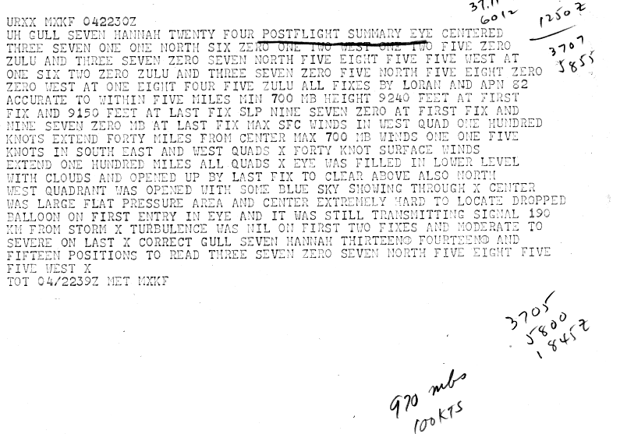

It is possible that the ATSR is referring to the NHRP mission, but this remains uncertain. The 1620Z fix had already been included in the excel database. (Not all center fixes are in the daily summary, only the ones closest to the synoptic times with the most relevant information.) We were unable to obtain a central pressure from the d-values, as these were not provided in the eye.

6. The Committee is currently split on the proposed earlier time of extratropical transition at 0600 UTC 7 October. Please obtain more detailed data from the Azores for the passage of Hannah, which might help determine if extratropical transition occurred before, during, or after the time the cyclone moved over the islands.

No additional observations are available from the Weather Service of Portugal for the Azores during Hannah. Extratropical transition indicated to be at 06Z on the 7th.

1959 Storm #13, Irene:

1. Please raise the intensity at 1200 UTC 7 July to 35 kt. The Committee feels there is sufficient evidence to call the system a tropical storm at that time.

Agreed.

2. In the Storm Wallet, there is an account of Irene that stated the pressure in Mobile, Alabama fell to 999.5 mb at 2:58 LST 8 October (see the image below). This does not match what is in the SWO, which shows a pressure of 1003.7 mb. It is possible that the wallet account is a station pressure instead of a sea level pressure, and this pressure should not be used for the re-analysis. However, the discrepancy should be noted in the write-up.

It is likely that this discrepancy is due to station pressure versus sea level pressure. This is now noted in the writeup.
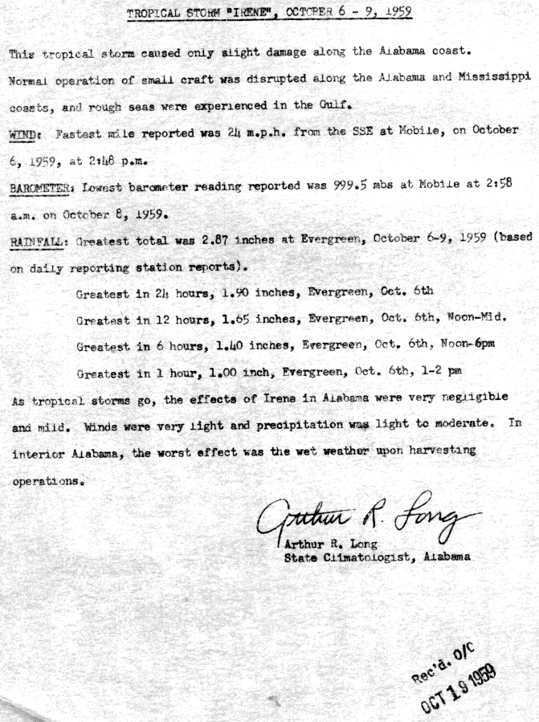

1959 Storm #14, Judith:

1. Please re-examine the entire pre-genesis period. The available data suggests that a tropical storm was present over the western Caribbean Sea on 14-15 October, with a standout observation of 50 kt and 1004-1005 mb from a Navy(?) aircraft – implying a cyclone with a pressure near 1000 mb. However, this system cannot be conclusively connected with Judith, as it seems to dissipate in a data void region. (There is a possible vorticity maximum in the surface data at 0000 UTC 16 October just south of western Cuba, but the connection with the system from 14 October is unclear.)

Also, there is the issue that during the flight where Judith was discovered on 17 October, the aircraft reported a possible new center forming north of western Cuba. This suggests the possibility that genesis did not occur until near 1800 UTC 17 October when the new centered formed.

Please investigate all of the possibilities, including 1) That another tropical storm existed during part of this time, 2) The center of the low over the Yucatan Channel on 17 October is not the center that became Judith, and 3) a vorticity center tracked from the Caribbean into the Gulf of Mexico in advance of the monsoonish low on 15-16 October.

1a. To this end, please obtain as much data as possible from Jamaica, the Cayman Islands, Swan Island, and western Cuba. While the microfilm maps have some of this data available already, they may not have the temporal resolution to detect potentially important features. In addition, some of the microfilm maps are centered too far south to show western Cuba.

1b. In support of scenario 2 above, it is noted that the 0000 UTC 18 October microfilm map shows Judith to the northeast of a larger low pressure area centered near 24N 86W.

After re-examining all of the available observations, the reanalysis now indicates Judtih forming as tropical storm on the 14th and 15th of October, weakening to a trough on the 16th, then reforming near the west coast of Cuba around 12Z on the 17th. We have reobtained the microfilm maps for 00 and 06Z on the 16th to cover western Cuba. However, Jamaica, the Cayman Islands, Swan Island, and western Cuba have no additional observations available.

2. The only data that suggests Judith was a hurricane over the Gulf of Mexico is the 65 kt ship report at 2300 UTC 17 October. Can any kind of quality control check be done on this data?

Unfortunately, it cannot be determined which ship reported the 65 kt observation. The only observation nearby (~30 nm) was Fort Jefferson with 40 kt SSW and 1007 mb. (There was a closer ship from COADS, but it appears that its longitude was provided five degrees too far west and thus was not actually in the vicinity of the hurricane-force ship.) This single 65 kt ship was the reason for Judith being considered a hurricane both operationally and in HURDAT. No other observation at sea or at landfall 15 hours later reported anything more than 55 kt winds (Carysfort Reef Light at 12Z – elevated anemometer) with a lowest pressure of 998 mb (12Z aircraft fix). Because of the uncertainty of the quality of this single observation and lack of corroboration with any other measurements, the peak intensity in the Gulf of Mexico and at landfall in Florida is analyzed to be 55 kt.

3. Data in the Judith Storm Wallet indicates the center passed over Okeechobee, Florida near 1230 EST 18 October with a central pressure of 1001 mb and a broad center. Please add this as a center fix.

Agreed.

4. Does the data support the presence of a new center forming near or off the east coast of Florida around 1200 UTC 18 October?

The data does not support the presence of a new center, but it does show an elongation of the vortex southwest-northeastward. This is now addressed in the writeup.

5. Regarding the aircraft fix at 0300 UTC 19 October, the ATSR indicates that the plane reported a minimum 850 mb height of 4700 ft/1433 m. This yields an extrapolated central pressure of 1003 mb.

This is now added to the daily summary and excel database.

6. Regard the 993 mb dropsonde at 0630 UTC 19 October: While it is not obviously wrong, the extrapolated pressures using the 850-mb and 700-mb data are near 995 mb.

A 2 mb difference is in the noise level of the dropsonde instrument and the extrapolation methodologies.

7. Did Judith become extratropical on 21-22 October before the circulation completely dissipated?

It does not appear that the system became associated with a significant baroclinic zone on the 21st and 22nd despite the frontal analyses shown in HWM and the microfilm maps, as the temperatures remained relatively isothermal across the Judith on these dates. Thus it would appear that showing dissipation with no extratropical stage is most appropriate.

8. Two typos or possible typos: In the MWR excerpt on 18 October, “wild” should be “wind”. Also, in the ATSR excerpt on 22 October, is the date of “28th of October” correct?

Both are now corrected.

1959 Additional Notes:

1. Please look for additional data for the August suspect #2 in the Gulf of Mexico, especially oil rig data and SWO data from the Texas coast. While the apparent lack of impact of this system suggests it was not a tropical storm, the central pressure of 1004 mb and the high pressures to the east suggest at least the possibility of 35 kt winds. Also, please construct six-hourly positions for this system.

Oil rig data were not available for this system. A search of the Texas observations indicate that the peak winds measured along with coast were only about 20 kt, though certainly stronger winds occurred between stations. More discussion about the possibility of tropical storm force winds has been added to the writeup. Constructing six hourly positions for a system not being added into HURDAT is beyond the scope of this project.

2. Are microfilm maps available for the October 21-24 suspect near the southeastern U. S. coast?

These have been obtained and added into the binder. However, they do not provide additional support for adding the system into HURDAT.

3. The Committee concurs with leaving the other systems out of HURDAT.

Agreed.

