Best Track Committee Re-Analysis Comments for 1958

(Responses given by Chris Landsea and Sandy Delgado in boldface – November 2015)

General comments:

1. The National Hurricane Research Project (NHRP) reports contain aircraft data on several 1958 cyclones, including Becky, Daisy, Ella, and Helene. They also have some information on other cyclones from the mid-1950’s to the early 1960’s. These data include detailed flight-level winds and central pressures, with best track type pressure curves with fixes available for several cyclones. Please make sure that the data submitted here has been checked against that in the NHRP reports.

Thank you for providing these reports. We have gone through and added in these in and included them in the reanalyses.

2. The Committee is not satisfied with the lack of use of the NHRP flight-level winds in the submission. It appreciates that these winds can be problematic as indicated by Shea and Gray (1976), and that they are likely of lower quality than those available in the P-3 era. That makes any quantitative use of them difficult. However, the solution of not using them at all seems to be going too far to the other extreme. Is there a way to utilize these winds in some qualitative fashion?

Given the uncertainties that make any quantitative use of the flight-level winds difficult, it would seem that instead to focus upon sophisticated use of pressure-wind relationships to convert the central pressure to a maximum surface wind would be preferable to making a qualitative use of these low quality and often low-biased flight-level winds.

3. There are contradictions between the NHRP central pressures reported in Shea and Gray and those reported in the various NHRP reports. Several of them are highlighted in the individual storms below. Perhaps the most glaring discrepancy is for the flight into Hurricane Daisy near 1800 UTC 28 August. Shea and Gray report a central pressure of 950 mb, while NHRP Report #48 by Colon and others reports a central pressure of 966 mb. The available D-value data supports the higher pressure. Could you please contact Bill Gray to see if he remembers how the central pressures for the Shea and Gray publication were compiled?

We contacted Dr. Gray, but he does not remember the details for how the central pressures were collected.

4. There are many central pressures in the 1958 HURDAT with unknown origins. In the 15 August write-up for Cleo, there is a comment about “analyses that were added in”. Please remove any such comments from the submission until the origins of these pressures can be determined, as we should not assume that they were just “added in”.

Agreed to remove such comments.

5. Since there are minimum pressures that do not coincide with synoptic times, is it time to start adding these in as separate best track points in agreement with current practice?

Agree to include an asynoptic best track point when the lowest central pressure does not closely coincide with a synoptic time.

1958 Storm #1 (new):

1. The Committee concurs with the addition of this system. Please make sure that the reference section explicitly mentions the May 1958 Monthly Weather Review (MWR) paper by Clark and French that led to the inclusion of this system. Also, the Clark and French paper called the system a subtropical depression, so the write-up needs to emphasize that the system was more likely subtropical than tropical.

Agreed for both.

2. Please re-examine the time of genesis. It is noted that the 0000 UTC 25 May microfilm map shows two low pressure centers, one near Florida Keys and one near western Cuba. Is the northern center the actual cyclone (which seems likely), and if so, how far back can in be traced? The Committee has concerns that 0000 UTC 24 May is too early, and that genesis may have happened between 1200 UTC 24 May and 0000 UTC 25 May.

Agreed that the system was more of a broad area of low pressure and that a well-defined low developed around 00Z on the 25th, which is now the time of genesis.

2a. That being said, given how long the system was present as a low pressure area prior to genesis, this portion of the track could be included as a low, possibly back to as early as 22 May.

No, since the system did not exhibit a well-defined low until 00Z on the 25th.

3. Can the best track pressures on 25 May (and elsewhere) be smoothed out? Note that detailed data from southeastern Florida is available in the binder if that will help refine the central pressures near there.

Agreed.

4. Was any kind of quality control check done for the ship with 45 kt winds on 26 May?

As was already mentioned, this ship likely has a high bias compared with other ship observations. It is now clarified that this is based upon nearby ships at that time, as well as other observations from the same ship.

5. Does the proposed time of extratropical transition match that of Clark and French?

The proposed time of extratropical transition is 18 hours after that suggested by Clark and French. This is now added into the writeup.

6. Please re-examine the history of the system after extratropical transition. Data from the North American maps (proposed track points available from David Roth) suggest the cyclone lasted through 30 May.

On May 29th, the extratropical cyclone moved over the Atlantic provinces of Canada where it merged with another extratropical cyclone. As the merger took place around 12Z, the last position for the system is analyzed to be 06Z on the 29th.

1958 Storm #2, Alma:

1. Is there any evidence that Alma continued to strengthen after the ship report on 14 June? If not, perhaps the peak intensity should be set to 55 kt.

Agreed to set the peak intensity at 55 kt.

2. Are any details available about the data from the Coast Guard aircraft that flew into Alma? Can it be determined if the reported winds were estimated or measured?

No additional details are available about this Coast Guard Aircraft data. It is likely that the reported winds were visually estimated surface winds.

3. The Committee does not concur with the proposed change of track after landfall. The Laredo, Texas Surface Weather Observations (SWO) write-up is available in the binder. The data from them strongly suggest the center passed near the station at 1658 LST 15 June with a wind shift from southeast to south-southwest and a minimum pressure of 1003.7 mb. Unless detailed data from Monterey, Mexico can be found to show that what passed Laredo was not the center, please use the original HURDAT track.

Agreed to adjust the track back to that of the original as Alma bypassed Laredo. Additionally, detailed observations were obtained for Del Rio, which – along with the other synoptic observations - indicated that the system had opened up to a trough by 12Z on the 16th. A search of the EV2 site containing original Mexican observations does not contain Monterey.

1958 Storm #3, Becky:

1. Has the Meteorological Service of the Cape Verde Islands been contacted for additional information on this cyclone? It is interesting that there were multiple ship reports of tropical-storm-force winds near the islands and no such apparent reports from the islands.

The Meteorological Service of the Cape Verde Islands have been contacted, but they have no additional information regarding this cyclone.

2. Please re-examine the proposed earlier genesis time. While it is possible that the system formed that early, there does not seem to be enough data on the 0000 UTC 8 August map to justify the proposed change.

Agreed to retained original genesis time of 12Z on the 8th.

2a. Are detailed observations available from Dakar, Senegal? This might help determine when genesis occurred.

No additional observations are available from Dakar, Senegal.

3. In reference to the ship report of 1004 mb and 45 kt on 9 August, why wasn’t the pressure used to make an intensity estimate?

This has now been added in and provides more evidence for the much earlier intensification to a tropical storm.

4. The intensity graph sent for Becky is labelled “Alma” and shows the wrong intensities. It looks like the Alma graph was included by mistake. Please correct this.

This has now been included.

5. The write-up for 11 August mentions a series of reports from the ship “Industrious”. One of these is on the 2100 UTC 11 August microfilm map, which looks like 35 kt and 1008 mb. If this is correct, please add it to the 11 August ship highlights. This report also appears in plain text on of the 0000 UTC 12 August microfilm maps.

This has now been added in to the raw database and the daily summary.

6. In regards to the aircraft pressure on 12 August, can it be determined if the report on Becky in the Storm Wallet was written before or after the MWR/Annual Tropical Storm Report (ATSR)? That might help determine which of the central pressure values to use.

The report in the Storm Wallet was written well before both the MWR/Annual Tropical Storm Report. Thus the 1006 mb from the MWR/Annual Tropical Storm Report is accepted as the central pressure.

7. Please provide a better explanation for the choice of 1009 mb for the pressure found by the reconnaissance mission on 13 August. The actual flight data in the ATSR says 1013 mb, with little evidence of a lower pressure.

It is unclear whether the 1013 mb pressure was a central pressure value, as it does not appear that they obtained a center fix. Given the uncertainties, no central pressure is included at 18Z on the 13th.

8. Is the kink in the track introduced on 13 August justifiable by the data? Please smooth this out if possible.

Agreed.

9. Is there supposed to be a discussion for the 14 August write-up?

No, as there were no significant observations and no significant changes made.

10. The 0600 UTC 17 August microfilm map shows what appears to be a ship report of 80 kt just northeast of the proposed center. Is this correct? If so, please make the appropriate adjustments to the best track. If not, please acknowledge it in the write-up and explain why it is wrong.

Instead of a flag and three barbs, it appears to be four barbs on the 06Z August 17th map. (The analysts on the microfilm typically used filled in flags to make it clear when there was a 50 kt report.) This has already been incorporated in the analysis, as a 09Z observation.

Note: After further consideration, Becky likely stayed in the warm sector of the larger extratropical cyclone to its north until it became absorbed. Thus the extratropiocal stage has been removed. Additionally, ship observations suggest that Becky was close to hurricane force before it became absorbed. Thus the intensity is boosted upward some more from late on the 16th and on the 17th.

1958 Storm #4, Cleo:

1. How well do the proposed best track pressure match those presented in the MWR season summary?

The central pressures in Figure 2 of the MWR seasonal summary match the proposed best track pressures reasonably well with the exception of one point - the figure contained a 956 mb central pressure at 08Z on the 16th not found elsewhere. This has been added into the reanalysis, but did not necessitate a change in intensity.

2. Please re-examine the pressure for the aircraft fix at 1400 UTC 15 August. The fix form reports 959 mb. However, the reported 700 mb height and temperature would produce an extrapolated pressure of 951 mb using today’s formulas. Also, the 700 mb height is 70 m lower than that reported on the previous fix, which was 960 mb. Perhaps the dropsonde fell into the eyewall?

Agreed to use 951 mb central pressure based upon extrapolation with the likelihood that the dropsonde fell into the eyewall instead of the eye.

3. Can a clear copy of the fix on the 0000 UTC 16 August microfilm map be found? Unfortunately, the important pressure information is covered up in the current version.

While a clear copy of the fix from this microfilm map is not available, we had already obtained the central pressure for this fix from the MWR figure.

4. Why isn’t the report from the ship “Tahitien” (954 mb/10 kt at 2330 UTC 15 August) used for the central pressure at 0000 UTC 16 August? Also, a more detailed account of this encounter is given in the Mariners Weather Log (MWL). Please acknowledge this in the write-up.

Agreed to use the Tahitien report for a central pressure analysis. This has allowed a slight change to the intensity at 00Z 16th from that used in the first draft.

5. According to the ASTR, the Navy flew an aircraft mission early on 16 August that was problematic due to bad navigation and an inability to receive data from the eye dropsonde. However, while the plane was in the eye at 1000 UTC it reported a 700 mb height of 8860 ft/2700 m and a 700 mb temperature of +16C. This produces an extrapolated pressure of 954 mb using today’s formulas. Please use this in the intensity analysis if it looks accurate.

Agreed to add this into the daily summary.

6. Since the aircraft-reported central pressures from 1400-2000 UTC 16 August showed a 5 mb (about 1 mb/h) rise in central pressure, is using the 959 mb pressure measured 2052 UTC appropriate for the 1800 UTC best track time?

Agreed to not include this value at the 18Z best track time.

7. Please comment further on the aircraft fixes at 1055 and 1112 UTC 19 August. Cleo was accelerating northeastward at the time, but the fixes suggest 24 n mi of motion in 17 minutes, which looks a bit extreme. What might have been happening here meteorologically?

It is likely that this was not due to meteorology but uncertainties in the position because of poor navigation.

1958 Storm #5, Daisy:

1. Please ensure that the appropriate aircraft data from NHRP Report #48 is included in the write-up for Daisy. There are several fixes included in the report that are not referenced, especially on 26 August. The 27 August metadata also includes several fix pressures that do not match the report.

All of the central pressures contained in the Colon NHRP report (primarily figure 5) are now included in the writeup. The discrepancies for the 27th and 28th are discussed and dealt with as best can be determined. See details below.

2. Please examine the data to see if the genesis time can be moved up to 1800 UTC 23 August.

Agreed to indicate genesis at 18Z on the 23rd, 18 hours earlier than originally shown in HURDAT.

3. A microfilm map for 1800 UTC 25 August has a post-flight summary from RESEARCH ONE, which appears to be an NHRP flight. The form says the pressure was 990 mb at 2030 UTC, which is the value sued in the write-up. However, NHRP Report #48 states that the central pressure at this time was near 997 mb, and presents graphs of D-value that support this pressure. Please resolve this discrepancy.

Given that the NHRP report was subsequent to the real-time information and that the 997 mb pressure better fits the D-value information, 997 mb central pressure is used at the 18Z slot on the 25th.

4. Please see if the track positions on 26 August need modification. The proposed track seems to be a significant distance away from the aircraft fix positions on the hand-plotted chart.

Agreed to move the positions closer to the aircraft fix positions late on the 25th and early on the 26th.

5. Please re-examine the minimum pressures recorded on 27 August. The original value was 935 mb, which was corrected later in the MWR to 948 mb. This values also agrees with the NHRP report on Daisy. However, as mentioned in point 1, the 27 August metadata has pressures lower than 948 mb that do not match the report. Are these from Gray and Shea, and is it possible that the Gray and Shea pressures are wrong? Please clarify this and make any necessary changes to the intensity.

These discrepancies are described in the daily summary. Given the consistency between the Colon NHRP report and the 1966 Tracy MWR report, it appears that the 944 mb and 940 mb values in Gray and Shea are incorrect. A lowest central pressure for Daisy of 948 mb is now used.

6. There is again contradictory aircraft pressure data for 28 August. The metadata, supported by the real-time advisories and data in Shea and Gray, show pressures of 947-950 mb. The NHRP report, supported by an analysis of dropsonde data in the ATSR, shows pressures above 960 mb. One example of the issue is that the dropsonde splash pressure for the 1933 UTC fix in the ATSR is reported as 949 mb. However, there is a pencil annotation suggesting the pressure was 968 mb, and the higher value better fits the surface pressure derived from the 700/850 mb heights and temperatures in the coded data. Please determine the correct pressure values and adjust the intensity accordingly.

These discrepancies are described in the daily summary. The first aircraft to reach the hurricane on the 28th reported measuring a central pressure of 947 mb at 14Z, and estimating surface winds of 100 kt and an eye diameter of 15 nm. Another reconnaissance aircraft measured a central pressure of 949 mb at 1933Z. However, Colon does not show a central pressure around 14Z and instead has 965 mb at 18Z and 968 mb at 1933Z. Comparison of the surface pressure derived from the 1933Z dropsondes 700/850 mb heights and temperatures, suggests that the higher values are correct. Thus no central pressure is shown at 12Z and 965 mb is indicated at 18z.

7. The committee does not concur with the proposed earlier time of extratropical transition. While Daisy was undergoing transition, the data near the core at 1200 UTC 29 August looks too scarce to justify this change. Please consider either the original HURDAT time or maybe 1800 UTC 29 August. Also, please provide hand-plotted maps with the surface temperatures. The plotted temperatures on the microfilm maps are unreadable.

Agree to indicate extratropical transition at 18Z on the 29th. The annotated 18Z map has temperatures that are legible.

1958 Storm #6, Ella:

1. Have the Meteorological Services of the Dominican Republic, Haiti, and Cuba been contacted for additional information on this system? Since the MWR write-up of this system apparently had reports from Haiti to determine if landfall occurred or not, it would be useful to obtain them.

The Meteorological Services of the Dominican Republic, Haiti, and Cuba been contacted for additional information on this system. However, they do not have any relevant observations available for this hurricane.

2. Is the data sufficient to determine of the system had a closed circulation when it moved through the Lesser Antilles on 30 August?

The observations are somewhat sparse when Ella crossed the Lesser Antilles on the 30th and it is uncertain if the system had a closed circulation. Given that Ella already exists within HURDAT on the 30th and that it is ambiguous whether it had a closed circulation, the system is retained on the 30th.

3. Please better justify the proposed change in intensity from 65 to 60 kt at 1200 UTC 31 August. The committee notes there was a ship report of 65 kt in the spreadsheet at that time, but this is not utilized in either the intensity analysis or the write-up. Please either justify not using this ship in the intensity analysis or use the original HURDAT intensity.

Agreed to retain the original HURDAT intensity of 65 kt at 12Z. The 65 kt ship report at that time is now explicitly mentioned in the daily writeup.

4. Please note in the ship highlights that the ship reported 40 kt and 1006 mb at 2100 UTC reported force 11 winds an hour earlier based on data on the 2100 UTC 31 August microfilm map.

Agreed to add this in to the ship highlights.
5. Is the behavior and structure of Ella on 1-2 September consistent with a system that actually made landfall on the southwestern Peninsula of Haiti? Please better explain the basis for going against the MWR comment that the system did not make landfall.

The track of Ella is based upon the available (and numerous) radar and center fixes from aircraft reconnaissance, which takes it across the southwest peninsula of Haiti. It is noted that the solution, despite what was written in MWR, is the same as what is currently in HURDAT. Indeed, even the track map for the 1958 seasonal summary in MWR shows Ella going across the Haitian peninsula. As would be expected, Ella weakened significantly after passing over this mountainous peninsula.

6. The Committee notes that the 995 mb pressure reported by dropsonde in the ASTR on 1 September is consistent with the reported 850 mb height on the sonde. Is there any known reason why 995 mb was discarded in favor of 989 mb?

Agreed to use the 995 mb pressure. The intensity is lowered slightly accordingly.

7. The Committee concurs with the proposed decrease in intensity for the first Cuba landfall, pending the resolution of point 6 and any additional Cuban data that might be available. However, it would like a more detailed explanation of the various possible landfall intensities to be added to the write-up.

Landfall occurred at 00Z on the 2nd near 20.0N, 76.2W or about 20 nm west of Santiago de Cuba with winds of 70 kt, based upon persistence from the center fix late on the 1st. HURDAT originally had 100 kt at 00Z on the 2nd, a major intensity change. Perez et al. indicates that Ella is recognized in Cuba as a category 1 hurricane impact, same as this reanalysis. Thus, Ella is analyzed to have never reached major hurricane status and the peak intensity is 95 kt, down from 100 kt originally in HURDAT. It is possible that Ella may have reached major hurricane status before impacting Haiti, but it is unlikely that it was a major hurricane when it struck Cuba as the very high terrain of the Tiburon peninsula should have disrupted the small circulation of the cyclone.

8. Please better state the basis for the 60 kt intensity estimate at the second Cuban landfall on 3 September.

Around that time, a couple of ships reported 50 kt, so an intensity of 60 kt already in HURDAT at 18Z is retained.

9. Given the poor organization of the storm on 4 September, is it certain that the 1003 mb aircraft ob at 1440 UTC is actually a central pressure?

The radar and penetration fixes from the reconnaissance aircraft on the 4th do not agree with the surface observations from ships and coastal stations on the position of the center of Ella, likely due to the somewhat disorganized center of the cyclone. Because of this, the central pressure may have been lower than the 1003 mb measured. Thus this value is not added into HURDAT.

10. A ship reported used to calculate a central pressure is included in the re-analysis summary, but it is not included in the daily highlights. Also, there is what appears to be a 50 kt (55 kt on the spreadsheet) ob for 0900 UTC that is also not included in the daily highlights.

These two ships are now included in the daily highlights.

11. The Committee notes that NHRP Report #65 shows central pressures of 1000, 1004, and 1010 mb on 31 August, 2 September, and 4 September respectively.

The 1004 mb central pressure is added in on 2 September. The 1000 mb on 31 August was from a pressure altitude of 14,200 ft and determination of central pressure from this high an altitude becomes very uncertain.) The 1010 mb reported on 4 September is likely not to have been a central pressure due to poor organization of the storm on that date.

1958 Storm #8, Fifi:

1. Please better explain why the HURDAT intensities on 5 September were decreased. There appears to be insufficient data to justify this change.

The intensity was decreased only at 12Z on the 5th to provide a more reasonable intensification during the day. The original intensities were 25, 30, 45, and 45 kt at 00Z, 06Z, 12Z, and 18Z accordingly, while the revised intensities smooth out the jump between 06Z and 12Z by showing 30, 35, 40, and 45 kt.

2. The Committee does not concur with the proposed downgrade to a tropical storm on 6 September. The re-analysis rejects the only aircraft pressure value reported that day, and without that pressure there is a 30 hour gap between reliable central pressures – a gap where the aircraft reported hurricane-force winds occurred. In other words, there is insufficient evidence to justify the proposed decrease in intensity. Please provide better evidence that Fifi was weaker or use the original HURDAT intensities.

2a. With the above being said, there is an operational track chart (see below) in the Fifi storm wallet that appears to show that the 75 kt winds were on the order of 85 n mi from the reported center. At the very least, this implies that Fifi had a different structure than it did on 5 September. Please note that the map below also shows data from the 5 September, which implies the strongest winds were closer to the center.

Agreed to retain Fifi was a hurricane and retained the 75 kt intensity at 12Z on the 6th. (It is noted that this same 75 kt recon report was seen in the 12Z 6th microfilm map.)

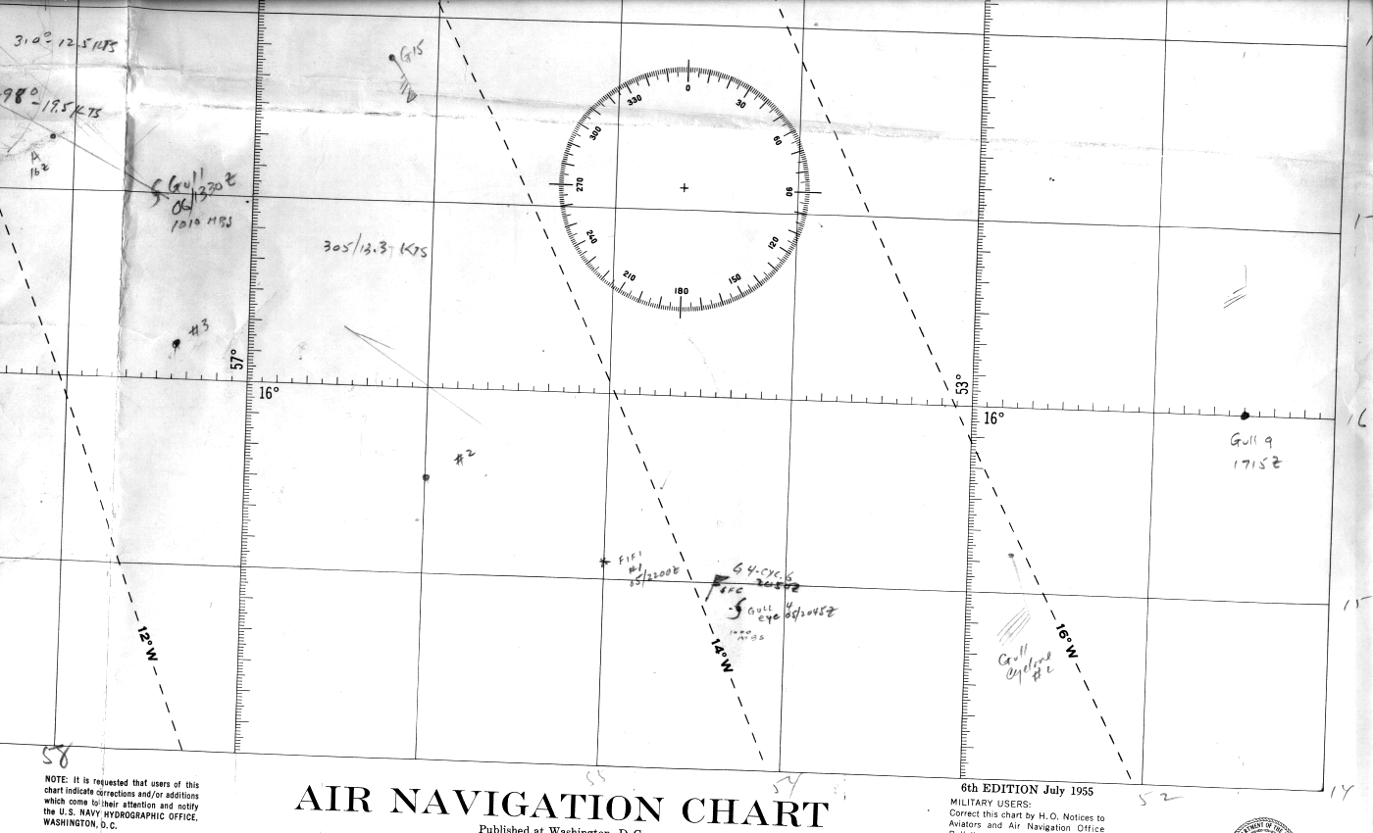

3. Please note that the environmental pressures were quite high on 7 September. Does that affect the proposed intensity analysis?

Yes, the intensities are boosted from the first draft to account for the high environmental pressures on the 7th and 8th.

4. Has NHRP data been examined to help clarify the central pressure on 8 September? It is noted that NHRP report #65 indicates a central pressure of 1011 mb.

This has been added in as a fix. However, given the pressure altitude of 13,000 ft, extrapolation to the surface is uncertain and they may not have sampled the center of the system. Because of this and big difference to the central pressure by the operational recon, 1011 mb is not added in as a central pressure.

5. The 11 September metadata states that the re-intensification show in HURDAT was actually winds associated with a frontal boundary. It is not clear from the microfilm maps what this means. A frontal boundary is present well northwest of Fifi, but the stronger winds are east or northeast of the cyclone. Please re-examine this for clarity.

HURDAT suggests that the system re-intensified late on the 10th and early on the 11th, but the observations clearly indicate that these winds were associated with a developing extratropical system north of Fifi and and not likely attributable to relatively small Fifi a few hundred miles away. Observations suggest that Fifi weakened into a surface trough on September 11th and was absorbed shortly thereafter.

6. Pending the resolution of point 5, the Committee concurs with the proposed earlier dissipation.

Agreed.

1958 Storm #8, Gerda:

1. Please add the original HURDAT track to the track map.

This has now been added to the individual track map:

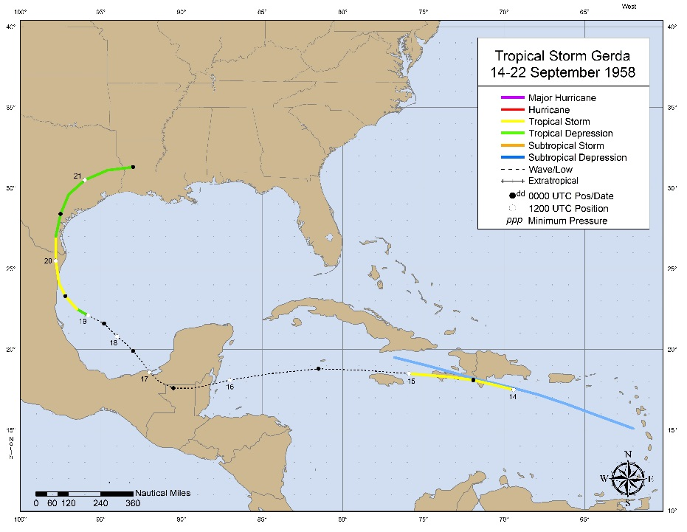

2. Please re-examine the proposed genesis time. One of the 0600 UTC 14 September microfilm maps has a radar fix on a storm center, along with a comment about 65 kt gusts. This also includes a coded message. It is not clear whether this is a ship or aircraft report, but either way it suggests a center was present before the proposed new genesis time. Please decode the message and, if necessary, adjust the genesis time on the basis of the data.

The radar center fix is at 17.6N 67.5W at 0600Z. Based upon this, genesis is revised to begin at 0600Z on the 14th as a tropical storm.

3. Please examine whether Gerda opened up to a tropical wave while over Hispaniola, or whether the circulation survived until after the system emerged over the Caribbean. The latter is what is in HURDAT, but the former seems more intuitive. Have the Meteorological Services of the Dominican Republic and Haiti been contacted for more information?

Agreed to indicate the system becoming a trough by 06Z on the 15th. The Meteorological Services of the Dominican Republic and Haiti have been contacted, but they have no additional information for this system.

4. One of the microfilm maps for 1200 UTC 20 September has a report from an oil rig, which appears to mention significant winds in squalls. However, some of the data is coded, and the exact value of the winds is unreadable. If possible, please obtain a clearer copy of this ob and decode it.

Unfortunately, a clearer copy of this observation is unavailable.

5. The Committee concurs with the proposed regeneration of Gerda to a tropical storm over the Gulf of Mexico. Please note in the metadata that this is a substantial change, both from a delay in dissipation and re-intensification standpoint.

Agreed to indicate in the metadata about significant changes including the redevelopment to a tropical cyclone stage and the delay in dissipation.

1958 Storm #9, Helene:

1. Please consult NHRP Reports #59, #65, and #72 for more data on Helene.

Agreed.

1a. NHRP report #72 mentions a mission on 24 September that is not in the write-up. However, there are issues about the central pressure. The NHRP report indicates a central pressure of 995 mb based on a 9800 ft flight level and a D-value of 80 ft. Directly using the nomogram in NHRP report #10 (hereafter Jordan’s nomogram) gives a 992 mb pressure for those values. This cannot be reconciled from the currently available data.

Agreed to add in the 995 mb central pressure around 18Z. This is now the basis for delaying intensification to a hurricane until around 00Z on the 25th.

2. In the write-up and the 1200 UTC 25 September microfilm map, there is a 65 kt ship report to the northeast of the center. Is this data believable, and if so, what does it mean for the intensity?

The ship about 90 nm northeast of the center of Helene reported 65 kt. This supports an intensity of 70 kt at that time as well as the system to have become a hurricane earlier in the day.

3. Please re-check the pressure and RMW parameters for the NHRP mission in the 25 September write-up. The NHRP report #72 states that the pressure was 987 mb based on D-values of -400 ft at 800 mb, while Shea and Gray use 982 mb. The latter is a better match for the Navy low-level penetration mission. NHRP #72 also states the flight-level RWM was 25 n mi as compared to 28 n mi in the write-up, and based on current knowledge the surface RMW would be smaller than either number. Please re-evaluate the proposed intensity after this re-check.

The disagreement between Shea and Gray with Colon is mentioned in the metadata. 982 mb retained as central pressure. RMW value is corrected and an intensity of 70 kt is analyzed, down from 80 kt in original HURDAT.

4. The proposed intensities show a decrease from 70 to 65 kt from 1800 UTC 25 September to 0000 UTC 26 September based on an apparent central pressure rise from 982 mb to 986 mb. Examination of the 986 mb pressure at 0230 UTC 26 September (from a dropsonde) suggests this value is in error. First, the aircraft reported a 700 mb height of 9600 ft/2926 m and a temperature of 14C. Using today’s formulas, this extrapolates to a pressure of 981 mb. Second, the dropsonde that reports 986 mb has a 700 mb height of 9790 ft/2983 m, suggesting it was not released in the center of the eye. Third, the aircraft descended to 850 mb for fixes at 0400 UTC and 0530 UTC. These fixes reported heights of 4180 ft/1274 m and 4100 ft/1250 m, which extrapolate to pressures of 984 mb and 982 mb using today’s formulas. Please re-examine the central pressure and the proposed intensities for this time, as it is possible that the proposed decrease never happened.

Agreed to use 981 mb as central pressure, extrapolated from flight-level and to discard the 986 mb dropsonde.

4a. Regardless of what the pressure was at 0230 UTC 26 September, should it be used as a 0000 UTC central pressure?

Yes, because there was no large change (actually no intensity change at all) between 18Z on the 25th until when the central pressure was observed at 0230Z on the 26th.

5. An NHRP aircraft penetrated the eye near 1930 UTC 26 September. However, there are discrepancies about the associated central pressure. Shea and Gray report 948 mb, while NHRP report #72 indicates 942 mb. Using the flight level of 9800 ft and D-value of -1170 ft in Jordan’s nomogram yields 952 mb. Please resolve this as well as the data will allow.

No additional information can be obtained to decipher these discrepancies. Given the the range of plausible answers, consistency with the Navy’s central pressure value suggests 948 mb should be used.

6. Please take another look at the minimum central pressure of Helene early on 27 September. The write-up and other literature on the storm uses a minimum pressure of 933 mb. However, as mentioned in the write-up, a Navy plane measured a 932 mb pressure with a dropsonde at 0800 UTC, and examination of the heights and temperatures does not show an obvious problem with this value. Finally, the aircraft reported a minimum 700 mb height of 8310 ft/2533 m at 0900 UTC (80 ft/24 m lower than that on the 932 mb sonde and 90 ft/27 m lower than that on the 933 mb sonde), suggesting this could have been Helene’s bottoming out time. Should 932 mb be the accepted minimum pressure, or some other value?

Agreed to indicate a slightly lower central pressure at 09Z on the 27th. Based upon these height changes, it is estimated that Helene bottomed out around 930 mb. This is now indicated in the writeup as an asynoptic best track point at 09Z with 930 mb central pressure and 130 kt intensity.

7. Please re-examine the proposed Category 1 impact in South Carolina, as well as the maximum observed winds there. While the Schwerdt et al model suggests hurricane-force winds occurred along the South Carolina coast, none of the observing stations reported more than 50 kt sustained winds. Thus, the model may have overestimated the winds, except maybe for the small area northeast of Myrtle Beach. Please provide better evidence that hurricane force winds occurred to justify the Category 1 designation. In addition, there is a write-up reference to peak winds in Myrtle Beach of 35 kt which is incorrect. The data table in the Climatological Data National Summary reports that four stations in South Carolina had fastest mile or 1-min winds of 50 -52 kt, with the strongest winds in Charleston.

Agreed to indicate high end (60 kt) tropical storm impact for South Carolina from Helene.

8. The Committee notes irreconcilable problems with the Navy recon flight data between 1700 UTC 27 September and 0600 UTC 28 September. The 700 mb heights on the eye dropsondes are 300-500 ft lower than the 700 mb heights the plane reports from the eye in the text messages. These drops need additional analyses to see if they should be discarded in favor of extrapolated pressures.

The 700 mb aircraft heights given in these messages appear to be from near the eye of Helene, but not in the center of the eye. Note that two locations are given in these message – once for the “PLANE POSIT” and one for the “RADAR EYE”, which are not the same. Thus having lower 700 mb heights in the dropsondes would not be inconsistent, as the value for the drop would be in the center of the eye and the aircraft 700 mb heights nearby but not in the center.

9. The 966 mb pressure at 1400 UTC 28 September appears to be a bad dropsonde pressure. The pressures extrapolated from the 700 mb and 850 mb data on the sonde are near 953-955 mb. Similar issues are seen on the fixes at 2130 UTC and 2230 UTC 28 September, where the dropsonde-reported pressures are 15-20 mb lower than the extrapolated values from the dropsonde data.

Agreed that 955 mb from the 700 and 850 mb height/temperature data is likely to be best analysis of central pressure at 14Z. 955 mb central pressure incorporated at 12Z. For the 2130Z drop, the 850/700 mb height/temperatures suggest about a 957 mb central pressure, compared with the 943 mb reported at the surface by the drop. The 2230Z drop – also inconsistent from surface to extrapolated values – appears to have been dropped in the periphery of the hurricane. The 957 mb value is accepted as the central pressure value at 00Z on the 29th.

10. Has any quality control check been made on the ship which reported 80 kt at 0600 UTC 29 September? If it is correct, the intensity at that time may need to be increased.

The 80 kt ship was available only in the microfilm, so it is difficult to judge the veracity of this record. Assuming that it valid, the intensity has been boosted from 70 to 85 kt at that time. While this is a major increase, it fits well with the 95 kt re-analyzed at 00Z and 75 kt at 12Z.

11. Please re-examine the proposed time of extratropical transition. While the Committee agrees that transition likely occurred earlier than currently shown in HURDAT, the proposed time of 0000 UTC 29 September appears to be too early.

Agreed to delay extratropical transition to 06Z on the 29th.

12. Please show why the track of the extratropical Helene was modified to show landfall in eastern Nova Scotia. Does information from the Meteorological Service of Canada support this change?

At 06Z, ship observations with a 45 kt ENE with 961 mb and 45 kt SE with 964 mb in particular indicate that Helene was about 80 nm NNW of the original HURDAT position. These along with a SSE wind at St. Paul Island at 12Z show that Helene’s center made landfall over Nova Scotia around 10Z. The Meteorological Service of Canada has no additional information available for this hurricane.

1958 Storm #10, Ilsa:

1. Are any microfilm maps available for the genesis area for 22 September?

The maps did not extend that far enough to the east on the 22nd.

2. What are the ship reports that the forecasters thought were so important on 23 September? Please note them in the ship highlights.

Presumably, these were the weak SW winds shown on the microfilm at 12 and 18Z. These are now indicated in the ship highlights section.

3. Can the discrepancy in the time of the first recon fix on 24 September be reconciled? The MWR says 1606 UTC and the ATSR says 1728 UTC.

This discrepancy cannot be reconciled. However, the discrepancy is now mentioned in the writeup.

4. Has any quality control check been made on the ship which reported 50 kt at 2030 UTC 24 September?

This ship was only available on microfilm and only at 18 and 2030Z with no other ships very close by. Thus quality control of the ship is not possible.

5. Given how fast the central pressure was changing during Ilsa’s life, is it really appropriate to use non-synoptic time aircraft pressures as synoptic time best track pressures? One of several examples is for 0000 UTC 27 September, where a 932 mb pressure has been added based on aircraft data at 0200 UTC. Since the 2000 UTC 26 September pressure was 940 mb, this does not look right. Please examine these cases and make any necessary revisions to the pressures and the intensities.

This 932 mb pressure value was erroneous, as it belonged instead to Helene, which was active (and extremely intense) at the same time. Thus this value has been removed. Given the rapid filling on Ilsa on the 27th, the 990 mb value is included as an asynoptic data point at 08Z.

6. On 25 September, were the 1400 UTC and 2000 UTC fixes made by the same aircraft?

Yes, this is now so clarified.

7. For the fix at 1400 UTC 25 September, the ATSR has a text message from the aircraft with lowest pressure 985 mb while the subsequent dropsonde message said 986 mb. Please clarify which is the correct central pressure.

The dropsonde should provide somewhat more reliable measurements of central pressure, so the 986 mb value is now used.

7a. According to the ATSR, the fixes at 1400 UTC and 2000 UTC 25 September were made by the same aircraft. Please modify the discussion where it says “Another reconnaissance aircraft reached…”.

Yes, this is now so clarified.

8. There are major issues for the aircraft fixes at 2000 UTC 26 September and 0200 UTC 27 September. The write-up has a pressure of 940 mb for the first fix. However, the data available in the ATSR shows a 957 mb pressure, which passes quality control checks. The write-up has a pressure of 932 mb for the second fix. However, the ATSR has the coded eye drop with a splash pressure of 966 mb, which also passes quality control checks. The plane also noted that the eyewall opened up and became diffuse by the time of the second fix, which could be consistent with the observed pressure changes. What is going on here? Did the MWR confuse Helene and Ilsa when it talked about the deepening to 932 mb? Is there really a 932 mb pressure on the microfilm map (the pressure being almost illegible)? Did the Navy dropsondes miss the pressure center that badly in an eye that started out as 30 n mi wide? Was there another aircraft in the eye near this time that might have reported a lower pressure?

This is a case of confused hurricane fixes. The 932 mb pressure supposedly for Ilsa was instead taken at 08Z on the 27th in Hurricane Helene. There was a 932 mb pressure on the 00Z 27th map, but again this was mistaken as separate flights were going on into Ilsa and Helene at the same time. 966 mb is instead used as the central pressure at that time. The 940 mb at 20Z on the 26th may also be mistaken with Helene, as Helene was close to that central pressure at that time. The 957 mb central pressure value is now included. Both changes make for significant downward revisions to HURDAT on the 26th and 27th.

9. There is also a major issue with the 949 mb pressure from the Navy fix at 0800 UTC 27 September. The dropsonde has a splash pressure of 949 mb. However, pressures computed from the 700/850 mb data from the sonde and the aircraft suggest a value near 990 mb.

Agreed that the 949 mb pressure value is incorrect. This has been replaced with 990 mb central pressure. Given the rapid filling, the 990 mb value is included as an asynoptic data point.

10. Given the problems highlighted in pointes 8 and 9, the peak intensity of Ilsa needs to be seriously re-evaluated. First of all, an effort needs to be made to determine the source of the 932 mb pressure quoted in the MWR. If the associated data cannot be located, then the re-analysis should use the ATSR pressures for which the data is available. This would require major changes to the proposed intensities.

Ilsa’s peak is thus revised to be a 95 kt Category 2 (at 12 and 18Z on the 26th) versus a 115 kt Category 4 (at 00Z on the 27th) originally in HURDAT.

11. On 28 September, the 989 mb pressure attributed to the 0728 UTC fix appears to have been measured near 0340 UTC according to the ATSR. The write-up needs to include this additional fix. There is no data in the ATSR that shows what the pressure might have been on the 0728 UTC fix.

Agreed and corrected.

12. A track map for Ilsa misfiled in the Daisy storm wallet (see below) appears to show a fix near 32N 59W at 0456 UTC 29 September with a pressure of 28.88 inches/978 mb. Please verify this data as best as possible and include it in the re-analysis if it is correct.

This value appears to be reasonable and is used at 06Z, though it does not change the intensity based upon 980 mb in the first draft.
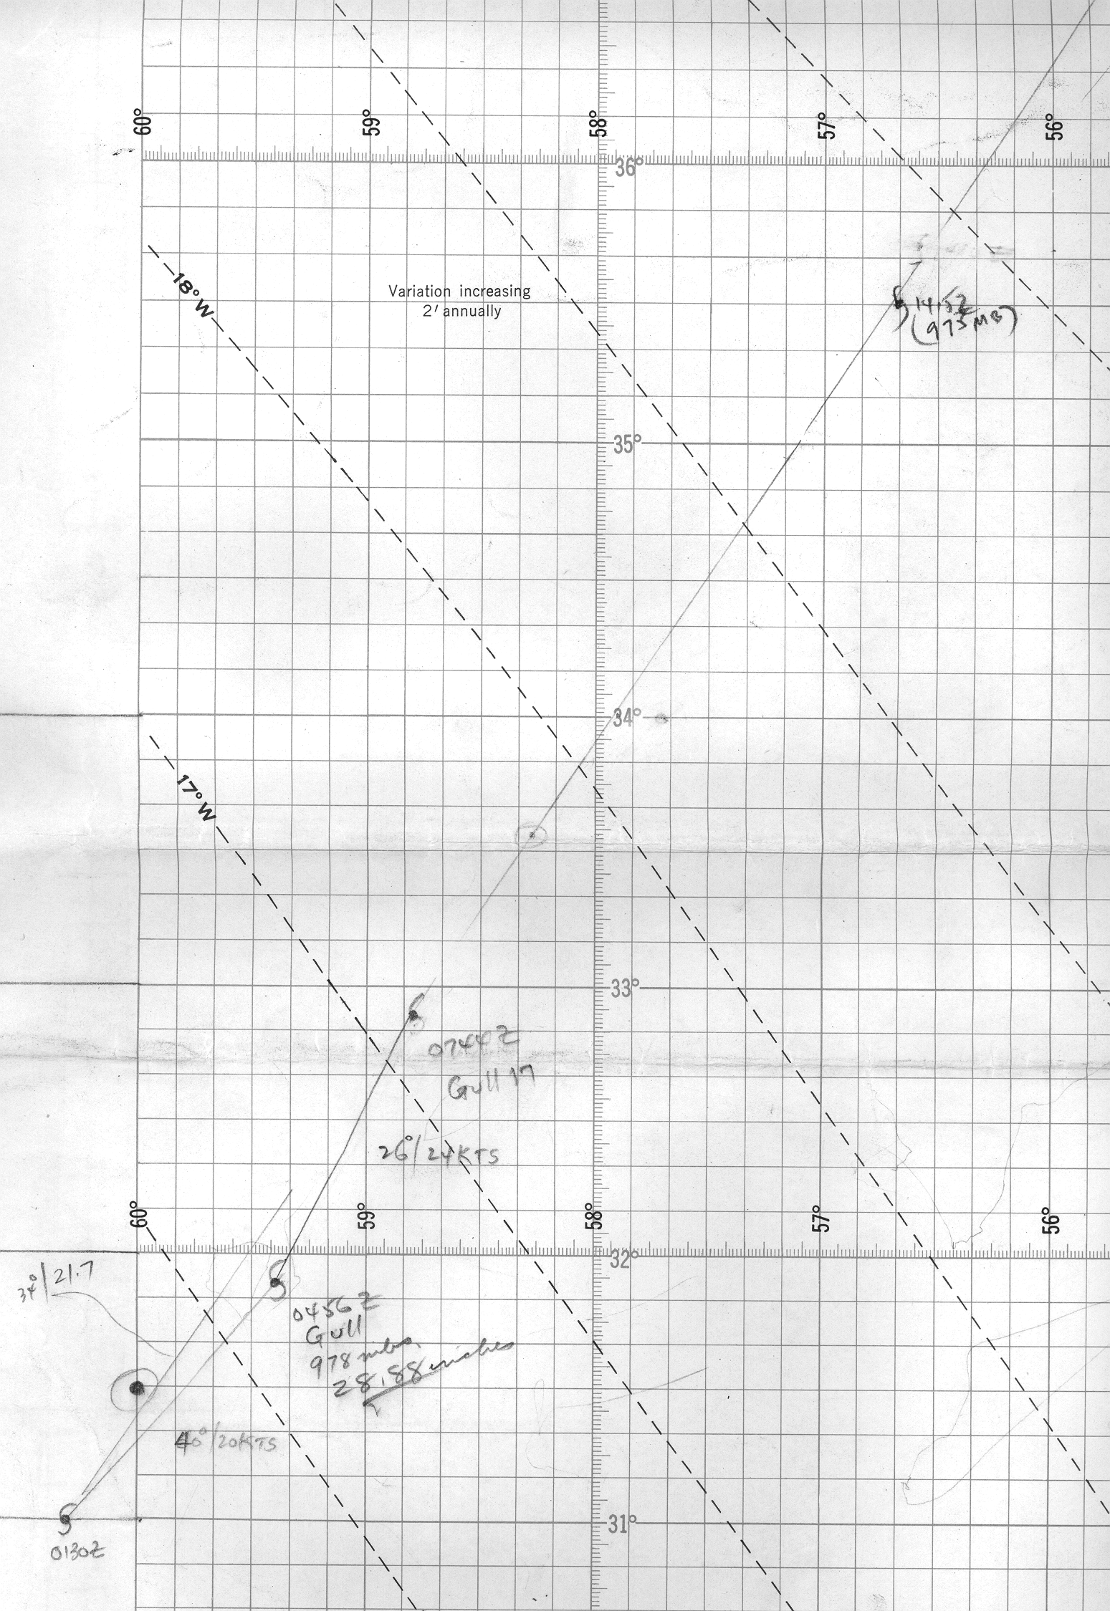

13. Please re-examine the proposed earlier time of extratropical transition. While it is apparent that the cold front associated with extratropical Helene entered the circulation of Ilsa, it is not as obvious from the data when the cold air reached the center. Please create a detailed temperature analysis on 29 September to help resolve this.

Synoptic analyses of the temperature/pressure/wind structure of Ilsa on the 29th and 30th have been conducted. However, these are hampered by lack of much data near the center. Ship observations at 00Z on the 30th suggest that the center of Ilsa had become embedded within the frontal boundary associated with a larger extratropical cyclone (Helene) to the north. Thus, it is analyzed that Ilsa became an extratropical cyclone at that time, six hours earlier than originally shown in HURDAT.

1958 Storm #11, Janice:

1. NHRP report #65 indicates that research mission were flow into Janice on 5, 6, and 8 October. These includes reports of central pressures of 1009, 995, and 988 mb respectively on those days.

These have been included into the daily summaries.

1a. One of the 1800 UTC microfilm maps on 5 October has a summary from a research mission that should be referenced.

The research mission indicated a central pressure of 1009 mb from a 12,000’ flight level. Given ship/coastal station observations below that, this value appears to be high biased.

2. The microfilm maps show a statement that a reconnaissance was investigating the pre-Janice wave on 1 October. Are these data plotted on any of the other microfilm maps?

Unfortunately, they are not.

3. Does the microfilm map for 0600 UTC 2 October show a 35 kt ship report? If so, please note this in the ship highlights section.

Yes, this is now noted in the daily summary.

4. One of the microfilm maps for 1800 UTC 2 October has a product on it that includes “APPEARANCE OF HURRICANE”. Unfortunately, a lot of it is illegible. Can it be determined what this is referring to?

Yes, this is a ship report from 17N 71W around 18Z indicating winds of 40 kt. This has now been added into the daily metadata.

5. In the 2 October discussion, should “on early October” be “in early October”?

Yes, this has been changed.

6. Are there any aircraft highlights to be included in the 3 October discussion?

Yes, these have been added in.

7. While the Committee concurs with the earlier genesis time, could the observations that it is based on be more explicitly included in the write-up? It is noted that the reconnaissance mission on 4 October was apparently a Navy plane, but the ATSR has no additional details or data.

Observations confirming the well-defined center were from Grand Cayman, Swan Island, and a couple of ship reports. It is now noted in the daily summary that the flight is not included in the ATSR, despite it being a Navy reconnaissance mission

8. Please re-examine the intensities at 1200 UTC and 1800 UTC 5 October, for the following reasons:

8a. Since a research aircraft measured 53 kt winds at 12000 ft, and a ship 3 hours later reported 45 kt winds, would 45 kt be a more appropriate intensity?

Agreed to indicate 45 kt at 18Z.

8b. On a related note, has any quality control check been made on the ship that reported 45 kt and 999 mb at 2100 UTC? IF the data is correct, it implies a considerable central pressure fall since the aircraft mission three hours earlier (but see below).

As shown in the excel database, this observation is only known from the microfilm records. Because of this and no other observations nearby, a quality control for it cannot be done.

8c. The Navy recon flight reported a minimum pressure of 1002 mb. The write-up attributes this to the fix at 1756 UTC. However, the flight data in the ATSR suggests this was actually measured at 1330 UTC at a time when the plane was in 35 kt winds. The ATSR shows that a dropsonde near 1800 UTC measured 1006 mb, which matches the pressures computed from the sonde 700 mb and 850 mb data. However, the 700 mb height on the sonde is 90 ft/27 m higher than the minimum 700 mb height reported by the research aircraft. It is also notable that the center positions reported by the aircraft are about 25 miles apart even though the two fixes were less than an hour apart.

It is agreed to indicate the 1002 mb central pressure at 1330Z. The dropsonde near 1800Z measuring 1006 mb pressure likely was in the periphery and not in the center of the tropical cyclone.

9. Does the microfilm map for 0300 UTC 6 October show a 1000.7 mb pressure ob just northwest of the center? If so, please add it to the land stations highlights.

N (no speed) and 1001 mb at Cienfuegos, Cuba at 03Z added to the daily station summary.

10. The write-up for 6 October mentions an aircraft penetration fix at 25.9N 76.1W at 2330 UTC. Is this position correct? It does not appear consistent with either the best track or other aircraft fixes.

Agreed that the position is dubious, which is why this was not weighted much at all in the best track.

11. The best track at 1800 UTC 7 October is notable east of the position reported by an aircraft at 1930 UTC that day? Please state the basis for this.

The fixes – as plotted on the map near the Bahamas – were due north from 0530Z to 1930Z then due east from 1930Z to 02Z on the 8th. The best track has been adjusted toward the fix locations, but not all the way as such an exact track is not realistic. This has now been mentioned in the daily summary.

12. Are the land highlights for 7 October necessary?

We are providing the peak winds/lowest pressure of at least 35 kt/at most 1005 mb every synoptic time here.

13. Why is the 55 kt wind at Cayo Coco, Cuba on 6 October being rejected in the intensity analysis? The stated reasons look quite thin, especially the part about “blowing from the land to the water”. Has Perez been contacted for additional information on this ob? Please provide a better rationale for rejecting it, or use it in the intensity analysis.

Perez could find no additional information regarding this observation. Agreed to incorporate this into the reanalysis and the intensity at 12Z is boosted to 55 kt.

14. The binder has detailed hourly observations from several of the Bahamas, including Mangrove Cay on Andros Island and North Eleuthera. Mangrove Cay apparently reported a minimum pressure of 991.4 mb. However, the hourly obs at 1600 UTC 6 October show winds 140 deg 36 mph with a 991.9 mb pressure, followed by the 1700 UTC ob with 320 deg 34 mph and 991.5 mb pressure. This, along with comments included in a report by a meteorologist with the Bahamas Meteorological Service about the quality of the Mangrove Cay observer, suggest the possibility the pressure was lower. The hourly obs at North Eleuthera shows an almost perfect center passage between 2200-2300 UTC 6 October, with winds of 16 and 10 mph and pressures of 988.2 and 988.8 mb. The Bahamas report also includes a minimum pressure of 988.0 mb (time unknown). This indicates that the inferred 985 mb pressure in the 7 October discussion is probably not correct.

Agreed to indicate 987 mb at 22Z, based upon these observations. The higher pressure supports about 60 kt intensity, which is unchanged from original HURDAT.

15. The Committee notes that there were multiple 65 kt ship observations on 7 October. If there ships pass quality control checks, wouldn’t that argue for an intensity higher than 65 kt?

Agreed to boost intensity at 12 and 18Z to 70 kt.

16. In reference to the aircraft-measured 983 mb pressure on 7 October, how certain is it that this was measured at 1930 UTC? The fix form on the 1800 UTC microfilm map does not explicitly state this.

It is uncertain as to the exact time of the 983 mb reading, which is now so indicated in the daily summary.

17. A track plot map for Janice (see image below) was misfiled in the Storm Wallets under Daisy. The map shows the AF aircraft fix at 1345 UTC 9 October reported a pressure of 982 mb. Please add this to the write-up.

This central pressure is added into the analysis, and helps to support a 70 kt intensity at 12Z on the 9th.

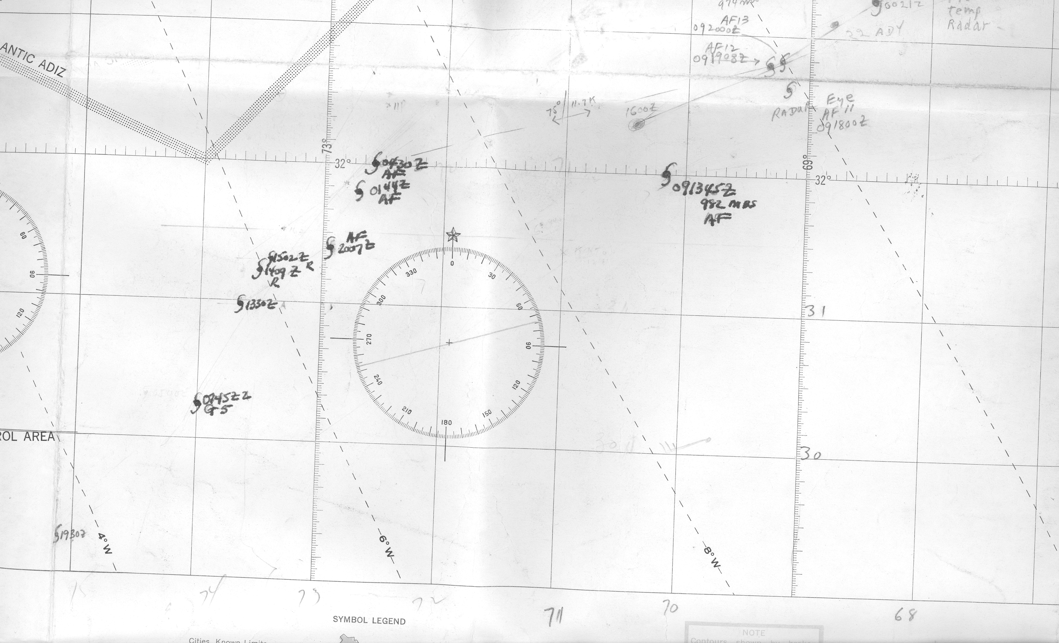

18. The 50 n mi wide eye at 0144 UTC 10 October was measured at 500 mb. Was might that mean for the surface diameter (likely smaller), and how might that affect the proposed intensities near that time?

This eye diameter of 50 nm usually equates to about 35-40 nm RMW. Given the high altitude of the fix, the surface RMW may have been about 25-30 nm. The climatologial RMW for this latitude and central pressure is 27 nm. Due to a near average RMW, an intensity of 85 kt is selected for 06Z on the 10th, up from 75 kt originally in HURDAT, a minor intensity change. 85 kt is also the peak intensity for this hurricane, 5 kt higher than originally.

19. What was the RMW on 10 October? It is stated as large, but no figure is mentioned.

This is now so indicated.

20. A second misfiled track map for Janice (see below) indicates that the fix at 1300 UTC 10 October had a pressure of 973 mb.

This is now included into the reanalyses for the 10th.

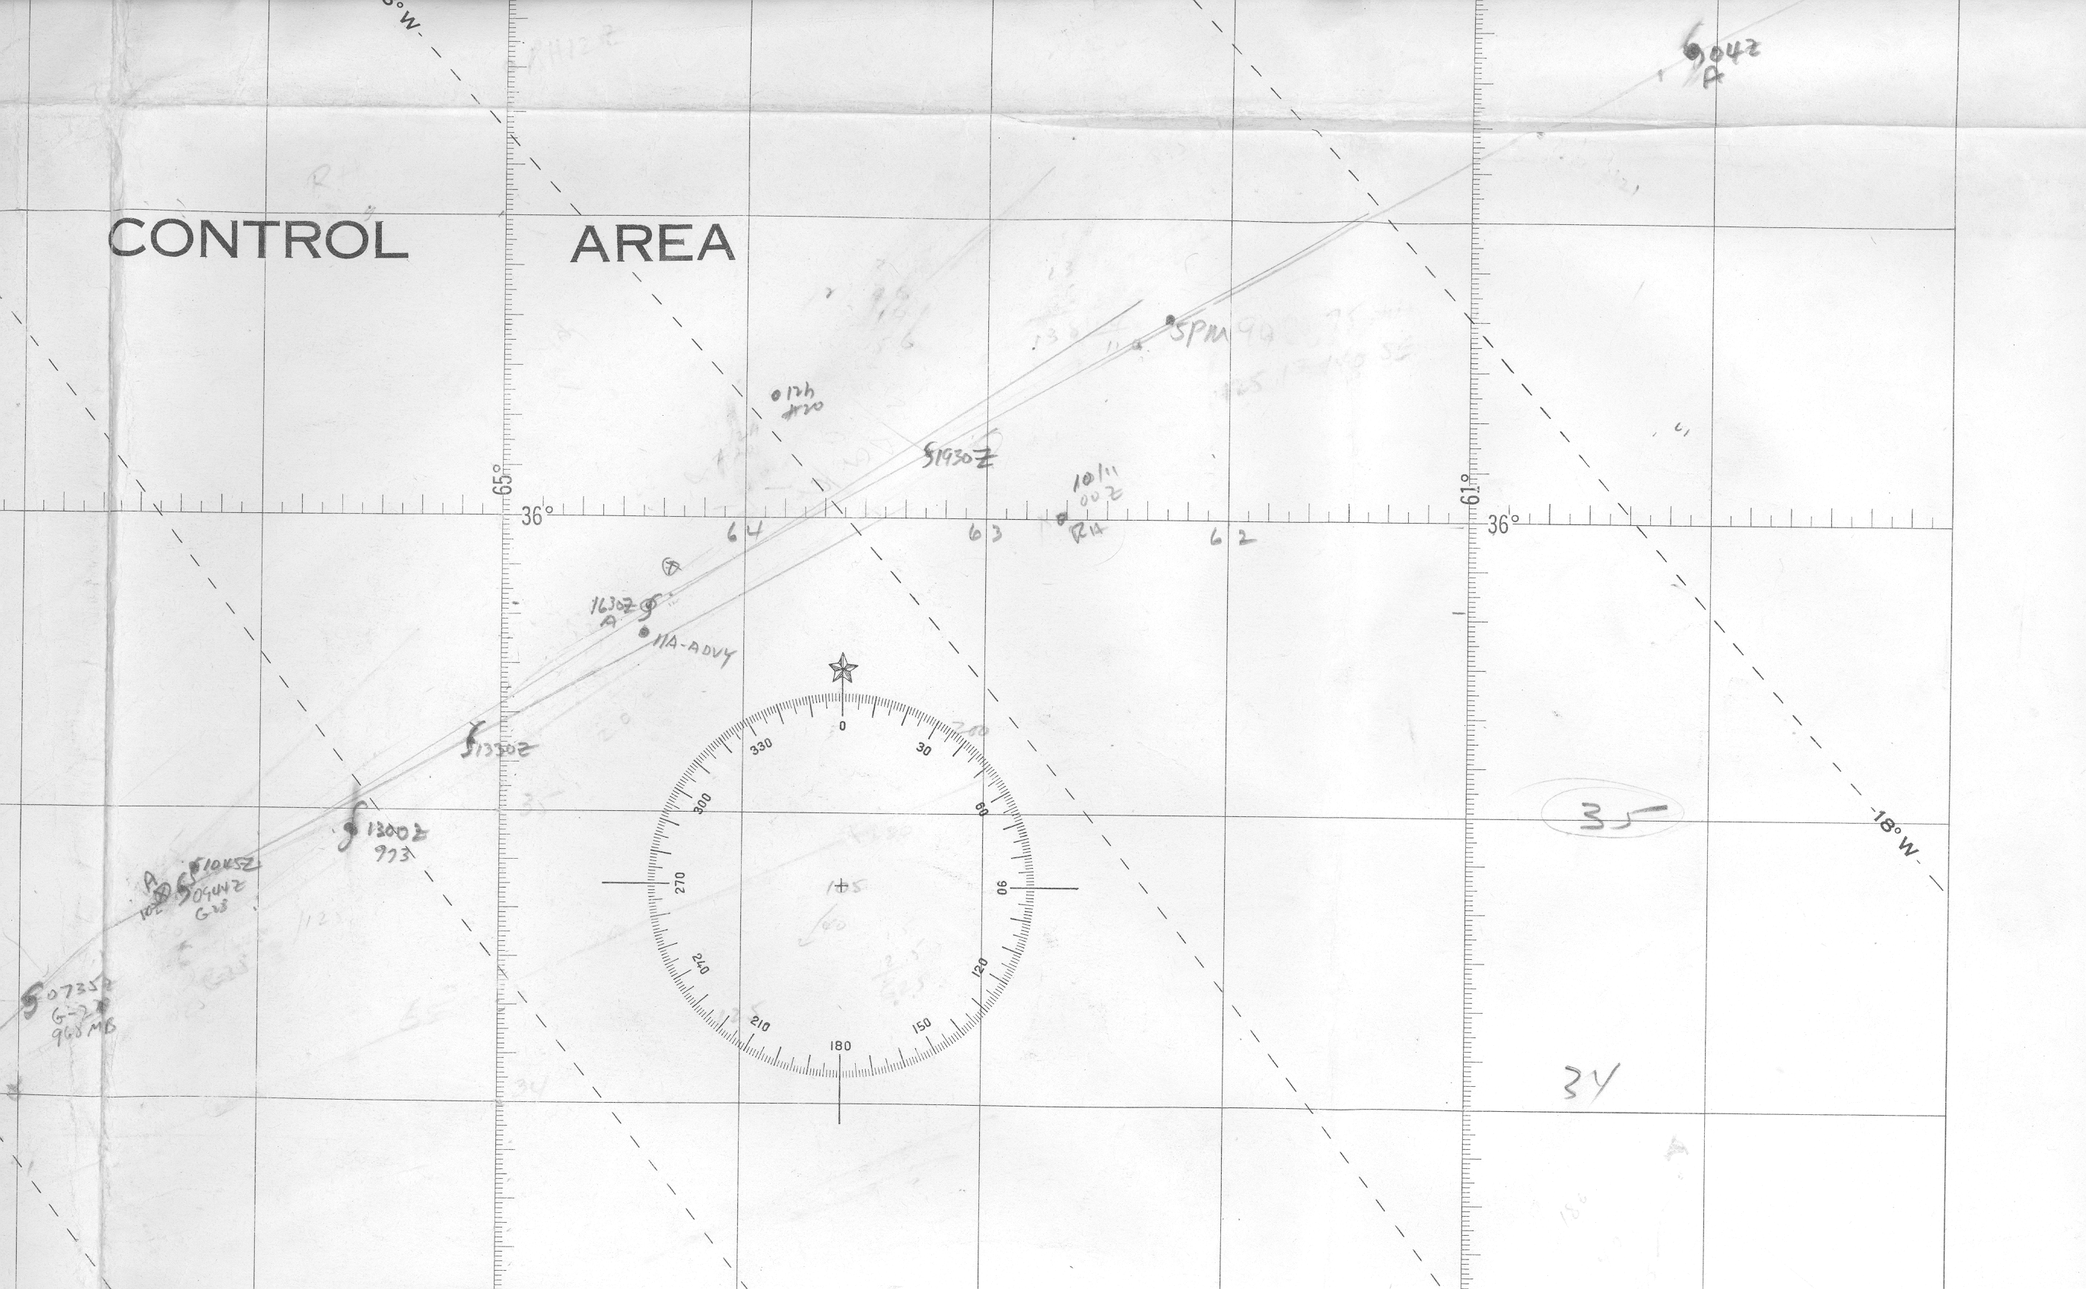

21. Given the ship reports of 75 kt winds at 1200 and 1800 UTC 11 October, should the intensity be higher than 75 kt if the ships pass quality control checks?

As these ship observations appear reasonable, the intensity at 12 and 18Z is set to 80 kt.

22. Based on the issues in points 13-21, the Committee has concerns that the proposed intensities are generally too low from 1200 UTC 6 October to 1800 UTC 11 October. Please re-examine every intensity during this time, including the proposed peak intensity for Janice.

Most of these intensities from 12Z October 6th through 18Z October 11th have been revised upward from the first draft of the reanalysis.

22. The Committee concurs with the earlier proposed time of extratropical transition.

Agreed.

1958 Additional Notes:

1. Are microfilm maps available for the #2 case in May and the #4 case in September?

These are now available on the w: drive.

2. Please take a closer look at suspect #6 in October. First, the MWL shows a 38 kt ship at 1200 UTC 16 October within 120 n mi of the center. This suggests that the proposed “subtropical depression” classification is not correct. Second, the ATSR shows investigative missions on 16 and 17 October that may be related to this system. Finally, please make a detailed analysis of the surface temperatures to see if the frontal analyses during this period are correct. This system may need to be written as another possible addition to the season.

After reconsideration, this system is added into HURDAT as a new tropical storm from October 15th to 18th. Additional analyses have been constructed, which indicates that the system was a tropical cyclone from 12Z on the 15th through 00Z on the 18th. It then transitioned to an extratropical cyclone around 12Z on the 17th before merging with another extratropical cyclone by 00Z on the 19th.

3. The Committee concurs with leaving the other systems out of HURDAT.

Agreed.

