Forecast for Tropical Areas of Interest
Forecast Synopsis 1800 UTC 13 August 2010
Author: Rogers

Summary:

The remains of TD#5 (PGI29L) remain over the Gulf coast states, with some potential for redevelopment if it moves back over water. PGI27L in the central Atlantic is forecast to move toward the west and the Caribbean, but it is in an extremely dry environment and is unlikely to develop. PGI28L in west Africa shows good rotation but it forecast to move toward the northwest into very dry air, where it is forecast to dissipate. PGI30L, southeast of PGI28L, shows some potential for development over 2-3 days, but it is forecast to also track toward the west-northwest and is not predicted at this time to develop significantly after that time. Finally, another system which is currently not identified as a pouch is predicted by the GFS to develop into a possible significant tropical cyclone in the central Atlantic in 6-7 days.

Discussion:

The large-scale environment remains dominated by a subtropical high in the eastern Atlantic and a baroclinic low and associated stationary front in the western Atlantic and southeastern U.S. (Fig. 1). A series of tropical waves is identified by NWS/TAFB, several of which have also been identified as pouches by PREDICT. These pouches are PGI29L, which is the remnants of TD#5 over Alabama; PGI27L, located at about 45W; PGI28L, just emerging off Africa at about 17N; and PGI30L, further inland over Africa at about 12N and 0W. PGI29L is associated with moist low-level air, as seen by a total precipitable water mosaic (Fig. 2). PGI27L is located along a low-level moisture gradient, including a filament of dry air ahead of it. PGI28L is emerging off Africa into very dry air.

A visible close-up of PGI29L (Fig. 3) shows scattered clouds and some deep convection over central Alabama and Mississippi. The system is located right along the axis of a mid- to upper-level ridge at the Gulf coast (Fig. 4). As a result of this positioning, all global model guidance predict this system to loop anticylonically around the ridge over the next 3-5 days, with some models bringing the system briefly over water (Fig. 5). The system is in a moist environment, with relative humidity as high as 90-95% following the system (Fig. 6). As a result, there is some chance for this system to regenerate, if it moves far enough over water.

PGI27L in the central Atlantic is forecast to move toward the west toward the Caribbean over the next several days (Fig. 7). However, the system is located along the southern boundary of very dry air. Additionally, dry air is clear ahead of the system. Pouch-following values of lower-tropospheric relative humidity show values as low as 30% (Fig. 8). As a result, no global models are predicting this system to develop.

PGI28L, emerging off the coast of Africa, has been associated with some vigorous mesoscale convective systems over the past few days. It does have a clear low-level vorticity maximum associated with it (Fig. 9). However, all model guidance predict the system to move toward the northwest as it exits the coast of Africa, well away from any possible operations.

PGI30L is the next system over Africa, and it is also associated with vigorous mesoscale convective systems (Fig. 10). Model guidance takes this system along a more west-northwesterly track than PGI28L, bring the system off the African coast at about 15N. The system is currently in a region of fairly low shear (Fig. 11), but there is higher shear ahead of it. However, it is possible that this shear will decrease as the system advances Indeed, pouch-following diagnostics indicate that the shear will decrease over the next 2-3 days to 5-10 m/s (Fig. 12). Both the ECMWF and the GFS maintain a system for several days (Figs. 12-13), with the GFS predicting a stronger system than the ECMWF. However, it is still at a fairly high latitude for being so far east, and possible operations several days after this time are not likely for this reason.

Long-range GFS forecasts (Figs. 14-15) indicate a well-defined tropical cyclone developing just off the African coast at about 15 N at 96h. This system is forecast to continue moving westward and intensifying somewhat out to 156h, or 6.5 days. This system does not appear to be identified as a pouch currently, but may represent an interaction between an existing pouch (perhaps PGI30L) and ITCZ-generated monsoonal flow and shear vorticity.

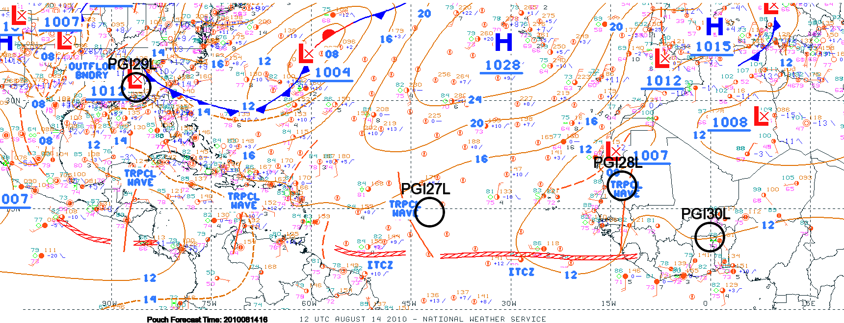
Figure 1.
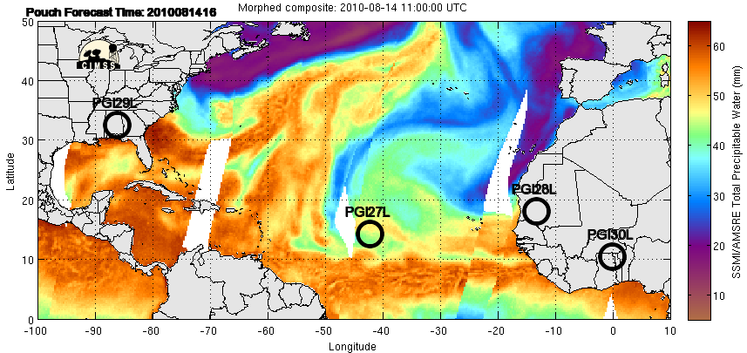
Figure 2.
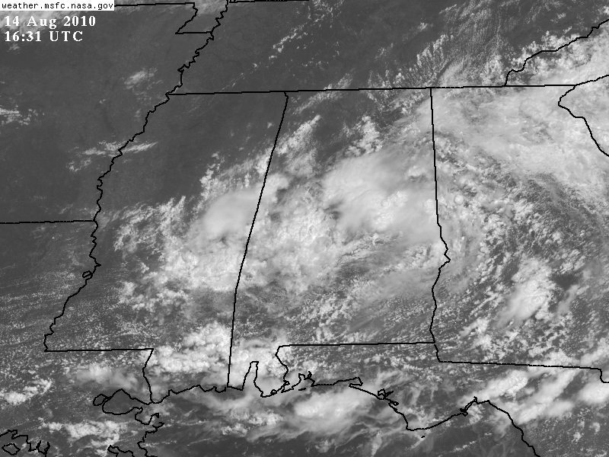
Figure 3.
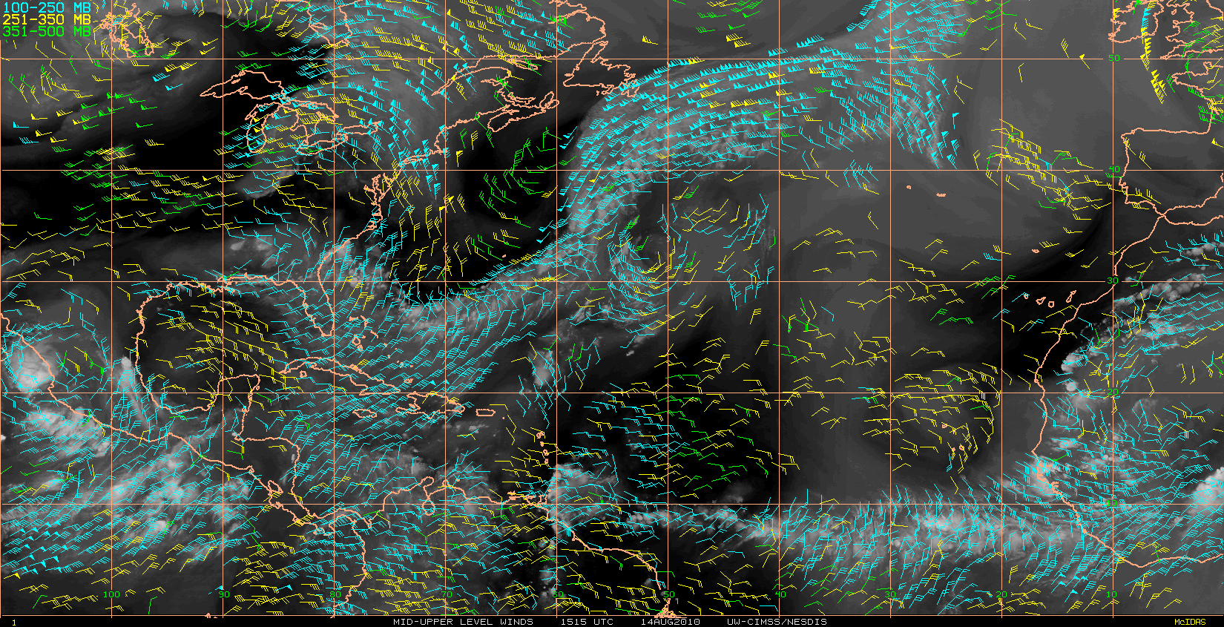
Figure 4.
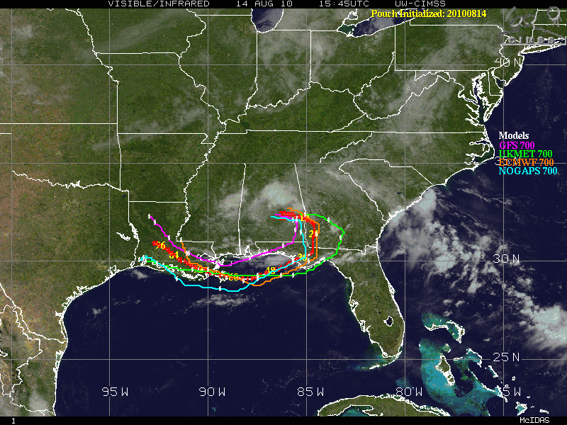
Figure 5.
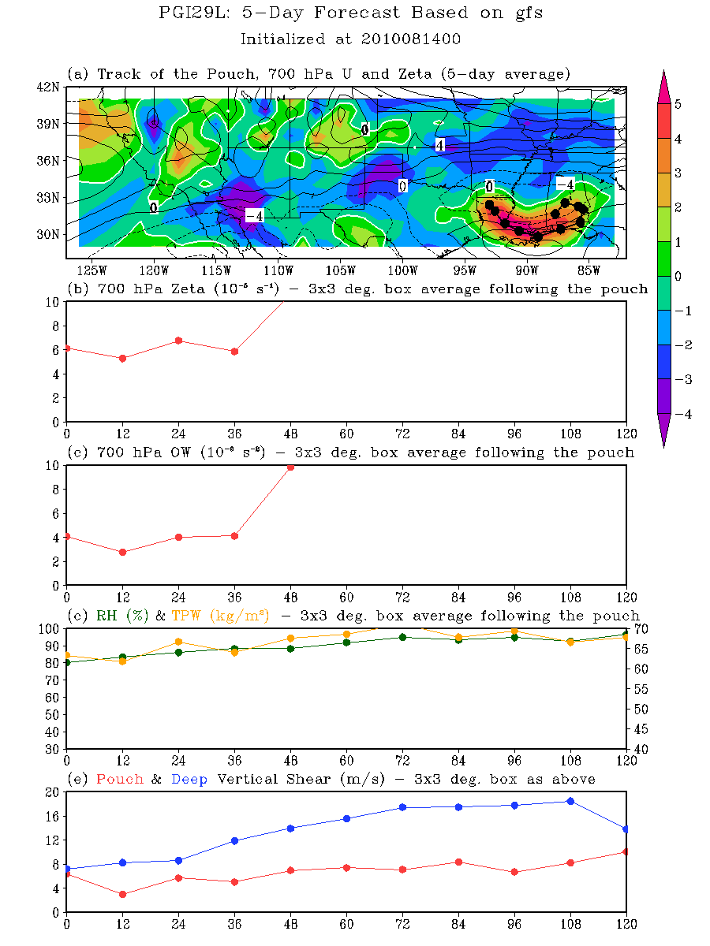
Figure 6.
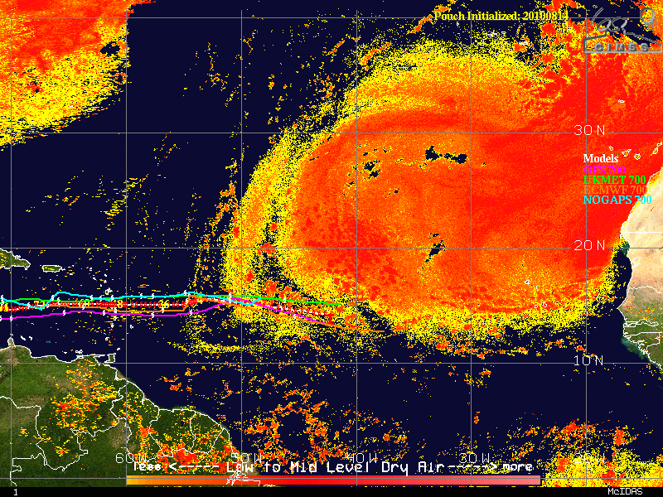
Figure 7.
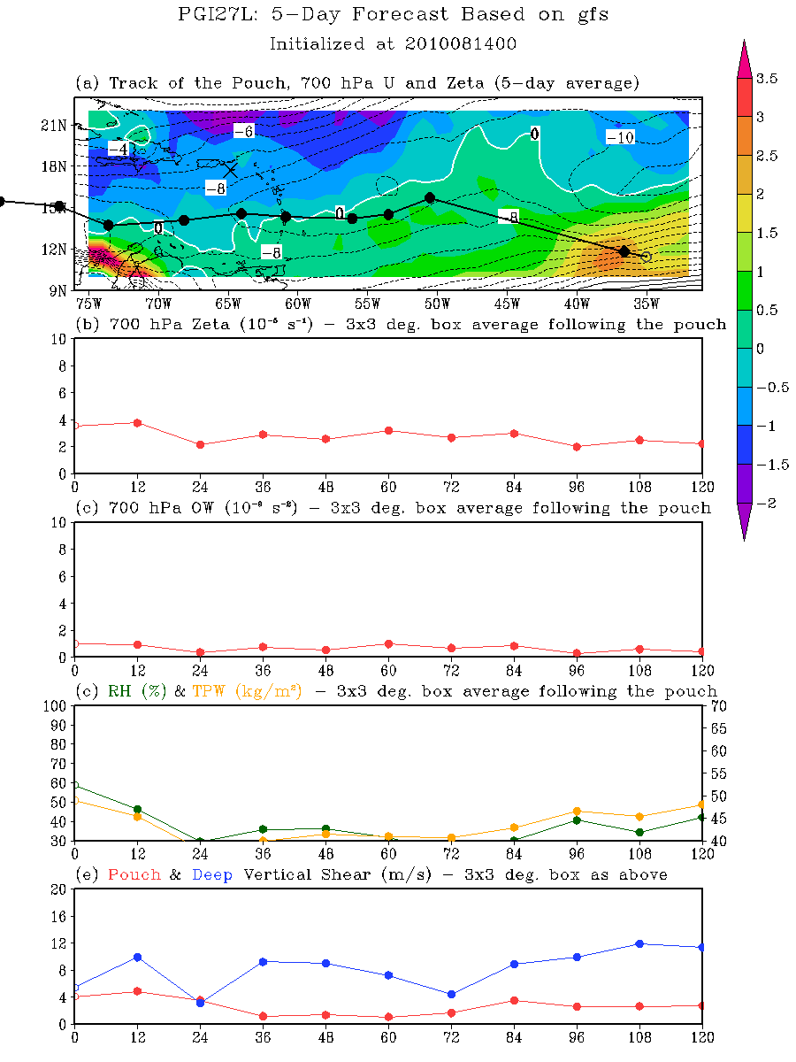
Figure 8.
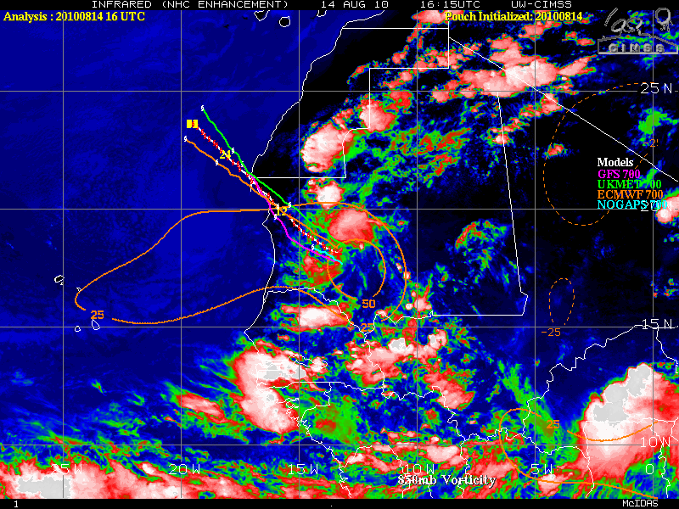
Figure 9.
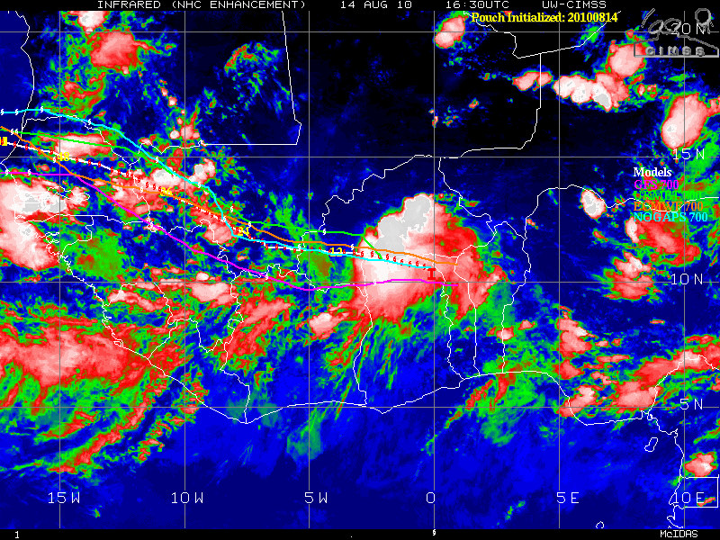
Figure 10.
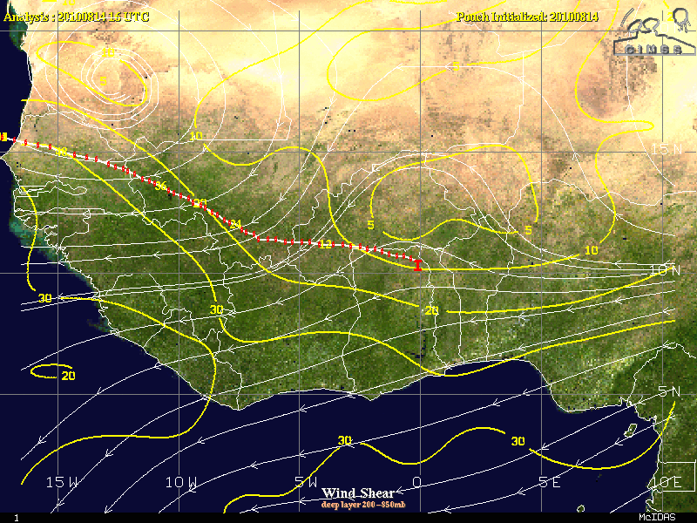
Figure 11.
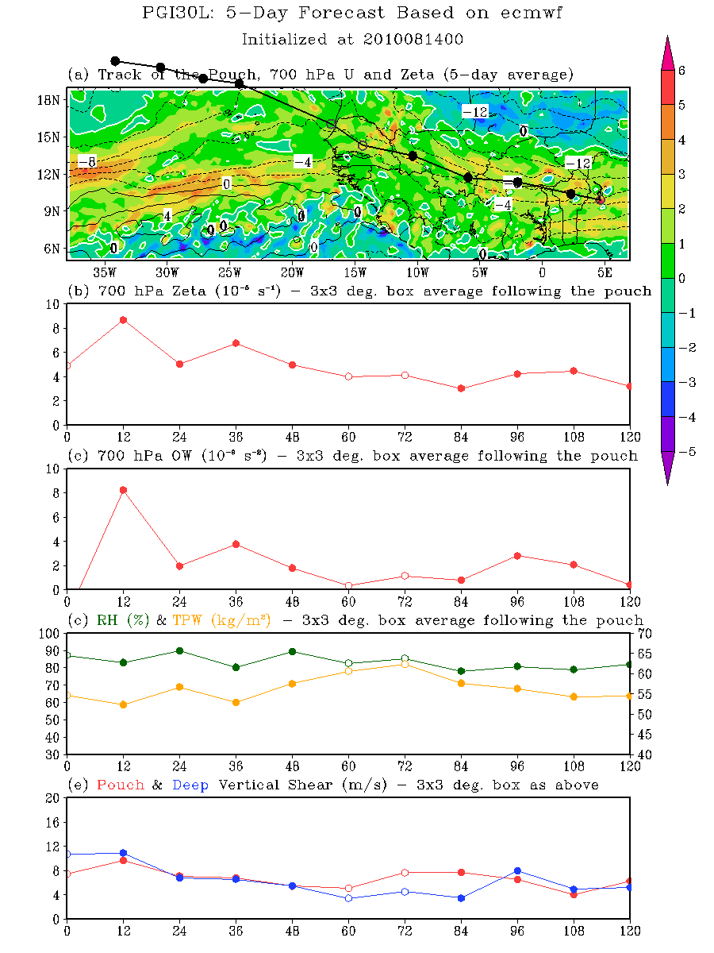
Figure 12.
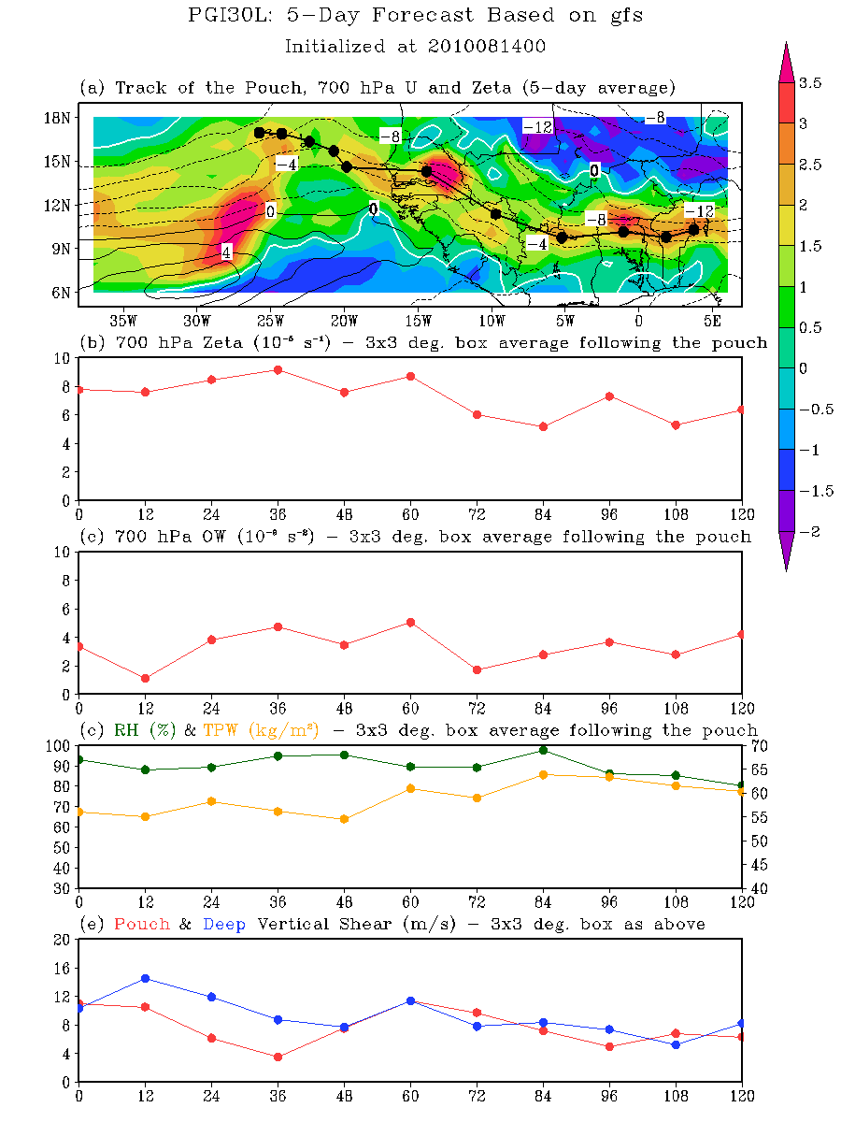
Figure 13.
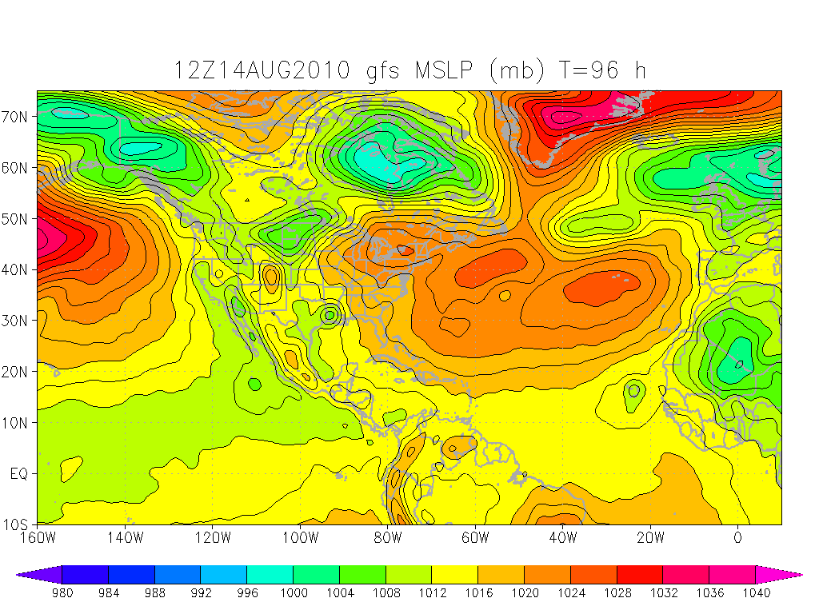
Figure 14.
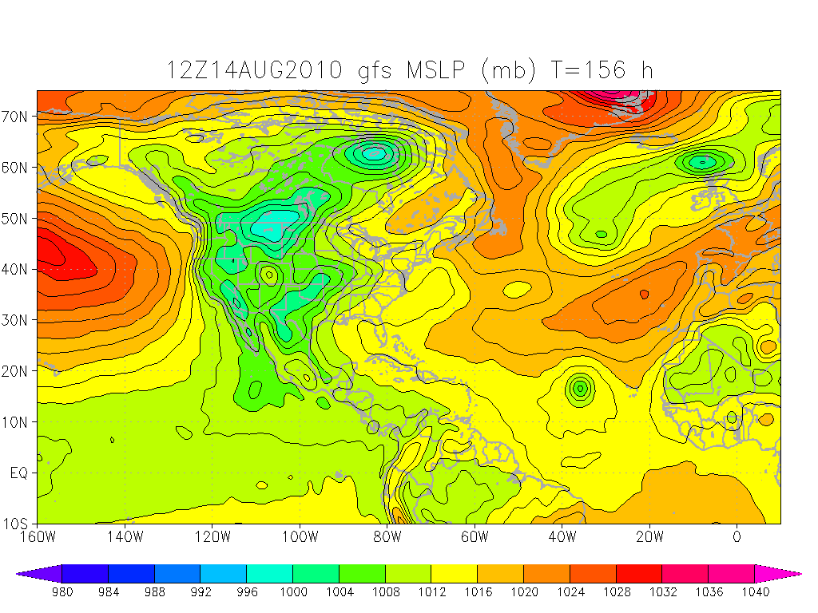
Figure 15.

