**Hurricane Harvey’s Rainfall and Global Warming**

* By Christopher W. Landsea[1]

Hurricane Harvey dumped incredible amounts of rain over southeastern Texas and southwestern Louisiana in late August 2017. Observations indicate a maximum of about 60” (1525 mm) just east of Houston with much of southeastern Texas receiving at least two feet (610 mm) of rainfall.[2]

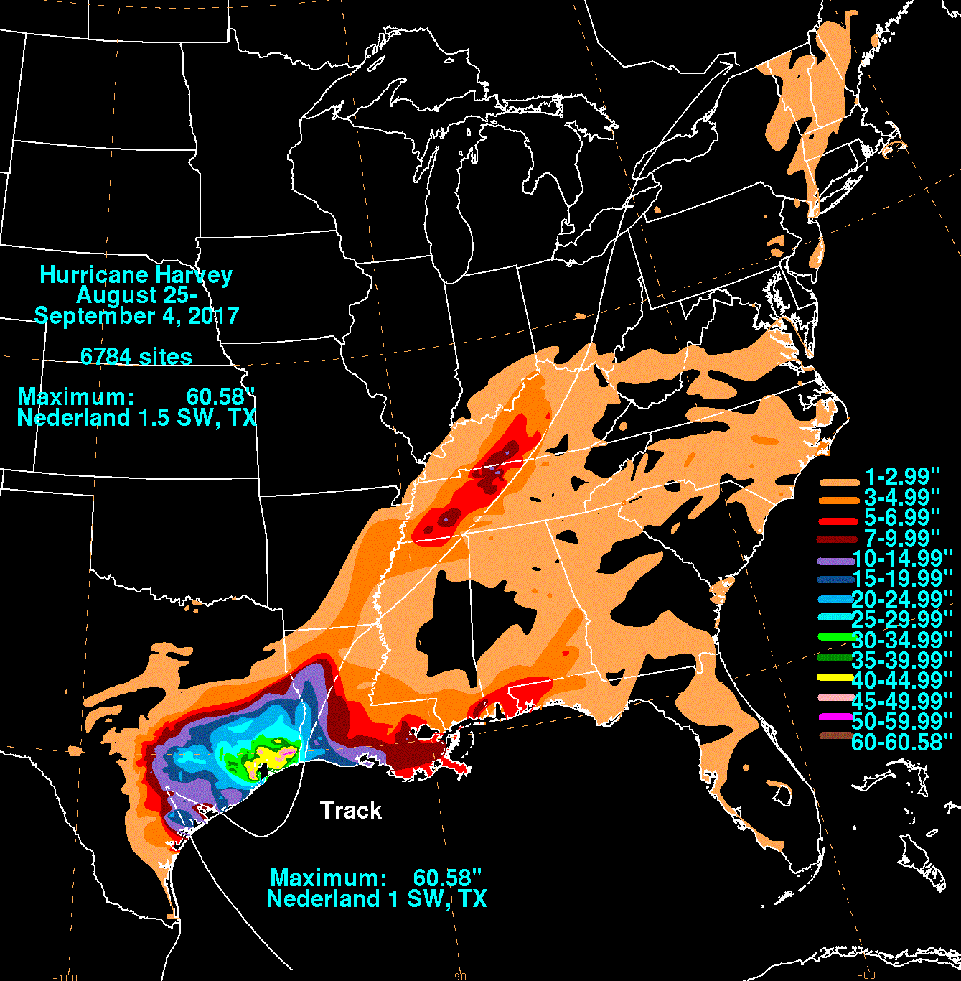

Source: Weather Prediction Center

The ensuing flooding ended up causing 68 direct deaths and a damage toll, while still uncertain, ranging from $90 to 160 billion with the latest best estimate being $125 billion.[3] The recovery from Harvey’s impact will take years[4].

A reasonable question that arises: **Can Harvey’s rainfall can be attributed to global warming (manmade climate change)?**  There have been some statements issued by climate scientists publicly concluding nearly one-third (30%) of Harvey’s total rainfall[5] was due to increased greenhouse gases and the global warming that they produce. If this is the case, then manmade global warming would have caused much of the extremely destructive flooding that has occurred. But is this a credible assessment?

**Is the Rain from Harvey a New Record for the United States?**

The first place to look for an answer is with the observed tropical storm and hurricane rainfall record. Harvey has indeed set the record for most amount of rainfall for any continental United States going back at least to the 1880s when comprehensive records begin. The previous top four rainfall producers were 1978’s Tropical Storm Amelia[6] with 48” (1225 mm) also in Texas, 1950’s Hurricane Easy[7] with 45” (1150 mm) in Florida, 1979’s Tropical Storm Claudette[8] with 45” (1150 mm) in Florida, and 2001’s Tropical Storm Allison[9] with 40” (1025 mm) in Texas.

What occurred from Harvey in Texas and Louisiana is similar to, in particular, Tropical Storms Claudette and Allison: all three meandered for a few days over the area as a tropical storm. But both the peak amount of rainfall from Harvey as well as Harvey’s areal extent of extreme rainfall amount (at least two feet – 610 mm) substantially surpassed either of these earlier storms. (It is worth noting that even though Harvey struck Texas as a Category 4 hurricane on the Saffir-Simpson Hurricane Wind Scale, nearly all of the rainfall in southeastern Texas and southwestern Louisiana occurred far from Harvey’s center while the system had weakened to a tropical storm.)

So, it is true that Harvey set a new record for maximum amount of rainfall as well as areal extend of extreme rain amounts from a tropical storm or hurricane in the continental United States. Reliable records for maximum amount of rainfall and areal extent from tropical storms and hurricanes begin in the 1880s.[10]

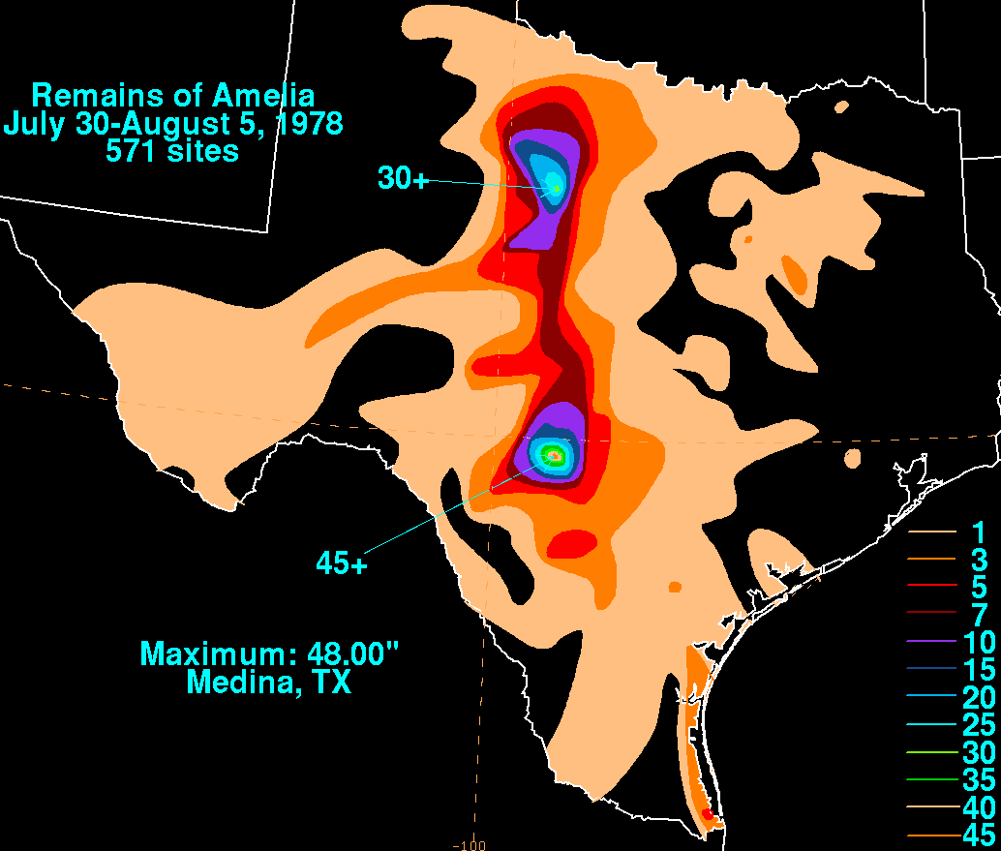 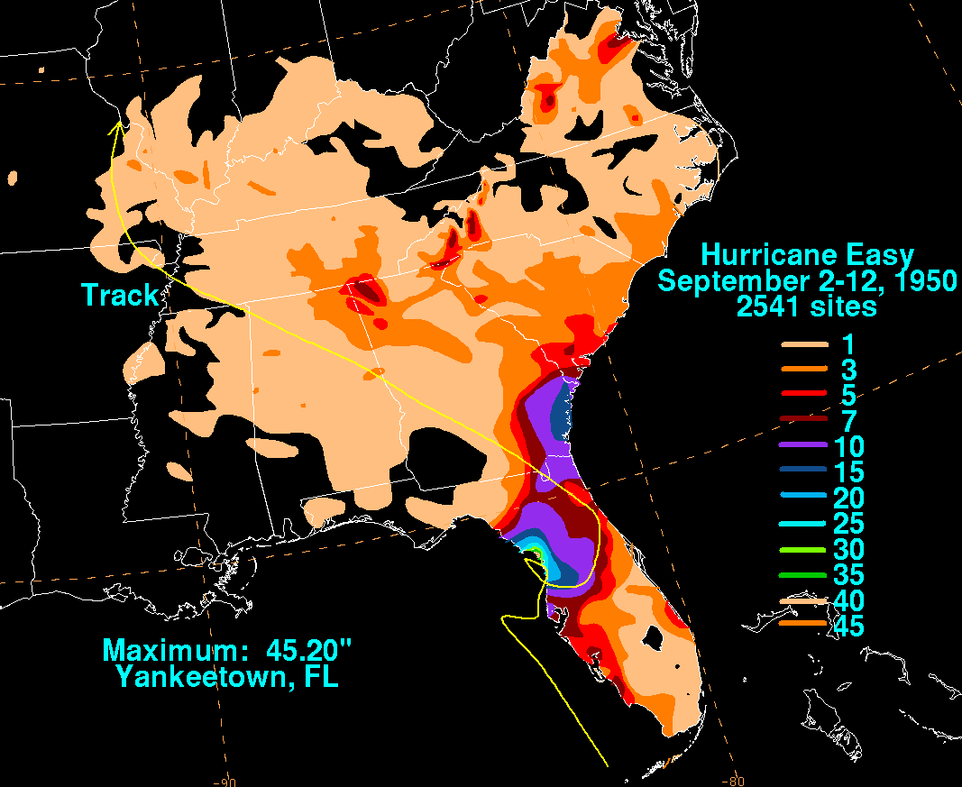

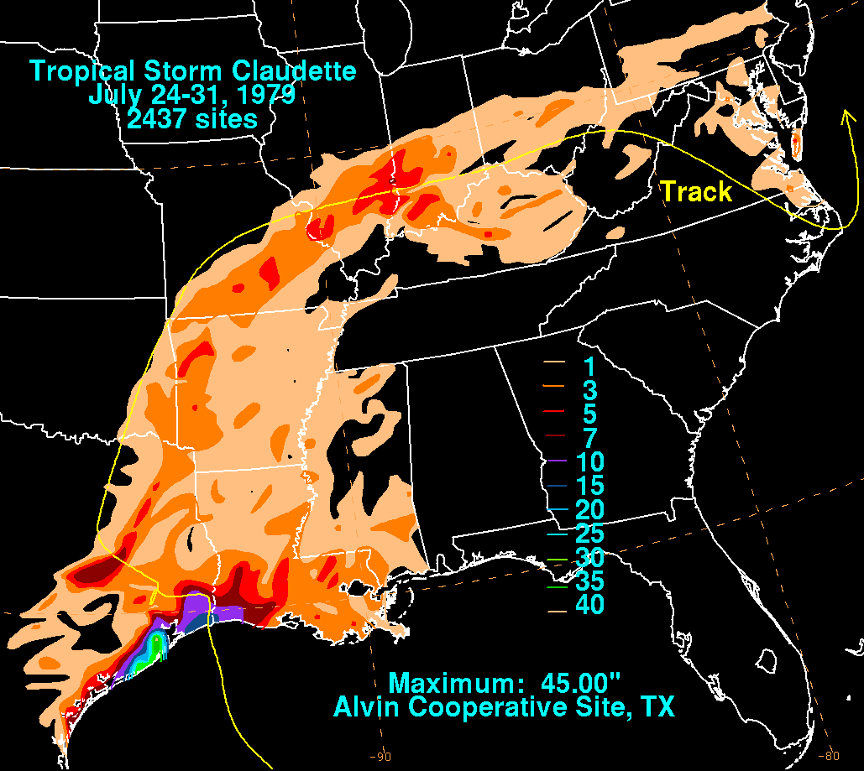 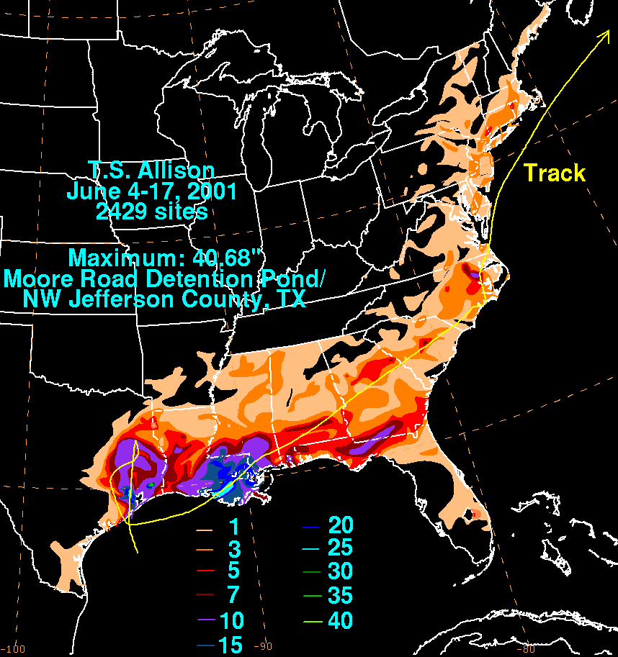

**Have there been any upward trends in U.S. tropical storm and hurricane rainfall?**

Somewhat surprisingly, the last research paper that thoroughly addressed this question was over a decade ago. Pavel Groisman and colleagues[11] showed back in 2004 that the September-November rainfall from tropical storms and hurricane did not show a significant upward trend for the time period of 1900 through 2000. The figure below shows (in the blue line) the amount of tropical storm and hurricane-related rainfall. While no long-term trend is apparent, instead the time series suggests periods of less rainfall (1900s to early 1920s), more rainfall (late 1920s to late 1960s), less rainfall (early 1970s to mid-1990s), and possibly more rainfall beginning again in the late 1990s. These decade-to-decade swings match closely the overall hurricane numbers for the Atlantic Ocean, Caribbean Sea, and Gulf of Mexico[12]. Bottom line is that there has not been a meaningful change in U.S. tropical storm and hurricane rain over the last century, but that there have been few studies to address the topic lately.

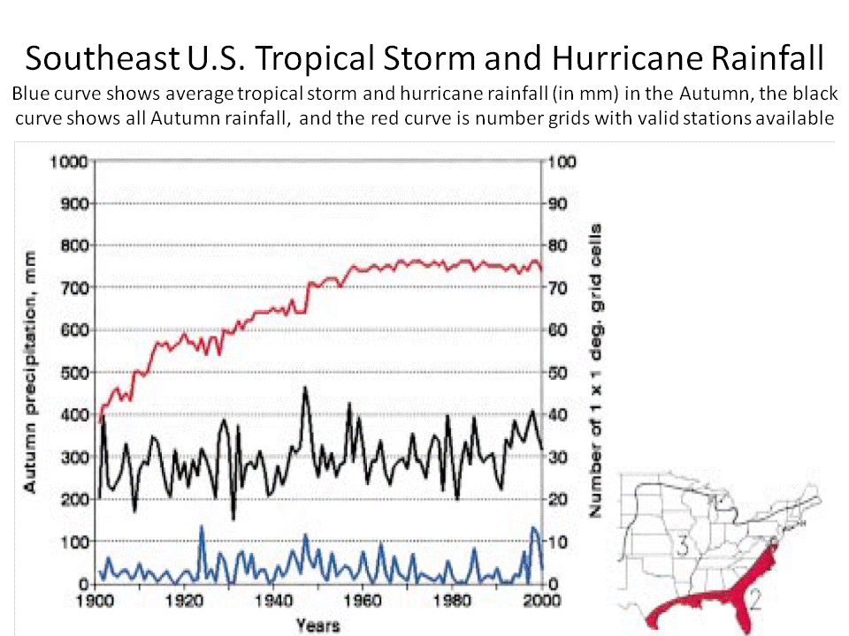

From Groisman et al. (2004)

**How much is hurricane rainfall expected to increase because of manmade climate change?**

Anthropogenic (manmade) climate change is occurring due to additional greenhouse gases – primarily carbon dioxide and methane – being placed into the atmosphere. There has been some warming of the atmosphere, earth’s surface, and oceans over the last few decades. Understanding the causes of the warming is difficult because many factors may be at play, including land surface changes (forests becoming farms, farms becoming cities and suburbs), aerosols (such as soot and dust), solar radiance, natural climate variations, as well as greenhouse gas increases. However, evidence from theory and modeling (using sophisticated computer programs to simulate the earth’s weather over the period of decades or centuries) is convincing that some of this warming is due to the growing greenhouse gases.[13]

Hurricanes are often linked by the public, media, and scientists to manmade climate change. [Another writeup](http://www.aoml.noaa.gov/hrd/Landsea/gw_hurricanes/index.html) I have provided discusses the relationship between manmade climate change versus hurricane numbers, winds, surge, formation location, and track. Rainfall from hurricanes might be expected – intuitively – to increase in a globally warmed world, as a warmer atmosphere can hold more moisture. Theory suggests that the amount of rainfall in the tropical latitudes would go up about 4% per oF sea surface temperature (7% per oC). Climate models forced by assuming continued emissions of greenhouse gases suggest around 2-2.5 oF (1-1.5 oC) warming by the year 2100, or about 10% more tropical rainfall.[14]

Studies examining future hurricanes in very fine resolution computer models suggest that rain inside hurricane may increase at a faster rate, perhaps 20% more rain within about 60 miles (100 km) of the center by the end of this century.[15] For some reason, the internal structure of the eyewall (the ring of violent thunderstorms surrounding the quiet eye) is more efficient in wringing out rainfall, likely associated with the slight increase in how strong hurricane winds may be.

However, only about one-fifth of all the rain in hurricanes occur within that 60 mile radius, see example below with red 60 mile ring for Hurricane Floyd. One has to examine out to 180 mile (300 km) radius circle to encompass about three-quarters of the total hurricane rain and out to 300 mile (500 km) radius circle for nearly all (~95%) of the rain.[16]

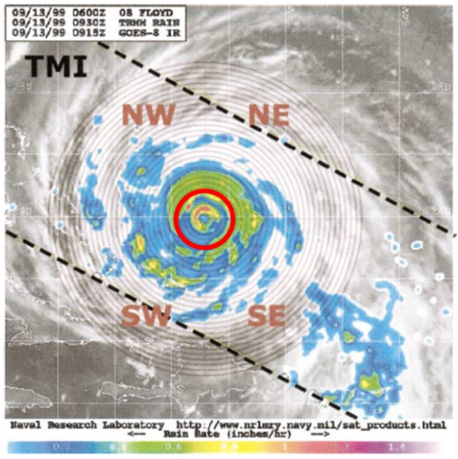

From Lonfat et al. (2004)

Indeed, hydrologists[17] typically use a 300 mile (500 km) radius when looking at flooding rains from hurricanes. It turns out that the possible change in hurricane rain inside this 300 mile (500 km) radius circle is the same as the overall change to tropical latitude rainfall (see figure below): **about 10% more total hurricane rainfall due to global warming by 2100**.[18]



From Knutnson et al. (2013)

**So, how has hurricane rainfall changed today because of global warming?**

The tropical North Atlantic Ocean, Caribbean Sea, and Gulf of Mexico have warmed up about 0.7 oF (0.4 oC) in the last few decades, much of which appears to be due to anthropogenic climate change (increased greenhouse gases)[19]. Scaling the results from both theory as well as climate model projections suggest, then, that roughly **3% of hurricane rainfall today can be reasonably attributed to manmade global warming**. This value is a rather tiny contribution. Thus **only about 2” (50 mm) of Hurricane Harvey’s peak amount of 60” (1525 mm) can be linked to manmade global warming.** (Note thatthe interpretation of Harvey’s rainfall is also made more uncertain because the source of much of the rainfall was due to the interaction of the very slow moving tropical storm with a stationary frontal boundary along the Texas/Louisiana coast. Such a complex situation has not been explicitly addressed with climate model simulations.)

A new paper by Kerry Emanuel[20] suggests from his downscaling-from-climate-model technique that the annual chance of at least 500 mm (20”) of rain over Texas like that seen from Hurricane Harvey would increase from about 1% between 1981-2000 to 18% by the end of the 21st Century assuming business as usual emissions. Moreover, he concludes that the risk from a Harvey event has already increase sixfold in 2017 (a 6% chance of occurrence yearly) versus that from just a couple decades ago. These projections appear, in my view, to be extremely inconsistent with current theoretical rainfall projections as well as explicit dynamical model forecasts from climate models as detailed above. Why the study using Emanuel's downscaling technique is inconsistent with climate model projections and theory is unknown. However, it has been pointed out[21] that this methodology has shown similar extreme inconsistencies with global climate models with respect to, for example, tropical storm and hurricane frequency (e.g., Emanuel's downscaling technique showing a large increase in numbers while explicitly counting the cyclones from the climate models showing no change or decreasing numbers). Thus I do not consider Emanuel’s findings to be reliable.

**What lessons can be learned from Harvey’s catastrophic flooding?**

There are several important points that should be recognized in the aftermath of Harvey’s impact:

1. Hurricanes (and Tropical Storms) have been associated for millenniums with extreme rainfall and freshwater flooding. There is nothing that one can do to prevent these storms from occurring, hitting land, and impacting people;
2. Massive flooding and catastrophic impact from tropical storms and hurricanes occurs when the system moves slowly over a major city. This is precisely what happened because of Harvey as a tropical storm over Texas;
3. Flooding is made worse when extreme rainfall occurs over impervious land (such as roads and buildings) and the rain cannot soak in. Land use decisions should better consider allowing building (or rebuilding) in flood prone areas;
4. Studies should be made to see if evacuating people in advance of extreme flooding rain is feasible. (Currently, only evacuations from hurricanes are primarily issued from possible storm surge – salt-water – flooding. However, because the skill of in day-to-day rainfall amounts and locations continues to improve, it might be feasible to call for limited evacuations in the most vulnerable locations.);
5. Linking hurricane rainfall to global warming today (and even decades from now) based upon such a tiny contribution is misleading. Moreover, such a fixation can delay steps that can be taken now to better mitigate the effects of extreme flooding from hurricanes. See the following sites for more action today that can be taken: the Federal Emergency Management Agency ([FEMA](https://www.fema.gov/coastal-flood-risks-achieving-resilience-together)), the Insurance Institute for Business and Home Safety ([IIBHS](https://disastersafety.org/)), the Environmental Protection Agency ([EPA](https://www.epa.gov/sites/production/files/2015-08/documents/flood_resilience_guide.pdf)), and academia ([University of Colorado](http://sciencepolicy.colorado.edu/research_areas/), [University of Pennsylvania](https://riskcenter.wharton.upenn.edu/), and [University of Iowa](http://www.iihr.uiowa.edu/research/iowa-flood-center/)).

1. Christopher W. Landsea is the Science and Operations Officer at the National Weather Service's National Hurricane Center in Miami, FL. Chris's responsibilities at NHC include hurricane and marine weather forecasting, training, outreach, and transitioning research results into operations. He also leads efforts in reanalyzing the historical hurricane records to provide a more complete, reliable database. Before joining NHC in 2005, he had previously worked for ten years at the Hurricane Research Division also in Miami. While at HRD, Chris participated in the annual Hurricane Field Program flying into and around 15 hurricanes aboard the Aircraft Operation Center's Orion P-3 and Gulfstream IV aircraft, as well as conducting research into the seasonal and climate variations of hurricanes. Much of his career within NOAA (the National Oceanic and Atmospheric Administration, of which NHC, NWS, HRD, and AOC are a part) has focused upon research into how hurricanes have changed over the historical record and how this relates to manmade global warming. Chris has published a few dozen peer-reviewed papers on the topics of the Atlantic hurricane database, hurricane changes over time, and the effects of man-made global warming on hurricanes. These papers are available [here](http://www.aoml.noaa.gov/hrd/Landsea/landsea_bio.html). It should be noted that the following discussion is Chris Landsea's opinion only and is not representing any official position of NHC, NWS or NOAA in general. Various scientists within NOAA have differing opinions about global warming's impact on hurricanes and there is no official NOAA policy on the topic. Varying ideas on an issue often mean that it is a science in progress with no definitive answers. That is certainly the case with regards to global warming and hurricanes. This summary reflects the state of the science as of January 2018.
2. Eric Blake and Dave Zelinsky, 2018, in [Hurricane Harvey, Tropical Cyclone Report](https://www.nhc.noaa.gov/data/tcr/AL092017_Harvey.pdf)
3. Eric Blake and Dave Zelinsky, 2018, in [Hurricane Harvey, Tropical Cyclone Report](https://www.nhc.noaa.gov/data/tcr/AL092017_Harvey.pdf)
4. Federal government plans years-long recovery effort in states hit by Harvey <https://www.usatoday.com/story/news/politics/2017/08/27/federal-emergency-officials-preparing-years-recovery-efforts-states-hittexas-and-other-harvey-target/606036001/>
5. Kevin Trenberth in The Atlantic [“Did Climate Change Intensify Hurricane Harvey”](https://www.theatlantic.com/science/archive/2017/08/did-climate-change-intensify-hurricane-harvey/538158/) – August 28, 2017; Kevin Trenberth in CBCNEWS [“Climate Change Likely Helped Fuel Harvey’s Strength”](http://www.cbc.ca/news/technology/hurricane-harvey-climate-change-1.4265636) – August 28th, 2017
6. David Roth’s Tropical Cyclone Rainfall Analyses for the United States, [Tropical Storm Amelia](http://www.wpc.ncep.noaa.gov/tropical/rain/amelia1978filledrainblk.gif)
7. David Roth’s Tropical Cyclone Rainfall Analyses for the United States, [Hurricane Easy](http://www.wpc.ncep.noaa.gov/tropical/rain/easy1950filledrainblk.gif)
8. David Roth’s Tropical Cyclone Rainfall Analyses for the United States, [Tropical Storm Claudette](http://www.wpc.ncep.noaa.gov/tropical/rain/claudette1979filledrainblk.gif)
9. David Roth’s Tropical Cyclone Rainfall Analyses for the United States, [Tropical Storm Allison](http://www.wpc.ncep.noaa.gov/tropical/rain/allison2001rainfilledblk.GIF)
10. David Roth, 2017, personal communication
11. Pavel Groisman and colleagues, 2004, in [*Journal of Hydrometorology*](http://journals.ametsoc.org/doi/pdf/10.1175/1525-7541%282004%29005%3C0064%3ACCOTHC%3E2.0.CO%3B2)
12. Gabe Vecchi and Tom Knutson, 2011, in [*Journal of Climate*](http://journals.ametsoc.org/doi/pdf/10.1175/2010JCLI3810.1)
13. Global Warming Frequently Asked Questions - <https://www.climate.gov/news-features/understanding-climate/global-warming-frequently-asked-questions>
14. Tom Knutson and colleagues, 2013, in [*Journal of Climate*](http://journals.ametsoc.org/doi/pdf/10.1175/JCLI-D-12-00539.1)
15. Tom Knutson and colleagues, 2013, in [*Journal of Climate*](http://journals.ametsoc.org/doi/pdf/10.1175/JCLI-D-12-00539.1)
16. Manuel Lonfat and colleagues, 2004, in [*Monthly Weather Review*](http://journals.ametsoc.org/doi/pdf/10.1175/1520-0493%282004%29132%3C1645%3APDITCU%3E2.0.CO%3B2)
17. Gabriele Villarini, 2017, personal communication
18. Tom Knutson and colleagues, 2013, in [*Journal of Climate*](http://journals.ametsoc.org/doi/pdf/10.1175/JCLI-D-12-00539.1)
19. Dave Enfield and Luis Cid-Serrano, 2010, in [*International Journal of Climatology*](http://www.aoml.noaa.gov/phod/docs/Enfield_Cid_2010.pdf)
20. Kerry Emanuel, 2017, in [*Proceedings of the National Academy of Sciences*](http://www.pnas.org/content/114/48/12681.full.pdf?sid=87780a96-c2f7-4931-820b-8147628ccdb1)
21. Suzana Carmago and Allison Wing, 2016, in [*WIREs Climate Change*](http://onlinelibrary.wiley.com/doi/10.1002/wcc.373/abstract)