7. SFMR High-Incidence Angle Measurements

Principal Investigator(s): Heather Holbach (lead), Brad Klotz, and Mark Bourassa (FSU)

Link to IFEX:
- Goal 2: Develop and refine measurement technologies that provide improved real-time monitoring of TC intensity, structure, and environment.

Motivation:
Surface winds in a tropical cyclone are essential for determining its intensity. Currently, the Stepped-Frequency Microwave Radiometer (SFMR) is used for obtaining surface wind measurements at nadir. Due to poor knowledge about sea surface microwave emission at large incidence angles and high wind speeds, SFMR winds are only retrieved when the antenna is pointed directly downward from the aircraft during level flight. Understanding the relationship between the SFMR measured brightness temperatures, surface wind speed, wind direction, and the ocean surface wave field at off-nadir incidence angles would potentially allow for the retrieval of wind speed measurements when the aircraft is not flying level. It is hypothesized that at off-nadir incidence angles the distribution of foam on the ocean surface from breaking waves impacts the SFMR measurements differently than at nadir and is dependent on polarization. Therefore, by analyzing the excess brightness temperature at various wind speeds and locations within the tropical cyclone environment at off-nadir incidence angles, the relationship between the ocean surface characteristics and the SFMR measurements will be quantified as a function of wind direction relative to the look angle and polarization.

Background:
Currently, if the aircraft pitch or roll angle exceeds a threshold of ± 5°, wind speeds are not reported for the SFMR. These thresholds result in wind speeds not being provided when the aircraft turns or if the aircraft exceeds the pitch threshold while flying a constant pressure surface through the eyewall where the highest wind speeds are usually measured. By understanding the physics of the air-sea interaction between the wind and sea surface, it will be possible to develop corrections for the SFMR algorithm to obtain wind speed measurements when the aircraft is not flying level.

Hypotheses:
- Hypothesis #1: Collecting high-incidence angle SFMR data will allow for quantification of the changes in the SFMR brightness temperature at off-nadir incidence angles that are related to the wind direction relative to the look angle and polarization.

Experiment/Module Description:
Two down-looking SFMRs should be mounted on the P-3 aircraft. The operational wing-pod mounted SFMR should be operating as usual. A second SFMR is to be mounted parallel to the latitudinal axis of the airframe (rotated 90° from the operational position). When the aircraft rolls, the operational SFMR will be collecting off-nadir data at H-pol and the second SFMR will be collecting off-nadir data at V-pol, simulating the data that the SFMR would collect when the aircraft pitches. The high-incidence angle modules can be flown during any mission with any flight pattern and are designed to obtain SFMR measurements in various locations of the tropical cyclone environment at several different wind speeds during constant banked aircraft turns at several different roll angles, specified below. A full pattern for each module consists of three complete circles for each specified roll angle (Figure 1). It is important to maintain as constant of a roll angle, pitch angle, and altitude as possible. A dropsonde and AXBT pair should be released at the beginning of the pattern. The wide swath radar altimeter (WSRA), if available, should also be obtaining measurements during the pattern for analysis of the ocean surface characteristics. The wave spectra obtained by the WSRA will allow for a more accurate investigation of the sensitivity of the SFMR to the surface wave characteristics. It is ideal to fly these modules in rain-free areas as to reduce the impact of the atmospheric emission on the SFMR measurements and to obtain measurements in regions of moderate to heavy precipitation, as deemed safe by the aircraft pilots, in order to understand the impact of varying the path length of the precipitation.

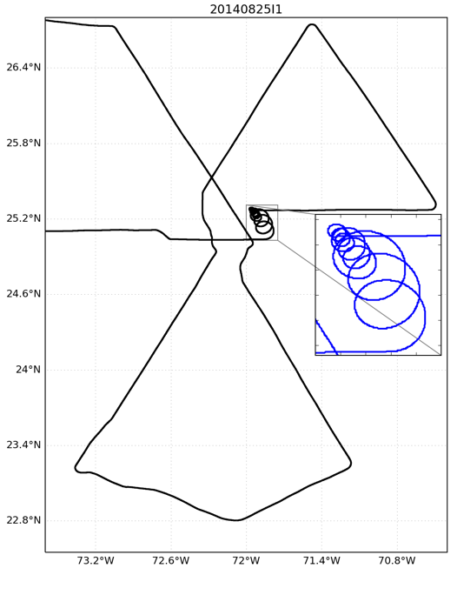
Figure 1: Example flight path (black) with SFMR high-incidence angle module. The inset zoomed in portion with the blue track displays the SFMR module in more detail.

Modules:
- Zero wind, high incidence angle response
  - This module is designed to determine the antenna pattern corrections and possible impacts of sun glint
  - Fly circles at roll angles of 15, 30, 45, and 60 degrees

- Moderate wind response (~15 m/s, 30 kts)
  - This module is designed to understand the mixed “phase” (i.e., foam vs roughness contributions to brightness temperature)
  - Fly circles at roll angles of 15, 30, and 45 degrees

- Moderate winds (~15 m/s, 30 kts) and substantial swell or varying fetch length response
  - This module is designed to determine the sensitivity to stress
  - This can be performed on the way to the storm or in different sectors of the storm
  - Fly circles at roll angles of 15, 30, and 45 degrees

- Strong wind response (>30 m/s, 60 kts)
  - This module should be flown in multiple storm quadrants (motion relative)
  - Fly circles at roll angles of 15, 30, and 45 degrees

Thus far, measurements have been obtained primarily on the right side of storms (Figure 2). To develop a more complete composite picture, we are particularly interested in obtaining measurements on the left side of storms (motion relative) this season. We would also like to focus on regions with wind speeds greater than 20 m/s.

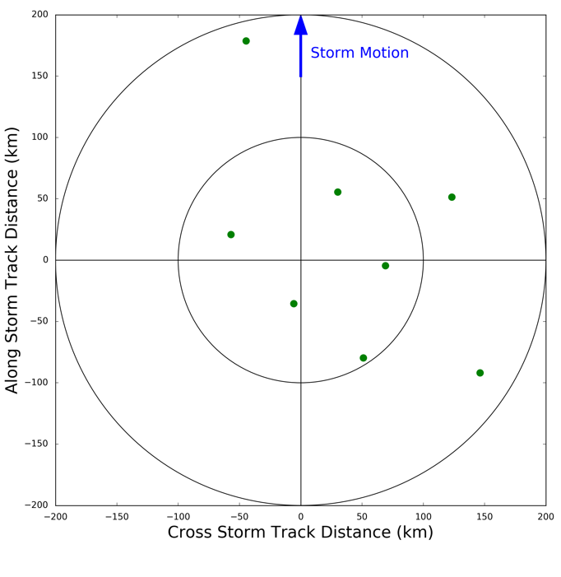
Figure 2: Storm-relative locations of high-incidence angle SFMR observations obtained in previous seasons.

Analysis Strategy:
The SFMR data from these flights will be analyzed to quantify the double harmonic oscillation that is evident in high-incidence angle SFMR data collected during previous seasons. The WSRA data will then be used to analyze the differences in the ocean surface characteristics to reveal any possible relationships between the double harmonic oscillation found in the SFMR measurements and the ocean surface characteristics. Wind direction from the dropsondes will be used to adjust the flight level wind directions to the surface to compute the relative look angle of the SFMR to the surface wind direction. Wind speed from the dropsondes will be used to quantify the differences in the SFMR brightness temperatures expected at nadir with the high-incidence angle measurements. SST from the AXBTs will be used as input to the brightness temperature algorithm.

