3. Offshore Wind Module

Principal Investigators: Shirley Murillo and Bachir Annane

Links to IFEX:
- Goal 1: Collect observations that span the TC life cycle in a variety of environments for model initialization and evaluation.
Motivation:
Modern offshore turbines are huge structures with masts near 100 m above the surface and rotor zones extending to near 180 m. Conventional offshore turbines are erected upon foundations constructed in shallow (<40 m) water but new designs for deep water turbines are in operation off Norway and Portugal and expected off the coast of Maine as part of a Department of Energy funded program to get demonstration projects in the water. Current standards for the design of tall offshore structures are governed by power law wind profiles specified with constant roughness or wind profiles based on Norwegian Sea that are unrepresentative when compared to GPS sonde based hurricane wind profiles. Turbulence intensity specifications used for the design of offshore wind turbines specified according to a marine roughness that increases with wind speed. To better document design wind profiles in hurricane conditions, additional GPS sonde and airborne Doppler wind profiles are needed in relatively shallow water areas in the vicinity of the proposed wind farm locations. In addition, wave height and directional wave spectrum measurements from NOAA’s wide-swath radar altimeter are needed to determine wave loading.
Background: This module is designed as a multi-agency (NOAA, Department of Energy, Department of the Interior) supplemental data collection effort to gather hurricane environmental information in the vicinity of proposed offshore wind farms. Offshore wind energy is an important component of the U.S. supplying 80% of energy needs from clean energy by the year 2030. The Bureau of Ocean Energy Management (BOEM) has identified several wind energy and lease areas in federal waters off the Atlantic coast and the Department of Energy has identified additional areas as demonstration projects for offshore wind power development. For offshore wind energy to develop into a new industry, the turbines must be designed to withstand extreme environmental conditions that occur during hurricanes.
Hypotheses: None
Experiment/Module Description: This module is generally a “piggyback” mission. We request additional GPS sonde launches in the vicinity of the wind farm location. The PIs will provide data collection coordinates to the Lead Project Scientist of the primary mission. This module is requested whenever a NOAA aircraft is flying and the hurricane is projected to be within 150 nm of an identified offshore wind development sites (Table 1).
Analysis Strategy: We plan to analyze the coastal offshore wind profiles in hurricane conditions. We will use the profile method to diagnose the friction velocity, roughness and drag coefficient as a function of wind speed, upstream fetch, water depth, and latitude. Then we will compare the observed mean wind profiles to those specified by various standards agencies. We will develop hurricane extreme wind return period maps within the turbine zone or at the surface, for offshore wind, and associated transmission facility locations identified offshore the Gulf of Mexico and the U. S. Atlantic coast for the wind industry use. The maps will include 20, 50, 100, and 250-year return period wind speeds at turbine height, rotor upper limit, rotor lower limit, and the surface (10 meters).

References:
Hong, L., and B. Moller, 2011: Risks of tropical cyclones on offshore wind farms in China. 6th Dubrovnik Conf. on Sustainable development of energy water and environmental systems. September 25 - 29, 2011, Dubrovnik, Croatia.

International Electro-technical Commission (IEC), 2005: IEC 61400-1 Ed. 3, Wind turbines - Part 1: Design requirements.

International Electro-technical Commission (IEC), 2008: IEC 61400-3 Ed. 1, Wind turbines - Part 3: Design requirements for offshore wind turbines.

Ishihara, T., Yamaguchi, A., Takahara, K., An analysis of damaged wind turbines by Typhoon Maemi in 2003. Seoul, Korea, 2005. pp. 1413-1428. 6th Asia-Pacific Conference on Wind Engineering, Seoul, Korea, Sept. 12-14, 2005.

Powell, M. D., and S. Cocke, 2012: Hurricane wind fields needed to assess risk to offshore wind farms. Proc. Natl. Acad. Sciences, doi/10.1073/pnas.1206189109.

Powell, M. D., G. Soukup, S. Cocke, S. Gulati, N. Morisseau-Leroy, S. Hamid, N. Dorst, and L. Axe, 2005: State of Florida hurricane loss projection model: Atmospheric science component. J.Wind Engineer. and Indust. Aerodyn., 93, 651-674.

Russell, L. R., 1971: Probability distributions for hurricane effects. Journal of Waterways, Harbors, and Coastal Engineering Division, ASCE, 97, 139-154.

Vickery, P. J., P. F. Skerjl, , and L. A. Twisdale, 2000b: Simulation of hurricane risk in the United States using an empirical storm track modeling technique, Journal of Structural Engineering., 126, 1222-1237.

Vickery, P. J., F. J. Masters, M. D. Powell, D. Wadhera, 2009: Hurricane hazard Modeling: The past, present, and future. J. Wind Eng. Ind. Aerodyn., doi:10.1016/j.jweia.2009.05.005

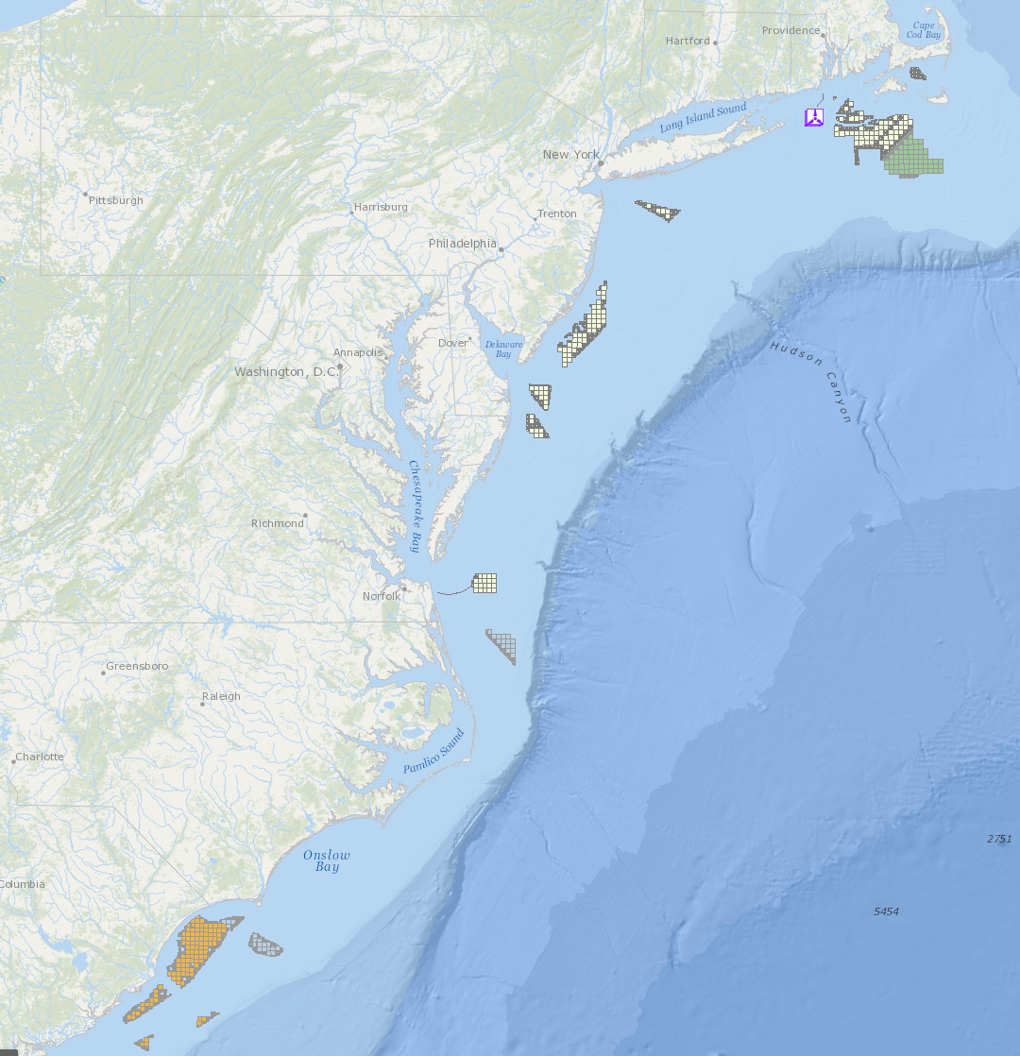
Figure 1: Potential offshore wind farm and Atlantic Wind Connection subsurface transmission line locations in federal waters off the U. S. Atlantic coast. Additional areas include state waters off Nantucket Sound MA, Block Island RI, Atlantic City NJ, Virginia Beach VA and Georgia. (Table 1).

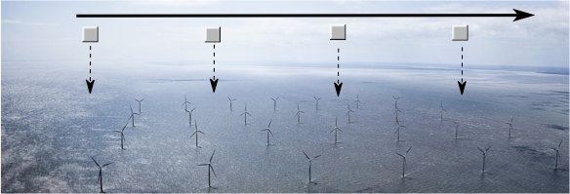
Figure 2: Schematic of piggyback pattern showing hypothetical wind farm fly-by with expendable launches at a 2-4 km interval. (Dong Energy Gunfleet Sands 1farm off SE England)

Offshore Wind Farm | Location | State or Federal
Fisherman’s Energy | Atlantic City, NJ (3 miles offshore) | State
Dominion Virginia Power | Virginia Beach | Federal
Statoil North America (Hywind Maine) | Boothbay Harbor | State
University of Maine (DeepCwind) | Monhegan Island | State
Deepwater Wind | Block Island (5 mi SE) | State
Cape Wind | Nantucket Sound (Horseshoe shoal) | State
Maryland Wind Energy Area | See Fig. 1 | Federal
Rhode Island Wind Energy Area | See Fig. 1 | Federal
New Jersey Wind Energy area | See Fig. 1 | Federal
Maryland Wind Energy Area | See Fig. 1 | Federal
Virginia Wind Energy Area | See Fig. 1 | Federal
Delaware | See Fig. 1 | Federal
North Carolina | See Fig. 1 | Federal
South Carolina | See Fig. 1 | Federal
Table 1: Listing of DOE funded demonstration projects and other offshore wind developments planned or projected in state and federal waters.

Observing system | Measurement | Number | Type
GPS sonde | Pressure, Temperature, Humidity, Velocity | 4-10 | Ex
Stepped Frequency Microwave Radiometer (SFMR) | Surface wind speed  rain rate |  | A/C
NOAA wide-swath radar altimeter | wave height and directional wave spectrum |  | A/C
Airborne Doppler radar | 3D wind velocity, rain rate |  | A/C
Lower fuselage radar | reflectivity |  | A/C
Table 2: Expendables (Ex) and aircraft (A/C) measurement systems required for conducting offshore wind experiment.

