2017 Hurricane Field Program Plan
Part II: Scientific Justification

TABLE OF CONTENTS

INTRODUCTION…………………………………………………………………….………….... 1
EXPERIMENT AND MODULE DESCRIPTIONS…………………………………….............. 2
IFEX GOAL 1
1. P-3 Three-Dimensional Doppler Winds Experiment…..………………………………….... 2
2. G-IV Tail-Doppler Radar Experiment....................…..……… ………………………......... 4
3. Offshore Wind Module …………………………………………………………………….... 6
IFEX GOAL 2
4. Doppler Wind Lidar (DWL) Experiment……………………………………………………... 11
5. Small Unmanned Aerial Vehicle Experiment (SUAVE)……………………………...…...... 14
6. NESDIS Ocean Winds and Rain Experiment……………………………………………….. 23
7. SFMR High-Incidence Angle Measurements Module......………………………………........ 25
8. SFMR-CYGNSS Validation Module……………………………………………………...... 28
9. G-IV SFMR Validation Module……………………………………………………….......... 29
10. Underwater Glider Module…………………………………………………………............ 32
IFEX GOAL 3
11. Easterly Wave Genesis Experiment ………………………………………………..……….. 38
12. Analysis of Intensification Processes Experiment (AIPEX).……………………………… 45
13. TC in Shear Experiment.……………………………………..…………….…………........ 51
14. TC Diurnal Cycle Experiment………………………………………………………....…........ 61
15. TC-Ocean Interaction Experiment …………………………………….................................... 66
16. Tropical Cyclone Landfall Experiment………………………………………………......... 78
17. Convective Burst Module................................…………………………………………....... 83
18. Eye-eyewall Mixing Module ……………………………………………………………… 89
19. Secondary Eyewall Formation/Eyewall Replacement Cycle Module ……………………….. 90
20. Arc Cloud Module …………………………………………………………………………… 94
21. Extratropical Transition Experiment…………………………..……...…………………….. 97

2017 HURRICANE FIELD PROGRAM PLAN: SCIENTIFIC JUSTIFICATION

INTRODUCTION
In this Part II of the Field Program Plan, the scientific justification for the experiments and modules described in Part I (the main Field Program document) is presented. The discussion here for each experiment or module includes:

- a listing of the primary IFEX goals addressed,
- motivation and background,
- specific hypotheses being tested (if applicable),
- an extended description of the mission,
- the data analysis plan, and
- any relevant references

The PIs are encouraged to reference flight modules described in Part I (e.g., "see P-3 Module 1") rather than reproduce them here. Additionally, PIs are encouraged to limit descriptions of the flight patterns to what is absolutely necessary to justify the scientific goals. For details regarding specific flight modules, the reader is referred to the experiment or module presentation in Part I.

EXPERIMENT AND MODULE DESCRIPTIONS

1. P-3 Three-dimensional Doppler Winds Experiment

Principal Investigator(s): John Gamache (lead), Sim Aberson, Altug Aksoy, Peter Dodge, Sonia Otero, Paul Reasor, Kathryn Sellwood, Jason Sippel, John Hill (AOC), Mingjing Tong, Vijay Tallapragada (EMC)

Links to IFEX:
- Goal 1: Collect observations that span the TC life cycle in a variety of environments for model initialization and evaluation.
- Goal 2: Develop and refine measurement technologies that provide improved real-time monitoring of TC intensity, structure, and environment.
- Goal 3: Improve understanding of the physical processes important in intensity change for a TC at all stages of its lifecycle.
Motivation:
This experiment is a response to the requirement listed as Core Doppler Radar in Section 5.4.2.9 of the National Hurricane Operations Plan. The goal of that particular mission is to gather airborne-Doppler wind measurements that permit an accurate initialization of HWRF, and also provide three- dimensional wind analyses for forecasters.
There are five main goals: 1) to provide a comprehensive data set for the initialization (including data assimilation) and validation of numerical hurricane simulations (in particular HWRF), 2) to improve understanding of the factors leading to TC intensity and structure changes by examining as much of the life cycle as possible, 3) to improve and evaluate technologies for observing TCs, 4) to develop rapid real-time communication of these observations to NCEP, and 5) to contribute to a growing tropical-cyclone database that permits the analysis of statistics of quantities within tropical cyclones of varying intensity.
Background:
The real-time analysis of tail Doppler radar data was made possible by an automated quality control process (Gamache 2005) and variational wind synthesis method (Gamache 1997; Reasor et al. 2009).
Hypotheses:
- Hypothesis: Improving representation of a storm's inner core in the HWRF initial conditions through assimilation of the P-3 TDR data leads to reduced error in short-term structure and intensity forecasts.
Experiment/Module Description:
NOAA will conduct a set of flights during several consecutive days, encompassing as much of a particular storm life cycle as possible. This would entail using P-3s on back-to-back flights on a 12-h schedule when the system is at depression, tropical storm, or hurricane strength.
The ultimate requirement for EMC is to obtain the three-dimensional wind field of Atlantic TCs from airborne Doppler data every 6 h to provide an initialization of HWRF through assimilation every 6 h. The maximum possible rotation of missions is two per day or every 12 h. A “poor man’s” version of the 6 h data collection is to collect data in the last half of one 6-h observing period, and in the first half of the next 6-h observing period. In hurricanes, coordination will be required between HRD, NCEP, and NESDIS, to effectively collect observations for both the Three- Dimensional Doppler Winds Experiment and the Ocean Winds and Rain Experiment, a NESDIS program designed to improve understanding of satellite microwave surface scatterometery in high-wind conditions over the ocean by collecting surface scatterometery data and Doppler data in the boundary layer of hurricanes.
At times when more than one system could be flown, one may take precedence over others depending on factors such as storm strength and location, operational tasking, and aircraft availability. All other things being equal, the target will be an organizing tropical depression or weak tropical storm, to increase the observations available in these systems. One scenario could likely occur that illustrates how the mission planning is determined: an incipient TC, at depression or weak tropical storm stage is within range of an operational base and is expected to develop and remain within range of operational bases for a period of several days. Here, the highest priority would be to start the set of Three-Dimensional Doppler Winds flights, with single-P-3 missions, while the TC is below hurricane strength (preferably starting at depression stage), with continued single-P-3 missions at 12-h intervals until the system is out of range or makes landfall. During the tropical depression or tropical-storm portion of the vortex lifetime, higher azimuthal resolution of the wind field is preferred over radial extent of observations, while in the hurricane portion, the flight plan would be designed to get wavenumber 0 and 1 coverage of the hurricane out to the largest radius possible, rather than the highest temporal resolution of the eyewall. In all cases adequate spatial coverage is preferred over increased temporal resolution during one sortie.
The highest vertical resolution is needed in the boundary and outflow layers. This is assumed to be where the most vertical resolution is needed in observations to verify the initialization and model. For this reason it is desirable that if sufficient dropwindsondes are available, they should be deployed in the radial penetrations in the Three-Dimensional Doppler Winds experiment to verify that the boundary-layer and surface wind forecasts produced by HWRF resemble those in observations. These observations will also supplement airborne Doppler observations, particularly in sectors of the storm without sufficient precipitation for radar reflectivity. If sufficient dropwindsondes are not available, a combination of SFMR, Advanced Wind and Rain Airborne Profiler (AWRAP), and airborne Doppler data will be used for verification.

Analysis Strategy:
The emphasis here is on "real-time" products. Quality-controlled, thinned Doppler radials are output, packaged and transmitted to NCO for assimilation into the operational HWRF model. Similarly, Doppler radial superobs are transmitted for use by research groups. Three-dimensional and vertical profile analyses of wind and reflectivity are also produced. Plan-view images derived from the analyses are transmitted to a location where NHC hurricane specialists can view them. Additional products include composite analysis images with dropwindsonde winds overlaid and, most recently, wind and reflectivity structure images for real-time mission planning and viewing by NHC specialists.
References:
Gamache, J. F., 1997: Evaluation of a fully three-dimensional variational Doppler analysis technique. Preprints, 28th Conf. on Radar Meteorology, Austin, TX, Amer. Meteor. Soc., 422–423.
Gamache, J. F., 2005: Real-time dissemination of hurricane wind fields determined from airborne Doppler radar data. National Hurricane Center, 38 pp. [Available online at http://www.nhc.noaa.gov/jht/2003-2005reports/DOPLRgamache_JHTfinalreport.pdf.]
Reasor, P. D., M. Eastin, and J. F. Gamache, 2009: Rapidly intensifying Hurricane Guillermo (1997). Part I: Low-wavenumber structure and evolution. Mon. Wea. Rev., 137, 603–631.

2. G-IV Three-dimensional Doppler Winds Experiment

Principal Investigator(s): John Gamache (lead), Sim Aberson, Altug Aksoy, Peter Dodge, Sonia Otero, Paul Reasor, Kelly Ryan, Kathryn Sellwood, Jason Sippel, John Hill (AOC), Mingjing Tong, Vijay Tallapragada (EMC)

Links to IFEX:
- Goal 1: Collect observations that span the TC life cycle in a variety of environments for model initialization and evaluation.
- Goal 2: Develop and refine measurement technologies that provide improved real-time monitoring of TC intensity, structure, and environment.
- Goal 3: Improve understanding of the physical processes important in intensity change for a TC at all stages of its lifecycle.
Motivation:
This experiment is a response to the requirement listed as Core Doppler Radar in Section 5.4.2.9 of the National Hurricane Operations Plan. The goal of that particular mission is to gather airborne-Doppler wind measurements that permit an accurate initialization of HWRF, and also provide three- dimensional wind analyses for forecasters. This experiment is similar to the P-3 Three-Dimensional Winds experiment, but employs the G-IV platform and tail Doppler radar.
There are four main goals: 1) to evaluate the G-IV as a platform for observing the cores of TCs, 2) to improve understanding of the factors leading to TC structure and intensity changes, 3) to provide a comprehensive data set for the initialization (including data assimilation) and validation of numerical hurricane simulations (in particular HWRF), and 4) to develop rapid real-time communication of these observations to NCEP.
Background:
The real-time analysis of tail Doppler radar data was made possible by an automated quality control process (Gamache 2005) and variational wind synthesis method (Gamache 1997; Reasor et al. 2009).
Hypotheses:
- Hypothesis: Improving representation of a storm's inner core in the HWRF initial conditions through assimilation of the G-IV TDR data leads to reduced error in short-term structure and intensity forecasts.
Experiment/Module Description:
The ultimate requirement for EMC is to obtain the three-dimensional wind field of Atlantic TCs from airborne Doppler data every 6 h to provide an initialization of HWRF through assimilation every 6 h. In 2017, the maximum possible rotation of missions is two per day or every 12 h. The G-IV platform is currently used by NHC for synoptic surveillance until approximately 36 h prior to TC landfall. In 2017 the flight modules described here are likely to be limited to cases within this landfall window or not of NHC operational interest. In anticipation of future operational use of the G-IV Doppler data, we recommend storm overflight whenever possible during synoptic surveillance missions. The most effective pattern, fulfilling the needs for inner-core assimilation and the current operational requirement for synoptic measurement, will be refined through experiments using the Hurricane Ensemble Data Assimilation System (HEDAS) and consultation with NHC.
The likely scenarios in which this experiment would be carried out are as follows: 1) at the conclusion of NHC tasking for a landfalling TC, likely coordinated with the P-3 aircraft; 2) prior to NHC tasking for a TC of interest to EMC (priority is coordination with P-3 aircraft); 3) a recurving TC (priority is coordination with P-3 aircraft). Since coordination with the P-3 aircraft is an early requirement, this experiment would have to be weighed against other experiments which stagger the P-3 and G-IV flight times. This initial coordination is necessary for 1) comparing and synthesizing storm structure derived from the two radar platforms and 2) the most thorough testing of HEDAS with this new data source. Subsequent flights may relax this requirement for P-3 coordination as the quality of the G-IV data is established and G-IV overflight of systems becomes more routine.
Analysis Strategy:
The emphasis here is on "real-time" products. Quality-controlled, thinned Doppler radials are output, packaged and transmitted to NCO for assimilation into a parallel version of the HWRF model. Similarly, Doppler radial superobs are transmitted for use by research groups. Three-dimensional and vertical profile analyses of wind and reflectivity are also produced. Plan-view images derived from the analyses are transmitted to a location where NHC hurricane specialists can view them. Additional products include composite analysis images with dropwindsonde winds overlaid and, most recently, wind and reflectivity structure images for real-time mission planning and viewing by NHC specialists.
Following the spring 2012 NOAA acceptance of the G-IV tail Doppler radar, the experiment has focused on documenting data coverage in TCs, in particular resolution of the outflow layer (via the central dense overcast). These observations will supplement those collected by the P-3 aircraft, and through HEDAS, their added value in TC initialization will be investigated. Flight patterns will also explore the viability of the G-IV as a substitute for the P-3 aircraft in terms of Doppler radar sampling of the TC core region.
In the course of the G-IV TDR evaluation, it has become clear that corrections to the INE data for drift and Schuler oscillation are imperative, at least for producing the best quality wind analyses. This correction is currently applied in post-flight analyses. A solution appropriate in real time is being sought.
References:
Gamache, J. F., 1997: Evaluation of a fully three-dimensional variational Doppler analysis technique. Preprints, 28th Conf. on Radar Meteorology, Austin, TX, Amer. Meteor. Soc., 422–423.
Gamache, J. F., 2005: Real-time dissemination of hurricane wind fields determined from airborne Doppler radar data. National Hurricane Center, 38 pp. [Available online at http://www.nhc.noaa.gov/jht/2003-2005reports/DOPLRgamache_JHTfinalreport.pdf.]
Reasor, P. D., M. Eastin, and J. F. Gamache, 2009: Rapidly intensifying Hurricane Guillermo (1997). Part I: Low-wavenumber structure and evolution. Mon. Wea. Rev., 137, 603–631.

3. Offshore Wind Module

Principal Investigators: Shirley Murillo and Bachir Annane

Links to IFEX:
- Goal 1: Collect observations that span the TC life cycle in a variety of environments for model initialization and evaluation.
Motivation:
Modern offshore turbines are huge structures with masts near 100 m above the surface and rotor zones extending to near 180 m. Conventional offshore turbines are erected upon foundations constructed in shallow (<40 m) water but new designs for deep water turbines are in operation off Norway and Portugal and expected off the coast of Maine as part of a Department of Energy funded program to get demonstration projects in the water. Current standards for the design of tall offshore structures are governed by power law wind profiles specified with constant roughness or wind profiles based on Norwegian Sea that are unrepresentative when compared to GPS sonde based hurricane wind profiles. Turbulence intensity specifications used for the design of offshore wind turbines specified according to a marine roughness that increases with wind speed. To better document design wind profiles in hurricane conditions, additional GPS sonde and airborne Doppler wind profiles are needed in relatively shallow water areas in the vicinity of the proposed wind farm locations. In addition, wave height and directional wave spectrum measurements from NOAA’s wide-swath radar altimeter are needed to determine wave loading.
Background: This module is designed as a multi-agency (NOAA, Department of Energy, Department of the Interior) supplemental data collection effort to gather hurricane environmental information in the vicinity of proposed offshore wind farms. Offshore wind energy is an important component of the U.S. supplying 80% of energy needs from clean energy by the year 2030. The Bureau of Ocean Energy Management (BOEM) has identified several wind energy and lease areas in federal waters off the Atlantic coast and the Department of Energy has identified additional areas as demonstration projects for offshore wind power development. For offshore wind energy to develop into a new industry, the turbines must be designed to withstand extreme environmental conditions that occur during hurricanes.
Hypotheses: None
Experiment/Module Description: This module is generally a “piggyback” mission. We request additional GPS sonde launches in the vicinity of the wind farm location. The PIs will provide data collection coordinates to the Lead Project Scientist of the primary mission. This module is requested whenever a NOAA aircraft is flying and the hurricane is projected to be within 150 nm of an identified offshore wind development sites (Table 1).
Analysis Strategy: We plan to analyze the coastal offshore wind profiles in hurricane conditions. We will use the profile method to diagnose the friction velocity, roughness and drag coefficient as a function of wind speed, upstream fetch, water depth, and latitude. Then we will compare the observed mean wind profiles to those specified by various standards agencies. We will develop hurricane extreme wind return period maps within the turbine zone or at the surface, for offshore wind, and associated transmission facility locations identified offshore the Gulf of Mexico and the U. S. Atlantic coast for the wind industry use. The maps will include 20, 50, 100, and 250-year return period wind speeds at turbine height, rotor upper limit, rotor lower limit, and the surface (10 meters).

References:
Hong, L., and B. Moller, 2011: Risks of tropical cyclones on offshore wind farms in China. 6th Dubrovnik Conf. on Sustainable development of energy water and environmental systems. September 25 - 29, 2011, Dubrovnik, Croatia.

International Electro-technical Commission (IEC), 2005: IEC 61400-1 Ed. 3, Wind turbines - Part 1: Design requirements.

International Electro-technical Commission (IEC), 2008: IEC 61400-3 Ed. 1, Wind turbines - Part 3: Design requirements for offshore wind turbines.

Ishihara, T., Yamaguchi, A., Takahara, K., An analysis of damaged wind turbines by Typhoon Maemi in 2003. Seoul, Korea, 2005. pp. 1413-1428. 6th Asia-Pacific Conference on Wind Engineering, Seoul, Korea, Sept. 12-14, 2005.

Powell, M. D., and S. Cocke, 2012: Hurricane wind fields needed to assess risk to offshore wind farms. Proc. Natl. Acad. Sciences, doi/10.1073/pnas.1206189109.

Powell, M. D., G. Soukup, S. Cocke, S. Gulati, N. Morisseau-Leroy, S. Hamid, N. Dorst, and L. Axe, 2005: State of Florida hurricane loss projection model: Atmospheric science component. J.Wind Engineer. and Indust. Aerodyn., 93, 651-674.

Russell, L. R., 1971: Probability distributions for hurricane effects. Journal of Waterways, Harbors, and Coastal Engineering Division, ASCE, 97, 139-154.

Vickery, P. J., P. F. Skerjl, , and L. A. Twisdale, 2000b: Simulation of hurricane risk in the United States using an empirical storm track modeling technique, Journal of Structural Engineering., 126, 1222-1237.

Vickery, P. J., F. J. Masters, M. D. Powell, D. Wadhera, 2009: Hurricane hazard Modeling: The past, present, and future. J. Wind Eng. Ind. Aerodyn., doi:10.1016/j.jweia.2009.05.005

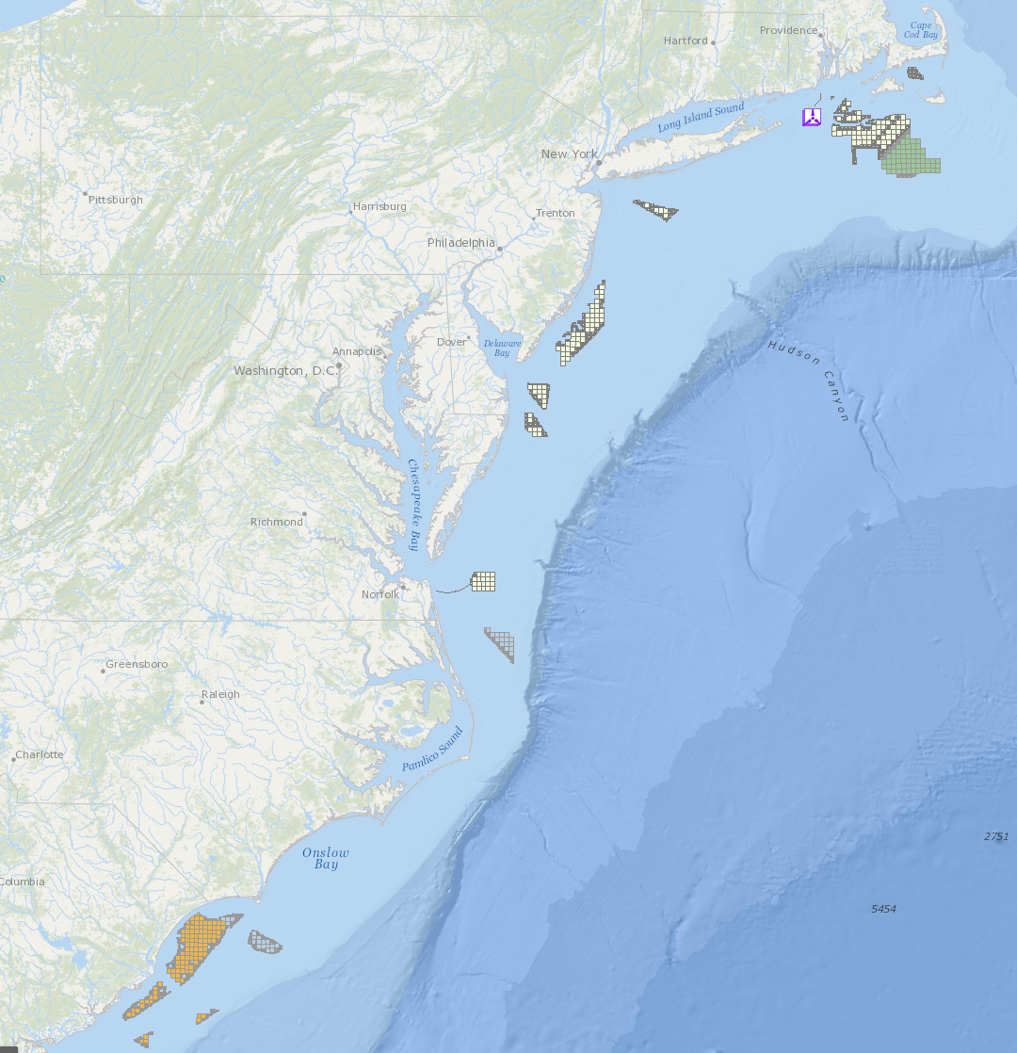
Figure 1: Potential offshore wind farm and Atlantic Wind Connection subsurface transmission line locations in federal waters off the U. S. Atlantic coast. Additional areas include state waters off Nantucket Sound MA, Block Island RI, Atlantic City NJ, Virginia Beach VA and Georgia. (Table 1).

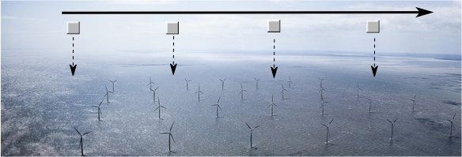
Figure 2: Schematic of piggyback pattern showing hypothetical wind farm fly-by with expendable launches at a 2-4 km interval. (Dong Energy Gunfleet Sands 1farm off SE England)

Offshore Wind Farm | Location | State or Federal
Fisherman’s Energy | Atlantic City, NJ (3 miles offshore) | State
Dominion Virginia Power | Virginia Beach | Federal
Statoil North America (Hywind Maine) | Boothbay Harbor | State
University of Maine (DeepCwind) | Monhegan Island | State
Deepwater Wind | Block Island (5 mi SE) | State
Cape Wind | Nantucket Sound (Horseshoe shoal) | State
Maryland Wind Energy Area | See Fig. 1 | Federal
Rhode Island Wind Energy Area | See Fig. 1 | Federal
New Jersey Wind Energy area | See Fig. 1 | Federal
Maryland Wind Energy Area | See Fig. 1 | Federal
Virginia Wind Energy Area | See Fig. 1 | Federal
Delaware | See Fig. 1 | Federal
North Carolina | See Fig. 1 | Federal
South Carolina | See Fig. 1 | Federal
Table 1: Listing of DOE funded demonstration projects and other offshore wind developments planned or projected in state and federal waters.

Observing system | Measurement | Number | Type
GPS sonde | Pressure, Temperature, Humidity, Velocity | 4-10 | Ex
Stepped Frequency Microwave Radiometer (SFMR) | Surface wind speed  rain rate |  | A/C
NOAA wide-swath radar altimeter | wave height and directional wave spectrum |  | A/C
Airborne Doppler radar | 3D wind velocity, rain rate |  | A/C
Lower fuselage radar | reflectivity |  | A/C
Table 2: Expendables (Ex) and aircraft (A/C) measurement systems required for conducting offshore wind experiment.

4. Doppler Wind Lidar (DWL) Experiment

Principal Investigators: Lisa Bucci, Jun Zhang, Kelly Ryan, Christopher O’Handley (SWA), G. David Emmitt (SWA), Jason Dunion, Robert Atlas (AOML)

Links to IFEX:
- Goal 1: Collect observations that span the TC life cycle in a variety of environments for model initialization and evaluation.
- Goal 2: Develop and refine measurement technologies that provide improved real-time monitoring of TC intensity, structure, and environment.
- Goal 3: Improve understanding of the physical processes important in intensity change for a TC at all stages of its lifecycle.
Motivation: Currently there are limited continuous high-resolution wind observations in the TC boundary layer and in regions of low or no precipitation. A coherent-detection Doppler wind profile (P3DWL) system will be available for the 2017 hurricane season onboard NOAA-43. P3DWL can collect wind profiles through the detection of aerosol scatters motion in areas of optically thin or broken clouds or where aerosols are ~1 micron or larger. A secondary goal is to use the data to understand physical processes in data sparse regions such as in the boundary layer, Saharan Air Layer (SAL), regions in-between rainbands, and in the ambient tropical environment around the TC.
Background: The P3DWL was previously used in the West Pacific field campaign THORPEX in 2008 for typhoon research (Pu et al. 2010). The study showed P3DWL data collected in the near storm environment improved both the track and intensity of one TC forecast. However, no in storm measurements were presented. NASA’s DAWN lidar was the first coherent lidar flown in an Atlantic tropical cyclone (Hurricane Earl, 2010) during the GRIP field campaign. Due to mechanical difficulties, only a very limited set of observations were collected. The P3DWL was flown with limited success in the 2015 Atlantic hurricane season. It collected continuous observations during one flight into Tropical Storm Erika. After some mechanical issues were resolved, the P3DWL was successfully flown in the 2016 season into two TCs for a total of 5 flights.
The DWL is capable of performing a variety of scanning patterns, both above and below the aircraft. Depending on the scanning pattern, the vertical resolution of the wind profiles is 25-50m and the horizontal resolution is 1-2km. Below the aircraft, the instrument can observe winds at or near the surface (~25m). When sampling above the aircraft, it can observe as high as ~14km (in the presence of high cirrus). However, in the presence of optically thick convection or within ~400m of the instrument, P3DWL is unable to collect measurements. The P3DWL will require an onboard operator during each mission.
Hypotheses:
- Hypothesis 1: Providing more continuous wind observations in data sparse regions to a data assimilation system will lead to a better analysis and forecast of a TC.
- Hypothesis 2: Collecting wind profiles in the TC boundary layer, inner core and environment will lead to identify key physical processes governing TC intensity change.
- Hypothesis 3: The P3DWL is capable of capturing accurate observations in regions with hurricane force winds.

Asymmetric Tropical Cyclone Module Description: The objective of this module is to provide symmetric coverage of the kinematic field in an asymmetric storm. The P3DWL will provide observations in low/no precipitation regions of a TC to complement the observations collected by the TDR. The combination of observations from these two platforms will be used to improve the initial structure of the TC in model analyses.
Secondary Eye Wall/Moat Region Module Description: This module will characterize the upper level subsidence and boundary layer kinematics within the region between two concentric eyewalls and/or within a rainband moat. It should only be performed in a stronger, more organized TC that contains either classic rainband structures (including a moat) or during an eyewall replacement cycle. The P3DWL should target the moat region and collect observations to complement data from the TDR.
Transit/Saharan Air Layer (SAL) Module Description: The objective of this module is to characterize the suspended Saharan dust and mid-level (~600-800 hPa) easterly jet that are associated with the SAL with a particular focus on SAL-TC interactions. Observations should target the possible impingement of the SAL mid-level jet and suspended dust along the edges of the storm inner core region. It can be conducted between the edges of the storm’s (African Easterly Wave’s (AEW)) inner core convection (deep convection) to points well outside (several hundred kilometers) of the TC environment during the commute to/from the storm.
Boundary Layer Module Description: This module will target sampling of the kinematic structure of the boundary layer with focus on investigating the characteristics of the boundary layer height and coherent structures. The purpose of this data will be to improve the initial state of the HWRF model and validate the boundary layer structures represented in the model.
High Winds Module Description: This module will target areas of high winds (above 35 m/s) below flight level with fewer optically thick clouds obstructing the P3DWL. The purpose is to expand the existing dataset and characterize how the P3DWL performs in a high wind regime. It will be necessary to deploy dropsondes for the validation process.
Mass Flux Budget Module Description: This module is to be performed on the ferry to/form a TC. A box will be flown in an area with winds 20 m/s or less and few optically thick clouds. The purpose of this module is to determine whether the P3DWL is a good tool to "close the box" and perform line integrals around a quiescent region where the flow is not apparently complex. Results will set a baseline for other future potentially boxes in more complicated flow regimes. This is also a module on NASA’s DC8 to be performed by the DAWN observing system.
Analysis Strategy:
The basic analysis of the DWL wind data follows that presented in recent observational studies of TC structure (e.g., Dunion and Velden 2004; Zhang and Uhlhorn 2012; Zhang et al. 2011; 2013; Montgomery et al. 2014; Rogers et al. 2015; Abarca et al. 2016). The analysis includes: the height of the maximum tangential wind speed, the inflow layer depth, the strength of the peak inflow, inflow angle, low-wavenumber kinematic structure of the boundary layer, a gradient wind in the secondary eyewall, and easterly jet in the SAL.
Observing System Experiments (OSEs) will be performed using both the line of sight (LOS) data and the post-processed vector wind data product to determine the impact of P3DWL observations on the analyses of TC structures, track, and intensity forecasts. Observations collected from the P3DWL in conjunction with other observing platforms will be used to evaluate the model representation of different aspects of a TC, such as the boundary layer, SAL intrusions, and sheared TCs. Multiple modeling frameworks are expected to be used. Options include the operational HWRF model, the latest Observing System Simulation Experiment (OSSE) system, and the HEDAS-HWRF setup.

References:
Abarca, S. F., M. T. Montgomery, S. A. Braun, J. Dunion, 2016: On the secondary eyewall formation of Hurricane Edouard (2014). Mon. Wea. Rev., 144, 3321–3331.
Dunion, J. and C. S. Velden, 2004: The impact of the Saharan air layer on atlantic tropical cyclone activity. Bull. Amer. Meteor. Soc., 85, 353–365.
Kavaya, M. J. et al., 2014: The Doppler aerosol wind (DAWN) airborne, wind-profiling coherent-detection Lidar system: overview and preliminary flight results. J. Atmos. Oceanic Technol., 31, 826 –842. 0739-0572
Montgomery, M. T., J. A. Zhang, and R. K. Smith, 2014: An analysis of the observed low-level structure of rapidly intensifying and mature Hurricane Earl, 2010: Quart. Jour. Roy. Met. Soc., 140, 2132-2146.
Pu, Z., L. Zhang, and G. D. Emmitt, 2010: Impact of airborne Doppler wind lidar data on numerical simulation of a tropical cyclone. Geophys. Res. Lett., 37, L05801, doi:10.1029/2009GL041765.
Rogers, R. F., P. D. Reasor, and J. A. Zhang, 2015: Multiscale structure and evolution of Hurricane Earl (2010) during rapid intensification. Mon. Wea. Rev., 143, 536–562.
Zhang, J. A., and E. Uhlhorn, 2012: Hurricane sea surface inflow angle and an observation-based parametric model. Mon. Wea. Rev., 140, 3587-3605.
Zhang, J. A., R. F. Rogers, D. S. Nolan, and F. D. Marks, 2011: On the characteristic height scales of the hurricane boundary layer, Mon. Wea. Rev., 139, 2523-2535.
Zhang, J. A., R. F. Rogers, P. D. Reasor, E. W. Uhlhorn, and F. D. Marks Jr., 2013: Asymmetric hurricane boundary layer structure in relation to the environmental vertical wind shear from dropsonde composites. Mon. Wea. Rev., 141, 3968–3984.

5. Small Unmanned Aerial VEhicle Experiment (SUAVE)
Principal Investigator and Co-Investigators: J. Cione, J, Zhang, L. Bucci, K, Ryan, E, Kalina, A. Aksoy, H. Holbach, G. Bryan, E. Konopleva

Links to IFEX:
- Goal 1: Collect observations that span the TC life cycle in a variety of environments for model initialization and evaluation.
- Goal 3: Improve understanding of the physical processes important in intensity change for a TC at all stages of its lifecycle.
Motivation:
In recent years, an increasing number of hurricanes have impacted the United States with devastating results, and many experts expect this trend to continue in the years ahead. In the wake of Hurricane Sandy (2012), NOAA is being looked at to provide improved and highly accurate hurricane-related forecasts over a longer time window prior to landfall. NOAA is therefore challenged to develop a program that will require applying the best science and technology available to improve hurricane prediction without placing NOAA personnel at increased risk. UAS are an emerging technology in the civil and research arena capable of responding to this need.

In late February 2006, a meeting was held between NOAA, NASA and DOE partners (including NOAA NCEP and NHC representatives) to discuss the potential for using UAS in hurricanes to take measurements designed to improve intensity forecasts. The group came to a consensus around the need for a UAS demonstration project focused on observing low-level (<200 meters) hurricane winds for the following reasons:

- Hurricane intensity and track forecasts are critical at sea level (where coastal residents live)
- The hurricane’s strongest winds are observed within the lowest levels of the atmosphere
- The air-sea interface is where the ocean's energy is directly transferred to the atmosphere
- Low-level observations will help improve operational model initialization and verification (especially boundary layer observations of temperature and moisture which are especially sparse)
- The low-level hurricane environment is too dangerous for manned aircraft

The potential importance of low-level UAS missions in hurricanes is further emphasized by the findings of the Hurricane Intensity Research Working Group established by the NOAA Science Advisory Board. Their recommendation is that:

“Low and Slow” Unmanned Aircraft Systems (UAS) have demonstrated a capacity to operate in hurricane conditions in 2005 and in 2007. Continued resources for low altitude UAS should be allocated in order to assess their ability to provide in situ observations in a critical region where manned aircraft satellite observations are lacking.

This effort is in direct support of NOAA’s operational requirements and research needs. Such a project will directly assist NOAA’s National Hurricane and Environmental Modeling Centers better meet several of their operational requirements by helping to assess:

The strength and location of the storm’s strongest winds
The radius of maximum winds
The storm’s minimum sea level pressure (potentially give forecasters advanced warning as it relates to dangerous episodes of tropical cyclone rapid intensification)
Thermodynamic conditions (particularly low level moisture) within the lower troposphere

In addition to these NOAA operational requirements, developing the capability to regularly fly low altitude UAS into tropical cyclones will also help advance NOAA research by allowing scientists to sample and analyze a region of the storm that would otherwise be impossible to observe in great detail (due to the severe safety risks associated with manned reconnaissance). It is believed that such improvements in basic understanding are likely to improve future numerical forecasts of tropical cyclone intensity change. Reducing the uncertainty associated with tropical cyclone intensity forecasts remains a top priority of the National Hurricane Center. Over time, projects such as this, which explore the utilization of unconventional and innovative technologies in order to more effectively sample critical regions of the storm environment should help reduce this inherent uncertainty.

Background:
Coyote is an aircraft platform that is built by the Raytheon Company (formerly Sensintel Corporation and British Aerospace Engineering (BAE)) and is currently being used by the US NAVY. The intended deployment vehicle for the Coyote is the P-3 Orion. The Coyote is a small electric-powered unmanned aircraft with 1-2 hour endurance and is capable of carrying a 1-2 lb payload. The Coyote can be launched from a P-3 sonobuoy tube in flight, and terrain-permitting, is capable of autonomous landing and recovery. The Coyote is supported by Raytheon’s integrated control station, which is capable of supporting multiple aircraft operations via touch screens that simultaneously show real-time video. This control station can also be incorporated onto the deployment aircraft (i.e. P-3), allowing for in-air command and control after launch. The Coyote, when deployed from NOAA's P-3's within a hurricane environment, provide a unique observation platform from which the low level atmospheric boundary layer environment can be diagnosed in great detail. In many ways, this UAS platform be considered a 'smart GPS dropsonde system' since it is deployed in similar fashion and currently utilizes a comparable meteorological payload (i.e. lightweight sensors for P, T, RH, V) similar to systems currently used by NOAA on the GIV and P-3 dropsonde systems. Unlike the GPS dropsonde however, the Coyote UAS can be directed from the NOAA P-3 to specific areas within the storm circulation (both in the horizontal and in the vertical). The Coyote payload will also be able to capture sea surface temperature (SST). Also unlike the GPS dropsonde, Coyote observations are continuous in nature and give scientists an extended look into important thermodynamic and kinematic physical processes that regularly occur within the near-surface boundary layer environment. Coyote UAS operations also represent a potentially significant upgrade relative to the more traditional "deploy, launch and recover" low altitude UAS hurricane mission plan used in the past (e.g. Aerosonde). By leveraging existing NOAA manned aircraft assets, Coyote operations significantly reduce the need for additional manpower. The Coyote concept of operations also reduces overall mission risk since there is no flight ingress/egress. This fact should also help simplify the airspace regulatory approval process. Specifications associated with the Coyote UAS are illustrated in Figure 1.

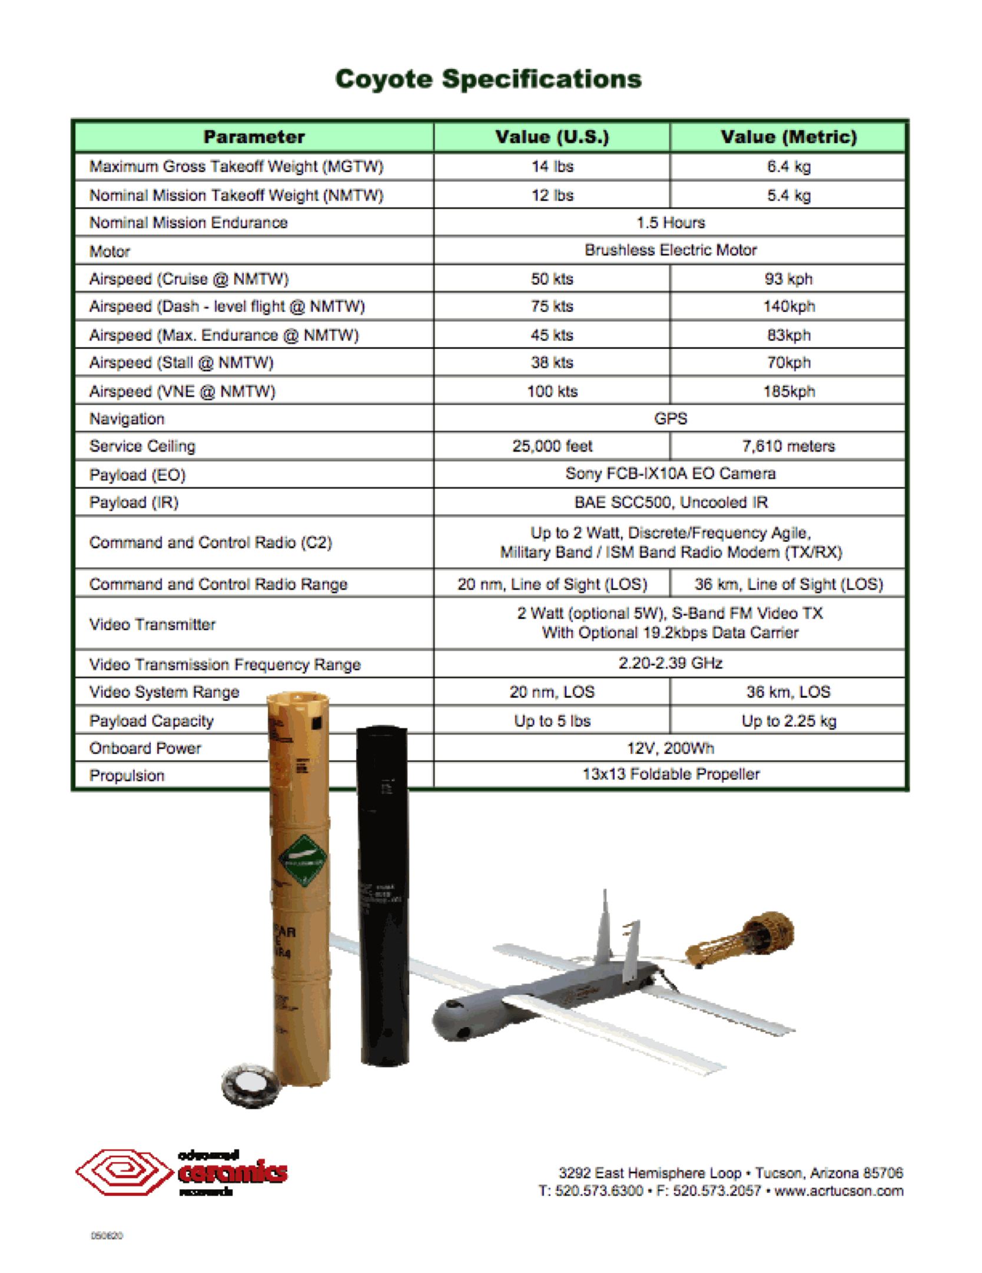
Figure 1. Coyote Unmanned Aerial System Specifications (Courtesy: Raytheon)

Hypotheses:
1. A more accurate estimation of the maximum 10m wind is possible using a continuously observing low altitude platform like the Coyote UAS (vs SFMR, Sondes alone)
2. A more accurate estimation of the Radius of Maximum Wind will be attained using a continuously observing low altitude platform like the Coyote UAS (vs SFMR, Sondes alone).
3. A more accurate estimation of the top of the hurricane boundary layer will be obtained.

Experiment/Module Description:
The primary objective of this experiment is further demonstrate and utilize the unique capabilities of a low altitude UAS platform in order to better document areas of the tropical cyclone environment that would otherwise be either impossible or impractical to observe. For this purpose, NOAA is proposing to use the Coyote UAS. Since the Coyote will be deployed from the manned P-3 aircraft, no UAS-specific forward deployment teams will be required. Furthermore, since the Coyote is launched using existing AXBT launch infrastructure, no special equipment is required beyond a ‘ground’ control station that Coyote operators will have onboard the P-3.

Module/Option 1a: UAS Eye/Eyewall with P-3 loiter
For this module the target candidate storm is a mature hurricane (likely strong category 2 or more) with a well-defined eye. Furthermore, since the P-3 will have to operate within the eye, daylight missions will be required so as to maintain P-3 visual contact with the eyewall at all times. In addition, other less restrictive Coyote-P3 modules are being developed and considered (see Module 1b). A 350-MHz communication stream between the UAS and the P-3 will be used to control the UAS flight characteristics and to receive data back from the Coyote. This capability will have the dual positive effect of minimizing risk to both science and safety, since the 350-MHz stream will permit communication over a range of at least 50 km. The immediate focus of this experimental module will be to test the operational capabilities of the Coyote UAS within a hurricane environment. Besides maintaining continuous command and control links with the P-3, these flights will test the accuracy of the new ITRI METOC payload by comparing UAS measurements with coincident observations taken from dropsondes released from the P-3. The UAS will be tested to see if it can maintain altitudes according to command. In addition, the Coyote UAS will attempt to fly at extreme altitudes (as low as 200 ft) in low (eye) and high (eyewall) wind conditions within the hurricane environment. The longer term goal for this UAS platform is to assist scientists so they can better document and ultimately improve their understanding of the rarely-observed tropical cyclone boundary layer. To help accomplish this, the UAS will make detailed observations of pressure, temperature, humidity, wind speed and wind direction (PTHU) at low altitudes within the hurricane eye and eyewall that will then be compared with multiple in-situ and remote-sensing observations obtained from manned aircraft (NOAA P-3 and as opportunities arise AFRES C-130, Global Hawk UAS) as well as select satellite-based remote sensor platforms. In addition, a primary objective (but not an immediate requirement) for this effort will be to provide real-time, near-surface wind observations to the National Hurricane and Environmental Modeling Centers in direct support of NOAA operational requirements. These unique data will also be used in a ‘post storm’ analysis framework in order to potentially assist in the numerical and NHC verification process.

For this experiment, the NOAA P-3 will descend to just above the top of the cloud layer in the eye, and return to the previous altitude when the module is concluded. Assuming multiple UAS are available, both (~1.5h duration) modules could be conducted on the same mission. The eye-only module would be conducted first, followed by the eye-eyewall UAS module. The P-3 flight pattern is identical for both eye and eye-eyewall UAS modules. GPS dropsonde and AXBT drop locations are also identical for each UAS module. AXBT and GPS drop locations are explicitly illustrated in the flight plan below. UAS deployment on leg 3-4 is also identical for both modules. UAS operational altitude will be entirely below 5000ft. UAS motor will not be activated until an altitude of 5000 ft is met. The UAS will be conducting a controlled, spiral glide (un-powered) descent from 10000 ft to 5000 ft.

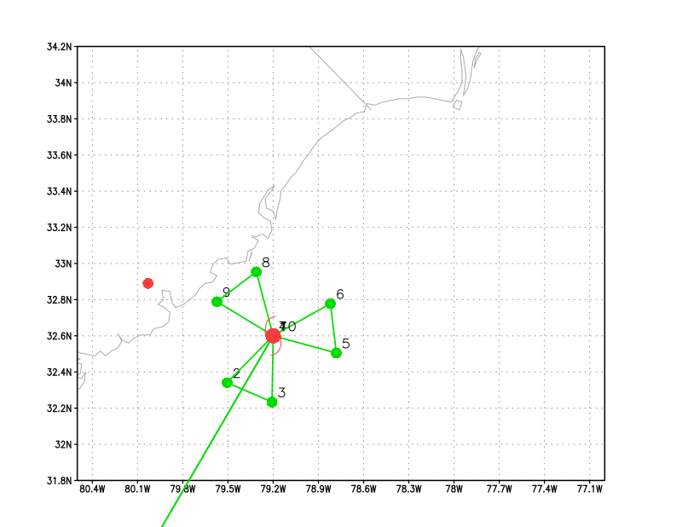
Figure 2. Pizza slice flight pattern for the eye/eyewall coyote experiment.

Module/Option 2: Enhanced Boundary Layer Inflow Sampling
At the IP the Coyote is released and slowly step descends down to 100m as it spirals inward. Once at 100m the UAS step ascends up to an altitude just above the inflow layer (~1.5km). Then again descends to 100m. This process continues until eyewall penetration occurs at 500m. Once in the eyewall the UAS step descends in 50m increments every 5 minutes until it reaches 50m and maintains altitude until battery failure.

This module extends work originally conducted by Cione et al. in 2000. It also expands the capabilities associated with the original BLI experiment by providing continuous (versus instantaneous) data at altitudes, radii and azimuths not previously sampled by GPS sonde deployments. In addition, these UAS data will help capture additional vertical variability associated with the inflow layer as a function of radius from the storm center. Once in the eyewall, UAS observations will provide wind and thermodynamic data utilizing a highly unique step descent eyewall orbiting sampling strategy.

Depending on storm conditions and other factors, it may be possible to combine portions of UAS Modules 2 and 3 into one UAS mission.

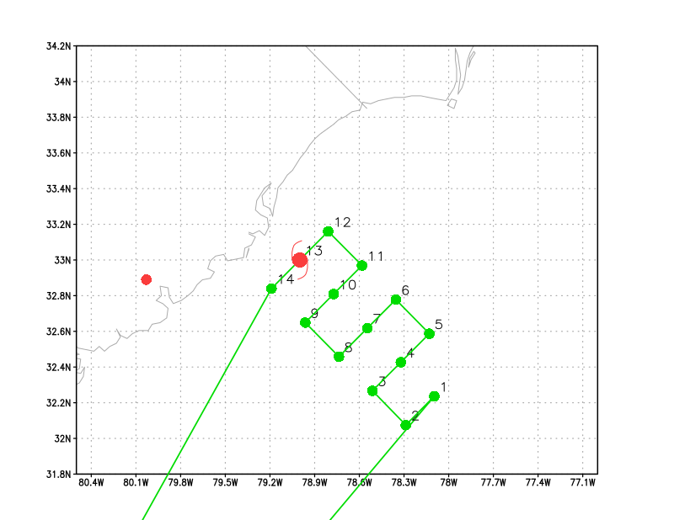
Figure 3. Lawn mower flight pattern for the inflow coyote experiment.

Module/Option 3: Boundary Layer Entrainment/Convective Downdraft module
This module builds upon and complements the existing ‘Boundary Layer Entrainment’ (see HFP 2013, experiment 14 for additional details). No modifications to the existing P-3 patterns are required for this module. Instead, the low flying Coyote UAS will conduct very low (down to 100m) stepped descents in addition to patterns flown by the P-3 manned aircraft (see Figure 4). These very low altitude UAS patterns should allow for (a more direct) estimation of surface fluxes. In turn, the UAS-derived estimates can then be compared with surface fluxes computed by sampling the top of the boundary layer (residual method). In addition, it is also possible to conduct a UAS box pattern at 100-120m to complement the P-3 1-2 km box pattern (not shown) that was designed to estimate divergence in precipitation-free areas.

It should also be noted that an additional goal of this module is to see how vertical mixing occurs above and within the boundary/surface layer just outside areas of active convection (e.g. near rainbands and radially outward of the TC’s primary convective envelope). A goal of this module is to compare observational details from these convectively driven processes with comparable output from high-resolution operational regional and global model simulations.

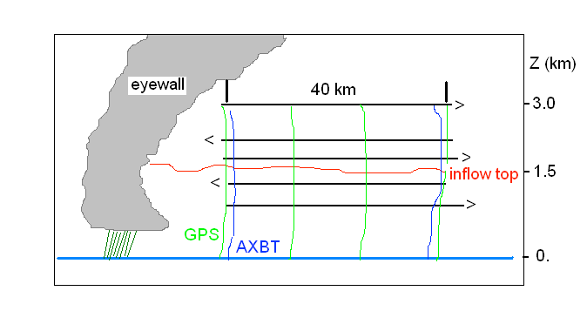
Figure 4. (From HFP Boundary Layer Entrainment Module) Vertical cross-section of the stepped-descent module. P3 pattern is in black, low altitude Coyote UAS in heavy blue.

Module/Option 4: Eddy Dissipation Rate Measurements
For this module, the target storm is a hurricane of any intensity, since low-altitude measurements of eddy dissipation rate and other turbulent quantities are rare in winds of 35 m s⁻¹ and greater. To complete this module, approximately 30 minutes of battery life are required. Therefore, this experiment does not need to be the sole focus of a particular Coyote flight. Instead, the eddy dissipation rate measurements can be made following a Coyote eyewall penetration (Module 1) or at the conclusion of the Boundary Layer Inflow experiment (Module 3) or the Radius of Maximum Wind Mapping experiment (Module 4), both of which terminate with the Coyote near or in the eyewall.
The objective is to collect measurements of eddy dissipation rate in strong wind conditions (35 m s⁻¹ or greater), with a focus on how the dissipation rate changes with altitude in the lower portion of the tropical cyclone boundary layer and in the surface layer. It is therefore preferable for the Coyote to remain at a constant radius from the tropical cyclone center (ideally at the radius of maximum wind) throughout the experiment. This will prevent the height-dependence of eddy dissipation from being confused with any dependence on distance from the tropical cyclone center.
Figure 5 is a schematic of the experimental design. The experiment will begin with the Coyote at a height of 350 m, in the eyewall and/or at the radius of maximum wind. The Coyote then will initiate and maintain a constant descent rate of 1/6 = 0.167 m s⁻¹. This descent rate was chosen because it will allow the Coyote to descend to a height of 50 m at the end of the 30-minute period. At this point, the Coyote may continue to descend at the constant rate, but errors in the GPS vertical position of up to 30 m and waves up to 20 m tall could end the Coyote flight shortly thereafter.
The only requirement of the P-3 flight pattern for this module is that the P-3 remains within 50 km of the Coyote position during the experiment (to prevent loss of communication between the two platforms). This proximity requirement can be satisfied either by the P-3 loitering within the eye (see Module 1a) or by the P-3 completing multiple passes through the eye and eyewall using a rotated figure-four pattern with shortened legs (see Module 1b). The second option may only be feasible in storms with a small radius of maximum wind (15 km or less), since the distance between the P-3 and the Coyote will at times exceed twice the radius of maximum wind when the P-3 samples the opposite side of the storm.

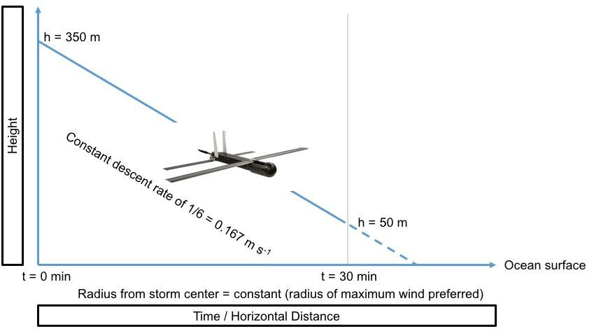

Figure 5. Eddy dissipation measurements. The Coyote begins the experiment at a height of 350 m, descends at a constant rate of 1/6 = 0.167 m s⁻¹, and reaches a height of 50 m after 30 minutes. The entire descent is conducted at a constant radius from the storm center (preferably at the radius of maximum wind).

Analysis Strategy:
The basic analysis follows that presented in recent observational studies of the COYOTE data (Zhang 2010; Zhang et al. 2008; 2011; Zhang and Drennan 2012: Cione et al. 2016). The analysis includes: validation of the wind, temperature and humidity measurements using the dropsonde data; validation of the wind measurements using the Doppler data; computation of turbulent fluxes using the eddy correlation method, estimation of the boundary layer height scales using the coyote data, estimation of vertical eddy diffusivity, and estimation of dissipation rate.
Optimization of Sampling Strategies:
Another goal of this experiment is to investigate how Coyote sampling strategies can be improved based on varying criteria. This will be carried out in an Observing System Simulation Experiment (OSSE) framework, where the “truth” is assumed to be known perfectly via a Nature Run (Nolan et al. 2013). The proposed plan of investigation is as follows:

- Analysis of existing Coyote flight track algorithms within the Nature Run framework: Here, the goal is to generate alternate Coyote flight tracks based on existing techniques and measure their effectiveness in achieving their objectives in a quantitative manner. Effectiveness, in this regard, can be measured by metrics such as percentage of completion of originally planned mission or percentage of flight duration within range of the P-3 for data coverage. By generating many possible flight tracks by varying inputs/assumptions of the flight track algorithm and embedding the resulting tracks within the high-resolution, three-dimensional wind field of the Nature Run, it is possible to accumulate statistics of failure/success and obtain how sensitive they are on the input parameters. Such statistical analysis is expected to inform operational decisions during the field program.

- Improving sampling strategies: An objective method for measuring the effectiveness of sampling strategies is to investigate the impact the data collected by the Coyote flights have on data assimilation and forecasts. This will be carried out by utilizing HRD’s in-house Hurricane Ensemble Data Assimilation System (HEDAS; Aksoy et al. 2013) for data assimilation and the HWRF model for forecasts. In the investigation, two alternative approaches to generating Coyote flight tracks will be tested:

  - Flight tracks described in this document to target data-void regions of the hurricane inner core.
  - Flight tracks that will be constructed to minimize the ensemble-based sensitivity of predetermined forecast metrics (e.g., intensity) and thus maximize the impact of observations collected by the Coyote. Two possible methods here include minimizing ensemble variance and minimizing ensemble sensitivity to observations.

References:
Aksoy, A., S. D. Aberson, T. Vukicevic, K. J. Sellwood, S. Lorsolo, and X. Zhang, 2013: Assimilation of high-resolution tropical cyclone observations with an ensemble Kalman filter using NOAA/AOML/HRD’s HEDAS: Evaluation of the 2008–11 vortex-scale analyses, Mon. Weather Rev., 141, 1842–1865, doi: http://dx.doi.org/10.1175/MWR-D-12-00194.1.
Cione, J. J., P. Black, and S. Houston (2000), Surface observations in the hurricane environment, Mon. Weather Rev., 128, 1550–1561.
Cione, J. J., E.A. Kalina, E.W. Uhlhorn, A.M. Farber, and A.B. Damiano, 2016: Coyote unmanned aircraft system observations in Hurricane Edouard (2014). Earth and Space Science, 3, 370-380, doi:10.1002/2016EA000187.
Nolan, D. S., R. Atlas, K. T. Bhatia, and L. R. Bucci, 2013: Development and validation of a hurricane nature run using the joint OSSE nature run and the WRF model, J. Adv. Model. Earth Syst., 5, 382–405, doi:10.1002/jame.20031.
Zhang, J. A., 2010: Estimation of dissipative heating using low-level in situ aircraft observations in the hurricane boundary layer. J. Atmos. Sci., 67, 1853–1862.
Zhang, J. a., and W. M. Drennan, 2012: An observational study of vertical eddy diffusivity in the hurricane boundary layer. J. Atmos. Sci., 69, 3223-3236.
Zhang, J. A., P. G. Black, J. R. French, and W. M. Drennan, 2008: First direct measurements of enthalpy flux in the hurricane boundary layer: The CBLAST results, 35, L14813, oi:10.1029/2008GL034374.
Zhang, J. A., F. D. Marks, M. T. Montgomery, and S. Lorsolo, 2011: An estimation of turbulent characteristics in the low-level region of intense Hurricanes Allen (1980) and Hugo (1989). Mon. Wea. Rev., 139, 1447–1462.

6. NESDIS Ocean Winds and Rain Experiment

Principal Investigators: Paul Chang and Zorana Jelenak (NESDIS)

Primary IFEX Goal: 2 - Develop and refine measurement technologies that provide improved real-time monitoring of TC intensity, structure, and environment

Motivation: This effort aims to improve our understanding of microwave scatterometer retrievals of the ocean surface wind field and to evaluate new remote sensing techniques/technologies. The NOAA/NESDIS/Center for Satellite Applications and Research in conjunction with the University of Massachusetts (UMASS) Microwave Remote Sensing Laboratory, the NOAA Hurricane Research Division, and the NOAA Aircraft Operations Center have been conducting flight experiments during hurricane season for the past several years. The Ocean Winds experiment is part of an ongoing field program whose goal is to further our understanding of microwave scatterometer and radiometer retrievals of the ocean surface winds in high wind speed conditions and in the presence of rain for all wind speeds. This knowledge is used to help improve and interpret operational wind retrievals from current and future satellite-based sensors. The hurricane environment provides the adverse atmospheric and ocean surface conditions required.

The Imaging Wind and Rain Airborne Profiler (IWRAP), which is also known as the Advanced Wind and Rain Airborne Profiler (AWRAP), was designed and built by UMass and is the critical sensor for these experiments. IWRAP/AWRAP consists of two dual-polarized, dual-incidence angle radar profilers operating at Ku-band and at C-band, which measure profiles of reflectivity and Doppler velocity of precipitation in addition to the ocean surface backscatter. The Stepped-Frequency Microwave Radiometer (SFMR) and GPS dropsonde system are also essential instrumentation on the NOAA-P3 aircraft for this effort. The NASA GORE (GNSS reflection) system is also desired to provide measurements to support the NASA CYGNSS mission.

The Ocean Winds P-3 flight experiment program has several objectives:
- Calibration and validation of satellite-based ocean surface vector wind (OSVW) sensors such as
ASCAT and ScatSat, and the new CYGNSS mission that uses GNSS-R techniques to infer the ocean wind speed.
- Product improvement and development for current and planned satellite-based sensors (ASCAT, ScatSat, CYGNSS and SCA)
- Testing of new remote sensing technologies for possible future satellite missions (risk reduction) such as the dual-frequency scatterometer concept. A key objective for this year will be the collection of cross-polarized data at C-band to support ESA and EUMETSAT studies for the ASCAT follow- on (SCA), which will be part of EPS-SG.
- Advancing our understanding of broader scientific questions such as:
  - Rain processes in tropical cyclones and severe storms: the coincident dual-polarized, dual- frequency, dual-incidence measurements would enable us to improve our understanding of precipitation processes in these moderate to extreme rainfall rate events.
  - Atmospheric boundary layer (ABL) wind fields: the conical scanning sampling geometry and the Doppler capabilities of this system provide a unique source of measurements from which the ABL winds can be derived. The raw data system will enable us to use spectral techniques to retrieve the wind field all the way down to the surface.
  - Analysis of boundary layer rolls: linearly organized coherent structures are prevalent in tropical cyclone boundary layers, consisting of an overturning “roll” circulation in the plane roughly perpendicular to the mean flow direction. IWRAP has been shown to resolve the kilometer-scale roll features, and the vast quantity of data this instrument has already collected offers a unique opportunity to study them.
  - Drag coefficient, Cd: extending the range of wind speeds for which the drag coefficient is known is of paramount importance to further our understanding of the coupling between the wind and surface waves under strong wind forcing, and has many important implications for hurricane and climate modeling. The new raw data capability, which allows us to retrieve wind profiles closer to the ocean surface, can also be exploited to derive drag coefficients by extrapolating the derived wind profiles down to 0 m altitude.

Flight Profiles:
Altitude:
The sensitivity of the IWRAP/AWRAP system defines the preferred flight altitude to be below 10,000 ft to enable the system to still measure the ocean surface in the presence of rain conditions typical of tropical systems. With the Air Force typically flying at 10,000 ft pressure this, we have typically ended up with an operating altitude of 7,000 ft radar. Operating at a constant radar altitude is desired to minimize changes in range and thus measurement footprint on the ground. Higher altitudes would limit the ability of IWRAP/AWRAP consistently see the surface during precipitation, but these altitudes would provide useful data, such as measurements through the melting layer, to study some of the broader scientific questions.
Maneuvers:
Straight and level flight with a nominal pitch offset unique to each P-3 is desired during most flight legs. Constant bank circles of 10-30 degrees have been recently implemented, as a method to obtain measurements at incidence angles greater than the current antenna was design for. These would be inserted along flight legs where the desired environmental conditions were present. Generally it would be a region of no rain and where we might expect the winds to be consistent over a range of about 6-10 miles, about the diameter of a circle. This would not be something we would want to do in a high gradient region where the conditions would change significantly while we did the circle.
Patterns:
Typically an ideal ocean winds flight pattern would include a survey pattern (figure 4 or butterfly) that extended 20-50 nm from the storm center. The actual distance would be dictated by the storm size and safety of flight considerations. Dependent upon what was observed during the survey pattern a racetrack or lawnmower pattern would be setup over a feature of interest such as a rain band or wind band.
Storm types:
The ideal ocean winds storm would typically be a developed hurricane (category 1 and above) where a large range of wind speeds and rain rates would be found. However, data collected within tropical depressions and tropical storms would still provide very useful observations of rain impacts.

7. SFMR High-Incidence Angle Measurements

Principal Investigator(s): Heather Holbach (lead), Brad Klotz, and Mark Bourassa (FSU)

Link to IFEX:
- Goal 2: Develop and refine measurement technologies that provide improved real-time monitoring of TC intensity, structure, and environment.

Motivation:
Surface winds in a tropical cyclone are essential for determining its intensity. Currently, the Stepped-Frequency Microwave Radiometer (SFMR) is used for obtaining surface wind measurements at nadir. Due to poor knowledge about sea surface microwave emission at large incidence angles and high wind speeds, SFMR winds are only retrieved when the antenna is pointed directly downward from the aircraft during level flight. Understanding the relationship between the SFMR measured brightness temperatures, surface wind speed, wind direction, and the ocean surface wave field at off-nadir incidence angles would potentially allow for the retrieval of wind speed measurements when the aircraft is not flying level. It is hypothesized that at off-nadir incidence angles the distribution of foam on the ocean surface from breaking waves impacts the SFMR measurements differently than at nadir and is dependent on polarization. Therefore, by analyzing the excess brightness temperature at various wind speeds and locations within the tropical cyclone environment at off-nadir incidence angles, the relationship between the ocean surface characteristics and the SFMR measurements will be quantified as a function of wind direction relative to the look angle and polarization.

Background:
Currently, if the aircraft pitch or roll angle exceeds a threshold of ± 5°, wind speeds are not reported for the SFMR. These thresholds result in wind speeds not being provided when the aircraft turns or if the aircraft exceeds the pitch threshold while flying a constant pressure surface through the eyewall where the highest wind speeds are usually measured. By understanding the physics of the air-sea interaction between the wind and sea surface, it will be possible to develop corrections for the SFMR algorithm to obtain wind speed measurements when the aircraft is not flying level.

Hypotheses:
- Hypothesis #1: Collecting high-incidence angle SFMR data will allow for quantification of the changes in the SFMR brightness temperature at off-nadir incidence angles that are related to the wind direction relative to the look angle and polarization.

Experiment/Module Description:
Two down-looking SFMRs should be mounted on the P-3 aircraft. The operational wing-pod mounted SFMR should be operating as usual. A second SFMR is to be mounted parallel to the latitudinal axis of the airframe (rotated 90° from the operational position). When the aircraft rolls, the operational SFMR will be collecting off-nadir data at H-pol and the second SFMR will be collecting off-nadir data at V-pol, simulating the data that the SFMR would collect when the aircraft pitches. The high-incidence angle modules can be flown during any mission with any flight pattern and are designed to obtain SFMR measurements in various locations of the tropical cyclone environment at several different wind speeds during constant banked aircraft turns at several different roll angles, specified below. A full pattern for each module consists of three complete circles for each specified roll angle (Figure 1). It is important to maintain as constant of a roll angle, pitch angle, and altitude as possible. A dropsonde and AXBT pair should be released at the beginning of the pattern. The wide swath radar altimeter (WSRA), if available, should also be obtaining measurements during the pattern for analysis of the ocean surface characteristics. The wave spectra obtained by the WSRA will allow for a more accurate investigation of the sensitivity of the SFMR to the surface wave characteristics. It is ideal to fly these modules in rain-free areas as to reduce the impact of the atmospheric emission on the SFMR measurements and to obtain measurements in regions of moderate to heavy precipitation, as deemed safe by the aircraft pilots, in order to understand the impact of varying the path length of the precipitation.

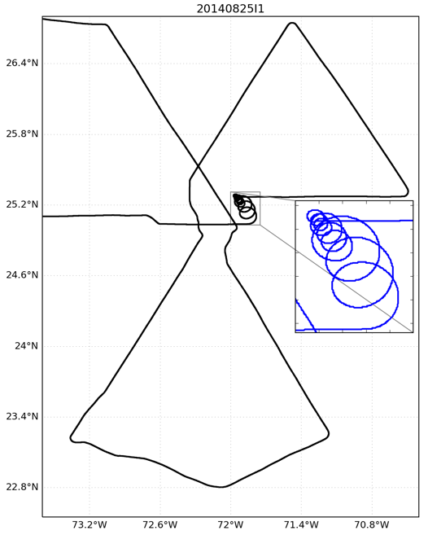
Figure 1: Example flight path (black) with SFMR high-incidence angle module. The inset zoomed in portion with the blue track displays the SFMR module in more detail.

Modules:
- Zero wind, high incidence angle response
  - This module is designed to determine the antenna pattern corrections and possible impacts of sun glint
  - Fly circles at roll angles of 15, 30, 45, and 60 degrees

- Moderate wind response (~15 m/s, 30 kts)
  - This module is designed to understand the mixed “phase” (i.e., foam vs roughness contributions to brightness temperature)
  - Fly circles at roll angles of 15, 30, and 45 degrees

- Moderate winds (~15 m/s, 30 kts) and substantial swell or varying fetch length response
  - This module is designed to determine the sensitivity to stress
  - This can be performed on the way to the storm or in different sectors of the storm
  - Fly circles at roll angles of 15, 30, and 45 degrees

- Strong wind response (>30 m/s, 60 kts)
  - This module should be flown in multiple storm quadrants (motion relative)
  - Fly circles at roll angles of 15, 30, and 45 degrees

Thus far, measurements have been obtained primarily on the right side of storms (Figure 2). To develop a more complete composite picture, we are particularly interested in obtaining measurements on the left side of storms (motion relative) this season. We would also like to focus on regions with wind speeds greater than 20 m/s.

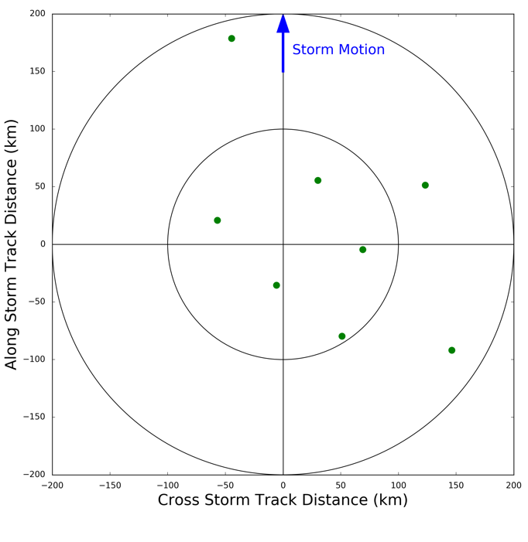
Figure 2: Storm-relative locations of high-incidence angle SFMR observations obtained in previous seasons.

Analysis Strategy:
The SFMR data from these flights will be analyzed to quantify the double harmonic oscillation that is evident in high-incidence angle SFMR data collected during previous seasons. The WSRA data will then be used to analyze the differences in the ocean surface characteristics to reveal any possible relationships between the double harmonic oscillation found in the SFMR measurements and the ocean surface characteristics. Wind direction from the dropsondes will be used to adjust the flight level wind directions to the surface to compute the relative look angle of the SFMR to the surface wind direction. Wind speed from the dropsondes will be used to quantify the differences in the SFMR brightness temperatures expected at nadir with the high-incidence angle measurements. SST from the AXBTs will be used as input to the brightness temperature algorithm.

8. CYGNSS Validation

Principal Investigator(s): Bachir Annane, Heather Holbach, Brad Klotz, and Mark Bourassa (FSU)

Links to IFEX:
- Goal 2: Develop and refine measurement technologies that provide improved real-time monitoring of TC intensity, structure, and environment.
Motivation: The Cyclone Global Navigation Satellite System (CYGNSS) is a constellation of eight small satellites equipped with receivers to measure reflected signals from existing Global Positioning System (GPS) satellites to measure ocean surface wind speeds. One of the primary goals of the CYGNSS mission is to obtain wind speed measurements in tropical cyclones. In order to calibrate and validate CYGNSS in the tropical cyclone environment, collocated SFMR and dropsonde data will be used.
Background: Each of the eight CYGNSS satellites contains a Delay Doppler Mapping Instrument (DDMI) that measures GPS signals reflected off the ocean surface. The distribution of the reflected GPS signal depends upon the ocean surface roughness from which a wind speed is derived. The CYGNSS constellation is capable of obtaining 32 wind speed measurements per second around the globe. However, the inclination angle of the CYGNSS satellites restricts the coverage to ±35° latitude. The median (mean) revisit time for CYGNSS is 2.8 (7.2) hours. One of the main advantages of CYGNSS is that by utilizing GPS signals it is able to obtain wind speed measurements in all weather conditions without signal saturation at high wind speeds. More information on the CYGNSS mission can be found in the CYGNSS handbook (Ruf et. al. 2016).
Hypotheses: None
Experiment/Module Description: This module is designed to obtain CYGNSS, SFMR, and dropsonde data that is collocated in space and time. It will require aligning the P-3 flight track so that one leg is oriented in the direction that the CYGNSS satellites will be flying over the storm. Ideally, the P-3 will be at the storm center when the CYGNSS overpasses occur. In order to accomplish this module, it is vital to have knowledge of the expected location/time of the CYGNSS satellite overpasses during the P-3 mission. Prior to the flight, the information on the expected CYGNSS locations will be provided by the PIs to the LPS. Based on the CYGNSS locations, it may be necessary to adjust the IP and take-off time so that one of the P-3 flight legs (straight leg passing through the storm center) is aligned with the direction and as close in time as possible to where/when the CYGNSS satellites will be flying over the storm. If resources allow, RMW drops along with the standard drop locations for dropsondes is ideal.
Analysis Strategy: SFMR data will be averaged spatially to the footprint size of CYGNSS (25 km) and compared with the collocated CYGNSS data. The CYGNSS and spatially averaged SFMR data will also be compared to the dropsonde surface wind data. The storm structure will also be compared between the SFMR and CYGNSS measurements.
References:
Ruf, C., P. Chang, M.P. Clarizia, S. Gleason, Z. Jelenak, J. Murray, M. Morris, S. Musko, D. Posselt, D. Provost, D. Starkenburg, V. Zavorotny, CYGNSS Handbook, Ann Arbor, MI, Michigan Pub., ISBN 978-1-60785-380-0, 154 pp, 1 Apr 2016.

9. G-IV SFMR Validation Module

Principal Investigator(s): Brad Klotz (lead) and Heather Holbach

Links to IFEX:
- Goal 2: Develop and refine measurement technologies that provide improved real-time monitoring of TC intensity, structure, and environment.
Motivation: The stepped frequency microwave radiometer (SFMR) on the P-3 has a proven track record for providing surface wind data in tropical cyclones (Uhlhorn et al. 2007, Klotz and Uhlhorn 2014). However, there is no documentation of the G-IV SFMR data and its usefulness under the current specifications of the G-IV flight patterns. To our knowledge no data from the G-IV SFMR has been released or used in any research or operational capacity. This data could potentially provide important information about the tropical cyclone wind radii as well as for mapping the environmental surface winds. The goal of this module is to validate the G-IV SFMR data with reliable, coincident P-3 SFMR data in the full spectrum of wind speeds and rain rates.
Background: Historically, the SFMR has primarily served as a research instrument that measured surface wind speeds and rain rates in hurricanes. As early as 1980, data were collected to estimate surface wind speeds from the breaking waves on the sea surface, but they were used in a limited capacity due to various errors. Beginning in 1998-1999, SFMR data were regularly collected on the P-3 aircraft with reasonable estimates of wind speeds, but an algorithm upgrade in the mid-2000s significantly improved the data. The SFMR still struggled at the low wind regime and within rainy conditions, which prompted a second algorithm update that became operational in 2015.
An SFMR was also installed on the G-IV, but it has several additional factors with which to contend. Because of the aircraft altitude, the footprint size is ~4-5 times larger than the SFMR on the P-3. The SFMR on the P-3 was designed to only interpret rain below the melting level because the P-3 normally operates at those altitudes. The G-IV must not only interpret rain but ice particles in the column between the flight-level and melting level. The combined factors call into question the G-IV SFMR ability to produce reasonable wind speeds (and rain rates) along the flight track.
A third SFMR (upward looking) was installed on the P-3 to take measurements of the air column above the aircraft. This data has not been used in any research or operational capacity either but could prove very useful for this module. Figure 1 provides a schematic of the footprint size and coverage for the three SFMR instruments based on standard flight altitudes of 42,000 ft and 10,000 ft for the G-IV and P-3, respectively. Note that this schematic is not to scale.
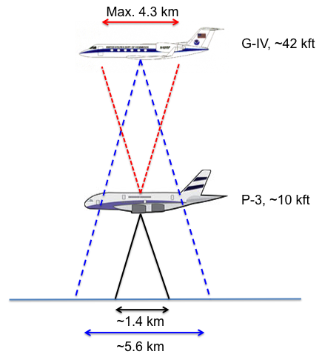
Figure 1. A schematic figure of the footprint coverage for the various SFMR instruments is provided. Also indicated are the normal operating altitudes of each aircraft. This schematic is not to scale.
Hypotheses:
- Hypothesis #1: Comparison with P-3 SFMR data will necessitate modifications to the G-IV SFMR processing and/or algorithm to account for the additional impacts on the received signal. It is expected that if the G-IV uses the P-3 processing algorithm, there will be noticeable deficiencies in the returned values.
Module Description: The premise behind this module is fairly simple: coordinate small sections of overlapping flight tracks between the G-IV and P-3. It is expected that this module should fit into a larger experiment so as not to interrupt the overall goals of said mission. Because the G-IV and P-3 often fly very different patterns, the best way to have the aircraft overlap is using the circumnavigation pattern (see flight pattern document). This flight option would coordinate along the inner circumnavigation (G-IV), targeting an area that is experiencing intermittent but occasionally moderate to heavy rain. This flight strategy allows for comparison of similar strength wind speeds (consistent radius) with a large variety of rain rates. If the G-IV can fly a radial pass in conjunction with the P-3 (maybe possible for a tropical storm), this would allow evaluation over a variety of wind speeds and rain rates. A third option would be to complete this module on a downwind leg of a P-3 TDR mission.
The two aircraft operate at different air speeds (~325 kt for the P-3 and ~440 kt for the G-IV), which limits the amount of time the aircraft will have reasonable coverage over the same portion of the ocean surface. Therefore, this module needs to be operated from the perspective of a preselected meeting point or midpoint of the pattern, which ensures both SFMR are observing the same portion of the ocean. The aircraft should be flying along the same heading during this coordinated overlap. For about 3-4 minutes prior to and after this midpoint, the two SFMR will have varying overlap in their footprints with the least overlap at the beginning and end of the module. A reasonable estimate of the duration of this module is ~8 minutes. Figure 2 is a schematic of the footprint coverage as a function time within the module centered on the preselected midpoint. As confirmation of the wind speeds observed at the midpoint, a dropsonde should be launched from the P-3.
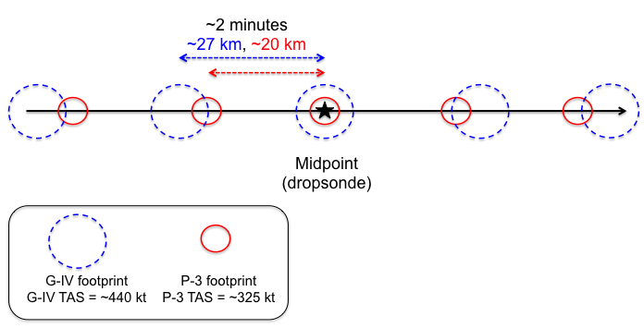
Figure 2. A schematic diagram of the flight path of the G-IV and P-3 aircraft during the module is provided. The red and blue circles indicate the P-3 and G-IV SFMR footprint size, respectively. The timing between successive locations in the figure is ~2 minutes with the distance covered by each aircraft noted. This figure is not to scale as the footprint size is emphasized for visibility.
Analysis Strategy:
Data that are collected during this module will first be post-processed and quality-controlled. The two downward looking SFMR will be compared and statistically evaluated depending on the overlapping footprint coverage and distance from the midpoint. From this perspective, differences can be determined based on coverage, wind speed, and rain rate. A surface-adjusted wind speed from the dropsonde will serve as the truth to validate both SFMR. A determination of the additional impacts of the air column above the P-3 on the G-IV SFMR results could prompt further investigation into changes for the G-IV processing or algorithm. Comparison of the upward looking P-3 SFMR will serve as an independent measure of the above aircraft air column and will help confirm any impacts the G-IV SFMR encounters.
References:
Klotz, B. W., and E. W. Uhlhorn, 2014: Improved Stepped Frequency Microwave Radiometer tropical cyclone surface winds in heavy precipitation. J. Atmos. Oceanic Technol., 31, 2392–2408.

Uhlhorn, E. W., P. G. Black, J. L. Franklin, M. Goodberlet, J. Carswell, and A. S. Goldstein, 2007: Hurricane Surface Wind Measurements from an Operational Stepped Frequency Microwave Radiometer. Mon. Wea. Rev., 135, 3070–3085.

10. Underwater Glider Operations

Principal Investigator(s): Gustavo Goni (NOAA/AOML), Robert Todd (WHOI), Ruth Curry (BIOS), Steven DiMarco (TAMU), Stephan Howden (USM), Jordon Beckler (Mote), Scott Glenn (Rutgers University), Julio Morell (CARICOOS), Kevin Martin (USM), Carl Szczerchowski (NAVO)

Links to IFEX:
- Goal 1: Collect observations that span the TC life cycle in a variety of environments for model initialization and evaluation.
- Goal 2: Develop and refine measurement technologies that provide improved real-time monitoring of TC intensity, structure, and environment.
- Goal 3: Improve understanding of the physical processes important in intensity change for a TC at all stages of its lifecycle.
Motivation:
The upper ocean thermal structure has been shown to be linked to hurricane intensification provided that the appropriate atmospheric conditions are present. The upper ocean has been shown to improve intensity forecast in several intense hurricanes (Mainelli et al, 2008). To complement other ocean observations and aircraft-based experiments and observations, underwater glider operations in support of the Hurricane Field Program will be continued during the 2017 hurricane season. Underwater gliders are cost-effective observational platforms used for targeted and sustained upper-ocean temperature and salinity observations. These vehicles are operated remotely and efficiently collect observations in harsh open ocean conditions, including under hurricane force winds. Gliders can be navigated across moderately strong currents. Gliders can navigate approximately 4,000 km during one mission and collect and transmit thousands of profiles during a several-month deployment. While on the surface, they transmit the ocean profile data and can also download any new instructions for altering the navigation route or sampling configurations at any time during the mission. These underwater glider data are key to initialize ocean numerical models used in ocean-coupled hurricane intensification forecast models.

Background:
Underwater glider data provides surface and subsurface data along predetermined tracks, containing information of temperature and salinity gradients that, once assimilated in numerical models, have a persistent impact on forecasted fields, larger than observations obtained at single locations (such as Argo floats, moorings, etc).
The main objectives of the proposed work are to:

- Share information on synergies of the individual efforts that provide glider ocean data that can be used for tropical cyclone studies and forecasts,
- Obtain upper ocean temperature, salinity, and current velocity observations from underwater gliders,
- Improve understanding of and evaluate the impact of hurricane force winds on the upper ocean, and
- Assess the impact of assimilating underwater glider data on hurricane intensity forecasts.

Of critical importance will be the joint analysis of the data collected through this project with those obtained through 1) other targeted observations made from WP-3D and WC-130J flights that deploy a suite of atmospheric sensors and oceanographic probes, and 2) components of the sustained ocean observing system, such as surface drifters, Argo floats, eXpendable BathyThermographs (XBTs), etc.

Hypotheses:
- Hypothesis #1: Underwater glider data (together with other upper ocean thermal data) impact hurricane intensity forecasts by reducing errors in the initialization of upper ocean thermal conditions.

Experiment/Module Description:
The first hurricane underwater glider mission included in the Hurricane Field Program was carried out by the NOAA/AOML-CARICOOS network in 2014, and continued during the 2015, and 2016 Atlantic hurricane seasons. These missions were geared exclusively towards obtaining upper-ocean observations in support of hurricane studies and forecasts. The goal of this network is to enhance the understanding of air-sea interaction processes during hurricane force wind events by assessing the ocean response to hurricane force wind events, and by investigating the impact of underwater glider data (and other ocean profile data, such as Argo floats, XBTs, moorings, etc) on hurricane intensity forecasts using coupled numerical models.

The efforts of several Institutions that also carry out glider operations and whose observations will be help to improve spatial coverage by providing observations in several areas in the North Atlantic Ocean will be coordinated during the 2017 season. The area of operation of the gliders of each institution are shown in the Figure, while details of their operations are included in the Table and described here:

NOAA/AOML-CARICOOS Mission

During the first two Hurricane Missions of 2014 and 2015, two gliders, one in the Caribbean Sea and one in the tropical North Atlantic Ocean, off Puerto Rico, were used to collect temperature, salinity, and oxygen profiles in regions that are severely undersampled. Starting in the 2016 Atlantic hurricane season, the network was expanded to four gliders, with two deployed in the Caribbean Sea and two in the tropical North Atlantic Ocean. Approximately 14,000 have been collected to date in areas that were previously poorly sampled. Data are transmitted in real-time into the GTS, to the IOOS DAC, and submitted to data centers for assimilation in forecast models.

During the previous hurricane missions, gliders were piloted to obtain repeated upper ocean sections of temperature and salinity before, and after the passage of a hurricane. During the passage of a hurricane, the gliders were in general parked at a fixed location, collecting profile observations analogous to the data collected by a fixed mooring, however with very dense depth resolution. These data allow to analyze the response of the ocean to the passage of a hurricane and to assess the recovery of the ocean. All gliders are now also equipped with additional sensors, such as CDOM, chlorophyll-a, and backscatter. Data collected by these additional sensors will enable further studies focused on assessing the impact of hurricanes on ocean ecosystems and biochemistry.

WHOI Mission

WHOI will operate 1-2 Spray gliders in the Gulf Stream between Miami and New England throughout the year. WHOI will also have 1-2 Spray gliders surveying continuously near Cape Hatteras beginning in April 2017 for the NSF-funded PEACH field program that is focused on shelf-deep ocean exchange near Cape Hatteras. Each Spray glider will be equipped to measure profiles of temperature, salinity, absolute velocity, chlorophyll fluorescence, and 1-MHz acoustic backscatter; realtime temperature and salinity profiles will be transmitted to GTS via the IOOS Glider DAC.

Bermuda’s BIOS Mission

BIOS will operate 2 Slocum gliders (1000 m buoyancy engines) in the central subtropical gyre, near 32°N 64°W -- the Bermuda Atlantic Time Series (BATS) site. One will keep station as a virtual mooring while the other tracks back and forth along a 60-km section to survey the regional eddy field. Both gliders are equipped with a CTD, ECO puck (chlorophyll, backscatter, CDOM) and oxygen optode. One vehicle additionally carries an TRDI DVL ADCP for velocity and acoustic backscatter profiles, the other a Satlantic SUNA for nitrate measurements. Real-time temperature and salinity profiles will be transmitted to GTS via the IOOS Glider DAC.

Rutgers University Mission

Rutgers University is again coordinating glider flights in the Mid-Atlantic region for the 2017 spring through fall stratified seasons as part of MARACOOS. Initial glider deployments will be in April. Rutgers will deploy a near shore glider to zig-zag along the New Jersey on the inner shelf in April. UMaryland will deploy a glider in early May from Ocean City, MD, that will travel out to the shelf break and back to be recovered further south at Wachapreague. In May the UDelaware Biolume glider will be deployed to zig-zag along the Delaware & Maryland inner shelf. Three glider deployments are planned for August. Rutgers will repeat the inner shelf survey along the NJ coast. UMassachusetts will complete 4 cross-shelf lines in a full shelf zig-zag pattern that starts in new Bedford and ends in Atlantic City. Simultaneously, UMaryland will conduct a similar survey further south, with 4 cross shelf lines zig-zagging across the full shelf starting at Atlantic City and ending at Assateague. In October, both the Rutgers and UDelaware inner shelf zig-zaga are repeated. In November, VIMS will conduct a cross-shelf survey out to the shelf break and back between Norfolk and Ocean City.

Texas A&M University Mission

In 2017, TAMU will deploy four (Teledyne-Webb Research) G2 Slocum gliders in the Gulf of Mexico. All are equipped with Seabird CTD, Wetlabs EcoPuck fluorometer (chlorophyll, CDOM, and turbidity), and dissolved oxygen sensor (either Aanderaa optode or Rockland RINKO). We also have a Rockland Scientific MicroRider with microstructure probes and associated cradle to equip one glider. Two of the gliders are equipped with the hybrid thruster assembly. We have two deep water (1000 m) buoyancy pumps, two shelf buoyancy pumps, and two shallow (800 cc) pumps for inner shelf deployments. Pumps will be used that are appropriate to mission objectives. TAMU had several missions during the past two years that have been in the deep water north western/central Gulf of Mexico, and have also targeted the stratified deep waters of the Texas-Louisiana Shelf to investigate processes associated with the development of the Louisiana Deadzone. This summer (2017) TAMU plans on four deployments on the shelf/slope of the Texas-Louisiana Shelf (June-July) and two deployments (one with microrider) in deepwater (August-October). The objectives of the shelf missions are to investigate coastal water quality and cross shelf exchange. These missions are funded separately by the Texas OneGulf Center of Excellence (RESTORE Act) and by the NOAA Center for Sponsored Coastal Ocean Research. The objectives of the deepwater missions are to investigate microstructure and turbulence on the outer continental shelf and slope, provide spatial context of hydrographic parameters being collected aboard an associated research vessel, and to collect observations of upper ocean heat content. The deep missions are funded by the Gulf of Mexico Research Initiative under the GoMIX Project (WHOI lead). All planned TAMU missions will be hosted by the Gulf of Mexico Coastal Ocean Observing System (GCOOS) website (http://gcoos2.tamu.edu/gandalf/deployed/); all data will be transmitted to the GTS through the IOOS Glider DAC. Additional missions are possible if adequate funds are procured.

University Of Southern Mississippi (USM) Mission

USM is still waiting on funding for this 2017, however for the past 5 years USM, in conjunction with NOAA/NDBC, Navy Oceanographics and Shell Oil (funding source), has operated one glider in the Gulf of Mexico to look at Ocean Heat Content as well as loop current dynamics. USM anticipates this year continuing this project. Exact area of operation will be determined by which glider platform is used on the project. All data from these flights are hosted by the Gulf of Mexico Coastal Ocean Observing System (GCOOS) and displayed on their website (http://gcoos2.tamu.edu/gandalf/deployed/). From GCOOS the data is passed through the IOOS Glider DAC to the GTS.

Mote Marine Laboratory Mission

Mote will conduct six 15-day glider deployments per year to survey coastal waters for subsurface evidence of Florida Red Tide (Karenia brevis) bloom initiations and progressions. Routine surveys with glider-mounted instrumentation can address such research and management-oriented questions such as the purported transport of blooms via bottom waters during upwelling events, accumulation at sub surface density fronts, and the diurnal migration of phytoplankton with the possibility of bloom support from sediment nutrient flux. Glider surveys across regions of relative hydrodynamic uncertainty, such as the mouths of estuaries, can also provide increased detail for initiation conditions of forecasting models. Routine monitoring with a Teledyne-Webb Slocum glider equipped with a CTD and instrumentation for measurement of chromophoric dissolved organic matter (CDOM), Chl. a, and backscatter (turbidity) will be employed along offshore transects between the 10 m to 40 m isobaths. This transect has been flown regularly since 2014 and in turn has generated a large, seasonal data set for a bloom-initiation “hot-spot”. However, in the case of an active bloom, the routine transect may be modified to investigate any areas of interest between the area offshore of Clearwater and Englewood, Florida. Typical sampling density during glider deployments provides physical and chemical parameters roughly every 1 sec. Differentials between dead reckoning and observed positions on surfacing provide information on relative current strength and direction. All glider deployment data is available in near real-time from the GCOOS Gulf AUV Network and Data Archiving Long-Term Storage Facility (GANDALF) data portal and incorporated into the IOOS National Glider Data Assembly Center (NGDAC).

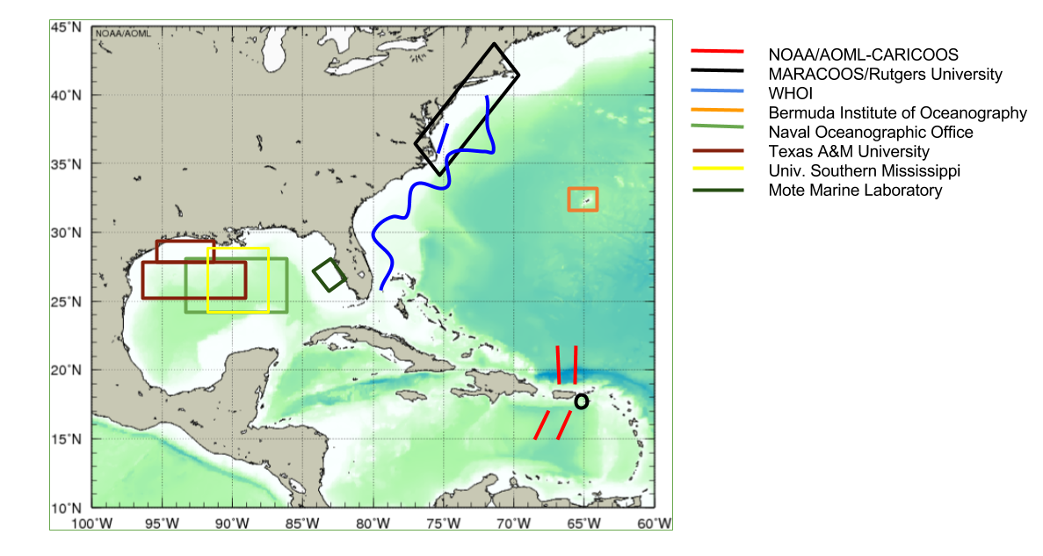
Figure 1. Location of planned underwater glider observations during the 2017 Atlantic hurricane season

Institution | Number of Gliders | Planned Observational Period | Planned Observational Region | Data Distribution | Project web site | Point of Contact
NOAA/AOML-CARICOOS | 4 | Jul-Nov 2017 | Tropical North Atlantic | GTS  IOOS DAC  AOML web pages | http://www.aoml.noaa.gov/phod/goos/gliders/ | Gustavo Goni  (Gustavo.Goni@noaa.gov)
 |  |  | Caribbean Sea
Rutgers University | TBD | Jun-Nov 2017 | Various regions in NE Atlantic Ocean |  |  | Scott Glenn (glenn@marine.rutgers.edu)
Woods Hole Oceanographic Institution | 2-4 | Jun-Nov 2017 | Gulf Stream (Miami to New England) | GTS  IOOS DAC  spraydata.ucsd.edu | gliders.whoi.edu | Robert Todd (rtodd@whoi.edu)
 |  |  | Cape Hatteras shelf/slope
BIOS (Bermuda) | 1 | Jul - Nov 2017 | Bermuda | GTS  IOOS DAC | magic.bios.edu | Ruth Curry  (ruth.curry@bios.edu)
Naval Oceanographic Office | TBD | Aug - Nov 2017 | Gulf of Mexico | GTS  NOAA/NDBC |  | Carl Szczechowski (carl.szczechowski@navy.mil)
Texas A&M University  Geochemical and Environmental Research Group | 4 | (2, shelf) Jun-Jul 2017  (2, deep) Aug-Oct 2017 | Gulf of Mexico | GCOOS/IOOS DAC | http://tabs.gerg.tamu.edu/tceq and  http://gcoos2.tamu.edu/gandalf/deployed/#6/25.016/-90.011 | Steve DiMarco (sdimarco@tamu.edu)
Univ. Southern Mississippi  Division of Marine Science | 1 | Jul-Nov 2017 | Gulf of Mexico | GCOOS/IOOS DAC | http://gcoos2.tamu.edu/gandalf/deployed/#6/25.036/-90.011 | Kevin.m.martin@usm.edu
Mote Marine Laboratory | 1 | 6 annually | Gulf of Mexico | GCOOS/IOOS DAC | http://gcoos2.tamu.edu/gandalf/deployed/#6/25.036/-90.011 | jbeckler@mote.org

Table 1: Underwater glider resources that will be in place during the upcoming 2017 Tropical Atlantic hurricane season.

Analysis Strategy:
The ocean data will be used to:
- Improve understanding of and evaluate the impact of hurricane force winds on the upper ocean (e.g. Domingues et al, 2015, Glenn et al, 2008, Glenn et al, 2016).
- Assess the impact of assimilating underwater glider data on hurricane intensity forecasts (e.g. Dong et al, 2017).

References:
Dong, J., R. Domingues, G. Goni, G. Halliwell, H-S Kim, S-K Lee, M. Mehari, F. Bringas, J. Morell, and L. Pomales (under review). Impact of assimilating glider data on Hurricane Gonzalo (2014) forecast, Weather Forecasting (in press).
Domingues, R., G. Goni, F. Bringas, S.-K. Lee, H.-S. Kim, G. Halliwell, J. Dong, J. Morell, and L. Pomales (2015), Upper ocean response to Hurricane Gonzalo (2015): Salinity effects revealed by targeted and sustained underwater glider observations, Geophys. Res. Lett., 42, doi:10.1002/2015GL065378.
Glenn, S. M., Jones, C., Twardowski, M., Bowers, L., Kerfoot, J., Kohut, J., Webb, D., Schofield, O. 2008. Glider observations of sediment resuspension in a Middle Atlantic Bight Fall Transition Storm. Limnology and Oceanography, 53(5, Part 2): 2180-2196.
Glenn, S., T. Miles, G. Seroka, Y. Xu, R. Forney, F. Yu, H. Roarty, O. Schofield & J. Kohut, 2016. Stratified coastal ocean interactions with tropical cyclones, Nature Communications, 7:10887 doi:10.1038/ncomms10887.
Mainelli, M., M. DeMaria, L. Shay, and G. Goni, 2008. Application of oceanic heat content estimation to operational forecasting of recent Atlantic category 5 hurricanes. Weather Forecast., 23(1):3-16.

11. Easterly Wave Genesis Experiment (GENEX)

Principal Investigator(s): Ghassan Alaka (Lead), Jason Dunion, Alan Brammer (U. Albany), Chris Thorncroft (U. Albany), Mark Boothe (NPS), Yuan-Ming Cheng (U. Albany)

Links to IFEX:
- Goal 1: Collect observations that span the TC life cycle in a variety of environments for model initialization and evaluation;
- Goal 3: Improve understanding of the physical processes important in intensity change for a TC at all stages of its lifecycle.

Background & Significance:
As early as the 1930s, westward propagating disturbances in the lower troposphere were identified as seed circulations for most tropical cyclones (TCs) in the North Atlantic Ocean (Dunn 1940). The origins of these disturbances were traced back to North Africa and are now known as African easterly waves (AEWs; Riehl 1945). About 70% of all TCs and, more impressively, 85% of major hurricanes in the North Atlantic Ocean have been found to initiate from AEWs (Landsea 1993). On average, sixty AEWs exit the West African coast each year. However, determining which of these AEWs will develop into TCs has proven to be a forecasting challenge. For example, over 50% of TC genesis events in the Atlantic main development region predicted by the Global Forecast System (GFS) from 2004-2011 were false alarms (Halperin et al. 2013).
Recent research has shed some light on the relationship between AEWs and TC genesis in the North Atlantic Ocean. The AEW-relative flow around an incipient disturbance has been hypothesized to be an important factor in protecting the disturbance from environmental intrusions and thus creating or maintaining a favorable environment for TC genesis to occur (Dunkerton et al. 2009). Brammer and Thorncroft (2015) have shown that, as AEWs leave West Africa, the troughs are sensitive to the low-level environment to their west and northwest (Fig. 1). Although the vortex at 700 hPa typically has closed circulation in the wave-relative reference frame, the AEW troughs are still cold-core in the lower troposphere and, therefore, there is relative westerly flow under the vortex and through the lower levels of the trough. In a composite analysis, significant differences in the moisture of the low-level environment to the northwest of the troughs were found between developing and non-developing waves. Favorable developing waves had significantly higher moisture content in the lower troposphere to the northwest of the trough as they exited the West African coast compared to favorable non-developing waves. Trajectory analysis for all the waves revealed that as the AEWs transition over the West African coast the troughs are typically open to the environment ahead and to the northwest of the trough. For developing waves this means that moist air (e.g. moist tropical sounding, Dunion 2011) is ingested into the lower levels of the system, while for non-developing waves dry air (e.g. SAL or mid-latitude dry air intrusion soundings) is ingested. At this stage in the AEW life cycle, moisture differences may be fundamental in determining whether a favorable wave will develop or not.
The depth and the integrity of the closed circulation around the pre-genesis disturbance is an important consideration for providing a convectively favorable environment for TC genesis. Freismuth et al. (2016) argue that the vortex of ex-Gaston (2010) was susceptible to dry air above the vortex maxima, which hindered deep convection and led to a weakening of the vortex. In addition, non-developing disturbance (AL90 2014) encountered lower tropospheric dry air to its west and northwest, which was ingested by the disturbance and was likely a major contributor in the failed genesis (Fig. 2). Preliminary results by Brammer (2015) suggest that as AEWs leave the West African coast, these troughs typically possess closed circulations at 700-600 hPa. Yet, these

troughs remain open to the environment both above and below the 700-600-hPa layer. As AEWs propagate across the North Atlantic, the troughs are more likely to exhibit closed circulations at low-levels due to either increased vorticity within the trough or the changing background shear profile over the central Atlantic. It was therefore hypothesized that AEWs are especially sensitive to the low-level environment to the west and northwest of the trough during the first three days after leaving the West African coast. Since AEWs typically propagate at 7.5 m s-1 over the Atlantic (Kiladis et al. 2006), these waves are typically located near 35°W after three days.

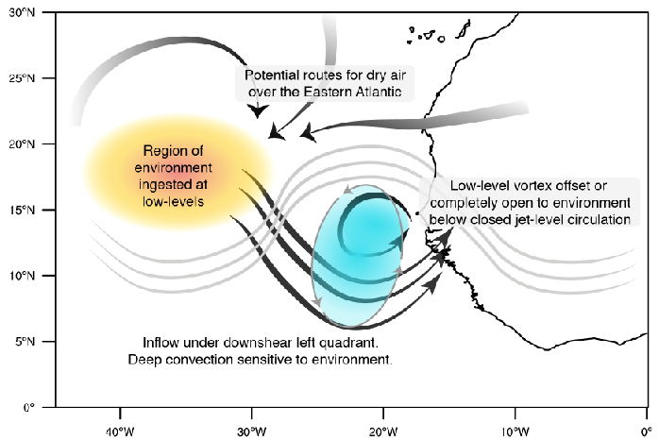
Figure 1. Schematic of the ingestion of dry environmental air by an African easterly wave.
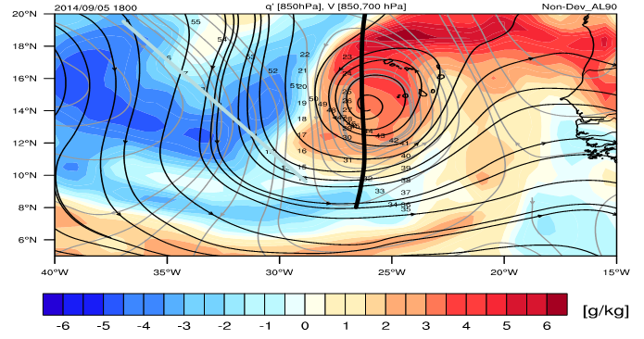
Figure 2. 850 hPa specific humidity anomalies (shading), 850 hPa streamflow (black contours) and 700 hPa streamflow (gray contours) are shown for a non-developing case (AL90) at 18Z 5 Sept 2014.

Objectives:
- Collect NOAA G-IV GPS dropwindsonde and flight level data in the environment to the west of an invest to improve model biases in temperature and humidity. This is known as the Environmental Survey option (Fig. 3). The invest should be an AEW that is expected to develop located at 35°W or further west. The target environment should be 5°-10° to the west of the approximate invest center.
- Collect NOAA G-IV and/or NOAA P-3 Doppler radar, GPS dropwindsonde and flight level data to assess the dynamic and thermodynamic structure of the invest to determine if environmental air was ingested into the disturbance once it has reached 40°W. This is known as the AEW Survey option (Fig. 4). Precise flight patterns will depend upon the developmental status of the invest. Two flight options are provided in Fig. 4.

Hypotheses:
- Hypothesis 1: Environmental air to the west and northwest of an AEW is ingested by an AEW, before the low-level circulation is closed, as it traverses the Atlantic Ocean.
- Hypothesis 2: Environmental air to the west and northwest of an AEW (i.e., TC seed) is vital to determine whether or not the disturbance will develop.
- Hypothesis 3: Dynamical models (e.g., GFS) are consistently too moist in the inflow layer to the west of the AEW, which incorrectly encourages genesis.

OSSE Evaluation:
Time and resource permitting, an OSSE will be performed to determine optimal flight patterns in order to maximize the impact of these observations on the GFS and HWRF systems. With the high genesis false alarm rate in the GFS, this data may be especially useful to that system in order to reduce the model bias for over-predicting TC genesis.
Experiment Description:
This is a multi-plane, multi-option experiment. The target of this experiment is an AEW that is deemed an “invest” (i.e., a disturbance that has a chance to become a TC) by the National Hurricane Center (NHC). In particular, priority will be given to AEW invests that have a high chance of development based on NHC probabilities and model forecasts. This experiment relies on the balance between sampling as far to the east as possible and optimizing on-station time. This balance highlights a region between 35°W ad 40°W as the optimal location to sample the AEW environment and the AEW itself. The NOAA G-IV is the primary aircraft for this experiment. However, the NOAA P-3 becomes an option for this experiment if the AEW approaches 45°W (~2.5 hr on-station time). When possible, the G-IV and P-3 will coordinate with NOAA Sensing Hazards with Operational Unmanned Technology (SHOUT) Global Hawk missions to optimize sampling of environmental targets of interest (see section: Coordination with Supplemental Aircraft).

This experiment will be broken up into two options:
OPTION #1 – G-IV – Environmental Survey
This option will sample the environment to the west of the AEW starting when the disturbance is near 35°W with the NOAA G-IV (Fig. 3 and G-IV Module 1). This experiment can be shifted to the west to accommodate AEWs that have propagated further without developing. Research shows that the disturbances typically close off in the low-levels by 35°W-40°W, so the number of candidates for this experiment decreases west of 40°W. This experiment will utilize GPS dropwindsonde and flight level data to document the thermodynamic properties of the AEW inflow region. In order to sample as much environmental moisture as possible, a Lawnmower Flight Pattern, rotated 90° for N-S orientation and with long meridional legs. The lawnmower pattern should be centered on the latitude of the approximate AEW center and should extend at least 3° to the north and to the south of that center. The zonal legs of this lawnmower pattern should be about 1°-2° (150 nm), while the meridional legs should be about 6°-10° (600-1000 nm). GPS dropwindsondes should be administered every 150-250 nm on each meridional leg, but this spacing is flexible based on dropwindsonde availability. See G-IV Module 1 for more information.
Importantly, the Environmental Survey option may be administered stand-alone experiment or may be included as a module in other experiments. If used as a module, the Environmental Survey would be administered as a “break-away module”. For example, the AEW Survey (see Option #2), which highlights the sampling of the actual AEW, may be altered to include the Environmental Survey as a module. In addition, the Environmental Survey may be added as a module within other NOAA P-3 and/or NOAA G-IV experiments or operational tasked missions. The proposed far-field sampling can often be performed during P-3 and G-IV aircraft ferries to and from the tropical disturbance. If a Saharan Air Layer outbreak is present in the far field environment, the DWL Experiment SAL module can be conducted.
Analysis Strategy:
NOAA G-IV (and, if applicable, NOAA P-3) GPS dropwindsonde and flight level data will be analyzed to determine the thermodynamic environment to the west of the AEW. NASA Global Hawk GPS dropwindsondes, if available, will be used in conjunction with NOAA aircraft data to observe the structure and evolution of the to-be-ingested environmental air. The vertical structure of specific humidity will be especially important in this environmental survey. These specific humidity measurements will be used to determine HWRF and GFS biases in the environment ahead of AEWs.
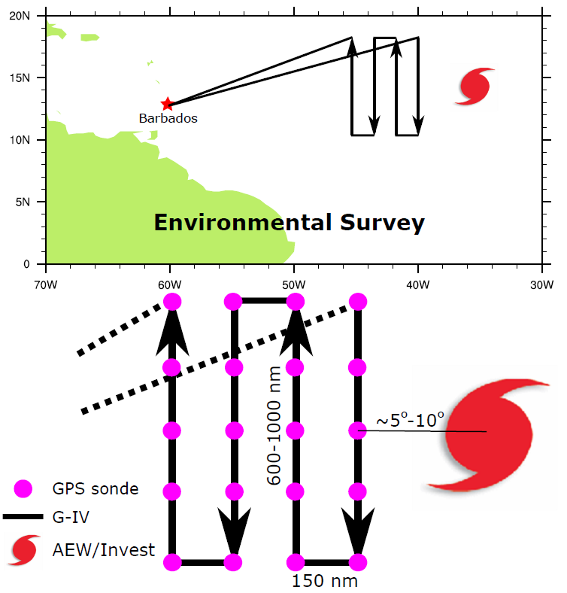
Figure 3. The Environmental Survey experiment (or module).

OPTION #2 – G-IV/P-3 – AEW Survey
This option will sample a developing AEW to determine if environmental air has been ingested and assess impacts on the structure and organization of the tropical disturbance. Once the AEW reaches 40°W, the disturbance may be investigated with the NOAA G-IV (Fig. 4, G-IV Module 2A, G-IV Module 2B). If the AEW reaches 45°W and has still not developed, the NOAA P-3 may also be used to carry out this experiment (P-3 Module 2). The AEW Survey experiment may incorporate the Environmental Survey (see Option #1), as shown by the dashed line in Fig. 4.
If the AEW is showing signs of genesis, the AEW Survey will focus on center fixes, as shown in the top of Fig. 4. This resembles the Butterfly Flight Pattern (see G-IV Module 2B, P-3 Module 2). If the AEW is disorganized, the AEW Survey will focus on a general survey pattern around the disturbance, as shown in the bottom of Fig. 4. This resembles the G-IV Circumnavigation (Hexagon) Flight Pattern, modified to remove the middle circle for time constraints. Regardless of the AEW developmental status, this experiment will employ Doppler radar, GPS dropwindsondes and flight level data to create a full picture of the dynamic and thermodynamic structure of the AEW. The strategy for GPS dropwindsonde sampling should be consistent with other survey or figure-four flight patterns.
Analysis Strategy:
NOAA G-IV and NOAA P-3 Doppler radar, GPS dropwindsonde and flight level data will be synthesized to assess the dynamic and thermodynamic structure of the AEW, with a focus on whether or not the previously-observed environmental air was ingested into the disturbance. In addition to searching for signs of development, evidence for the ingestion of environmental air observed in the previous flight will be sought out. In particular, the impact of this environmental air on the organization and the intensity of the system will be the focal point of this experiment. If the AEW is interacting with a Saharan Air Layer outbreak, GPS dropwindsonde sampling of the SAL’s low to mid-level dry air (~500-850 hPa) and mid-level easterly jet (25-50 kt near 600-800 hPa) should also be prioritized and the P-3 DWL Experiment SAL module can be conducted.
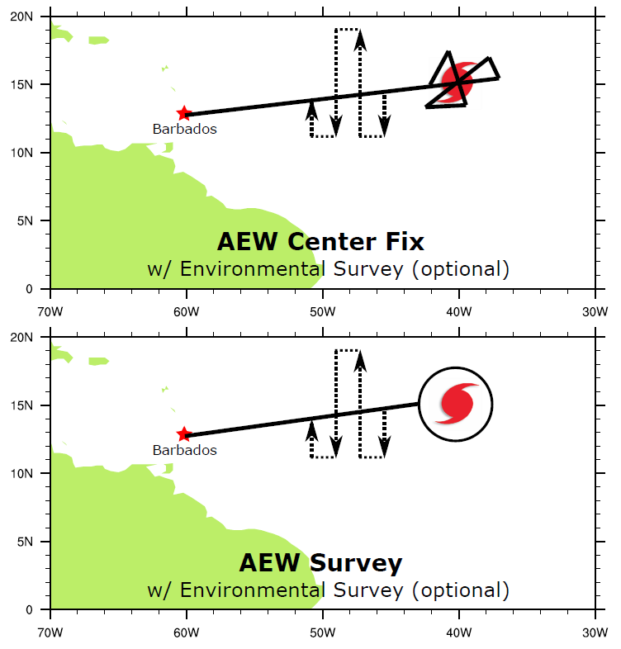
Figure 4. The AEW Survey experiment. (Top) AEW Center Fix option with optional Environmental Survey module. (Bottom) AEW Survey option with Environmental Survey module.

References:
Brammer A., (2015): Evolution of African easterly waves and their relationship to tropical cyclogenesis. Ph.D. thesis, SUNY at Albany. url: http://gradworks.umi.com/37/38/3738908.html
Brammer A., and C. D. Thorncroft, 2015: Variability and Evolution of African Easterly Wave Structures and Their Relationship with Tropical Cyclogenesis over the Eastern Atlantic. Mon. Wea. Rev. 143(12), 4975-4995.
Dunion, J.P., 2011: Re-writing the climatology of the tropical North Atlantic and Caribbean Sea atmosphere. J. Climate, 24 (3), 893-908.
Dunkerton, T. J., M. T. Montgomery, and Z. Wang, 2009: Tropical cyclogenesis in a tropical wave critical layer: Easterly waves. Atmos. Chem. Phys., 9, 5587–5646.
Dunn, G. E., 1940: Cyclogenesis in the tropical Atlantic. Bull. Amer. Meteor. Soc., 21, 215-229.
Freismuth, T. M., Rutherford, B., Boothe, M. A., and Montgomery, M. T, 2016: Why did the storm ex-Gaston (2010) fail to redevelop during the PREDICT experiment? Atmos. Chem. Phys. Discuss., doi:10.5194/acp-2015-692, in review.
Halperin, D. J., H. E. Fuelberg, R. E. Hart, J. H. Cossuth, P. Sura, and R. J. Pasch, 2013: An evaluation of tropical cyclone genesis forecasts from global numerical models. Wea. Forecasting, 28, 1423–1445, doi:10.1175/WAF-D-13-00008.1
Landsea, C. W., 1993: A climatology of intense (or major) Atlantic hurricanes. Mon. Wea. Rev., 121, 1703-1713.
Riehl, H., 1945: "Waves in the easterlies and the polar front in the tropics" Misc. Rep. No. 17, Department of Meteorology, University of Chicago, 79 pp.

12. Analysis of Intensification Processes Experiment (AIPEX)

Principal Investigator(s): Jon Zawislak, Robert Rogers, Leon Nguyen, John Kaplan, Jason Dunion, Paul Reasor, and Jun Zhang

Links to IFEX:

- Goal 1: Collect observations that span the TC lifecycle in a variety of environments

- Goal 3: Improve understanding of the physical processes important in intensity change for a TC at all stages of its lifecycle

Motivation:

While some improvements in operational tropical cyclone (TC) intensity forecasting have been made in recent years (DeMaria et al. 2014), predicting changes in TC intensity (as defined by the 1-min. maximum sustained wind) remains problematic. In particular, the operational prediction of rapid intensification (RI) has proven to be especially difficult (Kaplan et al. 2010). The significant impact of such episodes has prompted the Tropical Prediction Center/National Hurricane Center (TPC/NHC) to declare it as its top forecast priority (Rappaport et al. 2009).

Processes that govern TC intensification span spatial and temporal scales from the environmental to vortex to convective and smaller scales. Recent work has focused on the precipitation distribution and structure to assess regimes associated with TC intensification. Studies using airborne Doppler radar (Rogers et al. 2013) and passive microwave satellite (e.g., Alvey et. al 2015; Tao and Jiang 2015) observations have compared the inner-core structure of intensifying and non-intensifying TCs. Precipitation and deep convection in intensifying cases were found to be more symmetrically distributed and located preferentially inside the radius of maximum wind (RMW) compared to non-intensifying cases. Predictability of the azimuthal and radial distribution of precipitation and deep convection within TCs, however, remains low. Thus, identifying and understanding the environmental and internal (within the inner core) mechanisms that govern the azimuthal and radial distribution of precipitation and deep convection could improve the understanding of the intensification process. Recent studies indicate that these mechanisms may include: the interaction of the vortex with environmental vertical wind shear and dry air, vortex-scale subsidence, surface enthalpy fluxes from the underlying ocean, and precipitation mode (i.e., shallow, moderately deep, and deep convection, as well as stratiform rain).

The goal of this experiment is to collect datasets that can be used to: 1) improve the initialization and evaluation of 3-D numerical models; 2) improve the understanding of intensification processes across multiple scales, with particular focus on the mechanisms that govern the azimuthal and radial distribution of precipitation and deep convection. TCs that are experiencing moderate vertical wind shear (5–10 m s⁻¹) over a deep layer (850–200 hPa) are of particular interest, since this range of shear values is often associated with considerable uncertainty with respect to the prospect for TC intensification (Bhatia and Nolan 2013). The overarching goal is to improve the ability to predict the timing and magnitude of intensification, particularly RI, events.

Background:

Prior studies have found a number of large-scale environmental factors that are generally favorable for TC intensification, including low environmental vertical wind shear, high ocean heat content, and elevated low- to mid-tropospheric humidity. Thus far, statistically-based prediction schemes that employ predictors derived from large-scale environmental fields and GOES infrared satellite imagery have generally been shown to provide the most skillful objective RI guidance (Kaplan et al. 2015). These schemes include the SHIPS rapid intensification index (SHIPS-RII) (Kaplan et al. 2010) and the more recently developed Bayesian and logistic regression RI models (Rozoff and Kossin 2011). Kaplan et al. (2015) showed that these statistical models are capable of explaining roughly 20% of the skill of Atlantic basin RI forecasts at a lead-time of 24-h. The remaining 80% of the skill not explained by the statistical models is assumed to be attributable either to processes not explicitly accounted for by those models or by limitations in the predictability of RI events.

On the vortex-scale, a number of observational studies have found that intensifying TCs have more precipitation and convective bursts occur within the high inertial stability region inside the RMW (e.g., Rogers et al. 2013, 2015, 2016). This configuration is favorable for TC intensification for two hypothesized reasons: 1) In the high inertial stability region, heat energy is much more efficiently converted to kinetic energy (Schubert and Hack 1982; Vigh and Schubert 2009), and 2) Diabatic heating within the high inertial stability region enables angular momentum surfaces to be drawn inward at the RMW, resulting in tangential wind spinup (Smith and Montgomery 2016).

Observational studies have also found that intensifying TCs typically have more symmetrically distributed precipitation and deep convection than non-intensifying TCs (e.g., Rogers et al. 2013; Alvey et al. 2015; Tao and Jiang 2015). This is consistent with idealized modeling studies that show that TC intensification is most sensitive to the axisymmetric, azimuthal wavenumber-0 component of diabatic heating (e.g., Nolan et al. 2007). One principal environmental factor that can prevent the development of this symmetry is vertical wind shear. The interaction of TCs with environmental vertical wind shear typically results in a wavenumber-1 asymmetry in vertical motion and precipitation, in which upward vertical motion and deep convection is favored in the downshear semicircle, while downward motion and suppression of deep convection is observed in the upshear semicircle (e.g., Marks et al. 1992; Reasor et al. 2013; Rogers et al. 2016; Zawislak et al. 2016). An increase in asymmetry can lead to the decrease in the projection of diabatic heating onto the axisymmetric, azimuthal wavenumber-0 component that has been shown to be important for TC intensification. However, the magnitude of this asymmetry can exhibit considerable variability, particularly within the moderate shear regime (5–10 m s⁻¹) that has been shown to be problematic for operational intensity forecasts (Bhatia and Nolan 2013). This suggests the importance of understanding what governs the azimuthal distribution of precipitation and deep convection.

Recent studies have used airborne Doppler radar and dropsonde data to examine what hinders the development of precipitation symmetry in sheared TCs (Rogers et al. 2016; Zawislak et al. 2016; Nguyen et al. 2017). These studies show evidence for several potential hindering factors. First, convective downdrafts associated with the downshear convection can cool and stabilize the lower troposphere in the left of shear and upshear quadrants. Second, subsidence in the upshear quadrants can increase the temperature and decrease the relative humidity of the mid-troposphere, effectively capping the lower troposphere. Third, dry air can be transported laterally from the environment into the TC’s upshear quadrants. These hindering factors could be mitigated through several potential mechanisms, as listed in the hypotheses below.

Hypotheses:

The following hypotheses will guide the sampling strategies for TCs that have the potential to undergo (rapid) intensification:

- Intensification is favored when precipitation and deep convection are distributed symmetrically and located preferentially inside the radius of maximum wind (RMW).

- The local kinematic (e.g., location and depth of radial inflow, vertical alignment of the vortex) and thermodynamic forcing (e.g., SST, available moisture, and RH) are key in governing whether precipitation (deep convection) is symmetrically distributed and primarily inside the radius of maximum wind (RMW)

- Symmetry is favored when: (a) the mid-troposphere is moistened upshear due to detrainment from mid-tropospheric congestus, evaporation of falling stratiform rain, or reduced lateral advection of dry air from the environment; (b) the lower troposphere is convectively unstable in the upshear quadrants due to enhanced surface enthalpy fluxes from the underlying ocean and/or reduced convective downdrafts.

It should be noted that these hypotheses focus primarily on the vortex- and precipitation-scale structures. It is assumed that the environment is either favorable, or at least not hostile, to intensification. Specifically, deep layer vertical shear does not (and is not expected to) exceed a hostile value of >10–15 m s⁻¹, sea surface temperatures are at least 27–28°C, and environmental moisture is not exceedingly low (200–400 km radial average TPW > 45 mm) all the way around the storm. As mentioned above, there is a specific interest in targeting cases where the environmental vertical shear is moderate, i.e., 5–10 m s⁻¹, though cases where the shear is below this will be targeted as well.

Experiment Description:

Missions will be targeted for systems that have a reasonable chance of undergoing intensification based on statistical and numerical model forecast guidance. When possible (i.e., subject to range, timing, and other logistical constraints), missions will begin at least 24 h prior to the expected onset of intensification, while the TC is still at tropical depression or tropical storm intensity. This enables the documentation of TC structure during the time leading up to intensification onset (if it indeed occurs). Ideally missions will continue every 12 h, as long as feasible. If either the P-3 or G-IV aircraft cannot fly every 12 h the experiment can still be conducted provided that the gap between missions for any one of the two aircraft does not exceed 24 h. Although all intensification rates are of interest, priority will be given to those with a high potential for RI according to model guidance and/or are forecast to experience at least moderate (5–10 m s⁻¹) vertical wind shear over a deep layer. There are a few possible configurations for the execution of this experiment, as outlined below:

1. Both P-3 and G-IV are available:

This is the optimal configuration for this experiment as, under this scenario, the P-3 and G-IV would coordinate operations (i.e., takeoff times would allow both aircraft to sample the TC simultaneously). The P-3 will sample the inner-core with the standard rotated Figure-4 pattern (P-3 Module 1), while the G-IV will sample the outer environment and near-TC environment (typically around 60 n mi, or 100 km) with either the circumnavigation (G-IV Module 1) or star (G-IV Module 2) pattern.

2. Only P-3 is available:

When the G-IV is not available for coordinated operations, either because of operational tasking requirements or aircraft unavailability, P-3 targeted observations in the near environment and inner core can still contribute towards the objectives of the experiment. In this scenario there are two possible strategies for sampling, which depend on whether the precipitation distribution is asymmetric:

- TC is highly asymmetric:

This option will be chosen when the precipitation distribution in the targeted TC is expected to be highly asymmetric during the mission. Such an asymmetric configuration would allow for a high-altitude P-3 circumnavigation pattern to at least target the precipitation-free upshear semicircle, and when hazard avoidance is possible the downshear quadrants. Indications of an appropriate magnitude of asymmetry may include:

- Visible, infrared, or microwave satellite imagery indicates an exposed or partially-exposed low level circulation center (see example below).
- The environmental vertical wind shear, as indicated by SHIPS, is expected to be sufficient (> 5 m s⁻¹) during the mission to result in an asymmetric precipitation structure.
- High-resolution numerical guidance (i.e. HWRF) forecast a lack of precipitation in the upshear semicircle of the TC during the mission.

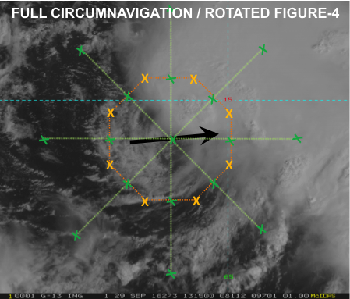
(Figure-4 in green, circumnavigation in orange, shear vector in black, ‘X’ is a dropsonde location)

Given this scenario, the P-3 will sample the near environment and inner core with a pattern that includes a high-altitude circumnavigation and, optimally, a rotated Figure-4 (P-3 Module 2). If time doesn’t permit for a complete rotated Figure-4, then a single Figure-4 can be substituted. The radius of the circumnavigation should be as close to the inner-core precipitation shield as safety allows, as best determined through available visible or infrared satellite, microwave, or radar imagery. The high-altitude circumnavigation allows for increased azimuthal and vertical dropsonde data coverage, particularly in the critical, precipitation-free upshear region that may fill in as intensification commences.

(b) TC is relatively symmetric:

This scenario applies to a targeted TC that has the potential for intensification, but the precipitation is expected to be too symmetric during the mission for the P-3 high-altitude circumnavigation to be conducted safely. Here, the P-3 will sample the inner-core vortex structure with the standard rotated Figure-4 pattern (P-3 Module 1).

3. Only G-IV is available:

This option is less preferable as targeted observations of the vortex structure are also important towards the objectives of the experiment. This option applies to any targeted TC that has the potential for intensification, regardless of asymmetric structure. Under this option, the G-IV will sample the outer and near environments with either the circumnavigation (G-IV Module 1) or star (G-IV Module 2), and requires that hazard avoidance permit the G-IV to obtain measurements within/very near the inner core.

4. Additional modules

If the opportunity arises during the execution of AIPEX, fly the Convective Burst Module or Arc Cloud Module (see accompanying discussion in Field Program plan). The Convective Burst Module would be optimal for determining the structure and evolution of deep convection within the framework of the broader vortex-scale circulation as it interacts with vertical shear (if appropriate), while the Arc Cloud Module would be ideal for documenting locations within the vortex circulation encountering significant low-to mid-level dry air and determining the impact of the associated outflow boundaries on the boundary layer temperature and moisture distribution.

Analysis Strategy:
The general analysis strategy follows that performed in recent observational studies (Reasor et al. 2013; Zhang et al. 2013; Rogers et al. 2016; Zawislak et al. 2016; Nguyen et al. 2017). The analysis strategy includes assessing and documenting the time evolution of the following:

- Azimuthal and radial distribution of inner-core precipitation and deep convection (P-3 TDR/LF, possibly G-IV TDR). The inner-core precipitation asymmetry, and its projection onto the axisymmetric, azimuthal wavenumber-0 component will be assessed quantitatively (assuming sufficient azimuthal coverage). The location of precipitation and convective bursts relative to the RMW will be examined.

- Precipitation mode, particularly upshear (P-3 TDR/LF, possibly G-IV TDR). An analysis of the precipitation mode (shallow, moderately deep, deep convection, as well as stratiform rain), using the vertical velocity and reflectivity structure, will allow for an assessment as to whether moistening of the inner core occurs through upscale growth of convection (moistening from convective detrainment at gradually higher altitudes), or from the top-down via stratiform rain as hydrometeors produced downshear are transported azimuthally upshear.

- Low-wavenumber thermodynamic and kinematic structure of the boundary layer (P-3/G-IV dropsondes, DWL for kinematic only). The thermodynamic focus will be on the boundary layer cooling by convective downdrafts and the subsequent recovery via surface enthalpy fluxes from the underlying ocean in the downstream (upshear-left through downshear-right) quadrants. Surface enthalpy fluxes will be calculated where dropsondes are paired with AXBTs that provide sea surface temperature. The kinematic focus will be on obtaining measurements of the strength and depth of boundary layer inflow and convergence in the boundary layer, both in a symmetric sense and relative to the shear vector (when relevant). Additionally, the gradient and agradient flow in the boundary layer will be calculated.

- Low-wavenumber thermodynamic and kinematic structure above the boundary layer (P-3/G-IV dropsondes, P-3/G-IV TDR and DWL for kinematic only). The presence of mid-tropospheric dry air is of particular interest. Assuming mid-tropospheric dry air is present (most likely in the upshear quadrants), the potential sources of this dry air (vortex-scale subsidence or lateral advection from the environment) and how this upshear dry air is removed (i.e., through detrainment from congestus or evaporation of stratiform precipitation) will be assessed.

- Vortex tilt (P-3 TDR, possibly G-IV TDR). Assuming sufficient TDR coverage, the vortex tilt will be examined quantitatively by merging TDR analyses from each Figure-4. If the vortex tilt appears to decrease rapidly during a flight, individual TDR analyses can be used to qualitatively examine the time evolution of vortex tilt during the alignment process.

- Vertical wind shear and upper-level divergence (G-IV dropsondes). These quantities will be computed and compared with global model analyses. The vertical distribution of shear will also be evaluated, as upper-level shear is hypothesized to be less deleterious than low-level shear.

The overarching hypothesis is that, by performing the above analyses for multiple AIPEX data sets collected during both RI and non-RI events, it will be possible to determine the conditions that are triggers for RI. This analysis strategy can also assist in the evaluation of 3-D numerical models, including the sufficiency (or lack thereof) of the horizontal resolution, and the microphysical and planetary boundary layer parameterization schemes.

References:

Alvey, G.R. III, J. Zawislak, and E. Zipser, 2015: Precipitation Properties Observed during Tropical Cyclone Intensity Change. Mon. Wea. Rev., 143, 4476–4492. doi: 10.1175/MWR-D-15-0065.1.

Bhatia, K. T., and D. S. Nolan, 2013: Relating the skill of tropical cyclone intensity forecasts to the synoptic environment. Wea. Forecasting, 28, 961–980, doi: 10.1175/WAF-D-12-00110.1.

DeMaria, M., C. R. Sampson, J. A. Knaff, and K. D. Musgrave, 2014: Is tropical cyclone intensity guidance improving? Bull. Amer. Meteor. Soc., 95, 387–398, doi:10.1175/BAMS-D-12-00240.1.

Kaplan, J., M. DeMaria, and J. A. Knaff, 2010: A revised tropical cyclone rapid intensification index for the Atlantic and eastern North Pacific basins. Wea. Forecasting, 25, 220–241, doi: 10.1175/2009WAF2222280.1.

Kaplan, J., and Coauthors, 2015: Evaluating environmental impacts on tropical cyclone rapid intensification predictability utilizing statistical models. Wea. Forecasting, 30, 1374–1396, doi: 10.1175/WAF-D-15-0032.1.

Marks, F. D., Jr., R. A. Houze Jr., and J. F. Gamache, 1992: Dual-aircraft investigation of the inner core of Hurricane Norbert. Part I: Kinematic structure. J. Atmos. Sci., 49, 919–942, doi: 10.1175/1520-0469(1992)049<0919:DAIOTI>2.0.CO;2.

Nguyen, L. T., R. Rogers, and P. Reasor 2017: Thermodynamic and kinematic influences on precipitation symmetry in sheared tropical cyclones: Bertha and Cristobal (2014). Mon. Wea. Rev. In review.

Nolan, D. S., Y. Moon, and D. P. Stern, 2007: Tropical cyclone intensification from asymmetric convection: Energetics and efficiency. J. Atmos. Sci., 64, 3377–3405, doi: 10.1175/JAS3988.1.

Rappaport, E. N., and Coauthors, 2009: Advances and Challenges at the National Hurricane Center. Wea. Forecasting, 24, 395–419.

Reasor, P. D., R. F. Rogers, and S. Lorsolo, 2013: Environmental flow impacts on tropical cyclone structure diagnosed from airborne Doppler radar composites. Mon. Wea. Rev., 141, 2949–2969, doi: 10.1175/MWR-D-12-00334.1.

Rogers, R., P. Reasor, and S. Lorsolo, 2013: Airborne Doppler observations of the inner-core structural differences between intensifying and steady-state tropical cyclones. Mon. Wea. Rev., 141, 2970–2991, doi: 10.1175/MWR-D-12-00357.1.

Rogers, R. F., P. D. Reasor, and J. A. Zhang, 2015: Multiscale structure and evolution of Hurricane Earl (2010) during rapid intensification. Mon. Wea. Rev., 143, 536–562, doi: 10.1175/MWR-D-14-00175.1.

Rogers, R., J. Zhang, J. Zawislak, H. Jiang, G. Alvey, E. Zipser, and S. Stevenson, 2016: Observations of the structure and evolution of Hurricane Edouard (2014) during intensity change. Part II: Kinematic structure and the distribution of deep convection. Mon. Wea. Rev., 144, 3355–3376, doi: 10.1175/MWR-D-16-0017.1.

Rozoff, C. M., and J. P. Kossin, 2011: New probabilistic forecast models for the prediction of tropical cyclone rapid intensification. Wea. Forecasting, 26, 677–689, doi: 10.1175/WAF-D-10-05059.1.

Schubert, W. H., and J. J. Hack, 1982: Inertial stability and tropical cyclone development. J. Atmos. Sci., 39, 1687–1697, doi: 10.1175/1520-0469(1982)039<1687:ISATCD>2.0.CO;2.

Tao, C., and H. Jiang, 2015: Distributions of shallow to very deep precipitation–convection in rapidly intensifying tropical cyclones. J. Climate, 28, 8791–8824, doi: 10.1175/JCLI-D-14-00448.1.

Vigh, J. L., and W. H. Schubert, 2009: Rapid development of the tropical cyclone warm core. J. Atmos. Sci., 66, 3335–3350, doi: 10.1175/2009JAS3092.1.

Zawislak, J., H. Jiang, G. Alvey, E. Zipser, R. Rogers, J. Zhang, and S. Stevenson, 2016: Observations of the structure and evolution of Hurricane Edouard (2014) during intensity change. Part I: Relationship between the thermodynamic structure and precipitation. Mon. Wea. Rev., 144, 3333–3354, doi: 10.1175/MWR-D-16-0017.1.

Zhang, J. A., R. F. Rogers, P. Reasor, E. Uhlhorn, and F. D. Marks Jr., 2013: Asymmetric hurricane boundary layer structure from dropsonde composites in relation to the environmental wind shear. Mon. Wea. Rev., 141, 3968–3984, doi: 10.1175/MWR-D-12-00335.1.

13. Tropical Cyclone in Shear Experiment

Principal Investigator(s): Paul Reasor (lead), Jason Dunion, John Kaplan, Leon Nguyen, Rob Rogers, Jon Zawislak, Jun Zhang, Michael Riemer (Johannes Gutenberg-Universität)

Links to IFEX:
- Goal 1: Collect observations that span the TC life cycle in a variety of environments for model initialization and evaluation.
- Goal 3: Improve understanding of the physical processes important in intensity change for a TC at all stages of its lifecycle.
Motivation:
Forecasting of TC intensity remains a great challenge in which the gains in skill over the past decade have significantly lagged those of track at most forecast intervals (Rogers et al. 2006, DeMaria et al. 2005). As a multiscale atmospheric and oceanic problem, one of the constraints on TC intensity change is the vortex’s interaction with the evolving environmental flow. Vertically-sheared flow in particular is generally acknowledged to limit storm intensity, especially when combined with other environmental factors like low sea-surface temperature and mid-tropospheric dry air (e.g., Tang and Emanuel 2012). In observation-based statistical models of intensity prediction (Kaplan and DeMaria 2003; DeMaria et al. 2005), the vertical wind shear (VWS) is an important predictor.
Although most TCs in HRD’s data archive experience some degree of VWS, the timing of flights with respect to the shear evolution and the spatial sampling of kinematic and thermodynamic variables have not always been carried out in an optimal way for testing hypotheses regarding shear-induced modifications of TC structure and their impact on intensity change (see below). This experiment will sample the TC at distinct phases of its interaction with VWS and measure kinematic and thermodynamic fields with the azimuthal and radial coverage necessary to test existing hypotheses.
In addition to enhancing basic understanding, the dataset collected will guide improvements in initial conditions and the representation of moist physical processes in models. These improvements are likely necessary to increase the accuracy of short-term (<24 h) numerical intensity guidance for vertically sheared TCs. Initial conditions within the core region are important because the resilience of a TC (i.e., its ability to maintain a vertically-coherent structure under differential advection by the VWS) is sensitive to the strength, depth, and radial profile of the vortex (Reasor et al. 2004; Reasor and Montgomery 2015). Properly representing the flow outside the core region is also important since the flow topology there is critical to the thermodynamic interaction of the TC with surrounding dry environmental air (Riemer and Montgomery 2011). Physical processes in the model must also be well-represented so that 1) the structure on which the vortex resilience depends is not errantly transformed over short periods (< 6 h), 2) the convective response of the TC to vertical shearing and its feedback on vortex resilience are properly simulated, and 3) the shear-induced intensity modification mechanisms are permitted to operate as in nature.
Background:
Vertical wind shear impacts TC structure directly through vertical tilting of the vortex wind field and indirectly through modulation of the convective field (Black et al. 2002; Reasor et al., 2009; Reasor and Eastin 2012; Reasor et al. 2013). The impact of VWS on TC intensity is less certain and depends, in part, upon the timescale over which one considers the response (Frank and Ritchie 2001; Wang et al. 2004; Wong and Chan 2004; Riemer et al. 2010). The view of VWS as a generally negative influence on TC formation and intensification is supported by observational studies (e.g., Gray 1968) and observation-based statistical models of intensity prediction (Kaplan and DeMaria 2003; DeMaria et al. 2005). During the early stages of TC development, however, VWS can play a potentially positive role by organizing deep convection and vorticity production in the downshear region of the weak, pre-existing vortex (Molinari et al. 2004, 2006).
Early studies of shear-induced intensity change mechanisms focused on the role of VWS in ventilating the warm core (Simpson and Riehl 1958). Frank and Ritchie (2001) simulated the development of pronounced convective asymmetry in a vertically-sheared TC and argued that weakening occurs through the hydrostatic response to outward fluxes of upper-level potential vorticity (PV) and equivalent potential temperature. An alternative explanation by DeMaria (1996) focused on the balance-dynamics response of the vortex to vertical tilting. To maintain thermal wind balance as the wind structure is tilted, static stability must increase at low levels in the eyewall region. The negative impact on intensity was then hypothesized to arise through suppression of eyewall convection. Using a multi-level adiabatic primitive equation model, Jones (1995, 2000) demonstrated that low-level static stability evolves in a manner consistent with balance dynamics but does so asymmetrically within the eyewall. An asymmetrically balanced thermal anomaly develops in phase with the distortion of the wind field caused by vertical tilting, resulting in anomalously low (high) values of static stability located downtilt (uptilt). Thus, while convection might be suppressed on one side of the eyewall, it can be enhanced on the other. Jones additionally implicated the mesoscale transverse circulation (required to maintain asymmetric balance) in the development of convective asymmetry in the eyewall (see also Braun et al. 2006; Davis et al. 2008). The net impact of such static stability and vertical motion asymmetry on convective asymmetry and intensity change remains unclear.
Recently, Riemer et al. (2010) and Riemer et al. (2013) have proposed an intensity modification mechanism also rooted in a balance-dynamics framework. They argue that balanced vorticity asymmetry at low levels, generated outside the core through shear forcing, organizes convection outside the eyewall into a wavenumber-1 pattern through frictional convergence. Downdrafts associated with this vortex-scale convective asymmetry arise as precipitation generated by the convective updrafts falls into unsaturated air below. In their simulations, the downdrafts led to a vortex-scale transport of low equivalent potential temperature (θ_{e}) air into the inflow layer and disruption of the TC heat engine (Emanuel 1986, 1991). If particularly low θ_{e} air at lower to middle levels of the environment is able to reach the core region where convective enhancement occurs, the thermodynamic impacts of the downward transport of low θ_{e} air would be enhanced. Riemer and Montgomery (2011) proposed a simple kinematic model for this environmental interaction, quantifying the shear-induced distortion of the “moist envelope” surrounding the TC core as a function of shear strength, vortex size, and vortex intensity.
In the simulations of Riemer et al. (2010), the TC core region developed vertical tilt following its initial encounter with VWS, but then realigned, i.e., the vortex was resilient. The problem of dynamic resilience focuses on the ability of the TC to maintain a vertically-coherent vortex structure as it experiences vertical shearing. Jones (1995) found that coupling between vertical layers, and the tendency for the upper- and lower-level potential vorticity (PV) of the cyclonic core to precess upshear, restricts the development of vertical tilt that would otherwise occur through differential advection. For small-amplitude tilt, Reasor et al. (2004) developed a balance theory for the shear forcing of vortex tilt in which the tilt asymmetry behaves as a vortex-Rossby wave. In this vortex-Rossby wave framework, they developed a heuristic model for the TC in shear which predicts a left-of-shear tilt equilibrium. Furthermore, they demonstrated that the evolution towards this equilibrium tilt state depends not only on intrinsic scales of the flow (e.g., Rossby number and Rossby deformation radius), but also on the radial distribution of (potential) vorticity in the core region. Reasor and Montgomery (2015) have recently evaluated this heuristic model. The model is capable of predicting the enhancement of resilience that arises as the PV gradient outside the core increases. Even when moist neutral conditions exist within the eyewall, the model still describes the long-time evolution of the tilt asymmetry outside the eyewall.

Hypotheses:
- Hypothesis 1: Structure evolution: The vertically-tilted vortex structure which develops following a significant increase in VWS is governed by balance-dynamics theory. [There are two components here: 1) determine whether the wavenumber-1 vorticity and thermodynamic structures of the tilt asymmetry within the eyewall region are consistent with the expectations of asymmetric balance (see Background); and 2) document, to the extent possible, the structural evolution of the tilt asymmetry on the timescale of a vortex circulation period (~1 h) and over the longer timescale dictated by the mission frequency (~12 h), and then compare the observed evolution with expectations from idealized modeling (Reasor et al. 2004; Reasor and Montgomery 2015). Core-region kinematic structure is sampled out to 4-5xRMW with Doppler radar at specific times relative to the VWS evolution. Thermodynamic structure is sampled with flight-level instruments and closely-spaced dropsondes.]
- Hypothesis 2: Convective asymmetry: Eyewall convective asymmetry is organized by shear-forced, balanced mesoscale ascent. [Several explanations have been proposed for shear-forced convective asymmetry, including balanced ascent associated with vortex tilting, vorticity budget balance, and interaction of mesovortices with the flow outside the eyewall. While it may not be possible (given our current limited understanding of shear-forced eyewall convective asymmetry) to determine the predominance of one mechanism over another using only observed data, at a minimum we may assess whether each mechanism is plausible in a given case. This data will aid future theoretical and numerical investigations designed to understand why convection is preferred in shear-relative locations of the TC eyewall. Core kinematic and precipitation structures are sampled with Doppler radar during a period when VWS is the dominant forcing of low-wavenumber asymmetry. Thermodynamic structure is sampled with flight-level instruments and closely-spaced dropsondes. Satellite observations of convective activity should also be archived during the observation periods.]
- Hypothesis 3: Intensity modification: As stated in Riemer et al. (2010), VWS inhibits intensification through the downward transport of low-θ_{e} air into the inflow layer outside the core, brought on by the wavenumber-1 organization of convection outside the core via balance-dynamics mechanisms. [The proposed link between balance-dynamics mechanisms and weakening, through modification of inflow layer thermodynamic properties, has not been demonstrated in the observational context. Core-region kinematic structure of the vortex (e.g., the tilt asymmetry) must be sampled out to 4-5xRMW with Doppler radar at specific times relative to the VWS evolution. Reflectivity data collected during the flight will also provide insight into the convective structure outside the eyewall. Thermodynamic structure of the inflow layer is sampled with closely-spaced dropsondes. Near-core thermodynamic structure of the lower to middle troposphere is sampled by flight-level and dropsonde measurements, especially before and during the period of increasing VWS.]
- Hypothesis 4: TC isolation: As stated in Riemer and Montgomery (2011), the shape of the moist envelope (i.e., high-θ_{e} air) surrounding the eyewall above the inflow layer (and below the outflow layer) is at first approximation closely related to the horizontal flow topology, and is distorted by VWS; for environmental air to impact eyewall convection, time-dependent and/or vertical motions outside the core (see Hypothesis 3) are generally necessary for all but the weakest TCs in VWS. [For a strong hurricane in VWS, the closest approach of environmental air is expected to be well-removed from the eyewall. If low- to mid-level low-θ_{e} air intrudes far enough into the core region, and undercuts near-core convection, the mechanism identified in Hypothesis 3 may operate in an amplified manner. The moist envelope is defined using P-3 flight-level and P-3/G-IV dropsonde data within and surrounding the eyewall out to about 150 n mi, before and after the shear increase. Similarly, the low- to mid-level storm-relative horizontal flow topology outside the core is examined using flight-level, dropsonde, and Doppler radar measurements.]

Experiment/Module Description:
The experiment design is motivated through the use of fields from an example sheared hurricane simulated by HWRF. These fields will be treated as atmospheric observations for the purpose of the discussion below. The mission details at each stage of the experiment are also described below.
The optimal experiment is one in which the VWS increases significantly over a short period of time, approximating the canonical idealized numerical experiment of a TC in VWS (e.g., Bender 1997; Frank and Ritchie 2001; Riemer et al. 2010, 2013). A hurricane-strength TC encounters an instantaneous increase in VWS and undergoes an immediate structural change in response to sustained shear forcing. Figure R1 illustrates the large-scale, deep-layer VWS evolution in a case (Hurricane Michael, initialized at 00Z on 7 Sept., 2012) that would constitute an acceptable target for this experiment. The VWS increases approximately 30 kts over 24 h, or at a rate of 1.25 kts/h.
Figure R1: Ideal shear evolution from HWRF (purple).

Pre-shear sampling:
The TC is sampled prior to increasing shear (~48 h in R1) to obtain a reference vortex and environmental structure. Figure R2 shows a vertically aligned vorticity structure through a deep layer near this time.
Mission 1: The G-IV aircraft performs storm-relative environmental TDR and dropsonde sampling (G-IV Module 1) through clockwise circumnavigation, starting at 150 n mi, moving inward to 90 n mi, and finishing at 60 n mi. A coordinated P-3 aircraft performs a Figure-4 pattern (orientation chosen for efficiency) with TDR to obtain the TC core structure (P-3 Module 1). Radial legs are standard length for TDR missions, from 90-105 n mi. As time permits, the aircraft executes a second, rotated Figure-4 pattern. A primary objective of the P-3 and G-IV dropsonde sampling is to document the initial “pre-shear” moist envelope surrounding the core.
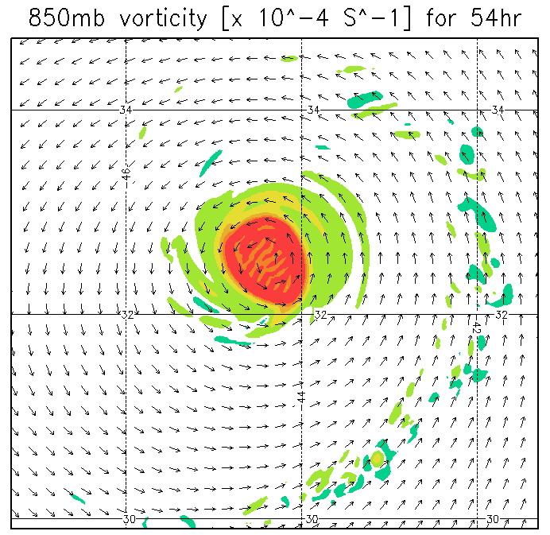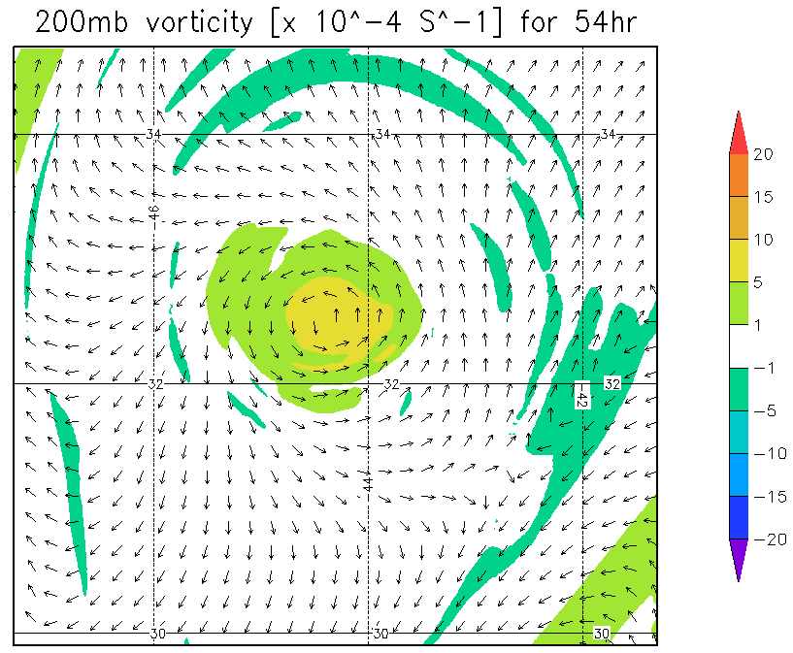
Figure R2: Anticipated “pre-shear” vortex structure from HWRF.

Threshold shear and large tilt sampling:
The TC’s kinematic structure responds to increasing VWS in one of three ways: 1) maintain a vertically upright vortex core throughout the troposphere, 2) develop significant tilt of the vortex core, but then realign into a steady-state tilt configuration (esp. if the shear is sustained), and 3) exhibit continuous and irreversible separation of the upper- and lower-level vortex cores, resulting in a shallow low-level circulation usually void of deep convection.
If a sufficiently high threshold value of VWS is employed, scenario 1) is least likely. For a TC that follows scenario 2), determining the target time of maximum tilt is critical. If the TC is sampled after realignment has already completed, the structural changes we wish to document may be greatly diminished. Furthermore, it would not be possible to fully test the intensity modification Hypothesis 3. For a TC that follows scenario 3), 12-h sampling of the TC until the low-level circulation becomes completely exposed (and void of deep convection) is adequate.
Since the possibility of scenario 2), and the precise timing of maximum tilt, depend on a variety of factors, as discussed in the Background, time series of forecast shear from a number of different sources (e.g., SHIPS, HWRF coarse grid, etc.) should be used in conjunction with a threshold shear value to guide the timing of flights subsequent to the pre-shear sampling. For the Category 2-3 hurricane in the example, a noticeable tilt of the circulation center with height becomes evident 18-24 h after the first mission, or when the shear approaches a value of 20 kts (not shown). An indication that the shear is beginning to strongly influence storm structure is the development of a pronounced convective asymmetry within the core region. Figure R3 illustrates this convective asymmetry at the time the shear threshold is reached (and the core begins to tilt). In this example, the second P-3 mission would commence ~12 h after the first.
Mission 2: A second P-3 will be prepared to sample the TC when the shear approaches a threshold value (~20 kts in the example). The objective is to document the initial development of shear-induced vertical tilt and the boundary layer response. The P-3 performs a single Figure-4 pattern (90-105 nmi legs) with TDR to obtain the TC core-region structure (P-3 Module 2). The P-3 then travels downwind to set up a rotated Figure-4 pattern with truncated radial legs. The radial legs should extend just outside the primary mesoscale region of convection radially beyond (~15-30 nmi) the eyewall. Dropsondes should be launched within and downwind of the convective region outside the eyewall in such a way as to sample low-θ_{e} air spiraling into the eyewall within the boundary layer.
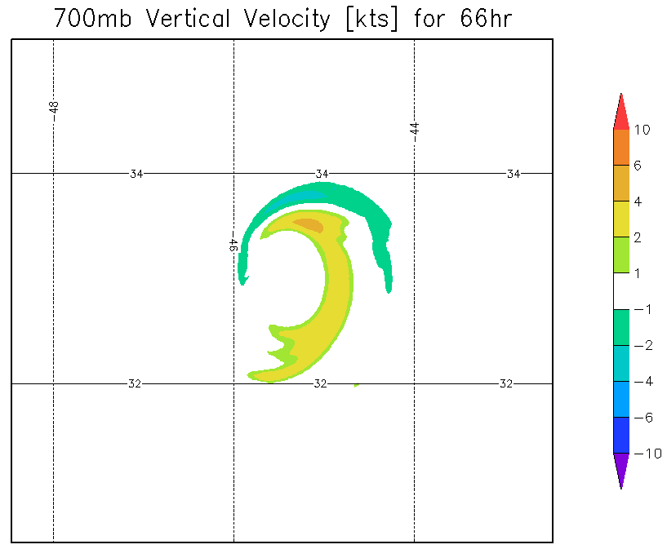
Figure R3: Anticipated “threshold shear” convective asymmetry from HWRF.

Figure R4 shows the tilted vorticity structure 12 h after the TC begins to develop a visible vertical tilt of the core (i.e., through the displacement of circulation centers with height). By this time, the shear magnitude is 30-35 kts. The vortex tilts to the left of the large-scale, deep-layer shear vector, as expected based upon work cited in the Background. In this example, the upper-level vorticity of the TC ultimately weakens and merges with an upper-level, north-south oriented vorticity feature to its west (not shown). This behavior is closest to that in scenario 3).
Mission 3: The P-3 used in the “pre-shear” mission will be prepared to sample (at least 24 h after the pre-shear mission) the TC when the vertical tilt of the core has reached a large value. The P-3 repeats the “threshold shear” sampling of the previous mission (P-3 Module 2). At the same time the G-IV repeats the “pre-shear” sampling pattern (G-IV Module 1).
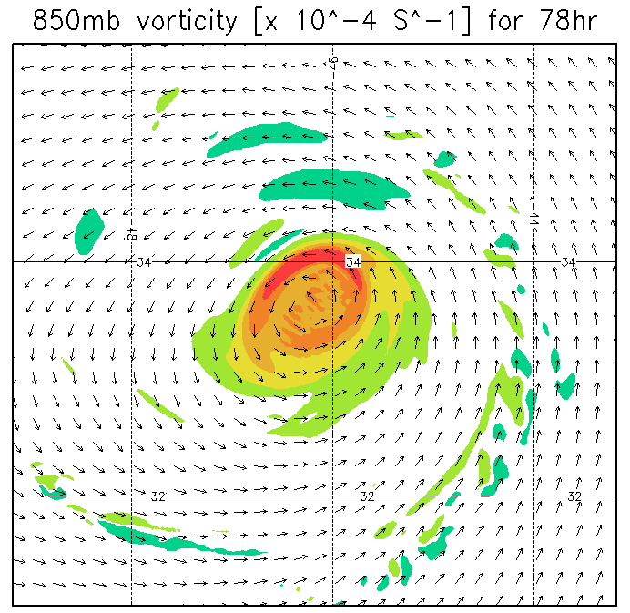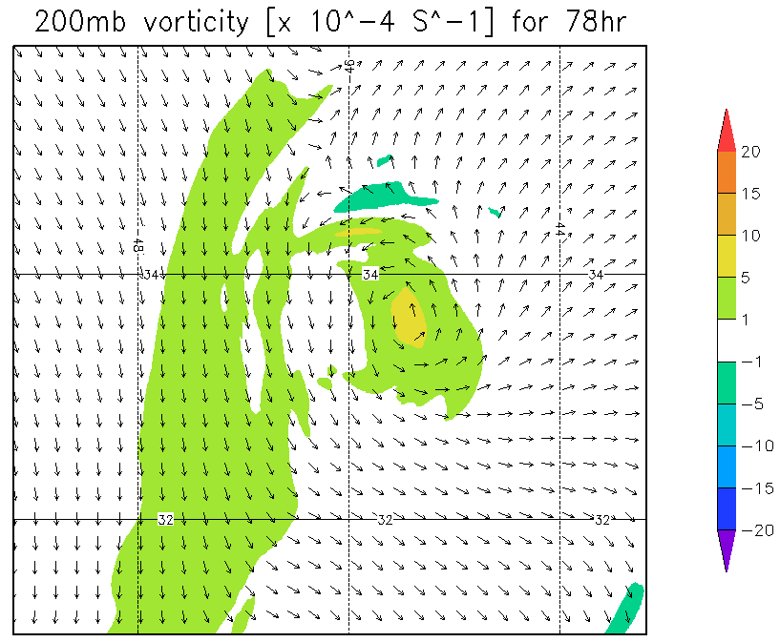
Figure R4: Anticipated “large-tilt” vortex structure from HWRF.

TC alignment and recovery sampling:
As discussed in the Background, some TCs are able to realign once tilted, even under sustained vertical wind shear. In the context of the intensity change Hypothesis 3, negative thermodynamic impacts on the TC should be reduced as the vortex aligns. In numerical simulations (e.g., Riemer et al. 2010), this is followed by re-intensification of the TC. In the example here, the vortex does not realign, and the primary circulation becomes increasingly shallow (not shown). The TC then continues to weaken (Figure R5). Whether the TC is resilient or is progressively sheared apart, a follow-up mission to investigate the continued evolution of the TC is important for a complete understanding of the life-cycle of a vertically-sheared storm.
Mission 4: The P-3 used in the “threshold shear” mission will be prepared to sample the TC after realignment has completed (or the vortex continues to be sheared apart). The objective is to verify vertical alignment in the kinematic field and the thermodynamic recovery of the boundary layer (or the continued deterioration of the circulation). The P-3 repeats the “threshold shear” and “large-tilt” sampling pattern (P-3 Module 2).

Figure R5: Anticipated weakening as shear-induced structure changes occur in HWRF (purple).

Analysis Strategy:
The basic analysis follows that presented in recent observational studies of the vertically sheared TC (Reasor et al. 2009; Reasor and Eastin 2012; Reasor et al. 2013; Rogers et al. 2013; Zhang et al. 2013). The analysis includes: low-wavenumber kinematic structure of the core region above the boundary layer, vortex tilt, and local VWS derived from airborne Doppler radar observations; low-wavenumber kinematic structure of the boundary layer derived from SFMR and dropsonde measurements; low-wavenumber thermodynamic structure within and above the boundary layer derived from dropsondes and flight-level measurements; and convective burst statistics derived from Doppler radar observations. New elements of the analysis will include: 3D kinematic structure out to at least 4-5xRMW using radar observations; low-wavenumber kinematic, thermodynamic, and moisture structures out to 150 n mi using G-IV radar and dropsonde observations; high azimuthal and radial representation of the inflow structure downwind of the mesoscale-organized convection radially outside the eyewall.
The above unprecedented dataset will be collected in the context of a TC encountering a large increase in VWS. We first document the basic kinematic evolution of the TC on both short (~1 h) and long (~12 h) timescales. For the optimal set of missions, the initial “pre-shear” vortex structure will be approximately axisymmetric and the vortex tilt should be a negligible fraction of the RMW. The core-region moisture envelope should also be approximately axisymmetric. The analysis may reveal horizontal inhomogeneities in θ_{e} at large distance from the core. Diagnostic analyses include: vertical tilt, local shear, 3D Doppler-derived vertical velocity and reflectivity, storm-relative streamline analyses out to 150 n mi, and 3D θ_{e} analyses below P-3 flight level within 4-5xRMW and below G-IV flight level between 60 and 150 n mi. These same diagnostics will also be computed at later stages of the sheared TC evolution.
Using the “threshold shear” mission data we document the development of tilt asymmetry out to 4-5xRMW, the distortion of the moist envelope, and the evolution of the near-core, storm-relative flow topology. Also at this stage, we document the development of convective asymmetry within and radially outside the eyewall, examine the shear-relative convective statistics (e.g., as in Eastin et al. 2005), and analyze changes in the boundary layer θ_{e} structure in relation to changes in convective organization outside the eyewall. At the “large tilt” stage, we anticipate asymmetric coverage of radar reflectors about the storm center. Where reflectors are, the analysis proceeds as above. Diagnostics relying on azimuthal coverage of the winds (e.g., the azimuthal-mean winds, tilt, and local shear) may be restricted to limited radial bands. If available, we will explore the benefits of Doppler Wind Lidar measurements in the echo-free regions of the storm. The objective at this stage is to examine whether the tilt asymmetry organizes convection on the vortex scale, how and where low θ_{e} air is transported into the near-core region, whether low θ_{e} air is transported into the boundary layer outside the eyewall, the modification of θ_{e} as parcels move inward towards the eyewall (if they do; see Zhang et al. (2013) and Riemer et al. (2013) for examples where the storm-relative core-region flow within the boundary layer of a sheared storm is radially outward), and changes in azimuthal-mean θ_{e} within the eyewall region and its relation to intensity change.
At the “realignment and recovery” stage, the optimal experiment will reveal a core kinematic and thermodynamic structure that more closely resembles the “pre-shear” structure than observed during the intermediate missions. The moist envelope may still be distorted, but the mechanism for downward transport of the low θ_{e} air will be diminished due to the reduction in vortex tilt. If the vortex continues to shear apart during this mission, the analysis will focus on the development of boundary layer “cold pools” using the dropsonde measurements, and, to the extent possible, the deterioration of the vertical structure of the TC’s primary circulation (e.g., Reasor et al. 2000; Sec. 4 of Riemer et al. (2013)).
References:
Bender, M. A., 1997: The effect of relative flow on the asymmetric structure in the interior of hurricanes. J. Atmos. Sci., 54, 703–724.
Black, M. L., J. F. Gamache, F. D. Marks, C. E. Samsury, and H. E. Willoughby, 2002: Eastern Pacific Hurricanes Jimena of 1991 and Olivia of 1994: The effect of vertical shear on structure and intensity. Mon. Wea. Rev., 130, 2291–2312.
Braun, S. A., M. T. Montgomery, and Z. Pu, 2006: High-resolution simulation of Hurricane Bonnie (1998). Part I: The organization of eyewall vertical motion. J. Atmos. Sci., 63, 19–42.
Davis, C. A., S. C. Jones, and M. Riemer, 2008: Hurricane vortex dynamics during Atlantic extratropical transition. J. Atmos. Sci., 65, 714–736.
DeMaria, M., 1996: The effect of vertical shear on tropical cyclone intensity change. J. Atmos. Sci., 53, 2076–2088.
DeMaria, M., M. Mainelli, L. K. Shay, J. A. Knaff, and J. Kaplan, 2005: Further improvements to the Statistical Hurricane Intensity Prediction Scheme (SHIPS). Wea. Forecasting, 20, 531–543.
Eastin, M. D., W. M. Gray, and P. G. Black, 2005: Buoyancy of convective vertical motions in the inner core of intense hurricanes. Part II: Case studies. Mon. Wea. Rev., 133, 209–227.
Emanuel, K. A., 1986: An air-sea interaction theory for tropical cyclones. Part I: Steady-state maintenance. J. Atmos. Sci., 43, 585–605.
Emanuel, K. A., 1991: The theory of hurricanes. Annu. Rev. Fluid Mech., 23, 179–196.
Frank, W. M. and E. A. Ritchie, 2001: Effects of vertical wind shear on the intensity and structure of numerically simulated hurricanes. Mon. Wea. Rev., 129, 2249–2269.
Gray, W. M., 1968: Global view of the origin of tropical disturbances. Mon. Wea. Rev., 96, 669-700.
Jones, S. C., 1995: The evolution of vortices in vertical shear. I: Initially barotropic vortices. Quart. J. Roy. Meteor. Soc., 121, 821–851.
Jones, S. C., 2000: The evolution of vortices in vertical shear. III: Baroclinic vortices. Quart. J. Roy. Meteor. Soc., 126, 3161–3185.
Kaplan, J., and M. DeMaria, 2003: Large-scale characteristics of rapidly intensifying tropical cyclones in the North Atlantic basin. Wea. Forecasting, 18, 1093–1108.
Molinari, J., D. Vollaro, K. L. Corbosiero, 2004: Tropical cyclone formation in a sheared environment: A case study. J. Atmos. Sci., 61, 2493-2509.
Molinari, J., P. Dodge, D. Vollaro, K. L. Corbosiero, F. D. Marks Jr., 2006: Mesoscale aspects of the downshear reformation of a tropical cyclone. J. Atmos. Sci., 63, 341-354.
Reasor, P. D., M. T. Montgomery, F. D. Marks Jr., and J. F. Gamache, 2000: Low-wavenumber structure and evolution of the hurricane inner core observed by airborne dual-Doppler radar. Mon. Wea. Rev., 128, 1653-1680.
Reasor, P. D., M. T. Montgomery, and L. D. Grasso, 2004: A new look at the problem of tropical cyclones in vertical shear flow: Vortex resiliency. J. Atmos. Sci., 61, 3–22.
Reasor, P. D., M. Eastin, and J. F. Gamache, 2009: Rapidly intensifying Hurricane Guillermo (1997). Part I: Low-wavenumber structure and evolution. Mon. Wea. Rev., 137, 603–631.
Reasor, P. D., and M. D. Eastin, 2012: Rapidly intensifying Hurricane Guillermo (1997). Part II: Resilience in shear. Mon. Wea. Rev., 140, 425–444.
Reasor, P. D., R. Rogers, and S. Lorsolo, 2013: Environmental flow impacts on tropical cyclone structure diagnosed from airborne Doppler radar composites. Mon. Wea. Rev.,141, 2949–2969.
Reasor, P. D., and M. T. Montgomery, 2015: Evaluation of a heuristic model for tropical cyclone resilience. J. Atmos. Sci., 72, 1765–1782.
Riemer, M., M. T. Montgomery, and M. E. Nicholls, 2010: A new paradigm for intensity modification of tropical cyclones: thermodynamic impact of vertical wind shear on the inflow layer. Atmos. Chem. Phys., 10, 3163–3188.
Riemer, M., and M. T. Montgomery, 2011: Simple kinematic models for the environmental interaction of tropical cyclones in vertical wind shear. Atmos. Chem. Phys., 11, 9395–9414.
Riemer, M., M. T. Montgomery, and M. E. Nicholls, 2013: Further examination of the thermodynamic modification of the inflow layer of tropical cyclones by vertical wind shear. Atmos. Chem. Phys., 13, 327–346.
Rogers, R., and Coauthors, 2006: The Intensity Forecasting Experiment: A NOAA Multiyear Field Program for Improving Tropical Cyclone Intensity Forecasts. Bull. Amer. Meteor. Soc., 87, 1523–1537.
Rogers, R., P. Reasor, and S. Lorsolo, 2013: Airborne Doppler observations of the inner-core structural differences between intensifying and steady-state tropical cyclones. Mon. Wea. Rev., 141, 2970–2971.
Simpson, R. H. and H. Riehl, 1958: Mid-tropospheric ventilation as a constraint on hurricane development and maintenance. Proc. Tech. Conf. on Hurricanes, Miami, FL, Amer. Meteor. Soc., D4.1-D4.10.
Tang, B., K. Emanuel, 2012: Sensitivity of tropical cyclone intensity to ventilation in an axisymmetric model. J. Atmos. Sci., 69, 2394–2413.
Wang, Y., M. Montgomery, and B. Wang, 2004: How much vertical shear can a well-developed tropical cyclone resist? Preprints, 26th Conference on Hurricanes and Tropical Meteorology, Miami, FL, Amer. Meteor. Soc., 100-101.
Wong, M. L. M. and J. C. L. Chan, 2004: Tropical cyclone intensity in vertical wind shear. J. Atmos. Sci., 61, 1859–1876.
Zhang, J. A., and E. Uhlhorn, 2012: Hurricane sea surface inflow angle and an observation-based parametric model. Mon. Wea. Rev., 140, 3587-3605.
Zhang, J. A., R. F. Rogers, P. D. Reasor, E. W. Uhlhorn, and F. D. Marks Jr., 2013: Asymmetric hurricane boundary layer structure in relation to the environmental vertical wind shear from dropsonde composites. Mon. Wea. Rev., 141, 3968–3984.

14. TC Diurnal Cycle Experiment

Principal Investigator: Jason Dunion

Links to IFEX:
- Goal 1: Collect observations that span the TC life cycle in a variety of environments for model initialization and evaluation.
- Goal 3: Improve understanding of the physical processes important in intensity change for a TC at all stages of its lifecycle.

Motivation: Numerous studies have documented the existence of diurnal maxima and minima associated with tropical convection. However, predicting the timing and extent of this variability remains a difficult challenge. Recent research using GOES satellite imagery has identified a robust signal of TC diurnal pulses. These diurnal pulses can be tracked using new GOES infrared satellite image differencing that reveals a “cool ring” (i.e. diurnal pulse) in the infrared that begins forming in the storm’s inner core near local sunset each day. This diurnal pulse continues to propagate away from the storm overnight, reaching areas several hundred km from the storm center by the following afternoon. There appear to be significant structural changes to TCs [as indicated by GOES infrared and microwave (37 and 85 GHz) satellite imagery and P-3 LF radar data] as diurnal pulses move out from the inner core each day and their timing/propagation also appears to be remarkably predictable. Although the relationships between the TC diurnal cycle and TC structure and intensity are unclear at this time, this phenomenon may be an important and fundamental TC process. The main objectives of the TC Diurnal Cycle Experiment are as follows:

- Collect aircraft datasets that can be used to improve the initialization and evaluation of 3-D numerical models.
- Improve the understanding of the thermodynamic and kinematic environment of radially propagating diurnal pulses at various stages of their life cycles, including their initial formation and subsequent evolution, and to observe any corresponding fluctuations in TC structure and intensity during these events.
- Quantify the capabilities of the operational coupled model forecast system to accurately capture thermodynamic (e.g. cirrus canopy cooling at sunset) and kinematic (e.g. periods of enhanced upper-level outflow and low-level inflow) characteristics of the TC diurnal cycle and associated diurnal pulses.

Background: Although numerous studies have documented the existence of diurnal maxima and minima associated with tropical oceanic convection and the TC upper-level cirrus canopy, we lack a thorough understanding of the nature and causes of these variations and especially the extent to which these variations are important for TCs. It is well known that the coherent diurnal cycle of deep cumulus convection and associated rainfall is different over the land and ocean (Gray and Jacobson 1977; Yang and Slingo 2001). While over the land it tends to peak in the late afternoon/early evening due to daytime boundary layer heating, over the ocean it peaks in the early morning. In addition, Gray and Jacobson (1977), Mapes and Houze (1993), and Liu and Moncrieff (1998) found that the oceanic peak was more prominent when the preexisting convection was more intense and associated with an organized weather system such as an African easterly wave or mesoscale convective system. Numerous studies have also highlighted diurnal changes in the cirrus anvils of tropical deep convection and TCs. Weikmann et al. (1977) noted that anvils emanating from large cumulonimbus clouds tended to grow preferably between 2200 and 0300 local standard time (LST). Browner et al. (1977) found that the areal extent of the TC cirrus canopy was a minimum at 0300 LST and a maximum at 1700 LST and suggested that this diurnal oscillation might be important for the TC. More recently, Kossin (2002) used storm-centered GOES infrared imagery to calculate azimuthally averaged brightness temperatures and create Hovmöller-type diagrams of brightness temperature diurnal oscillations over time. That study concluded that although a clear diurnal oscillation of the TC cirrus canopy was present at larger radii (e.g., 300 km), few storms exhibited diurnal oscillation signals in their innermost 100 km. It was hypothesized that different processes might be forcing periodic oscillations in the TC deep inner-core convection and the TC cirrus canopy.
Dunion et al. (2014) examined all North Atlantic major hurricanes from 2001 to 2010 and documented a phenomenon they referred to as the TC diurnal cycle and associated diurnal pulses in mature TCs. They found an intriguing diurnal pulsing pattern that appears to occur with remarkable regularity through a relatively deep layer of the TC. Storm-centered GOES and Meteosat infrared imagery were used to create 6-h brightness temperature difference fields of the storm’s inner core and its surrounding environment (R 5 100–600 km). The imagery revealed periodic oscillations of cooling and warming in the IR brightness temperature field over time. One prominent characteristic of these oscillations is a cold ring (i.e., local cooling of the brightness temperatures with time) that begins forming in the storm’s inner core (R~≤150 km; Rogers et al. 2012) near the time of sunset each day. This cold ring feature (that they referred to as a diurnal pulse) continues to move away from the storm overnight, reaching areas several hundred kilometers from the circulation center by the following afternoon. A marked warming of the cloud tops occurs behind this propagating feature and structural changes in the storm are noted as it moves away from the inner core. This systematic variation of cloud-top temperatures suggests that TC diurnal pulses are a distinguishing characteristic of the TC diurnal cycle may have implications for TC intensity change and structure.

Hypotheses:
- Hypothesis 1: TC diurnal cycle may be driven by rapid changes in incoming shortwave radiation resulting in rapid cooling at the cirrus canopy level around the time of local sunset each day.
- Hypothesis 2: TC diurnal pulses may be signatures of outwardly propagating gravity waves, harmonic oscillations of the CDO as it cools near the time of sunset, diurnally-driven changes in inertial stability in the upper-levels (i.e. cirrus canopy) of the storm, or temperature responses that lead to previously documented anvil expansion.
- Hypothesis 3: TC diurnal pulses manifest as semi-circular rings of enhanced convection that radially propagate away from the storm each day and may be associated with periods of enhanced upper-level outflow and lower-level inflow that extend through a relatively deep layer of the troposphere.
- Hypothesis 4: Observations of the TC diurnal cycle can be used to improve our understanding of this recently discovered phenomenon and test its observability in model simulations.

Experiment/Module Description: The experimental UW-CIMSS/HRD TC diurnal cycle web page (http://tropic.ssec.wisc.edu/real-time/tc_diurnal_cycle/tc_diurnal_cycle.php) will be used to monitor the development and propagation of TC diurnal pulses for storms of interest. The timing and propagation of diurnal pulses appears to be remarkably predictable: after its initial formation in the inner core region, it propagates outward at ~5-10 m s⁻¹ and reaches peripheral radii (e.g. 200-500 km) at very specific times of day (local time). Therefore, a 24-hr conceptual clock describing the evolution of this phenomenon has been developed. Figure 1 shows the TC diurnal cycle clock that predicts the approximate times that diurnal pulse passes various radii and will be used in concert with the UW-CIMSS/HRD real-time diurnal pulsing imagery to plan aircraft sampling strategies and takeoff times.

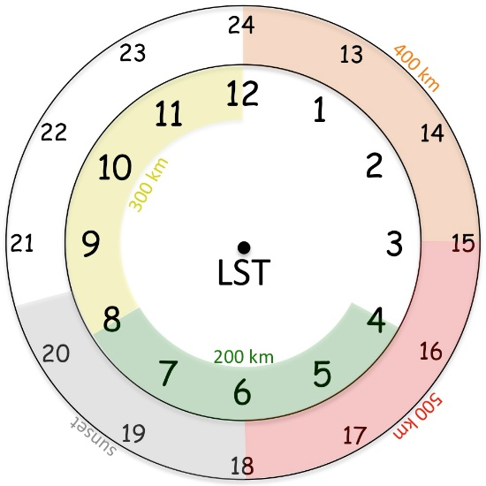

Fig. 1. Conceptual 24-hr TC diurnal cycle clock that estimates the radial location of TC diurnal pulses propagating away from storm. TC diurnal pulses typically form at local sunset (~ 1800-2030 LST, gray shading) and begin to propagate away from the inner core, passing the 200 km radius at ~0400-0800 LST (green shading) the following morning. It eventually reaches the 400 km radius at ~1200-1500 LST (orange shading) in the early to middle afternoon.

The circular outer band convective features depicted in Fig. 2 show examples of TC diurnal pulses as seen by the P-3 LF radar during missions in to 2010 Earl and 2014 Edouard. These features should be high priority targets during the mission and in order to adequately sample their 3-dimensional structure with the TDR, the P-3 and/or G-IV should completely transect through them on during inbound or outbound legs. The aircraft may also fly an arc cloud module (P-3 and/or G-IV) or convective burst module (P-3) as opportunities present. Since large arc cloud events have been noted to appear along the leading edge of diurnal pulses, the P-3 LPS and/or G-IV ground-based LPS should monitor TC diurnal cycle and visible satellite imagery and the P-3 LF radar for opportunities to conduct the former module. The execution of these optional modules will be at the discretion of the P-3 LPS and/or G-IV ground based LPS.

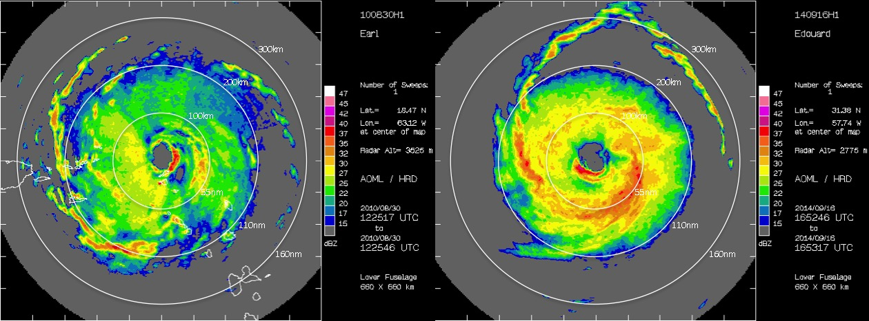

Fig. 2. P-3 lower fuselage radar showing 25-40 dBZ circular convective bands in the environments of (left) 2010 Hurricane Earl (R=~200-250 km) and (right) 2014 Hurricane Edouard (R=~200-300 km). These circular outer band features appear to be coincident with TC diurnal pulses and may be linked to the TC diurnal cycle.
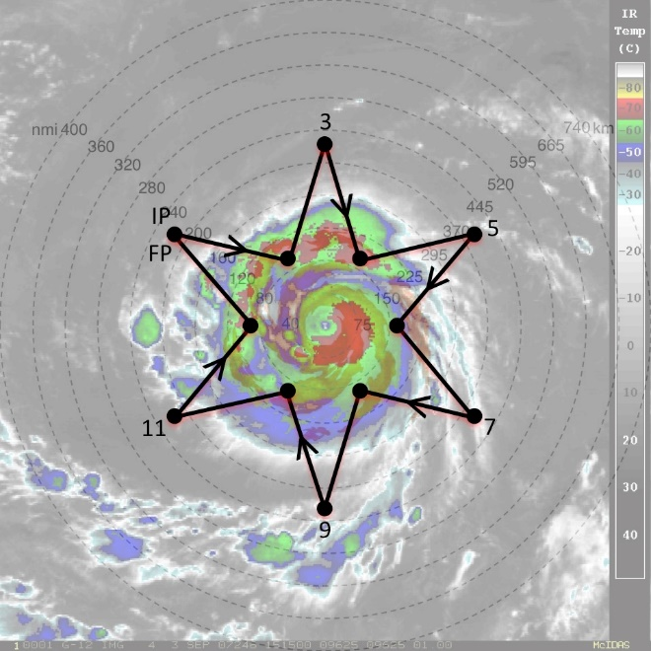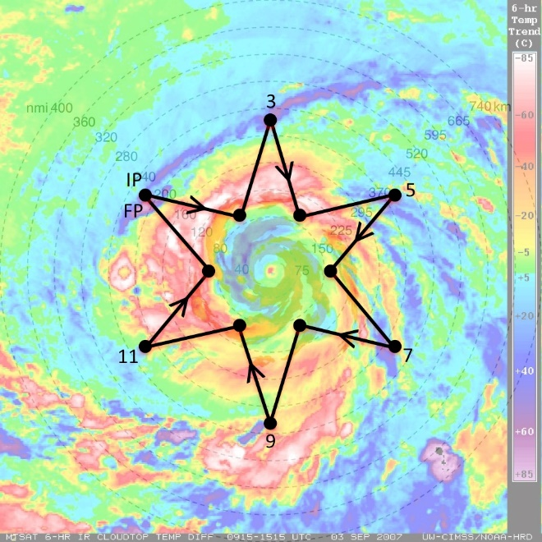

Fig. 3. Sample G-IV star pattern with endpoints that alternate between 90 and 215 nm (165 and 400 km). The endpoints can be adjusted inward or outward depending on the exact position of the outwardly propagating diurnal pulse and the size of the TC inner core. The pattern is overlaid on (left) GOES IR imagery and (right) UW-CIMSS IR diurnal cycle imagery. Yellow to pink shading in the latter image indicates a diurnal pulse propagating away from the storm during this time and shows its typical radial evolution at ~1100 LST when it has reached R=~160 nm (~300 km).

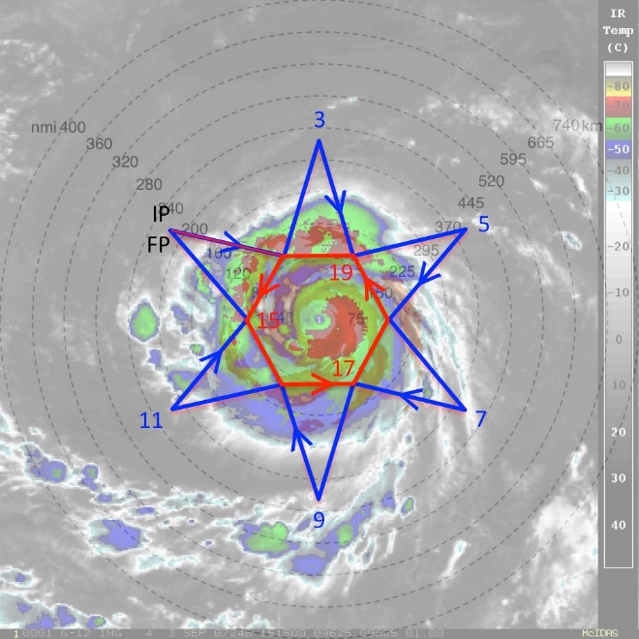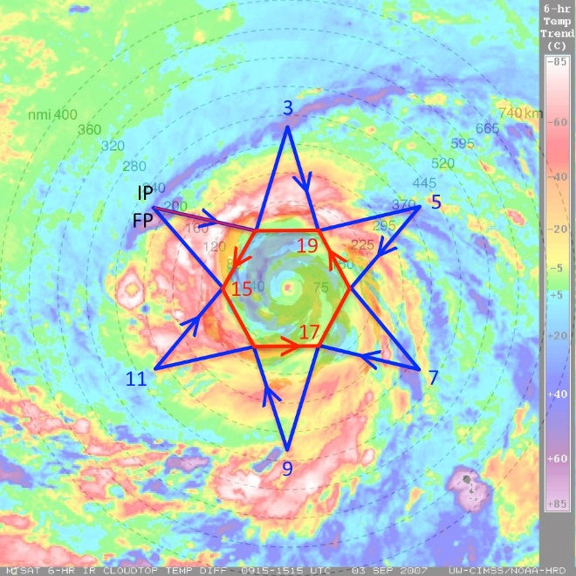

Fig. 4. Same as in Fig. 3, except that a circumnavigation of the storm is performed after or before the star pattern is completed. The hexagon circumnavigation that is shown has points that are 90 nm (165 km) from the storm center, but can be adjusted inward (if possible) or outward for safety considerations (depending on the strength and size of the TC).

There are a few possible configurations for the execution of this experiment that are outlined below:

- Both the P-3 and G-IV are available:
This is the optimal configuration for this experiment with the P-3 and G-IV coordinating operations with staggered take-off times that would allow both aircraft to optimally sample the radially propagating TC diurnal pulse. The P-3 will sample the inner-core and near environments of the TC (see P-3 Module 1), while the G-IV will sample the near and peripheral environments of the storm (see G-IV Module 1). Sample G-IV Module 1 flight patterns overlaid on GOES infrared and TC diurnal cycle imagery are shown for reference (Figs. 3 and 4).

- Only the P-3 is available:
When the G-IV is not available for coordinated operations, either because of operational tasking requirements or aircraft unavailability, P-3 targeted observations in the inner core and near environments using P-3 Module 1 can still contribute towards the objectives of the experiment.

- Only the G-IV is available:
When the P-3 is not available for coordinated operations, either because of operational tasking requirements or aircraft unavailability, G-IV targeted observations in the near and peripheral environments using G-IV Module 1 can still contribute towards the objectives of the experiment. Sample G-IV Module 1 flight patterns overlaid on GOES infrared and TC diurnal cycle imagery are shown for reference in Figs. 3 and 4).

Analysis Strategy: This experiment seeks to observe the formation and evolution of the TC diurnal cycle and associated TC diurnal pulses. Specifically, GPS dropsonde and radar observations will be used to analyze both the inner-core and environmental kinematics and thermodynamics that may lead to the formation of TC diurnal pulses and to document the kinematics, thermodynamics, and precipitation patterns that are associated with radially propagating TC diurnal pulses at various stages of their evolution.

References:
Browner, S. P., W. L. Woodley, and C. G. Griffith, 1977: Diurnal oscillation of cloudiness associated with tropical storms. Mon. Wea. Rev., 105, 856–864.

Dunion, J.P., C.D. Thorncroft, and C.S. Velden, 2014: The tropical cyclone diurnal cycle of mature hurricanes. Mon. Wea. Rev., 142, 3900-3919.
Gray, W. M., and R. W. Jacobson, 1977: Diurnal variation of deep cumulus convection. Mon. Wea. Rev., 105, 1171–1188.

Kossin, J. P., 2002: Daily hurricane variability inferred from GOES infrared imagery. Mon. Wea. Rev., 130, 2260–2270.

Liu, C., and M. W. Moncrieff, 1998: A numerical study of the diurnal cycle of tropical oceanic convection. J. Atmos. Sci., 55, 2329–2344.

Mapes, B. E., and R. A. Houze Jr., 1993: Cloud clusters and superclusters over the oceanic warm pool. Mon. Wea. Rev., 121, 1398–1415.

Rogers, R. F., S. Lorsolo, P. Reasor, J. Gamache, and F. Marks, 2012: Multiscale analysis of tropical cyclone kinematic structure from airborne Doppler radar composites. Mon. Wea. Rev., 140, 77–99.

Weickmann, H. K., A. B. Long, and L. R. Hoxit, 1977: Some examples of rapidly growing oceanic cumulonimbus clouds. Mon. Wea. Rev., 105, 469–476.

Yang, G., and J. Slingo, 2001: The diurnal cycle in the tropics. Mon. Wea. Rev., 129, 784–801.

15. Tropical Cyclone Ocean Interaction Experiment

Principal Investigator(s): Nick Shay (U. Miami/RSMAS), Jun Zhang (NOAA/HRD), Rick Lumpkin (NOAA/PhOD), George Halliwell (NOAA/PhOD), Elizabeth Sanabia (USNA), and Benjamin Jaimes (UM/RSMAS)

Links to IFEX:
- Goal 1: Acquire observations that span the TC life cycle in a variety of environments for model initialization and evaluation.
- Goal 3: Improve understanding of the physical processes important in intensity change for a TC at all stages of its lifecycle.
Motivation:
Modeling studies show that the effect of the ocean varies widely depending on storm size and speed and the preexisting ocean temperature and density structure. The overarching goal of these studies is to provide data on TC-ocean interaction with enough resolution to rigorously test coupled TC models, specifically:

- Measure the two-dimensional SST cooling, air temperature, humidity and wind fields beneath the storm and thereby deduce the effect of the ocean cooling on ocean enthalpy flux to the storm;
- Measure the three-dimensional temperature, salinity and velocity structure of the ocean beneath the storm and use this to deduce the mechanisms and entrainment rates (shear-induced) of ocean cooling;
- Conduct these measurements at several points along the storm evolution therefore investigating the role of pre-existing ocean variability; and,
- Use these data to assess the accuracy of the oceanic component of the coupled model system.

Recent improvement in flux parameterizations has led to significant improvements in the accuracy of TC simulations. These parameterizations, however, are based on a relatively small number of direct flux measurements. The overriding goal of these studies is to make additional flux measurements under a sufficiently wide range of conditions to improve flux parameterizations, specifically:

- Measure the air-sea fluxes of enthalpy and momentum using ocean-side budget and covariance measurements and thereby verify and improve parameterizations of these fluxes.
- Measure the air-sea fluxes of oxygen and nitrogen using ocean-side budget and covariance measurements and use these to verify newly developed gas flux parameterizations.
- Measure profiles of ocean boundary layer turbulence, its energy, dissipation rate and skewness and use these to investigate the unique properties of hurricane boundary layers.
- Conduct the above flux and turbulence measurements in all four quadrants of a TC so as investigate a wide range of wind and wave conditions.

Background:
Substantial resources for this work will be funded by external sources. The HRD contribution consists of coordination with the operational components of the NHC and the 53rd AFR squadron and P-3 survey flights over the array with SFMR and SRA wave measurements and dropwindsondes.
If the deployments occur in the Gulf of Mexico, Loop Current area, this work will be coordinated with P-3 deployments of AXBTs and AXCPs to obtain a more complete picture of the ocean response to storms in this complex region including velocity shear which is key to understanding vertical mixing and SST cooling.

Working Scientific Hypotheses:
- Hypothesis 1: TC intensity is highly sensitive to air-sea fluxes; and ocean heat content.
- Hypothesis 2: Upper ocean properties and dynamics play a key role in determining TC intensity.
Experiment/Module Description:
This multi-aircraft experiment is ideally conducted in geographical locales that avoid conflict with other operational requirements, for example, at a forward/eastward-deployed base targeting a storm not imminently threating the U.S. coastline. As an example, an optimal situation is shown in Fig. 1, with missions operating from St. Croix, USVI. A TC of at least minimal hurricane intensity is desired. In this example, the hypothetical storm remains within 600 nmi (a reasonable maximum distance) for four days, and at no time is forecasted to be a threat to land, including the U.S. coast.

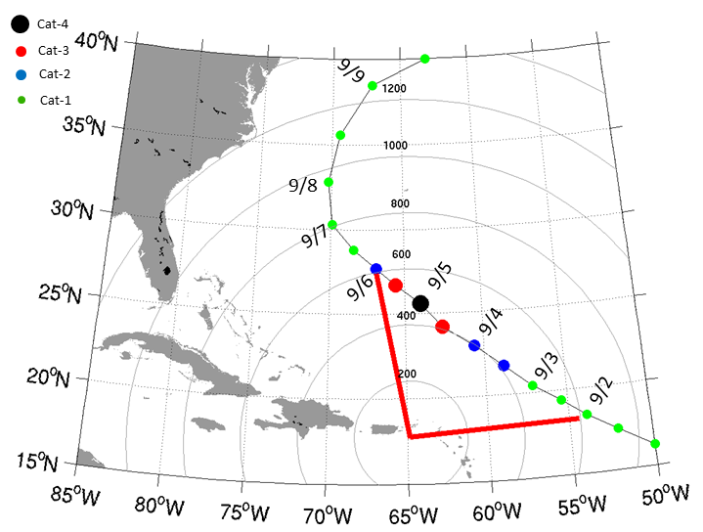
Figure 1: Storm track with locations plotted every 12 hours. of Range rings are 200 nmi relative to forward operating base at St. Croix, USVI (STX/TISX), and red line delineates storm locations within 600 nmi of STX. In this example, the storm center remains within 600 nmi for 4 days.

a) Expendable profiler surveys from P-3 aircraft

Flight sequence:

Pre-storm: To establish the pre-storm upper ocean thermal and mass structure prior to a storm’s arrival, a pre-storm expendable survey will be conducted. This mission will consist of deploying a large grid of AXCTDs/AXBTs to measure the three-dimensional temperature and salinity fields (Fig. 2). This flight would occur 48 hours prior to storm arrival, based primarily on the forecasted track, and optimally covers the forecast cone-of-error. A total of 50-60 probes would be deployed, depending on mission duration, and spaced approximate 0.5 deg. apart. The experiment is optimally conducted where horizontal gradients are relatively small, but AXCP probes may be included if significant gradients (and thus currents) are expected to be observed. Either P-3 aircraft may be used as long as it is equipped with ocean expendable data acquisition hardware.

Figure 2: Left: NHC official forecast track, which pre-storm ocean sampling region highlighted. Target region is centered ~48 hours prior to forecast arrival of storm. Right: P-3 flight track (red line) and ocean sampling pattern consisting of a grid of AXCTD/AXBT probes Probes are deployed at ~0.5 deg. intervals. Total time for this pattern is estimated to be ~9 hours.

In-storm: Next, a mission is executed within the storm over the ocean location previously sampled (Fig. 3). This flight shall by conducted by the P-3 carrying the Wide-swath Radar Altimeter (WSRA) for purposes of mapping the two-dimensional wave field. The flight pattern should be a rotated Figure-4, and up to 20 AXBTs should be deployed in combination with GPS dropwindsondes. Note that other experimental goals can and should be addressed during this mission, and a multi-plane mission coordinated with the other P-3, as well as G-IV, is desirable.

Figure 3: Left: NHC official forecast track at time of in-storm mission, with pre-storm sampled region highlighted. Right: P-3 in-storm flight pattern centered on storm and over previously-sampled ocean area. Typical pattern is expected to be a rotated Fig-4. Total flight time ~8 hrs.

Post-storm: A post-storm expendable survey shall be conducted over the same geographical location to assess ocean response, with slight pattern adjustments made based on the known storm track (Fig. 4). Approximately 60-70 probes would be deployed (depending on duration limits), consisting mainly of AXBTs/AXCPs to map the three-dimensional temperature and currents, ideally 1-2 days after storm passage. In the Figs. 3-8 example, the pattern extends 470 km along the storm track, which in this example is ~0.75Λ, where Λ = 2πV/f is the inertial wavelength. Ideally, the pattern should extend up to 1 Λ to resolve a full ocean response cycle. The storm speed V and flight duration limits will dictate whether this is possible. As for the pre-storm survey, either P-3 may be used since both of them have been equipped with new data systems as part of the HFIP program.
Figure 4: Left: Post-storm ocean sampling flight pattern (red line), over previously-sampled area (black box). In this example, the pattern extends around 470 km in the along-track dimension, or around 0.75 of a near-inertial wavelength. Right: Flight pattern with expendable drop locations, consisting of a combination of AXCP and AXBT probes.

b) Coordinated float/drifter deployment by AF C-130

Measurements will be made using arrays of drifters and E-M Apex (Gulf only) and Alamo (Beth) floats deployed by AFRC WC-130J aircraft in a manner similar to that used in the 2003 and 2004 CBLAST program. Additional deployments have since refined the instruments and the deployment strategies. These measurements provide the rapid time evolution of the response that will be coordinated with the synoptic snapshots of temperatures, salinities and currents from the P-3 deployments of AXBTs, AXCTDs and AXCPs to obtain a more complete picture of the mesoscale ocean response to storms.

MiniMet drifters measure SST, sea level air pressure and wind velocity. Thermistor chain Autonomous Drifting Ocean Station (ADOS) drifters add ocean temperature measurements to 150m. All drifter data are reported in real time through the Global Telecommunications System (GTS) of the World Weather Watch. An additional stream of real-time, quality controlled data is also provided by a server located at the Scripps Institution of Oceanography. A few E-M APEX Lagrangian floats will be deployed via the WC-130J that measure temperature, salinity and velocity profiles to as deep as 2000 m. Float profile data will be reported in real time on GTS via iridium. In addition, UM will have ten floats deployed in the northern Gulf of Mexico as part of a funded GoMRI study that measure these physical parameters as well as biogeochemical parameters.

Coordination and Communications

Alerts - Alerts of possible deployments will be sent to the 53rd AWRO up to 5 days before deployment, with a copy to CARCAH, in order to help with preparations. Luca Centurioni (SIO) and Rick Lumpkin (PhOD) will be the primary point of contact for coordination with the 53rd WRS and CARCAH.

Flights:

Coordinated drifter deployments would nominally consist of 2 flights, the first deployment mission by AFRC WC-130J and the second overflight by NOAA WP-3D. An option for follow-on missions would depend upon available resources.

Day 1- WC-130J Float and drifter array deployment- Figure 5 shows a possible nominal deployment pattern for the float and drifter array. It consists of two lines, A and B, set across the storm path with 8 and 4 elements respectively. The line length is chosen to be long enough to span the storm and anticipate the errors in forecast track, and the lines are approximately in the same location as the pre-storm P-3 expendable probe survey. Instrumentation should be deployed 24-48 hours prior to storm arrival. The element spacing is chosen to be approximately the RMW. In case of large uncertainties of the forecast track a single 10 node line is deployed instead. The thermistor chain drifters (ADOS) are deployed near the center of the array to maximize their likelihood of seeing the maximum wind speeds and ocean response. The Minimet drifters are deployed in the outer regions of the storm to obtain a full section of storm pressure and wind speeds. The drifter array is skewed one element to the right of the track in order to sample the stronger ocean response on the right side (cold wake).

Day 2. P-3 In-storm mission- The in-storm mission will be conducted by the P-3 as previously described. Efforts will be made to deploy AXBTs during the mission near the locations of drifters/floats as reported in real time. It is highly desirable that this survey be combined with an WSRA surface wave survey because high quality surface wave measurements are essential to properly interpret and parameterize the air-sea fluxes and boundary layer dynamics, and so that comparisons between the float wave measurements and the SRA wave measurements can be made. In addition, the directional wave measurements from the WSRA, when combined with current measurements from AXCPs or E-M Apex floats, provide structural observations of the effect of surface waves on the oceanic planetary boundary layer processes.

Figure 5: Drifter array deployed by AFRC WC-130J aircraft. The array is deployed ahead of the storm with the exact array location and spacing determined by the storm speed, size and the uncertainty in the storm track. The array consists of ADOS thermistor chain (A) and minimet (M) drifters, and EM-APEX Lagrangian floats (E). Two items are deployed at locations 3, 4 and 5, and one item elsewhere.

c) AXBT deployments by TROPIC on AF C-130

In addition to the P-3 expendable ocean probe deployments described above, additional ocean temperature profiles will be obtained by AFRC WC-130J aircraft as part of the Training and Research in Oceanic and Atmospheric Processes in Tropical Cyclones (TROPIC) program under the direction of CDR Elizabeth Sanabia, Ph.D. (USNA). Several overlapping mission goals have been identified providing an additional opportunity for collaboration and enhancing observational data coverage. See www.onr.navy.mil/reports/FY11/mmsanabi.pdf for details.

d) Loop Current Experiment

Pre- and post-storm expendable profiler surveys

Flight description:

Feature-dependent survey. Each survey consists of deploying 60-80 expendable probes, with take-off and recovery at AOC. Pre-storm missions are to be flown one to three days prior to the TC’s passage in the LC (Fig. 6). Post-storm missions are to be flown one to three days after storm passage, over the same area as the pre-storm survey. Since the number of deployed expendables exceeds the number of external sonobuoy launch tubes, profilers must be launched via the free-fall chute inside the cabin. Therefore the flight is conducted un-pressurized at a safe altitude (6-8k ft). In-storm missions, when the TC is passing directly over the observation region, will typically be coordinated with other operational or research missions (e.g. Doppler Winds missions). These flights will require 20-40 aircraft expendables deployed for measuring sea surface temperatures, salinity and currents underneath the storm.

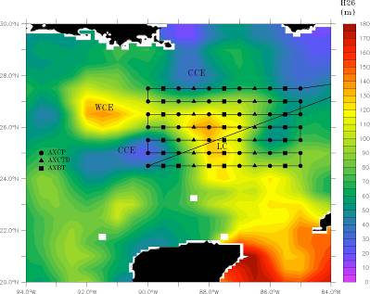

Figure 6: Typical pre- or post-storm pattern with ocean expendable deployment locations relative to the Loop Current. Specific patterns will be adjusted based on actual and forecasted storm tracks and Loop Current locations. Missions generally are expected to originate and terminate at KMCF.

Track-dependent survey. For situations that arise in which a TC is forecast to travel outside of the immediate Loop Current region, a pre- and post-storm ocean survey focused on the official track forecast is necessary. The pre-storm mission consists of deploying AXBTs/AXCTDs on a regularly spaced grid, considering the uncertainty associated with the track forecast. A follow-on post-storm mission would then be executed in the same general area as the pre-storm grid, possibly adjusting for the actual storm motion. Figure 7 shows a scenario for a pre-storm survey, centered on the 48 hour forecast position. This sampling strategy covers the historical “cone of uncertainty” for this forecast period.

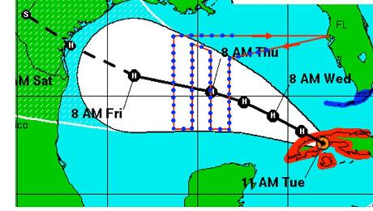

Figure 7: Track-dependent AXBT/AXCTD ocean survey. As for the Loop Current survey, a total of 60-80 probes would be deployed on a grid (blue dots).

Coordinated float/drifter deployment overflights:

Measurements will be made using arrays of drifters deployed by AFRC WC-130J aircraft in a manner similar to that used in the 2003 and 2004 CBLAST program. Additional deployments have since refined the instruments and the deployment strategies. MiniMet drifters measure SST, sea level air pressure and wind velocity. Thermistor chain Autonomous Drifting Ocean Station (ADOS) drifters add ocean temperature measurements to 150m. All drifter data are reported in real time through the Global Telecommunications System (GTS) of the World Weather Watch. An additional stream of real-time, quality controlled data is also provided by a server located at the Scripps Institution of Oceanography.

If resources are available from other Principal Investigators, flux Lagrangian floats will measure temperature, salinity, oxygen and nitrogen profiles to 200 m, boundary layer evolution and covariance fluxes of most of these quantities, wind speed and scalar surface wave spectra, while E-M APEX Lagrangian floats will measure temperature, salinity and velocity profiles to 200m. Float profile data will be reported in real time on GTS.

This drifter effort is supported by the Global Drifter Program. The HRD contribution consists of coordination with the operational components of the NHC and the 53rd AFRC squadron and P-3 survey flights over the array with SFMR and SRA wave measurements and dropwindsondes. If the deployments occur in the Gulf of Mexico, Loop Current area, this work will be coordinated with P-3 deployments of AXBTs, AXCTDs and AXCPs to obtain a more complete picture of the ocean response to storms in this complex region.

Coordination and Communications:

Alerts - Alerts of possible deployments will be sent to the 53rd AWRO up to 5 days before deployment, with a copy to CARCAH, in order to help with preparations. Luca Centurioni (SIO) and Rick Lumpkin (PhOD) will be the primary point of contact for coordination with the 53rd WRS and CARCAH.

Flights:

Coordinated drifter deployments would nominally consist of 2 flights, the first deployment mission by AFRC WC-130J and the second overflight by NOAA WP-3D. An option for follow-on missions would depend upon available resources.

Day 1- WC-130J Float and drifter array deployment- Figure 8 shows a possible nominal deployment pattern for the float and drifter array. It consists of two lines, A and B, set across the storm path with 8 and 4 elements respectively. The line length is chosen to be long enough to span the storm and anticipate the errors in forecast track. The element spacing is chosen to be approximately the RMW. In case of large uncertainties of the forecast track a single 10 node line is deployed instead. The thermistor chain drifters (ADOS) are deployed near the center of the array to maximize their likelihood of seeing the maximum wind speeds and ocean response. The Minimet drifters are deployed in the outer regions of the storm to obtain a full section of storm pressure and wind speeds. The drifter array is skewed one element to the right of the track in order to sample the stronger ocean response on the right side (cold wake). Three Lagrangian floats (E-M Apex) will be deployed along the track, 1-2 RMW and 3-4 RMW to measure the rapidly evolving velocity shear and extent of the vertical mixing and cooling of the surface mixed layer.

Day 2. P-3 In-storm mission- Figure 9 shows the nominal P-3 flight path and dropwindsonde locations during the storm passage over the float and drifter array. The survey should ideally be timed so that it occurs as the storm is passing over the drifter array.

The survey includes legs that follow the elements of float/drifter line ‘A’ at the start and near the end. The survey anticipates that the floats and drifters will have moved from their initial position since deployment and will move relative to the storm during the survey. Waypoints 1-6 and 13-18 will therefore be determined from the real-time positions of the array elements. Each line uses 10 dropwindsondes, one at each end of the line; and two at each of the 4 floats, the double deployments are done to increase the odds of getting a 10m data.

The rest of the survey consists of 8 radial lines from the storm center. Dropwindsondes are deployed at the eye, at half Rmax, at Rmax, at twice Rmax and at the end of the line, for a total of 36 releases. Aircraft expendables are deployed from the sonobuoy launch tubes at the eye, at Rmax and at 2 Rmax. This array is focused at the storm core where the strongest air-sea fluxes occur; the buoy and float array will fill in the SST field in the outer parts of the storm. In this particular example, the final two radials have been moved after the second float survey to avoid upwind transits. For other float drift patterns, this order might be reversed.

It is highly desirable that this survey be combined with an SRA surface wave survey because high quality surface wave measurements are essential to properly interpret and parameterize the air-sea fluxes and boundary layer dynamics, and so that intercomparisons between the float wave measurements and the SRA wave measurements can be made. In addition, the directional wave measurements from the WSRA, when combined with current measurements from AXCPs or E-M Apex floats, provide structural observations of the effect of surface waves on the oceanic planetary boundary layer processes.

Extended Mission Description:

If the storm remains strong and its track remains over water, a second or possibly third oceanographic array may be deployed, particularly if the predicted track lies over a warm ocean feature predicted to cause storm intensification (Fig. 10). The extended arrays will consist entirely of thermistor chain and minimet drifters, with 7-10 elements in a single line. As with the main mission, the spacing and length of the line will be set by the size of the storm and the uncertainty in the forecast track.

Mission timing and coordination will be similar to that described above. P-3 overflights would be highly desirable.

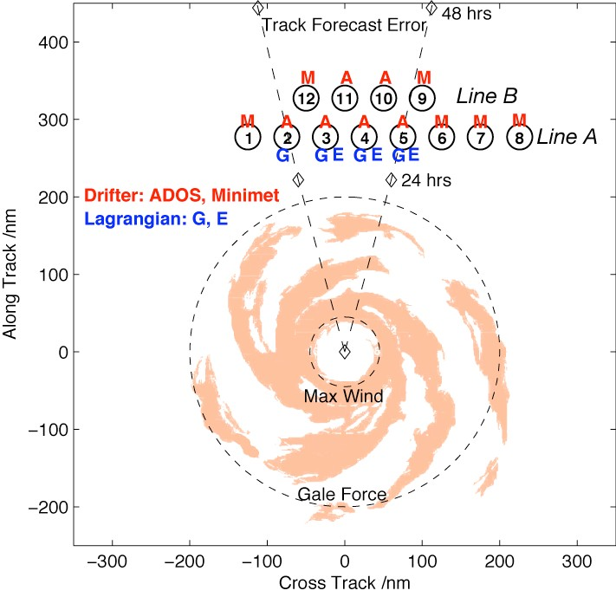

Figure 8: Drifter array deployed by AFRC WC-130J aircraft. The array is deployed ahead of the storm with the exact array location and spacing determined by the storm speed, size and the uncertainty in the storm track. The array consists of ADOS thermistor chain (A) and minimet (M) drifters. Gas (G) and EM (E) Lagrangian floats could be added if available. Three items are deployed at locations 3, 4 and 5, two items at location 3 and one item elsewhere.

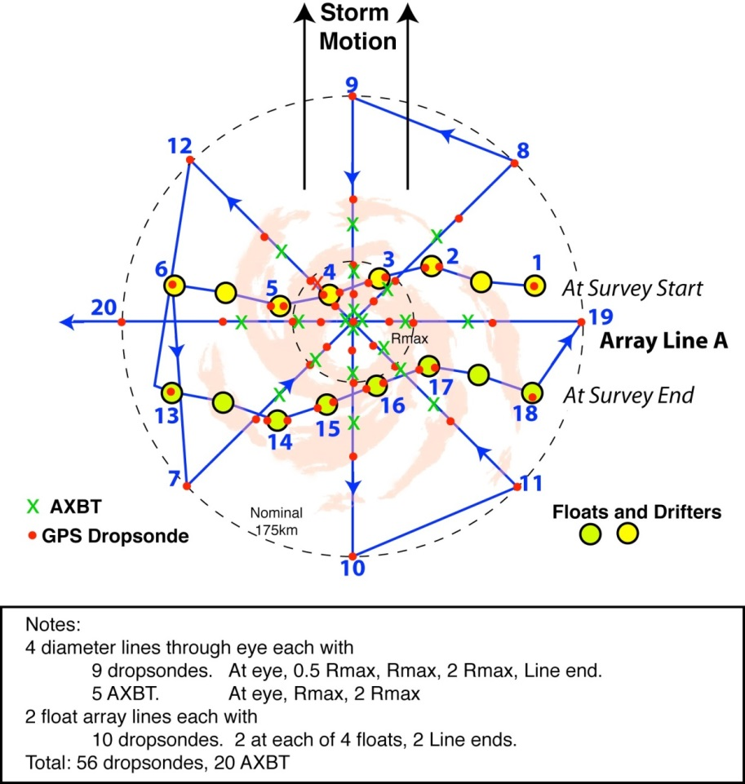

Figure 9: P-3 pattern over float and drifter array. The array has been distorted since its deployment on the previous day and moves relative to the storm during the survey. The pattern includes two legs along the array (waypoints 1-6 and 13-18) and an 8 radial line survey. Dropwindsondes are deployed along all legs, with double deployments at the floats. AXBTs are deployed in the storm core.

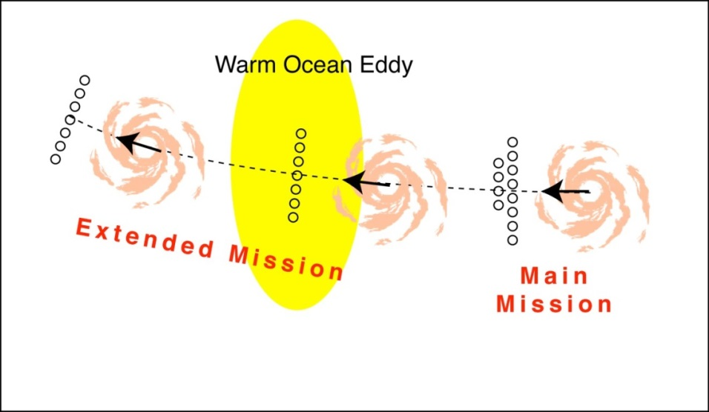

Figure 10: Extended Mission. Two additional drifter arrays will be deployed along the storm track.

Analysis Strategy:
Upper-ocean three-dimensional thermal, salinity, and current structures will be measured from P-3 aircraft with airborne expendable bathythermographs (AXBT), conductivity–temperature–depth sensors (AXCTD), and current profilers (AXCP). Specifically, AXBT data will be acquired to ~400-m depth, compared to 1000m and 1500m for AXTCD and AXCP data, respectively. Additionally, measurements will be made using arrays of profiling and Lagrangian floats (APEX-EM) and drifters deployed by AFRC WC-130J aircraft in a manner similar to that used in the 2003 and 2004 CBLAST program (Black et al. 2007). Additional deployments have since refined the instruments and the deployment strategies. MiniMet drifters will measure SST, surface pressure and wind speed and direction. Thermistor chain Autonomous Drifting Ocean Station (ADOS) drifters add ocean temperature measurements to 150m. All drifter data is reported in real time through the Global Telecommunications System (GTS). Flux Lagrangian floats will measure temperature, salinity, oxygen and nitrogen profiles to 200m, boundary layer evolution and covariance fluxes of most of these quantities, windspeed and scalar surface wave spectra. E-M Lagrangian floats will measure temperature, salinity and velocity profiles to 200m. Profile data will be reported in real time on GTS.
The basic analysis follows that presented in recent observational studies of TC-ocean interaction (Shay et al. 1992; 1994; 2000; Shay and Uhlhorn 2008; Halliwell et al. 2011; Zhang et al. 2011, 2013, 2015; Sanabia et al. 2013; Jaimes et al. 2015; 2016; Lumpkin 2016). These analyses include: estimate of sea surface cooling after the storm; estimate of change in the ocean mixed layer depth and ocean heat content (relative to the 26ºC isotherm depth) during and after the storm; computation of surface fluxes using the bulk method; estimate of ocean current change during and after the storm, with emphasis in upwelling processes and vertical shear development; and evaluation of the surface-layer and boundary-layer structure in operational hurricane models using the observational data collected in this experiment.

References:
Halliwell, G., L. K. Shay, J. K. Brewster, and W. J. Teague, 2011: Evaluation and sensitivity analysis to an ocean model to hurricane Ivan. Mon. Wea. Rev.139, 921-945.
Lumpkin, R.: Global Characteristics of Coherent Vortices from Surface Drifter Trajectories. J. Geophys. Res.-Oceans, 121, 1306–1321, http://dx.doi.org/10.1002/2015JC011435.
Jaimes, B., L. K. Shay and E. W. Uhlhorn, 2015: Observed enthalpy fluxes during the rapid intensity change of hurricane Earl. Mon. Wea. Rev., 131, 111-131.
Jaimes, B., L. K. Shay and J. K. Brewster, 2016: Observed Air-Sea Interactions in Tropical Cyclone Isaac Over Loop Current Mesoscale Eddy Features Dyn. Atmos. Ocean., 76, 306-324.
Sanabia, E. R., B. S. Barrett, P. G. Black, S. Chen, and J. A. Cummings, 2013: Real-time upper-ocean temperature observations from aircrafts during operational hurricane reconnaissance: AXBT demonstration project year one results. Wea. Forecasting, 28, 1404-1422
Shay, L.K., P.G. Black, A.J. Mariano, J.D. Hawkins and R.L. Elsberry, 1992: Upper ocean response to hurricane Gilbert. J. Geophys. Res., 97, 20,227 - 20,248.
Shay, L.K., E.J. Walsh and P.C. Zhang. 1994: Orbital velocities induced by surface waves. J. Atmos. Ocean. Tech., 11(4), Part 2, 1117 - 1125.
Shay, L.K., G.J. Goni and P.G. Black, 2000: Effects of a warm oceanic feature on Hurricane Opal. Mon. Wea. Rev., 125(5), 1366-1383.
Shay, L.K., and E. Uhlhorn, 2008: Loop current response to hurricanes Isidore and Lili, Mon. Wea Rev., 137, 3248-3274.
Zhang, J. A., R. F. Rogers, D. S. Nolan, and F. D. Marks, 2011: On the characteristic height scales of the hurricane boundary layer, Mon. Wea. Rev., 139, 2523-2535.
Zhang, J. A., R. F. Rogers, P. Reasor, E. Uhlhorn, and F. D. Marks, 2013: Asymmetric hurricane boundary layer structure from dropsonde composites in relation to the environmental vertical wind shear. Mon. Wea. Rev., 141, 3968–3984.
Zhang, J. A., D. S. Nolan, R. F. Rogers, and V. Tallapragada, 2015: Evaluating the impact of improvements in the boundary layer parameterization on hurricane intensity and structure forecasts in HWRF, Mon. Wea. Rev., 143, 3136-3155.

16. Tropical Cyclone Landfall Experiment
Principal Investigators: John Kaplan, Ghassan Alaka, Peter Dodge, Hua Chen, Frank Marks, Jun Zhang, Brad Klotz, and Matt Eastin (UNC Charlotte)
Links to the IFEX:

These modules support the following NOAA IFEX goals:

- Goal 1: Collect observations that span the TC lifecycle in a variety of environments for model initialization and evaluation;
- Goal 3: Improve our understanding of the physical processes important in intensity change for a TC at all stages of its lifecycle.

Motivation:

The lifecycle of a TC often ends when it makes landfall and decays as it moves inland. During a hurricane threat, an average of 300 nm (550 km) of coastline is placed under a hurricane warning, which costs approximately $150-300 million in preparation per event. The size of the warned area depends on the extent of hurricane and tropical storm-force wind speeds at the surface, evacuation lead-times, and the storm track forecast. Research has helped reduce uncertainties in the track and landfall forecasts, and now one of the goals of the IFEX is to improve the accuracy of the surface wind fields in TCs, especially near and after landfall. Improvements in track forecasts and surface wind field analyses could produce more accurate hurricane warning areas thereby optimizing the cost of hurricane landfall preparations. In addition to the surface wind field, the forecast of severe weather embedded within a landfalling TC is particularly difficult. Recent studies have highlighted the front-right quadrant of a landfalling TC as a region of increased severe weather risk, particularly TC tornadoes (e.g., Schultz and Cecil 2009). However, some landfalling TCs are associated with more severe weather than others, which has prompted the HRD to explore how numerical modeling (e.g., the HWRF model) can improve severe weather forecasts issued by the NHC and the SPC prior to, during, and after TC landfall. This experiment can help guide research at the HRD by providing real-time observations of severe weather to verify the HWRF model.

There are still uncertainties in deriving surface wind estimates from flight-level and SFMR wind speeds collected near the coast. Changing bathymetry could alter the breaking wave field, which could change the roughness length at higher wind speeds and microwave emissions. Evaluation of these effects may lead to adjustments to the operational surface wind speed algorithms.

Analysis of Doppler radar, GPS dropwindsonde, SFMR, flight-level and SRA or AWRAP data collected during hurricane flights can help achieve the IFEX goals for the 2015 Hurricane Field Program. A major goal of the IFEX is to capture the lifecycle of a TC and, while landfall typically occurs at the end of the TC lifecycle, the same data collection strategies developed for mature hurricanes over the open ocean can also be applied at landfall. Subsets of the collected data can be transmitted to the NHC and to the EMC, for assimilation into the HWRF model. Doppler and GPS dropwindsonde data can be analyzed to derive three-dimensional wind fields to compare with the HWRF output and data from the SRA can be compared to the HWRF wave fields. In addition to shear and heat flux from the ocean, landfalling hurricanes experience other conditions that may affect intensity change. These include changes in ocean wave action in shallow waters, change in surface roughness, drier and/or cooler inflow from the land, and topographical impacts. Radar, dropwindsonde, and SFMR data can help observe and analyze those conditions. Decay over land is also important, and data collected during and shortly after landfall should help refine both operational statistical models (such as the Kaplan/DeMaria decay model) and numerical models like HWRF.

The HRD has developed a real-time surface-wind analysis system to aid the NHC in the preparation of warnings and advisories in TCs. In the past, the wind analyses produced using the HRD analysis package have been used both for post-storm damage assessment by emergency management officials and by researchers seeking to validate their model analyses and forecasts. In addition, these wind analyses also have the potential to be employed for use in the initialization of real-time storm surge models.

As a TC approaches the coast, surface marine wind observations are normally only available in real time from National Data Buoy Center moored buoys, Coastal-Marine Automated Network (C-MAN) platforms, and a few ships. Surface wind estimates must therefore be based primarily on aircraft measurements. Low-level (<5,000 ft. [1.5 km] altitude) NOAA and AFRES aircraft flight-level wind speeds are adjusted to estimate surface wind speeds. These adjusted wind speeds, along with C-SCAT and SFMR wind estimates, are combined with actual surface observations to produce surface wind analyses. These surface wind analyses were initially completed after the landfall of Hurricane Hugo in South Carolina and of Hurricane Andrew in South Florida in support of post-landfall damage surveys conducted by FEMA. In recent years, these analyses have been produced in real time for use by the NHC for many of the TCs that have affected the Western Atlantic basin, including such notable landfalling storms as Opal (1995), Fran (1996), Georges (1998), Bret, Floyd (1999), Isidore (2003), Frances, Ivan, Jeanne (2004), Dennis (2005), Katrina (2005), Rita (2005), Wilma (2005), Ike (2008), Irene (2011) and Isaac (2012). Dual-Doppler analysis provides a complete description of the wind field in the core and, recently, the analysis techniques have been streamlined so that these real-time wind analyses can be computed aboard the aircraft and wind fields at selected levels transmitted from the aircraft to the NHC and the NCEP. These wind fields are also quite useful for post-storm analysis.

Severe weather, including the potential for tornadoes, is often associated with landfalling TCs. The basic dynamic and thermodynamic structures found in TC supercells are not well-understood. While some studies have found that TC tornadoes rely on some of the same factors as Great Plains tornadoes, some key differences exist, such as the height and amplitude of these vortices. Most TC tornadoes occur in the front-right quadrant of the TC primarily from 12 hours prior to 48 hours after landfall (Schultz and Cecil 2009). Additionally, the most damaging TC tornadoes occur in rain bands outside of the TC inner core (> 150 km). While TC tornadoes are typically weaker than their Great Plains counterparts, these TC tornadoes account for at least 10% of all tornado records from Louisiana to Maryland (Schultz and Cecil 2009). Unlike Great Plains tornadoes, TC tornadoes are typically associated with smaller values of CAPE. Instead of relying on high CAPE, TC tornadoes owe some of their existence to the friction-induced convergence that accompanies landfalling TCs. The sudden deceleration of the wind as it encounters the rougher land surface helps drive vertical motion, which promotes embedded mesovortices and severe weather.

Recent research efforts in coordination with the NHC and the SPC are focused on improving the prediction of TC tornadoes based on the HWRF model output prior to and during TC landfall. Unfortunately, the HWRF model does not possess a resolution fine enough to capture tornadoes. Instead, signatures of tornadoes (e.g., helicity, wind shear, vorticity, radar hook echoes) will be sought out in the flight data (e.g., Doppler, GPS dropwindsondes) and will be used to verify the HWRF model output. Since some landfalling TCs produce more tornadoes than others, one goal of this experiment is to better understand the structure and thermodynamical properties of tornado-inducing rainbands in landfalling TCs.

Recent GPS dropwindsonde data from near and inside the flight-level radius of maximum wind speeds (RMW) in strong hurricanes have shown remarkable variations of the wind with height. A common feature is a wind speed maximum at 300-500 m altitude. Theoretical and numerical modeling of the hurricane boundary layer suggests that the low-level jets are common features. The height of the jet varies by storm quadrant, and modeling indicates that this variation can be enhanced as a TC crosses land. In addition, GPS dropwindsonde data will provide critical observations of temperature and moisture associated with severe weather embedded within TC outer rain bands, which will help to provide a better picture of supercell structures within landfalling TCs.

While collection of dual-Doppler radar data by aircraft alone requires two P-3 aircraft flying in well-coordinated patterns, time series of dual-Doppler data sets have been collected by flying a single P-3 toward or away from a ground-based Doppler radar. In that pattern, the aircraft Doppler radar rays are approximately orthogonal to the ground-based Doppler radar rays, yielding true Dual-Doppler coverage. Starting in 1997, the Atlantic and Gulf coasts were covered by a network of Doppler radars (Weather Surveillance Radar 88 Doppler [WSR-88D]) deployed by the National Weather Service (NWS), Department of Defense, and Federal Aviation Administration. Each radar site transmits the base data (Level II) in near real time to a central site. These data are subsequently archived at the National Climatic Data Center. In precipitation or severe weather mode, the radars collect volume scans every 5-6 min.

If a significant TC moves within 215 nm (440 km) of the coast of the eastern or southern United States, then (resources permitting) a P-3 will obtain Doppler radar data to be combined with data from the closest WSR-88D radars in dual-Doppler analyses. The tail radar is tilted to point 20 degrees forward and aft from the track during successive sweeps (the fore-aft scanning technique [F/AST]). These analyses could resolve phenomena with time scales < 10 min, the time spanned by two WSR-88D volume scans. This time series of dual-Doppler analyses will be used to describe the storm core wind field and its evolution. The flight pattern is designed to obtain dual-Doppler analyses at intervals of 10-20 min in the core. Deploying dropwindsondes near the coast will augment the Doppler data, where knowledge of the boundary-layer structure is crucial for determining what happens to the wind field as a strong storm moves inland. Dropwindsondes will also be deployed in the eyewall in different quadrants of the TC. To augment the core analyses, dual-Doppler data can also be collected in the outer portions of the storm, beyond the range of the WSR-88D, because the alternating forward and aft scans in F/AST mode intersect at 40 degrees, sufficient for dual-Doppler synthesis of wind observations.

Objectives:

- Collect NOAA P-3 Doppler, flight-level, and SFMR surface wind data both within the inner-core (radius < 120 nm) and near storm (120 nm < radius < 240 nm) environment to help improve and validate real- time and post-storm surface wind estimates in tropical cyclones.

- Document the thermodynamic and kinematic changes in storm structure during and after landfall and improve our understanding of the factors that modulate changes in tropical cyclone intensity near the time of landfall.

- Collect observations that will aid in the evaluation of the current operational coupled model forecast system’s ability to predict the three-dimensional structure of tropical cyclones both at the time of landfall as well as after the cyclone has moved inland.

- Collect dynamic and thermodynamic data in outer rain bands (> 150 km from TC center) of tropical cyclones that are either likely to make landfall or to make a close enough approach to the coastline that they have the potential to produce tornadoes.

Hypotheses:

- It is possible to improve real-time surface wind estimates for landfalling tropical cyclones by obtaining in-situ inner-core and near storm wind data collected utilizing NOAA P-3 aircraft.

- The above landfall datasets can be used to validate statistical and numerical model landfall surface wind forecasts.

- Our understanding and ability to forecast changes in the structure and intensity of landfalling tropical cyclones can be enhanced utilizing the high-resolution kinematic and thermodynamic data sets collected during the aforementioned landfall research missions.

- Traditional environmental parameters (e.g., CAPE, vertical shear, helicity) will distinguish sectors of the storm that are most supportive of supercell development. Thus, the area coverage of SPC-issued severe weather watches may be optimized and the HWRF output can be validated based on datasets produced via the modules described in this experiment.

Model Evaluation Component:

Recent tropical cyclones (e.g., Irene [2011], Sandy [2012]) have produced over-land wind gusts that have often exceeded the values expected based upon both the simulated and observed maximum sustained wind. Thus, it is hypothesized that the collection of landfalling datasets such as those proposed for this experiment will help researchers evaluate the capability of the HWRF model to accurately predict both the maximum sustained wind and wind gusts of landfalling TCs. In addition, forecasts of TC tornadoes have generally depended on climatology even though some numerical models have the capability to resolve tornadic signatures within TCs. Thus, a goal of this experiment is to evaluate how accurately the HWRF model simulates the mesoscale convective features that are capable of producing tornadoes. Since the HWRF model resolution is currently too coarse to explicitly simulate TC tornadoes, the signatures of TC tornadoes will be analyzed in the landfalling datasets and compared with the HWRF output. This includes traditional environmental fields that are indicative of tornadoes, such as CAPE, vertical shear, and helicity.

Mission Description:

This is a multi-option, single-aircraft experiment designed to study the changes in TC surface wind structure and to document TC supercell characteristics near and after landfall. All three modules described here could also be incorporated into operational surveillance or reconnaissance missions. It is designed for one or two single-aircraft missions with a P-3 when a hurricane or tropical storm moves within ~215 nm (400 km) of the U.S. coastline. The first of these two flights will typically consist of the Offshore Intense Convective module followed by either the Coastal Survey or Real-time modules. While the storm location relative to the coastline will dictate which combination of these modules will be flown, the Offshore Intense Convection module will generally precede all of the others.

Landfall flights may be coordinated with mobile observing systems that are sometimes deployed ahead of landfalling tropical cyclones. These additional observations could be particularly useful for: 1) documenting the inland decay of surface winds associated with TC landfall and 2) for identifying the location of any tornadoes that might be generated by the landfalling tropical cyclone.

The aircraft must have working lower fuselage and tail radars. The HRD should have access to a workstation on board, so radar and GPS dropwindsonde data can be analyzed and transmitted to the NHC. The SFMR should be operated, to provide estimates of wind speed at the surface. If the AWRAP or C-SCAT is on the aircraft then it should also be operated to provide another estimate of the surface wind speeds. If the SRA is working it also should collect wave and sweep heights to characterize the storm surge and breaking wave field near the coast. If the scanning LIDAR is available, then it should be operated to obtain wind profiles in the clear air regions, especially in the offshore flow. If the portable Doppler radars (Shared Mobile Atmospheric Research and Teaching Radar [SMART- R] and/or Doppler on Wheels [DOW]) and portable wind towers are deployed, they should be placed between ~65 and 130 km inland in the onshore flow regime as depicted in Fig. 3 if possible, to document the decay of the tropical cyclone wind field and to help identify any tornadoes that the landfalling tropical cyclone may produce. If possible, one of the DOWs should be positioned relative to the nearest WSR-88D such that the dual-Doppler lobes cover the largest area of onshore flow possible. In the schematic shown in Fig. 3, one of the DOWs is positioned north-west of the Melbourne WSR-88D so that one dual- Doppler lobe is over the coastal waters and the other covers the inland region. The profiler is positioned within the inland dual-Doppler lobe to provide independent observations of the boundary layer to anchor the dual-Doppler analysis.

All modules support real-time and post-storm surface wind analyses and the identification/verification of potential tornadoes produced by the landfalling tropical cyclone. The flight patterns will depend on the location and strength of the storm relative to surface observing platforms and coastal radars. The three modules can be easily incorporated into a tasked operational mission. In the case of the Offshore Intense Convection module, different legs of this module may be incorporated into legs of a figure-4 pattern if supercells are encountered (Fig. 1).

Analysis Strategy:

1. Offshore Intense Convection Module

The P-3 Doppler radar data will be carefully edited and then synthesized into a three-dimensional wind field. Dropsonde and flight-level data will be analyzed and combined with an available rawinsonde and surface (e.g. buoys, CMAN, etc.) observations to establish the dynamic and thermodynamic environment of the targeted cells. Any available land-based radar will be used to augment the cell evolution documented by the airborne radars. Observations of TC supercells will be used to validate HWRF output and will assess the HWRF model’s ability to predict signatures of tornadic activity. The supercell’s environment and structure will be used to verify the HWRF model output and will allow for a direct comparison with mid-latitude supercells.

2. Coastal Survey module:

In addition to the data processing described in modules 1 and 3, the Doppler radar swath data will be edited and synthesized into wind fields. The winds will be compared with GPS dropwindsondes and SFMR, AWRAP, and/or LIDAR data to characterize the differences between the onshore and offshore flow.

3. Real-time module:

Flight level, Doppler radar, dropsonde, and SFMR data transmitted in real time will be ingested into the HRD wind-analysis system archive, where the observations are standardized to average 1 minute data at a standard height of 10 m in an open exposure. These data, in addition to other surface data could then be combined to produce analyses of surface wind speed that could be provided to forecasters and/or emergency manager in real-time. The quality-controlled data will also be available for assimilation into models such as HWRF and to validate forecasts the sustained wind, wind gusts, and thermodynamic fields such temperature, moisture, and rainfall obtained utilizing both operational numerical models (e.g. HWRF) as well as statistical models (e.g. Kaplan/DeMaria decay, Rainfall clipper).

17. Convective Burst Module

Principal Investigator(s): Robert Rogers, Altug Aksoy, Jon Zawislak, Leon Nguyen

Links to IFEX:
- Goal 1: Collect observations that span the TC life cycle in a variety of environments for model initialization and evaluation.
- Goal 3: Improve understanding of the physical processes important in intensity change for a TC at all stages of its lifecycle.

Motivation:
The objectives are to obtain a quantitative description of the kinematic and thermodynamic structure and evolution of intense convective systems (convective bursts) and the nearby environment to examine their role in TC intensity change.
Background:
It has long been known that deep convection is an integral component of TC structure. What has received greater attention in recent years is the potential role that deep convection, termed here “convective bursts”, or CBs, representing the peak updrafts and highest echo tops, plays in TC evolution, in particular intensity evolution. Various hypotheses attribute their contribution to TC intensification by vortex gradient adjustment to the imposed diabatic heating in the high-inertial stability region inside the radius of maximum wind (RMW) (e.g., Shapiro and Willoughby 1982, Schubert and Hack 1982, Hack and Schubert 1986, Nolan and Grasso 2003, Nolan et al. 2007, Vigh and Schubert 2009, Pendergrass and Willoughby 2009, Rogers et al. 2013, 2015, 2016), convergence of angular momentum surfaces in the lower troposphere and boundary layer (Smith and Montgomery 2016), upper-level subsidence warming around the CB periphery (e.g., Heymsfield et al. 2001, Guimond et al. 2010, Rogers 2010, Zhang and Chen 2012, Chen and Zhang 2013, Chen and Gopal 2015), stretching and axisymmetrization in vortical hot towers (Hendricks et al. 2004, Montgomery et al. 2006, Reasor et al. 2009), and vortex alignment/downshear reformation (Reasor et al. 2009, Molinari and Vollaro 2010, Nguyen and Molinari 2012, Reasor and Eastin 2012, Stevenson et el. 2014, Rogers et al. 2015, Nguyen and Molinari 2015). While these studies have emphasized the role of deep convection in TC intensification, other studies have focused on the role of shallow to moderate convection, and even stratiform precipitation, in initiating TC intensification (Kieper and Jiang 2012, Zagrodnik and Jiang 2014, Tao and Jiang 2015, Tao et al. 2017, Nguyen et al. 2017). Common to these and other (e.g., Miyamoto and Takemi 2015) studies, though, is that TC intensification is favored when precipitation, including CBs, are preferentially located inside the RMW with a maximum azimuthal distribution.
Vertical shear is one factor that has been shown to be important in organizing precipitation, including CBs, azimuthally around the TC vortex. This has generally been attributed to the fact that vertical shear tilts the vortex, leading to preferred regions of vortex-scale low-level convergence and upward motion downshear and low-level divergence and subsidence upshear (Jones 1995, Bender 1997, Frank and Ritchie 2001, Black et al. 2002, Corbosiero and Molinari 2003, Rogers et al. 2003, Braun et al. 2006, Wu et al. 2006, Reasor et al. 2009, Reasor and Eastin 2012, Reasor et al. 2013, Dolling and Barnes 2014, DeHart et al. 2014). Recent composite studies of vortices in shear using airborne Doppler radar have shown that the shear-induced circulations are maximized downshear right (DSR) (low-level convergence/upward motion) and upshear left (USL) (low-level divergence/downward motion) (Reasor et al. 2013, DeHart et al. 2014). A similar composite methodology has been performed in a CB-relative coordinate system (Wadler et al. 2017). This study found that the peak updraft magnitude and altitude for CBs was minimized DSR, consistent with the notion that this is the quadrant where CBs are initiated. Peak updraft magnitude and altitude increase in the DSL quadrant, as the CBs mature, and they reach their highest and strongest values USL. A similar shear-relative azimuthal relationship was found for echo top height. Significantly, when stratifying TCs by intensity change, it was found that the most significant differences in CB structure between intensifying and non-intensifying TCs were located in the USL quadrant. Intensifying TCs have CBs with stronger peak updrafts, at a higher altitude, with higher echo tops in the USL quadrant than non-intensifying TCs. This relationship suggests that the structure and evolution of CBs, which are to some extent a function of the local environment from which they initiate downshear and mature upshear -- including convective available potential energy, midlevel humidity, and subsidence upshear (Zawislak et al. 2016, Rogers et al. 2016, Nguyen et al. 2017) -- is an important factor to consider in assessing the potential for a TC to intensify.
It should be noted that the above descriptions presume that CBs do translate downwind, i.e., upshear. However, in some situations, mostly revealed from modeling studies (Munsell et al. 2017, Chen et al. 2017), CBs can remain “trapped” on the downshear side. In fact, cases where the CBs remain downshear were more likely to be associated with non-intensifying periods of TC evolution. This is consistent with the notion of greater azimuthal symmetry of diabatic heating being associated with TC intensification. CBs propagating into the upshear quadrants may also be related to a greater likelihood of vortex alignment, as revealed in the observational analysis of Hurricane Earl (2010; Rogers et al. 2015) and a WRF-ARW ensemble forecast of Edouard (2014; Munsell et al. 2017).
The results described above are valid for composites of many different CBs from many different TCs. They therefore lack the temporal continuity needed to measure the structure of specific individual (or groups of) CBs, and how they evolve in a shear-relative sense. The purpose of this module is to repeatedly sample individual (or groups of) CBs to provide this temporal continuity.
Hypotheses:
The following hypotheses will guide the sampling strategies for CBs. One set of hypotheses is for CBs that translate downwind/upshear, the other set is for CBs that remain confined downshear:
- CBs are preferentially initiated in the DSR quadrant; as such, the updraft maxima is likely to be weaker and at a lower altitude in this quadrant;

For CBs translating downwind/upshear:

- Traveling downwind into the DSL quadrant, peak updrafts will strengthen and be located at a higher altitude;
- The strength of the CB in the USL quadrant (as measured by strength and height of peak updraft and echo top height relative to the DSL quadrant) will vary depending on the local, vortex-scale environment of the convection. This environment includes midlevel humidity, strength of subsidence upshear, and sea surface temperature (and CAPE) on the downshear side of the TC;
- If the CB strength USL is higher (lower) than DSL, the TC will intensify (not intensify).

For CBs remaining confined downshear:

- The structural evolution will follow a similar path to those CBs translating downwind/upshear; i.e., updraft peaks beginning in lower to middle troposphere, then ascending with time before becoming dominated by downdrafts and collapse while remaining downshear
- TC will not intensify

Experiment/Module Description:
This is a stand-alone module that takes 1-2 h to complete. Execution is dependent on system attributes, aircraft fuel and weight restrictions, and proximity to operations base. It can be flown separately within a mission designed to study local areas of convection or at the end of one of the survey patterns. Once a local area of intense convection is identified, the P-3 will transit at altitude (10-12 kft) to the nearest point just outside of the convective cores and sample the convective area. The sampling pattern will be a series of inbound/outbound radial penetrations or bowtie patterns (when sampling a CB near the radius of maximum wind of a tropical storm or hurricane). If the CB is at or near the RMW, repeated sampling can allow for a following of the burst around the storm. This is especially useful to sample the structural evolution of the burst as it moves around the storm. If the CB remains confined to the downshear side of the TC rather than translate upshear, the pattern should still be flown.

Analysis Strategy:
Radar analyses will be performed for each radial pass through the CB, preferentially with a temporal spacing of 30 minutes or less. These analyses will provide high-frequency observations of the structure of the CB, as measured by the peak updraft magnitude and altitude and echo top heights. Additionally, the full spectrum of vertical velocity associated with each radar analysis will be evaluated using contoured frequency by altitude diagrams (CFADs; Yuter and Houze 1995) to obtain a more complete picture of the updraft and downdraft structure and evolution of the CB. Ideally a CB will be flown beginning with its initiation (likely to be downshear) and then followed around the storm as it travels through the downwind quadrants and into the upshear quadrants (or continuously sampled on the downshear side if it remains confined there). Dropsondes released at the starting and ending points of each radial leg will document the thermodynamic structure of the boundary layer. Optimally, the G-IV will be flying in the storm to provide deep-layer humidity profiles around the storm in addition to the P-3 dropsondes. If the G-IV is not available, the module could still be flown to examine the evolution using the Doppler radar and boundary layer thermodynamics from the P-3 dropsondes.

In addition to the observational analysis described above, the high-resolution data collected in this module is planned to be embedded within the typical Hurricane Ensemble Data Assimilation System (HEDAS; e.g., Aksoy et al. 2013) framework to carry out storm-scale data assimilation that focuses specifically on the high-resolution analysis of the identified intense convective region. With current technology, a smaller domain with 1-km grid spacing will be nested within the HEDAS 3-km analysis domain, where the data will be assimilated for the duration of its collection (1-2 hours, at 5-10 min intervals). This is a typical setup that has been traditionally used in continental storm-scale radar data assimilation applications and has been shown to be effective to obtain realistic storm structures in analyses and short-range forecasts. With such high-resolution analyses, we hope to be able to obtain fully three-dimensional model representations of the observed convective regions for more detailed investigation, as well as investigate their short-range predictability. In an observing system experiment (OSE) mode, various assimilation experiments can also be devised to investigate hypothetical scenarios for how an observed convective region could interact with the surrounding vortex and impact its evolution.

References:

Aksoy, A., S. D. Aberson, T. Vukicevic, K. J. Sellwood, S. Lorsolo, and X. Zhang (2013), Assimilation of high-resolution tropical cyclone observations with an ensemble Kalman filter using NOAA/AOML/HRD’s HEDAS: Evaluation of the 2008–11 vortex-scale analyses, Mon. Wea. Rev., 141, 1842–1865, doi: http://dx.doi.org/10.1175/MWR-D-12-00194.1.
Bender, M. A., 1997: The effect of relative flow on the asymmetric structure in the interior of hurricanes. J. Atmos. Sci., 54, 703–724, doi:10.1175/1520-0469(1997)054<0703:TEORFO>2.0.CO;2.
Black, M. L., J. F. Gamache, F. D. Marks, C. E. Samsury, and H. E. Willoughby, 2002: Eastern Pacific Hurricanes Jimena of 1991 and Olivia of 1994: The effect of vertical shear on structure and intensity. Mon. Wea. Rev., 130, 2291–2312, doi:10.1175/1520-0493(2002)130<2291:EPHJOA>2.0.CO;2.
Braun, S. A., M. T. Montgomery, and Z. Pu, 2006: High-resolution simulation of Hurricane Bonnie (1998). Part I: The organization of eyewall vertical motion. J. Atmos. Sci., 63, 19–42, doi:10.1175/JAS3598.1.
Chen, H., and S. G. Gopalakrishnan, 2015: A study on the asymmetric rapid intensification of Hurricane Earl (2010) using the HWRF system. J. Atmos. Sci., 72, 531–550, doi:10.1175/JAS-D-14-0097.1.
Chen, H., and D. L. Zhang, 2013: On the rapid intensification of Hurricane Wilma (2005). Part II: Convective bursts and the upper-level warm core. J. Atmos. Sci., 70, 146–162, doi:10.1175/JAS-D-12-062.1.
Chen, H., S.Gopalakrishnan, J.A. Zhang, R.F. Rogers, Z. Zhang, and V. Tallapragada, 2017: Use of HWRF ensembles for providing improved understanding of hurricane RI problem: Case study of Hurricane Edouard (2014). J. Atmos. Sci., in review.
Corbosiero, K. L., and J. Molinari, 2003: The relationship between storm motion, vertical wind shear, and convective asymmetries in tropical cyclones. J. Atmos. Sci., 60, 366–376, doi:10.1175/1520-0469(2003)060<0366:TRBSMV>2.0.CO;2.
DeHart, J. C., R. A. Houze Jr., and R. F. Rogers, 2014: Quadrant distribution of tropical cyclone inner-core kinematics in relation to environmental shear. J. Atmos. Sci., 71, 2713–2732, doi:10.1175/JAS-D-13-0298.1.
Dolling, K., and G. M. Barnes, 2014: The evolution of Hurricane Humberto (2001). J. Atmos. Sci., 71, 1276–1291, doi:10.1175/JAS-D-13-0164.1.
Frank, W. M., and E. A. Ritchie, 2001: Effects of vertical wind shear on the intensity and structure of numerically simulated hurricanes. Mon. Wea. Rev., 129, 2249–2269, doi:10.1175/1520-0493(2001)129<2249:EOVWSO>2.0.CO;2.
Guimond, S. R., G. M. Heymsfield, and F. J. Turk, 2010: Multiscale observations of Hurricane Dennis (2005): The effects of hot towers on rapid intensification. J. Atmos. Sci., 67, 633–654, doi:10.1175/2009JAS3119.1.
Hack, J. J., and W. H. Schubert, 1986: Nonlinear response of atmospheric vortices to heating by organized cumulus convection. J. Atmos. Sci., 43, 1559–1573, doi:10.1175/1520-0469(1986)043<1559:NROAVT>2.0.CO;2.
Hendricks, E. A., M. T. Montgomery, and C. A. Davis, 2004: The role of “vortical” hot towers in the formation of Tropical Cyclone Diana (1984). J. Atmos. Sci., 61, 1209–1232, doi:10.1175/1520-0469(2004)061<1209:TROVHT>2.0.CO;2.
Heymsfield, G. M., J. B. Halverson, J. Simpson, L. Tian, and T. P. Bui, 2001: ER-2 Doppler radar investigations of the eyewall of Hurricane Bonnie during the Convection and Moisture Experiment-3. J. Appl. Meteor., 40, 1310–1330, doi:10.1175/1520-0450(2001)040<1310:EDRIOT>2.0.CO;2.
Jones, S. C., 1995: The evolution of vortices in vertical shear. I: Initially barotropic vortices. Quart. J. Roy. Meteor. Soc., 121, 821–851, doi:10.1002/qj.49712152406.
Kieper, M. E., and H. Jiang, 2012: Predicting tropical cyclone rapid intensification using the 37 GHz ring pattern identified from passive microwave measurements. Geophys. Res. Lett., 39, L13804, doi:10.1029/2012GL052115.
Miyamoto, Y., and T. Takemi, 2015: A triggering mechanism for rapid intensification of tropical cyclones. J. Atmos. Sci., 72, 2666–2681, doi:10.1175/JAS-D-14-0193.1.
Molinari, J., and D. Vollaro, 2010: Rapid intensification of a sheared tropical storm. Mon. Wea. Rev., 138, 3869–3885, doi:10.1175/2010MWR3378.1.
Montgomery, M. T., M. Nicholls, T. Cram, and A. Saunders, 2006: A “vortical” hot tower route to tropical cyclogenesis. J. Atmos. Sci., 63, 355–386, doi:10.1175/JAS3604.1.
Munsell, E.B., F. Zhang, J.A. Sippel, S.A. Braun, and Y. Weng, 2017: Dynamics and Predictability of the Intensification of Hurricane Edouard (2014). J. Atmos. Sci., 74, 573–595, doi: 10.1175/JAS-D-16-0018.1.
Nguyen, L. T., and J. Molinari, 2012: Rapid intensification of a sheared, fast-moving hurricane over the Gulf Stream. Mon. Wea. Rev., 140, 3361–3378, doi:10.1175/MWR-D-11-00293.1.
Nguyen, L. T., and J. Molinari, 2015: Simulation of the downshear reformation of a tropical cyclone. J. Atmos. Sci., 72, 4529–4551, doi:10.1175/JAS-D-15-0036.1.
Nguyen, L.T., R.F. Rogers, and P.D. Reasor, 2017: Thermodynamic and kinematic influences on precipitation symmetry in sheared tropical cyclones: Bertha and Cristobal (2014). Mon. Wea. Rev., in review.
Nolan, D. S., and L. D. Grasso, 2003: Nonhydrostatic, three-dimensional perturbations to balanced, hurricane-like vortices. Part II: Symmetric response and nonlinear simulations. J. Atmos. Sci., 60, 2717–2745, doi:10.1175/1520-0469(2003)060<2717:NTPTBH>2.0.CO;2.
Nolan, D. S., Y. Moon, and D. P. Stern, 2007: Tropical cyclone intensification from asymmetric convection: Energetics and efficiency. J. Atmos. Sci., 64, 3377–3405, doi:10.1175/JAS3988.1.
Pendergrass, A. G., and H. E. Willoughby, 2009: Diabatically induced secondary flows in tropical cyclones. Part I: Quasi-steady forcing. Mon. Wea. Rev., 137, 805–821, doi:10.1175/2008MWR2657.1.
Reasor, P. D., and M. D. Eastin, 2012: Rapidly intensifying Hurricane Guillermo (1997). Part II: Resilience in shear. Mon. Wea. Rev., 140, 425–444, doi:10.1175/MWR-D-11-00080.1.
Reasor, P. D., M. D. Eastin, and J. F. Gamache, 2009: Rapidly intensifying Hurricane Guillermo (1997). Part I: Low-wavenumber structure and evolution. Mon. Wea. Rev., 137, 603–631, doi:10.1175/2008MWR2487.1.
Reasor, P. D., R. F. Rogers, and S. Lorsolo, 2013: Environmental flow impacts on tropical cyclone structure diagnosed from airborne Doppler radar composites. Mon. Wea. Rev., 141, 2949–2969, doi:10.1175/MWR-D-12-00334.1.
Rogers, R.F., 2010: Convective-scale structure and evolution during a high-resolution simulation of tropical cyclone rapid intensification. J. Atmos. Sci., 67, 44–70, doi:10.1175/2009JAS3122.1.
Rogers, R., S. S. Chen, J. E. Tenerelli, and H. E. Willoughby, 2003: A numerical study of the impact of vertical shear on the distribution of rainfall in Hurricane Bonnie (1998). Mon. Wea. Rev., 131, 1577–1599, doi:10.1175//2546.1.
Rogers, R., P. D. Reasor, and S. Lorsolo, 2013: Airborne Doppler observations of the inner-core structural differences between intensifying and steady-state tropical cyclones. Mon. Wea. Rev., 141, 2970–2991, doi:10.1175/MWR-D-12-00357.1.
Rogers, R., P. D. Reasor, and J. A. Zhang, 2015: Multiscale structure and evolution of Hurricane Earl (2010) during rapid intensification. Mon. Wea. Rev., 143, 536–562, doi:10.1175/MWR-D-14-00175.1.
Rogers, R.F., J.A. Zhang, J. Zawislak, H. Jiang, G.R. Alvey III, E.J. Zipser, and S.N. Stevenson, 2016: Observations of the structure and evolution of Hurricane Edouard (2014) during intensity change. Part II: Kinematic structure and the distribution of deep convection. Mon. Wea. Rev., 144, 3355-3376.
Schubert, W. H., and J. J. Hack, 1982: Inertial stability and tropical cyclone development. J. Atmos. Sci., 39, 1687–1697, doi:10.1175/1520-0469(1982)039<1687:ISATCD>2.0.CO;2.
Shapiro, L. J., and H. E. Willoughby, 1982: The response of balanced hurricanes to local sources of heat and momentum. J. Atmos. Sci., 39, 378–394, doi:10.1175/1520-0469(1982)039<0378:TROBHT>2.0.CO;2.
Smith, R. K., and M. T. Montgomery, 2016: The efficiency of diabatic heating and tropical cyclone intensification. Quart. J. Roy. Meteor. Soc., 142, 2081–2086, doi:10.1002/qj.2804.
Stevenson, S. N., K. L. Corbosiero, and J. Molinari, 2014: The convective evolution and rapid intensification of Hurricane Earl (2010). Mon. Wea. Rev., 142, 4364–4380, doi:10.1175/MWR-D-14-00078.1.
Tao, C., and H. Jiang, 2015: Distributions of shallow to very deep precipitation–convection in rapidly intensifying tropical cyclones. J. Climate, 28, 8791–8824, doi:10.1175/JCLI-D-14-00448.1.
Tao, C., H. Jiang, and J. Zawislak, 2017: The Relative Importance of Stratiform and Convective Rainfall in Rapidly Intensifying Tropical Cyclones. Mon. Wea. Rev., 145, 795–809, doi: 10.1175/MWR-D-16-0316.1.
Vigh, J. L., and W. H. Schubert, 2009: Rapid development of the tropical cyclone warm core. J. Atmos. Sci., 66, 3335–3350, doi:10.1175/2009JAS3092.1.
Wadler, J., R.F. Rogers, and P.D. Reasor, 2017: Radial and azimuthal variations in convective burst structure in tropical cyclones from airborne Doppler observations. Mon. Wea. Rev., manuscript in review.
Wu, L., S. A. Braun, J. Halverson, and G. Heymsfield, 2006: A numerical study of Hurricane Erin (2001). Part I: Model verification and storm evolution. J. Atmos. Sci., 63, 65–86, doi:10.1175/JAS3597.1.
Zagrodnik, J. P., and H. Jiang, 2014: Rainfall, convection, and latent heating distributions in rapidly intensifying tropical cyclones. J. Atmos. Sci., 71, 2789–2809, doi:10.1175/JAS-D-13-0314.1.
Zawislak, J., H. Jiang, G. R. Alvey III, E. J. Zipser, R. F. Rogers, J. A. Zhang, and S. N. Stevenson, 2016: Observations of the structure and evolution of Hurricane Edouard (2014) during intensity change. Part I: Relationship between the thermodynamic structure and precipitation. Mon. Wea. Rev., 144, 3333–3354, doi:10.1175/MWR-D-16-0018.1.
Zhang, D.-L., and H. Chen, 2012: Importance of the upper level warm core in the rapid intensification of a tropical cyclone. Geophys. Res. Lett., 39, L02806, doi:10.1029/2012GL052355.
Yuter, S. E., and R. A. Houze, 1995: Three-dimensional kinematic and microphysical evolution of Florida cumulonimbus. Part II: Frequency distributions of vertical velocity, reflectivity, and differential reflectivity. Mon. Wea. Rev., 123, 1941–1963, doi:10.1175/1520-0493(1995)123<1941:TDKAME>2.0.CO;2.

18. Eye-Eyewall Mixing

Principal Investigator(s): Sim Aberson

Links to IFEX:
- Goal 3: Improve understanding of the physical processes important in intensity change for a TC at all stages of its lifecycle.
Motivation and background:
Eyewall mesovortices have been hypothesized to mix high-entropy air from the eye into the eyewall, thus increasing the amount of energy available to the hurricane. Signatures of such mesovortices have been seen in cloud formations within the eyes of strong TCs, in radar reflectivity signatures (Hurricane Fabian), and from above during aircraft penetrations (Hurricanes Hugo and Felix). Doppler radar was able to sample such features in Hurricanes Hugo and Felix, though interpretation with sparse observations through the small features has been difficult. Dropwindsondes released in very intense tropical cyclones, in conjunction with large-eddy simulations, have provided some thermodynamic data. However, the kinematic and thermodynamic structures of these features have never been directly observed. Observations within the eye near or below the inversion can allow for the study of these mesovortices and improve knowledge of small-scale features and intensity changes in very strong TCs.
Hypothesis: Eyewall mesovortices play an important role in tropical cyclone intensity change.
Experiment/Module Description:
This is a break-away pattern that is compatible with any standard pattern with an eye passage (all P-3 patterns except the square spiral or lawnmower). The P-3 will penetrate the eyewall at the standard-pattern altitude. Once inside the eye, the P-3 will descend to a safe altitude below the inversion while performing a figure-4 pattern. The leg lengths will be determined by the eye diameter, with the ends of the legs at least 2 n mi from the edge of the eyewall. Upon completion of the descent, the P-3 will circumnavigate the eye about 2 n mi from the edge of the eyewall in the shape of a pentagon or hexagon. Time permitting; another figure-4 will be performed during ascent to the original flight level. Depending upon the size of the eye, this pattern should take between 0.5 and 1 h. The module need only be done once and will then be evaluated for the future.
Analysis Strategy: The data will be examined to look for meso- or miso-scale vortices at the eye-eyewall interface. Analyses with an advanced data assimilation system will also be conducted.
References:
Aberson, S. D., J. A. Zhang, and K. Nunez-Ocasio, 2017: An extreme event in the eyewall of Hurricane Felix on 2 September 2007. Mon. Wea. Rev., in press.
Aberson, S. D., J. P. Dunion, and F. D. Marks, 2006: A photograph of a wavenumber-2 asymmetry in the eye of Hurricane Erin. J. Atmos. Sci., 63, 387-391.
Aberson, S. D., M. T. Montgomery, M. M. Bell, and M. L. Black. 2006: Hurricane Isabel (2003): New insights into the physics of intense storms. Part II: Extreme localized wind. Bull. Amer. Met. Soc., 87, 1349-1354.
Marks, F.D., P.G. Black, M.T. Montgomery, and R.W. Burpee. Structure of the eye and eyewall of Hurricane Hugo (1989). Mon. Wea. Rev., 136, 1237-1259.
Rogers, R. F., S. Aberson, M. M. Bell, D. J. Cecil, J. D. Doyle, T. B. Kimberlain, J. Morgerman, L. K. Shay, and C. Velden, 2017: Re-writing the tropical record books: The extraordinary intensification of Hurricane Patricia (2015). Bull. Amer. Met. Soc., in press.

Stern, D. P., G. H. Bryan, and S. D. Aberson, 2016: Extreme low-level updrafts and wind speeds measured by dropsondes in tropical cyclones. Mon. Wea. Rev., 144, 2177-2204.

19. Secondary Eyewall Formation and Eyewall Replacement Cycle Module

Principal Investigator(s): Hui Christophersen, Robert Rogers, Jason Dunion, Jun Zhang
Collaborators: Jeff Kepert, Kristen Corbosiero, Anthony Didlake, Yuqing Wang, David Nolan and Sergio Abarca

Primary IFEX Goals:
- Goal 1: Collect observations primarily for mature hurricanes that may undergo a secondary eyewall formation (SEF) and eyewall replacement cycles (ERCs) based on radar, dropsonde, flight-level, Doppler Wind Lidar (DWL), and Coyote PBL measurements;
- Goal 2: Test utility of new observing platforms (Coyote UAS) and instruments (DWL) in diagnosing physical processes responsible for SEF/ERC, and use data to optimize sampling strategies for improving TC structure predictions in an OSE/OSSE framework;
- Goal 3: Improve understanding of the dynamic and physical processes that are responsible for SEF/ERC.

Motivation:
Secondary eyewall formation (SEF) and eyewall replacement cycles (ERCs) frequently occur during the mature phase of the tropical cyclone (TC) lifecycle. These processes typically result in a halting of the intensification of a TC, and occasionally lead to a temporary weakening as the secondary eyewall becomes the dominant eyewall (Sitkowski et al., 2011). Additionally, they typically lead to a significant broadening of the wind field, increasing the total kinetic energy of the storm and thus the risks from storm surge. Statistical analysis of a 10-year (1997-2007) dataset shows that 77% of major hurricanes (120 knots or higher) in the Atlantic Ocean, 56% in the eastern Pacific, 81% in the western Pacific, and 50% in the Southern Hemisphere underwent at least one ERC (Hawkins and Helveston, 2008). Despite the relative frequency of their occurrence, operational forecasting of SEF/ERCs remains a great challenge, partly since there is no consensus on the mechanisms responsible for SEF or ERC.

Background:
There are a wide variety of studies that aim to understand SEF and ERC with different emphases on the internal dynamics and external environmental forcing. The axisymmetric balanced flow, constrained by heat and tangential momentum forcing, generally satisfies gradient wind and hydrostatic balance above the boundary layer (BL) (Abarca and Montgomery, 2013). From the perspective of diabatic forcing, Rozoff et al. (2012) proposed that a sustained azimuthal-mean latent heating outside of the primary eyewall could lead to SEF. This hypothesis was supported by the numerical simulations given by Zhu and Zhu (2014). In a similar sense, diabatic heating/cooling associated with rainbands plays an important role in the structure and intensity change of the storm (Wang 2009; Li et al 2014; Moon and Nolan 2010; Didlake and Houze, 2013a, b) and thus they may also contribute to the SEF/ERC. Didlake and Houze (2013a) proposed that there exists a critical zone where sufficiently high vertical shear of the radial wind can limit the altitude of the convectively induced supergradient flow, leading to low-level convergence in this radial zone and allowing the convection to develop into a secondary eyewall. Corbosiero and Torn (2016) proposed a hypothesis that an increase of convergence induced by the cold pool that formed from convectively-driven downdrafts and low-level radial inflow could enhance rainband convection and lead to SEF. The roles of convective and stratiform heating profiles in rainbands in modifying hurricane structure and intensity, and potentially SEF, is an area of ongoing research.

Montgomery and Kallenbach (1997) proposed that vortex Rossby wave (VRW) interaction with the mean flow may contribute to SEF. VRWs, supported by the radial vorticity gradient outside of the radius of the maximum wind (RMW), propagate from the primary eyewall radially outward until they reach their stagnation radius. At this stagnation radius, inward-moving cyclonic eddy momentum may contribute to SEF. The role of VRWs in SEF is further examined in high-resolution hurricane simulations by Abarca and Corbosiero (2011). Judt and Chen (2010), by contrast, downplayed the importance of VRWs, and instead attributed the large accumulation of convectively generated PV through eddy heating in the rainband region as an essential factor for SEF.
In contrast to the balanced arguments discussed above, unbalanced dynamics in the BL have also been recognized as an important element in SEF. In this framework, the axisymmetric flow in the BL does not satisfy gradient wind and thermal wind balance. Several studies (Wu et al., 2011; Huang et al., 2012; Abarca and Montgomery, 2013) have pointed out that the precursors of SEF include the broadening of the tangential wind field and the intensification of inflow in the BL, followed by development of supergradient winds and an enhanced horizontal convergence. In-situ observations also demonstrated this existence of supergradient flow (Didlake and Houze, 2011; Bell et al. 2012). Kepert (2013) specifically examined the role of the BL in a balanced vortex framework. He proposed that the BL contributed to the SEF and ERC through a positive feedback mechanism that involves a local enhancement of the radial gradient of vorticity, frictionally forced updraft and convection. Moon et al. (2010) attributed the local vorticity enhancement from processes such as rainband convection.

To test the varying mechanisms proposed to explain SEF and ERC, it is important to obtain kinematic and thermodynamic observations near the eyewall and rainbands. In particular, since most previous analyses focus on azimuthally averaged quantities, it is important to obtain adequate azimuthal and radial sampling both near the primary eyewall and a potentially-developing secondary eyewall. For example, Abarca et al. (2016) pointed out the lack of data particularly at radial distance between 120-200 km in Hurricane Edouard (2014). Additionally, some measure of kinematic and thermodynamic structures along a rainband/developing secondary eyewall can be used to evaluate the along-band structures (Wang 2009; Moon and Nolan 2010; Didlake and Houze 2011, 2013a,b). Observations sampled through this module can be used to evaluate the different proposed mechanisms of SEF and ERC. Data-impact studies on TC analyses and forecasts can also be conducted using the OSSE approach to find optimal sampling strategies for the prediction of SEF/ERC. If this module is flown every 12 h (e.g., in conjunction with the TDR experiment), then the temporal resolution will provide an opportunity to evaluate the importance of the various proposed mechanisms at different stages in the evolution of the secondary eyewall. The dataset from this module eventually will benefit our understanding of the dynamic and physical processes that are responsible for SEF/ERC.

The main objectives of the SEF/ERC module are:
- Perform analyses with sampled observations to examine key factors that are responsible for SEF/ERCs;
- Validate key features linked with different hypotheses of SEF/ERCs using observations;
- Conduct OSE/OSSE studies to optimize sampling strategies for improving SEF/ERC predictions;
- Improve understanding of the dynamic and physical processes of SEF/ERCs.

Hypotheses:
There are many hypotheses for the formation of the secondary eyewall and subsequent ERCs. The sampling strategy proposed here is intended to allow for a testing of as many of these hypotheses as possible. This experiment aims to investigate the following hypotheses:

- Unbalanced boundary layer (BL) spinup paradigm. Processes potentially linked to SEF/ERCs will be examined, including: the generation of supergradient winds in boundary layer, increases in boundary layer inflow, and the emergence of deep convection originating from the boundary layer.
- A feedback mechanism for SEF/ERCs that consists of a local enhancement of the radial vorticity gradient outside of the primary eyewall, with induced frictional updrafts and convection. This feedback mechanism is linked to a combination of both balanced (e.g. vorticity generation and initiation of upward motion) with unbalanced theory (e.g. the development of enhanced and potentially supergradient flow in the BL).
- Enhanced convergence between cold pools that form from convectively-driven downdrafts and low-level inflow. This convergence invigorates rainband convection that eventually becomes the secondary eyewall.

We note that the above hypotheses place a decidedly different importance on the role of balanced vs. unbalanced processes in SEF/ERC. The first hypothesis states that unbalanced BL processes alone can develop secondary wind maxima without prescribed heat sources and/or inertially constrained swirling flow either within or above the boundary layer. The development of the supergradient winds near the top of the boundary layer coincides with horizontal convergence and the eruption of deep convection out of the BL. The second hypothesis states that the BL process is a ‘slave’ to the SEF. The local enhancement of the vorticity gradient causes the local frictional updraft, while the existence of the supergradient flow is a by-product of this frictional convergence. Though the last tested hypothesis lies in the overall framework of the unbalanced BL spinup paradigm, it emphasizes the role of low moist static energy air within the boundary layer that are associated with the convergence.

Experiment/Module Description:
This module focuses on mature hurricanes (e.g. category 2 or stronger) with a well-defined eye as seen in visible, infrared, and microwave satellite imagery. Sampling can be achieved in combination with the P-3 Doppler Wind Lidar, Coyote UAS, P-3 and G-IV dropsondes. This module can generally be flown in conjunction with TDR Experiment survey patterns, with the addition of either a spiral pattern (pre-SEF) or moat circumnavigation (post-SEF) added onto the survey. The module can also be flown during the TC Diurnal Cycle Experiment and DWL Experiment.

Analysis Strategy:
Data collected by the pre-SEF module can be used to diagnose different roles in SEF. Specifically, gradient wind (and departures thereof) within and above the BL can be calculated from dropsondes; tangential winds and vorticity can be calculated from dropsonde, Doppler radar, flight-level, and DWL measurements; and moist static energy calculation, can be calculated from dropsondes. Observations that are collected can also be used to conduct data impact studies as well as provide insights for OSSE studies.
Data measured by the post-SEF module would be useful to diagnose the formation and characteristics of the moat region and its role in ERC. Azimuthal coverage of the data would be particularly important to carry out analysis to validate different hypotheses of SEF/ERC.

References:
Abarca, S. F., and K. L. Corbosiero, 2011: Secondary eyewall formation in WRF simulations of Hurricanes Rita and Katrina (2005). Geophys. Res. Lett., 38, 1-5.
Abarca, S. F., and M. T. Montgomery, 2013: Essential Dynamics of Secondary Eyewall Formation. J. Atmos. Sci., 70, 3216-3230.
Abarca, S. F., M. T. Montgomery, S. Braun, and J. Dunion, 2016: Secondary Eyewall Dynamics as Captured by an Unprecedented Array of GPS Dropsondes Deployed into Edouard 2014, 32nd Conf. on Hurricanes and Tropical Meteorology, San Juan, PR.
Bell, M. M., M. T. Montgomery, and W.-C. Lee, 2012: An Axisymmetric View of Concentric Eyewall Evolution in Hurricane Rita (2005). J. Atmos. Sci., 69, 2414-2432.
Corbosiero K. L., and R. D. Torn, 2016: Diagnosis of Secondary Eyewall Formation Mechanisms in Hurricane Igor (2010), 32nd Conf. on Hurricanes and Tropical Meteorology, San Juan, PR.
Didlake Jr., A. C., and R. A. Houze, 2011: Kinematics of the Secondary Eyewall Observed in Hurricane Rita (2005). J. Atmos. Sci., 68, 1620–1636.
Didlake, Jr., A. C., and R. A. Houze, 2013a: Convective-Scale Variations in the Inner-Core Rainbands of a Tropical Cyclone. J. Atmos. Sci., 70, 504-523.
Didlake, A. C., and R. A. Houze, 2013b: Dynamics of the Stratiform Sector of a Tropical Cyclone Rainband. J. Atmos. Sci., 70, 1891-1911.
Hawkins, J. D., and M. Helveston, 2008: Tropical cyclone multiple eyewall characteristics. Preprints, 28th Conf. on Hurricanes and Tropical Meteorology, Amer. Meteor. Soc., Orlando, FL.
Huang, Y.-H., M. T. Montgomery, and C.-C. Wu, 2012: Concentric Eyewall Formation in Typhoon Sinlaku (2008). Part II: Axisymmetric Dynamical Processes. J. Atmos. Sci., 69, 662-674.
Judt, F., and S. S. Chen, 2010: Convectively Generated Potential Vorticity in Rainbands and Formation of the Secondary Eyewall in Hurricane Rita of 2005. J. Atmos. Sci., 67, 3581-3599.
Kepert, J. D., 2013: How does the boundary layer contribute to eyewall replacement cycles in axisymmetric tropical cyclones? J. Atmos. Sci., 70, 2808-2830.
Li, Q., Y. Wang, and Y. Duan, 2014: Effects of Diabatic Heating and Cooling in the Rapid Filamentation Zone on Structure and Intensity of a Simulated Tropical Cyclone. J. Atmos. Sci., 71, 3144-3163.
Montgomery, M. T., and R. J. Kallenbach, 1997: A theory for vortex Rossby-waves and its application to spiral bands and intensity changes in hurricanes. Quart. J. Roy. Meteor. Soc., 123, 435-465.
Moon, Y., and D. S. Nolan, 2010: The Dynamic Response of the Hurricane Wind Field to Spiral Rainband Heating. J. Atmos. Sci., 67, 1779-1805.
Moon, Y., D. S. Nolan, and M. Iskandarani, 2010: On the Use of Two-Dimensional Incompressible Flow to Study Secondary Eyewall Formation in Tropical Cyclones. J. Atmos. Sci., 67, 3765-3773.
Rozoff, C. M., D. S. Nolan, J. P. Kossin, F. Zhang, and J. Fang, 2012: The Roles of an Expanding Wind Field and Inertial Stability in Tropical Cyclone Secondary Eyewall Formation. J. Atmos. Sci., 69, 2621–2643.
Sitkowski, M., J. P. Kossin, and C. M. Rozoff, 2011: Intensity and Structure Changes during Hurricane Eyewall Replacement Cycles. Mon. Wea. Rev., 139, 3829-3847.
Wang, Y., 2009: How Do Outer Spiral Rainbands Affect Tropical Cyclone Structure and Intensity?. J. Atmos. Sci., 66, 1250-1273.
Wu, C.-C., Y.-H. Huang, and G.-Y. Lien, 2012: Concentric Eyewall Formation in Typhoon Sinlaku (2008). Part I: Assimilation of T-PARC Data Based on the Ensemble Kalman Filter (EnKF). Mon. Wea. Rev., 140, 506–527.
Zhu, Z.-D., and P. Zhu, 2014: The role of outer rainband convection in governing the eyewall replacement cycle in numerical simulations of tropical cyclones, J. Geophys. Res. Atmos., 119, 8049–8072.

20. Arc Cloud Module

Principal Investigator: Jason Dunion

Links to IFEX:
- Goal 1: Collect observations that span the TC life cycle in a variety of environments for model initialization and evaluation.
- Goal 3: Improve understanding of the physical processes important in intensity change for a TC at all stages of its lifecycle.

Motivation: Arc clouds are common features in mid-latitude thunderstorms and mesoscale convective systems. They often denote the presence of a density current that forms when dry mid-level (~600-850 hPa) air has interacted with precipitation. The convectively-driven downdrafts that result reach the surface/near-surface and spread out from the convective core of the thunderstorm. Substantial arc clouds (i.e. >55 nm (100 km) in length and lasting for several hours) are also common features in the tropics (Fig. 1), particularly on the periphery of African easterly waves (AEWs) and TCs. However, the physical processes responsible for such tropical arc clouds as well as their impacts on the short-term evolution of their parent disturbances are not well understood. The main objectives of the Arc Cloud Module are as follows:

- Collect observations in mid-level dry layers (e.g. the SAL) that are hypothesized to be a necessary ingredient for the formation of strong downdrafts and subsequent outflow boundaries and arc clouds.
- Collect observations across arc cloud features in the periphery of AEWs or TCs using aircraft flight-level data, tail Doppler radar data, and GPS dropsondes to improve our understanding of the physical processes responsible for their formation and evolution and how these features may limit short-term intensification.
- Target observations ahead of and behind arc cloud features to sample the horizontal gradients of temperature, moisture, and winds (e.g. outflow) from ~600 hPa to the surface.
- Quantify the capabilities of the operational coupled model forecast system to accurately capture and represent both mid-level dry air (e.g. the SAL) and thermodynamic and kinematic gradients across arc cloud features through direct comparison to observations as well as high-resolution analyses provided by HRD’s Hurricane Ensemble Data Assimilation System (HEDAS).

Background: Large low-level thunderstorm outflow boundaries emanating from TCs have been previously documented and have been hypothesized to occur when high vertical wind shear promotes the intrusion of dry mid-level air toward the TC eyewall (Knaff and Weaver 2000). However, the mid-level moisture found in the moist tropical North Atlantic sounding described by Dunion (2011) is hypothesized to be insufficiently dry to generate extensive near-surface density currents around an AEW or TC. However, Dunion (2011) also described two additional air masses that are frequently found in the tropical North Atlantic and Caribbean during the summer months and could effectively initiate the formation of large arc clouds: (1) the Saharan Air Layer (SAL) and (2) mid-latitude dry air intrusions. Both of these air masses were found to contain substantially dry air (~50% less moisture than the moist tropical sounding) in the mid-levels that could support convectively-driven downdrafts and large density currents. Furthermore, outward-propagating arc clouds on the periphery of AEWs or TCs could be enhanced by near-surface super-gradient winds induced by the downward transport of high momentum air. Since most developing tropical disturbances in the North Atlantic are associated with a mid-level jet and/or mesoscale convective vortex near a state of gradient balance, any convectively-driven downdrafts would inject high momentum air into a near-surface environment that often contains a weaker horizontal pressure gradient. In such cases, density currents may be temporarily enhanced during local adjustments to gradient balance. Finally, tropical arc clouds may be further enhanced by outward-propagating diurnal pulses that originate from the convective core of the tropical disturbance (see HRD’s TC Diurnal Cycle Experiment). New GOES IR TC diurnal cycle imagery indicates that arc clouds tend to form along the leading edge of outwardly propagating diurnal pulses that are associated with the TC diurnal cycle. The diurnal pulses reach peripheral radii where low to mid-level dry air is often located (e.g. R=300-500 km) at remarkably predictable times of day (e.g. 400 km at ~1200-1500 LST). Therefore, UW-CIMSS real-time TC diurnal cycle and visible satellite imagery, as well as P-3 lower fuselage (LF) radar data (where TC diurnal pulses are denoted by 25+ dBZ semi-circular convective bands propagating away from the storm) will be used to monitor the diurnal pulse propagation throughout the local morning hours and signs of arc cloud formation.

As arc clouds propagate away from the tropical disturbance, they visibly emerge from underneath the central dense overcast that can obscure them from visible an infrared satellite view. Therefore, when arc clouds are identified using satellites, they are often in the middle to later stages of their lifecycles. Hence, the mechanism of enhanced low-level outflow is likely occurring at the time of satellite identification, while the mechanism of cooling/drying of the boundary layer has already occurred (though the effects may still be observable by aircraft flight-level, GPS dropsonde, and satellite data). This necessitates that the arc clouds be identified and sampled as early in their lifecycle as possible using available aircraft observations (e.g. flight-level, GPS dropsonde and P-3 LF radar, and P-3/G-IV Doppler radar data) and satellite imagery (e.g. TC diurnal cycle infrared, visible, infrared, and microwave).

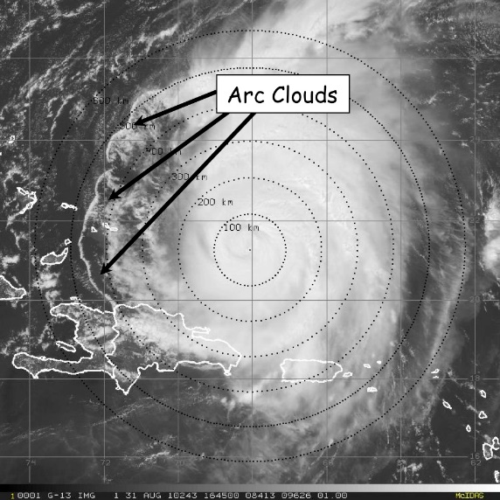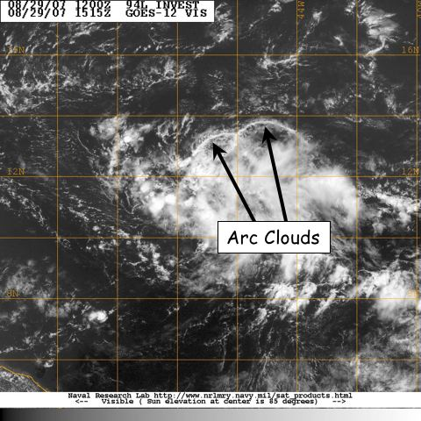

Fig. 1: GOES visible satellite imagery showing arc clouds racing away from the convective cores of (left) 2003 Hurricane Isabel and (right) 2007 Pre-Tropical Depression Felix.

Hypotheses:
- Hypothesis 1: Arc clouds form along the leading edge of TC diurnal pulses and are particularly favored to occur when these TC diurnal pulses reach areas of mid-level (~600-850 hPa) dry air (≤45 TPW) at radii of ~105-215 nm (~200-400 km).
- Hypothesis 2: the cool, dry air associated with the convectively-driven downdrafts that form arc clouds can help stabilize the middle to lower troposphere and may even act to stabilize the boundary layer. Arc clouds events tend to affect the TC near environment (R~100-150 km/55-80 nm) and peripheral environment (R~150-400 km/80-215 nm).
- Hypothesis 3: As they race away from the convective core region of the AEW or TC, arc clouds may act to disrupt the storm by creating low-level outflow in the quadrant/semicircle in which they form. This outflow pattern counters the typical low-level inflow that is vital for TC formation and maintenance.
Experiment/Module Description: This research module is designed to utilize the P-3 [flight-level (flying at multiple levels above 1500 feet), GPS dropsondes, and TDR data] or G-IV (GPS dropsonde and TDR data) aircraft. Although this module is not a standalone experiment, it could be included as a module within any number of missions. TPW microwave satellite imagery will be used to identify mid-level dry air (≤45 mm TPW) in the periphery of the AEW or TC. These areas of mid-level dry air will be favorable locations for arc cloud formation, especially when TC diurnal pulses are passing radii where this low to mid-level dry air is located. Additionally, when this low- to mid-level dry air is located in the upshear quadrant or semicircle of the storm, arc cloud formation may be especially favorable. These favorable areas will be regions of preferred arc cloud formation and should be monitored closely using satellite imagery (e.g. UW-CIMSS TC diurnal cycle IR imagery, 1 km GOES visible, and 37 GHz microwave) and the P-3 LF radar during the mission. Depending on connection rates on the aircraft, supplemental communications via X-Chat with scientists on the ground would be desirable, especially given the unpredictability and rapid evolution of arc cloud features.

Analysis Strategy: This experiment seeks to collect observations across arc cloud features in the periphery of AEWs or TCs using aircraft flight-level, GPS dropsonde, and TDR data to improve our understanding of the physical processes responsible for their formation and evolution, as well as how these features may affect TC structure and intensity in the short-term. The GPS dropsonde data will be used to calculate changes in static stability and possible impacts on surface fluxes both ahead of and behind the arc cloud (e.g. enhanced stability/reduced surface fluxes behind the arc cloud leading edge). Also, kinematics and thermodynamic associated with arc cloud events will also be compared to corresponding locations in model analysis fields (e.g. GFS and HWRF).
References:
Dunion, J.P., 2011: Rewriting the climatology of the tropical North Atlantic and Caribbean Sea atmosphere. J. Climate, 24, 893-908.
Knaff, J.A., and J.F. Weaver, 2010: A mesoscale low-level thunderstorm outflow boundary associated with Hurricane Luis. Mon. Wea. Rev., 128, 3352-3355.

21. Extratropical Transition

Principal Investigator(s): Sim Aberson

Links to IFEX:
- Goal 1: Collect observations that span the TC life cycle in a variety of environments for model initialization and evaluation.
- Goal 3: Improve understanding of the physical processes important in intensity change for a TC at all stages of its lifecycle.
Motivation and background: The poleward movement of a tropical cyclone (TC) initiates complex interactions with the midlatitude environment frequently leading to sharp declines in hemispheric predictive skill. In the Atlantic basin, such interactions frequently result in upstream cyclone development leading to high-impact weather events in the U. S. and Canada, as well as downstream ridge development associated with the TC outflow and the excitation of Rossby waves leading to downstream cyclone development. Such events have been shown to be precursors to extreme events in Europe, the Middle East, and may have led to subsequent TC development in the Pacific and Atlantic basins as the waves progress downstream. During this time, the TC structure begins changing rapidly: the symmetric distributions of winds, clouds, and precipitation concentrated about a mature TC circulation center develop asymmetries that expand. Frontal systems frequently develop, leading to heavy precipitation events, especially along the warm front well ahead of the TC. The asymmetric expansion of areas of high wind speeds and heavy precipitation may cause severe impacts over land without the TC center making landfall. The poleward movement of a TC also may produce large surface wave fields due to the high wind speeds and increased translation speed of the TC that results in a trapped-fetch phenomenon.
During this phase of development, hereafter referred to as extratropical transition (ET), the TC encounters increasing vertical wind shear and decreasing sea surface temperatures, factors that usually lead to weakening of the system. However, transitioning cyclones sometimes undergo explosive cyclogenesis as extratropical cyclones, though this process is poorly forecast. The small scale of the TC and the complex physical processes that occur during the interactions between the TC and the midlatitude environment make it very difficult to forecast the evolution of track, winds, waves, precipitation, and the environment. Due to sparse observations and the inability of numerical models to resolve the structure of the TC undergoing ET, diagnoses of the changes involved in the interaction are often inconclusive without direct observations. Observations obtained during this experiment will be used to assess to what extent improvements to TC structure analyses and the interaction with the midlatitude flow improve numerical forecasts and to develop techniques for forecasting these interactions. Improved understanding of the changes associated with ET will contribute to the development of conceptual and numerical models that will lead to improved warnings associated with these dangerous systems.
Hypotheses: ET depends upon the survival of the TC as it penetrates into midlatitudes in regions of increasing vertical wind shear.
Questions for study:
- How is the TC vortex maintained in regions of vertical wind shear exceeding 30 ms-1?
- How is the warm core maintained long after the TC encounters vertical wind shear exceeding 30 ms-1?
- How does vertical shear exceeding 30ms-1 alter the distribution of latent heating and rainfall?
- Does vortex resilience depend upon diabatic processes? On subsequent formation of new vortex centers, or by enlisting baroclinic cyclogenesis?
- Does the vertical mass flux increase during ET, as has been shown in numerical simulations?
- Is downstream error growth related to errors in TC structure during ET?
- Is ET sensitive to the sea-surface temperatures?

Experiment/Module Description: Two specific targets are to be sampled during each mission, the TC itself, and the interface between the TC and the environmental flow. The systems will be sampled every 12 h from the time it begins the transition to an extratropical cyclone to the time it is out of range of the aircraft, or the system dissipates.
Analysis Strategy: Data analysis will occur after the final mission, mainly via case studies based on incorporating the data in a sophisticated data assimilation/model system.
References:
Evans, C., K. M. Wood, S. D. Aberson, H. M. Archambault, S. M. Milrad, L. F. Bosart, K. L. Corbosiero, C. A. Davis, J. R. Dias Pinto, J. Doyle, C. Fogarty, T. J. Galarneau, Jr., C. M. Grams, K. S. Griffin, J. Gyakum, R. E. Hart, N. Kitabatake, J. S. Lentink, R. McTaggart-Cowan, W. Perrie, J. F. D. Quinting, C. A. Reynolds, J. Riemer, E. Ritchie, Y. Sun, and F. Zhang, 2017: The Extratropical Transition of Tropical Cyclones. Part I: Cyclone Evolution and Direct Impacts. Mon. Wea. Rev., accepted for publication.

