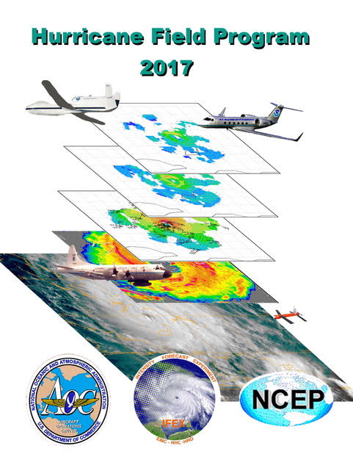

2017 Hurricane Field Program Plan

Hurricane Research Division
National Oceanographic and Atmospheric Administration
Atlantic Oceanographic and Meteorological Laboratory
4301 Rickenbacker Causeway
Miami, FL 33149

Prepared by: (HFP director and lead PIs – other contributors are listed in specific experiments/modules)

Paul Reasor, Sim Aberson, Ghassan Alaka, Bachir Annane, Lisa Bucci, Hui Christophersen, Joe Cione, Jason Dunion, John Gamache, Heather Holbach, John Kaplan, Brad Klotz, Shirley Murillo, Robert Rogers, Jon Zawislak, Jun Zhang, Paul Chang, Gustavo Goni, Nick Shay

30 May 2017

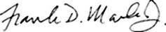
Frank D Marks, Jr Date
Director, Hurricane Research Division

TABLE OF CONTENTS

INTRODUCTION…………………………………………………………………….…………….... 1
1. Description of Intensity Forecasting Experiment (IFEX)……………………………………. 1
2. Experiment and module summaries………………………………………………………….. 2
OPERATIONS……………………………………………………………………………………...... 5
1. Locations……………………………………………………………………………............... 5
2. Field Program Duration…………………………………………………………………….... 5
3. Research Mission Operations…………………………………………………………........... 5
4. Task Force Configuration…………………………………………………………………..... 5
5. Field Operations…………………………………………………………………………........ 5
5.1 Scientific Leadership Responsibilities………………………………………….......... 5
5.2 Aircraft Scientific Crews………………………………………………………........... 5
5.3 Principal Duties of the Scientific Personnel…………………………….…….…….... 5
5.4 HRD Communications………………………………………………………….......... 5
6. Data Management……………………………………………………………….................... 6
7. Operational Constraints…………………………………………………………………........ 6
8. Calibration of Aircraft Systems………………………………………………………........... 6
EXPERIMENT AND MODULE DESCRIPTIONS……………………………………................ 7
STANDARD PATTERNS AND EXPENDABLE LOCATIONS………………… ………............... 7
IFEX GOAL 1
1. P-3 Three-Dimensional Doppler Winds Experiment…..……………………………………. 10
2. G-IV Tail-Doppler Radar Experiment....................…..……… ………………………......... 12
3. Offshore Wind Module …………………………………………………………………….... 14
IFEX GOAL 2
4. Doppler Wind Lidar (DWL) Experiment……………………………………………………... 15
5. Small Unmanned Aerial Vehicle Experiment (SUAVE)……………………………...…...... 18
6. NESDIS Ocean Winds and Rain Experiment……………………………………………….. 22
7. SFMR High-Incidence Angle Measurements Module......………………………………........ 23
8. SFMR-CYGNSS Validation Module……………………………………………………...... 24
9. G-IV SFMR Validation Module……………………………………………………….......... 25
10. Underwater Glider Module…………………………………………………………............ 26
IFEX GOAL 3
11. Easterly Wave Genesis Experiment ………………………………………………..……….. 27
12. Analysis of Intensification Processes Experiment (AIPEX).……………………………… 30
13. TC in Shear Experiment.……………………………………..…………….…………........ 33
14. TC Diurnal Cycle Experiment………………………………………………………....…........ 35
15. TC-Ocean Interaction Experiment …………………………………….................................... 37
16. Tropical Cyclone Landfall Experiment………………………………………………......... 41
17. Convective Burst Module................................…………………………………………....... 44
18. Eye-eyewall Mixing Module ……………………………………………………………… 46
19. Secondary Eyewall Formation/Eyewall Replacement Cycle Module ……………………….. 48
20. Arc Cloud Module …………………………………………………………………………… 51
21. Extratropical Transition Experiment…………………………..……...…………………….. 54
SUPPLEMENTAL: OPERATIONAL MAPS………………………………………...…….......... 56
Map 1: Primary operating bases and operating ranges (P-3).……….….....………..……......... 56
Map 2: Primary operating bases and operating ranges (G-IV) ………………………………... 57
Map 3: Primary operating bases and operating ranges (Global Hawk) ………………….….... 58

2017 HURRICANE FIELD PROGRAM PLAN
INTRODUCTION
National Oceanic and Atmospheric Administration Atlantic Oceanographic and Meteorological Laboratory Hurricane Research Division
Miami, Florida. USA

1. Description of Intensity Forecasting Experiment (IFEX)

One of the key activities in the NOAA Strategic Plan Mission Goal 3 (Reduce Society’s Risks from Weather and Water Impacts) is to improve the understanding and prediction of tropical cyclones (TCs). The National Centers for Environmental Prediction (NCEP) National Hurricane Center (NHC) is responsible for forecasting TCs in the Atlantic and East Pacific basins, while the Environmental Modeling Center (EMC) provides NWP guidance for the forecasters. Together they have made great strides in improving forecasts of TC track. With support from the research community, forecast errors of TC track have decreased by about 50% over the past 30 years. However, there has been much less improvement in forecasts of TC intensity, structure, and rainfall. This lack of improvement is largely the result of deficiencies in routinely collecting inner-core data and assimilating it into the modeling system, limitations in the numerical models themselves, and gaps in understanding of the physics of TCs and their interaction with the environment. Accurate forecasts will rely heavily on the use of improved numerical modeling systems, which in turn will rely on accurate observational datasets for assimilation and validation.

The operational Hurricane Weather Research and Forecasting (HWRF) model is run at 2 km grid length using an assortment of physical parameterizations intended to represent subgrid-scale processes important in TC evolution. Such a modeling system holds the potential of improving understanding and forecasting of TC track, intensity, structure, and rainfall. In order to realize such improvements, however, new data assimilation techniques must be developed and refined, physical parameterizations must be improved and adapted for TC environments, and the models must be reliably evaluated against detailed observations from a variety of TCs and their surrounding environments.

To conduct the research necessary to address the issues raised above, since 2005 NOAA has been conducting an experiment designed to improve operational forecasts of TC intensity, called the Intensity Forecasting EXperiment (IFEX; Rogers et al., BAMS, 2006, 2013). The IFEX goals, developed through a partnership involving the NOAA Hurricane Research Division (HRD), NHC, and EMC, are to improve operational forecasts of TC intensity, structure, and rainfall by providing data to improve the operational numerical modeling system (i.e., HWRF) and by improving understanding of the relevant physical processes. These goals will be accomplished by satisfying a set of requirements and recommendations guiding the collection of the data:

- Goal 1: Collect observations that span the TC life cycle in a variety of environments for model initialization and evaluation;
- Goal 2: Develop and refine measurement technologies that provide improved real-time monitoring of TC intensity, structure, and environment;
- Goal 3: Improve understanding of the physical processes important in intensity change for a TC at all stages of its lifecycle.

A unique, and critical, aspect of IFEX is the focus on providing measurements of TCs at all stages of their life cycle. The focus of hurricane research flights during the past 30 years has been on mature storms, leading to a dataset biased toward these types of systems. The strategy of observing the entire life cycle of a TC is new and unique, and will provide invaluable information, particularly in sparsely observed environments.

2. Experiment and module summaries

The field program aircraft missions presented in this document are separated into three distinct sections, corresponding to the primary IFEX goal being addressed (note that most experiments address multiple IFEX goals). The flight patterns that comprise these research and operational missions address various aspects of the TC lifecycle, and they all specifically address the main goals of IFEX. Execution details for each research or operational mission, including patterns and expendable requirements, follows. Routinely-used ("standard") patterns are described upfront and are simply referenced by a given mission if substantial alterations to them have not been made. The scientific objectives of each mission, including the motivation, hypotheses to be tested, and analysis methods are described in the companion 2017 Scientific Justification document.

In this document, contributions are categorized as either “experiments” or “modules.” For this discussion, “experiments” refer to missions in which research scientists (i.e., from HRD) set the flight pattern for the duration of the mission. Operational needs take priority in this scenario. “Modules” refer to short patterns that can be flown as a part of a larger experiment (either operational- or research-oriented). The patterns that comprise an experiment are individually referred to as modules despite the fact that some may span the duration of the flight.

IFEX GOAL 1: Collect observations that span the TC life cycle in a variety of environments for model initialization and evaluation

(1) P-3 Three-Dimensional Doppler Winds Experiment: This is a multi-option, single-aircraft operational mission designed to use the NOAA P-3 to sample TCs ranging in intensity from tropical depression to major hurricane. The definition is intended to separate this category from tropical waves and disturbances that have yet to develop a well-defined warm-core circulation. The main goals of these missions are: 1) to improve understanding of the factors leading to TC intensity and structure changes, 2) to provide a comprehensive data set for the initialization (including data assimilation) and validation of numerical hurricane simulations (in particular HWRF), 3) to improve and evaluate technologies for observing TCs, and 4) to develop rapid real-time communication of these observations to NCEP.

(2) G-IV Tail-Doppler Radar Experiment: This experiment uses the G-IV aircraft. The goals are to 1) to evaluate the G-IV as a platform for observing the cores of TCs, 2) to improve understanding of the factors leading to TC structure and intensity changes, 3) to provide a comprehensive data set for the initialization (including data assimilation) and validation of numerical hurricane simulations (in particular HWRF), and 4) to develop rapid real-time communication of these observations to NCEP.

(3) Offshore Wind Module: This module is designed as a multi-agency (NOAA, Department of Energy, Department of the Interior) supplemental data collection effort to gather hurricane environmental information in the vicinity of proposed offshore wind farms.

IFEX GOAL 2: Develop and refine measurement technologies that provide improved real-time monitoring of TC intensity, structure, and environment

(4) Doppler Wind Lidar (DWL) Experiment: This is a multi-option, single-aircraft missions designed to use the DWL to sample dust and winds in dry air. The main objectives of the P-3 DWL Experiment are to: 1) sample winds in a TC with an asymmetric distribution of precipitation, where this is little or no precipitation on one side of the storm; 2) characterize the suspended Saharan dust and mid-level (~600-800 hPa) easterly jet that are associated with the Saharan Air Layer (SAL) with a particular focus on SAL-TC interactions; 3) sample the kinematic structure of the hurricane boundary layer with a focus on investigating the characteristics of the boundary layer height and coherent structures; 4) characterize the upper level subsidence and boundary layer kinematics within the region between two concentric eyewalls and/or within a rainband moat.

(5) Small Unmanned Aerial Vehicle Experiment (SUAVE): The primary objective of this experiment is to further demonstrate and utilize the unique capabilities of a low latitude UAS platform in order to better document areas of the tropical cyclone environment that would otherwise be either impossible or impractical to observe. In addition, inter-comparisons of these unique data with comparable output from NOAA's coupled operational modeling system will be explored.

(6) NESDIS Ocean Winds and Rain Experiment: This will be executed by NESDIS and aims to improve understanding of microwave scatterometer retrievals of the ocean surface wind and to test new remote sensing techniques. The NESDIS/Center for Satellite Research and Applications in conjunction with the University of Massachusetts (UMASS) Microwave Remote Sensing Laboratory and AOC have been conducting flights as part this experiment for the past several years. Collecting the raw data allows spectral processing to be done which will allow the rain and surface contributions in the IWRAP data to be decoupled. This is critical in understanding the impacts of rain on the measurements, and thus, the ocean surface wind vector retrievals.

(7) SFMR High-Incidence Angle Measurements Module: The objective of this module is to determine the relationship between the SFMR measured surface brightness temperature and the ocean surface wave field characteristics.

(8) SFMR-CYGNSS Validation Module: The objective of this module is to collect SFMR and dropsonde data that is as closely collocated in space and time to CYGNSS satellite overpasses as possible in the tropical cyclone environment.

(9) G-IV SFMR Validation Module: The objective of this module is to sample the wind speed and rain rate from the G-IV SFMR in coordination with the P-3 SFMR.

(10) Underwater Glider Module: The objective of this module is to clarify the deployment of expendables (AXBTs and dropsondes) in support of underwater glider observations.

IFEX GOAL 3: Improve understanding of the physical processes important in intensity change for a TC at all stages of its lifecycle

(11) Easterly Wave Genesis Experiment: This is a multi-option, multi-aircraft experiment that is designed to sample the conditions of the environment and the inner-core structure of disturbances associated with easterly waves in the central Atlantic This experiment can use the G-IV aircraft in conjunction with the P-3 and/or Global Hawk.

(12) Analysis of Intensification Processes Experiment (AIPEX): The objective of this experiment is to collect precipitation, kinematic, thermodynamic, and ocean observations within the environment, near environment (~100 km, or 60 nmi), and inner core regions of tropical cyclones (TCs) that have a reasonable potential for intensification (based on statistical and/or numerical model forecast guidance), with a particular focus on the early stages (i.e., TD, TS, weak hurricane).

(13) TC in Shear Experiment: The objective of this multi-aircraft experiment is to sample the TC at distinct phases of its interaction with vertical wind shear, measuring the kinematic and thermodynamic fields with the azimuthal and radial coverage necessary to test structure and intensity change hypotheses motivated by recent theoretical and numerical studies.

(14) TC Diurnal Cycle Experiment: This multi-option, multi aircraft experiment employs both NOAA P-3 and G-IV aircraft to collect kinematic and thermodynamic observations both within the inner-core (i.e., radius < 200 km) and in the surrounding large- scale environment (i.e., 200 km < radius < 600 km) for systems that have exhibited signs of diurnal pulsing in the previous 24 hours.

(15) TC-Ocean Interaction Experiment: This is a multi-option, single aircraft experiment designed to address questions regarding the general role of various upper-ocean processes on TC intensification. It consists of: i) Pre-storm and post-storm expendable probe surveys associated with TC passage; and ii) Support of upper ocean and air-sea flux measurements made by oceanic floats and drifters. Specifically, one to three float and drifter arrays will be deployed into one or two mature storms by an AFRC C-130J and provide real-time ocean data, and, a NOAA P-3 will deploy dropwindsondes and make SFMR and Scanning Radar Altimeter (SRA) measurements within the float and drifter array as the storm passes over it.

(16) Tropical Cyclone Landfall Experiment: This is a multi-option, single-aircraft experiment designed to study the changes in TC surface wind structure near landfall. It has several modules that could also be incorporated into operational surveillance or reconnaissance missions. An accurate description of the TC surface wind field is important for warning, preparedness, and recovery efforts.

(17) Convective Burst Module: This is a multi-option, single aircraft module whose objective is to sample the wind, temperature, and moisture fields within and around an area of deep convection at high time frequency and to use them in high-resolution data assimilation experiments.

(18) Eye-eyewall Mixing Module: This single-aircraft module is designed to sample meso- and miso-vortices along the interface of the eye and eyewall, which are thought to impact the structure and intensity of tropical cyclones.

(19) Secondary Eyewall Formation/Eyewall Replacement Cycle Module: This multi-aircraft, multi-option module is designed to sample the kinematic and thermodynamic structure of rainbands outside the primary eyewall of mature hurricanes (generally category 2 or stronger) to determine precursor signals to secondary eyewall formation, and to sample these structures once a secondary eyewall has formed to document an eyewall replacement cycle.

(20) Arc Cloud Module: This is a single-aircraft module, designed to investigate how the thermodynamics and kinematics in the environment surrounding a TC are modified when low to mid-level dry air interacts with convection in the TC periphery. Objectives include improving our understanding of how arc clouds and the processes leading to arc cloud formation relate to TC intensity change. Observations could be made using either the P-3 aircraft conducting another experiment, or the G-IV during a synoptic surveillance mission.

(21) Extratropical Transition Experiment: This experiment is designed to monitor interactions between the TC and the midlatitude circulation.

OPERATIONS

1. Locations
Starting on 15 July, the N42RF aircraft will be available with two flight crews for back to back research missions. The Gulfstream IV-SP (N49RF) aircraft will be available 01 June with two flight crews available for back to back missions. Operations for all aircraft will primarily base out of Lakeland, Florida and deployments to U.S. coastal locations in the western Gulf of Mexico for suitable Gulf storms, as well as other locations along the U.S. East Coast, St. Croix, Barbados, Bermuda, and La Paz, Mexico. Occasionally, post-mission recovery may be accomplished elsewhere.

2. Field Program Duration
The hurricane field research program will be conducted from 15 July through 31 October 2017.

3. Research Mission Operations
The decision and notification process for hurricane research missions is shown, in flow chart form, in Appendix A (Figs. A-1, A-2, and A-3). The names of those who receive primary notification at each decision or notification point are shown in Figs. A-1, A-2, and A-3, and are also listed in Appendix A. Contacts are also maintained each weekday among the directors of HRD, NHC, EMC, and AOC.

Research operations must consider that the research aircraft are required to be placed in the National Hurricane Operations Plan of the Day (POD) 24 h before a mission. If operational requirements are accepted, the research aircraft must follow the operational constraints described in Section 7.

4. Task Force Configuration
The NOAA P-3 aircraft, equipped as shown in Appendix G, will be available for research missions on a non-interference basis with tasked operational missions from 15 July to 31 October 2017. Also, the G-IV aircraft should be available, on a non-interference basis with tasked operational missions from 01 June to 31 October 2017.

5. Field Operations
5.1 Scientific Leadership Responsibilities
The implementation of the Hurricane Field Program Plan is the responsibility of the Field Program Director, who in turn, reports directly to the HRD director. In the event of deployment, the Field Program Director may assign a ground team manager to assume overall responsibility for essential ground support logistics, site communications, and site personnel who are not actively engaged in flight. Designated lead project scientists are responsible to the Field Program Director or designated assistants. While in flight, lead project scientists are in charge of the scientific aspects of the mission.

5.2 Aircraft Scientific Crews
Tables B-2.1 through B-2.4 (Appendix B) list the NOAA scientific crewmembers needed to conduct the experiments. Actual named assignments may be adjusted on a case-by-case basis. Operations will include completion of detailed records by each scientific member while on the aircraft. General checklists of NOAA science-related functions are included in Appendix E.

5.3 Principal Duties of the Scientific Personnel
A list of primary duties for each NOAA scientific personnel position is given in Appendix D.

5.4 HRD Communications
All field program activities are communicated via our web blog and emails. When field activities are occurring, an internal email will be sent out daily to HRD. The internal email will include up-to-date crew, hotel, storm status and schedules. The blog is our main forum where we will provide field operation status, including deployment information of aircraft and personnel for operations outside Miami.

NHC will serve as the communications center for information and will provide interface between AOC, NHC, and CARCAH (Chief, Aerial Reconnaissance Coordinator, All Hurricanes). Personnel who have completed a flight will provide information to the Field Program Director, as required.

6. Data Management
Data management and dissemination will be according to the HRD data policy that can be viewed at:
http://www.aoml.noaa.gov/hrd/data2.html

A brief description of the primary data types and contact information may be found at:
http://www.aoml.noaa.gov/hrd/data/products.html

Raw data are typically available to all of NOAA-sponsored personnel and co-investigators immediately after a flight, subject to technical and quality assurance limitations. Processed data or other data that has undergone further quality control or analyses are normally available to the principal and co-investigators within a period of several months after the end of the Hurricane Field Program.

All requests for NOAA data gathered during the Hurricane Field Program should be forwarded by email to the associated contact person in the HRD data products description (link above) or in writing to: Director, Hurricane Research Division/AOML, 4301 Rickenbacker Causeway, Miami, Florida 33149.

7. Operational Constraints
NOAA P-3 aircraft are routinely tasked by NHC and/or EMC through CARCAH (Chief, Aerial Reconnaissance Coordinator, All Hurricanes) to perform operational missions that always take precedence over research missions. Research objectives can frequently be met, however, through these operational missions. Occasionally, HRD may request, through NHC and CARCAH, slight modifications to the flight plan on operational missions. These requests must not deter from the basic requirements of the operational flight as determined by NHC and coordinated through CARCAH.

Hurricane research missions are routinely coordinated with hurricane reconnaissance operations. As each research mission is entered into the planned operation, a block of time is reserved for that mission and operational reconnaissance requirements are assigned. A mission, once assigned, must be flown in the time period allotted and the tasked operational fixes met. Flight departure times are critical. Scientific equipment or personnel not properly prepared for the flight at the designated pre-take-off time will remain inoperative or be left behind to insure meeting scheduled operational fix requirements. Information on delays to, or cancellations of, research flights must be relayed to CARCAH.

8. Calibration of Aircraft Systems
Calibration of aircraft systems is described in Appendix B (B.1 en-route calibration of aircraft systems). True airspeed (TAS) calibrations are required for each NOAA flight, both to and from station and should be performed as early and as late into each flight as possible (Fig. B-1).

EXPERIMENT AND MODULE DESCRIPTIONS

Standard Patterns and Expendable Locations

Figure-4: Centers, mid-points and turn points of each leg [10 sondes]
In-pattern duration (105 n mi legs): ~ 2 h 15 min (P-3), 1 h 20 min (G-IV)

Rotated Figure-4: Centers, mid-points and turn points of each leg [20 sondes]
In-pattern duration (105 n mi legs): ~ 5 h (P-3), 2 h 55 min (G-IV)

Alpha (recon): Centers, mid-points and turn points of each leg [20 sondes]
In-pattern duration (105 n mi legs): ~ 5 h 20 min (P-3), 3 h (G-IV)

Butterfly: Centers, mid-points and turn points of each leg [15 sondes]
In-pattern duration (105 n mi legs): ~ 3 h 25 min (P-3), 2 h (G-IV)

P-3 Circumnavigation: Center of first pass, end points of Figure-4 and vertices of octagon [14 sondes]
In-pattern duration (105 n mi legs): ~ 4 h 5 min

Square Spiral: Turn points [13 sondes]
In-pattern duration (180 n mi on a side): ~ 5 h 50 min (P-3), 3 h 20 min (G-IV)

Lawnmower: Turn points and mid-points of N-S legs [12 sondes]
In-pattern duration (240 n mi by 180 n mi): ~ 4 h 20 min (P-3), 2 h 25 min (G-IV)

G-IV Circumnavigation: Vertices of hexagon (octagon) [18 (24) sondes]
In-pattern duration (150, 90, 60 n mi): ~ 4 h 25 min (4 h 35 min)

G-IV Star: Vertices of 6-point star (w/ circumnavigation) [13 (20) sondes]
In-pattern duration (210, 90 n mi): ~ 4 h (5 h 20 min)

1. P-3 Three-dimensional Doppler Winds Experiment

Principal Investigator(s): John Gamache (lead), Sim Aberson, Altug Aksoy, Peter Dodge, Sonia Otero, Paul Reasor, Kathryn Sellwood, Jason Sippel, John Hill (AOC), Mingjing Tong, Vijay Tallapragada (EMC)

Mission Description: This experiment is a response to the requirement listed as Core Doppler Radar in Section 5.4.2.9 of the National Hurricane Operations Plan. The goal of that particular mission is to gather airborne tail-Doppler radar (TDR) wind measurements that permit an accurate initialization of HWRF, and also provide three-dimensional wind analyses for forecasters.

P-3 Module 1
What to Target: Clear air over open ocean conditions in a low-wind region.
When to Target: At the beginning of the season, preferably during a pre-season test flight.
Pattern: Straight and level flight, reversing course. The pattern should be flown upwind and downwind, defined by the flight-level winds.

Flight altitude: 15-20 kft is best.
Leg length or radii: 5-10-minute segment (10-20 minutes for entire pattern)
Estimated in-pattern flight duration: 10-20 minutes
Expendable distribution: None.
Instrumentation Notes: The purpose of this sea-surface module is to identify angle corrections to be applied in the P-3 TDR software for the season. The sea surface should be unobstructed by intervening scatterers and the winds should be light enough so as to yield a smooth sea state.

P-3 Module 2
What to Target: Sample invests and tropical cyclones of interest to the NHC/EMC.
When to Target: Sampling commences when tasked by the NWS. Missions tasked for TDR assimilation purposes are carried out every 12 h, typically with take-off times of 6 and 18 UTC.
Pattern: While TDR data can be collected whenever the P-3 is flying, the standard patterns are best used during a tasked mission. For reconnaissance, the Alpha pattern is typically employed. For TDR assimilation purposes, the Lawnmower and Square-spiral patterns are appropriate for invests and tropical depressions. For systems having a more well-defined center of circulation, the Figure-4, Rotated Figure-4, Alpha, Butterfly, and P-3 Circumnavigation patterns are all appropriate.
Flight altitude: TDR data for assimilation and analysis can be collected at most flight altitudes. Typical flight altitude is 10 kft.
Leg length or radii: The standard leg length for TDR missions is 105 n mi, but this can be adjusted as needed for land restrictions and ferry times. Legs may be shortened due to lack of scatterers, but the LPS should be consulted first to ensure that other scientific objectives are not adversely impacted.
Estimated in-pattern flight duration: See the listing of standard pattern figures.
Expendable distribution: Expendables are not required. Dropsondes may be requested by the NHC.
Instrumentation Notes: TDR coverage and analyses are best when straight and level flight is maintained. During tasked missions, straight leg segments (e.g., passes through the center of circulation) should not be interrupted with break-away modules. Doppler radars should be operated in a single-PRF mode, at a PRF of 2100 Hz.

2. G-IV Tail-Doppler Radar Experiment

Principal Investigator(s): John Gamache (lead), Sim Aberson, Altug Aksoy, Peter Dodge, Sonia Otero, Paul Reasor, Kelly Ryan, Kathryn Sellwood, Jason Sippel, John Hill (AOC), Mingjing Tong, Vijay Tallapragada (EMC)

Mission Description: This experiment is a response to the requirement listed as Core Doppler Radar in Section 5.4.2.9 of the National Hurricane Operations Plan. The goal of that particular mission is to gather airborne tail-Doppler radar (TDR) wind measurements that permit an accurate initialization of HWRF, and also provide three-dimensional wind analyses for forecasters. The experiment is similar to the P-3 Three-dimensional Doppler Winds Experiment, but employs the G-IV platform and TDR.

G-IV Module 1
What to Target: Clear air over open ocean conditions in a low-wind region.
When to Target: At the beginning of the season, preferably during a pre-season test flight.
Pattern: Straight and level flight, reversing course. The pattern should be flown upwind and downwind, defined by the flight-level winds.

Flight altitude: 15-20 kft is best.
Leg length or radii: 5-minute segment (10 minutes for entire pattern)
Estimated in-pattern flight duration: 10-15 minutes
Expendable distribution: None.
Instrumentation Notes: The purpose of this sea-surface module is to identify angle corrections to be applied in the G-IV TDR software for the season. The sea surface should be unobstructed by intervening scatterers and the winds should be light enough so as to yield a smooth sea state.

G-IV Module 2
What to Target: Sample invests and tropical cyclones of interest to the NHC/EMC.
When to Target: G-IV TDR missions are currently HRD-research-tasked. Missions tend to follow the NHC synoptic surveillance schedule, typically with a take-off time of 0530 and/or 1730 UTC. The ability to perform storm overflights at any time is desirable, but safety concerns (e.g., the impact of intense convection on flight and lack of visual) may restrict overflight to certain conditions and times of day.
Pattern: While TDR data can be collected whenever the G-IV is flying, the standard patterns are best used during a TDR-focused mission. For TDR assimilation purposes, the Lawnmower and Square-spiral patterns are appropriate for invests and tropical depressions. For systems having a more well-defined center of circulation, the Figure-4, Rotated Figure-4, Alpha, Butterfly, and G-IV Circumnavigation patterns are all appropriate.
Flight altitude: TDR data for assimilation and analysis can be collected at most flight altitudes. Typical flight altitude is 40-45 kft.
Leg length or radii: The standard leg length for TDR missions is 105 n mi, but this can be adjusted as needed for land restrictions and ferry times. Legs may be shortened due to lack of scatterers, but the LPS should be consulted first to ensure that other scientific objectives are not adversely impacted. For circumnavigations without a P-3 present, the radius of the innermost “circle” should be set to resolve the maximum wind region. Typically, winds can be retrieved out to 40-50 km from the aircraft.
Estimated in-pattern flight duration: See the listing of standard pattern figures.
Expendable distribution: Expendables are not required.
Instrumentation Notes: TDR coverage and analyses are best when straight and level flight is maintained. During tasked missions, straight leg segments (e.g., passes through the center of circulation) should not be interrupted with break-away modules. Doppler radars should be operated in a single-PRF mode, at a PRF of 3000 Hz.

3. Offshore Wind Module

Principal Investigator(s): Shirley Murillo and Bachir Annane

Mission Description: If there is a TC over or near the vicinity of the offshore wind farm lease areas and there are ongoing missions we request to fly over the lease areas and drop sondes in a 2-4 km interval. This can be executed by either the P3 or the G-IV.

P-3/G-IV Module 1
What to Target: Sample the TC as it makes landfall.
When to Target: The main target is to fly over the wind lease area.
Pattern: Fly a straight leg over the wind farm lease area and launch dropsondes in a 2-4 km interval. The leg can be parallel to the coast line.

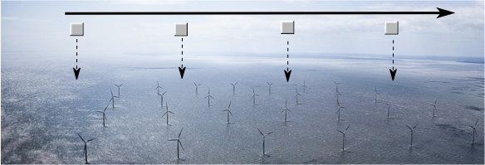

Flight altitude: Standard P3/G-IV altitude.
Leg length or radii: The length of the legs is not specific. The flight leg or a portion of the leg should be over the wind lease area.
Estimated in-pattern flight duration: 10 mins
Expendable distribution: Drop sondes in a 2-4 km interval over the wind lease area.
Instrumentation Notes: Straight and level leg. Drop sondes over the offshore wind lease areas in a 2-4 km interval. Having the wide-swath radar altimeter on the P3 up and running would be ideal but not required.

4. Doppler Wind Lidar (DWL) Experiment

Principal Investigator(s): Lisa Bucci, Jun Zhang, Kelly Ryan, Christopher O’Handley (SWA), G. David Emmitt (SWA), Jason Dunion, Robert Atlas (AOML)

Mission Description: Continuously collect wind observations using the DWL in and near various types of tropical cyclones. Target areas previously unobserved (or sporadically observed) like regions with low or no precipitation, in the boundary layer, between eyewalls and rainbands, etc.

P-3 Module 1: Asymmetric Tropical Cyclone
What to Target: A sheared TC with an asymmetric distribution of precipitation
When to Target: Any strength TC; no land or time of day restrictions
Pattern: Any standard pattern that provides symmetric coverage (Rotated Figure-4, butterfly, etc)
Flight altitude: 10,000-12,000 feet. Not below 1000 feet.
Leg length or radii: Standard leg length (105 n mi)
Estimated in-pattern flight duration: 2-5 hours
Expendable distribution: Standard distribution (eye, RMW/midpoints, endpoints)
Instrumentation Notes: Four scans at down 20 with a 5 second nadir followed by one scan up 20 with 5 second vertical. If signal strength in the up scan is very weak, only scan downward.

P-3 Module 2: Secondary EyeWall/Moat Region
What to Target: The moat region between either an existing eyewall and a secondary eyewall or an eyewall and rainband. Avoid optically thick, deep convection-- fly between the deep convection from each feature.
When to Target: Stronger, more organized TCs with an existing eye
Pattern: Circumnavigation
Flight altitude: 10,000-12,000 feet. Not below 1000 feet
Leg length or radii: The radii between two eyewalls or eyewall and rainband
Estimated in-pattern flight duration: Approximately 1 hour (depending on storm size)
Expendable distribution: 4 dropsondes-- 1 centered in each quadrant
Instrumentation Notes: Two scans at down 20 with a 5 second nadir followed by one scan up 20 with 5 second vertical. If signal strength in the up scan is very weak, only scan down.

P-3 Module 3: Transit/Saharan Air Layer (SAL)
What to Target: Interaction between a TC and SAL (if present) or the environment en route to/from TC.
When to Target: No lifecycle or time of day requirements. Although not a requirement, conducting this module on the ferry back from the storm is advantageous, since the P-3 will have burned off fuel and will be able to climb to a slightly higher flight altitude.
Pattern: In presence of SAL, ensure entrance/exit point from transit transects SAL as shown in figure below
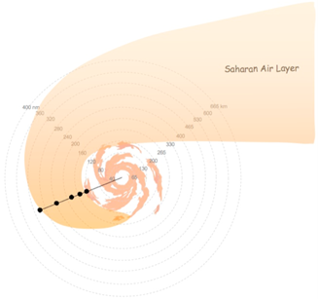
Flight altitude: Maximum allowable altitude (~20,000 feet)
Leg length or radii: Not applicable
Estimated in-pattern flight duration: Since this module will take advantage of the ferry to/from the storm, it will add ~0-15 min to the total mission duration.
Expendable distribution: In the presence of SAL, up to 5 dropsondes should be deployed spaced 50-75 nm farther away from the TC. These expendables are needed to determine the exact location and extent of the kinematics and thermodynamics associated with the SAL that is interacting with the TC.
Instrumentation Notes: DWL operated in DN 20 mode (12 point stepstare)

P-3 Module 4: Boundary Layer
What to Target: TC boundary layer in all quadrants
When to Target: Any strength TC; no land or time of day restrictions
Pattern: Any standard pattern that provides symmetric coverage (Rotated Figure-4, butterfly, etc)
Flight altitude: 10,000-12,000 feet. Not below 1000 feet
Leg length or radii: Standard leg lengths
Estimated in-pattern flight duration: 2-5 hours
Expendable distribution: Standard dropsonde distribution
Instrumentation Notes: DWL operated in DN 20 mode (12 point stepstare) with 5 second vertical stare between 360 degree scans.

P-3 Module 5: High Winds
What to Target: Regions of high wind (35 m/s or higher) with few optically thick clouds. For example, a break in the convection in an eyewall.
When to Target: When a TC is at or near hurricane strength
Pattern: Short radials as shown below. Red represents RMW, black is flight track, green X is dropsonde location, blue are optically thick clouds. Pattern can be repeated.
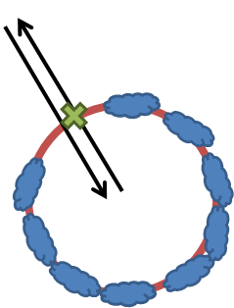
Flight altitude: 10,000-12,000 feet. Not below 1000 feet
Leg length or radii: ~50 km (depending on storm size)
Estimated in-pattern flight duration: 30 minutes to 1 hour
Expendable distribution: Ideally one dropsonde per out-and-back radial for the purpose of validating the P3DWL measurements
Instrumentation Notes: DWL operated in DN 20 mode (12 point stepstare) with 5 second vertical stare between 360 degree scans. DWL also can be operated in forward sweep (9 point stepstare). Dropsondes need to be released in a cloud free region.

P3 Module 6: Mass flux budget reference cell
What to Target: Regions of low winds (20 m/s or lower) with very few optically thick clouds
When to Target: During ferry flight to convective target.
Pattern: 50km box
Flight altitude: Ferry leg altitude,
Leg length or radii: 50km box (200km total with 90 degree turns)
Estimated in-pattern flight duration: ~ 25 minutes (at 260 Kts GND). Could be less at higher P3 cruise speeds.
Expendable distribution: One dropsonde per leg for a total of 4.
Instrumentation Notes: DWL operated in DN 20 mode (12 point stepstare) with 5 second vertical stare between 360 degree scans.

5. Small Unmanned Aerial VEhicle Experiment (SUAVE)

Principal Investigator and Co-Investigators: J. Cione, J, Zhang, L. Bucci, K. Ryan, E. Kalina, A. Aksoy, H. Holbach, G. Bryan, E. Konopleva

Mission Description: Sample the boundary layer wind velocities, temperature and humidity within and around a tropical cyclone.

P-3 Module 1 (UAS Eye/Eyewall)
What to Target: Sample the core region of a TC.
When to Target: after the hurricane eye is formed.
Pattern: (3 slice) pizza pie pattern (see figure 1)
Flight altitude: 12 kft preferable for best dropsonde coverage (10 kft if required for AXBT launch)
Leg length or radii: 105 n mi
Estimated in-pattern flight duration: ~ 1 h
Expendable distribution: A total of 13 sondes (for a 3 slice pattern) with 6 AXBTs are required. All turn points (6) and eyewall penetrations (6) will have dropsondes. There will also be 1 dropsonde in the eye at the center. For this module, IR sondes are used at all turn points and for the center drop. For the eyewall drops, regular sondes are deployed with combo AXBTs. Note: For a 2 pizza slice pattern (not shown) 9 sondes (5 IR, 4 regular) and 4 AXBTs would be required.
Instrumentation Notes: Use straight flight legs as safety permits.
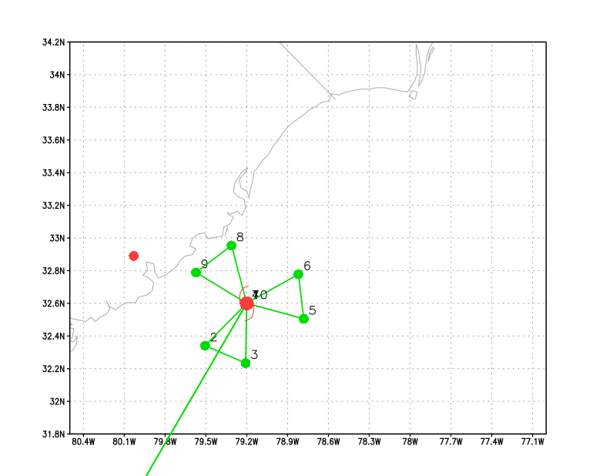
Figure 1: Pizza slice flight pattern for the eye/eyewall coyote experiment

P-3 Module 2 (UAS inflow module)
What to Target: Sample the inflow layer of a TC.
When to Target: no constraint.
Pattern: lawn mower pattern (see figure 2)
Flight altitude: 12 kft preferable for best dropsonde coverage (10 kft if required for AXBT launch)
Leg length or radii: 105 n mi
Estimated in-pattern flight duration: ~ 1 h
Expendable distribution: Drop one sonde each time P3 overpasses the Coyote (points 4, 7, 10, 13) and at select turn points (3, 6, 9, 12). A total of 8 drops are estimated. IRsondes are preferred for this experiment. Up to 3 AXBTs may be deployed as well (LPS discretion).
Instrumentation Notes: Use straight flight legs as safety permits.
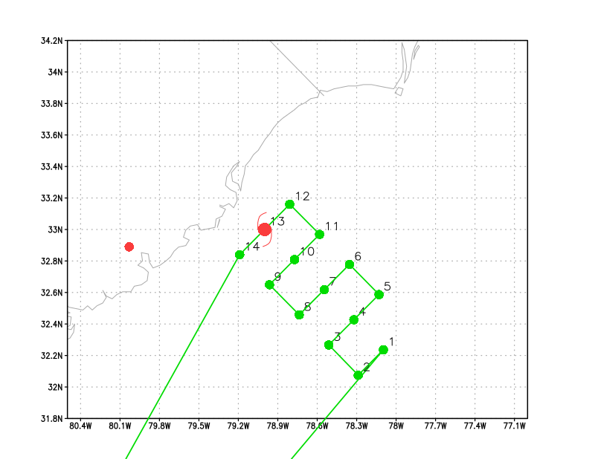
Figure 2: lawn mower flight pattern for the inflow coyote experiment.

Coyote Module 1 (Boundary Layer)
What to Target: Sample the low level boundary of a TC away from the inner core.
When to Target: no constraint.
P-3 and UAS Pattern: stepped descent (see figure 3).
Flight altitude: P3 deploys Coyote at 10 kft then descents to 3 kft.
Leg length or radii: 30 n mi
Estimated in-pattern flight duration: ~ 1 h
Expendable distribution: 5 IR sondes BT combos launched (one combo per P-3 flight level). Up to 3 AXBTs may be deployed as well (LPS discretion).
Instrumentation Notes: Use straight flight legs as safety permits.
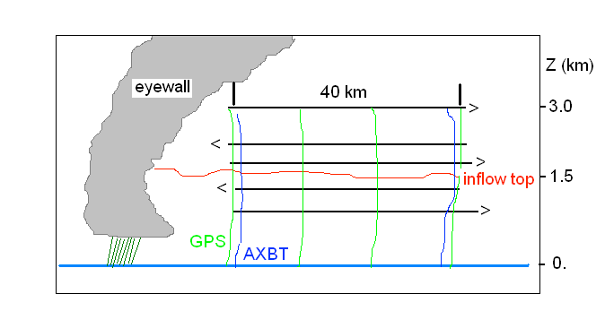
Figure 3. Vertical cross-section of the stepped-descent module. P3 pattern is in black, low altitude Coyote UAS in heavy blue.

Coyote Module 2 (Turblulence/Eddy Dissipation)
What to Target: Sample the near-surface boundary layer of a TC in order to collect measurements of eddy dissipation rate in strong wind conditions (35 m s⁻¹ or greater),
When to Target: no constraint.
UAS Pattern: descent (see figure 4)
Flight altitude: No P-3 requirement other than to remain in comms range of UAS
Leg length or radii: N/A
Estimated in-pattern flight duration: N/A
Expendable distribution: N/A
Instrumentation Notes: N/A

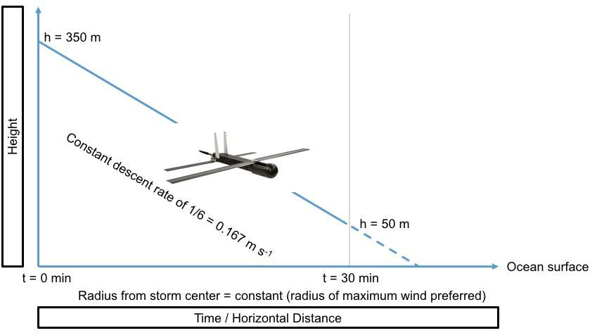

Figure 4: Eddy dissipation measurements. The Coyote begins the experiment at a height of 350 m, descends at a constant rate of 1/6 = 0.167 m s⁻¹, and reaches a height of 50 m after 30 minutes. The entire descent is conducted at a constant radius from the storm center (preferably at the radius of maximum wind).

6. NESDIS Ocean Winds and Rain Experiment

Principal Investigator(s): Paul Chang and Zorana Jelenak (NESDIS)

Mission Description: This will be executed by NESDIS and aims to improve understanding of microwave scatterometer retrievals of the ocean surface wind and to test new remote sensing techniques. The NESDIS/Center for Satellite Research and Applications in conjunction with the University of Massachusetts (UMASS) Microwave Remote Sensing Laboratory and AOC have been conducting flights as part this experiment for the past several years. Collecting the raw data allows spectral processing to be done which will allow the rain and surface contributions in the Imaging Wind and Rain Airborne Profiler (IWRAP) data to be decoupled. This is critical in understanding the impacts of rain on the measurements, and thus, the ocean surface wind vector retrievals.

P-3 Module 1
What to Target: The highest-wind region of a TC
When to Target: The ideal ocean winds storm would typically be a developed hurricane (category 1 and above) where a large range of wind speeds and rain rates would be found. However, data collected within tropical depressions and tropical storms would still provide very useful observations of rain impacts.
Pattern: Start with a survey pattern (Figure-4 or butterfly). Then execute a racetrack or lawnmower pattern over a feature of interest such as a rain band or wind band. Constant bank circles of 10-30 degrees: inserted along flight legs where the desired environmental conditions were present (region of no rain and where we might expect the winds to be consistent over a range of about 6-10 miles, about the diameter of a circle). This would not be something we would want to do in a high gradient region where the conditions would change significantly while we did the circle.
Flight altitude: The sensitivity of the IWRAP system defines the preferred flight altitude to be below 10 kft to enable the system to still measure the ocean surface in the presence of rain conditions typical of tropical systems. With the Air Force typically flying at 10 kft pressure, we have typically ended up with an operating altitude of 7 kft radar.
Leg length or radii: Initial survey extends 20-50 n mi from the storm center. The actual distance would be dictated by the storm size and safety of flight considerations. The racetrack/lawnmower legs are just long enough to cover the feature of interest.
Estimated in-pattern flight duration: Typically 8-9 h for full-duration mission.
Expendable distribution: Sondes dropped in high-wind regions.
Instrumentation Notes: Operating at a constant radar altitude is desired to minimize changes in range and thus measurement footprint on the ground. Higher altitudes would limit the ability of IWRAP consistently see the surface during precipitation, but these altitudes would provide useful data, such as measurements through the melting layer, to study some of the broader scientific questions. Straight and level flight with a nominal pitch offset unique to each P-3 is desired during most flight legs.

7. SFMR High-Incidence Angle Measurements Module

Principal Investigator(s): Heather Holbach (lead), Brad Klotz, and Mark Bourassa (FSU)

Mission Description: Collect high-incidence angle (off-nadir) SFMR data in regions with different wind speeds (> 15 m/s), rain rates, storm relative quadrants, and radii from the storm center.

P-3 Module 1
What to Target: Regions of wind speeds > 15 m/s with homogenous rain rates (or no rain) and wind direction (e.g. not in eye). Avoid regions with large wind speed or rain rate gradients.
When to Target: This module can be flown at any point during the flight while in the storm.
Pattern: This module can be flown with any of the traditional in-storm flight patterns. The module consists of flying at least 3 consecutive circles at a given roll angle. Roll angles to be sampled are 15°, 30°, and 45°. Best to begin circles by turning upwind for station keeping.
Flight altitude: 7–12 kft
Leg length or radii: Any
Estimated in-pattern flight duration: 3 circles at 15° takes ~17 min., 3 circles at 30° takes ~7 min., and 3 circles at 45° takes ~4.5 min. for a total time of ~28.5 min. If time is a concern, remove 15° circles for a total time of ~11.5 min.
Expendable distribution: Release a dropsonde/AXBT combo at the beginning of the module. If no AXBTs are available, this module can still be flown while only releasing a dropsonde at the beginning of the module.
Instrumentation Notes: Use standard SFMR set-up. Important to maintain as constant of a roll angle, pitch angle, and altitude as possible. Ideal to fly this module while the WSRA is also operating and gathering surface wave data. However, any data collected is useful as long as there is a dropsonde for comparison.

8. CYGNSS Validation Module

Principal Investigator(s): Bachir Annane, Heather Holbach, Brad Klotz, and Mark Bourassa (FSU)

Mission Description: Collect SFMR and dropsonde data that is as closely collocated in space and time to CYGNSS satellite overpasses as possible in the tropical cyclone environment.

P-3 Module 1
What to Target: Any flight legs that pass through the storm center and are oriented in the direction of the CYGNSS overpasses.
When to Target: As close as possible in time to when the CYGNSS satellites will be flying over the storm.
Pattern: Any standard in-storm, low-level reconnaissance pattern that contains a straight leg that passes through the center of the storm. The IP and take-off time may need to be shifted in order to obtain the correct orientation and time for the P-3 flight leg that will occur while CYGNSS is flying over the storm. Estimated CYGNSS overpass time and location will be provided by the PIs to the LPS prior to the flight. It is ideal to have the P-3 at the center of the storm when the CYGNSS overpasses occur.
Flight altitude: 7-12 kft
Leg length or radii: < 120 n mi
Estimated in-pattern flight duration: No additional time required.
Expendable distribution: No additional dropsondes are required beyond the standard drop locations. However, RMW drops would be beneficial.
Instrumentation Notes: Standard SFMR set-up.

9. G-IV SFMR Validation Module

Principal Investigator(s): Brad Klotz (lead) and Heather Holbach

Mission Description: Sample the wind speed and rain rate from the G-IV SFMR in coordination with the P-3 SFMR.

G-IV Module 1
What to Target: Sample various wind and rain regions within a tropical cyclone, including light (< 20 m/s), moderate (20-33 m/s), and strong wind speed regions (> 33 m/s). This strategy will depend on the strength of the TC.
When to Target: Because this module depends more on aircraft coordination rather than a specific storm structure or environmental variable, any point in the TC development is acceptable. Various radial and azimuthal positions are desirable, depending on the structure of the TC and limitations of the aircraft. The P-3 and G-IV need to be traveling on the same heading for ~20-25 nmi on either side of the module center point. We would also prefer the G-IV fly at the lower end of its allowable operating speed to provide more time of overflight with the P-3.
Pattern: Preferred G-IV Circumnavigation (either hexagon or octagon). Most other patterns are acceptable as well as long as they can overlap with the P-3 for a short period.
Flight altitude: 40-45 kft
Leg length or radii: Maximum of ~60 nmi, centered on location where the G-IV is directly above the P-3
Estimated in-pattern flight duration: ~6-10 minutes for each overlap
Expendable distribution: None.
Instrumentation Notes: Use the standard SFMR instrument set-up

P-3 Module 1
What to Target: Same as G-IV Module 1.
When to Target: Select a point along a portion of the flight pattern (whether part of the circumnavigation ring, a downwind leg, or inbound/outbound radial pass) for the G-IV to match. The P-3 and G-IV need to be traveling on the same heading for ~20-25 nmi on either side of the module center point.
Pattern: P-3 Circumnavigation is preferred to more easily match G-IV. Other patterns are acceptable as long as a small portion of the pattern can overlap with the G-IV.
Flight altitude: 10-12 kft
Leg length or radii: Maximum of ~45 nmi, centered on location where the G-IV is directly above the P-3
Estimated in-pattern flight duration: ~ 6-10 minutes for each overlap
Expendable distribution: 1 dropsonde at module center when G-IV directly above the P-3 (required); 2 additional dropsondes at ~10 nmi on either side of the center point (optional).
Instrumentation Notes: Use standard SFMR set-up. Also, ensure that the upward looking SFMR is working and collecting data.
10. Underwater Glider Operations Module

Principal Investigator(s): Gustavo Goni (NOAA/AOML), Robert Todd (WHOI), Ruth Curry (BIOS), Steven DiMarco (TAMU), Stephan Howden (USM), Jordon Beckler (Mote), Scott Glenn (Rutgers University), Julio Morell (CARICOOS), Kevin Martin (USM), Carl Szczerchowski (NAVO)

Mission Description: Deployment of expendables (AXBTs and dropsondes) in support of underwater glider observations.

P-3 Module 1
What to Target: The target is the region where the underwater glider observations are being carried out, closer (not larger than 150nmi) to the hurricane track or forecasted hurricane track. Preferably the expendable observations should be made at the locations between where the underwater glider observations were made during the previous five days (approximately 65nmi) and the current glider location. The preferred complementary P3 ocean observations are from AXBTs and atmospheric observations are from dropsondes to assess and study the boundary layer structure.
When to Target: These observations are equally valuable if done over the area of hurricane wind influence or over the forecasted hurricane track. Any time of the day will be fine.
Pattern: One or two lines where expendables are deployed, where the line(s) is(are) determined by the location of the glider observations during the previous five days.
Hurricane track
Underwater glider tracks
Underwater glider locations
Preferred location of expendables

Flight altitude: appropriate for deployment of expendables
Leg length or radii: Varies, one length of approximately 65nmi
Estimated in-pattern flight duration: 15-20 min for a single line of expendables
Expendable distribution: The number of expendable (dropsondes and AXBTs) deployed will depend on their availability. Ideally, deployments every 5nmi will be better to combine with underwater glider data.
Instrumentation Notes: Follow best practice for deployment and data acquisition of expendable instruments.

11. Easterly Wave Genesis Experiment (GENEX)

Principal Investigator(s): Ghassan Alaka (Lead), Jason Dunion, Alan Brammer (U. Albany), Chris Thorncroft (U. Albany), Mark Boothe (NPS), Yuan-Ming Cheng (U. Albany)

Mission Description: Sample the wind, temperature and moisture fields in the environment ahead and/or within a disturbance that has the potential to develop into a tropical cyclone (i.e. “invest”).

G-IV Module 1
What to Target: Sample the environment to the west of an easterly wave, especially if dry air is detected in that region.
When to Target: Sample when easterly wave is forecast to develop in reliable computer models or is showing signs of development in observations. Sample when easterly wave is located at or west of 35°W (to be within range of G-IV).
Pattern: Lawnmower, rotated 90° for N-S orientation. Pattern should be centered to the west of an advancing tropical wave.

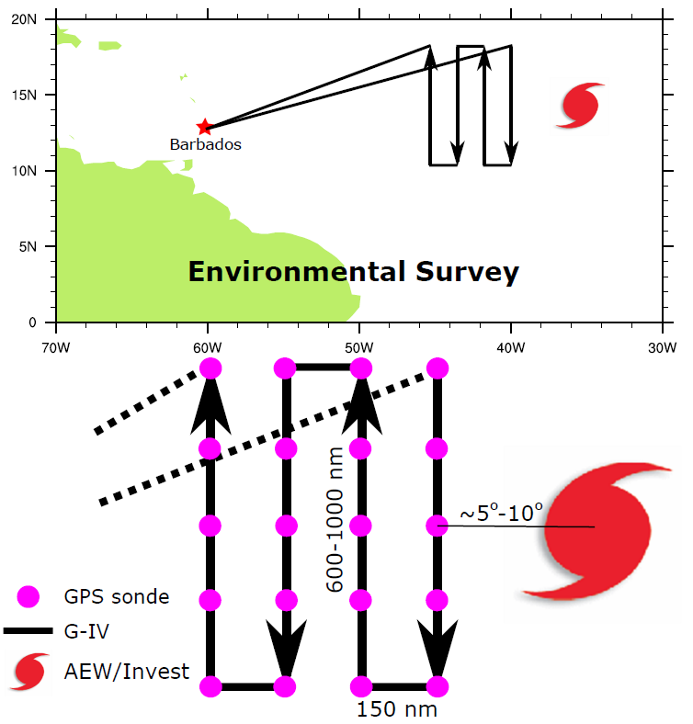

Flight altitude: 40-45 kft
Leg length or radii: Long Legs = 600-1000 n mi, Short Legs = 150 n mi
Estimated in-pattern flight duration: 3 – 4.5 hrs per box
Expendable distribution: ~150 n mi between dropwindsondes. ~10 drops per box
Instrumentation Notes: Use TDR defaults. Use straight flight legs as safety permits.

G-IV Module 2A
What to Target: Sample the environment in and around an easterly wave that is within G-IV range, especially if the wave is expected to develop into a tropical cyclone.
When to Target: Sample when easterly wave is within G-IV range (west of ~40°W) and is forecast to develop in reliable computer models or is showing signs of development in observations.
Pattern: G-IV Circumnavigation (hexagon), especially if no low-level center is discernible panel). To fit within time constraints, pattern should be modified by removing the middle circle.
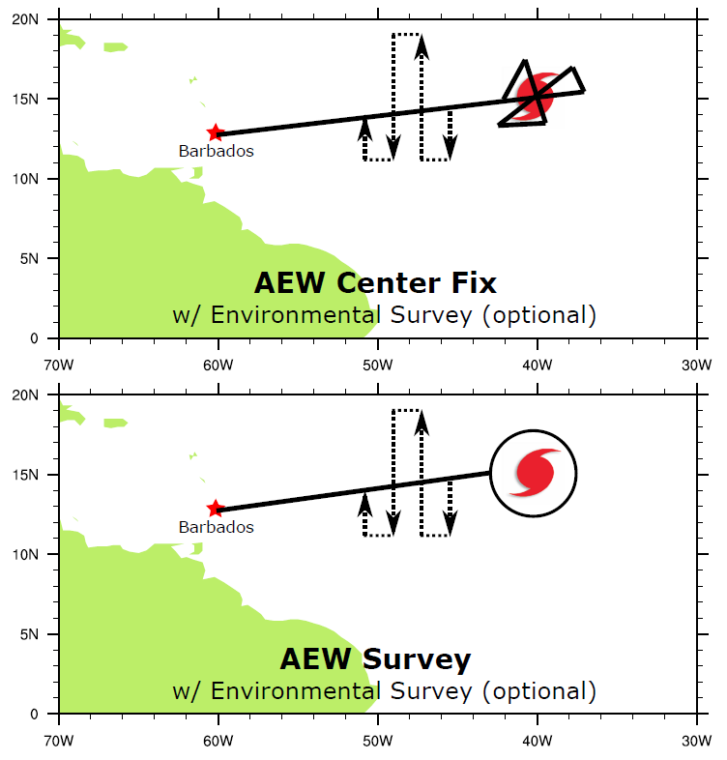
Flight altitude: 40-45 kft
Leg length or radii: Outer circle = 150 n mi. Inner circle = 60 n mi
Estimated in-pattern flight duration: 3 hrs
Expendable distribution: 12 dropsondes, although less may be used to conserve resources.
Instrumentation Notes: Use TDR defaults. Use straight flight legs as safety permits.

G-IV Module 2B
What to Target: Sample the environment in and around an easterly wave, especially if the wave is expected to develop into a tropical cyclone.
When to Target: Sample when easterly wave is within G-IV range (west of ~40°W) and is forecast to develop in reliable computer models or is showing signs of development in observations.
Pattern: Butterfly, especially if easterly wave “center” is clearly discernable.

Flight altitude: 40-45 kft
Leg length or radii: Standard - 105 n mi legs
Estimated in-pattern flight duration: Standard - 2 hrs
Expendable distribution: Standard - 15 dropsondes, although fewer may be used
Instrumentation Notes: Use TDR defaults. Use straight flight legs as safety permits.

P-3 Module 2
What to Target: Sample the environment in and around an easterly wave, especially if the wave is expected to develop into a tropical cyclone.
When to Target: Sample when easterly wave is forecast to develop in reliable computer models or is showing signs of development in observations. Sample when easterly wave is located at or west of 35°W (to be within range of G-IV).
Pattern: Butterfly, especially if easterly wave “center” is clearly discernable (see top panel).
Flight altitude: 10-20 kft
Leg length or radii: Standard - 105 n mi legs
Estimated in-pattern flight duration: Standard - 3:25 hrs
Expendable distribution: Standard - 15 dropsondes, although fewer may be used
Instrumentation Notes: Use TDR defaults. Use straight flight legs as safety permits.

12. Analysis of Intensification Processes Experiment (AIPEX)

Principal Investigator(s): Jon Zawislak (FIU/HRD), Robert Rogers, Leon Nguyen (NRC/HRD), John Kaplan, Jason Dunion, Paul Reasor, and Jun Zhang

Mission Description: Collect precipitation, kinematic, thermodynamic, and ocean observations within the environment, near environment (~100 km, or 60 nmi), and inner core regions of tropical cyclones (TCs) that have a reasonable potential for intensification (based on statistical and/or numerical model forecast guidance), with a particular focus on the early stages (i.e., TD, TS, weak hurricane). When possible (i.e., subject to range, timing, and other logistical constraints), missions will begin at least 24 h prior to the expected onset of intensification.

G-IV Module 1
What to Target: Sample the environment and near environment of the TC
When to Target: Every 12 h [optimal] or every 24 h [minimal], preferably in coordination with a corresponding P-3 mission (P-3 Module 1).
Pattern: G-IV Circumnavigation (octagon [optimal], hexagon [minimal]). Should be storm centered and oriented such that the left and right of shear semicircles are sampled equally by dropsondes.
Flight altitude: 40–45 kft
Leg length or radii: 200 n mi (370 km), 120 n mi (222 km), and 60 n mi (111 km) (radii). The innermost radii can be adjusted outward if necessitated by hazard avoidance (outer two radii rings should be similarly adjusted, if time allows).
Estimated in-pattern flight duration: ~ 5–6 h
Expendable distribution: Dropsonde at each turn point; 24 in total (octagon) [optimal], or 18 in total (hexagon) [minimal]
Instrumentation Notes: Use TDR defaults. Use straight flight legs as safety permits.

G-IV Module 2
What to Target: Sample the surrounding environment of the TC
When to Target: Every 12 h [optimal] or every 24 h [minimal]
Pattern: G-IV Star (with circumnavigation if no coordination with P-3)
Flight altitude: 40–45 kft
Leg length or radii: 210 n mi (388 km) outer, 90 n mi (167 km) inner radii (standard). Depending on the time of day, aircraft duration limitations, and safety considerations, the lengths of the inner (outer) points could be shortened (extended) if an opportunity to sample a diurnal pulse presents itself (see TC Diurnal Cycle Experiment).
Estimated in-pattern flight duration: ~ 4 h (~ 5 h with circumnavigation)
Expendable distribution: Dropsonde at each turn point; 13 dropsondes total (20 with circumnavigation)
Instrumentation Notes: Use TDR defaults. Use straight flight legs as safety permits.

P-3 Module 1
What to Target: Sample the inner core region of a TC
When to Target: Every 12 h [optimal] or every 24 h [minimal], preferably in coordination with a corresponding G-IV mission (G-IV Module 1 or G-IV Module 2).
Pattern: Rotated Figure-4
Flight altitude: [optimal] 10–12 kft (5 kft is minimum altitude for dropsonde launches)
Leg length or radii: 105 n mi
Estimated in-pattern flight duration: ~ 5 h
Expendable distribution:
[optimal] (up to 28 dropsondes total) Modify standard by moving the mid-point dropsonde to half the radius of innermost G-IV radii. AXBTs preferably paired with dropsondes at mid- and turn points and center. If radius of maximum wind (RMW) is significantly different (> 10 n mi) from any of the standard dropsonde locations, release dropsonde there, and also release dropsonde at 1.5 x RMW, subject to same constraint regarding proximity to standard dropsonde locations. No AXBTs need to be coordinated with these RMW-based drops.
[minimal] (10–12 dropsondes total) Modify standard as stated in [optimal], keeping only midpoint drops, as well as center drops on the first and last pass. AXBTs preferably paired with dropsondes at midpoints and center.
Instrumentation Notes: Use TDR defaults. Use straight flight legs as safety permits. Inbound-outbound passes should be uninterrupted. DWL should be downward looking, 20° off nadir.

P-3 Module 2 (No coordination with the G-IV; TC experiencing a Precipitation Asymmetry)
What to Target: Sample the inner core and near environment regions of a TC when the inner core precipitation distribution is asymmetric and when the G-IV is not available for coordination
When to Target: Every 12 h [optimal] or every 24 h [minimal]
Pattern:
[optimal] P-3 Circumnavigation with rotated Figure-4 (modified from the standard)
[minimal] P-3 Circumnavigation with single Figure-4 (standard)
Note: The circumnavigation can be adjusted for hazard avoidance; e.g., if pattern in downshear hemisphere is not possible, the circumnavigation can be abbreviated to the upshear hemisphere with a pass over the center (see example below: Figure-4 in green, circumnavigation in orange, shear vector heading in black, ‘X’ is a dropsonde location):
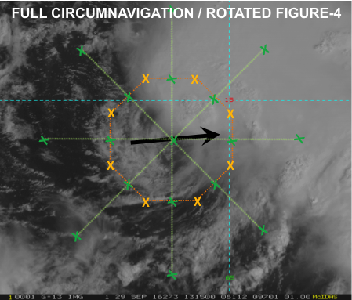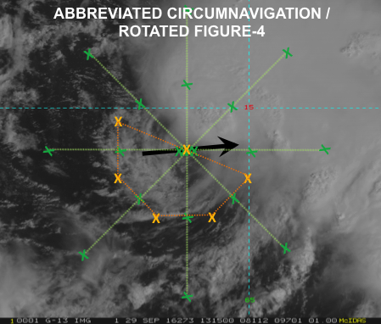

Flight altitude: Figure-4: [optimal] 10–12 kft (5 kft is minimum altitude for dropsonde launches). Circumnavigation: As high as possible [optimal] above 25 kft [minimal]
Leg length or radii: 105 n mi (leg length). Radius of circumnavigation is preferably as close to the inner-core precipitation shield as safety allows.
Estimated in-pattern flight duration: [optimal] Circumnavigation with rotated Figure-4, ~6 h; [minimal] Circumnavigation with single Figure-4, ~ 4 h
Expendable distribution:
[optimal] Use the standard for P-3 circumnavigation (8 dropsondes), as well as for rotated Figure-4 (20 dropsondes, 28 total with circumnavigation) or single Figure-4 (10 dropsondes, 18 total with circumnavigation). AXBTs preferably paired with dropsondes at mid- and turn points and center.
[minimal] Use the standard for P-3 circumnavigation (8 dropsondes), and modify standard Figure-4 by keeping only turn point drops, as well as center drops on the first and last pass (for rotated Figure-4, 10 dropsondes, 18 total with circumnavigation; for single Figure-4, 6 dropsondes, 14 total with circumnavigation). AXBTs preferably paired with dropsondes at turn points and center.
Instrumentation Notes: Use TDR defaults. Use straight flight legs as safety permits. Inbound-outbound passes should be uninterrupted. DWL should be downward looking, 20° off nadir.

13. Tropical Cyclone in Shear Experiment

Principal Investigator(s): Paul Reasor (lead), Jason Dunion, John Kaplan, Leon Nguyen, Rob Rogers, Jon Zawislak, Jun Zhang, Michael Riemer (Johannes Gutenberg-Universität)

Mission Description: Sample the wind, temperature and moisture fields within and around a tropical cyclone experiencing a significant increase in environmental vertical wind shear (> 10 kts in 24 h).

G-IV Module 1
What to Target: Sample the environment of a TC for which the distance of the center from significant land mass and significant SST gradients exceeds ~ 3x the radius of maximum wind.
When to Target: Sample before a significant increase in environmental vertical wind shear; during the period of maximum vortex tilt. Coordinate G-IV take-off with the corresponding P-3 mission such that the innermost G-IV circumnavigation coincides with the P-3 sampling.
Pattern: G-IV Circumnavigation (Hexagon). Should be storm centered. Alternate patterns: G-IV Circumnavigation (Octagon) for more sondes; G-IV Star if TDR coverage is not crucial
Flight altitude: 40-45 kft
Leg length or radii: 150 n mi, 90 n mi, and 60 n mi
Estimated in-pattern flight duration: ~ 4 h 25 min
Expendable distribution: Standard (18 dropsondes total).
Instrumentation Notes: Use TDR defaults. Use straight flight legs as safety permits.

P-3 Module 1
What to Target: Sample the core region of a TC for which the distance of the center from significant land mass and significant SST gradients exceeds ~ 3x the radius of maximum wind.
When to Target: Sample before a significant increase in environmental vertical wind shear. The P-3 should be coordinated with G-IV Module 1.
Pattern: Rotated Figure-4. Alternate patterns: Butterfly; Fig-4; Alpha
Flight altitude: 12 kft preferable for best dropsonde coverage
Leg length or radii: 105 n mi
Estimated in-pattern flight duration: ~ 5 h
Expendable distribution: Modify standard by including an RMW dropsonde, moving the mid-point dropsonde to half the radius of innermost G-IV circumnavigation (or 30 n mi) and removing turn-point dropsondes. Modification ensures eyewall thermodynamic coverage and 30 n mi radial sampling of thermodynamic fields immediately outside the eyewall. Modification also leverages availability of G-IV dropsondes (20 dropsondes total).
Instrumentation Notes: Use TDR defaults. Use straight flight legs as safety permits. Inbound-outbound passes should be uninterrupted.

P-3 Module 2
What to Target: Sample the core region of a TC for which the distance of the center from significant land mass and significant SST gradients exceeds ~ 3x the radius of maximum wind.
When to Target: Sample as the large-scale, deep-layer shear increases and downshear convective asymmetry is evident; when the TC core exhibits large vertical tilt (an intensifying TC may have reduced its rate of intensification or begun to weaken); and when the TC core has realigned (a weakening or steady state TC may have begun to intensify).
Pattern: Figure-4, fly 45 deg downwind, then uninterrupted small-scale Rotated Figure-4. Orient initial pass along shear vector if possible. Purpose of small-scale Rotated Figure-4 is high-temporal-resolution sampling of eyewall and near-eyewall thermodynamic structure. Alternate (small-scale) patterns: Butterfly for coarser azimuthal sampling; P-3 Circumnavigation
Flight altitude: 12 kft preferable for best dropsonde coverage
Leg length or radii: 105 n mi (initial Figure-4); small-scale Rotated Figure-4 should extend just beyond the primary region of organized convection outside the eyewall (~15-30 n mi beyond mean radius of maximum wind).
Estimated in-pattern flight duration: ~ 4 h 45 min for Figure-4 + Rotated Figure-4 (45 n mi legs)
Expendable distribution: For initial Figure-4, modify standard by removing mid-point dropsondes (if G-IV present, remove IP and turn-point dropsondes). For small-scale Rotated Figure-4, modify standard by launching 4 equally-spaced dropsondes from the mean radius of maximum wind to the turn point of each leg (42 dropsondes total, 38 if G-IV present). Given limited resources, may target only quadrant downwind of organized convection (22 dropsondes total, 18 if G-IV present).
Instrumentation Notes: Use TDR defaults. Use straight flight legs as safety permits. Inbound-outbound passes should be uninterrupted.

14. TC Diurnal Cycle Experiment

Principal Investigator: Jason Dunion

Mission Description: Collect precipitation, wind, and thermodynamic observations in the inner core region, near environment (~100-150 km/55-80 nm) and peripheral environment (~150-400 km/80-215 nm) of TCs exhibiting radially propagating TC diurnal pulses.

P-3 Module 1 (Optional coordination with G-IV)
What to Target: Sample the inner core and near environments of the TC.
When to Target: Any strength TC (though TC diurnal cycle signals tend to be stronger in Cat2+ storms); no land restrictions. There are time restrictions for this experiment: in-storm sampling should occur in the time window from ~0200-1200 LST during the early stages of the TC diurnal cycle when the TC diurnal pulse is located at R≤300 km (≤160 nm). Approximate radial locations of TC diurnal pulses relative to local time are shown by the TC diurnal clock below. If possible, this P-3 module should be conducted in coordination with G-IV Module.

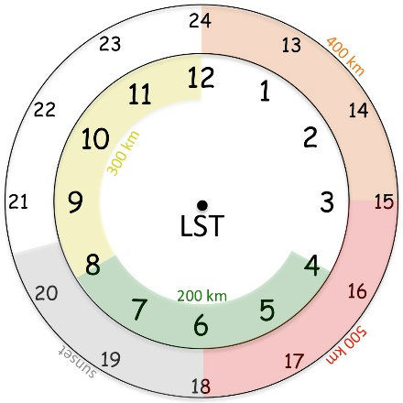
Fig. 1. Conceptual 24-hr TC diurnal cycle clock that estimates the radial location of TC diurnal pulses propagating away from storm.

Pattern: Any standard pattern that provides symmetric coverage (e.g. Rotated Figure-4, Figure-4 butterfly, etc.). Leg lengths should be adjusted as needed to ensure that the aircraft perpendicularly crosses TC diurnal pulses that are indicated by satellite imagery and/or the P-3 LF radar.
Flight altitude: 10-12 kft or as high as possible to provide better vertical sampling by GPS dropsondes that are deployed.
Leg length or radii: Standard leg lengths (105 n mi), but legs should be extended as needed to ensure that the aircraft perpendicularly crosses TC diurnal pulses that are indicated by satellite imagery and/or the P-3 LF radar.
Estimated in-pattern flight duration: ~2.5-5.0 hr
Expendable distribution: Standard distribution of GPS dropsondes except increased density of ~15-20 nm (30-35 km) spacing just ahead of, within, and behind the diurnal pulse convective features that will be identified in real-time using satellite imagery and/or the P-3 LF radar (10-25 GPS dropsondes total). AXBTs are not a mission requirement.
Instrumentation Notes: Use TDR defaults. Use straight flight legs as safety permits.

G-IV Module 1 (Optional coordination with P-3)
What to Target: Sample the near and peripheral environments of the TC.
When to Target: Any strength TC (though TC diurnal cycle signals tend to be stronger in Cat2+ storms); no land restrictions. There are time restrictions for this experiment: in-storm sampling should occur in the time window from approximately 0800-1500 LST during the middle to late stages of the TC diurnal cycle when the TC diurnal pulse is located between R~200-400 km (~105-215 nm). Approximate radial locations of TC diurnal pulses relative to local time are shown in Fig. 1. If possible, this G-IV module should be conducted in coordination with P-3 Module.
Pattern: G-IV Star Pattern (with circumnavigation [optimal], without circumnavigation [minimal]). Leg lengths should be adjusted as needed to ensure that the aircraft perpendicularly crosses TC diurnal pulses that are indicated by satellite imagery and/or the P-3 LF radar (if available).
Flight altitude: 40–45 kft
Leg length or radii: 190-215 nm (350-400 km) for the outer points and ~60-90 nm (110-165 km) for the inner points. If a circumnavigation is being performed, a constant radius [typically 60-90 nm (110-165 km)] should be selected. Selection of the inner points and circumnavigation radii should be as close to the edge of the inner core convection as possible (this distance will be dictated by safety considerations) and will require coordination between the HRD ground-based LPS and the G-IV flight director.
Estimated in-pattern flight duration: ~4 hr without circumnavigation and ~5.25 hr with circumnavigation
Expendable distribution: Standard plus mid-points of Star Pattern (25-31 GPS dropsondes total) except increased density of ~15-20 nm (30-35 km) spacing just ahead of, within, and behind the diurnal pulse convective features that will be identified in real-time using satellite imagery and/or the P-3 LF radar.
Instrumentation Notes: Use TDR defaults. Use straight flight legs as safety permits.

15. Tropical-Cyclone-Ocean Interaction Experiment

Principal Investigator(s): Nick Shay (U. Miami/RSMAS), Jun Zhang (NOAA/HRD), Rick Lumpkin (NOAA/PhOD), George Halliwell (NOAA/PhOD), Elizabeth Sanabia (USNA), and Benjamin Jaimes (U.Miami/RSMAS)

Mission Description: Sample the sea surface temperature, ocean temperature and salinity profiles, air-sea temperature and humidity contrast within and around a tropical cyclone.

P-3 Module 1 (Gulf of Mexico warm eddy pre- or post-storm survey)
What to Target: Sample the LC and associated eddy field.
When to Target: Pre- and post-storm.
Pattern: as in Fig. 1
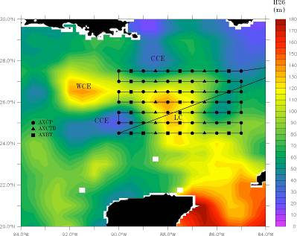

Figure 1: Typical pre- or post-storm pattern with ocean expendable deployment locations relative to the Loop Current. Specific patterns will be adjusted based on actual and forecasted storm tracks and Loop Current locations. Missions generally are expected to originate and terminate at AOC.

Flight altitude: 6-8k ft preferable.
Leg length or radii: 250 n mi
Estimated in-pattern flight duration: ~ 8 h
Expendable distribution: a total of 60-80 aircraft ocean expendables (AXBTs, AXCPs, and AXCTDs)
Instrumentation Notes: Use straight flight legs as safety permits.

P-3 Module 2 (Gulf of Mexico warm in-storm survey)
What to Target: Sample the core region of a TC and LC eddy field.
When to Target: In storm, no constraint
Pattern: as in Fig. 2

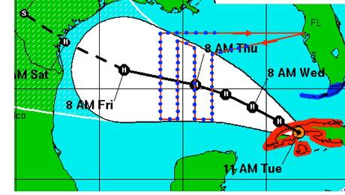

Figure 2: Track-dependent AXBT/AXCTD ocean survey. As for the Loop Current survey, a total of 40 probes would be deployed on a grid (blue dots).
Flight altitude: 8-10 kft
Leg length or radii: 105 n mi
Estimated in-pattern flight duration: ~ 4 h 45 min for Figure-4 + Rotated Figure-4 (45 n mi legs)
Expendable distribution: A total of 40 aircraft ocean expendables (AXBTs, AXCPs, and AXCTDs).
Instrumentation Notes: Use straight flight legs as safety permits.

P-3 Module 3 (pre-storm Atlantic Ocean survey)
What to Target: Region before storm pass by based NHC’s best track.
When to Target: 48 hours prior to forecast arrival
Pattern: as in Fig.3
Figure 3: Left: NHC official forecast track, which pre-storm ocean sampling region highlighted. Target region is centered ~48 hours prior to forecast arrival of storm. Right: P-3 flight track (red line) and ocean sampling pattern consisting of a grid of AXCTD/AXBT probes Probes are deployed at ~0.5 deg. intervals. Total time for this pattern is estimated to be ~9 hours.
Flight altitude: 6-8 kft preferable for best dropsonde coverage
Leg length or radii: 105 n mi
Estimated in-pattern flight duration: ~ 5 h
Expendable distribution: 50 aircraft ocean expendables
Instrumentation Notes: Use straight flight legs as safety permits.

P-3 Module 4 (In storm survey)
What to Target: Sample the core region of a TC
When to Target: no constraint
Pattern: Rotated Figure-4.
Flight altitude: 10 kft preferable for best dropsonde coverage
Leg length or radii: 105 n mi
Estimated in-pattern flight duration: ~ 5 h
Expendable distribution: 20 to 30 aircraft ocean expendables
Instrumentation Notes: Use straight flight legs as safety permits.

P-3 Module 5 (post storm Ocean survey)
What to Target: Sample the core region of a TC
When to Target: post storm
Pattern: as in Fig. 4
Figure 4: Left: Post-storm ocean sampling flight pattern (red line), over previously-sampled area (black box). In this example, the pattern extends around 470 km in the along-track dimension, or around 0.75 of a near-inertial wavelength. Right: Flight pattern with expendable drop locations, consisting of a combination of AXCP and AXBT probes.

Flight altitude: 8 kft preferable for best dropsonde coverage
Leg length or radii: 105 n mi
Estimated in-pattern flight duration: ~ 5 h
Expendable distribution: 30 -40 aircraft ocean expendables (AXCPs and AXBTs)
Instrumentation Notes: no constraint

P-3 Module 6 (Coordinated float/drifter deployment overflight mission)
What to Target: Sample the core region of a TC.
When to Target: In storm, no constraint
Pattern: As in Fig. 5
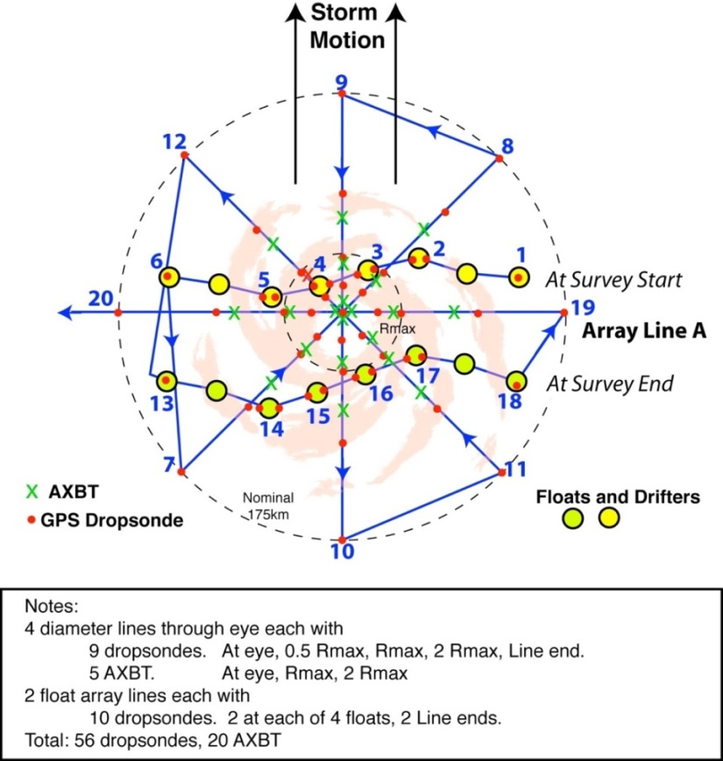

Figure 5: P-3 pattern over float and drifter array. The array has been distorted since its deployment on the previous day and moves relative to the storm during the survey. The pattern includes two legs along the array (waypoints 1-6 and 13-18) and an 8 radial line survey. Dropwindsondes are deployed along all legs, with double deployments at the floats. AXBTs are deployed in the storm core.

Flight altitude: 10-12 kft preferable for best dropsonde coverage
Leg length or radii: 105 n mi
Estimated in-pattern flight duration: ~ 4 h 45 min for Figure-4 + Rotated Figure-4 (45 n mi legs)
Expendable distribution: 56 sondes and 20 aircraft ocean expendables
Instrumentation Notes: Use straight flight legs as safety permits.
16. Tropical Cyclone Landfall Experiment
Principal Investigator(s): John Kaplan, Ghassan Alaka, Peter Dodge, Hua Chen, Frank Marks, Jun Zhang, Brad Klotz, and Matt Eastin (UNC Charlotte)
Mission Description: This is a multi-option, multi-flight, single-aircraft experiment designed to study the changes in tropical cyclone surface wind structure and to document TC supercell characteristics just prior to (<24-h) and after landfall. The first of the mission's two flights will typically consist of the Offshore Intense Convective module followed by either the Coastal Survey or Real-time modules. The storm location relative to the coastline will dictate which combination of these modules will be flown; however, the Offshore Intense Convection module will generally precede all of the others.
P-3 Module 1: Offshore Intense Convection Module
What to Target: An intense rain band > 150 nm from the center of either a tropical storm or hurricane that is forecast to make landfall along the U.S coastline.
When to Target: This module should be performed within 12-24 h of the time of landfall.
Pattern: Break-away/non-standard (see Fig. 1 and description below):

Fig. 1 shows a sample Offshore Intense Convection flight pattern near the Carolina coast. The P-3 should cross the target band ~20-25 km downwind of the intense convective cells and then proceed to ~25 km outside the rain band axis. The aircraft then turns upwind and proceeds along a straight track parallel to the band axis. When the P-3 is ~20-25 km upwind of the target cells, the aircraft turns and proceeds along a track orthogonal to the band axis until the P-3 is 25 km inside the rain band then turns downwind and flies parallel to the rain band axis.
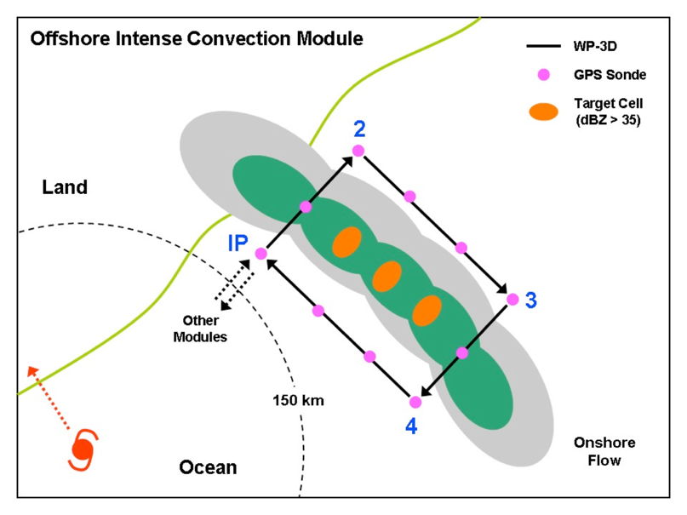

Fig. 1. Offshore Intense convection module.

Flight altitude: 10,000 ft. (3000m) or higher.
Leg lengths: > 75 km for each parallel leg.
Estimated in-pattern flight duration: 1-2 h.
Expendable distribution: Deploy GPS dropwindsondes at the start or end points of each leg, at the band axis crossing points, and at ~20-25 km intervals along each leg parallel to the band. At least 2 dropwindsondes should be deployed on either side of the convection and at least 1 dropwindsonde should be deployed each time the band-axis is crossed (for a minimum of 6 dropwindsondes).
Instrumentation Notes: Set airborne Doppler to scan in F/AST mode on all legs. Aircraft should avoid penetration of intense reflectivity regions (particularly over land).

P-3 Module 2: Coastal Survey Module
What to Target: A tropical storm or hurricane that is forecast to make landfall along the U.S coastline.
When to Target: This module should be performed within ~6-12-h of the time of landfall.
Pattern: Break-away/non-standard (see Fig. 2 below and description below):

Fig. 2 shows a sample Coastal Survey pattern for a hurricane landfall near Melbourne, Florida. The P-3 would fly parallel but ~10-15 km offshore so that the SFMR footprint is out of the surf zone. The second pass should be parallel and as close to the coast as safety permits. Finally, a short leg would be flown from the coast spiraling towards the storm center.

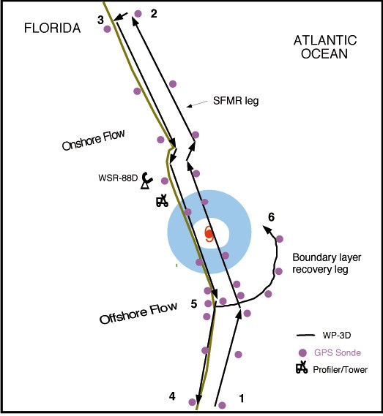
Fig. 2. Coastal Survey module

Flight altitude: 5000 ft. (1.5 km) for first pass and then climb to slightly higher altitude (~7,500 ft.) if needed for second pass.
Leg lengths: ~150 km.
Estimated in-pattern flight duration: ~2 h.
Expendable distribution: Dropwindsondes at RMW, and 12.5, 25, 50, 75, 100 km from RMW on either side of storm in both the near shore and offshore legs that are to be flown parallel to the shoreline. Dropwindsondes should be deployed quickly at start of outbound leg between near shore and offshore parallel legs and then every 10-15 km thereafter.
Instrumentation Notes: Set airborne Doppler on all legs in FAST Aircraft should avoid penetration of intense reflectivity regions (particularly those overland).
P-3 Module 3: Real-time Module
What to Target: A hurricane that is forecast to make landfall along the U.S coastline.
When to Target: This module should be performed within ~6-12-h of the time of landfall.
Pattern: Break-away/non-standard (see Fig. 3 and description below):

Fig. 3 shows a sample Real-time module flight pattern. The P-3 descends at the initial point and begins a low- level figure-4 pattern, possibly modifying the legs to fly over buoy or C-MAN sites if possible. If time permits, the P-3 would make one more pass through the eye and then fly the Dual-Doppler option.
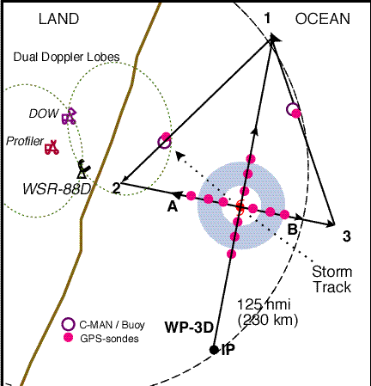

Fig. 3. Real-time module.

Flight altitude: Below 5,000 ft. (1.5 km) (or the lowest level deemed to be safe by flight personnel).
Leg lengths: ~ 185 km.
Estimated in-pattern flight duration: ~-2-3 h.
Expendable distribution: Dropwindsondes should be released near buoys or C-MAN sites (if possible) and at or just inside the flight-level RMW.
Instrumentation Notes: Set airborne Doppler on all legs in F/AST mode. It is essential that these passes be flown as straight as possible, because turns to fix the eye will degrade the Doppler radar coverage.

17. Convective Burst Module

Principal Investigator(s): Robert Rogers, Altug Aksoy,
Jon Zawislak (FIU/UM/CIMAS/HRD), Leon Nguyen (NRC/HRD)

Mission Description: Sample the wind, temperature, and moisture fields within and around an area of deep convection at high time frequency and to use them in high-resolution data assimilation experiments.

P-3 Module 1
What to Target: An area of vigorous, deep convection occurring within the circulation of a tropical cyclone (TC) (tropical depression or stronger).
When to Target: When deep convection is identified either by radar or satellite during the execution of a survey pattern at or near the radius of maximum wind (RMW) of a tropical depression, tropical storm, or Category 1 hurricane. Particular attention should be paid when a developing area of deep convection can be detected on the downshear (shear direction inferred by real-time SHIPS analyses) side of the storm.
Pattern: Series of inbound/outbound radial penetrations / bowtie pattern: Repeated sampling can allow for a following of the burst around the storm, or if the burst remains confined downshear.
- Repeat penetrations as long as time permits within the 1-2 h window
- When a high-altitude aircraft is present, efforts should be made to coordinate the pattern with the high-altitude aircraft, so that the two aircraft are as close to vertically stacked as possible.

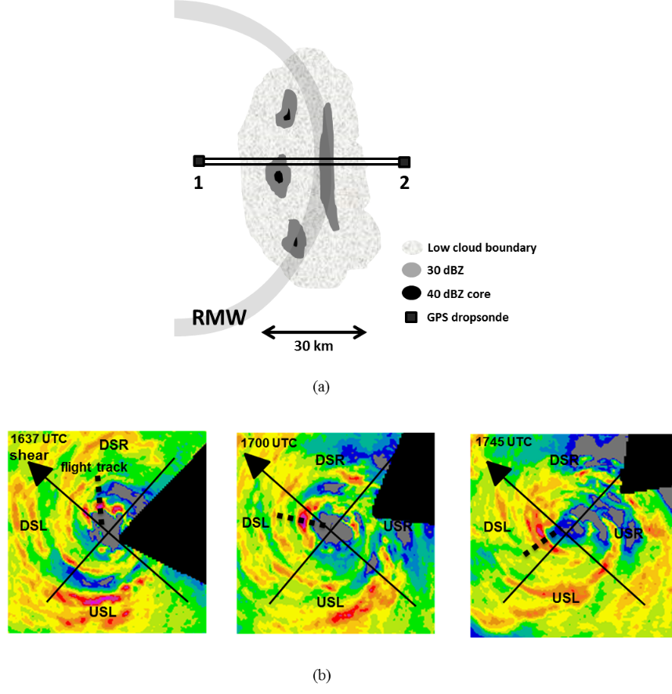
P-3 Convective burst module: (a) Radial penetrations / bowtie pattern. Black square denote locations of GPS dropsondes from P-3. This pattern should be repeated multiple times as time allows, following the CB around the storm or remains confined downshear. (b) Example of sampling strategy following CBs around the storm, beginning downshear right (DSR) and into the upshear quadrants. Each radial pass is separated by ~30 minutes.
Flight altitude: A constant altitude of 10-12 kft (radar or pressure altitude) is preferable
Leg length or radii: Variable depending on size of CB, but should extend at least 10 nm inside and 10 nm outside radar-defined edges of CB.
Estimated in-pattern flight duration: 1-2 h added to the mission
Expendable distribution: Dropsondes at turn points. No more than 15 dropsondes needed for this module.
Instrumentation Notes: Every effort made to fly the aircraft level for optimal Doppler radar sampling. The TDR should be operated in F/AST scan mode.

18. Eye-eyewall Mixing Module

Principal Investigator(s): Sim Aberson (HRD)

Mission Description: Eyewall mesovortices have been hypothesized to mix high-entropy air from the eye into the eyewall, thus increasing the amount of energy available to the hurricane. Signatures of such mesovortices have been seen in cloud formations within the eyes of strong TCs, in radar reflectivity signatures (Hurricane Fabian), and from above during aircraft penetrations (Hurricanes Hugo and Felix). Doppler radar was able to sample such features in Hurricanes Hugo and Felix, though interpretation with sparse observations through the small features has been difficult. Dropwindsondes released in very intense tropical cyclones, in conjunction with large-eddy simulations, have provided some thermodynamic data. However, the kinematic and thermodynamic structures of these features have never been directly observed. Observations within the eye near or below the inversion can allow for the study of these mesovortices and improve knowledge of small-scale features and intensity changes in very strong TCs.

P-3 Module 1
What to Target: This module requires a TC with a clearly defined, visible eye, eyewall, and inversion and an eye diameter of at least 25 n mi.
When to Target: The module should only be attempted during daytime missions. It can be included within any missions during aircraft passage through the eye.
Pattern: This is a break-away pattern that is compatible with any standard pattern with an eye passage (all P-3 patterns except the square spiral or lawnmower). The P-3 will penetrate the eyewall at the standard-pattern altitude. Once inside the eye, the P-3 will descend to a safe altitude below the inversion while performing a figure-4 pattern. The leg lengths will be determined by the eye diameter, with the ends of the legs at least 2 n mi from the edge of the eyewall. Upon completion of the descent, the P-3 will circumnavigate the eye about 2 n mi from the edge of the eyewall in the shape of a pentagon or hexagon. Time permitting; another figure-4 will be performed during ascent to the original flight level. Depending upon the size of the eye, this pattern should take between 0.5 and 1 h.
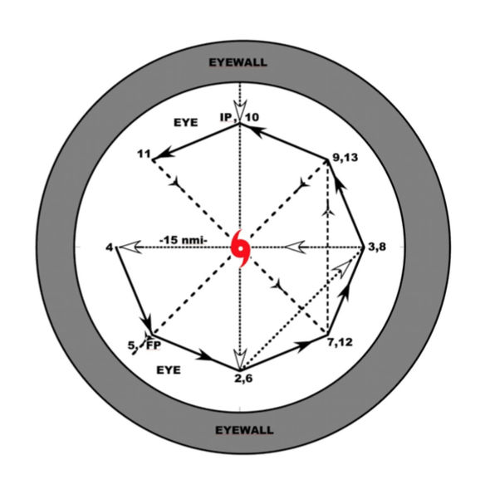

Flight altitude: The flight altitude will vary from just below the inversion inside the eye to the standard-pattern altitude.
Leg length or radii: The leg lengths will be determined by the eye diameter, with the ends of the legs at least 2 n mi from the edge of the eyewall. Upon completion of the descent, the P-3 will circumnavigate the eye about 2 n mi from the edge of the eyewall in the shape of a pentagon or hexagon.
Estimated in-pattern flight duration: Depending upon the size of the eye, this pattern should take between 0.5 and 1 h.
Expendable distribution: No expendables required
Instrumentation Notes: No special instructions for operation. If Doppler wind lidar is available, it should scan downward, though not exclusively, during the pattern. Each leg of the pattern should be straight within safety constraints.

19. Secondary Eyewall Formation and Eyewall Replacement Cycle Module

Principal Investigators: Hui Christophersen, Robert Rogers, Jason Dunion, Jun Zhang

Collaborators: Jeff Kepert, Kristen Corbosiero (SUNY), Anthony Didlake (Penn State), Yuqing Wang (U Hawaii), David Nolan (UM) and Sergio Abarca

Mission Description:
This module focuses on mature hurricanes (e.g. category 2 or stronger) with a well-defined eye as seen in visible, infrared, and microwave satellite imagery. Sampling can be achieved in combination with the P-3 Doppler Wind Lidar, Coyote UAS and P-3, G-IV or Global Hawk dropsondes. This module can generally be flown in conjunction with TDR Experiment survey patterns, with the addition of either a spiral pattern (pre-SEF) or moat circumnavigation (post-SEF) added onto the survey. The module can also be flown during the TC Diurnal Cycle Experiment and DWL Experiment.

P-3 Module Option 1 (PRE-SEF)

What to Target: Mature hurricane that has pronounced rainband activity, and possibly a secondary eyewall forming. We are targeting the inside edge of primary rainband and the overall primary rainband.
When to Target: Proposed flight pattern (Fig. 1) should take place when microwave satellite imagery indicates the presence of asymmetric rainbands occurring in the storm environment.
Pattern: Fly a combination of a rotated Figure-4 and a rainband spiral along the inside edge of the rainband, within ~5-10 nm of the inner edge of the rainband. Fly the spiral pattern straight and level as long as possible, i.e., keeping aircraft bank angle at a minimum, to minimize loss of radar data due to aircraft banking. Ferry time may preclude the second Figure-4.

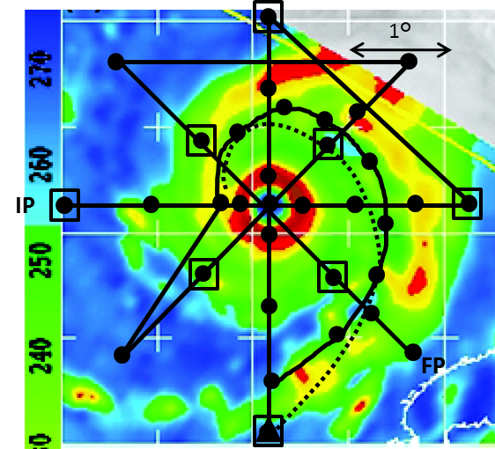
Fig. 1: P-3 Rotating figure-four pattern with Coyote deployed inflow path (dashed line; proposed launch point for Coyote Inflow Module indicated by triangle) overlain on a sample 85 GHz satellite image, showing pre-SEF, to depict features to target. Circles indicate dropsonde locations; open squares indicate AXBT deployment locations. Alternatively, the use of IR sondes would be preferred. This scenario may be combined with DWL Experiment.

Flight Altitude: 10,000-12,000ft (3-4 km) altitude preferable
Leg length or radii: The flight leg or radii depends on the primary rainband location. Ideally, the extension of the leg should be just outside of the primary rainband as indicated by Fig. 1.
Expendable distribution: For P-3, deploy dropsondes at all turn and mid-points in Figure 4 survey pattern, plus first center pass, at four locations in primary eyewall, and in the middle of rainband precipitation feature. Also release dropsonde at ~50 nm spacing along rainband spiral. If Coyote is available, deploy it following the inflow path where it will collect observations that can be used to calculate BL characteristics outside, within, and inside rainband. For G-IV, release dropsondes at all turn points.

P-3 Module Option 2 (POST-SEF)
What to Target: Mature hurricanes that are expected to have a secondary eyewall already formed or are undergoing an ERC. We are targeting the concentric rings and the moat region.
When to Target: These concentric rings can be easily detected based on radar or microwave satellite imagery. For storms that are already undergoing these ERCs and repeated ERCs are forecast, sampling patterns as indicated in Figure 2 are proposed.
Pattern: Fly a combination of a rotated Figure-4 and a circumnavigation in the moat region, within ~5-10 nm of the inner edge of the outer eyewall. Fly the circumnavigation straight and level as long as possible, i.e., keeping aircraft bank angle at a minimum, to minimize loss of radar data due to aircraft banking. Ferry time may preclude the second Figure-4.

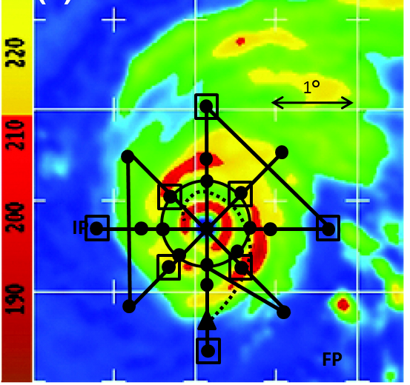
Fig. 2: P-3 Rotating figure-four pattern with Coyote deployed inflow path (dashed line; proposed launch point for Coyote inflow module indicated by triangle) overlain on a sample 85 GHz satellite image, showing post-SEF, to depict features to target. Circles indicate dropsonde locations; open squares indicate AXBT deployment locations. Alternatively, the use of IR sondes would be preferred. This scenario may be combined with DWL module.

Flight Altitude: 10,000-12,000ft (3-4 km) altitude preferable
Leg length or radii: The flight leg or radii depends on the primary rainband location. Ideally, the extension of the leg should be just outside of the primary rainband as indicated by Fig. 2 and the circumnavigation is inside the moat region (Fig. 2).
Expendable distribution: Deploy dropsondes at all turn and mid-points in Figure 4 survey pattern, plus first center pass, at four locations in primary eyewall. Also release dropsonde at ~50 nm spacing along circumnavigation in moat region. If Coyote is available, deploy it following the inflow path where it will collect observations that can be used to calculate BL characteristics outside, within, and inside outer eyewall.

G-IV Module 1

What to target: Sample the environment of a TC right outside of the primary rainband.
When to target: Proposed flight pattern should take place when microwave satellite imagery indicates the presence of asymmetric rainbands occurring in the storm environment when there is a high chance the storm may undergo SEF. In the case that the ERC is already occurring, these concentric rings can be easily detected based on radar or microwave satellite imagery. Fly the circumnavigation patterns outside of the outer rainband.
Pattern: Fly pattern such that the innermost circumnavigation (octagon or hexagon) is as close to outer edge of rainband as is safely allowed. Standard circumnavigation (octagon or hexagon) would work as long as the inner radius is close to outer edge of the rainband.
Fligth altitude: 40,000-45,000 ft preferable
Leg length or radii: The flight leg or radii depends on the primary rainband location. The innermost radius should be as close to the outer edge of the rainband as is safely allowed.
Expendable distribution: Deploy dropsondes at all turn points. The octagons are all turn points could also be stagged rather than aligned to achieve better azimuthal sonde coverage.

20. Arc Cloud Module

Principal Investigator: Jason Dunion

Mission Description: Sample the 3-dimensional wind, thermodynamics, and precipitation patterns of arc cloud features emanating from TCs.

P-3 Module 1
What to Target: Large arc cloud features (100s of km in length) emanating from the periphery of TCs.
When to Target: There are optimal times of day when large arc clouds occur and therefore preferred times of day for conducting this module. Arc clouds are linked to the position of radially propagating TC diurnal pulses that pass through areas of dry mid-level air (≤45 mm TPW) and therefore will tend to occur from ~0400-1200 LST in the approximate radial operating area of the P-3 (Fig. 1).

Fig. 1. Conceptual 24-hr TC diurnal cycle clock that estimates the radial location of TC diurnal pulses propagating away from storm.

Pattern: [Break-Away Pattern] Arc cloud transect.
Flight altitude: 10-12 kft or as high as possible to provide better vertical sampling of arc clouds by GPS dropsondes that are deployed.
Leg length or radii: Variable depending on the location of the arc cloud, but a transect through the arc cloud should be made that spans from the convective area where the arc cloud originated to at least 20 km beyond the leading edge of the arc cloud.
Estimated in-pattern flight duration: ~30-60 min added to the mission
Expendable distribution: GPS dropsonde spacing should be ~10 nm (20 km) [reduced to ~5 nm (10 km) spacing closer (≤10 nm (20 km)) to the arc cloud] and the transect can be made inbound (sampling in front of, across, and behind the arc cloud) or outbound (sampling behind, across, and then ahead of the arc cloud) relative to the convective core region of the AEW/TC.
Instrumentation Notes: Use TDR defaults. Use straight flight legs as safety permits.

P-3 Module 2
What to Target: Large arc cloud features (100s of km in length) emanating from the periphery of TCs.
When to Target: There are optimal times of day when large arc clouds occur and therefore preferred times of day for conducting this module. Arc clouds are linked to the position of radially propagating TC diurnal pulses that pass through areas of dry mid-level air (≤45 mm TPW) and therefore will tend to occur from ~0400-1200 LST in the approximate radial operating area of the P-3 (Fig. 1).
Pattern: [Break-Away Pattern]

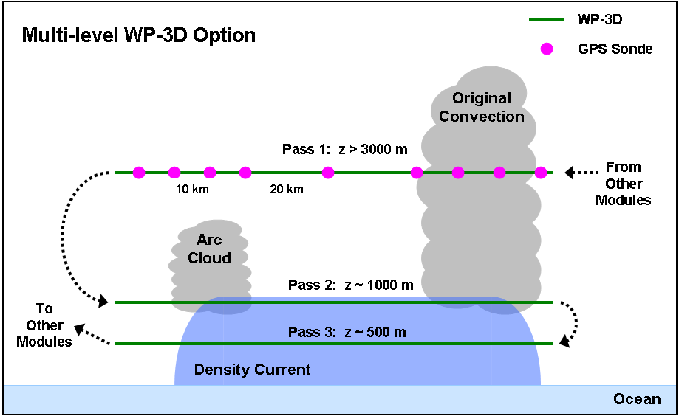
Figure 2: The P-3 flight track for P-3 Module 2. Azimuth and length of initial midlevel pass with GPS dropsonde sequence will be dictated by the pre-determined flight plan. Lengths of each of the 3 passes should span from the convective area where the arc cloud originated to at least 20 km beyond the leading edge of the arc cloud.

Flight altitude: 3 passes transecting the arc cloud will be made: 1st pass: 10-12 kft, 2nd pass: 3 kft, 3rd pass: 1.5 kft (Fig. 2). Note: if other experiment goals, time constraints, and/or aircraft safety would prevent the 2nd and 3rd low-level passes, this option could be altered to include only the 1st higher level pass and GPS dropsonde deployment sequence.
Leg length or radii: Variable depending on the location of the arc cloud, but each of the 3 transects through the arc cloud should extend from the convective area where the arc cloud originated to at least 20 km beyond the leading edge of the arc cloud.
Estimated in-pattern flight duration: ~45-60 min added to the mission
Expendable distribution: For the 1st pass, GPS dropsonde spacing should be ~20 km [reduced to ~10 km spacing closer (≤20 km) to the arc cloud] and the transect can be made inbound (sampling in front of, across, and then behind the arc cloud) or outbound (sampling behind, across, and then ahead of the arc cloud) relative to the convective core region of the AEW/TC (Fig. 2). No GPS dropsondes are required for the 2nd and 3rd passes and no AXBTs are required for this module.
Instrumentation Notes: Use TDR defaults. Use straight flight legs as safety permits.

G-IV Module 1
What to Target: Large arc cloud features (100s of km in length) emanating from the periphery of TCs.
When to Target: There are optimal times of day when large arc clouds occur and therefore preferred times of day for conducting this module. Arc clouds are linked to the position of radially propagating TC diurnal pulses that pass through areas of dry mid-level air (≤45 mm TPW) and therefore will tend to occur from ~0400-1500 LST in the approximate radial operating area of the G-IV (Fig. 1).
Pattern: [Break-Away Pattern] Arc cloud transect.
Flight altitude: 41–45 kft
Leg length or radii: Variable depending on the location of the arc cloud, but a transect through the arc cloud should be made that spans from the convective area where the arc cloud originated to at least 50 km beyond the leading edge of the arc cloud.
Estimated in-pattern flight duration: ~30 min added to the mission
Expendable distribution: GPS dropsonde spacing should be ~20 nm (~35 km) and the transect can be made inbound (sampling in front of, across, and behind the arc cloud) or outbound (sampling behind, across, and then ahead of the arc cloud) relative to the convective core region of the AEW/TC.
Instrumentation Notes: Use TDR defaults. Use straight flight legs as safety permits.

21. Extratropical Transition Experiment

Principal Investigator(s): Sim Aberson

Mission Description: The mission is designed to monitor interactions between the TC and the midlatitude circulation. The ideal storm will be a poleward-moving hurricane that is offshore the United States mid-Atlantic coastline. The optimal mission is designed to examine the TC core and the TC/midlatitude interface. Aircraft will participate in staggered (12-hly) missions until out of range, because of the possible rapid changes in structure.

P-3 Module 1
What to Target: Two specific targets are to be sampled during each mission, the TC itself, and the interface between the TC and the environmental flow.
When to Target: The systems will be sampled every 12 h from the time it begins the transition to an extratropical cyclone to the time it is out of range of the aircraft, or the system dissipates.
Pattern: The patterns would likely be non-standard patterns. At least two passes through the center of the TC will be completed during the mission, though they need not be consecutive. The P-3 will fly as high as possible to avoid hazards such as convective icing. Legs should be of equal length, except that they can be shortened to the south of the storm center if necessary to save time, or shortened due to land.
If extra time is available, important interactions between the midlatitude jet stream and the outflow from the TC occur. This region will be investigated by releasing dropwindsondes every ~120 n mi during this part of the pattern.
Flight altitude: as high as safely possible.
Leg length or radii: Leg lengths depend on the size of the transitioning system. They should be of equal length, but can be shortened to the south, or due to land.
Estimated in-pattern flight duration: 8 h
Expendable distribution: 10 dropwindsondes, 10 AXBTs. During passes through the center, dropwindsondes will be deployed at each turn point and at evenly spaced intervals along each leg with optimal spacing near 90 n mi. AXBTs will be deployed at each turn point and at the midpoint of each leg only in the northern semicircle from the cyclone center.
Instrumentation Notes: Due to a trapped-fetch phenomenon, the ocean surface wave heights can reach extreme levels ahead of a TC undergoing ET. Therefore, primary importance for the WP-3D in the northeast quadrant of the TC will be the scanning radar altimeter (WSRA) to observe the ocean surface wave spectra, if available. Flight level will be chosen to accommodate this instrument.

G-IV Module 1
What to Target: Two specific targets are to be sampled during each mission, the TC itself, and the interface between the TC and the environmental flow.
When to Target: The systems will be sampled every 12 h from the time it begins the transition to an extratropical cyclone to the time it is out of range of the aircraft, or the system dissipates.
Pattern: The patterns would likely be non-standard patterns. At least two passes through the center of the TC will be completed during the mission, though they need not be consecutive. Legs should be of equal length, except that they can be shortened to the south of the storm center if necessary to save time, or shortened due to land.
Ahead of the TC, important interactions between the midlatitude jet stream and the outflow from the TC occur.
Flight altitude: at altitude
Leg length or radii: Leg lengths depend on the size of the transitioning system. They should be of equal length, but can be shortened to the south, or due to land.
Estimated in-pattern flight duration: 8 h
Expendable distribution: ~20 dropwindsondes. During passes through the center, dropwindsondes will be deployed at each turn point and at evenly spaced intervals along each leg with optimal spacing near 90 n mi. At the TC-environment interface, dropwindsondes l be released every ~120 n mi.
Instrumentation Notes: None

SUPPLEMENTAL: OPERATIONAL MAPS
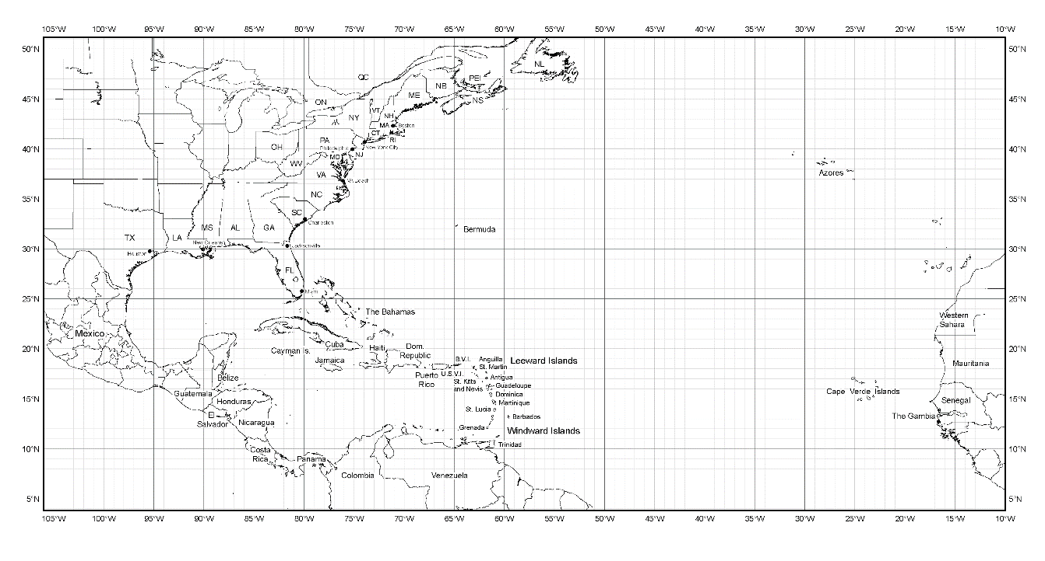

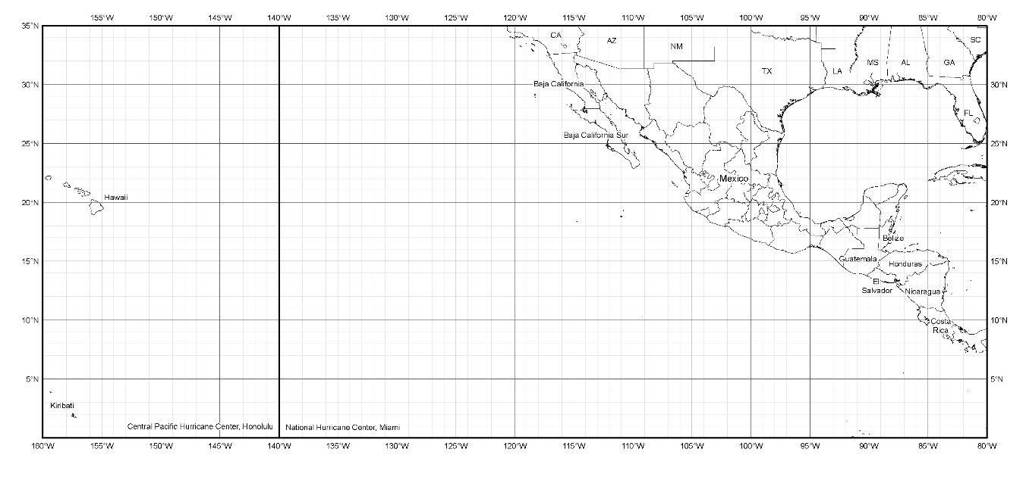
Bermuda

Lakeland
St. Croix
Barbados

Harlingen
La Paz

Map 1. Primary Atlantic and East Pacific operating bases and ranges (assuming ~2-h on-station time) for P-3.

Lakeland
Bermuda
St. Croix
Barbados

Harlingen

La Paz

Map 2. Primary Atlantic and East Pacific operating bases and ranges (assuming ~2-h on-station time) for G-IV.

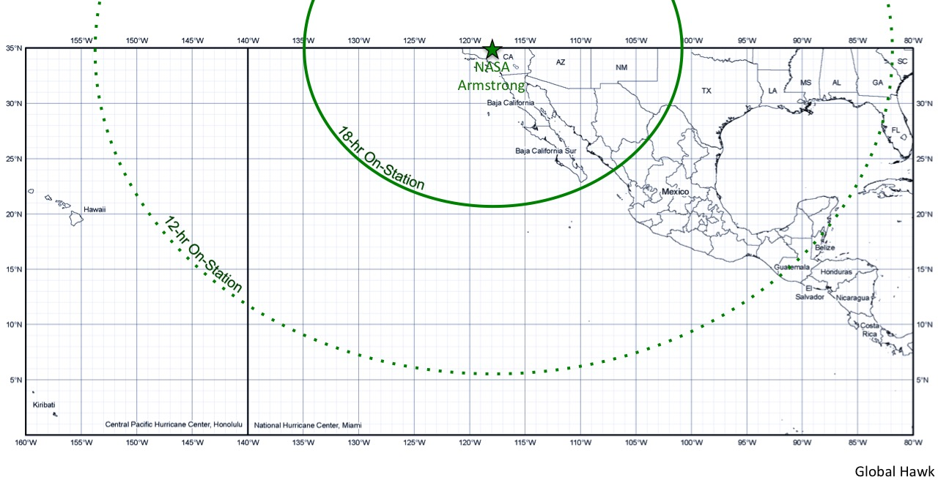
Map 3. Primary East Pacific operating base and range for Global Hawk.

