19. Secondary Eyewall Formation and Eyewall Replacement Cycle Module

Principal Investigators: Hui Christophersen, Robert Rogers, Jason Dunion, Jun Zhang

Collaborators: Jeff Kepert, Kristen Corbosiero (SUNY), Anthony Didlake (Penn State), Yuqing Wang (U Hawaii), David Nolan (UM) and Sergio Abarca

Mission Description:
This module focuses on mature hurricanes (e.g. category 2 or stronger) with a well-defined eye as seen in visible, infrared, and microwave satellite imagery. Sampling can be achieved in combination with the P-3 Doppler Wind Lidar, Coyote UAS and P-3, G-IV or Global Hawk dropsondes. This module can generally be flown in conjunction with TDR Experiment survey patterns, with the addition of either a spiral pattern (pre-SEF) or moat circumnavigation (post-SEF) added onto the survey. The module can also be flown during the TC Diurnal Cycle Experiment and DWL Experiment.

P-3 Module Option 1 (PRE-SEF)

What to Target: Mature hurricane that has pronounced rainband activity, and possibly a secondary eyewall forming. We are targeting the inside edge of primary rainband and the overall primary rainband.
When to Target: Proposed flight pattern (Fig. 1) should take place when microwave satellite imagery indicates the presence of asymmetric rainbands occurring in the storm environment.
Pattern: Fly a combination of a rotated Figure-4 and a rainband spiral along the inside edge of the rainband, within ~5-10 nm of the inner edge of the rainband. Fly the spiral pattern straight and level as long as possible, i.e., keeping aircraft bank angle at a minimum, to minimize loss of radar data due to aircraft banking. Ferry time may preclude the second Figure-4.

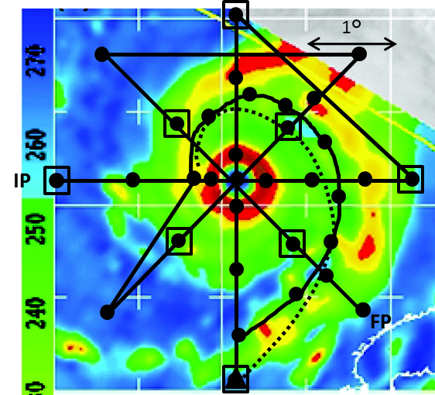
Fig. 1: P-3 Rotating figure-four pattern with Coyote deployed inflow path (dashed line; proposed launch point for Coyote Inflow Module indicated by triangle) overlain on a sample 85 GHz satellite image, showing pre-SEF, to depict features to target. Circles indicate dropsonde locations; open squares indicate AXBT deployment locations. Alternatively, the use of IR sondes would be preferred. This scenario may be combined with DWL Experiment.

Flight Altitude: 10,000-12,000ft (3-4 km) altitude preferable
Leg length or radii: The flight leg or radii depends on the primary rainband location. Ideally, the extension of the leg should be just outside of the primary rainband as indicated by Fig. 1.
Expendable distribution: For P-3, deploy dropsondes at all turn and mid-points in Figure 4 survey pattern, plus first center pass, at four locations in primary eyewall, and in the middle of rainband precipitation feature. Also release dropsonde at ~50 nm spacing along rainband spiral. If Coyote is available, deploy it following the inflow path where it will collect observations that can be used to calculate BL characteristics outside, within, and inside rainband. For G-IV, release dropsondes at all turn points.

P-3 Module Option 2 (POST-SEF)
What to Target: Mature hurricanes that are expected to have a secondary eyewall already formed or are undergoing an ERC. We are targeting the concentric rings and the moat region.
When to Target: These concentric rings can be easily detected based on radar or microwave satellite imagery. For storms that are already undergoing these ERCs and repeated ERCs are forecast, sampling patterns as indicated in Figure 2 are proposed.
Pattern: Fly a combination of a rotated Figure-4 and a circumnavigation in the moat region, within ~5-10 nm of the inner edge of the outer eyewall. Fly the circumnavigation straight and level as long as possible, i.e., keeping aircraft bank angle at a minimum, to minimize loss of radar data due to aircraft banking. Ferry time may preclude the second Figure-4.

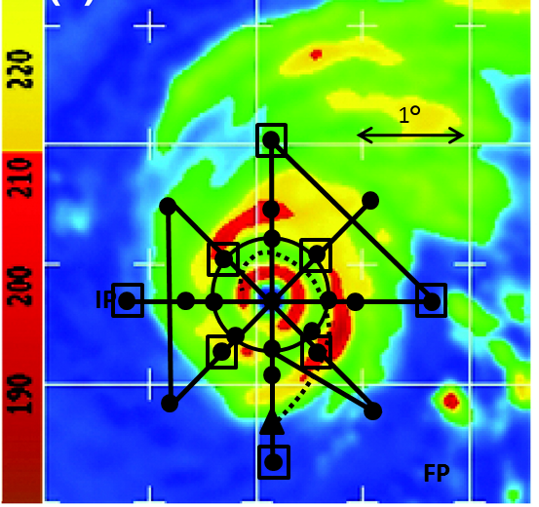
Fig. 2: P-3 Rotating figure-four pattern with Coyote deployed inflow path (dashed line; proposed launch point for Coyote inflow module indicated by triangle) overlain on a sample 85 GHz satellite image, showing post-SEF, to depict features to target. Circles indicate dropsonde locations; open squares indicate AXBT deployment locations. Alternatively, the use of IR sondes would be preferred. This scenario may be combined with DWL module.

Flight Altitude: 10,000-12,000ft (3-4 km) altitude preferable
Leg length or radii: The flight leg or radii depends on the primary rainband location. Ideally, the extension of the leg should be just outside of the primary rainband as indicated by Fig. 2 and the circumnavigation is inside the moat region (Fig. 2).
Expendable distribution: Deploy dropsondes at all turn and mid-points in Figure 4 survey pattern, plus first center pass, at four locations in primary eyewall. Also release dropsonde at ~50 nm spacing along circumnavigation in moat region. If Coyote is available, deploy it following the inflow path where it will collect observations that can be used to calculate BL characteristics outside, within, and inside outer eyewall.

G-IV Module 1

What to target: Sample the environment of a TC right outside of the primary rainband.
When to target: Proposed flight pattern should take place when microwave satellite imagery indicates the presence of asymmetric rainbands occurring in the storm environment when there is a high chance the storm may undergo SEF. In the case that the ERC is already occurring, these concentric rings can be easily detected based on radar or microwave satellite imagery. Fly the circumnavigation patterns outside of the outer rainband.
Pattern: Fly pattern such that the innermost circumnavigation (octagon or hexagon) is as close to outer edge of rainband as is safely allowed. Standard circumnavigation (octagon or hexagon) would work as long as the inner radius is close to outer edge of the rainband.
Fligth altitude: 40,000-45,000 ft preferable
Leg length or radii: The flight leg or radii depends on the primary rainband location. The innermost radius should be as close to the outer edge of the rainband as is safely allowed.
Expendable distribution: Deploy dropsondes at all turn points. The octagons are all turn points could also be stagged rather than aligned to achieve better azimuthal sonde coverage.

