16. Tropical Cyclone Landfall Experiment
Principal Investigator(s): John Kaplan, Ghassan Alaka, Peter Dodge, Hua Chen, Frank Marks, Jun Zhang, Brad Klotz, and Matt Eastin (UNC Charlotte)
Mission Description: This is a multi-option, multi-flight, single-aircraft experiment designed to study the changes in tropical cyclone surface wind structure and to document TC supercell characteristics just prior to (<24-h) and after landfall. The first of the mission's two flights will typically consist of the Offshore Intense Convective module followed by either the Coastal Survey or Real-time modules. The storm location relative to the coastline will dictate which combination of these modules will be flown; however, the Offshore Intense Convection module will generally precede all of the others.
P-3 Module 1: Offshore Intense Convection Module
What to Target: An intense rain band > 150 nm from the center of either a tropical storm or hurricane that is forecast to make landfall along the U.S coastline.
When to Target: This module should be performed within 12-24 h of the time of landfall.
Pattern: Break-away/non-standard (see Fig. 1 and description below):

Fig. 1 shows a sample Offshore Intense Convection flight pattern near the Carolina coast. The P-3 should cross the target band ~20-25 km downwind of the intense convective cells and then proceed to ~25 km outside the rain band axis. The aircraft then turns upwind and proceeds along a straight track parallel to the band axis. When the P-3 is ~20-25 km upwind of the target cells, the aircraft turns and proceeds along a track orthogonal to the band axis until the P-3 is 25 km inside the rain band then turns downwind and flies parallel to the rain band axis.
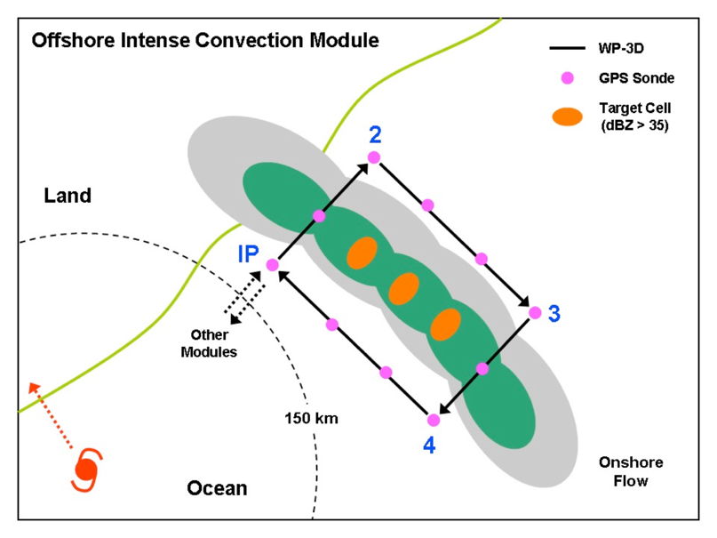

Fig. 1. Offshore Intense convection module.

Flight altitude: 10,000 ft. (3000m) or higher.
Leg lengths: > 75 km for each parallel leg.
Estimated in-pattern flight duration: 1-2 h.
Expendable distribution: Deploy GPS dropwindsondes at the start or end points of each leg, at the band axis crossing points, and at ~20-25 km intervals along each leg parallel to the band. At least 2 dropwindsondes should be deployed on either side of the convection and at least 1 dropwindsonde should be deployed each time the band-axis is crossed (for a minimum of 6 dropwindsondes).
Instrumentation Notes: Set airborne Doppler to scan in F/AST mode on all legs. Aircraft should avoid penetration of intense reflectivity regions (particularly over land).

P-3 Module 2: Coastal Survey Module
What to Target: A tropical storm or hurricane that is forecast to make landfall along the U.S coastline.
When to Target: This module should be performed within ~6-12-h of the time of landfall.
Pattern: Break-away/non-standard (see Fig. 2 below and description below):

Fig. 2 shows a sample Coastal Survey pattern for a hurricane landfall near Melbourne, Florida. The P-3 would fly parallel but ~10-15 km offshore so that the SFMR footprint is out of the surf zone. The second pass should be parallel and as close to the coast as safety permits. Finally, a short leg would be flown from the coast spiraling towards the storm center.

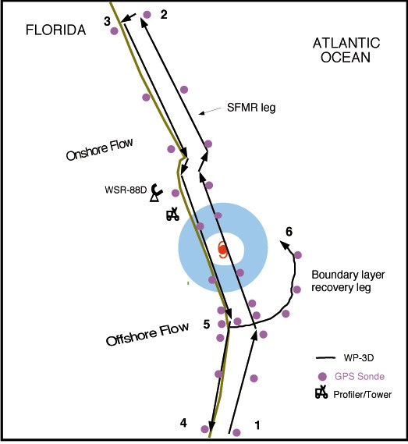
Fig. 2. Coastal Survey module

Flight altitude: 5000 ft. (1.5 km) for first pass and then climb to slightly higher altitude (~7,500 ft.) if needed for second pass.
Leg lengths: ~150 km.
Estimated in-pattern flight duration: ~2 h.
Expendable distribution: Dropwindsondes at RMW, and 12.5, 25, 50, 75, 100 km from RMW on either side of storm in both the near shore and offshore legs that are to be flown parallel to the shoreline. Dropwindsondes should be deployed quickly at start of outbound leg between near shore and offshore parallel legs and then every 10-15 km thereafter.
Instrumentation Notes: Set airborne Doppler on all legs in FAST Aircraft should avoid penetration of intense reflectivity regions (particularly those overland).
P-3 Module 3: Real-time Module
What to Target: A hurricane that is forecast to make landfall along the U.S coastline.
When to Target: This module should be performed within ~6-12-h of the time of landfall.
Pattern: Break-away/non-standard (see Fig. 3 and description below):

Fig. 3 shows a sample Real-time module flight pattern. The P-3 descends at the initial point and begins a low- level figure-4 pattern, possibly modifying the legs to fly over buoy or C-MAN sites if possible. If time permits, the P-3 would make one more pass through the eye and then fly the Dual-Doppler option.
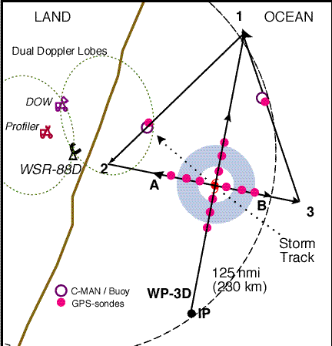

Fig. 3. Real-time module.

Flight altitude: Below 5,000 ft. (1.5 km) (or the lowest level deemed to be safe by flight personnel).
Leg lengths: ~ 185 km.
Estimated in-pattern flight duration: ~-2-3 h.
Expendable distribution: Dropwindsondes should be released near buoys or C-MAN sites (if possible) and at or just inside the flight-level RMW.
Instrumentation Notes: Set airborne Doppler on all legs in F/AST mode. It is essential that these passes be flown as straight as possible, because turns to fix the eye will degrade the Doppler radar coverage.

