15. Tropical-Cyclone-Ocean Interaction Experiment

Principal Investigator(s): Nick Shay (U. Miami/RSMAS), Jun Zhang (NOAA/HRD), Rick Lumpkin (NOAA/PhOD), George Halliwell (NOAA/PhOD), Elizabeth Sanabia (USNA), and Benjamin Jaimes (U.Miami/RSMAS)

Mission Description: Sample the sea surface temperature, ocean temperature and salinity profiles, air-sea temperature and humidity contrast within and around a tropical cyclone.

P-3 Module 1 (Gulf of Mexico warm eddy pre- or post-storm survey)
What to Target: Sample the LC and associated eddy field.
When to Target: Pre- and post-storm.
Pattern: as in Fig. 1
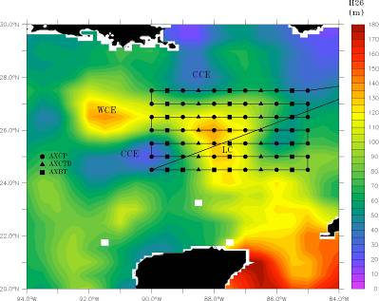

Figure 1: Typical pre- or post-storm pattern with ocean expendable deployment locations relative to the Loop Current. Specific patterns will be adjusted based on actual and forecasted storm tracks and Loop Current locations. Missions generally are expected to originate and terminate at AOC.

Flight altitude: 6-8k ft preferable.
Leg length or radii: 250 n mi
Estimated in-pattern flight duration: ~ 8 h
Expendable distribution: a total of 60-80 aircraft ocean expendables (AXBTs, AXCPs, and AXCTDs)
Instrumentation Notes: Use straight flight legs as safety permits.

P-3 Module 2 (Gulf of Mexico warm in-storm survey)
What to Target: Sample the core region of a TC and LC eddy field.
When to Target: In storm, no constraint
Pattern: as in Fig. 2

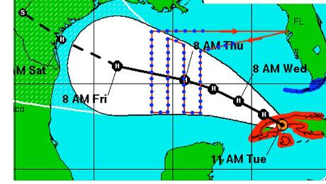

Figure 2: Track-dependent AXBT/AXCTD ocean survey. As for the Loop Current survey, a total of 40 probes would be deployed on a grid (blue dots).
Flight altitude: 8-10 kft
Leg length or radii: 105 n mi
Estimated in-pattern flight duration: ~ 4 h 45 min for Figure-4 + Rotated Figure-4 (45 n mi legs)
Expendable distribution: A total of 40 aircraft ocean expendables (AXBTs, AXCPs, and AXCTDs).
Instrumentation Notes: Use straight flight legs as safety permits.

P-3 Module 3 (pre-storm Atlantic Ocean survey)
What to Target: Region before storm pass by based NHC’s best track.
When to Target: 48 hours prior to forecast arrival
Pattern: as in Fig.3
Figure 3: Left: NHC official forecast track, which pre-storm ocean sampling region highlighted. Target region is centered ~48 hours prior to forecast arrival of storm. Right: P-3 flight track (red line) and ocean sampling pattern consisting of a grid of AXCTD/AXBT probes Probes are deployed at ~0.5 deg. intervals. Total time for this pattern is estimated to be ~9 hours.
Flight altitude: 6-8 kft preferable for best dropsonde coverage
Leg length or radii: 105 n mi
Estimated in-pattern flight duration: ~ 5 h
Expendable distribution: 50 aircraft ocean expendables
Instrumentation Notes: Use straight flight legs as safety permits.

P-3 Module 4 (In storm survey)
What to Target: Sample the core region of a TC
When to Target: no constraint
Pattern: Rotated Figure-4.
Flight altitude: 10 kft preferable for best dropsonde coverage
Leg length or radii: 105 n mi
Estimated in-pattern flight duration: ~ 5 h
Expendable distribution: 20 to 30 aircraft ocean expendables
Instrumentation Notes: Use straight flight legs as safety permits.

P-3 Module 5 (post storm Ocean survey)
What to Target: Sample the core region of a TC
When to Target: post storm
Pattern: as in Fig. 4
Figure 4: Left: Post-storm ocean sampling flight pattern (red line), over previously-sampled area (black box). In this example, the pattern extends around 470 km in the along-track dimension, or around 0.75 of a near-inertial wavelength. Right: Flight pattern with expendable drop locations, consisting of a combination of AXCP and AXBT probes.

Flight altitude: 8 kft preferable for best dropsonde coverage
Leg length or radii: 105 n mi
Estimated in-pattern flight duration: ~ 5 h
Expendable distribution: 30 -40 aircraft ocean expendables (AXCPs and AXBTs)
Instrumentation Notes: no constraint

P-3 Module 6 (Coordinated float/drifter deployment overflight mission)
What to Target: Sample the core region of a TC.
When to Target: In storm, no constraint
Pattern: As in Fig. 5
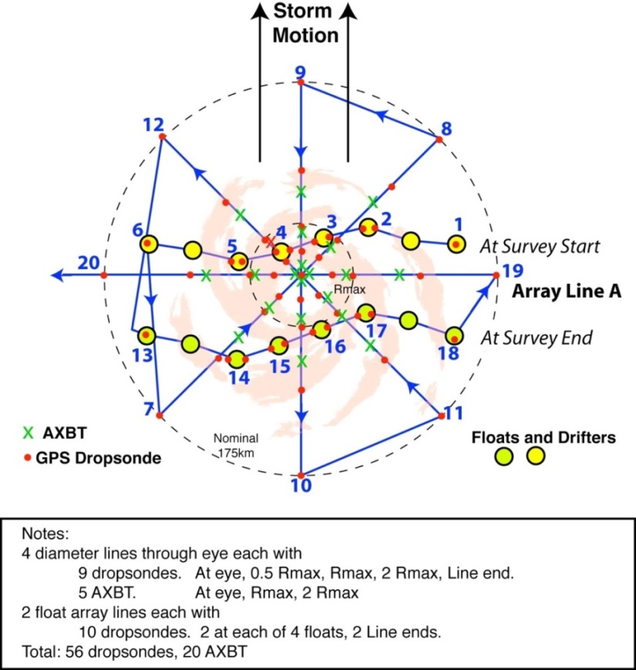

Figure 5: P-3 pattern over float and drifter array. The array has been distorted since its deployment on the previous day and moves relative to the storm during the survey. The pattern includes two legs along the array (waypoints 1-6 and 13-18) and an 8 radial line survey. Dropwindsondes are deployed along all legs, with double deployments at the floats. AXBTs are deployed in the storm core.

Flight altitude: 10-12 kft preferable for best dropsonde coverage
Leg length or radii: 105 n mi
Estimated in-pattern flight duration: ~ 4 h 45 min for Figure-4 + Rotated Figure-4 (45 n mi legs)
Expendable distribution: 56 sondes and 20 aircraft ocean expendables
Instrumentation Notes: Use straight flight legs as safety permits.

