12. Analysis of Intensification Processes Experiment (AIPEX)

Principal Investigator(s): Jon Zawislak (FIU/HRD), Robert Rogers, Leon Nguyen (NRC/HRD), John Kaplan, Jason Dunion, Paul Reasor, and Jun Zhang

Mission Description: Collect precipitation, kinematic, thermodynamic, and ocean observations within the environment, near environment (~100 km, or 60 nmi), and inner core regions of tropical cyclones (TCs) that have a reasonable potential for intensification (based on statistical and/or numerical model forecast guidance), with a particular focus on the early stages (i.e., TD, TS, weak hurricane). When possible (i.e., subject to range, timing, and other logistical constraints), missions will begin at least 24 h prior to the expected onset of intensification.

G-IV Module 1
What to Target: Sample the environment and near environment of the TC
When to Target: Every 12 h [optimal] or every 24 h [minimal], preferably in coordination with a corresponding P-3 mission (P-3 Module 1).
Pattern: G-IV Circumnavigation (octagon [optimal], hexagon [minimal]). Should be storm centered and oriented such that the left and right of shear semicircles are sampled equally by dropsondes.
Flight altitude: 40–45 kft
Leg length or radii: 200 n mi (370 km), 120 n mi (222 km), and 60 n mi (111 km) (radii). The innermost radii can be adjusted outward if necessitated by hazard avoidance (outer two radii rings should be similarly adjusted, if time allows).
Estimated in-pattern flight duration: ~ 5–6 h
Expendable distribution: Dropsonde at each turn point; 24 in total (octagon) [optimal], or 18 in total (hexagon) [minimal]
Instrumentation Notes: Use TDR defaults. Use straight flight legs as safety permits.

G-IV Module 2
What to Target: Sample the surrounding environment of the TC
When to Target: Every 12 h [optimal] or every 24 h [minimal]
Pattern: G-IV Star (with circumnavigation if no coordination with P-3)
Flight altitude: 40–45 kft
Leg length or radii: 210 n mi (388 km) outer, 90 n mi (167 km) inner radii (standard). Depending on the time of day, aircraft duration limitations, and safety considerations, the lengths of the inner (outer) points could be shortened (extended) if an opportunity to sample a diurnal pulse presents itself (see TC Diurnal Cycle Experiment).
Estimated in-pattern flight duration: ~ 4 h (~ 5 h with circumnavigation)
Expendable distribution: Dropsonde at each turn point; 13 dropsondes total (20 with circumnavigation)
Instrumentation Notes: Use TDR defaults. Use straight flight legs as safety permits.

P-3 Module 1
What to Target: Sample the inner core region of a TC
When to Target: Every 12 h [optimal] or every 24 h [minimal], preferably in coordination with a corresponding G-IV mission (G-IV Module 1 or G-IV Module 2).
Pattern: Rotated Figure-4
Flight altitude: [optimal] 10–12 kft (5 kft is minimum altitude for dropsonde launches)
Leg length or radii: 105 n mi
Estimated in-pattern flight duration: ~ 5 h
Expendable distribution:
[optimal] (up to 28 dropsondes total) Modify standard by moving the mid-point dropsonde to half the radius of innermost G-IV radii. AXBTs preferably paired with dropsondes at mid- and turn points and center. If radius of maximum wind (RMW) is significantly different (> 10 n mi) from any of the standard dropsonde locations, release dropsonde there, and also release dropsonde at 1.5 x RMW, subject to same constraint regarding proximity to standard dropsonde locations. No AXBTs need to be coordinated with these RMW-based drops.
[minimal] (10–12 dropsondes total) Modify standard as stated in [optimal], keeping only midpoint drops, as well as center drops on the first and last pass. AXBTs preferably paired with dropsondes at midpoints and center.
Instrumentation Notes: Use TDR defaults. Use straight flight legs as safety permits. Inbound-outbound passes should be uninterrupted. DWL should be downward looking, 20° off nadir.

P-3 Module 2 (No coordination with the G-IV; TC experiencing a Precipitation Asymmetry)
What to Target: Sample the inner core and near environment regions of a TC when the inner core precipitation distribution is asymmetric and when the G-IV is not available for coordination
When to Target: Every 12 h [optimal] or every 24 h [minimal]
Pattern:
[optimal] P-3 Circumnavigation with rotated Figure-4 (modified from the standard)
[minimal] P-3 Circumnavigation with single Figure-4 (standard)
Note: The circumnavigation can be adjusted for hazard avoidance; e.g., if pattern in downshear hemisphere is not possible, the circumnavigation can be abbreviated to the upshear hemisphere with a pass over the center (see example below: Figure-4 in green, circumnavigation in orange, shear vector heading in black, ‘X’ is a dropsonde location):
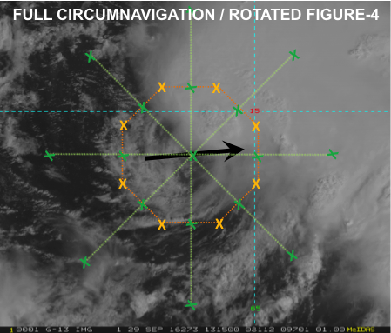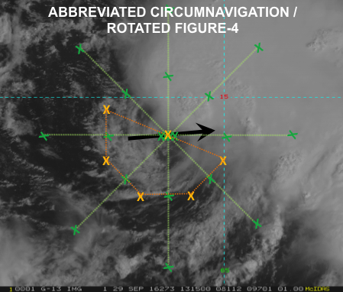

Flight altitude: Figure-4: [optimal] 10–12 kft (5 kft is minimum altitude for dropsonde launches). Circumnavigation: As high as possible [optimal] above 25 kft [minimal]
Leg length or radii: 105 n mi (leg length). Radius of circumnavigation is preferably as close to the inner-core precipitation shield as safety allows.
Estimated in-pattern flight duration: [optimal] Circumnavigation with rotated Figure-4, ~6 h; [minimal] Circumnavigation with single Figure-4, ~ 4 h
Expendable distribution:
[optimal] Use the standard for P-3 circumnavigation (8 dropsondes), as well as for rotated Figure-4 (20 dropsondes, 28 total with circumnavigation) or single Figure-4 (10 dropsondes, 18 total with circumnavigation). AXBTs preferably paired with dropsondes at mid- and turn points and center.
[minimal] Use the standard for P-3 circumnavigation (8 dropsondes), and modify standard Figure-4 by keeping only turn point drops, as well as center drops on the first and last pass (for rotated Figure-4, 10 dropsondes, 18 total with circumnavigation; for single Figure-4, 6 dropsondes, 14 total with circumnavigation). AXBTs preferably paired with dropsondes at turn points and center.
Instrumentation Notes: Use TDR defaults. Use straight flight legs as safety permits. Inbound-outbound passes should be uninterrupted. DWL should be downward looking, 20° off nadir.

