5. Small Unmanned Aerial VEhicle Experiment (SUAVE)

Principal Investigator and Co-Investigators: J. Cione, J, Zhang, L. Bucci, K. Ryan, E. Kalina, A. Aksoy, H. Holbach, G. Bryan, E. Konopleva

Mission Description: Sample the boundary layer wind velocities, temperature and humidity within and around a tropical cyclone.

P-3 Module 1 (UAS Eye/Eyewall)
What to Target: Sample the core region of a TC.
When to Target: after the hurricane eye is formed.
Pattern: (3 slice) pizza pie pattern (see figure 1)
Flight altitude: 12 kft preferable for best dropsonde coverage (10 kft if required for AXBT launch)
Leg length or radii: 105 n mi
Estimated in-pattern flight duration: ~ 1 h
Expendable distribution: A total of 13 sondes (for a 3 slice pattern) with 6 AXBTs are required. All turn points (6) and eyewall penetrations (6) will have dropsondes. There will also be 1 dropsonde in the eye at the center. For this module, IR sondes are used at all turn points and for the center drop. For the eyewall drops, regular sondes are deployed with combo AXBTs. Note: For a 2 pizza slice pattern (not shown) 9 sondes (5 IR, 4 regular) and 4 AXBTs would be required.
Instrumentation Notes: Use straight flight legs as safety permits.
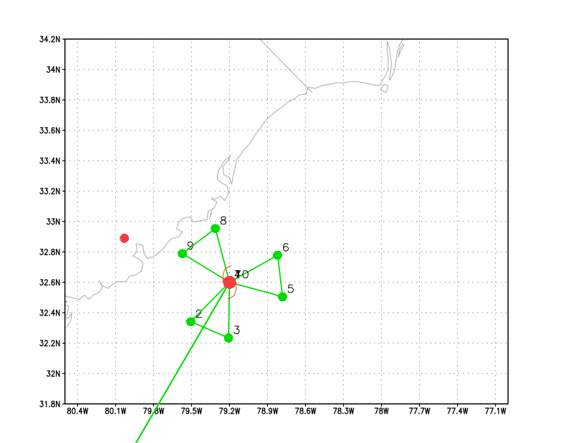
Figure 1: Pizza slice flight pattern for the eye/eyewall coyote experiment

P-3 Module 2 (UAS inflow module)
What to Target: Sample the inflow layer of a TC.
When to Target: no constraint.
Pattern: lawn mower pattern (see figure 2)
Flight altitude: 12 kft preferable for best dropsonde coverage (10 kft if required for AXBT launch)
Leg length or radii: 105 n mi
Estimated in-pattern flight duration: ~ 1 h
Expendable distribution: Drop one sonde each time P3 overpasses the Coyote (points 4, 7, 10, 13) and at select turn points (3, 6, 9, 12). A total of 8 drops are estimated. IRsondes are preferred for this experiment. Up to 3 AXBTs may be deployed as well (LPS discretion).
Instrumentation Notes: Use straight flight legs as safety permits.
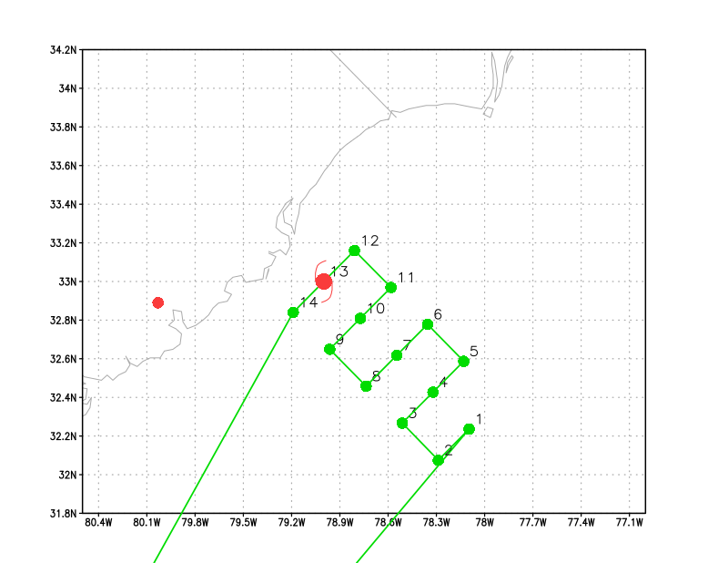
Figure 2: lawn mower flight pattern for the inflow coyote experiment.

Coyote Module 1 (Boundary Layer)
What to Target: Sample the low level boundary of a TC away from the inner core.
When to Target: no constraint.
P-3 and UAS Pattern: stepped descent (see figure 3).
Flight altitude: P3 deploys Coyote at 10 kft then descents to 3 kft.
Leg length or radii: 30 n mi
Estimated in-pattern flight duration: ~ 1 h
Expendable distribution: 5 IR sondes BT combos launched (one combo per P-3 flight level). Up to 3 AXBTs may be deployed as well (LPS discretion).
Instrumentation Notes: Use straight flight legs as safety permits.
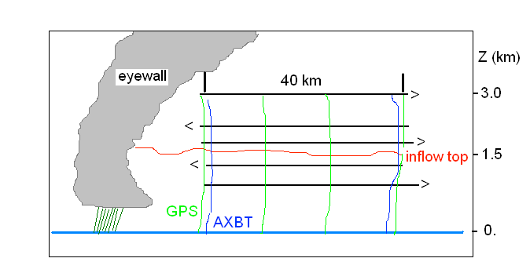
Figure 3. Vertical cross-section of the stepped-descent module. P3 pattern is in black, low altitude Coyote UAS in heavy blue.

Coyote Module 2 (Turblulence/Eddy Dissipation)
What to Target: Sample the near-surface boundary layer of a TC in order to collect measurements of eddy dissipation rate in strong wind conditions (35 m s⁻¹ or greater),
When to Target: no constraint.
UAS Pattern: descent (see figure 4)
Flight altitude: No P-3 requirement other than to remain in comms range of UAS
Leg length or radii: N/A
Estimated in-pattern flight duration: N/A
Expendable distribution: N/A
Instrumentation Notes: N/A

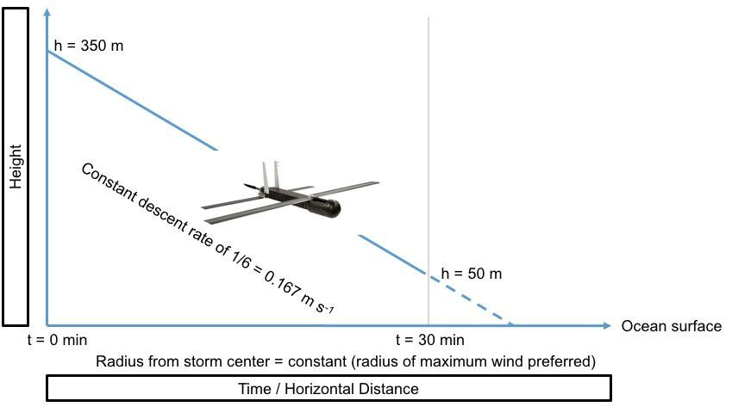

Figure 4: Eddy dissipation measurements. The Coyote begins the experiment at a height of 350 m, descends at a constant rate of 1/6 = 0.167 m s⁻¹, and reaches a height of 50 m after 30 minutes. The entire descent is conducted at a constant radius from the storm center (preferably at the radius of maximum wind).

