4. Doppler Wind Lidar (DWL) Experiment

Principal Investigator(s): Lisa Bucci, Jun Zhang, Kelly Ryan, Christopher O’Handley (SWA), G. David Emmitt (SWA), Jason Dunion, Robert Atlas (AOML)

Mission Description: Continuously collect wind observations using the DWL in and near various types of tropical cyclones. Target areas previously unobserved (or sporadically observed) like regions with low or no precipitation, in the boundary layer, between eyewalls and rainbands, etc.

P-3 Module 1: Asymmetric Tropical Cyclone
What to Target: A sheared TC with an asymmetric distribution of precipitation
When to Target: Any strength TC; no land or time of day restrictions
Pattern: Any standard pattern that provides symmetric coverage (Rotated Figure-4, butterfly, etc)
Flight altitude: 10,000-12,000 feet. Not below 1000 feet.
Leg length or radii: Standard leg length (105 n mi)
Estimated in-pattern flight duration: 2-5 hours
Expendable distribution: Standard distribution (eye, RMW/midpoints, endpoints)
Instrumentation Notes: Four scans at down 20 with a 5 second nadir followed by one scan up 20 with 5 second vertical. If signal strength in the up scan is very weak, only scan downward.

P-3 Module 2: Secondary EyeWall/Moat Region
What to Target: The moat region between either an existing eyewall and a secondary eyewall or an eyewall and rainband. Avoid optically thick, deep convection-- fly between the deep convection from each feature.
When to Target: Stronger, more organized TCs with an existing eye
Pattern: Circumnavigation
Flight altitude: 10,000-12,000 feet. Not below 1000 feet
Leg length or radii: The radii between two eyewalls or eyewall and rainband
Estimated in-pattern flight duration: Approximately 1 hour (depending on storm size)
Expendable distribution: 4 dropsondes-- 1 centered in each quadrant
Instrumentation Notes: Two scans at down 20 with a 5 second nadir followed by one scan up 20 with 5 second vertical. If signal strength in the up scan is very weak, only scan down.

P-3 Module 3: Transit/Saharan Air Layer (SAL)
What to Target: Interaction between a TC and SAL (if present) or the environment en route to/from TC.
When to Target: No lifecycle or time of day requirements. Although not a requirement, conducting this module on the ferry back from the storm is advantageous, since the P-3 will have burned off fuel and will be able to climb to a slightly higher flight altitude.
Pattern: In presence of SAL, ensure entrance/exit point from transit transects SAL as shown in figure below
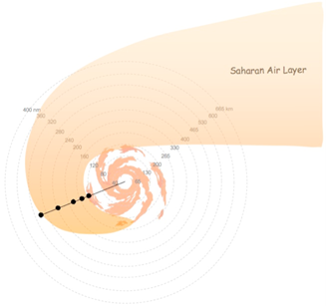
Flight altitude: Maximum allowable altitude (~20,000 feet)
Leg length or radii: Not applicable
Estimated in-pattern flight duration: Since this module will take advantage of the ferry to/from the storm, it will add ~0-15 min to the total mission duration.
Expendable distribution: In the presence of SAL, up to 5 dropsondes should be deployed spaced 50-75 nm farther away from the TC. These expendables are needed to determine the exact location and extent of the kinematics and thermodynamics associated with the SAL that is interacting with the TC.
Instrumentation Notes: DWL operated in DN 20 mode (12 point stepstare)

P-3 Module 4: Boundary Layer
What to Target: TC boundary layer in all quadrants
When to Target: Any strength TC; no land or time of day restrictions
Pattern: Any standard pattern that provides symmetric coverage (Rotated Figure-4, butterfly, etc)
Flight altitude: 10,000-12,000 feet. Not below 1000 feet
Leg length or radii: Standard leg lengths
Estimated in-pattern flight duration: 2-5 hours
Expendable distribution: Standard dropsonde distribution
Instrumentation Notes: DWL operated in DN 20 mode (12 point stepstare) with 5 second vertical stare between 360 degree scans.

P-3 Module 5: High Winds
What to Target: Regions of high wind (35 m/s or higher) with few optically thick clouds. For example, a break in the convection in an eyewall.
When to Target: When a TC is at or near hurricane strength
Pattern: Short radials as shown below. Red represents RMW, black is flight track, green X is dropsonde location, blue are optically thick clouds. Pattern can be repeated.
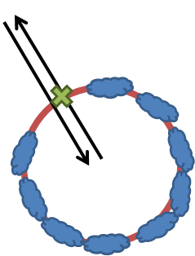
Flight altitude: 10,000-12,000 feet. Not below 1000 feet
Leg length or radii: ~50 km (depending on storm size)
Estimated in-pattern flight duration: 30 minutes to 1 hour
Expendable distribution: Ideally one dropsonde per out-and-back radial for the purpose of validating the P3DWL measurements
Instrumentation Notes: DWL operated in DN 20 mode (12 point stepstare) with 5 second vertical stare between 360 degree scans. DWL also can be operated in forward sweep (9 point stepstare). Dropsondes need to be released in a cloud free region.

P3 Module 6: Mass flux budget reference cell
What to Target: Regions of low winds (20 m/s or lower) with very few optically thick clouds
When to Target: During ferry flight to convective target.
Pattern: 50km box
Flight altitude: Ferry leg altitude,
Leg length or radii: 50km box (200km total with 90 degree turns)
Estimated in-pattern flight duration: ~ 25 minutes (at 260 Kts GND). Could be less at higher P3 cruise speeds.
Expendable distribution: One dropsonde per leg for a total of 4.
Instrumentation Notes: DWL operated in DN 20 mode (12 point stepstare) with 5 second vertical stare between 360 degree scans.

