**2015 Hurricane Field Program Plan**

**Part II: Appendices**

Table of Contents

**APPENDIX A**…………………………………………………………………………………………. 3

Decision and Notification Process………………………………………………………………. 3

**APPENDIX B: CALIBRATION**………….……….……….………….……….……….……….….. 7

B.1 En-route Calibration of Aircraft Systems…………………………………………………... 7

**APPENDIX C: DOD/NWS RAWIN/RAOB AND NWS COASTAL LAND-BASED RADARS**... 8

**APPENDIX D: PRINCIPAL DUTIES OF THE NOAA SCIENTIFIC PERSONNEL**………….. 10

**APPENDIX E: NOAA RESEARCH OPERATIONAL PROCEDURES AND CHECK LISTS**... 14

E.1 “Conditions-of-Flight” Commands…………………………………………………………. 15

E.2 Lead Project Scientist………………………………………………………………………. 16

E.3 Cloud Physics Scientist……………………………………………………………………... 23

E.4 Boundary Layer Scientist…………………………………………………………………… 25

E.5 Radar Scientist……………………………………………………………………………… 28

E.6 Dropsonde Scientist………………………………………………………………………… 31

**APPENDIX F: SYSTEMS OF MEASURE AND UNIT CONVERSION FACTORS**…………… 34

**APPENDIX G: AIRCRAFT SCIENTIFIC INSTRUMENTATION**……………………………… 35

**APPENDIX H: NOAA EXPENDABLES** ..................................................…………………………. 37

**APPENDIX I: OPERATIONAL MAPS** …………………………………………………………….. 38

Map 1: Primary Atlantic operating bases and operating ranges (P-3)…………………………… 38

Map 2: Primary Atlantic operating bases and operating ranges (G-IV) ………………………… 39

**APPENDIX J: FLIGHT PATTERNS**……………………………………………………………….. 40

J.1 Patterns from Experiments…………………………………………………………………… 40

P-3 Lawnmower pattern………………………………………………………………….. 40

P-3 Box spiral pattern……………………………………………………………………. 41

P-3 Figure-4 pattern……………………………………………………………………… 42

P-3 Rotating figure-4 pattern……………………………………………………………. 43

P-3 Butterfly pattern…………………………………………………………………….. 44

G-IV Square spiral pattern………………………………………………………………. 45

G-IV Rotating figure-4 pattern………………………………………………………….. 46

G-IV Surveillance/TDR combination pattern…………………………………………… 47

G-IV RAPX pattern (optimal dropsonde)……………………………………………….. 48

G-IV RAPX pattern (optimal radar)……………………………………………………. 49

G-IV Shear pattern…………………………………………………………………….. 50

P-3 Shear Figure-4/circumnavigation pattern…………………………………………. 51

G-IV Diurnal cycle star pattern………………………………………………………… 52

P-3 Pre- or post-storm Ocean survey pattern………………………………………….. 53

P-3 In-storm Ocean survey pattern (over existing drifter array)………………………. 54

J.2 Patterns from Modules………………………………………………………………………. 55

P-3 DWL SAL module…………………………………………………………………. 55

P-3 DWL Box module…………………………………………………………………. 56

P-3 SUAVE eye/eyewall module………………………………………………………. 57

P-3 SUAVE PBL entrainment flux module……………………………………………. 58

P-3 SFMR-HI module…………………………………………………………………. 59

P-3 Offshore intense convection module……………………………………………… 60

P-3 Coastal survey module……………………………………………………………. 61

P-3 Real-time module…………………………………………………………………. 62

P-3 Convective burst module…………………………………………………………. 63

P-3/G-IV Arc cloud module………………………………………………………….. 64

P-3 Arc cloud module (multi-level option)…………………………………………. 65

P-3 Offshore wind module…………………………………………………………… 66

**ACRONYMS AND ABBREVIATIONS**……………………………………………………………. 67

**2015**

**Hurricane Field Program Plan**

**Part II**

**Appendix A**

**DECISION AND NOTIFICATION PROCESS**

The decision and notification process is illustrated in Figs. A-1, A-2, and A-3. This process occurs in four steps:

1) A research mission is determined to be probable within 72 h [field program director]. Consultation with the director of HRD, and the AOC Project Manager determines: flight platform availability, crew and equipment status, and the type of mission(s) likely to be requested.

2) The Field Program Advisory Panel [F. Marks (Director, HRD), R. Rogers (Director, Hurricane Field Program), J. Dunion, M. Black, J. Cione, J. Gamache, J. Kaplan, P. Reasor, S. Murillo, J. Zhang and J. McFadden (or AOC designee) meets to discuss possible missions and operational modes. Probable mission determination and approval to proceed is given by the HRD director (or designee).

3) Primary personnel are notified by the Hurricane Field Program Director [R. Rogers].

4) Secondary personnel are notified by their primary affiliate (Table A-2).

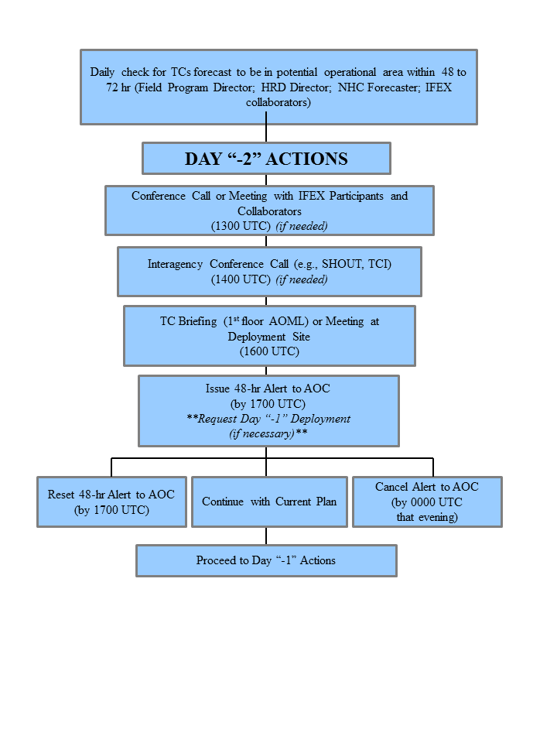

Fig. A-1: Decision and notification process for Day “-2”.

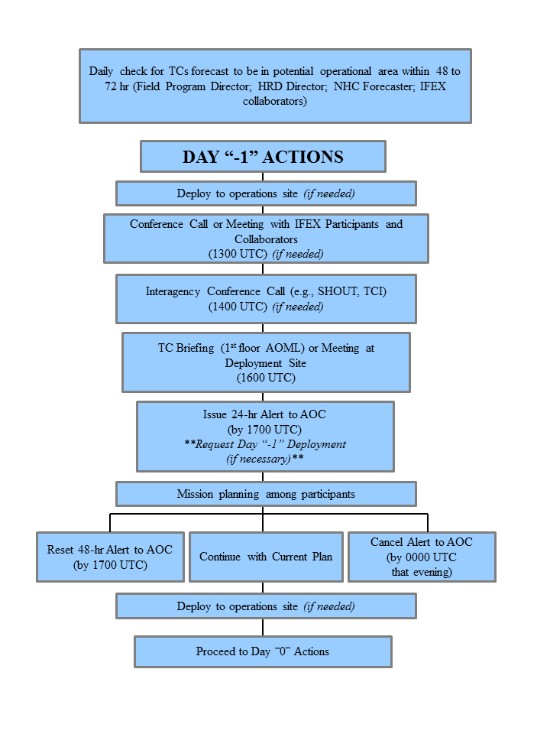

**Note: Time of briefings, conference calls, decisions, and deployments are dictated by timing limitations imposed by the AOC crew.

Fig. A-2: Decision and notification process for Day “-1”

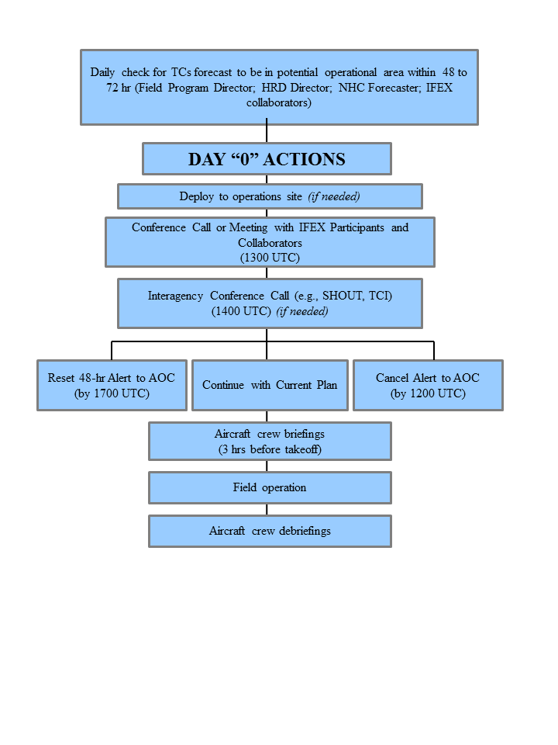

**Note: Time of briefings, conference calls, decisions, and deployments are dictated by timing limitations imposed by the AOC crew.

Fig. A-3: Decision and notification process for Day “0”

**Appendix B:** **Calibration**

**B.1 En-Route Calibration of Aircraft Systems**

Instrument calibrations are checked by flying aircraft intercomparison patterns whenever possible during the hurricane field program or when the need for calibration checks is suggested by a review of the data. In addition, an over flight of a surface pressure reference is advisable en route or while on station when practicable. Finally, all flights enroute to and from the storm are required to execute a true airspeed (TAS) calibration pattern. This pattern is illustrated in Fig. B-1.

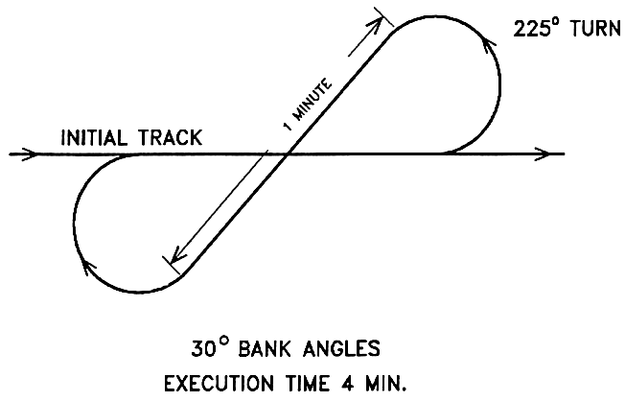

**Fig. B-1 En-Route TAS calibration pattern.**

Appendix C: DOD/NWS RAWIN/RAOB and NWS Coastal Land-based Radar Locations



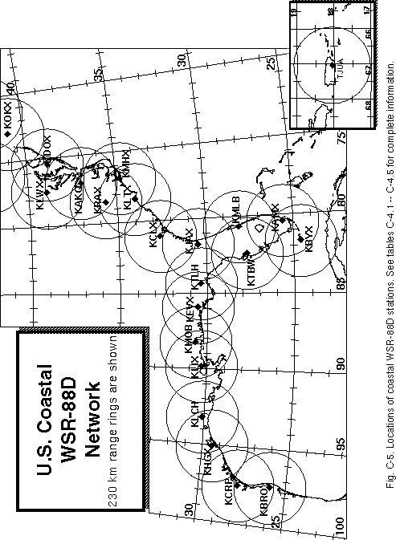

**APPENDIX D: PRINCIPAL DUTIES OF THE NOAA SCIENTIFIC PERSONNEL**

CAUTION

Flight operations are routinely conducted in turbulent conditions. Shock-mounted electronic and experimental racks surround most seat positions. Therefore, ***for safety*** ***onboard the aircraft all personnel should wear a flight suit and closed toed shoes***. For comfort, personnel should bring a jacket or sweater, as the cabin gets cold during flight.

Smoking is prohibited within 50 ft of the aircraft while they are on the ground. No smoking is permitted on the aircraft at any time.

Section 4-401, of the NOAA Safety Rules Manual state that: “Don’t let your attention wander, either through constant conversation, use of cell phone or sightseeing while operating vehicles. Drivers must use caution and common sense under all conditions. Operators and passengers are not permitted to smoke or eat in the government vehicles. Cell phone use is permitted while car is parked.”

GENERAL INFORMATION FOR ALL SCIENTIFIC MISSION PARTICIPANTS

Mission participants are advised to carry the proper personal identification [i.e., travel orders, "shot" records (when appropriate), and passports (when required)]. Passports will be checked by AOC personnel prior to deployment to countries requiring it. All participants must provide their own meals for in-flight consumption. AOC provides a refrigerator, microwave, coffee, utensils, condiments, ice, water, and soft drinks for a nominal fee per flight.

**D.1 Field Program Director/ IFEX Chief Scientist;**

(1) Responsible to the HRD director for the implementation of the Hurricane Field Program Plan.

(2) Only official communication link to AOC. Communicates flight requirements and changes in mission to AOC.

(3) Only formal communication link between AOML and CARCAH during operations. Coordinates scheduling of each day's operations with AOC only after all (POD) reconnaissance requirements are completed between CARCAH and AOC.

(4) Convenes the Hurricane Field Program Operations Advisory Panel. This panel selects missions to be flown.

(5) Provides for pre-mission briefing of flight crews, scientists, and others (as required).

(6) Assigns duties of field project scientific personnel. Ensures safety during the field program.

(7) Coordinates press statements with NOAA/Public Affairs.

**D.2 Assistant Field Program Director**

(1) Assumes the duties of the field program director in their absence.

**D.3 Named Experiment Lead Project Scientist**

(1) Has overall responsibility for the experiment.

(2) Coordinates the project and sub-project requirements.

(3) Determines the primary modes of operation for appropriate instrumentation.

(4) Assists in the selection of the mission.

(5) Provides a written summary of the mission to the field program director (or his designee) at the experiment's debriefing.

**D.4 Lead Project Scientist**

(1) Has overall scientific responsibility for his/her aircraft.

(2) Makes in-flight decisions concerning alterations of: (a) specified flight patterns; (b) instrumentation operation; and (c) assignment of duties to on-board scientific project personnel.

(3) Acts as project supervisor on the aircraft and is the focal point for all interactions of project personnel with operational or visiting personnel.

(4) Conducts preflight and post flight briefings of the entire crew. Completes formal checklists of safety, instrument operations - noting malfunctions, problems, etc.

(5) Provides a written report of each mission day's operations to the field program director at the mission debriefing.

**D.5 Cloud Physics Scientist**

(1) Has overall responsibility for the cloud physics project on the aircraft.

(2) Briefs the on-board lead project scientist on equipment status before takeoff.

(3) Determines the operational mode of the cloud physics sensors (i.e., where, when, and at what rate to sample).

(4) Operates and monitors the cloud physics sensors and data systems.

(5) Provides a written preflight and post flight status report and flight summary of each mission day's operations to the on-board lead project scientist at the post flight debriefing.

**D.6 Boundary-Layer Scientist**

(1) Insures that the required number of AXCPs, AXBTs, and AXCTDs are on the aircraft for each mission.

(2) Operates the AXCP, AXBT, and AXCTD equipment (as required) on the aircraft.

(3) Briefs the on-board lead project scientist on equipment status before takeoff.

(4) Determines where and when to release the AXCPs, AXBTs, and AXCTDs (as appropriate) subject to clearance by flight crew.

(5) Performs preflight, inflight, and post flight checks and calibrations.

(6) Provides a written preflight and post flight status report and a flight summary of each mission day's operations to the on-board lead project scientist at the post flight debriefing.

**D.7 Radar Scientist**

(1) Determines optimum meteorological target displays. Continuously monitors displays for performance and optimum mode of operations. Thoroughly documents modes and characteristics of the operations.

(2) Provides a summary of the radar display characteristics to the on-board lead project scientist at the post flight debriefing.

(3) Maintains tape logs.

(4) During the ferry to the storm, the radar scientist should record a tape of the sea return on either side of the aircraft at elevation angles varying from -20° through +20°. This tape will allow correction of any antenna mounting biases or elevation angle corrections.

**D.8 Dropsonde Scientist**

(1) Processes dropsondes observations on HRD workstation for accuracy.

(2) Provides TEMP drop message for ASDL, transmission or insures correct code in case of automatic data transmission.

**D.9 Workstation Scientist**

(1) Operates HRD's workstation.

(2) Runs programs that determine wind center and radar center as a function of time, composite flight-level and radar reflectivity relative to storm center and then process and code dropwindsonde observations.

(3) Checks data for accuracy and sends appropriate data to ASDL computer.

(4) Maintains records of the performance of the workstation and possible software improvements.

**APPENDIX E: NOAA RESEARCH OPERATIONAL PROCEDURES AND CHECK LISTS**

Hurricane Field Program Deployment Safety Checklist

The Field Program Director is responsible for making sure safety is enforced and ensuring necessary materials are in place and/or any actions have been completed before the start of the HFP. Field program participants are responsible for reviewing this checklist.

Scientist_______________________________ Date ______________

**Before leaving AOML**

_____ 1. Contact the HRD Field Program Director personnel to notify departure time.

_____ 2. Things to take

1. Flight bag (s)
2. Cell phone
3. List of HFP important numbers
4. HRD Field program plan
5. Flight suit

**Ground transportation**

_____ 1. Arrange for ground transportation

_____ 2. Visual inspection of government vehicle

1. Make sure tires do not appear to be flat
2. Check for any cracked/broken lights, windshield and mirrors
3. Check for any major dents around the vehicle

_____ 3. Inspection inside the government vehicle

1. Check all lights work properly (head and tail lights, dome lights, dashboard and turn signal lights)
2. Make sure the engine, oil, or temperature indicator light does not flash. *If so, contact facilities management.*

c. **Note** the gas and mileage

_____ 4. Contents inside the government vehicle

1. Make sure there is first aid kit and fire extinguisher
2. Proper jack and lug wrench
3. Spare tire
4. Basic auto repair kit (i.e. road hazard reflector or flares)
5. *Consider carrying a flashlight*

_____ 5. If possible, return vehicle with full tank (regular unleaded gasoline)

_____ 6. Contact the HRD Field Program Director personnel upon returning

**E.1 "Conditions-of-Flight" Commands**

Mission participants should be aware of the designated "conditions-of-flight." There are five designated basic conditions of readiness encountered during flight. The pilot will set a specific condition and announce it to all personnel over the aircraft's PA (public address) and ICS (interphone communications systems). All personnel are expected to act in accordance with the instructions for the specific condition announced by the pilot. These conditions and appropriate actions are shown below.

**CONDITION 1**: TURBULENCE/PENETRATION. All personnel will stow loose equipment and fasten safety belts.

**CONDITION 2**: HIGH ALTITUDE TRANSIT/FERRY. There are no cabin stations manning requirements.

**CONDITION 3**: NORMAL MISSION OPERATIONS. All scientific and flight crew stations are to be manned with equipment checked and operating as dictated by mission requirements. Personnel are free to leave their ditching stations.

**CONDITION 4**: AIRCRAFT INSPECTION. After take-off, crew members will perform wings, engines, electronic bays, lower compartments, and aircraft systems check. All other personnel will remain seated with safety belts fastened and headsets on.

**CONDITION 5**: TAKE-OFF/LANDING. All personnel will stow or secure loose equipment, don headsets, and fasten safety belts/shoulder harnesses.

**E.2 Lead Project Scientist**

**E.2.1 Preflight**

_____ 1. Participate in general mission briefing.

_____ 2. Determine specific mission and flight requirements for assigned aircraft.

_____ 3. Determine from field program director whether aircraft has operational fix responsibility and discuss with AOC flight director/meteorologist unless briefed otherwise by field program director.

_____ 4. Contact HRD members of crew to:

1. Assure availability for mission.
2. Review field program safety checklist

c. Arrange ground transportation schedule when deployed.

d. Determine equipment status.

_____ 5. Meet with AOC flight director and navigator at least 3 hours before take-off for initial briefing.

_____ 5. Meet with AOC flight crew at least 2 hours before take-off for crew briefing. Provide copies of flight requirements and provide a formal briefing for the flight director, navigator, and pilots.

_____ 6. Report status of aircraft, systems, necessary on-board supplies and crews to appropriate HRD Field Program Director.

_____ 7. Before take-off, brief the on-board GPS dropsonde operator on times and positions of drop times.

_____ 7. Make sure each HRD flight crew members have life vests

_____ 7. Perform a headset operation check with all HRD flight crew members. Make sure everyone can hear and speak using the headset.

_____ 8. Collect “mess” fee (generally ~$2.00) from all on-board HRD flight crew members as needed.

**E.2.2 In-Flight**

_____ 1. Confirm from AOC flight director that satellite data link is operative (information).

_____ 2. Confirm camera mode of operation.

_____ 3. Confirm data recording rate.

_____ 4. Complete Lead Project Scientist Form.

_____ 5. Check in with the flight director to make sure the mission is going as planned (i.e. turns are made when they are supposed to be made).

**E.2.3 Post flight**

_____ 1. Debrief scientific crew.

_____ 2. Report landing time, aircraft, crew, and mission status along with supplies (tapes, *etc.*) remaining aboard the aircraft to the HRD Field Program Director.

_____ 3. Gather completed forms for mission and turn in at the appropriate operations center. [**Note**: all data removed from the aircraft by HRD personnel should be cleared with the AOC flight director.]

_____ 4. Obtain a copy of the 10-s flight listing from the AOC flight director. Turn in with completed forms.

_____ 5. Obtain a copy of the radar DAT tapes and if possible a copy of the radar data-packet files should be copied onto a flash drive. Turn in with completed forms.

_____ 6. Obtain a copy of the all VHS videos form aircraft cameras (3-4 approx.). Turn in with completed forms.

_____ 7. Obtain a copy of CD with all flight data. Turn in with completed forms.

_____ 8. Determine next mission status, if any, and brief crews as necessary.

_____ 9. Notify HRD Field Program Director as to where you can be contacted and arrange for any further coordination required.

_____ 10. Prepare written mission summary using **Mission Summary** form (due to Field Program Director 1 week after the flight).

**Form E-2**

Page 1 of 5

**Lead Project Scientist Check List**

**Date _______________ Aircraft ______________ Flight ID ____________________**

**A. —Participants:**

|  |  |  |  |  |
| --- | --- | --- | --- | --- |
| **HRD** | |  | **AOC** | |
| **Function** | **Participant** |  | **Function** | **Participant** |
| Lead Project Scientist |  |  | Flight Director |  |
| Radar |  |  | Pilots |  |
| Workstation |  |  | Navigator |  |
| Cloud Physics |  |  | Systems Engineer |  |
| Photographer/Observer/Guests |  |  | Data Technician |  |
| Dropwindsonde |  |  | Electronics Technician |  |
| AXBT/AXCP |  |  | Other |  |

**B. Take-off and Landing Locations:**

Take-Off: ________ Location: _______________

Landing: ________ Location: _________________

Number of Eye Penetrations: ______

**C. Past and Forecast Storm Locations:**

|  |  |  |  |  |
| --- | --- | --- | --- | --- |
| **Date/Time** | **Latitude** | **Longitude** | **MSLP** | **Maximum Wind** |
|  |  |  |  |  |
|  |  |  |  |  |
|  |  |  |  |  |
|  |  |  |  |  |
|  |  |  |  |  |

**D. Mission Briefing:**

**Form E-2**

Page 2 of 5

**E. Equipment Status** (Up ****, Down ****, Not Available **—**, Not Used **O**)

|  |  |  |  |  |
| --- | --- | --- | --- | --- |
| **Equipment** | **Pre-Flight** | **In-Flight** | **Post-Flight** | # DATs / Cds  **/Expendables/Printouts** |
| Radar/LF |  |  |  |  |
| Doppler Radar/TA |  |  |  |  |
| Cloud Physics |  |  |  |  |
| Data System |  |  |  |  |
| GPS sondes |  |  |  |  |
| AXBT/AXCP |  |  |  |  |
| Ozone instrument |  |  |  |  |
| Workstation |  |  |  |  |
| Videography |  |  |  |  |

**REMARKS:**

**Form E-2**

Page 3 of 5

**Mission Summary**

**Storm name**

YYMMDDA# Aircraft 4 _RF

Scientific Crew (4 RF)

Lead Project Scientist

Radar Scientist

Cloud Physics Scientist

Dropwindsonde Scientist

Boundary-Layer Scientist

Workstation Scientist

Observers

*Mission Briefing: (include sketch of proposed flight track or page #)*

*Mission Synopsis: (include plot of actual flight track)*

*Evaluation: (did the experiment meet the proposed objectives?)*

*Problems:(list all problems)*

*Expendables used in mission:*

GPS sondes : ________________

AXBTs :__________________

Sonobuoys: _________________

**Form E-2**

Page 5 of 5

**Lead Project Scientist Event Log**

**Date ________________ Flight ________________ LPS _____________________**

|  |  |  |  |
| --- | --- | --- | --- |
| **Time** | **Event** | **Position** | **Comments** |
|  |  |  |  |
|  |  |  |  |
|  |  |  |  |
|  |  |  |  |
|  |  |  |  |
|  |  |  |  |
|  |  |  |  |
|  |  |  |  |
|  |  |  |  |
|  |  |  |  |
|  |  |  |  |
|  |  |  |  |
|  |  |  |  |
|  |  |  |  |
|  |  |  |  |
|  |  |  |  |
|  |  |  |  |
|  |  |  |  |
|  |  |  |  |
|  |  |  |  |
|  |  |  |  |
|  |  |  |  |
|  |  |  |  |
|  |  |  |  |
|  |  |  |  |
|  |  |  |  |
|  |  |  |  |

**E.3 Cloud Physics Scientist**

The on-board cloud physics scientist (CPS) is responsible for cloud physics data collection on his/her assigned aircraft. Detailed operational procedures are contained in the cloud physics kit supplied for each aircraft. General procedures follow. (Check off and initial.)

**E.3.1 Preflight**

_____ 1. Determine status of cloud physics instrumentation systems and report to the on-board lead project scientist (LPS).

_____ 2. Confirm mission and pattern selection from the on-board LPS.

_____ 3. Select mode of instrument operation.

_____ 4. Complete appropriate instrumentation preflight check lists as supplied in the cloud physics operator's manual.

**E.3.2 In-Flight**

_____ 1. Operate instruments as specified in the cloud physics operator's manual and as directed by the on-board LPS.

**E.3.3 Post flight**

_____ 1. Complete summary checklist forms and all other appropriate forms.

_____ 2. Brief the LPS on equipment status and turn in completed check sheets to the LPS.

_____ 3. Take cloud physics data tapes and other data forms and turn these data sets in as follows:

a. Outside of Miami-to the LPS.

b. In Miami-to AOML/HRD. [**Note**: all data removed from the aircraft by HRD personnel should be cleared with the AOC flight director.]

_____ 4. Debrief as necessary at HRD Field Program Director or the hotel during a deployment.

_____ 5. Determine the status of future missions and notify HRD Field Program Director as to where you can be contacted.

**Form E-3**

Page 1 of 2

**Cloud Physics Scientist Check List**

**Date ___________________ Aircraft ____________ Flight ID __________________**

**A. —Instrument Status and Performance:**

|  |  |  |  |
| --- | --- | --- | --- |
| **System** | **Pre-Flight** | **In-Flight** | **Downtime** |
| DMT CCP |  |  |  |
| DMT PIP |  |  |  |
| SEA LWC |  |  |  |
| King Probe |  |  |  |
| DRI Field Mills |  |  |  |
| King Probe |  |  |  |
| DMT PADS data system |  |  |  |

**B. —Remarks:**

**E.4 Boundary-Layer Scientist**

The on-board boundary-layer scientist (BLS) is responsible for data collection from AXBTs, AXCPs, AXCTDs, Buoys, and SST radiometers (if these systems are used on the mission). Detailed calibration and instrument operation procedures are contained in the air-sea interaction (ASI) manual supplied to each operator. General supplementary procedures follow. (Check off and initial.)

**E.4.1 Preflight**

_____ 1. Determine the status of equipment and report results to the on-board lead project scientist (LPS).

_____ 2. Confirm mission and pattern selection from the LPS.

_____ 3. Select the mode of operation for instruments after consultation with the HRD/BLS and the LPS.

_____ 4. Complete appropriate preflight check lists as specified in the ASI manual and as directed from the LPS.

**E.4.2 In-Flight**

_____ 1. Operate the instruments as specified in the ASI manual and as directed by the on-board LPS.

**E.4.3 Post flight**

_____ 1. Complete summary checklist forms and all other appropriate forms.

_____ 2. Brief the on-board LPS on equipment status and turn in completed checklists to the LPS.

_____ 3. Debrief as necessary at HRD Field Program Director or the hotel during a deployment.

_____ 4. Determine the status of future missions and notify HRD Field Program Director as to where you can be contacted.

**Form E-4**

Page 1 of 2

**AXBT and Sonobuoy Check Sheet Summary**

**Flight _________________ Aircraft _____________ Operator _________________**

Number

(1) Probes dropped _______

(2) Failures _______

(3) Failures with no signal _______

(4) Failures with sea surface temperature, but terminated above thermocline _______

(5) Probes that terminated above 250 m, but below thermocline _______

(6) Probes used by channel number CH12 _______

CH14 _______

CH16 _______

CH__ _______

**NOTES:**

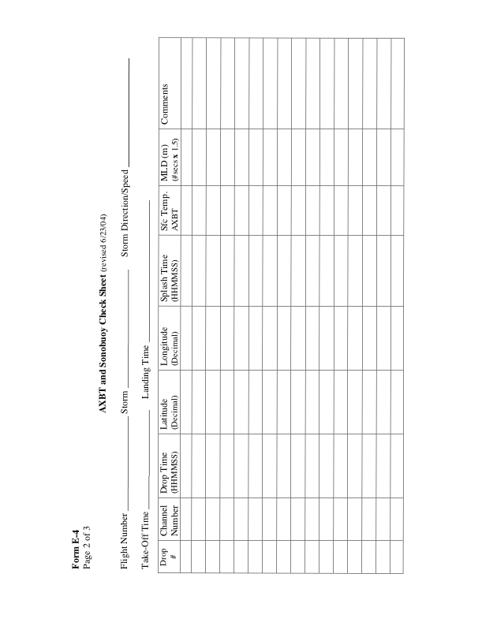 **E.5 Radar Scientist**

The on-board radar scientist is responsible for data collection from all radar systems on his/her assigned aircraft. Detailed operational procedures and checklists are contained in the operator's manual supplied to each operator. General supplementary procedures follow. (Check off and initial.)

**E.5.1 Preflight**

_____ 1. Determine the status of equipment and report results to the lead project scientist (LPS).

_____ 2. Confirm mission and pattern selection from the LPS.

_____ 3. Select the operational mode for radar system(s) after consultation with the LPS.

_____ 4. Complete the appropriate preflight calibrations and check lists as specified in the radar operator's manual.

**E.5.2 In-Flight**

_____ 1. Operate the system(s) as specified in the operator's manual and as directed by the LPS or as required for aircraft safety as determined by the AOC flight director or aircraft commander.

_____ 2. Maintain a written commentary in the radar logbook of tape and event times, such as the start and end times of F/AST legs. Also document any equipment problems or changes in R/T, INE, or signal status.

**E.5.3 Post flight**

_____ 1. Complete the summary checklists and all other appropriate check lists and forms.

_____ 2. Brief the LPS on equipment status and turn in completed forms to the LPS.

_____ 3. Hand-carry all radar tapes and arrange delivery as follows:

a. Outside of Miami-to the LPS.

b. In Miami-to AOML/HRD. [**Note**: all data removed from the aircraft by HRD personnel should be cleared with the AOC flight director.]

_____ 4. Debrief at AOML/HRD or the hotel during a deployment.

_____ 5. Determine the status of future missions and notify HRD Field Program Director as to where you can be contacted.

**Form E-5**

Page 1 of 2

**HRD Radar Scientist Check List**

Flight ID:

Aircraft Number:

Radar Operators:

Radar Technician:

Number of digital magnetic tapes on board:

Component Systems Status:

MARS __________________________ Computer ____________________________

DAT1___________________________ DAT2 _______________________________

LF _____________________________ R/T Serial # ___________________________

TA _____________________________ R/T Serial # ___________________________

Time correction between radar time and digital time:

**Radar Post flight Summary**

Number of digital tapes used: DAT1 _______________________

DAT2 _______________________

Significant down time:

DAT1 ______________________ Radar LF ____________________

DAT2 ______________________ Radar TA ____________________

**Other Problems:**

**Form E-5**

Page 2 of 2

HRD Radar Tape Log

**Flight ______________ Aircraft _______ Operator _______________** Sheet **____** of **____**

LF RPM _______________ TA RPM ______________

(Include start and end times of DATs, as well as times of F/AST legs and any changes of radar equipment status)

|  |  |  |  |
| --- | --- | --- | --- |
| **Tape #** | **F/AST**  **On?** | **Event Time**  **(HHMMSS)** | **Event** |
|  |  |  |  |
|  |  |  |  |
|  |  |  |  |
|  |  |  |  |
|  |  |  |  |
|  |  |  |  |
|  |  |  |  |
|  |  |  |  |
|  |  |  |  |
|  |  |  |  |
|  |  |  |  |
|  |  |  |  |
|  |  |  |  |
|  |  |  |  |
|  |  |  |  |
|  |  |  |  |
|  |  |  |  |
|  |  |  |  |
|  |  |  |  |
|  |  |  |  |
|  |  |  |  |
|  |  |  |  |

**Item List**: DAT1, DAT2, COMP, MARS, LF, and TA.

Include serial numbers of any new R/Ts.

**E.6 Dropsonde Scientist**

The lead project scientist (LPS) on each aircraft is responsible for determining the distribution patterns for dropwindsonde releases. Predetermined desired data collection patterns are illustrated on the flight patterns. However, these patterns often are required to be altered because of clearance problems, etc. Operational procedures are contained in the operator's manual. The following list contains more general supplementary procedures to be followed. (Check off and initial.)

**E.6.1 Preflight**

_____ 1. Determine the status of the AVAPS and HAPS. Report results to the LPS.

_____ 2. Confirm the mission and pattern selection from the LPS and assure that enough dropsondes are on board the aircraft.

_____ 3. Modify the flight pattern or drop locations if requested by AOC to accommodate changes in storm location or closeness to land.

_____ 4. Complete the appropriate preflight set-up and checklists.

**E.6.2 In-Flight**

_____ 1. Operate the system as specified in the operator's manual.

_____ 2. Ensure the AOC flight director is aware of upcoming drops.

_____ 3. Ensure the AVAPS operator has determined that the dropsonde is (or is not) transmitting a good signal. Recommend if a backup dropsonde should be launched in case of failure.

_____ 4. Report the transmission of each drop and fill in the Dropwindsonde Scientist Log.

**E.6.3 Post flight**

_____ 1. Complete Dropwindsonde Scientist Log.

_____ 2. Brief the LPS on equipment status and turn in reports and completed forms.

_____ 3. Hand-carry all dropwindsonde data tapes or CDs as follows:

a. Outside of Miami-to the LPS or PI.

b. In Miami-to AOML/HRD. [**Note**: all data removed from the aircraft by HRD personnel should be cleared with the AOC flight director.]

_____ 4. Debrief at the AOML/HRD or the hotel during a deployment.

_____ 5. Determine the status of future missions and notify HRD Field Program Director as to where you can be contacted.

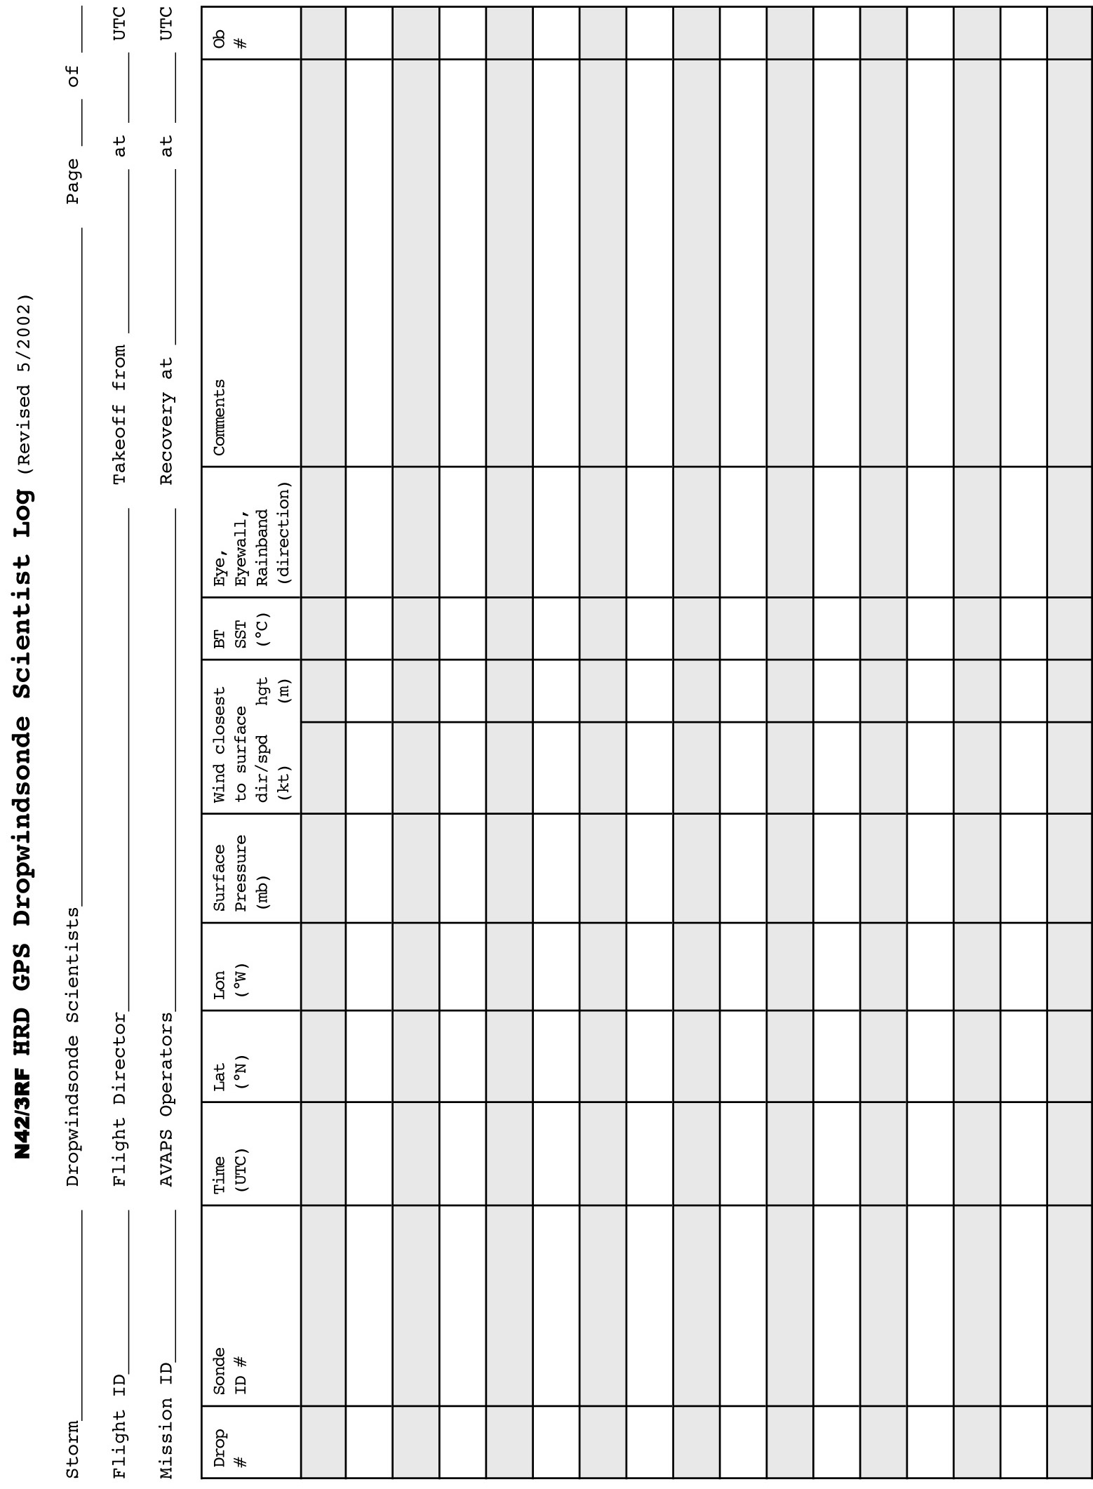

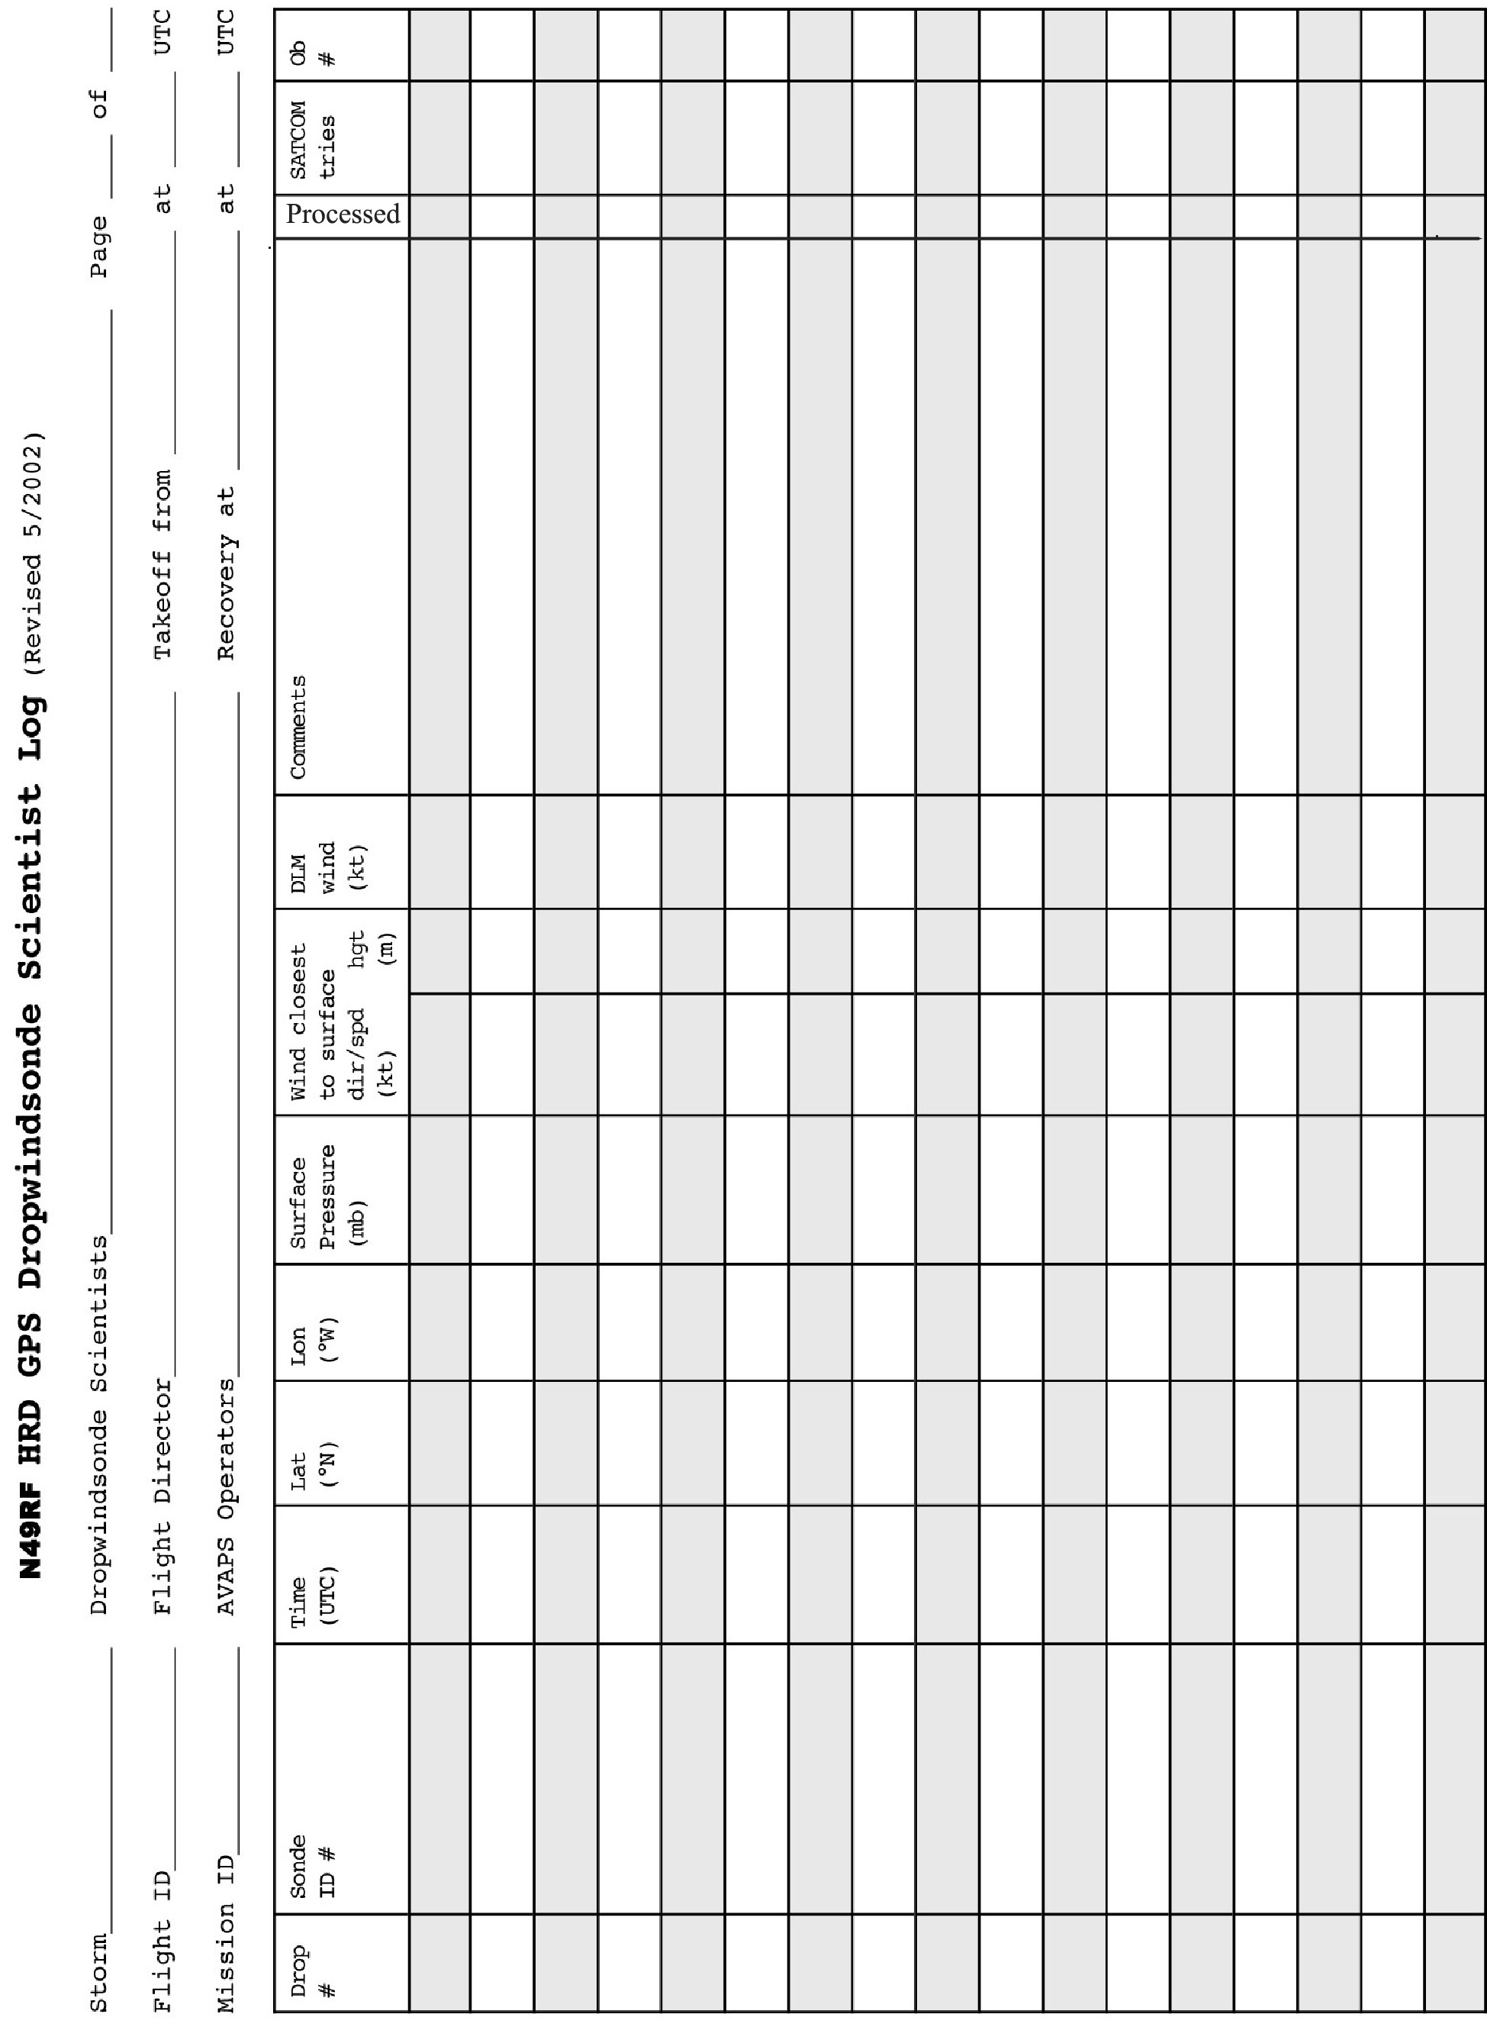

**APPENDIX F: SYSTEMS OF MEASURE AND UNIT CONVERSION FACTORS**

Table F-1 Systems of measure: Units, symbols, and definitions

|  |  |  |  |  |
| --- | --- | --- | --- | --- |
| **Quantity** | **SI Unit** | **Early Metric** | **Maritime** | **English** |
| *length* | meter (m) | centimeter (cm) | foot (ft) | foot (ft) |
| *distance* | meter (m) | kilometer (km) | nautical  mile (nm) | mile (mi) |
| *depth* | meter (m) | meter (m) | fathom (fa) | foot (ft) |
| *mass* | kilogram (kg) | gram (g) |  |  |
| *time* | second (s) | second (s) | second (s) | second (s) |
| *speed* | meter per second (mps) | centimeter per second (cm s-1) | knot (kt) (nm h-1) | miles per hour (mph) |
|  |  | kilometers per hour (km h-1) |  |  |
| *temperature*  *-­sensible* | degree Celsius (°C) | degree Celsius (°C) | --- | degree Fahrenheit (°F) |
| *-­potential* | Kelvin (K) | Kelvin (K) | --- | Kelvin (K) |
| *force* | Newton (N)  (kg m s-2) | dyne (dy)  (g cm s-2) | poundal (pl) | poundal (pl) |
| *pressure* | Pascal (Pa)  (N m-2) | millibar (mb)  (103 dy cm-2) | inches (in)  mercury (Hg) | inches (in)  mercury (Hg) |

Table F-2. Unit conversion factors

|  |  |  |
| --- | --- | --- |
| **Parameter** | **Unit** | **Conversions** |
| *length* | 1 in  1 ft  1 m | 2.540 cm  30.480 cm  3.281 ft |
| *distance* | 1 nm (nautical mile) | 1.151 mi  1.852 km  6080 ft |
|  | 1 mi (statute mile) | 1.609 km  5280 ft |
|  | 1° latitude | 59.996 nm  69.055 mi  111.136 km |
| *depth* | 1 fa | 6 ft  1.829 m |
| *mass* | 1 kg | 2.2 lb |
| *force* | 1 N | 105 dy |
| *pressure* | 1 mb | 102 Pa  0.0295 in Hg |
|  | 1 lb ft-2 | 4.88 kg m-2 |
| *speed* | 1 m s-1 | 1.94 kt  3.59 kph |
|  | 1° lat. 6 h-1 | 10 kt |

**APPENDIX G: AIRCRAFT SCIENTIFIC INSTRUMENTATION**



Table G.2: NOAA/AOC WP-3D (N43RF) instrumentation

**APPENDIX G: AIRCRAFT SCIENTIFIC INSTRUMENTATION (CONT’D)**



Table G.3 (Cont’d): NOAA/AOC G-IV (N49RF) instrumentation

**APPENDIX H: NOAA EXPENDABLE AND MEDIA**

|  |  |  |  |  |
| --- | --- | --- | --- | --- |
| **Experiment** | **GPS Dropwindsondes** | | **AXBTs** | **CADs** |
|  | *G-IV* | *P-3* | *P-3* | *P-3* |
| **P-3 3D Doppler Winds** | - | 20 | 10 | 10 |
| **G-IV Tail Doppler Radar** | 20 | 20 | 10 | 10 |
| **HWRF Model Evaluation** | 25 | 20 | 15 | 15 |
| **DWL SAL** | - | 10 | - | - |
| **DWL HBL** | - | 10 | - | - |
| **SUAVE** | - | 20 | 15 | 15 |
| **NESDIS Ocean Winds** | - | 5 | - | - |
| **SFMR HIA** | - | 1 | 1 | 1 |
| **Rapid Intensification** | 25 | 25 | 25 | 25 |
| **TC in Shear** | 25 | 30 | - | - |
| **TC Diurnal Cycle** | 25 | 10 | - | - |
| **TC-Ocean Interaction** | - | 20 | 15 | 15 |
| **TC Landfall** | - | 20 | 5 | 5 |
| **Convective Burst** | - | 15 | - | - |
| **TC Warm Core** | - | 5 | - | - |
| **SALEX Arc Cloud** | - | 10 | - | - |
| **Eye-eyewall mixing** | - | - | - | - |
| **Offshore Wind** | - | 10 | - | - |

Table H-1: Required expendables for 2015 experiments and modules for a single mission of the P-3 and the G-IV. For media, most data are now recorded on USB sticks. 1-2 DAT tapes are required for saving Lower Fuselage (LF) radar data.

**APPENDIX I: OPERATIONAL MAPS**

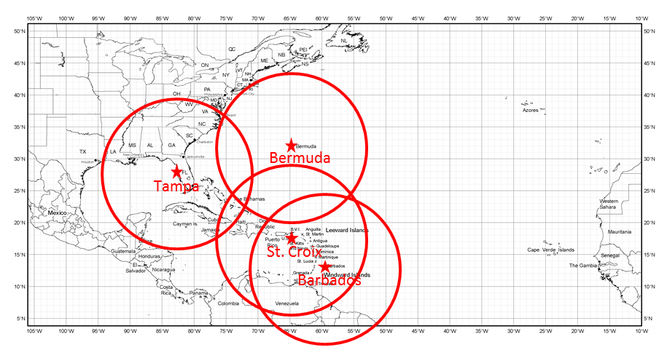

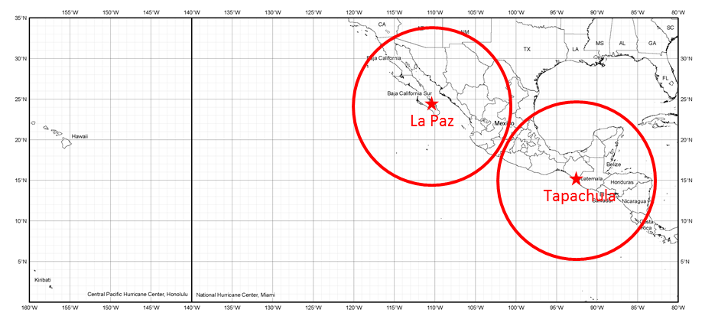

Map 1. Primary Atlantic and East Pacific operating bases and ranges (assuming ~2-h on-station time) for P-3.

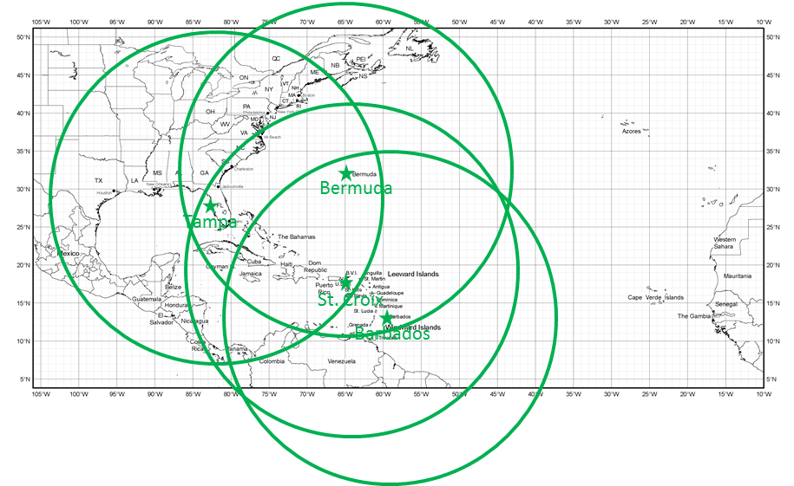

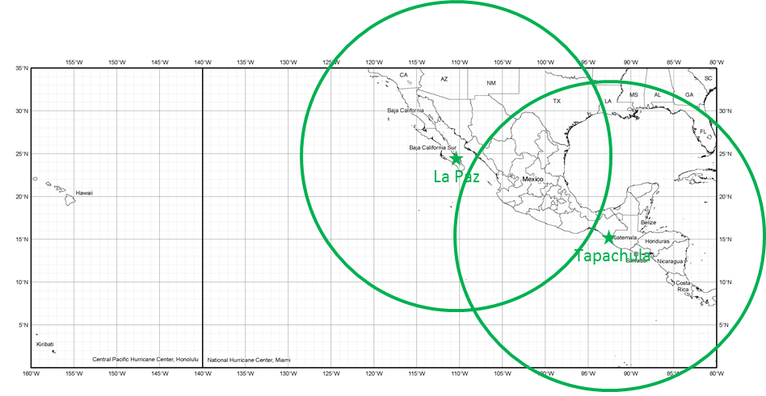

Map 1. Primary Atlantic and East Pacific operating bases and ranges (assuming ~2-h on-station time) for G-IV.

**APPENDIX J: FLIGHT PATTERNS**

**J.1 Patterns from Experiments**

**P-3 Lawnmower pattern**

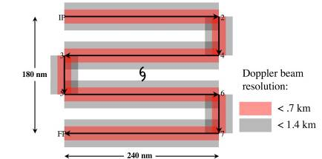

**Figure 1:** Display of Doppler coverage for A (upper panel) and B (lower panel) lawnmower patterns. Pink region shows areas where vertical beam resolution is better than 0.7 km and gray regions delineate areas where vertical beam resolution is better than 1.4 km. Maximum extent of gray area is approximately 40 km from flight track, generally the maximum usable extent of reliable airborne Doppler radar coverage. Total flight distance is 1160 nm for A and 1140 nm for B, and flight times are 4.8 and 4.75 hours, respectively.

Note 1. This is to be flown where even coverage is required, particularly in tropical depressions and tropical storms. Aircraft flies IP-2-3-4-5-6-7-FP. No attempt should be made to fix a center of circulation unless it is an operational request.

Note 2. Doppler radars should be operated in single-PRF mode, at a PRF of 2100. Radar scientist should

verify this mode of operation with AOC engineers. If there is no assigned radar scientist, LPS

should verify. *This is crucial for the testing and implementation of real-time quality control.*

Note 3. Unless specifically requested by the LPS, both tail Doppler radars should be operated in F/AST

with a fore/aft angle of 20 degrees relative to fuselage. French antenna automatically operates

with fore/aft angle of 20 degrees, but it should be confirmed, nevertheless that the scanning is

F/AST continuous, rather than sector scanning. Not choosing F/AST scanning will prevent

switching between fore and aft antennas on the French antenna system.

Note 4. IP can be at any desired heading relative to storm center

Note 5. To maximize dropwindsonde coverage aircraft should operate at highest altitudes that still

minimize icing

Note 6. If dropwindsondes are not deployed, aircraft can operate at any level below the melting level, with

10,000 ft preferred.

Note 7. Dropwindsondes shown are not a required part of this flight plan and are optional.

Note 8. Flight pattern should be centered around either the 18, 00, 06, or 12 UTC operational model analysis times.

**P-3 Box-spiral pattern**

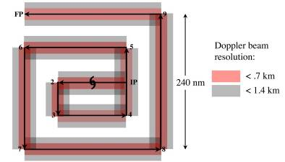

**Figure 2:** Doppler radar coverage for box-spiral pattern with 200- (top) and 240- (bottom) nm legs. Pink region shows areas where vertical beam resolution is better than 0.7 km and gray regions delineate areas where vertical beam resolution is better than 1.4 km. Maximum extent of gray area is approximately 40 km from flight track, approximately the maximum usable extent of reliable airborne Doppler radar coverage. Upper pattern is 1500 nm and uses 6.25 hours, while lower pattern is 1250 nm and uses 5.2 hours.

Note 1. Pattern flown where even coverage is required, particularly in tropical depressions and tropical storms. Doppler radars should be operated in single-PRF mode, at a PRF of 2100, unless in a hurricane—then 2400. Radar scientist should verify this mode of operation with AOC engineers. If there is no assigned radar scientist, LPS should verify. *This is crucial for the testing and implementation of real-time quality control.*

Note 2. Both tail Doppler radars should be operated in F/AST with a fore/aft angle of 20 degrees relative to fuselage. French antenna automatically operates with fore/aft angle of 20 degrees, but it should be confirmed, nevertheless that the scanning is F/AST continuous, rather than sector or continuous scanning. Not choosing F/AST scanning will prevent switching between fore and aft antennas in the French antenna system.

Note 3. IP can be at any desired heading relative to storm center

Note 4. To maximize dropwindsonde coverage aircraft should operate at highest altitudes that still

minimize icing.

Note 5. Maximum radius may be decreased or increased within operational constraints.

Note 6. Dropwindsondes shown are not a required part of this flight plan and are optional.

Note 7. Flight pattern should be centered around either the 18, 00, 06, or 12 UTC operational model analysis times.

Note 8. Maximum radius may be changed to meet operational needs while conforming to flight-length

constraints.

**P-3 Figure-4 pattern**

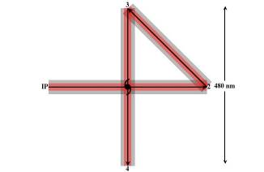

**Figure 3:** Doppler radar coverage for 300-nm legs for a single figure-4 pattern. Pink region shows areas where vertical beam resolution is better than 0.75 km and gray regions delineate areas where vertical beam resolution is better than 1.5 km. Maximum extent of gray area is approximately 40 km from flight track, approximately the maximum usable extent of reliable airborne Doppler radar coverage. Flight distance for radial extents of 240 nm is 1300 nm. Corresponding on-station time is 5.4 h.

Note 1. Pattern for large storms, to obtain as full a radial extent of observations of the full storm circulation as possible. Doppler radars should be operated in single-PRF mode, at a PRF of 2400-

3200. The default will be 2400 PRF for hurricanes and 2800 for major hurricanes. Radar scientist should verify this mode of operation with AOC engineers. If there is no assigned radar scientist,

LPS should verify. *This is crucial for the testing and implementation of real-time quality control.*

Note 2. Both tail Doppler radars should be operated in F/AST with a fore/aft angle of 20 degrees relative to

fuselage. French antenna automatically operates with fore/aft angle of 20 deg, but it should be confirmed, nevertheless that the scanning is F/AST continuous, rather than sector or continuous

scanning. Not choosing F/AST scanning will prevent switching between fore and aft antennas in the French antenna system.

Note 3. IP can be at any desired heading relative to storm center

Note 4. To maximize dropwindsonde coverage aircraft should operate at highest altitudes that still

minimize icing

Note 5. Maximum radius may be decreased or increased within operational constraints

Note 6. Dropwindsondes shown are not a required part of this flight plan and are optional.

Note 7. Flight pattern should be centered around the 18, 00, 06, or 12 UTC operational model analysis times.

Note 8. Maximum radius may be changed to meet operational needs while conforming to flight-length constraints.

**P-3 Rotating figure-4 pattern**

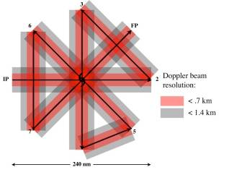

**Figure 4**: Doppler radar coverage for radial extents of 100 (top) and 120 (bottom) nm of the rotating figure-4 patterns. Pink region shows areas where vertical beam resolution is better than 0.7 km and gray regions delineate areas where vertical beam resolution is better than 1.4 km. Maximum extent of gray area is approximately 40 km from flight track, approximately the maximum usable extent of reliable airborne Doppler radar coverage. Flight distance for 120 nm radial extent is 1395 nm. Corresponding on-station time is:5.8 h.

**P-3 Butterfly pattern**

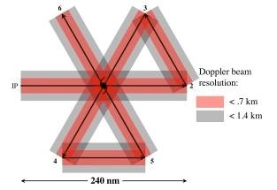

**Figure 5:** Doppler radar coverage for 120- (top) and 180- (bottom) nm legs for the Butterfly pattern. Pink region shows areas where vertical beam resolution is better than 0.75 km and gray regions delineate areas where vertical beam resolution is better than 1.5 km. Maximum extent of gray area is approximately 40 km from flight track, approximately the maximum usable extent of reliable airborne Doppler radar coverage. Flight distance for the pattern with 120 nm radials legs is 960 nm. Corresponding on-station time is 4 h.

Note 1. This pattern will be flown in large tropical storms, as well as hurricanes. Doppler radars should be operated in single-PRF mode, at a PRF of 2400-3200. The default will be 2400 PRF for hurricanes, and 2800 for major hurricanes. Radar scientist should verify this mode of operation with AOC engineers. If there is no assigned radar scientist, LPS should verify. *This is crucial for the testing and implementation of real-time quality control.*

Note 2. Unless specifically requested by the LPS, both tail Doppler radars should be operated in F/AST with a fore/aft angle of 20 degrees relative to fuselage. French antenna automatically operates with fore/aft angle of 20 degrees, but it should be confirmed, nevertheless that the scanning is F/AST continuous, rather than sector or continuous scanning. Not choosing F/AST scanning will prevent switching between fore and aft antennas in the French antenna system.

Note 3. IP can be at any desired heading relative to storm center

Note 4. To maximize dropwindsonde coverage aircraft should operate at highest altitudes that still minimize icing

Note 5. Maximum radius may be decreased or increased within operational constraints

Note 6. Dropwindsondes shown are not a required part of this flight plan and are optional.

Note 7. Flight pattern should be centered around either the 18, 00, 06, or 12 UTC operational model

analysis times.

Note 8. Maximum radius may be changed to meet operational needs while conforming to flight-length constraints.

**G-IV Square spiral pattern**

Duration: 5.75 h

IP

FP

**Figure 6:** G-IV tail Doppler radar pattern – Square Spiral (inward)

Note 1. G-IV begins 150 nm to north and east of estimated circulation center (with proper rotation starting point can be NE, NW, SW, or SE of center)

Note 2. Fly 300 nm due west (due south, east, north, for IP NW, SW, or SE of center, respectively)--left turn--300 nm--left turn--300 nm--left turn--240 nm--left turn--240 nm--left turn--180 nm--left turn--180 nm--left turn--120 nm--left turn--120 nm--left turn--60 nm--left turn--60 nm

Note 3. Duration: 2100 nm, or 4.75 hour + 1 hour for deviations--covers 150 nm (2.5 deg) in each cardinal direction from center

Note 4. Aircraft should operate at its maximum cruising altitude of ~40-45 kftNote 5. On all legs, deviate to avoid weather deemed to pose possible hazard

Note 6. As flight duration and ATC allow, attempt to sample as much of regions that require deviation

Note 7. Tail Doppler radar should be operated at a dual-PRF of 3/2, with the PRFs at 2000 and 3000 (effective Nyquist velocity of 48 m/s)

Note 8. If flying above 40,000 ft, pattern may be flown clockwise, if preferred.

**G-IV Rotating figure-4 pattern**

1

2

3

4

5

6

7

8

400 nm

Duration: 6.25 h

Preferred track (if safe)

**Figure 7:** G-IV tail Doppler radar pattern – Rotating Figure-4

Note 1. IP is 200 nm from storm center

Note 2. Fly 1-2, deviating around eyewall if conditions require (eyewall assumed to extend 20 nm from center)--if deviation is required, fly to right of convection if possible. If conditions permit, fly through center of circulation

Note 3. Fly 2-3, deviating around convection if necessary

Note 4. Fly 3-4, as described in segment 1-2

Note 5. Fly 4-5, deviating around convection, if necessary

Note 6. Fly 5-6-7-8 in the same manner as 1-2-3-4

Note 7. Duration: 2317 nm, or 5.25 hours + 1 hour for deviations

Note 8. Aircraft should operate at its maximum cruising altitude of ~40-45 kft

Note 9. As flight duration and ATC allow, attempt to sample as much of regions that require deviations

Note 10. Tail Doppler radar should be operated at a dual-PRF of 3/2, with the PRFs at 2000 and 3000 (effective Nyquist velocity of 48 m/s)

Note 11. If flying above 40,000 ft, pattern may be flown clockwise, if preferred.

**G-IV Surveillance/TDR combination pattern**

1, 18

2

3

4

5

6

7

8

9

10

11

12

13

14

15

16

17

300 nm

Duration: 5.5 h

Preferred track (if safe)

**Figure 8:** G-IV tail Doppler radar pattern – Surveillance/TDR Combination

Note 1. IP is 150 nm from storm center

Note 2. Fly 1-2-3-4-5-6-7-8-9-10-11-12-11-12-13-14-15-16-17-18, deviating around eyewall if conditions require (eyewall assumed to extend 30 nm from center)--if deviation is required, fly to right of convection if possible. If conditions permit, fly through center of circulation

Note 3. Dropsondes should be launched at all numbered points (except 11 and 12). If the aircraft is able to cross the center, a sonde should be dropped there. Extra sondes may be requested.

Note 4. On-station Duration: ~1933 nm, or about 4.5 hours + 1 hour for deviations

Note 5. Aircraft should operate at its maximum cruising altitude of ~40-45 kft

Note 6. As flight duration and ATC allow, attempt to sample as much of regions that require deviations

Note 7. Tail Doppler radar should be operated at a dual-PRF of 3/2, with the PRFs at 2000 and 3000 (effective Nyquist velocity of 48 m/s)

Note 8. If flying above 40,000 ft, pattern may be flown clockwise, if preferred.

**G-IV RAPX pattern (optimal dropsonde)**

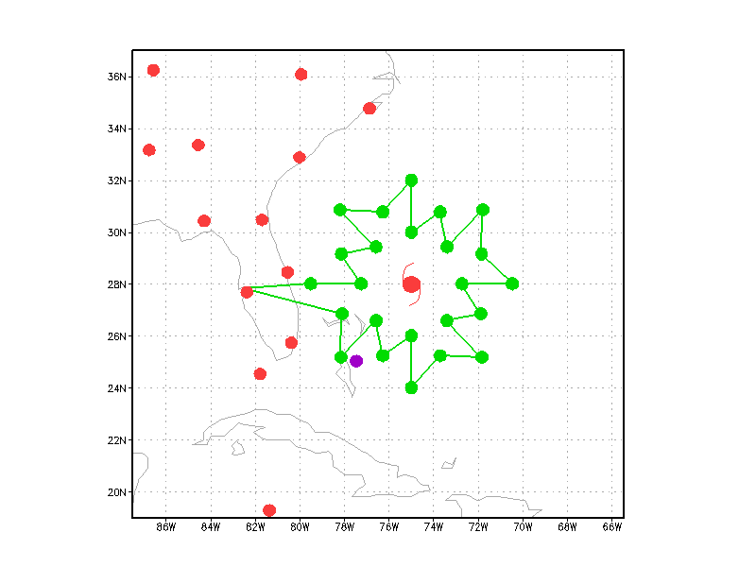

**Figure 14**. A sample G-IV flight pattern for the RAPX mission. The green dots denote the desired dropsonde locations at 220, 330, and 440 km radius from the storm center. Note that the end points of each leg can be rounded slightly as required for aircraft flight considerations. The flight pattern (excluding ferry time to and from the storm) requires about 6 hours to complete.

**G-IV RAPX pattern (optimal radar)**

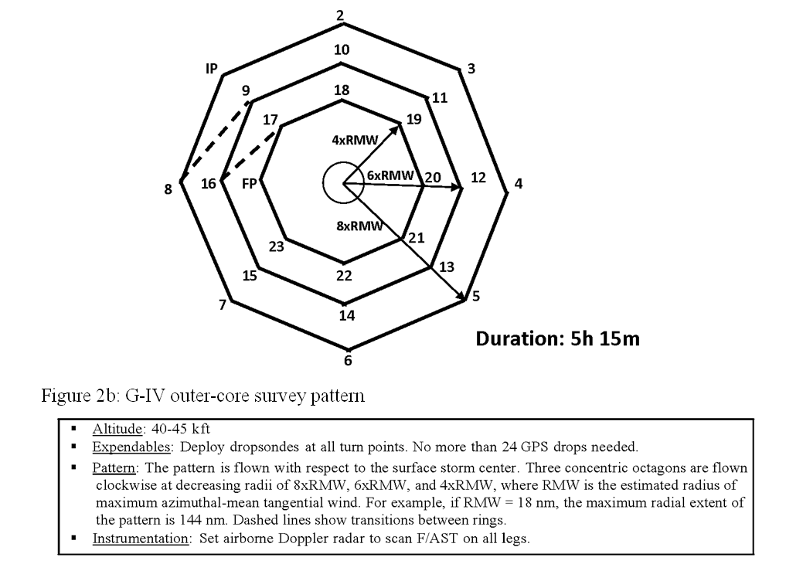

**Figure 15:** G-IV outer-core survey pattern

**G-IV Shear pattern**

**1°**

**1.5°**

**2°**

**Duration: ~4 h**

**IP**

**2**

**3**

**5**

**4**

**6**

**8**

**7**

**10**

**11**

**12**

**13**

**14**

**15**

**16**

**9**

**FP**

**23**

**19**

**20**

**21**

**22**

**18**

**17**

**Figure 16:** G-IV “pre-shear” and “large tilt” outer-core survey pattern

▪  Altitude: 40-45 kft

▪  Expendables: Deploy dropsondes at all turn points. No more than 24 GPS drops needed. (18 if suboptimal hexagon pattern is flown)

▪  Pattern: The pattern is flown with respect to the surface storm center. Three concentric octagons (or suboptimal hexagons) are flown clockwise at decreasing radii of 2 deg, 1.5 deg, and 1 deg. Dashed lines show transitions between rings. If a P-3 is available for sampling out to 1-2 deg, then the radii of the G-IV pattern can be increased to sample on a larger scale. Time permitting, a fourth circumnavigation may be added. The option also exists to rotate the vertices of the middle circumnavigation to increase azimuthal resolution of the dropsonde observations.

▪  Instrumentation: Set airborne Doppler radar to scan F/AST on all legs.

**P-3 Shear Figure-4/circumnavigation pattern**

**Duration: 3-4 h**

**(5-6 h full pattern)**

**4.5xRMW**

**RMW**

**2xRMW**

**IP**

**2**

**3**

**4**

**5**

**6**

**7**

**8**

**9**

**10**

**11**

**FP**

**12**

**FP’**

**16’**

**15’**

**14’**

**Figure 17:** P-3 Core-region survey pattern

▪  Altitude: 12,000 ft (4 km) altitude preferable.

▪  Expendables: Deploy dropsondes at center of first pass, RMW, and 1.2xRMW of Figure-4 legs (if no G-IV, then also at turn points). Deploy dropsondes at turn points (vertices) of octagonal flight pattern legs. No more than 33 drops needed (17 if G-IV present and second Figure-4 not performed).

▪  Pattern: The pattern is flown with respect to the surface storm center. Radial legs of the initial Figure-4 pattern extend to 4.5xRMW, where RMW is the estimated radius of maximum azimuthal-mean tangential wind. Standard 100 nm legs are generally sufficient. The aircraft then turns inbound and performs a counter-clockwise octagonal circumnavigation at a radius of 2xRMW. Safety considerations may require initiation of the circumnavigation on the upshear side in weak echo. If time permits, additional passes may be done from 14’ to 15’, and from 16’ to FP’.

▪  Instrumentation: Set airborne Doppler radar to scan F/AST on all legs.

**G-IV Diurnal Cycle Star pattern**

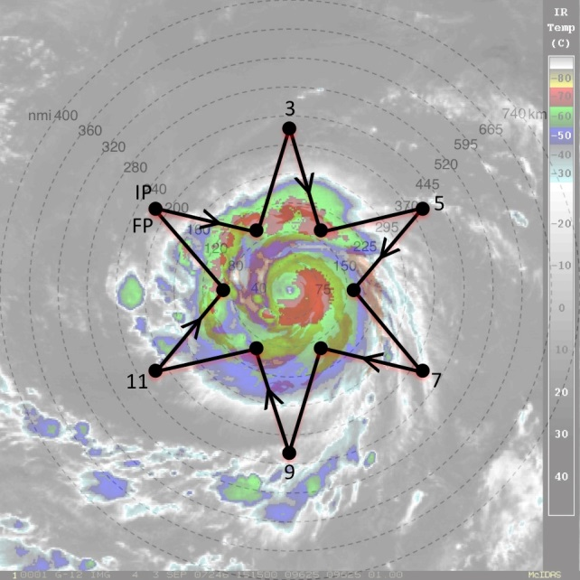

**Fig. 18a**. Sample G-IV star pattern with endpojnts that alternate between 90 and 216 nm (165 and 400 km). The endpoints can be adjusted inward or outward depending on the exact position of the outwardly propagating diurnal pulse and the size of the TC inner core. The pattern is overlaid on (left) GOES IR imagery and (right) UW-CIMSS IR diurnal cycle imagery. Yellow to pink shading in the latter image indicates a diurnal pulse propagating away from the storm during this time and shows its typical radial evolution at ~1100 LST when it has reached R=~300 km.

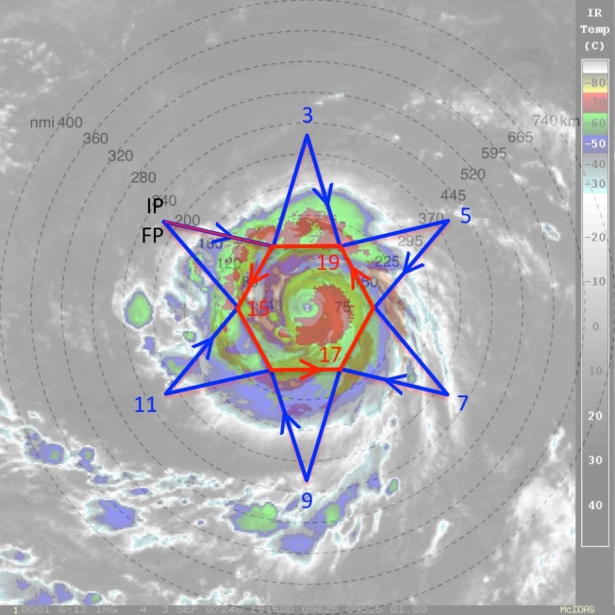

**Fig. 18b**. Same as in Fig. 3, except that a circumnavigation of the storm is performed after (or before) the star pattern is completed. The hexagon circumnavigation that is shown has points that are 90 nm (165 km) from the storm center, but can be adjusted outward for safety considerations depending on the strength and size of the TC.

**P-3 Pre- or post-storm Ocean survey pattern**

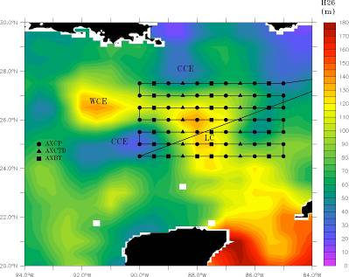

**Figure 19a:** Typical pre- or post-storm pattern with ocean expendable deployment locations relative to the Loop Current. Specific patterns will be adjusted based on actual and forecasted storm tracks and Loop Current locations. Missions generally are expected to originate and terminate at KMCF.

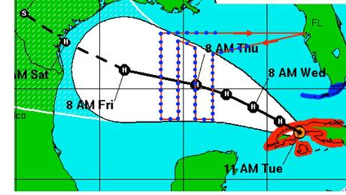

**Figure 19b:** Track-dependent AXBT/AXCTD ocean survey. As for the Loop Current survey, a total of 60-80 probes would be deployed on a grid (blue dots).

**P-3 In-storm Ocean survey pattern (over existing drifter array)**

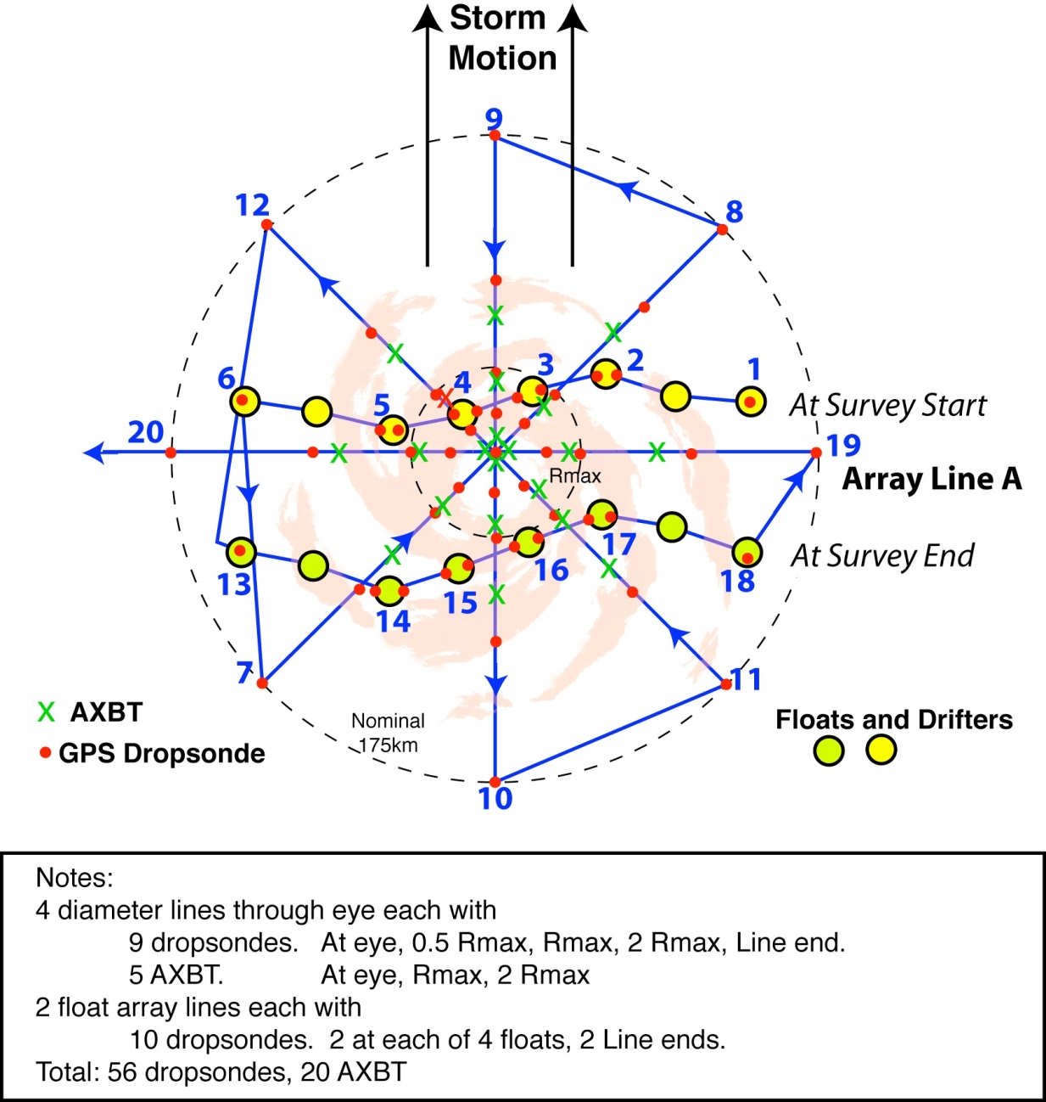

**Figure 20**: P-3 pattern over float and drifter array. The array has been distorted since its deployment on the previous day and moves relative to the storm during the survey. The pattern includes two legs along the array (waypoints 1-6 and 13-18) and an 8 radial line survey. Dropwindsondes are deployed along all legs, with double deployments at the floats. AXBTs are deployed in the storm core.

**J.2 Patterns from Modules**

**P-3 DWL SAL module**

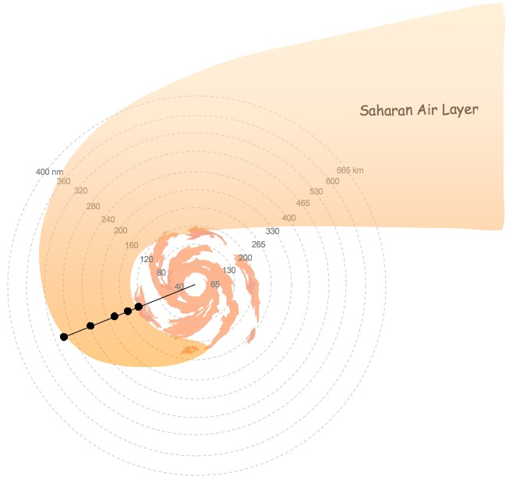

**Fig. 9:** Sample WP-3D flight track during the ferry to/from the storm and GPS dropsonde points for the P-3DWL SAL module.

**P-3 DWL Box module**

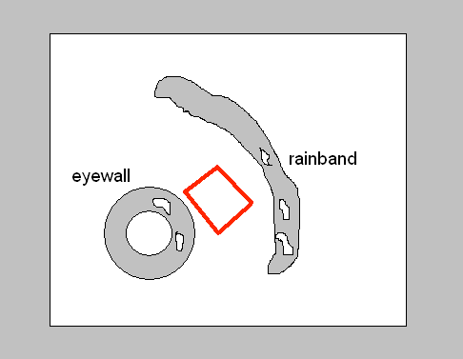

**Figure 10:** Box module (20-25 minutes) for DWL observations at altitudes between 500 m and 1500 m as low as safety permits. The blue dots show the locations for releasing dropsondes.

**P-3 SUAVE eye/eyewall module**

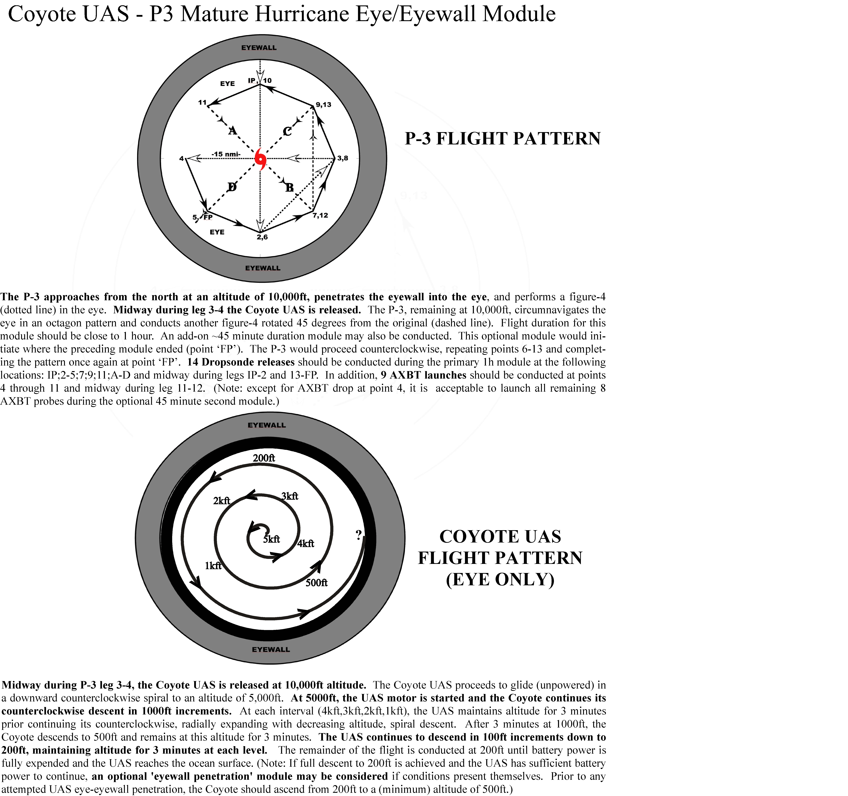

**Figure 11.** P3 pattern for SUAVE eye/eyewall module

**P-3 SUAVE PBL entrainment flux module**

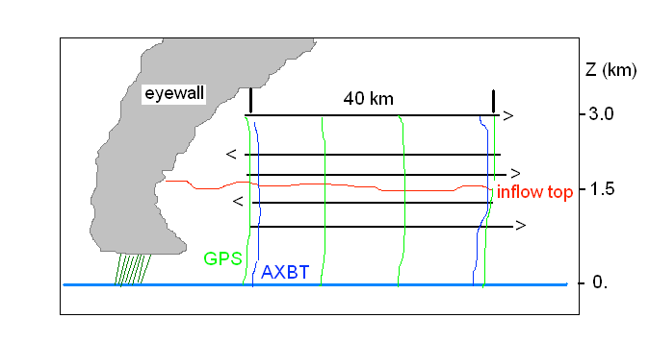**Figure 12.** Vertical cross-section of the stepped-descent module. P3 pattern is in black, low altitude Coyote UAS in heavy blue. Alternatively, the P3 could stay at the highest altitude shown here (i.e., 3.0 km), while the Coyote performs the stepped descent.

**P-3 SFMR-HI module**



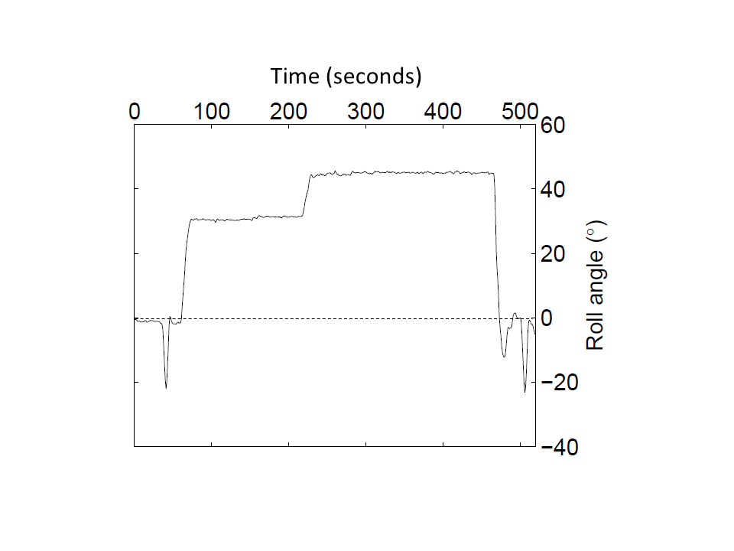

**Figure 13:** Flight pattern for module flown in Hurricane Gustav (2008) in a rain-free portion of the eyewall experiencing approximately 35 ms-1 surface winds (top panel). Time series of P-3 roll angle during period of turns in Gustav (bottom panel).

**P-3 Offshore Intense Convection Module**

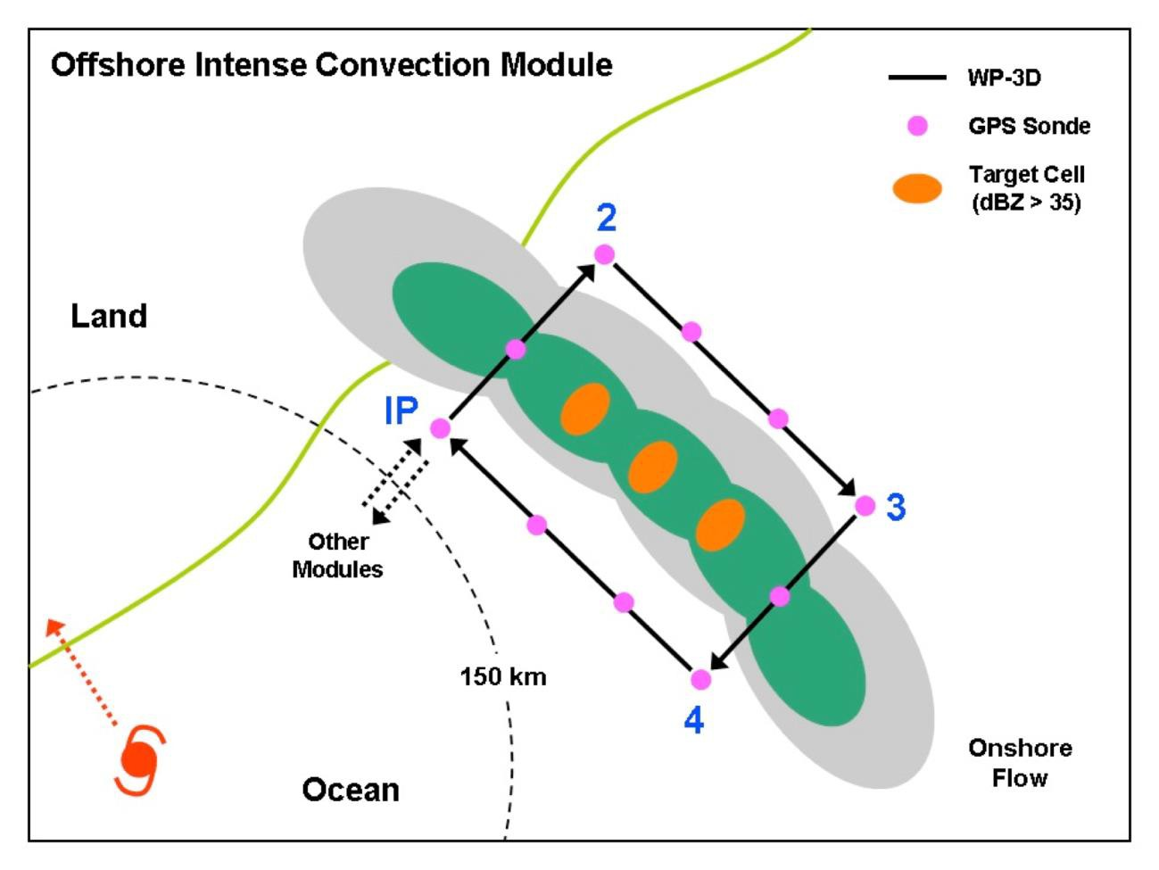

**Fig. 21**. Offshore Intense convection module.

Notes:

• The **IP** should be a minimum of 90 nm (150 km) from the storm center. The first leg (**IP-2**) starts 13 km (25 km) inside the rain band axis. Legs **IP-2** and **3-4** should be ~10-13 (20-25 km) downwind and upwind of the target cells to ensure adequate Doppler coverage. Legs **2-3** and **4-IP** should be 13 nm inside and outside the rain band axis. The length of legs **2-3** and **4-IP** can be adjusted but should be 40 nm (75 km) at a minimum.

• Deploy GPS dropwindsondes at the start or end points of each leg, at the band axis crossing points, and at ~10-13 nm intervals along each leg parallel to the band. The interval at which GPS dropwindsondes are deployed depends on how many are available, but **at least 2 GPS dropwindsondes should be deployed on either side of the convection and at least 1 dropwindsonde should be deployed each time the band-axis is crossed (for a minimum of 6 GPS dropwindsondes)**.

• Aircraft altitude should be at 10,000 ft. (3.0 km) or higher. Set airborne Doppler to scan in F/AST mode on all legs. Aircraft should avoid penetration of intense reflectivity regions (particularly over land).

**P-3 Coastal Survey Module**

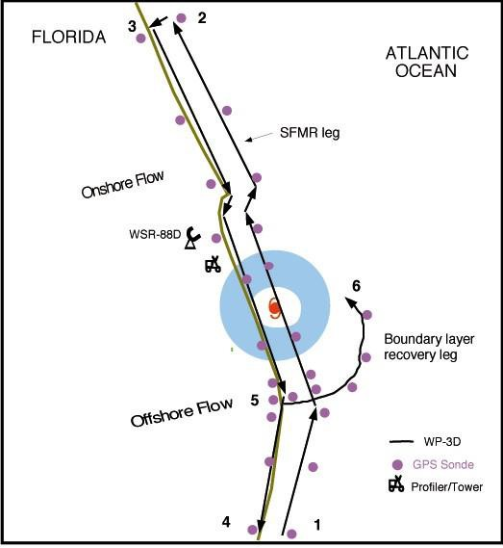

**Fig. 22.** Coastal Survey module.

Notes:

• First pass starts 80 nm (150 km) from center or at radius of gale-force wind speeds, whichever is closer. Pass from

**1-2** should be 6-10 nm (10-15 km) offshore for optimum SFMR measurements. Release GPS dropwindsondes at RMW, and 7.5, 15, 30, 45, and 60 or 75 nm (12.5, 25, 50, 75, and 100 or 125 km) from RMW on either side of storm in legs **1-2** and **3-4**. GPS dropwindsondes should be deployed quickly at start of leg **5-6**, and then every 6-10 nm hereafter.

• Set airborne Doppler on all legs with single PRF > 2400 and 20% tilt. Aircraft should avoid penetration of intense reflectivity regions (particularly those over land)

**P-3 Real-time Module**

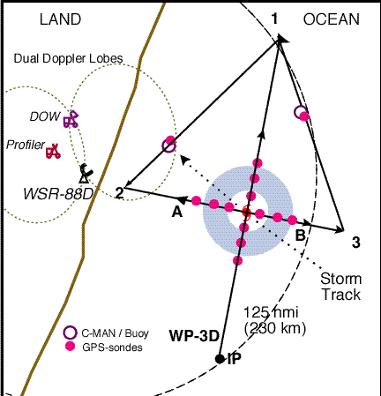

**Fig. 23.** Real-time module.

Notes:

• TAS calibration required. The legs through the eye may be flown along any compass heading along a radial from the ground-based radar. The **IP** is approximately 100 nm (185 km) from the storm center. Downwind legs may be adjusted to pass over buoys.

• P-3 should fly legs along the WSR-88D radials.

Aircraft should avoid penetration of intense reflectivity regions (particularly those over land).

• Wind center penetrations are optional.

**P-3 Convective burst Module**



**Figure 24**: P-3 Convective burst module. (a) circumnavigation for when burst is well outside RMW or within a TC of tropical depression strength or less; (b) bowtie pattern for when burst is within or near RMW of tropical storm or hurricane.

* Altitude: 12,000 ft (4 km) altitude preferable.
* Expendables: Release dropsondes at turn points and at intermediate points as indicated in Figure. Additionally, release 1-2 drops during penetration of convective system. No more than 15 dropsondes needed for this module.
* Pattern: Circumnavigation (IP to point 6) by single P-3 when burst is outside RMW or in weak system. Then fly convective crossing (6-7-FP). Repeat circumnavigation (time permitting). If available, high-altitude aircraft (e.g., ER-2 or Global Hawk) flies either racetrack or bowtie pattern during P-3 circumnavigation, flies vertically aligned with P-3 during convective crossing. Repeated radial penetration (i.e. bowtie) when burst is inside or near RMW of tropical storm or hurricane.
* Instrumentation: Set airborne Doppler radar to scan F/AST on all legs.

**P-3/G-IV Arc Cloud Module**

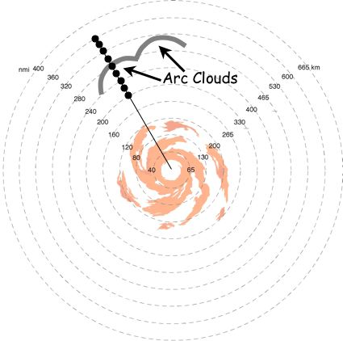

**Figure 25:** The G-IV (or WP-3D) flight track inbound or outbound to/from the TC/AEW. Azimuth and length of GPS dropsonde sequences during G-IV missions will be dictated by the pre-determined flight plan. For these cases, any G-IV flight legs that transect through the trailing and leading edges of the arc cloud are candidates for this module. When multiple arc clouds are present, the feature closest to the pre-determined flight track is desirable.

**P-3 Arc Cloud Module (Multi-level option)**

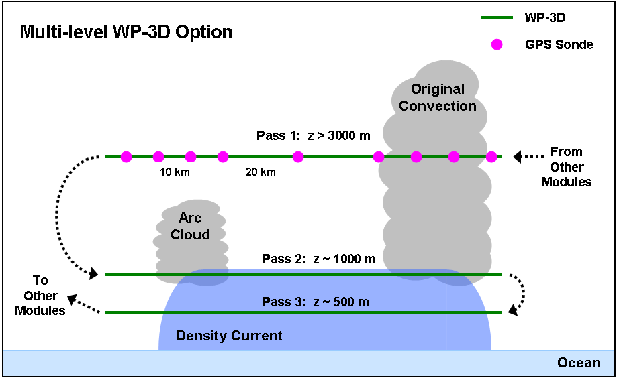

**Figure 26:** The WP-3D flight track for the multi-level option. Azimuth and length of initial midlevel pass with GPS dropsonde sequence will be dictated by the pre-determined flight plan. Lengths of the low-level passes should span much of the distance between the arc cloud and its initiating convection, while flight altitudes should be near the top and middle of any near-surface density currents (adjusting for safe aircraft operation as needed).

**P-3 Offshore Wind Module**

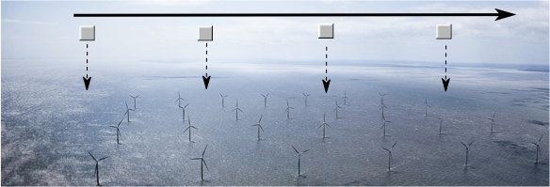

**Figure 27:** Schematic of piggyback pattern showing hypothetical wind farm fly-by with expendable launches at a 2-4 km interval. No U.S. wind farms are yet in operation. (Dong Energy Gunfleet Sands 1farm off SE England)

**ACRONYMS AND ABBREVIATIONS**

e equivalent potential temperature

ABL atmospheric boundary-layer

A/C aircraft

ACLAIM Airborne Coherent Lidar for Advanced In-flight Measurements

AES Atmospheric Environment Service (Canada)

AFRES U. S. Air Force Reserve

AOC Aircraft Operations Center

AOML Atlantic Oceanographic and Meteorological Laboratory

ASDL aircraft-satellite data link

AXBT airborne expendable bathythermograph

AXCP airborne expendable current probe

AXCTD airborne expendable conductivity, temperature, and depth probe

CARCAH Chief, Aerial Reconnaissance Coordinator, All Hurricanes

CDO central dense overcast

CIRA Cooperative Institute for Research in the Atmosphere

C-MAN Coastal-Marine Automated Network

CP coordination point

CW cross wind

DLM deep-layer mean

DOD Department of Defense

DOW Doppler on Wheels

DRI Desert Research Institute (at Reno)

E vector electric field

EPAC Eastern Pacific

ETL Environmental Technology Laboratory

EVTD extended velocity track display

FAA Federal Aviation Administration

F/AST fore and aft scanning technique

FEMA Federal Emergency Management Agency

FL flight level

FP final point

FSSP forward scattering spectrometer probe

GFDL Geophysical Fluid Dynamics Laboratory

G-IV Gulfstream IV-SP aircraft

GOMWE Gulf of Mexico Warm Eddy

GPS global positioning system

HL Hurricanes at Landfall

HRD Hurricane Research Division

INE inertial navigation equipment

IP initial point (or initial position

IWRS Improved Weather Reconnaissance System

JW Johnson-Williams

Ku-SCAT Ku-band scatterometer

LF lower fuselage (radar)

LIP Lightning Instrument Package

LPS Lead Project Scientist

MCS mesoscale convective systems

MLD Mixed Layer Depth

MPO Meteorology and Physical Oceanography

NASA National Aeronautics and Space Administration

NCAR National Center for Atmospheric Research

NCEP National Centers for Environmental Prediction

NDBC NOAA Data Buoy Center

NESDIS National Environmental Satellite, Data and Information Service

NHC National Hurricane Center

NOAA National Oceanic and Atmospheric Administration

NWS National Weather Service

OML oceanic mixed-layer

PDD pseudo-dual Doppler

PMS Particle Measuring Systems

POD Plan of the Day

PPI plan position indicator

PV potential vorticity

RA radar altitude

RAOB radiosonde (upper-air observation)

RAWIN rawinsonde (upper-air observation)

RECCO reconnaissance observation

RHI range height indicator

RSMAS Rosenstiel School of Marine and Atmospheric Science

SFMR Stepped-Frequency Microwave Radiometer

SLOSH sea, lake, and overland surge from hurricanes (operational storm surge model)

SRA Scanning Radar Altimeter

SST sea-surface temperature

TA tail (radar)

TAS true airspeed

TC tropical cyclone

TOPEX The Ocean Topography Experiment

UMASS University of Massachusetts (at Amherst)

USACE United States Army Corps of Engineers

USAF United States Air Force

USWRP U. S. Weather Research Program

UTC universal coordinated time (U.S. usage; same as “GMT” and "Zulu" time)

VTD velocity-track display

**Acknowledgments**

The preparation of HRD's 2014 **Hurricane Field Program Plan** was a team effort. The authors would like to express their appreciation to: the HRD scientists that contributed information on specific experiments.