2014 Hurricane Field Program Plan
Part II: Appendices

Table of Contents

APPENDIX A…………………………………………………………………………………………. 2
Decision and Notification Process………………………………………………………………. 2
APPENDIX B: CALIBRATION………….……….……….………….……….……….……….….. 5
B.1 En-route Calibration of Aircraft Systems…………………………………………………... 5
APPENDIX C: DOD/NWS RAWIN/RAOB AND NWS COASTAL LAND-BASED RADARS... 7
APPENDIX D: PRINCIPAL DUTIES OF THE NOAA SCIENTIFIC PERSONNEL………….. 9
APPENDIX E: NOAA RESEARCH OPERATIONAL PROCEDURES AND CHECK LISTS... 13
E.1 “Conditions-of-Flight” Commands…………………………………………………………. 14
E.2 Lead Project Scientist………………………………………………………………………. 15
E.3 Cloud Physics Scientist……………………………………………………………………... 22
E.4 Boundary Layer Scientist…………………………………………………………………… 24
E.5 Radar Scientist……………………………………………………………………………… 27
E.6 Dropsonde Scientist………………………………………………………………………… 30
APPENDIX F: SYSTEMS OF MEASURE AND UNIT CONVERSION FACTORS…………… 33
APPENDIX G: AIRCRAFT SCIENTIFIC INSTRUMENTATION……………………………… 34
APPENDIX H: NOAA EXPENDABLES ..................................................…………………………. 38
ACRONYMS AND ABBREVIATIONS……………………………………………………………. 40

2014

Hurricane Field Program Plan

Part II

Appendix A

DECISION AND NOTIFICATION PROCESS
The decision and notification process is illustrated in Figs. A-1, A-2, and A-3. This process occurs in four steps:

1) A research mission is determined to be probable within 72 h [field program director]. Consultation with the director of HRD, and the AOC Project Manager determines: flight platform availability, crew and equipment status, and the type of mission(s) likely to be requested.

2) The Field Program Advisory Panel [F. Marks (Director, HRD), P. Reasor (Director, Hurricane Field Program), J. Dunion, M. Black, J. Cione, J. Gamache, J. Kaplan, R. Rogers, S. Murillo, J. Zhang and J. McFadden (or AOC designee) meets to discuss possible missions and operational modes. Probable mission determination and approval to proceed is given by the HRD director (or designee).

3) Primary personnel are notified by the Hurricane Field Program Director [P. Reasor].

4) Secondary personnel are notified by their primary affiliate (Table A-2).

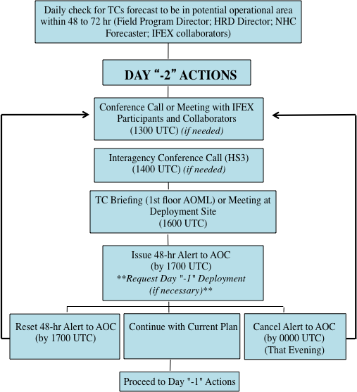

Fig. A-1: Decision and notification process for Day “-2”.

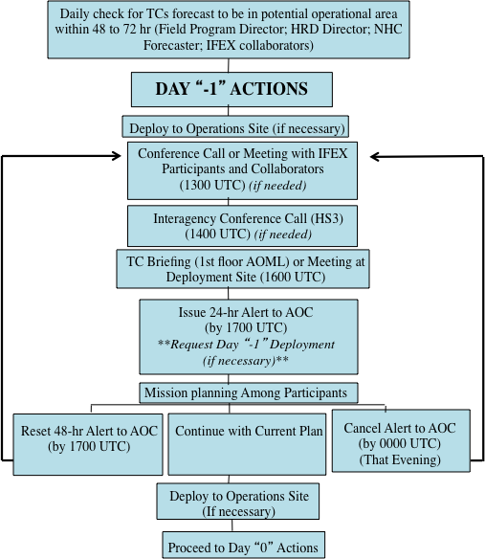

**Note: Time of briefings, conference calls, decisions, and deployments are dictated by timing limitations imposed by the AOC crew.

Fig. A-2: Decision and notification process for Day “-1”

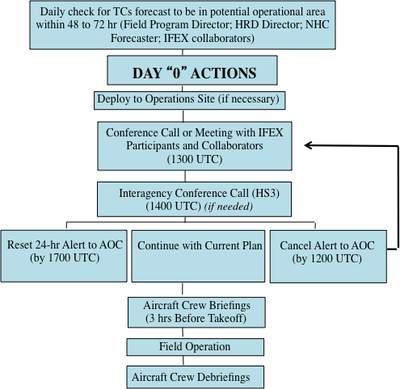

**Note: Time of briefings, conference calls, decisions, and deployments are dictated by timing limitations imposed by the AOC crew.

Fig. A-3: Decision and notification process for Day “0”

Appendix B: Calibration

B.1 En-Route Calibration of Aircraft Systems

Instrument calibrations are checked by flying aircraft intercomparison patterns whenever possible during the hurricane field program or when the need for calibration checks is suggested by a review of the data. In addition, an over flight of a surface pressure reference is advisable en route or while on station when practicable. Finally, all flights enroute to and from the storm are required to execute a true airspeed (TAS) calibration pattern. This pattern is illustrated in Fig. B-1.

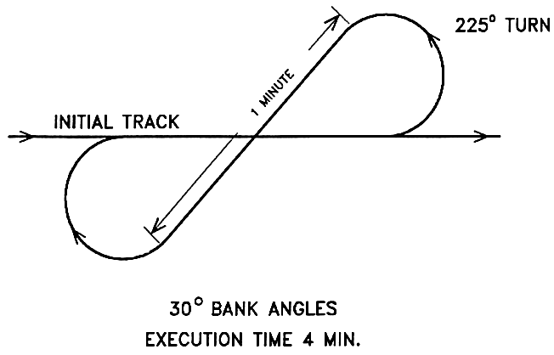

Fig. B-1 En-Route TAS calibration pattern.

Appendix C: DOD/NWS RAWIN/RAOB and NWS Coastal Land-based Radar Locations

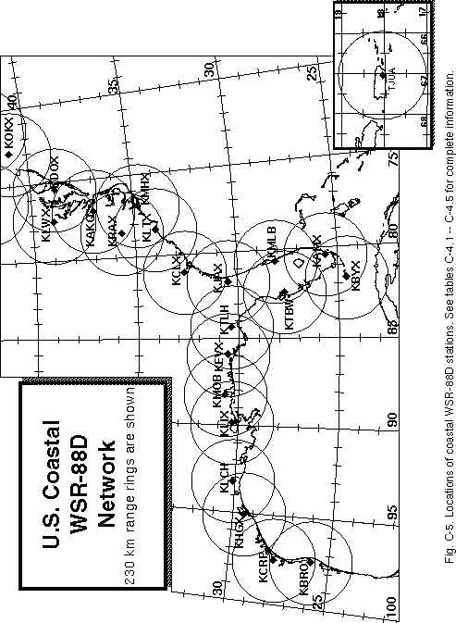

APPENDIX D: PRINCIPAL DUTIES OF THE NOAA SCIENTIFIC PERSONNEL

CAUTION

Flight operations are routinely conducted in turbulent conditions. Shock-mounted electronic and experimental racks surround most seat positions. Therefore, for safety onboard the aircraft all personnel should wear a flight suit and closed toed shoes. For comfort, personnel should bring a jacket or sweater, as the cabin gets cold during flight.

Smoking is prohibited within 50 ft of the aircraft while they are on the ground. No smoking is permitted on the aircraft at any time.

Section 4-401, of the NOAA Safety Rules Manual state that: “Don’t let your attention wander, either through constant conversation, use of cell phone or sightseeing while operating vehicles. Drivers must use caution and common sense under all conditions. Operators and passengers are not permitted to smoke or eat in the government vehicles. Cell phone use is permitted while car is parked.”

GENERAL INFORMATION FOR ALL SCIENTIFIC MISSION PARTICIPANTS

Mission participants are advised to carry the proper personal identification [i.e., travel orders, "shot" records (when appropriate), and passports (when required)]. Passports will be checked by AOC personnel prior to deployment to countries requiring it. All participants must provide their own meals for in-flight consumption. AOC provides a refrigerator, microwave, coffee, utensils, condiments, ice, water, and soft drinks for a nominal fee per flight.

D.1 Field Program Director/ IFEX Chief Scientist;

(1) Responsible to the HRD director for the implementation of the Hurricane Field Program Plan.

(2) Only official communication link to AOC. Communicates flight requirements and changes in mission to AOC.

(3) Only formal communication link between AOML and CARCAH during operations. Coordinates scheduling of each day's operations with AOC only after all (POD) reconnaissance requirements are completed between CARCAH and AOC.

(4) Convenes the Hurricane Field Program Operations Advisory Panel. This panel selects missions to be flown.

(5) Provides for pre-mission briefing of flight crews, scientists, and others (as required).

(6) Assigns duties of field project scientific personnel. Ensures safety during the field program.

(7) Coordinates press statements with NOAA/Public Affairs.

D.2 Assistant Field Program Director

(1) Assumes the duties of the field program director in their absence.

D.3 Named Experiment Lead Project Scientist

(1) Has overall responsibility for the experiment.

(2) Coordinates the project and sub-project requirements.

(3) Determines the primary modes of operation for appropriate instrumentation.

(4) Assists in the selection of the mission.

(5) Provides a written summary of the mission to the field program director (or his designee) at the experiment's debriefing.

D.4 Lead Project Scientist

(1) Has overall scientific responsibility for his/her aircraft.

(2) Makes in-flight decisions concerning alterations of: (a) specified flight patterns; (b) instrumentation operation; and (c) assignment of duties to on-board scientific project personnel.

(3) Acts as project supervisor on the aircraft and is the focal point for all interactions of project personnel with operational or visiting personnel.

(4) Conducts preflight and post flight briefings of the entire crew. Completes formal checklists of safety, instrument operations - noting malfunctions, problems, etc.

(5) Provides a written report of each mission day's operations to the field program director at the mission debriefing.

D.5 Cloud Physics Scientist

(1) Has overall responsibility for the cloud physics project on the aircraft.

(2) Briefs the on-board lead project scientist on equipment status before takeoff.

(3) Determines the operational mode of the cloud physics sensors (i.e., where, when, and at what rate to sample).

(4) Operates and monitors the cloud physics sensors and data systems.

(5) Provides a written preflight and post flight status report and flight summary of each mission day's operations to the on-board lead project scientist at the post flight debriefing.

D.6 Boundary-Layer Scientist

(1) Insures that the required number of AXCPs, AXBTs, and AXCTDs are on the aircraft for each mission.

(2) Operates the AXCP, AXBT, and AXCTD equipment (as required) on the aircraft.

(3) Briefs the on-board lead project scientist on equipment status before takeoff.

(4) Determines where and when to release the AXCPs, AXBTs, and AXCTDs (as appropriate) subject to clearance by flight crew.

(5) Performs preflight, inflight, and post flight checks and calibrations.

(6) Provides a written preflight and post flight status report and a flight summary of each mission day's operations to the on-board lead project scientist at the post flight debriefing.

D.7 Radar Scientist

(1) Determines optimum meteorological target displays. Continuously monitors displays for performance and optimum mode of operations. Thoroughly documents modes and characteristics of the operations.

(2) Provides a summary of the radar display characteristics to the on-board lead project scientist at the post flight debriefing.

(3) Maintains tape logs.

(4) During the ferry to the storm, the radar scientist should record a tape of the sea return on either side of the aircraft at elevation angles varying from -20° through +20°. This tape will allow correction of any antenna mounting biases or elevation angle corrections.

D.8 Dropsonde Scientist

(1) Processes dropsondes observations on HRD workstation for accuracy.

(2) Provides TEMP drop message for ASDL, transmission or insures correct code in case of automatic data transmission.

D.9 Workstation Scientist

(1) Operates HRD's workstation.

(2) Runs programs that determine wind center and radar center as a function of time, composite flight-level and radar reflectivity relative to storm center and then process and code dropwindsonde observations.

(3) Checks data for accuracy and sends appropriate data to ASDL computer.

(4) Maintains records of the performance of the workstation and possible software improvements.
APPENDIX E: NOAA RESEARCH OPERATIONAL PROCEDURES AND CHECK LISTS

Hurricane Field Program Deployment Safety Checklist

The Field Program Director is responsible for making sure safety is enforced and ensuring necessary materials are in place and/or any actions have been completed before the start of the HFP. Field program participants are responsible for reviewing this checklist.

Scientist_______________________________ Date ______________

Before leaving AOML
_____ 1. Contact the HRD Field Program Director personnel to notify departure time.
_____ 2. Things to take
- Flight bag (s)
- Cell phone
- List of HFP important numbers
- HRD Field program plan
- Flight suit

Ground transportation
_____ 1. Arrange for ground transportation
_____ 2. Visual inspection of government vehicle
- Make sure tires do not appear to be flat
- Check for any cracked/broken lights, windshield and mirrors
- Check for any major dents around the vehicle
_____ 3. Inspection inside the government vehicle
- Check all lights work properly (head and tail lights, dome lights, dashboard and turn signal lights)
- Make sure the engine, oil, or temperature indicator light does not flash. If so, contact facilities management.
c. Note the gas and mileage
_____ 4. Contents inside the government vehicle
- Make sure there is first aid kit and fire extinguisher
- Proper jack and lug wrench
- Spare tire
- Basic auto repair kit (i.e. road hazard reflector or flares)
- Consider carrying a flashlight
_____ 5. If possible, return vehicle with full tank (regular unleaded gasoline)
_____ 6. Contact the HRD Field Program Director personnel upon returning

E.1 "Conditions-of-Flight" Commands

Mission participants should be aware of the designated "conditions-of-flight." There are five designated basic conditions of readiness encountered during flight. The pilot will set a specific condition and announce it to all personnel over the aircraft's PA (public address) and ICS (interphone communications systems). All personnel are expected to act in accordance with the instructions for the specific condition announced by the pilot. These conditions and appropriate actions are shown below.

CONDITION 1: TURBULENCE/PENETRATION. All personnel will stow loose equipment and fasten safety belts.

CONDITION 2: HIGH ALTITUDE TRANSIT/FERRY. There are no cabin stations manning requirements.

CONDITION 3: NORMAL MISSION OPERATIONS. All scientific and flight crew stations are to be manned with equipment checked and operating as dictated by mission requirements. Personnel are free to leave their ditching stations.

CONDITION 4: AIRCRAFT INSPECTION. After take-off, crew members will perform wings, engines, electronic bays, lower compartments, and aircraft systems check. All other personnel will remain seated with safety belts fastened and headsets on.

CONDITION 5: TAKE-OFF/LANDING. All personnel will stow or secure loose equipment, don headsets, and fasten safety belts/shoulder harnesses.
E.2 Lead Project Scientist

E.2.1 Preflight
_____ 1. Participate in general mission briefing.
_____ 2. Determine specific mission and flight requirements for assigned aircraft.
_____ 3. Determine from field program director whether aircraft has operational fix responsibility and discuss with AOC flight director/meteorologist unless briefed otherwise by field program director.
_____ 4. Contact HRD members of crew to:
- Assure availability for mission.
- Review field program safety checklist
c. Arrange ground transportation schedule when deployed.
d. Determine equipment status.
_____ 5. Meet with AOC flight director and navigator at least 3 hours before take-off for initial briefing.
_____ 5. Meet with AOC flight crew at least 2 hours before take-off for crew briefing. Provide copies of flight requirements and provide a formal briefing for the flight director, navigator, and pilots.
_____ 6. Report status of aircraft, systems, necessary on-board supplies and crews to appropriate HRD Field Program Director.
_____ 7. Before take-off, brief the on-board GPS dropsonde operator on times and positions of drop times.
_____ 7. Make sure each HRD flight crew members have life vests
_____ 7. Perform a headset operation check with all HRD flight crew members. Make sure everyone can hear and speak using the headset.
_____ 8. Collect “mess” fee ($2.00) from all on-board HRD flight crew members.
E.2.2 In-Flight
_____ 1. Confirm from AOC flight director that satellite data link is operative (information).
_____ 2. Confirm camera mode of operation.
_____ 3. Confirm data recording rate.
_____ 4. Complete Lead Project Scientist Form.
_____ 5. Check in with the flight director to make sure the mission is going as planned (i.e. turns are made when they are supposed to be made).
E.2.3 Post flight
_____ 1. Debrief scientific crew.
_____ 2. Report landing time, aircraft, crew, and mission status along with supplies (tapes, etc.) remaining aboard the aircraft to the HRD Field Program Director.
_____ 3. Gather completed forms for mission and turn in at the appropriate operations center. [Note: all data removed from the aircraft by HRD personnel should be cleared with the AOC flight director.]
_____ 4. Obtain a copy of the 10-s flight listing from the AOC flight director. Turn in with completed forms.
_____ 5. Obtain a copy of the radar DAT tapes and if possible a copy of the radar data-packet files should be copied onto a flash drive. Turn in with completed forms.
_____ 6. Obtain a copy of the all VHS videos form aircraft cameras (3-4 approx.). Turn in with completed forms.
_____ 7. Obtain a copy of CD with all flight data. Turn in with completed forms.
_____ 8. Determine next mission status, if any, and brief crews as necessary.
_____ 9. Notify HRD Field Program Director as to where you can be contacted and arrange for any further coordination required.
_____ 10. Prepare written mission summary using Mission Summary form (due to Field Program Director 1 week after the flight).

Form E-2

Page 1 of 5

Lead Project Scientist Check List

Date _______________ Aircraft ______________ Flight ID ____________________

A. —Participants:

HRD |  |  | AOC
Function | Participant |  | Function | Participant
Lead Project Scientist |  |  | Flight Director
Radar |  |  | Pilots
Workstation |  |  | Navigator
Cloud Physics |  |  | Systems Engineer
Photographer/Observer/Guests |  |  | Data Technician
Dropwindsonde |  |  | Electronics Technician
AXBT/AXCP |  |  | Other

B. Take-off and Landing Locations:

Take-Off: ________ Location: _______________

Landing: ________ Location: _________________
Number of Eye Penetrations: ______

C. Past and Forecast Storm Locations:

Date/Time | Latitude | Longitude | MSLP | Maximum Wind

D. Mission Briefing:

Form E-2

Page 2 of 5

E. Equipment Status (Up ↑, Down ↓, Not Available —, Not Used O)

Equipment | Pre-Flight | In-Flight | Post-Flight | # DATs / Cds  /Expendables/Printouts
Radar/LF
Doppler Radar/TA
Cloud Physics
Data System
GPS sondes
AXBT/AXCP
Ozone instrument
Workstation
Videography

REMARKS:

Form E-2

Page 3 of 5

Mission Summary
Storm name
YYMMDDA# Aircraft 4 _RF

Scientific Crew (4 RF)

Lead Project Scientist
Radar Scientist
Cloud Physics Scientist
Dropwindsonde Scientist
Boundary-Layer Scientist
Workstation Scientist

Observers

Mission Briefing: (include sketch of proposed flight track or page #)

Mission Synopsis: (include plot of actual flight track)

Evaluation: (did the experiment meet the proposed objectives?)

Problems:(list all problems)

Expendables used in mission:
GPS sondes : ________________
AXBTs :__________________
Sonobuoys: _________________

Form E-2

Page 5 of 5

Lead Project Scientist Event Log

Date ________________ Flight ________________ LPS _____________________

Time | Event | Position | Comments
E.3 Cloud Physics Scientist

The on-board cloud physics scientist (CPS) is responsible for cloud physics data collection on his/her assigned aircraft. Detailed operational procedures are contained in the cloud physics kit supplied for each aircraft. General procedures follow. (Check off and initial.)

E.3.1 Preflight

_____ 1. Determine status of cloud physics instrumentation systems and report to the on-board lead project scientist (LPS).

_____ 2. Confirm mission and pattern selection from the on-board LPS.

_____ 3. Select mode of instrument operation.

_____ 4. Complete appropriate instrumentation preflight check lists as supplied in the cloud physics operator's manual.

E.3.2 In-Flight

_____ 1. Operate instruments as specified in the cloud physics operator's manual and as directed by the on-board LPS.

E.3.3 Post flight

_____ 1. Complete summary checklist forms and all other appropriate forms.

_____ 2. Brief the LPS on equipment status and turn in completed check sheets to the LPS.

_____ 3. Take cloud physics data tapes and other data forms and turn these data sets in as follows:

a. Outside of Miami-to the LPS.
b. In Miami-to AOML/HRD. [Note: all data removed from the aircraft by HRD personnel should be cleared with the AOC flight director.]

_____ 4. Debrief as necessary at HRD Field Program Director or the hotel during a deployment.

_____ 5. Determine the status of future missions and notify HRD Field Program Director as to where you can be contacted.

Form E-3

Page 1 of 2

Cloud Physics Scientist Check List

Date ___________________ Aircraft ____________ Flight ID __________________

A. —Instrument Status and Performance:

System | Pre-Flight | In-Flight | Downtime
DMT CCP
DMT PIP
SEA LWC
King Probe
DRI Field Mills
King Probe
DMT PADS data system

B. —Remarks:

E.4 Boundary-Layer Scientist

The on-board boundary-layer scientist (BLS) is responsible for data collection from AXBTs, AXCPs, AXCTDs, Buoys, and SST radiometers (if these systems are used on the mission). Detailed calibration and instrument operation procedures are contained in the air-sea interaction (ASI) manual supplied to each operator. General supplementary procedures follow. (Check off and initial.)

E.4.1 Preflight

_____ 1. Determine the status of equipment and report results to the on-board lead project scientist (LPS).

_____ 2. Confirm mission and pattern selection from the LPS.

_____ 3. Select the mode of operation for instruments after consultation with the HRD/BLS and the LPS.

_____ 4. Complete appropriate preflight check lists as specified in the ASI manual and as directed from the LPS.

E.4.2 In-Flight

_____ 1. Operate the instruments as specified in the ASI manual and as directed by the on-board LPS.

E.4.3 Post flight

_____ 1. Complete summary checklist forms and all other appropriate forms.

_____ 2. Brief the on-board LPS on equipment status and turn in completed checklists to the LPS.

_____ 3. Debrief as necessary at HRD Field Program Director or the hotel during a deployment.

_____ 4. Determine the status of future missions and notify HRD Field Program Director as to where you can be contacted.

Form E-4

Page 1 of 2

AXBT and Sonobuoy Check Sheet Summary

Flight _________________ Aircraft _____________ Operator _________________

Number

(1) Probes dropped _______

(2) Failures _______

(3) Failures with no signal _______

(4) Failures with sea surface temperature, but terminated above thermocline _______

(5) Probes that terminated above 250 m, but below thermocline _______

(6) Probes used by channel number CH12 _______

CH14 _______

CH16 _______

CH__ _______

NOTES:

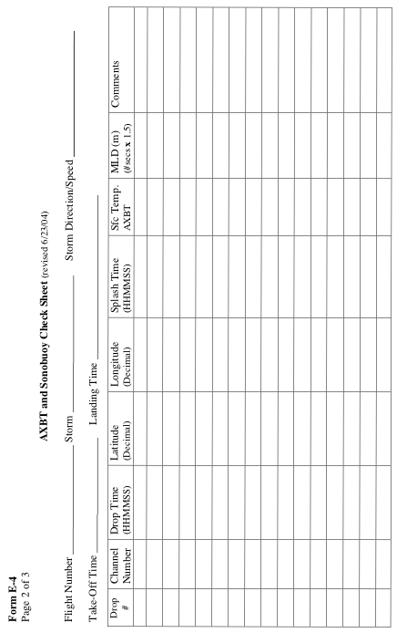
E.5 Radar Scientist

The on-board radar scientist is responsible for data collection from all radar systems on his/her assigned aircraft. Detailed operational procedures and checklists are contained in the operator's manual supplied to each operator. General supplementary procedures follow. (Check off and initial.)

E.5.1 Preflight

_____ 1. Determine the status of equipment and report results to the lead project scientist (LPS).

_____ 2. Confirm mission and pattern selection from the LPS.

_____ 3. Select the operational mode for radar system(s) after consultation with the LPS.

_____ 4. Complete the appropriate preflight calibrations and check lists as specified in the radar operator's manual.

E.5.2 In-Flight

_____ 1. Operate the system(s) as specified in the operator's manual and as directed by the LPS or as required for aircraft safety as determined by the AOC flight director or aircraft commander.

_____ 2. Maintain a written commentary in the radar logbook of tape and event times, such as the start and end times of F/AST legs. Also document any equipment problems or changes in R/T, INE, or signal status.

E.5.3 Post flight

_____ 1. Complete the summary checklists and all other appropriate check lists and forms.

_____ 2. Brief the LPS on equipment status and turn in completed forms to the LPS.

_____ 3. Hand-carry all radar tapes and arrange delivery as follows:

a. Outside of Miami-to the LPS.
b. In Miami-to AOML/HRD. [Note: all data removed from the aircraft by HRD personnel should be cleared with the AOC flight director.]

_____ 4. Debrief at AOML/HRD or the hotel during a deployment.

_____ 5. Determine the status of future missions and notify HRD Field Program Director as to where you can be contacted.

Form E-5

Page 1 of 2

HRD Radar Scientist Check List

Flight ID:

Aircraft Number:

Radar Operators:

Radar Technician:

Number of digital magnetic tapes on board:

Component Systems Status:

MARS __________________________ Computer ____________________________

DAT1___________________________ DAT2 _______________________________

LF _____________________________ R/T Serial # ___________________________

TA _____________________________ R/T Serial # ___________________________

Time correction between radar time and digital time:

Radar Post flight Summary

Number of digital tapes used: DAT1 _______________________

DAT2 _______________________

Significant down time:

DAT1 ______________________ Radar LF ____________________

DAT2 ______________________ Radar TA ____________________

Other Problems:

Form E-5

Page 2 of 2

HRD Radar Tape Log

Flight ______________ Aircraft _______ Operator _______________ Sheet ____ of ____

LF RPM _______________ TA RPM ______________

(Include start and end times of DATs, as well as times of F/AST legs and any changes of radar equipment status)

Tape # | F/AST  On? | Event Time  (HHMMSS) | Event

Item List: DAT1, DAT2, COMP, MARS, LF, and TA.
Include serial numbers of any new R/Ts.
E.6 Dropsonde Scientist

The lead project scientist (LPS) on each aircraft is responsible for determining the distribution patterns for dropwindsonde releases. Predetermined desired data collection patterns are illustrated on the flight patterns. However, these patterns often are required to be altered because of clearance problems, etc. Operational procedures are contained in the operator's manual. The following list contains more general supplementary procedures to be followed. (Check off and initial.)

E.6.1 Preflight
_____ 1. Determine the status of the AVAPS and HAPS. Report results to the LPS.
_____ 2. Confirm the mission and pattern selection from the LPS and assure that enough dropsondes are on board the aircraft.
_____ 3. Modify the flight pattern or drop locations if requested by AOC to accommodate changes in storm location or closeness to land.
_____ 4. Complete the appropriate preflight set-up and checklists.

E.6.2 In-Flight
_____ 1. Operate the system as specified in the operator's manual.
_____ 2. Ensure the AOC flight director is aware of upcoming drops.
_____ 3. Ensure the AVAPS operator has determined that the dropsonde is (or is not) transmitting a good signal. Recommend if a backup dropsonde should be launched in case of failure.
_____ 4. Report the transmission of each drop and fill in the Dropwindsonde Scientist Log.

E.6.3 Post flight
_____ 1. Complete Dropwindsonde Scientist Log.
_____ 2. Brief the LPS on equipment status and turn in reports and completed forms.
_____ 3. Hand-carry all dropwindsonde data tapes or CDs as follows:
a. Outside of Miami-to the LPS or PI.
b. In Miami-to AOML/HRD. [Note: all data removed from the aircraft by HRD personnel should be cleared with the AOC flight director.]
_____ 4. Debrief at the AOML/HRD or the hotel during a deployment.
_____ 5. Determine the status of future missions and notify HRD Field Program Director as to where you can be contacted.
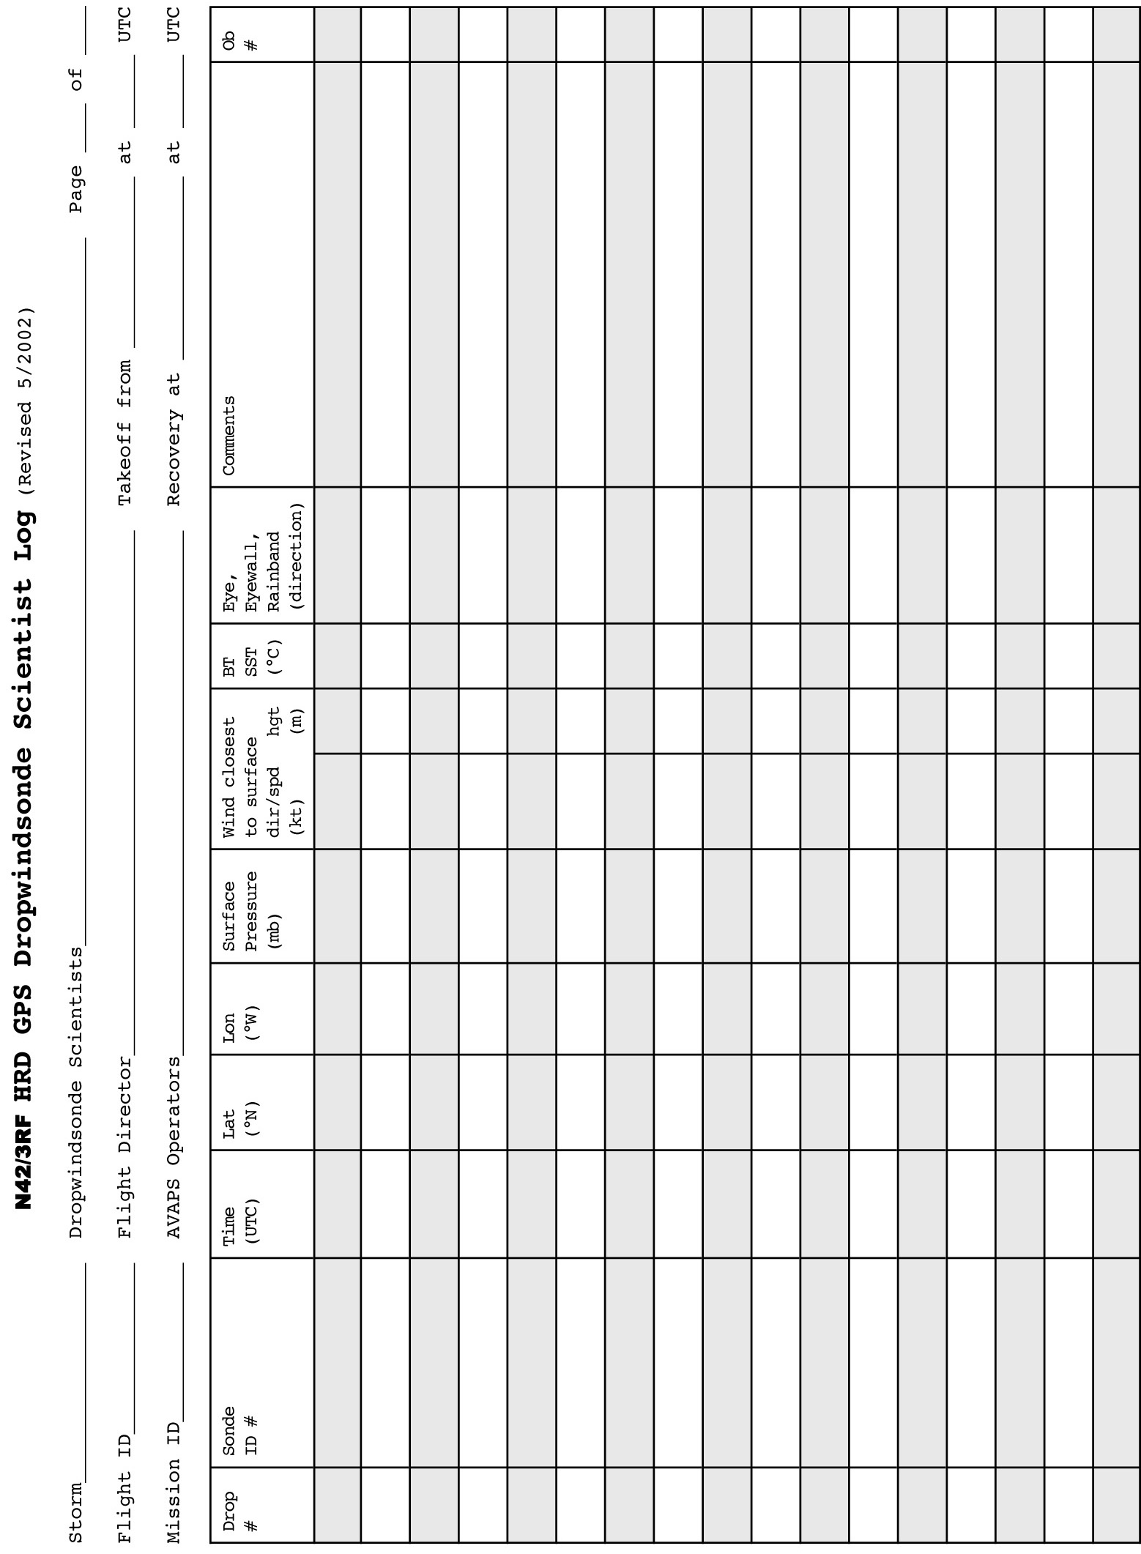

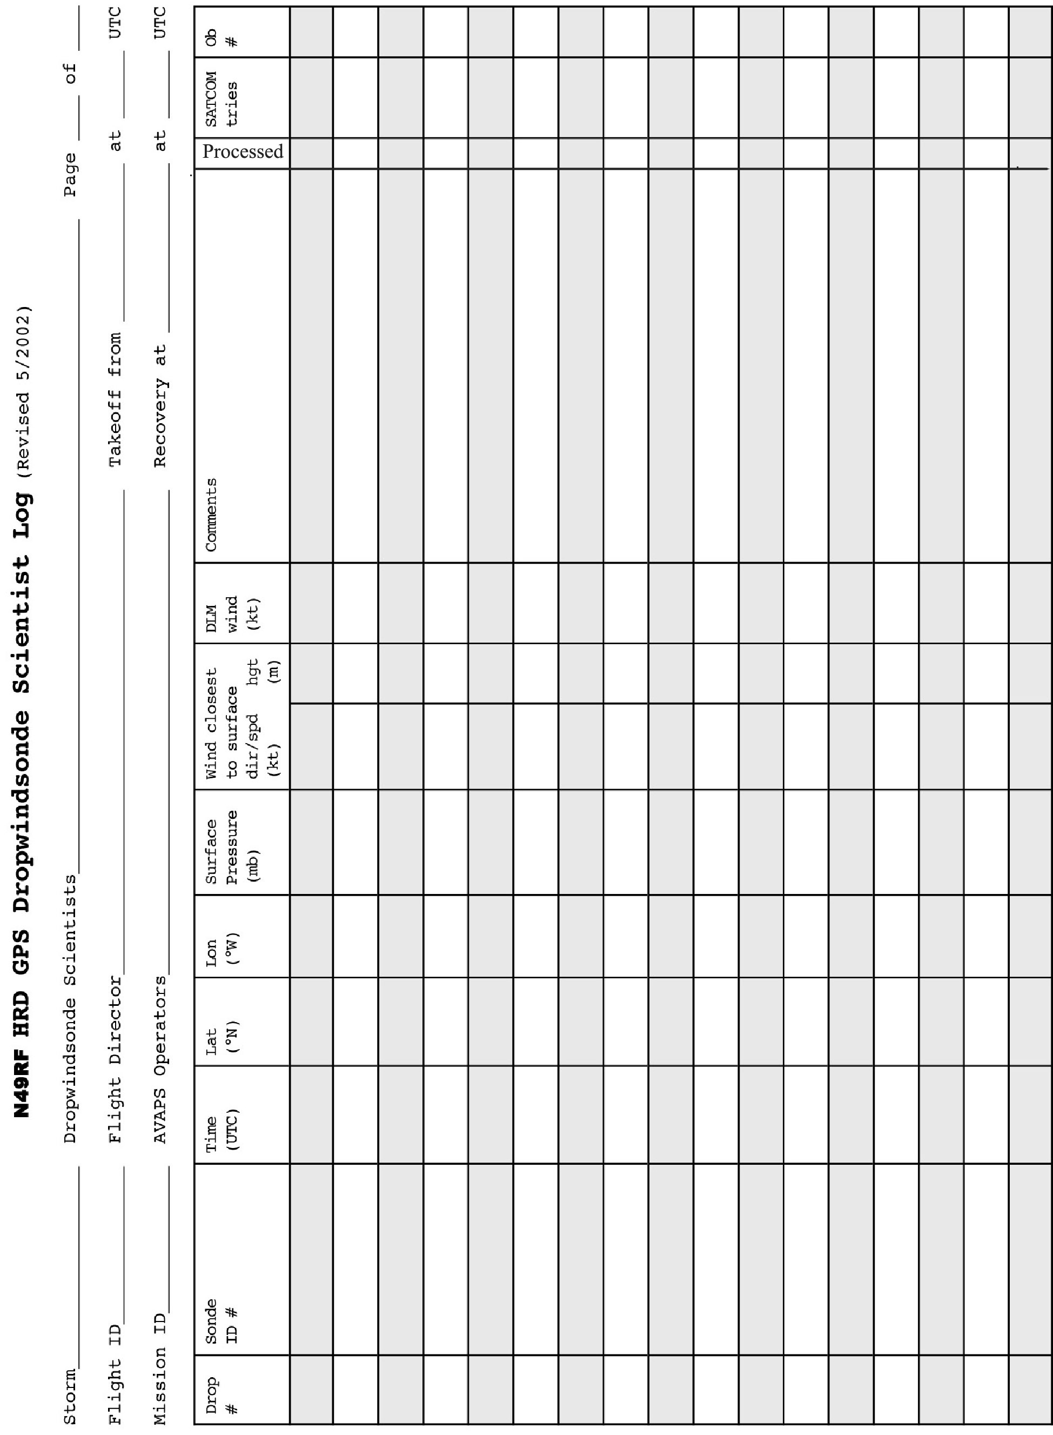

APPENDIX F: SYSTEMS OF MEASURE AND UNIT CONVERSION FACTORS

Table F-1 Systems of measure: Units, symbols, and definitions

Quantity | SI Unit | Early Metric | Maritime | English
length | meter (m) | centimeter (cm) | foot (ft) | foot (ft)
distance | meter (m) | kilometer (km) | nautical  mile (nm) | mile (mi)
depth | meter (m) | meter (m) | fathom (fa) | foot (ft)
mass | kilogram (kg) | gram (g)
time | second (s) | second (s) | second (s) | second (s)
speed | meter per second (mps) | centimeter per second (cm s⁻¹) | knot (kt) (nm h⁻¹) | miles per hour (mph)
 |  | kilometers per hour (km h⁻¹)
temperature  -sensible | degree Celsius (°C) | degree Celsius (°C) | --- | degree Fahrenheit (°F)
-potential | Kelvin (K) | Kelvin (K) | --- | Kelvin (K)
force | Newton (N)  (kg m s⁻²) | dyne (dy)  (g cm s⁻²) | poundal (pl) | poundal (pl)
pressure | Pascal (Pa)  (N m⁻²) | millibar (mb)  (10³ dy cm⁻²) | inches (in)  mercury (Hg) | inches (in)  mercury (Hg)

Table F-2. Unit conversion factors

Parameter | Unit | Conversions
length | 1 in  1 ft  1 m | 2.540 cm  30.480 cm  3.281 ft
distance | 1 nm (nautical mile) | 1.151 mi  1.852 km  6080 ft
 | 1 mi (statute mile) | 1.609 km  5280 ft
 | 1° latitude | 59.996 nm  69.055 mi  111.136 km
depth | 1 fa | 6 ft  1.829 m
mass | 1 kg | 2.2 lb
force | 1 N | 10⁵ dy
pressure | 1 mb | 102 Pa  0.0295 in Hg
 | 1 lb ft⁻² | 4.88 kg m⁻²
speed | 1 m s⁻¹ | 1.9at. 6 h⁻¹
10 kt

APPENDIX G: AIRCRAFT SCIENTIFIC INSTRUMENTATION
Instrument | Parameter |  | PI |  | Group
Navigational
INE1/2 | lat, lon |  |  |  | AOC
GPS1/2 | lat, lon |  |  |  | AOC
Honeywell HG9550 altimeter | Radar altitude |  |  |  | AOC
Standard Meteorological
Buck1101c, Edgetech Vigilant, Maycom TDL | T_{d} |  |  |  | AOC
Rosemount temp | T, T' |  |  |  | AOC
Static pressure | p |  |  |  | AOC
Dynamic pressure | p' |  |  |  | AOC
Horizontal wind | V_{h} |  |  |  | AOC
Vertical wind | w |  |  |  | AOC
Infrared Radiation
Side CO₂ radiometer | T |  |  |  | AOC
AOC down radiometer | SST |  |  |  | AOC
Lightning Emissions
ADELE gamma-ray detector | Gamma, x-ray count rate |  | D. Smith |  | UCSC
Weather Radar
LF radar | R |  | Gamache |  | AOC
TA Doppler radar, AOC flat plate antenna | V, R |  | Gamache |  | AOC
Doppler Wind Lidar | V, R |  | Atlas |  | HRD
Passive Microwave
AOC SFMR/pod | V₁₀, Z |  | Goldstein |  | AOC
Active Microwave
ProSensing WSRA | HS, WPS, WDS |  | Fairall |  | ESRL, NHC
Passive GPS
GPS bistatic altimeter | ocean height |  | Fairall |  | ESRL
Airborne Ocean Profiler
AOC AXBT (MK-21) receivers | TS vs z |  | Smith (N. Shay) |  | AOC (UM)
Dropsonde Systems
GPS AVAPS Dropsonde-8CH | V, T, RH, p vs z |  | Smith |  | AOC
Video Systems
Down video | F(%), WD |  |  |  | AOC
Side, nose video | LCL |  |  |  | AOC
Cloud Microphysics/Sea Spray
SEA Probe | Liquid water |  | R. Black |  | AOC, HRD
DMT CCP probe | Cloud particle spectra |  | R. Black |  | AOC
DMT PIP probe | Precipitation particle spectra |  | R. Black |  | AOC
DMT CAS probe | Aerosol/cloud droplet spectra |  | R. Black |  | AOC
DMT DAS | processor |  | R. Black |  | AOC
CCN probe | Aerosol spectra |  | B. Anderson |  | NASA
TSI3787 CN counter | Aerosol concentration |  | B. Anderson |  | NASA
Wide-Band Integrated Bio-Aerosol Sensor | Aerosol composition |  | B. Anderson |  | NASA
Turbulence Systems
LICOR-750 water vapor analyzer | q’ | J. Zhang, Drennan |  | HRD, UM, AOC
Friehe radome gust probe system | U',V',W',T' |  | J. Zhang, Drennan |  | HRD, UM
On board processing
PC/LINUX workstation | Radar processing |  | Hill |  | AOC
PC/LINUX workstation | x-chat/Web |  | Hill |  | AOC
PC/LINUX workstation | ASPEN |  | Hill |  | AOC
Real-time data communications systems | FL, radar data |  | Chang, Carswell |  | NESDIS, RSS

Table G.1: NOAA/AOC WP-3D (N42RF) instrumentation

APPENDIX G: AIRCRAFT SCIENTIFIC INSTRUMENTATION (CONT’D)
Instrument | Parameter | PI | Group
Navigational
INE1/2 | lat, lon |  | AOC
GPS1/2 | lat, lon |  | AOC
Honeywell HG9550 altimeter | Radar altitude |  | AOC
Standard Meteorological
Buck1101c, Edgetech Vigilant, Maycom TDL | T_{d} |  | AOC
Rosemount temp | T, T' |  | AOC
Static pressure | p |  | AOC
Dynamic pressure | p' |  | AOC
Horizontal wind | V_{h} |  | AOC
Vertical wind | w |  | AOC
Infrared Radiation
Side CO₂ radiometer | T |  | AOC
AOC down radiometer | SST |  | AOC
Weather Radar
LF radar | R | Gamache | AOC
TA Doppler radar, AOC flat plate antenna | V, R | Gamache | AOC
Passive Microwave
AOC SFMR/pod | V₁₀, Z | Goldstein | AOC
Active Microwave
IWRAP (CSCAT, KSCAT) | V₁₀, Z, V vs z | Chang | NESDIS
Airborne Ocean Profiler
AOC AXBT (MK-21) receivers | TS vs z | Smith (N. Shay) | AOC (UM)
Dropsonde Systems
GPS AVAPS Dropsonde-8CH | V, T, RH, p vs z | Smith | AOC
Video Systems
Down video | F(%), WD |  | AOC
Side, nose video | LCL |  | AOC
Cloud Microphysics/Sea Spray
SEA probe | liquid water | R. Black | AOC, HRD
Turbulence Systems
Friehe radome gust probe system | U',V',W',T' | J. Zhang, Drennan | HRD, UM
On board processing
PC/LINUX workstation | Radar processing | Hill | AOC
PC/LINUX workstation | x-chat/Web | Hill | AOC
PC/LINUX workstation | ASPEN | Hill | AOC
Real-time data communications systems | FL, radar data | Chang, Carswell | NESDIS, RSS

Table G.2 (Cont’d): NOAA/AOC WP-3D (N43RF) instrumentation
APPENDIX G: AIRCRAFT SCIENTIFIC INSTRUMENTATION (CONT’D)
Instrument | Parameter | PI | Group
Navigational
INE1/2 | lat, lon |  | AOC
GPS1/2 | lat, lon |  | AOC
Honeywell HG9550 altimeter | Radar altitude |  | AOC
Standard Meteorological
Buck1101c, Edgetech Vigilant, Maycom TDL | T_{d} |  | AOC
Rosemount temp | T, T’ |  | AOC
Static pressure | p |  | AOC
Dynamic pressure | p' |  | AOC
Horizontal wind | V_{h} |  | AOC
Vertical wind | w |  | AOC
Weather Radar
TA Doppler radar | V, R | Gamache | AOC
Passive Microwave
SFMR | V₁₀, Z | Goldstein | AOC
Dropsonde Systems
GPS AVAPS Dropsonde-8CH | V, T, RH, p vs z | Smith | AOC
On board processing
Real-time data communications systems | FL, radar data | Chang, Carswell | AOC
PC/LINUX Computer | radar data, sondes | Goldstein | AOC

Table G.3 (Cont’d): NOAA/AOC G-IV (N49RF) instrumentation

APPENDIX H: NOAA EXPENDABLE AND MEDIA

Experiment | GPS Dropwindsondes |  | AXBTs | CADs
 | G-IV | P-3 | P-3 | P-3
P-3 3D Doppler Winds | - | 20 | 10 | 10
G-IV Tail Doppler Radar | 20 | 20 | 10 | 10
HWRF Model Evaluation* | 25 | 40 | 30 | 30
DWL SAL | - | 10 | - | -
DWL HBL | - | 10 | - | -
NESDIS Ocean Winds | - | 5 | - | -
Small UAV | - | 20 | 15 | 15
SFMR HIA | - | 1 | 1 | 1
TC in Shear | 25 | 30 | - | -
TC Diurnal Cycle | 25 | 10 | - | -
TC-Ocean Interaction | - | 20 | 15 | 15
Convective Burst | - | 15 | - | -
Rapid Intensification | 25 | 25 | 25 | 25
TC Landfall | - | 20 | 5 | 5
SALEX Arc Cloud | - | 10 | - | -
BL Entrainment | - | 15 | 10 | 10
Offshore Wind | - | 10 | - | -

Table H-1: Required expendables for 2014 experiments and modules for a single mission of the P-3 and the G-IV. *Note that since the HWRF Model Evaluation experiment requires two simultaneous P-3s, the expendable counts are doubled. For media, most data are now recorded on usb sticks. 1-2 DAT tapes are required for saving Lower Fuselage (LF) radar data.

ACRONYMS AND ABBREVIATIONS

θe equivalent potential temperature

ABL atmospheric boundary-layer
A/C aircraft
ACLAIM Airborne Coherent Lidar for Advanced In-flight Measurements
AES Atmospheric Environment Service (Canada)
AFRES U. S. Air Force Reserve
AOC Aircraft Operations Center
AOML Atlantic Oceanographic and Meteorological Laboratory
ASDL aircraft-satellite data link
AXBT airborne expendable bathythermograph
AXCP airborne expendable current probe
AXCTD airborne expendable conductivity, temperature, and depth probe

CARCAH Chief, Aerial Reconnaissance Coordinator, All Hurricanes
CDO central dense overcast
CIRA Cooperative Institute for Research in the Atmosphere
C-MAN Coastal-Marine Automated Network
CP coordination point
CW cross wind

DLM deep-layer mean
DOD Department of Defense
DOW Doppler on Wheels
DRI Desert Research Institute (at Reno)

E vector electric field
EPAC Eastern Pacific
ETL Environmental Technology Laboratory
EVTD extended velocity track display

FAA Federal Aviation Administration
F/AST fore and aft scanning technique
FEMA Federal Emergency Management Agency
FL flight level
FP final point
FSSP forward scattering spectrometer probe

GFDL Geophysical Fluid Dynamics Laboratory
G-IV Gulfstream IV-SP aircraft
GOMWE Gulf of Mexico Warm Eddy
GPS global positioning system

HL Hurricanes at Landfall
HRD Hurricane Research Division

INE inertial navigation equipment
IP initial point (or initial position
IWRS Improved Weather Reconnaissance System

JW Johnson-Williams
Ku-SCAT Ku-band scatterometer

LF lower fuselage (radar)
LIP Lightning Instrument Package
LPS Lead Project Scientist

MCS mesoscale convective systems
MLD Mixed Layer Depth
MPO Meteorology and Physical Oceanography

NASA National Aeronautics and Space Administration
NCAR National Center for Atmospheric Research
NCEP National Centers for Environmental Prediction
NDBC NOAA Data Buoy Center
NESDIS National Environmental Satellite, Data and Information Service
NHC National Hurricane Center
NOAA National Oceanic and Atmospheric Administration
NWS National Weather Service

OML oceanic mixed-layer

PDD pseudo-dual Doppler
PMS Particle Measuring Systems
POD Plan of the Day
PPI plan position indicator
PV potential vorticity

RA radar altitude
RAOB radiosonde (upper-air observation)
RAWIN rawinsonde (upper-air observation)
RECCO reconnaissance observation
RHI range height indicator
RSMAS Rosenstiel School of Marine and Atmospheric Science

SFMR Stepped-Frequency Microwave Radiometer
SLOSH sea, lake, and overland surge from hurricanes (operational storm surge model)
SRA Scanning Radar Altimeter
SST sea-surface temperature

TA tail (radar)
TAS true airspeed
TC tropical cyclone
TOPEX The Ocean Topography Experiment

UMASS University of Massachusetts (at Amherst)
USACE United States Army Corps of Engineers
USAF United States Air Force
USWRP U. S. Weather Research Program
UTC universal coordinated time (U.S. usage; same as “GMT” and "Zulu" time)

VTD velocity-track display

Acknowledgments

The preparation of HRD's 2014 Hurricane Field Program Plan was a team effort. The authors would like to express their appreciation to: the HRD scientists that contributed information on specific experiments.

