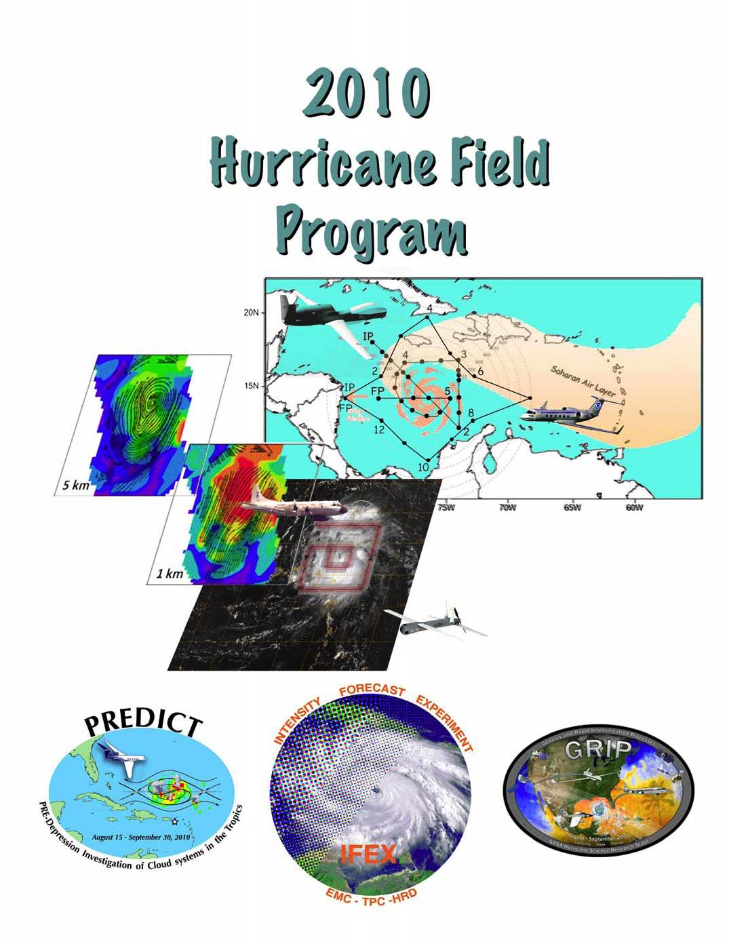

2010 Hurricane Field Program Plan

Hurricane Research Division
National Oceanographic and Atmospheric Administration
Atlantic Oceanographic and Meteorological Laboratory
4301 Rickenbacker Causeway
Miami, FL 33149

Prepared by:
Robert Rogers, Sim Aberson, Michael Black, Robert Black, Joe Cione, Peter Dodge, Jason Dunion, John Gamache, John Kaplan, Sylvie Lorsolo, Shirley Murillo, Eric Uhlhorn, Jun Zhang, Gary Barnes, Eric D’Asaro, Matthew Eastin, Rick Lumpkin, Nick Shay

1 June 2010
Frank D Marks, Jr Date
Director, Hurricane Research Division
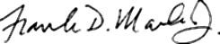

Distribution of the NOAA/HRD Hurricane Field Program Plan is restricted to personnel directly involved in the hurricane field program or to those persons who are on a need-to-know basis. This plan, in whole or in part, is not to be abstracted, cited or reproduced in the open literature.

Mention of a commercial establishment, company or product does not constitute any endorsement by the NOAA/Office of Oceanic and Atmospheric Research or the U.S. Government. Use, for publicity of advertisement, of information from this publication concerning proprietary products or their testing is not authorized.

�2010, U.S. Department of Commerce, NOAA/AOML/Hurricane Research Division

Cover: Saharan Air Layer flight pattern (top right) and 5-km and 1-km altitude streamlines and reflectivity (middle left) obtained from airborne Doppler analyses and GOES-visible satellite image with P-3 square-spiral flight pattern overlain for pre-Tropical Depression Fay (2008).

TABLE OF CONTENTS

INTRODUCTION……………………………………………………………………………………….. 1
1. Description of Intensity Forecasting Experiment (IFEX)……………………………………………. 1
2. Experiment and module summaries…………………………………………………………………. 2
3. Partnering experiments……………………………………………………………………………… 5
OPERATIONS………………………………………………………………………………………….... 6
- Locations…………………………………………………………………………………………….. 6
- Field Program Duration…………………………………………………………………………….. 6
- Research Mission Operations………………………………………………………………………. 6
- Task Force Configuration…………………………………………………………………………... 6
- Field Operations…………………………………………………………………………………….. 6
5.1 Scientific Leadership Responsibilities………………………………………………………….. 6
5.2 Aircraft Scientific Crews………………………………………………………………….. …….. 6
5.3 Principal Duties of the Scientific Personnel………………………………………….…… …….. 6
5.4 HRD Communications…………………………………………………………………….. …….. 6

6. Data Management…………………………………………………………………………………... 7
- Operational Constraints…………………………………………………………………………….. 7
- Calibration of Aircraft Systems…………………………………………………………………….. 8

EXPERIMENT AND MODULE DESCRIPTIONS……………….……………………………….. 9
IFEX GOAL 1
- Three-Dimensional Doppler Winds Mission…..……………………………………………………. 9
- Hurricane Synoptic Surveillance………………………………………………………………….. 27

IFEX GOAL 2
- Coyote UAS Module …………………………………………………………………………….. 35
- Doppler Wind Lidar Module …………………………….……………………………………........ 41

IFEX GOAL 3
- Tropical Cyclogenesis Experiment (GENEX)………………………………………………………... 45
- Rapid Intensification Experiment (RAPX).……………………….…………………………….…... 58
- TC-Ocean Interaction Experiment………………………………………………………………….. 63
- Saharan Air Layer Experiment (SALEX).…………………………………...……………………... 70
- Tropical Cyclone Landfall and Inland Decay Experiment …………………………………………. 80
- Tropical Cyclone/AEW Arc Cloud Module..…………………………………………………......... 91
- Hurricane Boundary Layer Entrainment Flux Module ………………………………………….. .. 96
- Aerosol/Cloud Droplet Measurement Module ……………………………………………………. 101

SUPPLEMENTAL: OPERATIONAL MAPS

…

…

…

…

…

…

…

…

…

…

…

…

…

…

…

…

…

…

…

...

…

…

..103

Map 1: Primary Atlantic operating bases and operating ranges (G-IV).…………………….…...………..103
Map 2: Primary Atlantic operating bases and operating ranges (P-3) ……………………………….……103

2010 HURRICANE FIELD PROGRAM PLAN

INTRODUCTION

National Oceanic and Atmospheric Administration
Atlantic Oceanographic and Meteorological Laboratory
Hurricane Research Division
Miami, Florida. USA

1. Description of Intensity Forecasting Experiment (IFEX)

One of the key activities in the NOAA Strategic Plan Mission Goal 3 (Reduce Society’s Risks from Weather and Water Impacts) is to improve the understanding and prediction of tropical cyclones (TCs). The National Centers for Environmental Prediction (NCEP) National Hurricane Center (NHC) is responsible for forecasting TCs in the Atlantic and East Pacific basins, while the Environmental Modeling Center (EMC) provides NWP guidance for the forecasters. Together they have made great strides in improving forecasts of TC track. With support from the research community, forecast errors of TC track have decreased by about 50% over the past 30 years. However, there has been much less improvement in forecasts of TC intensity, structure, and rainfall. This lack of improvement is largely the result of deficiencies in routinely collecting inner-core data and assimilating it into the modeling system, limitations in the numerical models themselves, and gaps in understanding of the physics of TCs and their interaction with the environment. Accurate forecasts will rely heavily on the use of improved numerical modeling systems, which in turn will rely on accurate observational datasets for assimilation and validation.

The operational TC model, HWRF, is run at 9 km grid length, using an assortment of physical parameterizations intended to represent subgrid-scale processes important in TC evolution. Such a modeling system holds the potential of improving understanding and forecasting of TC track, intensity, structure, and rainfall. In order to realize such improvements, however, new data assimilation techniques must be developed and refined, physical parameterizations must be improved and adapted for TC environments, and the models must be reliably evaluated against detailed observations from a variety of TCs and their surrounding environments.

To conduct the research necessary to address the issues raised above, since 2005 NOAA has been conducting an experiment designed to improve operational forecasts of TC intensity, called the Intensity Forecasting EXperiment (IFEX; Rogers et al., BAMS, 2006). The IFEX goals, developed through a partnership involving the NOAA Hurricane Research Division (HRD), NHC, and EMC, are to improve operational forecasts of TC intensity, structure, and rainfall by providing data to improve the operational numerical modeling system (i.e., HWRF) and by improving understanding of the relevant physical processes. These goals will be accomplished by satisfying a set of requirements and recommendations guiding the collection of the data:

Goal 1: Collect observations that span the TC life cycle in a variety of environments for model initialization and evaluation;
Goal 2: Develop and refine measurement technologies that provide improved real-time monitoring of TC intensity, structure, and environment;

Goal 3

: Improve understanding of the physical processes important in intensity change for a TC at all stages of its lifecycle.

A unique, and critical, aspect of IFEX is the focus on providing measurements of TCs at all stages of their life cycle. The focus of hurricane research flights during the past 30 years has been on mature storms, leading to a dataset biased toward these types of systems. The strategy of observing the entire life cycle of a TC is new and unique, and it will provide invaluable information, particularly in sparsely observed environments.

2. Experiment and module summaries

The field program aircraft missions presented in this document are separated into three distinct sections, each one corresponding to which IFEX goal they most directly address (note that many experiments address multiple IFEX goals). The flight patterns that comprise these various experiments and operational missions address various aspects of the TC lifecycle, and they all specifically address the main goals of IFEX. A detailed description of each experiment or operational mission follows, including descriptions of the scientific and details of the associated flight patterns.

In this document reference is made to either “experiments” or “modules.” For this discussion, “experiments” refer to when research scientists (i.e., from HRD) set the flight pattern for the entire mission. Operational needs take priority in this scenario. “Modules” refer to short patterns that can be flown as a part of larger experiments (either operationally- or research-tasked). Modules generally take 1 h or less for completion.

IFEX GOAL 1: Collect observations that span the TC life cycle in a variety of environments for model initialization and evaluation

(1) Three-Dimensional Doppler Winds Experiment: This is a multi-option, single-aircraft operational mission designed to use the NOAA P-3 to sample TCs ranging in intensity from tropical depression to a major hurricane. The definition is meant to separate this category from tropical waves and disturbances that have yet to develop a well-defined warm-core circulation. The main goals of these missions is: 1) to improve understanding of the factors leading to TC intensity and structure changes, 2) to provide a comprehensive data set for the initialization (including data assimilation) and validation of numerical hurricane simulations (in particular HWRF), 3) to improve and evaluate technologies for observing TCs, and 4) to develop rapid real-time communication of these observations to NCEP. The overall experiment is comprised of two parts: one designed to obtain regular 12- or 24-h resolution airborne Doppler-radar observations of hurricanes, with optional dropwindsondes, and one, the National Environmental Satellite, Data, and Information Service (NESDIS) Ocean Winds and Rain Experiment, designed to improve understanding of microwave surface scatterometery in high-wind conditions over the ocean by collecting surface scatterometery data and Doppler data in the boundary layer of hurricanes.

(2)
Hurricane Synoptic Surveillance Experiment
: This is a multi-option, single or multi-aircraft operational mission that uses dropwindsondes launched from the NOAA G-IV, and the AFRES C-130 to improve landfall predictions of TCs by releasing dropwindsondes in the environment of the TC center. These data will be used by NCEP to prepare objective analyses and official forecasts

through their assimilation into operational numerical prediction models. Because the atmosphere is known to be chaotic, very small perturbations to initial conditions in some locations can amplify with time. However, in other locations, perturbations may result in only small differences in subsequent forecasts. Therefore, targeting locations in which the initial conditions have errors that grow most rapidly may lead to the largest possible forecast improvements. Locating these regions that impact the particular forecast is necessary. When such regions are sampled at regularly spaced intervals the impact is most positive. The optimal targeting and sampling strategies is an ongoing area of research.

IFEX GOAL 2: Develop and refine measurement technologies that provide improved real-time monitoring of TC intensity, structure, and environment

(3) Coyote UAS Module: This is a single-aircraft module whose primary objective is to further demonstrate and utilize the unique capabilities of a low latitude UAS platform in order to better document areas of the tropical cyclone environment that would otherwise be either impossible or impractical to observe.

(4) Doppler Wind Lidar Module: This is a single-aircraft module that will focus on acquiring data for a better characterization of the hurricane boundary layer structure and associated smaller scale organized eddies. Additional goals include characterizing the suspended Saharan dust and mid-level (~600-800 hPa) easterly jet that are associated with the Saharan Air Layer (SAL) and observing possible impingement of the SAL’s mid-level easterly jet and suspended dust along the edges of the storm’s (AEW’s) inner core convection. An emphasis will also be placed in coordinating parts of the flights with the NASA DC-8 aircraft used during the Genesis and Rapid Intensification Processes (GRIP) Experiment for wind profile comparison.

IFEX GOAL 3: Improve understanding of the physical processes important in intensity change for a TC at all stages of its lifecycle

(5) Tropical Cyclogenesis Experiment: This multi-option, multi-aircraft experiment is designed to study how a tropical disturbance becomes a tropical depression with a closed surface circulation. It seeks to answer the question through multilevel aircraft penetrations using dropwindsondes, flight-level data, and radar observations on the synoptic, mesoscale, and convective spatial scales. It will focus particularly on dynamic and thermodynamic transformations in the low- and mid-troposphere and lateral interactions between the disturbance and its synoptic-scale environment.

(6) Rapid Intensity Change Experiment: This multi-option, multi-aircraft experiment is designed to collect datasets that encompass multiple scales with the overarching goal of improving our ability to predict the timing and magnitude of RI events. This experiment is designed to employ both NOAA P-3 and G-IV aircraft to collect oceanic, kinematic, and thermodynamic observations both within the inner-core (i.e., radius < 120 nm) and in the surrounding large-scale environment (i.e., 120 nm < radius < 240 nm) for systems that have been identified as having the potential to undergo RI within 24-72 h. When possible the experiment may also make use of NASA DC-8 and global hawk aircraft to supplement the NOAA aircraft to further improve data coverage. The SHIPS RI index will be the primary guidance that is used for selecting candidate systems for the short-term time periods (24-36 h), while both the RI index and 3-D numerical models will be used for the longer time ranges (i.e. beyond 36 h).

(7) TC-Ocean Interaction Experiment: This is a multi-option, single aircraft experiment designed to address questions regarding the general role of various upper-ocean processes on TC intensification. It consists of: i) Pre-storm and post-storm expendable probe surveys associated with TC passage; and ii) Support of upper ocean and air-sea flux measurements made by oceanic floats and drifters. Specifically, one to three float and drifter arrays will be deployed into one or two mature storms by an AFRC C-130J and provide real-time ocean data, and, a NOAA P-3 will deploy dropwindsondes and make SFMR and Scanning Radar Altimeter (SRA) measurements within the float and drifter array as the storm passes over it.

(8) Saharan Air Layer Experiment: This is a multi-option, multi-aircraft experiment which uses dropwindsondes launched from the NOAA G-IV and NOAA P-3 to examine the thermodynamic and kinematic structure of the SAL and its potential impact on TC genesis and intensity change. The dropwindsonde release points will be selected using real-time GOES SAL tracking imagery from UW-CIMSS and mosaics of SSM/I total precipitable water from the Naval Research Laboratory. Specific effort will be made to gather atmospheric information within the SAL as well as regions of high moisture gradients across its boundaries and the region of its embedded mid-level easterly jet. The goals are to better understand and predict how the SAL dry air, mid-level easterly jet, and suspended mineral dust affect Atlantic TC intensity change and to assess how well these components of the SAL are being represented in forecast models.

(9) Tropical Cyclone Landfall and Inland Decay Experiment: This is a multi-option, single-aircraft experiment designed to study the changes in TC surface wind structure near and after landfall. It has several modules that could also be incorporated into operational surveillance or reconnaissance missions. An accurate description of the TC surface wind field is important for warning, preparedness, and recovery efforts.

(10) Tropical Cyclone/AEW Arc Cloud Module: This is a single-aircraft experiment, designed to investigate how the thermodynamics and kinematics in the environment surrounding a TC are modified when low to mid-level dry air interacts with convection in the TC periphery. Objectives include improving our understanding of how arc clouds and the processes leading to arc cloud formation relate to TC intensity change. Observations could be made using either the P-3 aircraft conducting another experiment, or the G-IV during a synoptic surveillance mission.

(11) Hurricane Boundary Layer Entrainment Flux Module: This is a single-aircraft module designed to directly measure turbulent fluxes of momentum and enthalpy near the top of the inflow layer. These fluxes coupled with the energy content measured by the GPS dropsonde data can determine surface fluxes as a residual of the energy budget. The surface turbulent fluxes are also estimated through the bulk aerodynamic parameterization method using the dropsonde and AXBT data.

(12)
Aerosol/Cloud Droplet Measurement Module:
This is a single-aircraft module designed to detect the size of the aerosol particles and the activation spectrum in the hurricane environment to determine their impact on the low altitude cloud droplet layer, whose droplets coalesce into larger precipitation particles. The need for this data is to help the numerical modelers improve model physics to obtain better precipitation forecasts, both as rain rate and mass concentration. An additional goal is to determine the possible impacts of pollutant aerosol entrainment into the

hurricane cloud structure, as pollutant loading has been theorized to be a mitigating factor in the intensity of the eyewall and rainband convection.

3. Partnering experiments

In addition to the HRD-led experiments presented above that comprise IFEX, several other experiments, both within NOAA and external to it, are occurring simultaneously and will be partnering with IFEX:

- NESDIS will be conducting the Ocean Winds Experiment, using N43RF for part of the season. The goal is to further understand ocean surface wind vector retrievals in high wind speed conditions and in the presence of rain for all wind speeds from microwave remote-sensing measurements.

EMC ran HWRF in operational mode for the first time in 2007. In addition a parallel run of HWRF will be run that assimilates the airborne Doppler observations. These will be run simultaneously with the operational run to evaluate the assimilation of airborne Doppler observations.

- NASA will be conducting an experiment named the Genesis and Rapid Intensification Processes (GRIP) experiment. Its focus will be on better understanding the processes important in tropical cyclone genesis and rapid intensification. The aircraft used in GRIP are the NASA DC-8 and NASA Global Hawk. The DC-8 will be based in Fort Lauderdale, FL, while the Global Hawk will be based in Dryden, CA. The duration of the experiment is from Aug. 15- Sept. 30, 2010.
- NSF will be conducting an experiment named PRE-Depression Investigation of Cloud systems in the Tropics (PREDICT). The focus of PREDICT will be on better understanding the processes governing the transition of easterly waves into a tropical depression, with a focus on the mesoscale and synoptic-scale environment supportive for tropical cyclogenesis. The aircraft used in PREDICT will be a G-V aircraft. It will be based in St. Croix, USVI. The duration of the experiment is from Aug. 15- Sept. 30, 2010.

OPERATIONS

1. Locations
Starting on 01 June, N42RF and Gulfstream IV-SP (N49RF) aircraft will be available for possible missions. Operations for both aircraft will primarily base out of Tampa, Florida, with provision for deployments to Barbados, St. Croix, and Bermuda for storms in the Atlantic basin (including the Atlantic Ocean and the Caribbean Sea) and deployments to U.S. coastal locations in the western Gulf of Mexico for suitable Gulf storms. Occasionally, post mission recovery may be accomplished elsewhere. It is anticipated that N43RF will be available by 01 August.

2. Field Program Duration
The hurricane field research program will be conducted from 01 June through 30 September 2010.

3. Research Mission Operations
The decision and notification process for hurricane research missions is shown, in flow chart form, in Appendix A (Figs. A-1, A-2, and A-3). The names of those who are to receive primary notification at each decision or notification point are shown in Figs. A-1, A-2, and A-3 are also listed in Appendix A. Contacts are also maintained each weekday among the directors of HRD, NHC, EMC, and AOC.

Research operations must consider that the research aircraft are required to be placed in the National Hurricane Operations Plan of the Day (POD) 24 h before a mission. If operational requirements are accepted, the research aircraft must follow the operational constraints described in Section 7.

4. Task Force Configuration
The NOAA P-3 aircraft, equipped as shown in Appendix G, will be available for research operations on a non-interference basis with tasked operational missions from 01 June to 30 September 2010. Also, the G-IV aircraft should be available, on a non-interference basis with tasked operational missions from 01 June to 30 September 2010.

5. Field Operations
5.1 Scientific Leadership Responsibilities
The implementation of the 2010 Hurricane Field Program Plan is the responsibility of the field program director, who in turn, reports directly to the HRD director. The field program director will be assisted by the field program ground team manager. In the event of deployment, the field program ground team manager shall be prepared to assume overall responsibility for essential ground support logistics, site communications, and site personnel who are not actively engaged in flight. Designated lead project scientists are responsible to the field program director or designated assistants. While in flight, lead project scientists are in charge of the scientific aspects of the mission.

5.2 Aircraft Scientific Crews
Tables B-2.1 through B-2.4 (Appendix B) list the NOAA scientific crewmembers needed to conduct the experiments. Actual named assignments may be adjusted on a case-by-case basis. Operations in 2010 will include completion of detailed records by each scientific member while on the aircraft. General checklists of NOAA science-related functions are included in Appendix E.

5.3

Principal Duties of the Scientific Personnel

A list of primary duties for each NOAA scientific personnel position is given in Appendix D.

5.4 HRD Communications
The Miami Ground Operations Center (MGOC) will operate from offices at AOML on Virginia Key (4301 Rickenbacker Causeway, Miami, FL) or from NHC (11691 S.W. 17th Street, Miami, FL). MGOC, operating from AOML or NHC, will serve as the communications center for information and will provide interface with AOC, NHC, and CARCAH (Chief, Aerial Reconnaissance Coordinator, All Hurricanes). In the event of a deployment of aircraft and personnel for operations outside Miami, the field program ground team manager will provide up-to-date crew and storm status and schedules through the field program director or the named lead project scientist. Personnel who have completed a flight will provide information to MGOC, as required.

6. Data Management
Data management and dissemination will be according to the HRD data policy that can be viewed at:
http://www.aoml.noaa.gov/hrd/data2.html

A brief description of the primary data types and contact information may be found at:
http://www.aoml.noaa.gov/hrd/data/products.html

Raw data are typically available to all of NOAA-sponsored personnel and co-investigators immediately after a flight, subject to technical and quality assurance limitations. Processed data or other data that has undergone further quality control or analyses are normally available to the principle and co-investigators within a period of several months after the end of the Hurricane Field Program. Examples of co-investigators are NASA-sponsored NAMMA investigators and associated university or other Governmental partners.

All requests for NOAA data gathered during the 2010 Hurricane Field Program should be forwarded by email to the associated contact person in the HRD data products description (link above) or in writing to: Director, Hurricane Research Division/AOML, 4301 Rickenbacker Causeway, Miami, Florida 33149.

7. Operational Constraints
NOAA P-3 aircraft are routinely tasked by NHC through CARCAH to perform operational missions that always take precedence over research missions. Research objectives can frequently be met, however, on these operational missions. Occasionally, HRD may request, through NHC and CARCAH, slight modifications to the flight plan on operational missions. These requests must not deter from the basic requirements of the operational flight as determined by NHC and coordinated through CARCAH.

Hurricane research missions are routinely coordinated with hurricane reconnaissance operations. As each research mission is entered into the planned operation, a block of time is reserved for that mission and operational reconnaissance requirements are assigned. A mission, once assigned,
must be flown in the time period allotted and the tasked operational fixes met.
Flight departure times are critical. Scientific equipment or personnel not properly prepared for the flight at the designated pre-take-off time will remain inoperative or be left behind to insure meeting scheduled operational fix

requirements. Information on delays to or cancellations of research flights must be relayed to CARCAH.

8. Calibration of Aircraft Systems
Calibration of aircraft systems is described in Appendix B (B.1 en-route calibration of aircraft systems). True airspeed (TAS) calibrations are required for each NOAA flight, both to and from station and should be performed as early and as late into each flight as possible (Fig. B-1).

EXPERIMENT AND MODULE DESCRIPTIONS

1. Three-Dimensional Doppler Winds

Primary IFEX Goal: 1 - Collect observations that span the TC life cycle in a variety of environments for model initialization and evaluation

Program significance: This experiment is a response to the requirement listed as Core Doppler Radar in Section 5.4.2.9 of the National Hurricane Operations Plan. The goal of that particular mission is to gather airborne-Doppler wind measurements that permit an accurate initialization of HWRF, and also provide three-dimensional wind analyses for forecasters.

There are four main goals: 1) to improve understanding of the factors leading to TC intensity and structure changes, 2) to provide a comprehensive data set for the initialization (including data assimilation) and validation of numerical hurricane simulations (in particular HWRF), 3) to improve and evaluate technologies for observing TCs, and 4) to develop rapid real-time communication of these observations to NCEP.

The ultimate requirement for EMC is to obtain the three-dimensional wind field of Atlantic TCs from airborne Doppler data every 6 h to provide an initialization of HWRF through assimilation every 6 h. In 2010, the maximum possible rotation of missions is two per day or every 12 h. In hurricanes, coordination will be required between HRD, NCEP, and NESDIS, to effectively collect observations for both the Three-Dimensional Doppler Winds Experiment and the Ocean Winds and Rain Experiment, a NESDIS program designed to improve understanding of microwave surface scatterometery in high-wind conditions over the ocean by collecting surface scatterometery data and Doppler data in the boundary layer of hurricanes.

The highest vertical resolution is needed in the boundary and outflow layers. This is assumed to be where the most vertical resolution is needed in observations to verify the initialization and model. For this reason it is desirable that if sufficient dropwindsondes are available, they should be deployed in the radial penetrations in the Three-Dimensional Doppler Winds experiment to verify that the boundary-layer and surface wind forecasts produced by HWRF resemble those in observations. These observations will also supplement airborne Doppler observations, particularly in sectors of the storm without sufficient precipitation for radar reflectivity. If sufficient dropwindsondes are not available, a combination of SFMR, Advanced Wind and Rain Airborne Profiler (AWRAP), and airborne Doppler data will be used for verification.

NESDIS Ocean Winds and Rain Experiment: This will be executed by NESDIS and aims to improve understanding of microwave scatterometer retrievals of the ocean surface wind. The NESDIS/Office of Research and Applications in conjunction with the University of Massachusetts (UMASS) Microwave Remote Sensing Laboratory and AOC have been conducting flights as part this experiment for the past several years. It is part of an ongoing field program whose goal is to further understanding of microwave scatterometer and radiometer retrievals of the ocean surface wind vector in high wind speed conditions and in the presence of rain for all wind speeds. This knowledge will be used to help improve and interpret operational wind retrievals from current and future satellite-based scatterometers. The hurricane environment provides the adverse atmospheric and ocean surface conditions required. The AWRAP and the SFMR (USFMR), both designed and built by UMASS, are the critical sensors. AWRAP consists of two scatterometers operating at Ku-band and C-band, which measure the reflectivity profile in precipitation in addition to the surface backscatter. The capabilities of AWRAP are essential in unraveling the effects of precipitation on scatterometer wind retrievals. A raw data mode acquisition system was tested for AWRAP during the Winter Storms Experiment this year, and it will be fully implemented during this hurricane season. Collecting the raw data allows spectral processing to be done which will allow the rain and surface contributions in the AWRAP data to be decoupled. This is critical in understanding the impacts of rain on the measurements, and thus, the ocean surface wind vector retrievals.

A secondary objective of NESDIS is to explore how much of this remotely sensed data collected on the P-3 can be processed and sent off the plane in near real time. NESDIS has been working with Remote Sensing Solutions, Inc. in developing an effective data processing, distribution and display system to accomplish this within the constraints of a satellite phone data connection. AOC and HRD have been integral partners in accomplishing this task. Remotely sensed surface data is not only extremely useful for flight planning but also to the hurricane analysts at the Tropical Prediction Center as has been demonstrated with the use of the SFMR on the P-3s and C130s. The P-3s are equipped with a dedicated Globalstar satellite phone and a computer system to process and distribute to the ground the flight-level serial data stream and the lower fuselage radar data in near real time. A second Globalstar satellite data connection will be used to test dissemination of products derived from the X-band tail radar, a near real-time processing system for AWRAP and USFMR, and the serial data stream from the AVAPS station. The transmission of full resolution tail radar data packets may also be tested if a higher bandwidth satellite phone system becomes available.

Due to similar operating frequencies, the AWRAP and P-3 lower fuselage radar can interfere. Therefore, NESDIS may request the LF radar be operated in sector mode, where aft scans are not obtained. For coordination purposes, the LF radar should be operated in full-scan mode for the entirety of the first Figure-4 pattern. After completing this pattern, sector scanning can be enabled if so requested.

Links to IFEX: The Three-Dimensional Doppler Winds experiment supports the following NOAA IFEX goals:
- Goal 1: Collect observations that span the TC lifecycle in a variety of environments
- Goal 2: Develop and refine measurement technologies that provide improved real-time monitoring of TC intensity, structure, and environment
- Goal 3: Improve understanding of the physical processes important in intensity change for a TC at all stages of its lifecycle

Mission Descriptions: The NESDIS Ocean Winds and Rain Experiment will be executed by NESDIS. Specific details regarding these NESDIS missions are not included here.

Three-Dimensional Doppler Winds: Several different options are possible: i) the lawnmower pattern (Fig. 1-1); ii) the box-spiral pattern (Figs. 1-2 and 1-3); iii) the rotating figure-4 pattern (Fig. 1-4); iv) the butterfly pattern that consists of 3 penetrations across the storm center at 60-degree angles with respect to each other (Fig. 1-5); and v) the single figure-4 (Fig. 1-6). These patterns provide the maximum flexibility in planning, in which the need for dense date coverage must be balanced against the need to sample the entire vortex.

Single-aircraft option only:

Temporal resolution (here defined as data collected as close as possible to a 6-h interval as possible) is important, for both initialization and verification of HWRF. This has been verified in communication with EMC. In 2010, to obtain the maximum temporal resolution feasible, this mission is expected to be a single-P-3 mission, to allow another crew to operate 12 h later, and to continue in a 12-h cycle of sorties. The type of flight pattern will be determined from the organization, strength and radial extent of the circulation.

Lawnmower pattern: This pattern will be chosen for systems with small, weak, newly developed circulations, namely tropical depressions and weak tropical storms. If the system is small enough, lawnmower pattern A (Fig. 1-1) will be chosen, to permit complete coverage of all reflectors within the developing circulation. Otherwise pattern B will be flown. Pattern B permits a larger area to be sampled, at the expense of some gaps in the Doppler coverage. A specific flight level is not required for this mission. It is likely that the Air Force will be flying at an investigation level at this time, and the Three-Dimensional Doppler Winds Experiment can be flown anywhere from 5,000 ft to 12,000 ft. If detailed thermodynamic data from dropwindsondes is desirable, or the distribution of Doppler winds is highly asymmetric, then the preferred level would be 12,000 ft to allow the deepest observation of the thermodynamic and wind structure from the dropwindsondes, while reducing the likelihood of lightning strikes by staying below the melting level. Any orientation of the long and short flight legs may be flown, to permit the location of the initial and final points to be closest to the base of operations.

Box-spiral pattern: As the weak, developing, poorly organized circulations become larger, it will be necessary to spread out the pattern to cover a larger area at the expense of complete Doppler coverage. Pattern A, as shown in Fig. 1-2, is designed to cover a box 280 nm x 280 nm with radial gaps in the coverage. As long as the circulation is still weak, but covers a larger area, this pattern will be considered; however, lack of symmetric coverage at all radii render this a less viable option as the system organizes. Pattern B has denser coverage within the outside box, and it will be considered in smaller systems. Any orientation of the flight legs may be flown, to permit the location of the initial and final points to be closest to the base of operations.

Rotating figure-4 pattern: As the system intensity and/or organization increases, and a circulation center becomes clearly defined, a rotating figure-4 pattern may be preferred (Fig. 1-4). The advantage of this pattern over the larger versions of the lawnmower pattern is symmetric wind coverage, and the advantage over the box-spiral pattern is good definition of the wind field at all radii within the pattern. This pattern is obviously preferable to the lawnmower pattern in the event there is any operational fix responsibility for the aircraft. Any orientation of the flight legs may be flown, to permit the location of the initial and final points to be closest to the base of operations. See discussion of “lawnmower pattern” regarding flight altitude and use of dropwindsondes.

Butterfly pattern: This pattern (Fig. 1-5) should be flown in larger, well-organized TCs, generally in hurricanes. As the hurricane circulation becomes larger, it will be necessary to get the full radial coverage at the expense of full Doppler coverage. As an example, a butterfly pattern out to 100 nm could be flown in 3.3 h, compared to a similar lawnmower coverage that would take 4.8 h. This pattern is obviously preferable to the lawnmower pattern in the event there is any operational fix responsibility for the aircraft. Any orientation of the flight legs may be flown, to permit the location of the initial and final points to be closest to the base of operations. See discussion of “lawnmower pattern” regarding flight altitude and use of dropwindsondes.

Single figure-4 pattern

: This pattern (Fig. 1-6) will be flown in very large circulations. It still provides wavenumber 0 and 1 coverage with airborne Doppler data, which should be sufficient in strong, organized systems. Radial coverage out to 240 and 300 nm (4 and 5 degrees) is possible in 5.4 and 6.8 h in pattern. Any orientation of the flight legs may be flown, to permit the location of the initial and final points to be closest to the base of operations. See discussion of

“

lawnmower pattern

”

regarding flight altitude and use of dropwindsondes.

Three-Dimensional Doppler Winds Experiment Flight Planning Approach: NOAA will conduct a set of flights during several consecutive days, encompassing as much of a particular storm life cycle as possible. This would entail using the two available P-3s on back-to-back flights on a 12-h schedule when the system is at depression, tropical storm, or hurricane strength.

At times when more than one system could be flown, one may take precedence over others depending on factors such as storm strength and location, operational tasking, and aircraft availability. All other things being equal, the target will be an organizing tropical depression or weak tropical storm, to increase the observations available in these systems. One scenario could likely occur that illustrate how the mission planning is determined: an incipient TC, at depression or weak tropical storm stage is within range of an operational base and is expected to develop and remain within range of operational bases for a period of several days. Here, the highest priority would be to start the set of Three-Dimensional Doppler Winds flights, with single-P-3 missions, while the TC is below hurricane strength (preferably starting at depression stage), with continued single-P-3 missions at 12-h intervals until the system is out of range or makes landfall. During the tropical depression or tropical-storm portion of the vortex lifetime, higher azimuthal resolution of the wind field is preferred over radial extent of observations, while in the hurricane portion, the flight plan would be designed to get wavenumber 0 and 1 coverage of the hurricane out to the largest radius possible, rather than the highest time resolution of the eyewall. In all cases maximum spatial coverage is preferred over temporal resolution during one sortie.

Tropical Cyclone Eye Mixing Module: Eyewall mesovortices have been hypothesized to mix high entropy air from the eye into the eyewall, thus increasing the amount of energy available to the hurricane. Signatures of such mesovortices have been seen in cloud formations within the eyes of very strong TCs, and from above during aircraft penetrations. Observations within the eye below the inversion can allow for the study of the dynamic and thermodynamic structures of these mesovortices and improve knowledge of small-scale features and intensity changes in very strong TCs.

Although this is not a standalone experiment, it could be included within any of the following missions: SALEX, or TC Landfall and Inland Decay Experiment. A Category 4 or 5 TC with a clearly defined eye and eyewall and an eye diameter of at least 25 nm is needed (Fig. 1-7). The P-3 will penetrate the eyewall at the altitude proposed for the rest of the flight. Once inside the eye, the P-3 will descend from that altitude to a safe altitude below the inversion (about 2500 ft) while performing a figure-4 pattern. The leg lengths will be determined by the eye diameter, with the ends of the legs at least 2 nm from the edge of the eyewall. Upon completion of the descent, the P-3 will circumnavigate the eye about 2 nm from the edge of the eyewall in the shape of a pentagon or hexagon. Time permitting; another figure-4 will be performed during ascent to the original flight level. Depending upon the size of the eye, this pattern should take between 0.5 and 1 h.

Eyewall Sampling and Intensity Change Module:

Hurricane intensity, defined by either minimum sea-level pressure or maximum sustained wind speed, is determined by processes in the core (radial distance < 100 km). These processes include, but are not limited to, enhanced sea to air fluxes near and under the eyewall, eye-eyewall mixing, convective outbreaks in the eyewall, increased mass and moisture inflow to the eyewall, contraction of the eyewall, and the interaction of the upper-level flow with the eyewall. To more fully understand these processes the research community needs detailed monitoring of the core of several hurricanes. The observations can also serve some real-time needs of NHC.

Dropwindsondes, when combined with the TC track, will allow the calculation of storm-relative variables. Each dropwindsonde will provide estimates of inflow rate and depth, and energy content. These profiles are then assembled to construct an azimuth-height surface that extends from a few hundred meters below aircraft altitude to the sea surface around the eyewall. The azimuth-height surface allows the estimation of fluxes of mass, moisture, and energy flux to the eyewall for the entire inflow. If the module is repeated at other radii (e.g., 100 km or just inside the eyewall), net vertical transports through a given altitude, or net fluxes through the sea surface can be determined using divergence to infer processes between the two surfaces. The surface fluxes may be solved as a residual or estimated using the data collected at 10 m by the dropwindsonde. Mixing across the top surface remains an issue, but if the aircraft is equipped with turbulence sensors, this exchange can be determined.

The plan views of the eyewall region from the lower fuselage radar are used to estimate net LHR. As the aircraft moves around the eyewall it will get views of each quadrant. These quadrants are assembled for a complete view of the eyewall region that limits beam filling or attenuation issues. A Z-R relationship is then applied to this map of reflectivity to estimate LHR. LHR can be compared to other standard measures of TC intensity such as MSLP and maximum sustained wind speeds estimated from the aircraft. LHR has the advantage that it does not rely on a single pass or reading, instead it is the integration of the net LHR from the entire eyewall region. The lower fuselage radar also reveals if the eyewall consists of one or more cumulonimbus clouds, is more mesoscale, or is asymmetric. The tail radar provides estimates of echo top, and echo slope. These also serve as measures of TC intensity – higher, less sloped systems expected for higher category TCs. As the aircraft circumnavigates the eyewall F/AST can be applied. F/AST provides approximately 2-km horizontal resolution wherever there are scatterers. Continuity applied to these windfields results in an estimate of the vertical velocity field. The dropwindsondes provide data that can be used as an initial condition for the lowest 500 m where sea clutter may contaminate the Doppler wind estimates.

The pattern is a circumnavigation around the eyewall with the P-3 flying counterclockwise to exploit strong tailwinds (Fig. TDDW-8). The aircraft would maintain a ~10 km separation from the eyewall that places the aircraft in an excellent position to obtain tail radar data for both reflectivity and Doppler wind measurements. Altitude may be 8500 feet to 11,500 feet (750 to 650 hPa). Circumnavigation around the eyewall can be done relatively quickly, on the order of one-half hour, for an eyewall radius of about 35 km. About 12 dropwindsondes would be deployed during circumnavigation that provides estimates of the depth, rate and thermodynamics of the inflow. AXBTs should also be deployed at points 1, 5, 8, and 11. The circumnavigation can be done as part of the standard figure-4 pattern used routinely during reconnaissance missions and often at the start and finish of research missions.

There are several possible variations. More dropwindsondes could be released in the eyewall in rapid succession. It would also be possible to do multiple rings. For hurricanes with a large eyewall a circumnavigation along the inner edge of the eyewall would be possible to ascertain more about the interaction of the eye and eyewall. More distant circumnavigations allow for an assessment of where the inflow is gaining or losing energy as the inflow approaches the eyewall.

Three-Dimensional Doppler Winds

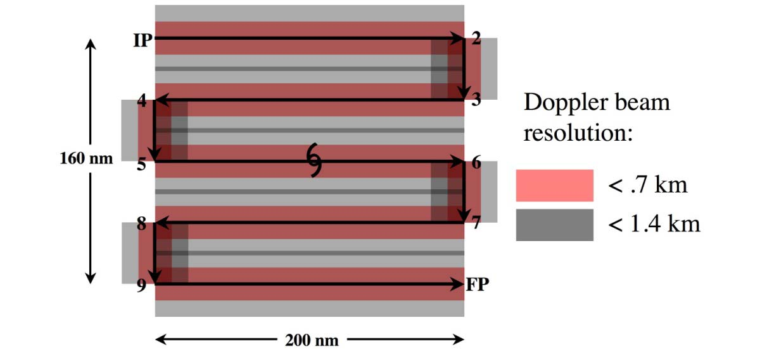

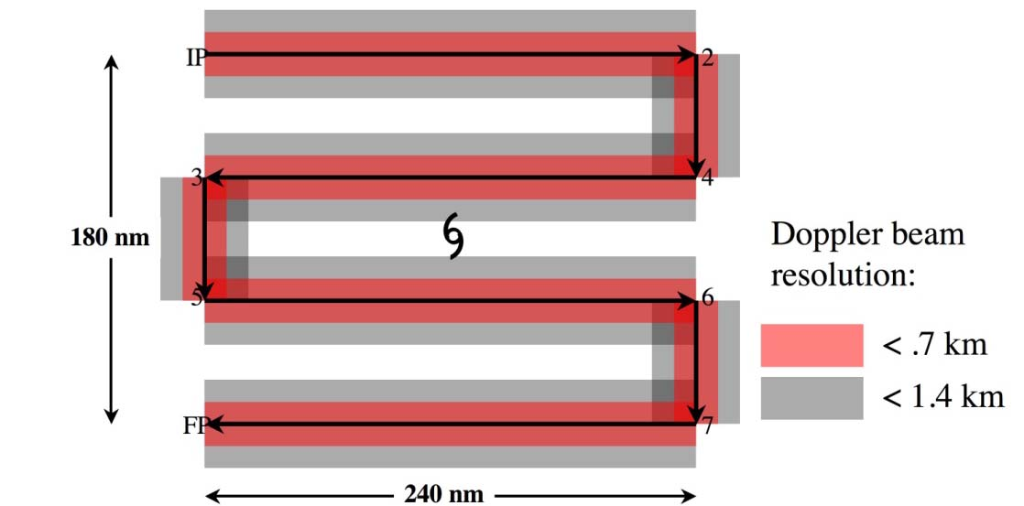
Figure 1-1: Display of Doppler coverage for A (upper panel) and B (lower panel) lawnmower patterns. Pink region shows areas where vertical beam resolution is better than 0.7 km and gray regions delineate areas where vertical beam resolution is better than 1.4 km. Maximum extent of gray area is approximately 40 km from flight track, generally the maximum usable extent of reliable airborne Doppler radar coverage. Total flight distance is 1160 nm for A and 1140 nm for B, and flight times are 4.8 and 4.75 hours, respectively.
Note 1. This is to be flown where even coverage is required, particularly in tropical depressions and tropical storms. Aircraft flies IP-2-3-4-5-6-7-FP. No attempt should be made to fix a center of circulation unless requested it is an operational request.
Note 2. Doppler radars should be operated in single-PRF mode, at a PRF of 2400-3200. The default will be 2400 PRF. Radar scientist should verify this mode of operation with AOC engineers. If there is no assigned radar scientist, LPS should verify. This is crucial for the testing and implementation of real-time quality control.
Note 3. Unless specifically requested by the LPS, both tail Doppler radars should be operated in F/AST with a fore/aft angle of 20 degrees relative to fuselage. French antenna automatically operates in F/AST, but it should be confirmed, nevertheless that the scanning is continuous, rather than sector scanning.
Note 4. IP can be at any desired heading relative to storm center
Note 5. To maximize dropwindsonde coverage aircraft should operate at highest altitudes that still minimize icing

Note 6. If dropwindsondes are not deployed, aircraft can operate at any level below the melting

level, with 10,000 ft preferred.

Note 7. Dropwindsondes shown are not a required part of this flight plan and are optional.
Note 8. Flight pattern should be centered around either the 18, 00, 06, or 12 UTC operational model analysis times.

Three-Dimensional Doppler Winds

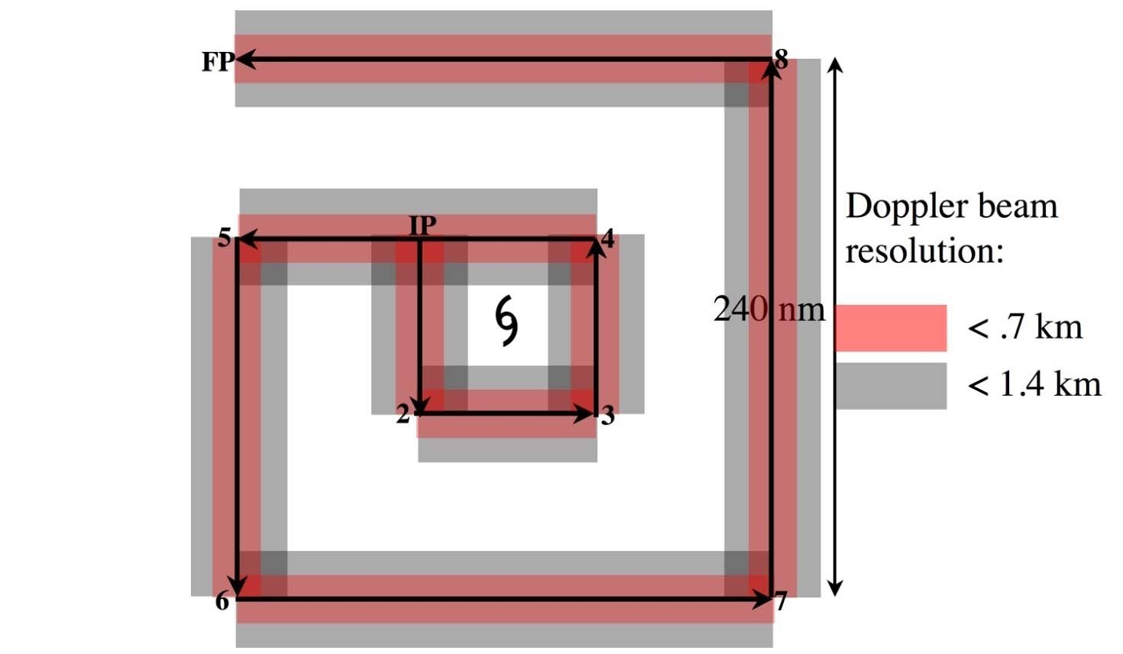
Figure 1-2: Doppler radar coverage for box-spiral pattern A. Pink region shows areas where vertical beam resolution is better than 0.7 km and gray regions delineate areas where vertical beam resolution is better than 1.4 km. Maximum extent of gray area is approximately 40 km from flight track, approximately the maximum usable extent of reliable airborne Doppler radar coverage. Flight distance in pattern above is 1280 nm, and flight time is 5.33 hours.
Note 1. This is to be flown where even coverage is required, particularly in tropical depressions and tropical storms. Aircraft flies IP-2-3-4-5-6-7-8-FP. No attempt should be made to fix a center of circulation unless requested it is an operational request.
Note 2. Doppler radars should be operated in single-PRF mode, at a PRF of 2400-3200. The default will be 2400 PRF. Radar scientist should verify this mode of operation with AOC engineers. If there is no assigned radar scientist, LPS should verify. This is crucial for the testing and implementation of real-time quality control.
Note 3. Unless specifically requested by the LPS, both tail Doppler radars should be operated in F/AST with a fore/aft angle of 20 degrees relative to fuselage. French antenna automatically operates in F/AST, but it should be confirmed, nevertheless that the scanning is continuous, rather than sector scanning.
Note 4. IP can be at any desired heading relative to storm center
Note 5. To maximize dropwindsonde coverage aircraft should operate at highest altitudes that still minimize icing
Note 6. If dropwindsondes are not deployed, aircraft can operate at any level below the melting level, with 10,000 ft preferred.
Note 7. Dropwindsondes shown are not a required part of this flight plan and are optional.
Note 8. Flight pattern should be centered around either the 18, 00, 06, or 12 UTC operational model analysis times.

Three-Dimensional Doppler Winds

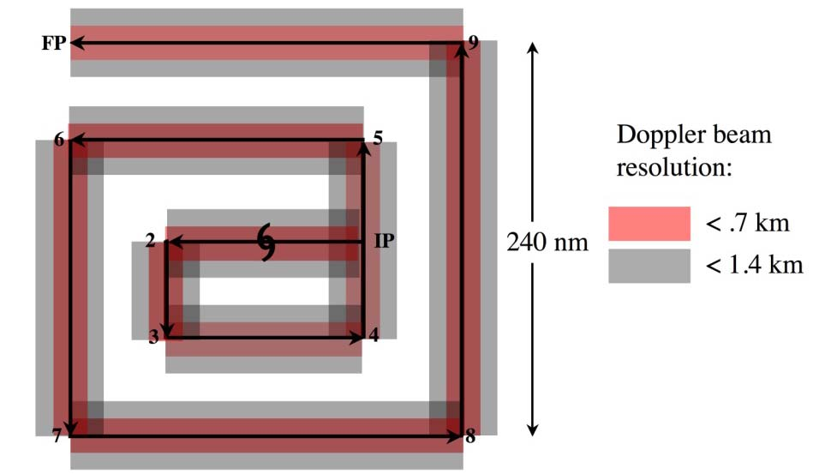

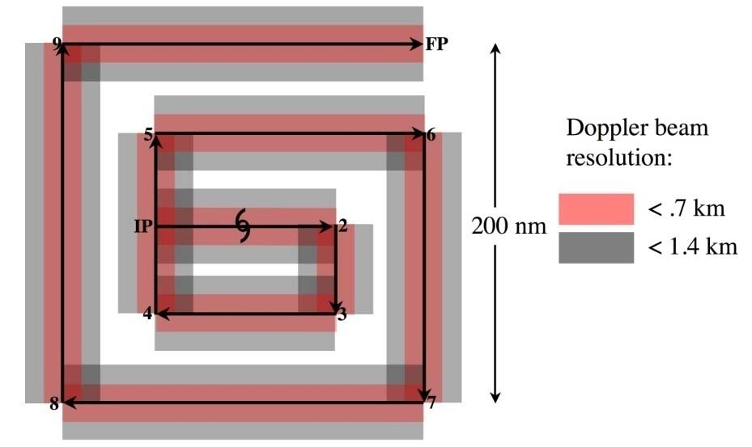
Figure 1-3: Doppler radar coverage for box-spiral pattern with 200- (top) and 240- (bottom) nm legs. Pink region shows areas where vertical beam resolution is better than 0.7 km and gray regions delineate areas where vertical beam resolution is better than 1.4 km. Maximum extent of gray area is approximately 40 km from flight track, approximately the maximum usable extent of reliable airborne Doppler radar coverage. Upper pattern is 1250 nm and uses 5.2 hours, while lower pattern is 1500 nm and uses 6.25 hours.
Note 1. This is to be flown where even coverage is required, particularly in tropical depressions and tropical storms. Doppler radars should be operated in single-PRF mode, at a PRF of 2400-3200. The default will be 2400 PRF. Radar scientist should verify this mode of operation with AOC engineers. If there is no assigned radar scientist, LPS should verify. This is crucial for the testing and implementation of real-time quality control.
Note 2. Unless specifically requested by the LPS, both tail Doppler radars should be operated in F/AST with a fore/aft angle of 20 degrees relative to fuselage.
Note 3. IP can be at any desired heading relative to storm center
Note 4. To maximize dropwindsonde coverage aircraft should operate at highest altitudes that still minimize icing
Note 5. Shaded areas show airborne-Doppler radar coverage with a maximum flight radius of 100 nm
Note 6. Maximum radius may be decreased or increased within operational constraints
Note 7. Dropwindsondes shown are not a required part of this flight plan and are optional.

Note 8. Flight pattern should be centered around either the 18, 00, 06, or 12 UTC operational

model analysis times.

Note 9. Maximum radius may be changed to meet operational needs while conforming to flight-length constraints.

Three-Dimensional Doppler Winds

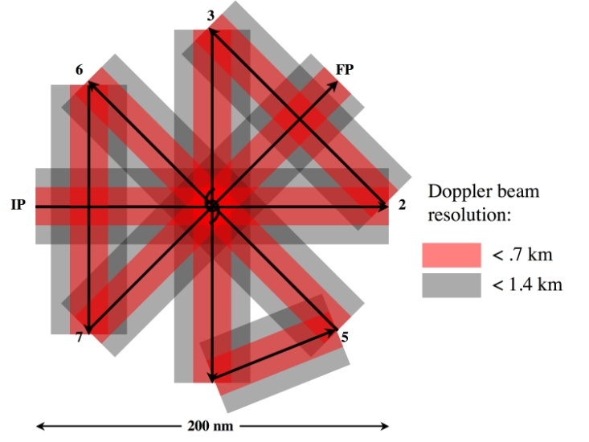

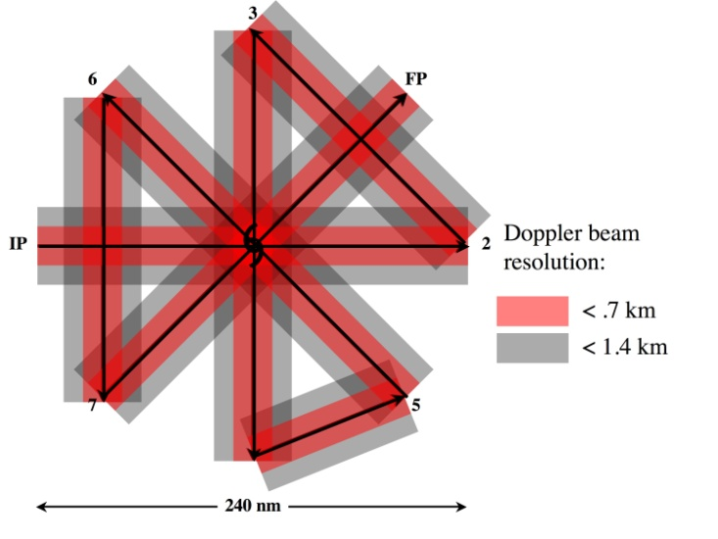
Figure 1-4: Doppler radar coverage for radial extents of 100 (top) and 120 (bottom) nm of the rotating figure-4 patterns. Pink region shows areas where vertical beam resolution is better than 0.7 km and gray regions delineate areas where vertical beam resolution is better than 1.4 km. Maximum extent of gray area is approximately 40 km from flight track, approximately the maximum usable extent of reliable airborne Doppler radar coverage. Flight distances for 100, 120 and 150 nm radial extents are 1160, 1395, and 1745 nm. Corresponding flight times are: 4.8, 5.8, and 7.3 h.

Three-Dimensional Doppler Winds

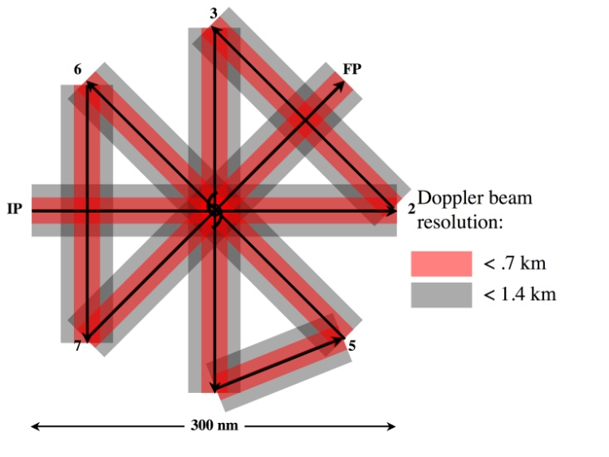
Figure 1-4 (continued): Doppler radar coverage for 150-nm legs for a rotating figure-4. Flight distances for 100, 120 and 150 nm radial extents are 1160, 1395, and 1745 nm. Corresponding flight times are: 4.8, 5.8, and 7.3 h.
Note 1. This pattern should be flown in strong tropical storms and hurricanes, where the circulation extends from 100 nm to 150 nm from the center. Doppler radars should be operated in single-PRF mode, at a PRF of 2400-3200. The default will be 2400 PRF. Radar scientist should verify this mode of operation with AOC engineers. If there is no assigned radar scientist, LPS should verify. This is crucial for the testing and implementation of real-time quality control.
Note 2. Unless specifically requested by the LPS, both tail Doppler radars should be operated in F/AST with a fore/aft angle of 20 degrees relative to fuselage.
Note 3. IP can be at any desired heading relative to storm center
Note 4. To maximize dropwindsonde coverage aircraft should operate at highest altitudes that still minimize icing
Note 5. Shaded areas show airborne-Doppler radar coverage with a maximum flight radius of 100 nm
Note 6. Maximum radius may be decreased or increased within operational constraints
Note 7. Dropwindsondes shown are not a required part of this flight plan and are optional.
Note 8. Flight pattern should be centered around either the 18, 00, 06, or 12 UTC operational model analysis times.
Note 9. Maximum radius may be changed to meet operational needs while conforming to flight-length constraints.

Three-Dimensional Doppler Winds

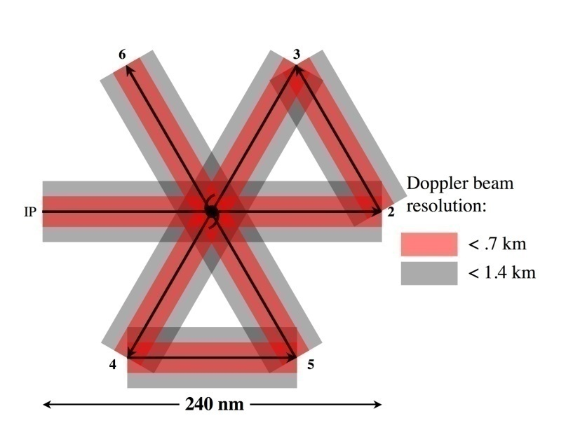

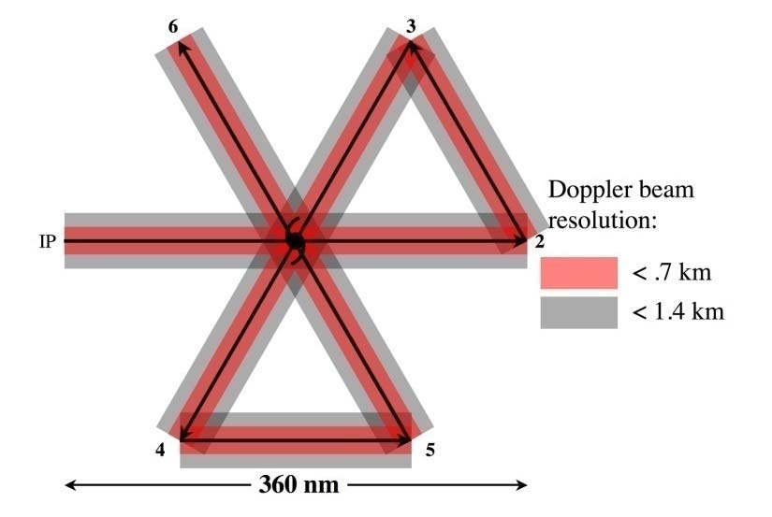
Figure 1-5: Doppler radar coverage for 120- (top) and 180- (bottom) nm legs for the Butterfly pattern. Pink region shows areas where vertical beam resolution is better than 0.75 km and gray regions delineate areas where vertical beam resolution is better than 1.5 km. Maximum extent of gray area is approximately 40 km from flight track, approximately the maximum usable extent of reliable airborne Doppler radar coverage. Flight distances for the patterns with 120 and 180 nm radials legs are 960 and 1440 nm. Corresponding flight durations are 4 and 6 h.
Note 1. This pattern will be flown in large tropical storms, as well as hurricanes. Doppler radars should be operated in single-PRF mode, at a PRF of 2400-3200. The default will be 2400 PRF. Radar scientist should verify this mode of operation with AOC engineers. If there is no assigned radar scientist, LPS should verify. This is crucial for the testing and implementation of real-time quality control.
Note 2. Unless specifically requested by the LPS, both tail Doppler radars should be operated in F/AST with a fore/aft angle of 20 degrees relative to fuselage.
Note 3. IP can be at any desired heading relative to storm center
Note 4. To maximize dropwindsonde coverage aircraft should operate at highest altitudes that still minimize icing
Note 5. Shaded areas show airborne-Doppler radar coverage with a maximum flight radius of 100 nm
Note 6. Maximum radius may be decreased or increased within operational constraints
Note 7. Dropwindsondes shown are not a required part of this flight plan and are optional.

Note 8. Flight pattern should be centered around either the 18, 00, 06, or 12 UTC operational

model analysis times.

Note 9. Maximum radius may be changed to meet operational needs while conforming to flight-length constraints.

Three-Dimensional Doppler Winds

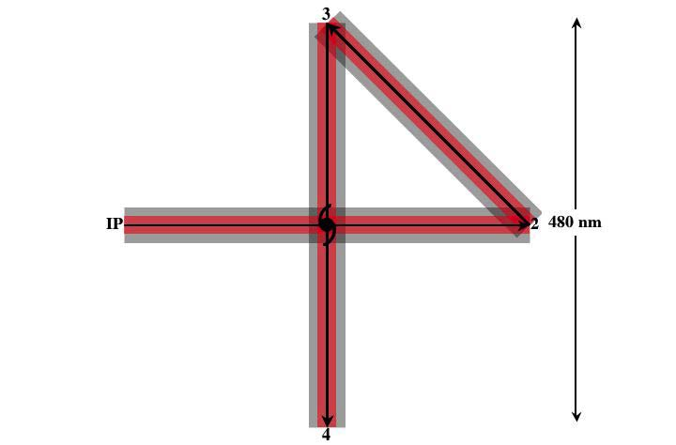

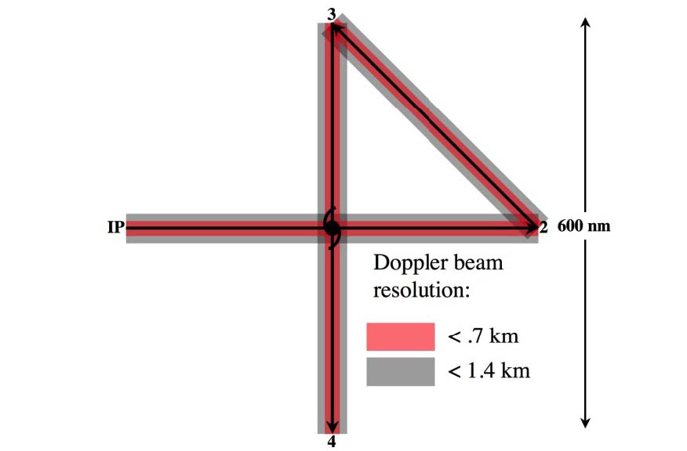
Figure 1-6: Doppler radar coverage for 300-nm legs for a single figure-4 pattern. Pink region shows areas where vertical beam resolution is better than 0.75 km and gray regions delineate areas where vertical beam resolution is better than 1.5 km. Maximum extent of gray area is approximately 40 km from flight track, approximately the maximum usable extent of reliable airborne Doppler radar coverage. Flight distances for radial extents of 240 and 300 nm are 1300 and 1645 nm, respectively. Corresponding flight times are 5.4 and 6.8 h.
Note 1. This pattern should be flown for large storms, to obtain as full a radial extent of observations of the full storm circulation as possible. Doppler radars should be operated in single-PRF mode, at a PRF of 2400-3200. The default will be 2400 PRF. Radar scientist should verify this mode of operation with AOC engineers. If there is no assigned radar scientist, LPS should verify. This is crucial for the testing and implementation of real-time quality control.
Note 2. Unless specifically requested by the LPS, both tail Doppler radars should be operated in F/AST with a fore/aft angle of 20 degrees relative to fuselage.
Note 3. IP can be at any desired heading relative to storm center
Note 4. To maximize dropwindsonde coverage aircraft should operate at highest altitudes that still minimize icing
Note 5. Shaded areas show airborne-Doppler radar coverage with a maximum flight radius of 100 nm
Note 6. Maximum radius may be decreased or increased within operational constraints
Note 7. Dropwindsondes shown are not a required part of this flight plan and are optional.

Note 8. Flight pattern should be centered around either the 18, 00, 06, or 12 UTC operational

model analysis times.

Note 9. Maximum radius may be changed to meet operational needs while conforming to flight-length constraints.

Three-Dimensional Doppler Winds

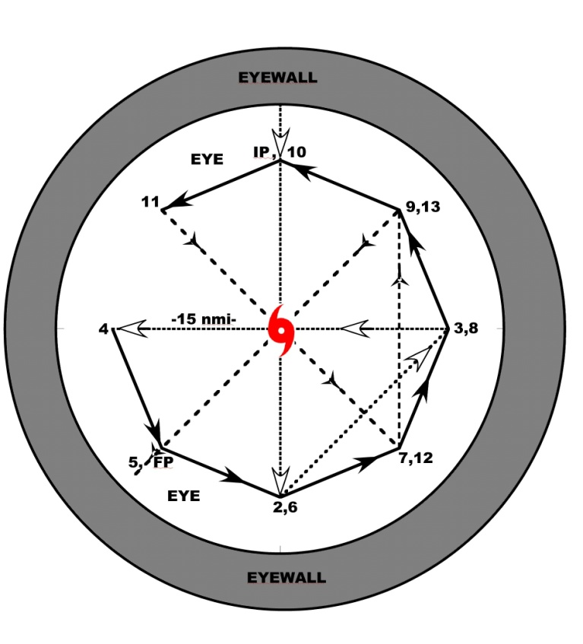
Figure 1-7: The P-3 approaches from the north, penetrates the eyewall into the eye, and descends below the inversion to 2500 ft while performing a figure-4 (dotted line) in the eye. The P-3 circumnavigates the eye in an octagon or pentagon (solid line), and then ascends while conducting another figure-4 (time permitting) rotated 45 degrees from the original (dashed line).

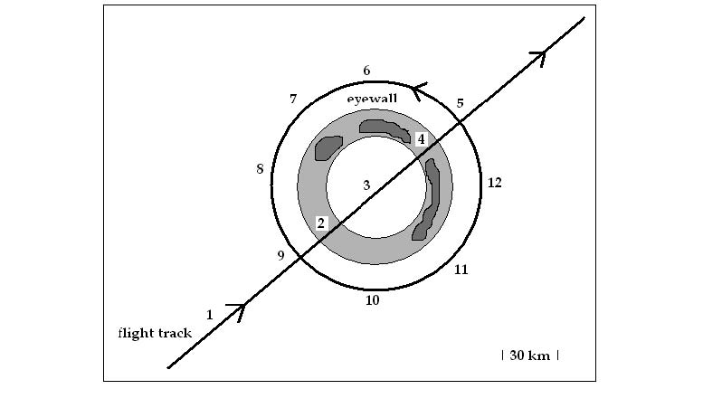

Fig. 1-8: Flight track (bold line), eyewall (gray region), and GPS dropwindsondes (numbered).

2. Hurricane Synoptic Surveillance

Primary IFEX Goal: 1 - Collect observations that span the TC life cycle in a variety of environments for model initialization and evaluation

Program Significance: Accurate numerical TC forecasts require the representation of meteorological fields on a variety of scales, and the assimilation of the data into realistic models. Omega dropwindsonde (ODW) observations from P-3 aircraft obtained between 1982 and 1996 during the Hurricane Synoptic Flow Experiment produced significant improvement in the guidance for official track forecasts. Since 1997, more than 150 operational Synoptic Surveillance missions have been flown with the NOAA G-IV jet in the environments of TCs threatening the United States coastline; some of these have been supplemented with dropwindsonde observations from one or two P-3 or USAF C-130 aircraft. An improved dropwindsonde based on GPS has been developed by the National Center for Atmospheric Research and has replaced the ODW. With further operational use of the G-IV aircraft, and as other mobile observing platforms become available, optimal sampling and utilization techniques must be devised to provide the greatest possible improvement in initial condition specification.

Objectives: The goal of synoptic surveillance is to improve landfall predictions of TCs by releasing dropwindsondes in the TC environment. These data will be used by NCEP to prepare objective analyses and official forecasts through their assimilation into operational numerical prediction models. Because the atmosphere is known to be chaotic, very small perturbations to initial conditions in some locations can amplify with time. However, in other locations, perturbations may result in only small differences in subsequent forecasts. Therefore, targeting locations in which the initial conditions have errors that grow most rapidly may lead to the largest possible forecast improvements. Locating these regions that impact the particular forecast is necessary. When such regions are sampled at regularly spaced intervals the impact is most positive. The optimal targeting and sampling strategies is an ongoing area of research.

A number of methods to find targets are being investigated. Potential vorticity diagnosis can help to find the cause of forecast failure. Singular vectors of the linearized equations of motion can estimate the growth of small perturbations in the model. Related strategies involve the sensitivity vector, and quasi-inverse linear method. A fully nonlinear technique uses the operational NCEP Ensemble Forecasting System in which initially random perturbations are repeatedly evolved and rescaled over a relatively short cycling time. The ensemble spread is related to local Lyapunov vectors and, therefore, define the fastest growing modes of the system. Changes to initial conditions due to synoptic surveillance grow (decay) in regions of large (small) perturbation in the operational NCEP Ensemble Forecasting System. Therefore, these modes provide a good estimate of the locations in which supplemental observations are likely to have the most impact. However, though this method can find locations of probable error growth in the model globally, it does not distinguish those locations, which impact the particular forecast from those that do not. A more generalized method that can use any dynamical ensemble forecast system is the Ensemble Transform Kalman Filter. This method transforms an ensemble of forecasts appropriate for one observational network into one appropriate for other observational networks. Ensemble forecasts corresponding to adaptations of the standard observational network are computed, and the expected prediction error variance at the observation time is computed for each potential network. The prediction error variance is calculated using the distances between the forecast tracks from all ensemble members and the

ensemble mean. These methods are currently undergoing testing with Observing System Experiments (OSEs) to discern an optimal targeting technique.

Links to IFEX: This supports the following NOAA IFEX goals:
- Goal 1: Collect observations that span the TC lifecycle in a variety of environments.

Mission Description: To assess targeting strategies a relatively uniform distribution of dropwindsondes will be released over a minimal period by various aircraft (the NOAA G-IV and AFRES C-130s) operating simultaneously. Specific flight tracks will vary depending on such factors as the location of the storm, relative both to potential bases of operation and to particular environmental meteorological features of interest. A sample mission is shown in Fig. 2-1. The two C-130 aircraft and the G-IV will begin their missions at the same time. Subject to safety and operational constraints, each aircraft will climb as rapidly as possible, then proceed, step-climbing, along the routes assigned during preflight. It is particularly important that both aircraft climb to and maintain the highest possible altitude as early into the mission as aircraft performance and circumstances allow, and attain additional altitude whenever possible during the mission.

Of paramount importance is the transmission of the dropwindsonde data to NCEP for timely incorporation into operational analyses, models, forecasts, and warnings. Operational constraints dictate an 0600 or 1800 UTC departure time, so that most of the dropwindsonde data will be included in the 1200 or 0000 UTC analysis cycle. Further, limiting the total block time to 9 h allows adequate preparation time for aircraft and crews to repeat the mission at 24-h intervals. These considerations will ensure a fixed, daily real-time data collection sequence that is synchronized with NCEP analysis and forecasting schedules.

Saharan Air Layer Module: This module will be executed by HRD, using HRD resources and will be carried out within the constraints of the pre-determined operational flight track. Additional intermediate dropwindsondes (HRD-supplied) may be requested along the flight track to target specific areas of interest. Dropwindsondes will be launched from the G-IV (flying at ~200 hPa or ~41,000 ft) or the P-3 (flying at ~500 hPa or ~20,000 ft) along the operational Synoptic Surveillance flight pattern. These additional release locations will be selected using real-time GOES SAL tracking imagery from UW-CIMSS and mosaics of SSM/I total precipitable water from the Naval Research Laboratory. Specific effort will be made to gather atmospheric information within the SAL as well as regions of high moisture gradients across its boundaries. The main goals are to:
- Better understand how the SAL dry air, mid-level easterly jet, and suspended mineral dust affect Atlantic TC intensity change.
- Include the moisture information from the dropwindsondes in operational parallel runs of the GFS. The impact of this data on the GFS initial or forecast humidity fields and its forecasts of TC track and intensity will be assessed.

Several SAL/TC interaction scenarios are candidates:

Figure 2-2 shows a single TC located along the southern edge of the SAL. Depending on the proximity of these two features, the SAL dry air may be wrapping into the TC low-level circulation (western quadrants). Dropwindsonde sequences will be focused along this dry air inflow region (west of the TC), across regions of high moisture gradients at the SAL leading edge (northwest of the TC), and across the southern boundary of the SAL (north and northeast of the TC). The SAL mid-level jet will also be sampled in the region of the latter transect.

Figure 2-3 shows a single TC is embedded within the SAL and intensifies upon emerging. These systems are often candidates for rapid intensification. Dropwindsonde transects perpendicular to the northern boundary of the SAL and near to possible points of the TC emergence from the SAL are desirable. Additional transects will be focused along the SAL southern boundary (south of the TC). The SAL mid-level jet will also be sampled, particularly along those transects on the eastern sides of the TC.

Figure 2-4 shows a single TC embedded within the SAL throughout most or all of its lifecycle. These systems struggle to intensify and are often characterized by their low-level circulation racing out ahead (west) of their mid-level convection. Depending on the proximity of the TC to the SAL, the SAL dry air may be wrapping into its low-level circulation (western semicircle). Dropwindsonde sequences will be focused along this dry air inflow region (west of the TC), across regions of high moisture gradients at the SAL northern boundary (north of the TC), and across regions of high moisture gradients at the SAL southern boundary (east of the TC). The SAL mid-level jet will also be sampled, particularly in the region of the latter transect.

Global Hawk Module: From August 15 to September 30, NASA will by flying the high-altitude Global Hawk (GH) UAS as part of their Genesis and Rapid Intensification Processes experiment (GRIP). The GH will be based at NASA Dryden at Edwards AFB, California, has an endurance of up to 30 hours, and cruises at altitudes ranging from 60-65 kft with an airspeed of about 340 kt. Because of its long endurance, it is anticipated that the GH will fly a series of modules per mission with each individual module either sampling the synoptic environment, near environment, or a convective area of a tropical system of interest.

A synoptic survey module could be flown with the GH during the ferry to or from Dryden in route to a developing system or a TC that has potential for rapid intensification. The NOAA G-IV could also be flying synoptic surveillance missions as tasked by NHC or be flying research missions for NOAA/HRD as part of IFEX. In either case, the tracks and timing of any synoptic sampling by the GH should be coordinated with any flights that the G-IV may be conducting.

The NSF is also conducting a field experiment, Pre-Depression Investigation of Cloud-systems in the Tropics (PREDICT) during the same August and September dates as GRIP. The NCAR G-V aircraft, based out of St. Croix, V. I., will be performing some near-environmental sampling in convective systems that have potential to develop. Any flight modules that sample the synoptic or near-environment of such systems with the GH should also be coordinated with the missions of the NCAR G-V.

An example of a synoptic sampling module for the GH in the Gulf of Mexico is in Fig. 2-5. In this case, the target storm is located in the western Bahamas and the GH would sample the environment with GPS dropsondes on the ferry to or from the target storm. The module as drawn would take about 5.5 hours to complete from the location of the first drop to the last. This compares to a 2.5-hour ferry directly across the Gulf. The location, sampling strategy, and length of this module, would be changed for each particular case depending on the location of the system of interest, and priorities and lengths of other modules to be flown on the same GH mission.

The primary instrument focus for this module would be the GPS dropsondes but other instruments that will be operating on the GH would also be of great value, both in the relatively clear air of the environment as well as any convection the GH might over fly while performing this module.

Figure 2-1: Sample environmental patterns.

• Note 1: During the ferry to the IP, the C-130 aircraft will climb as quickly as possible.
• Note 2.: During the ferry to the IP, The G-IV should climb to the 41,000 ft (200 hPa) as soon as possible and climb as feasible to maintain the highest altitude for the duration of the pattern.

P3 or C-130

P3 or C-130

Figure 2-3: Sample flight track for a TC emerging from the SAL.
Figure 2-2: Sample flight track for a TC positioned along the SAL southern boundary.
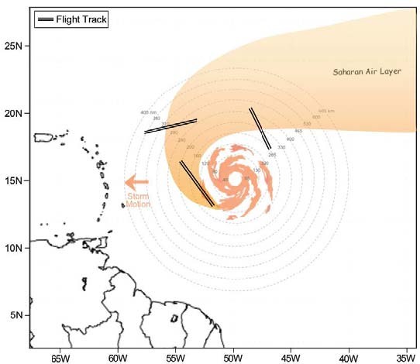

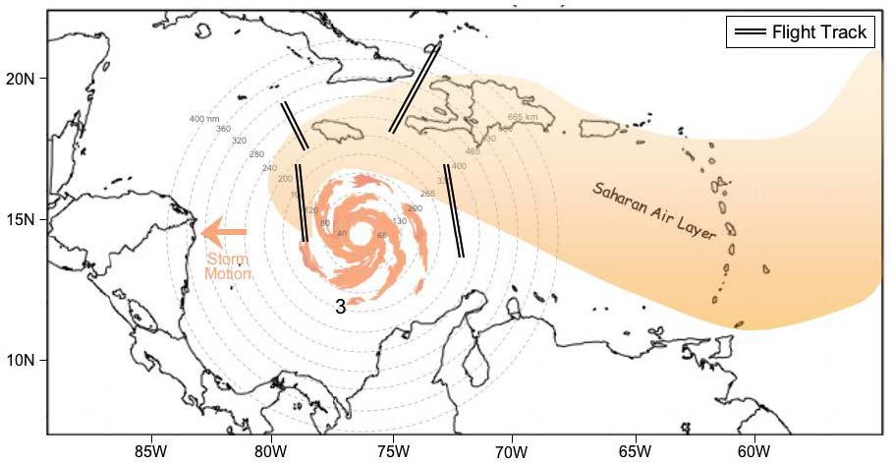

Figure 2-4: Sample flight track for a TC embedded in the SAL for most or all of its lifecycle.

- Note 1: During the ferry to the IP, the P-3 aircraft will climb to the ~500 hPa level (~20,000 ft). The 400-hPa level (~25,000 ft) should be reached as soon as possible and maintained throughout the remainder of the pattern, unless icing or electrical conditions require a lower altitude.
- Note 2: During the ferry to the IP, The G-IV should climb to the ~200 hPa (~41,000 ft) as soon as possible and climb as feasible to maintain the highest altitude for the duration of the pattern.
- Note 3: In order to capture the SAL structure, particular attention should be paid to regions of high moisture gradients across its boundaries.

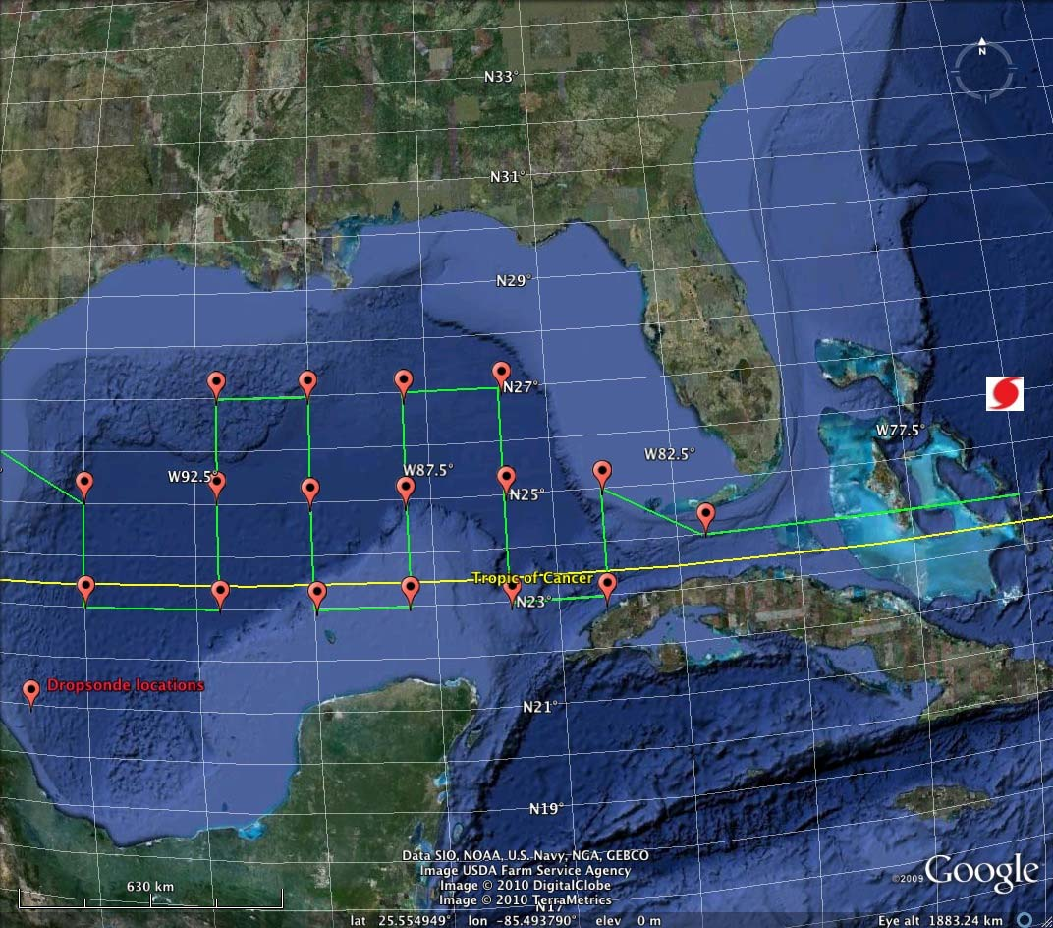

Figure 2-5. A sample synoptic-survey module of the NASA GH UAS on the ferry to or from the target storm that, in this case, is located in the western Bahamas. The tracks, timing, and sampling strategy of this module would need to be changed for each particular mission. Close coordination of the timing and location of this module with other aircraft such as the NOAA G-IV and NCAR G-V is required.

3. Coyote UAS Module

Primary IFEX Goal: 2 - Develop and refine measurement technologies that provide improved real-time monitoring of TC intensity, structure, and environment

Principal Investigator(s): Joe Cione

Why UAS?

The interaction between the ocean and the hurricane is important, complex, and not well handled in current observing systems and models. Specifically, the hurricane depends on the ocean to supply the necessary heat and moisture to form and maintain the system. The detailed process by which a storm ‘draws heat’ from the ocean and ultimately converts it into kinetic energy (i.e. strong winds) is very complex and is currently not well understood. This lack of understanding is primarily due to the limited availability of detailed observations within the storm near the air-sea interface. The amount of heat and moisture extracted from the ocean is a function of wind speed, ocean temperature, atmospheric temperature, pressure and humidity. Accurate measurements of these variables are required, yet exceedingly difficult to obtain due to the severe weather conditions that exist at the ocean surface during a hurricane. A limited array of surface buoys make in-situ measurements in this region spotty at best, while direct measurements at very low altitudes using NOAA and Air Force hurricane hunter manned aircraft is impossible due to the severe safety risks involved. Nevertheless, for scientists to dramatically improve our understanding of this rarely observed region, detailed, continuous observations must be obtained. To this end, an aggressive effort to utilize low level unmanned aerial systems (UAS) designed to penetrate and sample the violent low level hurricane environment would help fill this critical data void. Such improvements in observation and understanding would likely lead to significant advancements in the area of hurricane intensity prediction. Enhancing this predictive capability would in turn reduce the devastating impact hurricanes have on our Nation’s economy and more importantly help save countless lives.

Coyote UAS

Coyote is an aircraft platform that is currently under development by BAE (formerly Advanced Ceramics Research) for the US NAVY. The intended deployment vehicle for the Coyote is the P-3 Orion. The Coyote is a small electric-powered unmanned aircraft with 1-3 hour endurance and is capable of carrying a 1-2lb payload. The Coyote can be launched from a P-3 sonobuoy tube in flight, and terrain-permitting, is capable of autonomous landing and recovery. The Coyote is supported by BAE’s integrated control station which is capable of supporting multiple aircraft operations via touch screens that simultaneously show real-time video. This control station can also be incorporated onto the deployment aircraft (i.e. P-3), allowing for in-air command and control after launch. The Coyote, when deployed from NOAA's P-3's within a hurricane environment, provide a unique observation platform from which the low level atmospheric boundary layer environment can be diagnosed in great detail. In many ways, this UAS platform be considered a 'smart GPS dropsonde system' since it is deployed in similar fashion and will be able to carry a comparable meteorological payload (i.e. lightweight sensors for P, T, RH, V). Unlike the GPS sonde however, the Coyote UAS can be directed from the NOAA P-3 to specific areas within the storm circulation (both in the horizontal and in the vertical). Also unlike the GPS dropsonde,

Coyote observations are continuous in nature and give scientists an extended look into important thermodynamic and kinematic physical processes that regularly occur within the near-surface boundary layer environment. Coyote UAS operations also represent a potentially significant upgrade relative to the more traditional "deploy, launch and recover" low altitude UAS hurricane mission plan used in the past. By leveraging existing NOAA manned aircraft assets, Coyote operations significantly reduces the need for additional manpower. The Coyote concept of operations also reduces overall mission risk since there is no flight ingress/egress. This fact should also help simplify the airspace regulatory approval process. Specifications associated with the Coyote UAS are illustrated in Figure 3-1.

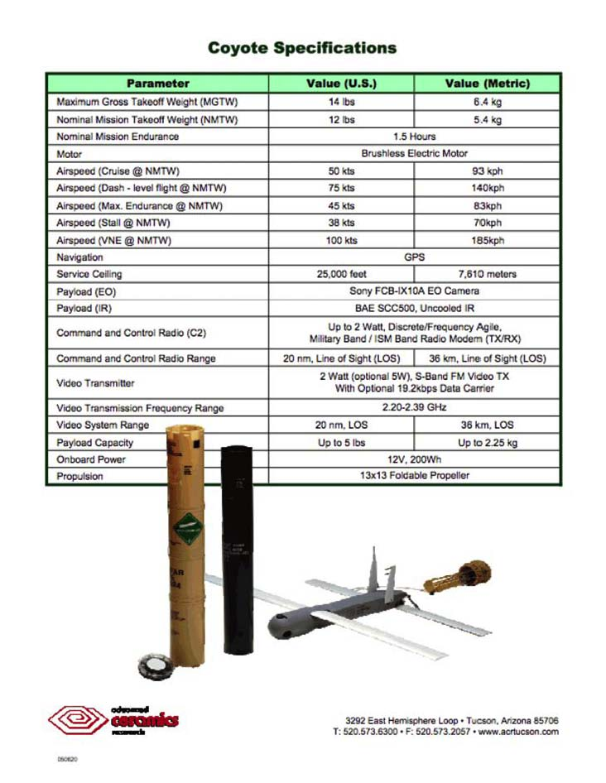
Figure 3-1. Coyote Unmanned Aerial System Specifications

Relevance to NOAA

In recent years, an increasing number of hurricanes have impacted the United States with devastating results, and many experts expect this trend to continue in the years ahead. In the wake of Katrina, NOAA is being looked at to provide improved and highly accurate hurricane-related forecasts over a longer time window prior to landfall. NOAA is therefore challenged to develop a program that will require applying the best science and technology available to improve hurricane prediction without placing NOAA personnel at increased risk. UAS are an emerging technology in the civil and research arena capable of responding to this need.

In late February 2006, a meeting was held between NOAA, NASA and DOE partners (including NOAA NCEP and NHC representatives) to discuss the potential for using UAS in hurricanes to take measurements designed to improve intensity forecasts. The group came to a consensus around the need for a UAS demonstration project focused on observing low-level (<200 meters) hurricane winds for the following reasons:

- Hurricane intensity and track forecasts are critical at sea level (where coastal residents live)
- The hurricane’s strongest winds are observed within the lowest levels of the atmosphere
- The air-sea interface is where the ocean's energy is directly transferred to the atmosphere
- Ultimately, low-level observations will help improve operational model initialization and verification
- The low-level hurricane environment is too dangerous for manned aircraft

The potential importance of low-level UAS missions in hurricanes is further emphasized by the findings of the Hurricane Intensity Research Working Group established by the NOAA Science Advisory Board. Their recommendation is that:

“Low and Slow” Unmanned Aircraft Systems (UAS) have demonstrated a capacity to operate in hurricane conditions in 2005 and in 2007. Continued resources for low altitude UAS should be allocated in order to assess their ability to provide in situ observations in a critical region where manned aircraft satellite observations are lacking.

This effort is in direct support of NOAA’s operational requirements and research needs. Such a project will directly assist NOAA’s National Hurricane Center better meet several of its ongoing operational requirements by helping to assess:

The strength and location of the storm’s strongest winds
The radius of maximum winds
The storm’s minimum sea level pressure (which in turn may give forecasters advanced warning as it relates to dangerous episodes of rapid intensity change)

In addition to these NOAA operational requirements, developing the capability to regularly fly low altitude UAS into tropical cyclones will also help advance NOAA research by allowing scientists to sample and analyze a region of the storm that would otherwise be impossible to observe in great detail (due to the severe safety risks involved associated with manned reconnaissance). It is believed that such improvements in basic understanding are likely to improve future numerical forecasts of tropical cyclone intensity change. Reducing the uncertainty associated with tropical cyclone intensity forecasts remains a top priority of the National Hurricane Center. Over time, projects such

as this, which explore the utilization of unconventional and innovative technologies in order to more effectively sample critical regions of the storm environment should help reduce this inherent uncertainty.

This HRD field program module is designed to build on the successes and strong momentum from recent UAS missions conducted in 2005 and 2007. Using the experience gained from the Ophelia and Noel UAS experiences. As part of this effort, any UAS data collected will continue to be made available to NOAA’s National Hurricane Center in real-time.

Mission Description

The primary objective of this experiment is further demonstrate and utilize the unique capabilities of a low latitude UAS platform in order to better document areas of the tropical cyclone environment that would otherwise be either impossible or impractical to observe. For this purpose, in 2010, we will be using the Coyote UAS. Since the Coyote will be deployed from the manned P-3 aircraft, no UAS-specific forward deployment teams will be required. Furthermore, since the Coyote is launched using existing AXBT launch infrastructure, no special equipment is required beyond a ‘ground’ control station BAE Coyote operators will have onboard the P-3. In 2010 the Coyote UAS will not be freely launched into the US National airspace. Instead Since low altitude UAS deployments in 2010 will be limited in 2010 to within three locations: 1. Piarco controlled airspace (requiring a Barbados or St Croix deployment); 2. warning areas in the southeastern Gulf of Mexico; and 3. specific warning areas off the U.S. mid-Atlantic coast. For 2010, the target candidate storm is a mature hurricane with a well- defined eye. Furthermore, since the P-3 will have to operate within the eye, daylight missions will be required so as to maintain P-3 visual contact with the eyewall at all times. For 2010, Iridium/satcomm communications between UAS and P-3 are planned. If successfully installed in 2010 this capability will have the dual positive effect of minimizing experimental and safety risks. The immediate focus of this experimental module will be to test the operational capabilities of the Coyote UAS within a hurricane environment. Besides maintaining continuous command and control links with the P-3, these flights will test the accuracy of the new MISTSONDE meteorological payload (vs. observations taken from dropsondes released near the UAS). The UAS will be tested to see if it can maintain altitudes according to command. In addition, the Coyote UAS will attempt to fly at extreme altitudes (as low as 200 ft) in low (eye) and high (eyewall) wind conditions within hurricane environment. The longer term goal for this UAS platform is to assist scientists so they can better document and ultimately improve their understanding of the rarely-observed tropical cyclone boundary layer. To help accomplish this, the UAS will make detailed observations of PTHU at low altitudes within the hurricane eye and eyewall that will then be compared with multiple in-situ and remote-sensing observations obtained from manned aircraft (NOAA P-3 and AFRES C-130, DC-8? Global Hawk?) and select satellite-based platforms. In addition, a primary objective (but not a 2010 requirement) for this effort will be to provide real-time, near-surface wind observations to the National Hurricane Center in direct support of NOAA operational requirements. These unique data will also be used in a ‘post storm’ analysis framework in order to potentially assist in the numerical and NHC verification process.

For this experiment, NOAA P-3 flight altitude will be at 10000ft at all times. Ideally both modules (~1.5h each) would be conducted on the same manned mission. The eye-only module would be conducted first, followed by the eye-eyewall UAS module. The P-3 flight pattern is identical for both eye and eye-eyewall UAS modules. GPS dropsonde and AXBT drop locations

are also identical for each UAS module. AXBT and GPS drop locations are explicitly illustrated in the flight plan below. UAS deployment on leg 3-4 is also identical for both modules. UAS operational altitude will be entirely below 5000ft. UAS motor will not be activated until an altitude of 5000ft is met. The UAS will be conducting a controlled, spiral glide (un-powered) descent from 10000ft to 5000ft.

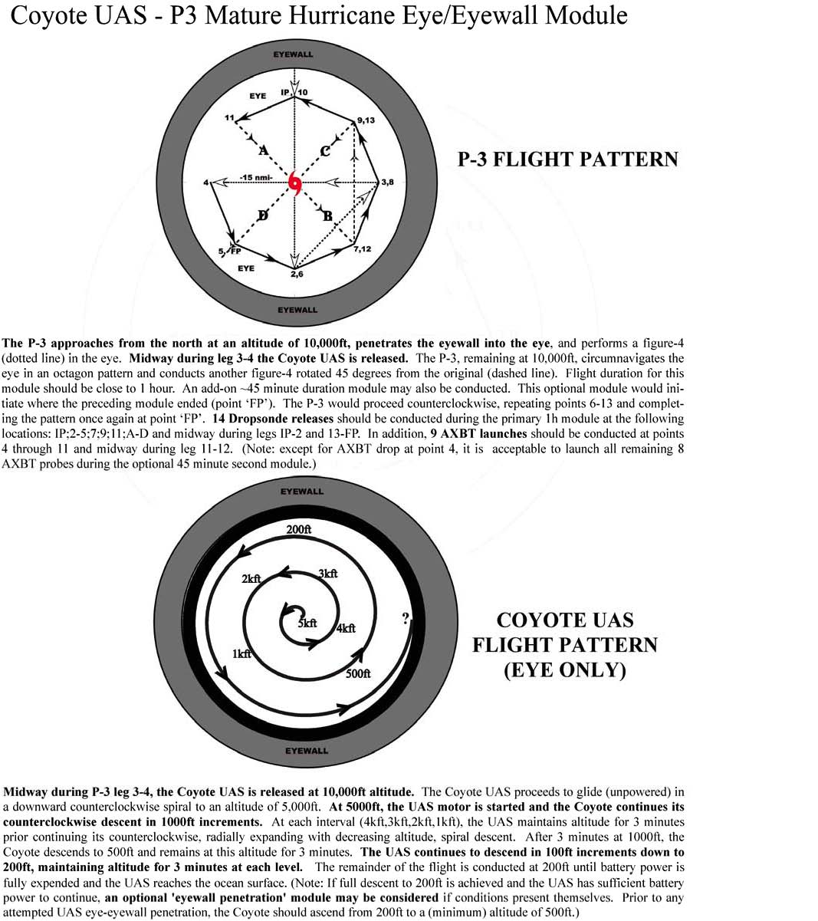

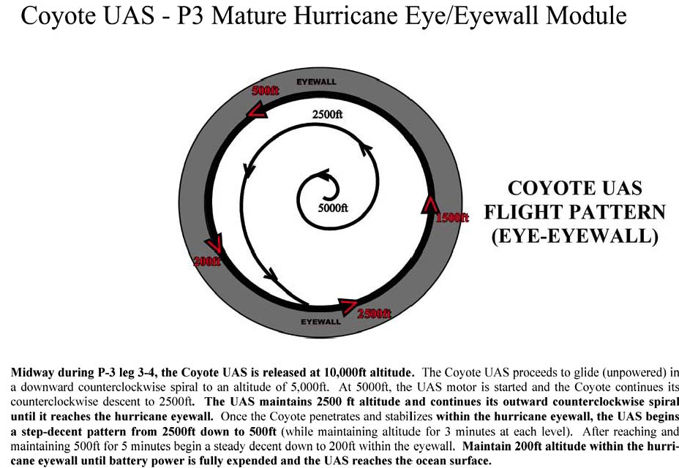

4. Doppler Wind Lidar (DWL) Module

Primary IFEX Goal: 2 - Develop and refine measurement technologies that provide improved real-time monitoring of TC intensity, structure, and environment

Principal Investigator(s): Jason Dunion, Sylvie Lorsolo, Jun Zhang, Robert Atlas (AOML), Dave Emmitt (Simpson Weather Associates)

Program Significance:

Installation of a multi-agency (Navy, Army and NASA) pulsed 2-micron coherent-detection Doppler wind profiling lidar system (DWL) onboard NOAA-42 is anticipated prior to the 2010 Atlantic hurricane season. This instrument, referred to as the P3DWL, was flown on board a Navy P3 in 2008 during typhoon research in the western Pacific. The P3DWL includes a compact, packaged, coherent Doppler lidar transceiver and a biaxial scanner that enables scanning above, below and ahead of the aircraft. The transceiver puts out 2 mJ eyesafe pulses at 500 Hz.

The P3DWL will have the capability to detect winds and aerosols both above (up to ~14 km in the presence of high level cirrus) and below (down to ~100 m above the ocean surface) the aircraft flight level (typically 3 -5 km). The vertical resolution of these retrievals will be ~50 m with a horizontal spacing ~2 km for u, v, and w wind profiles. There is an anticipated data void region ~300 m above and below the aircraft. Given the P3DWL’s operating wavelength (~2 microns), the instrument requires aerosol scatterers in the size range of ~1+ microns and while measurements within and below optically thin or broken clouds are frequent, there is limited capability in the presence of deep, optically thick convection. Therefore, it is anticipated that the optimal environments for conducting the P-3 DWL module will be in the periphery of the TC inner core, moat regions in between rainbands, the hurricane eye, the ambient tropical environment around the storm, and the Saharan Air Layer. Options for this module will primarily focus on these environments in and around the storm. The P3DWL will require an onboard operator during each mission. When possible, the DWL module could be coordinated with the HRD Convective Burst and HPBL Entrainment Modules.

Objectives:

The main objectives of the P-3 DWL Module are to:
- Provide data allowing retrieval of turbulent characteristics of the hurricane boundary layer (HBL);
- Identify and document the physical characteristics of organized eddies of the HBL over a relatively large spatial coverage;
- Estimate the impact of the HBL smaller-scale processes on hurricane intensity change;
- Collect data in the entire HBL including the lowest levels (down to 100 m) with spatial and temporal continuity;
- Characterize the suspended Saharan dust and mid-level (~600-800 hPa) easterly jet that are associated with the Saharan Air Layer (SAL) with a particular focus on SAL-TC interactions;
- Observe possible impingement of the SAL’s mid-level jet and suspended dust along the edges of the storm’s (AEW’s) inner core convection (deep convection);

Links to IFEX:

This experiment supports the following NOAA IFEX goals:
Goal 1: Collect observations that span the TC lifecycle in a variety of environments;
Goal 2: Development and refinement of measurement technologies;
Goal 3: Improve our understanding of the physical processes important in intensity change for a TC at all stages of its lifecycle;

Mission Description:

This multi-option research module is designed to utilize the WP-3D aircraft [P3DWL, flight-level (flying at various flight levels both in and outside of the storm from ~500 m to18,000 ft) and GPS dropsonde data]. Although this module is not a standalone experiment, it could be included as a module within any of the following HRD research missions: TC Genesis Experiment, Saharan Air Layer Experiment, Arc Cloud Module or TC Landfall and Inland Decay Experiment or as part of operational NHC-EMC-HRD Tail Doppler Radar (TDR) missions.
Option #1 (HBL):
The primary value of the P3DWL data would be to investigate the HBL-related scientific goals stated above. Because of possible limitations due to clouds, it will be best to focus transects in cloud free areas, such as the eye, moat regions and between rainbands. The module can easily be combined with other experiments and modules, as it does not necessarily require a specific flight track. However, “box transects” (See Fig. 4-1) associated with dropsondes would be the preferred experimental setup. GPS dropsonde data and flight-level data (1 Hz and 40 Hz) will be crucial to quantitatively evaluate the quality of the P3DWL measurements. Moreover, the “box transects” would also be used to investigate the kinematic characteristics of small-scale processes of the HBL. The P3DWL will be scanning in one of 3 modes. For all modes the scanning will be down looking. The first mode will be a full scan mode when the aircraft will be completing other modules. When completing the “box transects”, the second and third scanning modes will performed. The second mode will be a sector scan strategy, which will allow an increase of the horizontal resolution while allowing wind retrieval. For the third mode, the P3DWL will be pointing forward with only ~10 deg scanning, which will allow for higher horizontal resolution, but wind retrieval will not be possible. The optimal flight level will be to be around 500 m, when possible (or as low as safety permits). Cloud avoidance will be crucial for the experiment and might require adjusting the flight level when possible.

Option #2 (SAL):
This option will target sampling of the SAL’s suspended dust and mid-level jet by the P3DWL and can be conducted between the edges of the storm’s (AEW’s) inner core convection (deep convection) to points well outside (several 100 km) of the TC environment during the inbound or outbound ferry to/from the storm (no minimum leg lengths are required). For fuel considerations, the outbound ferry is preferable and the optimal flight-level is ~500 mb (~19,000 ft) or as high as possible. The P3DWL should be set to the downward looking and full scan modes. GPS dropsonde sampling along the transect will be used to observe the SAL’s thermodynamics and winds as well as to validate the P3DWL’s wind retrievals. Drop points should be spaced at ~25-50 nm increments to near the region where the SAL is impinging on the storm/AEW and spaced at 50-75 nm increments farther from the storm (Fig. 4-2). GPS dropsonde spacing will determined on a case by case basis at the PI’s discretion.

Option #3 (DC-8 coordination):

The main objective of this option will be to compare P3DWL wind profiles with those being obtained by NASA’s DAWN DWL being flown on the NASA DC8 during the Genesis and Rapid Intensification Processes (GRIP) Experiment being conducted from 15 August - 30 Sept. PIs Dunion and Emmitt will facilitate this coordination between the NOAA P-3 and NASA DC-8. The optimal P-3 flight level will be ~3 km, but can also be carried out at the flight-level of the overarching experiment being conducted. This option should be flown in scattered to no cloud-cover conditions below 12 km outside the storm environment (e.g. during the ferry to/from the storm) and does not require specific wind conditions. The aircraft should be flown along a straight and level leg (~25 km in length) with GPS dropsondes launched at ~8 km increments at the discretion of the PI. This same leg will be overflown by the DC-8 at an altitude of ~9-11 km. Temporal spacing between the two coordinated aircraft along this coincident leg should not exceed 4-5 min and will require close coordination between the aircraft. Given the lower altitude of the P-3 relative to the DC-8 and the likelihood that the DC-8 will be dropping GPS dropsondes, it is preferable that the P-3 be the lead aircraft along this coordinated leg.

Option #4 (OLEs in the MBL):
The main objective of this option is to use the P3DWL to observe organized large eddies (OLEs) in the marine boundary layer (MBL). This option should be flown outside the storm environment (e.g. to/from the storm during the ferry) and preferably in areas where cloud streets are observed from satellite imagery and/or from the aircraft. Winds at the surface should range from ~5-10 m/s and can be determined using data from the SFMR. The P-3 should fly a ~50 km leg at or just below level of the trade wind cloud base (~500 m altitude) and preferably toward the end of the mission when the aircraft is light. GPS dropsondes should be launched at ~10-15 km increments at the discretion of the PI.

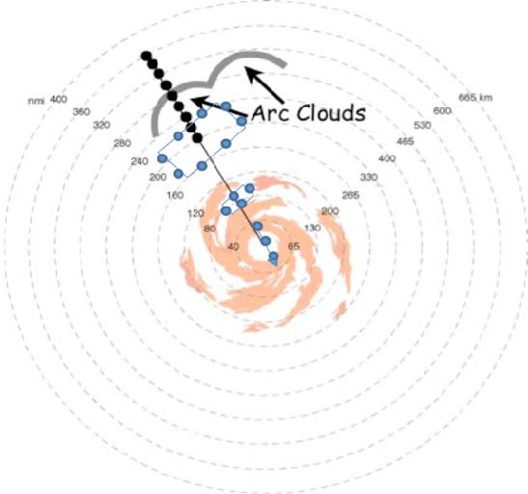

Fig. 4-1:
The WP-3D flight track inbound or outbound to/from the TC/AEW for
Option #1 (HBL)
of the P-3 DWL module. Azimuth and length of legs and associated GPS dropsonde sequences will be dictated by the pre-determined flight plan of the overarching experiment being conducted. This figure highlights preferred regions of sampling for the HBL option: the hurricane eye, moat regions between rainbands (with a box transect), and clear air areas

behind arc clouds in the periphery of the storm (with a box transect).

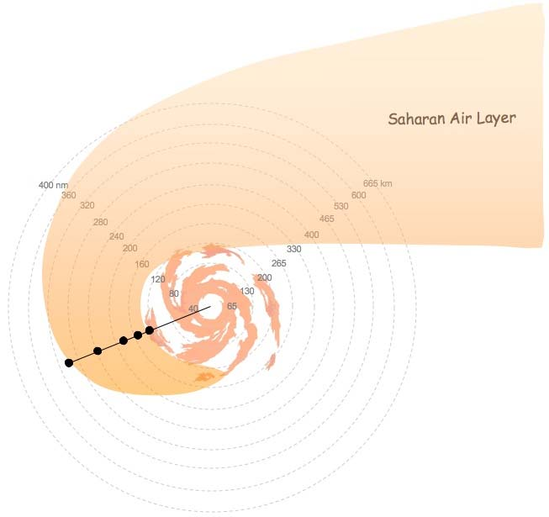

Fig. 4-2: Sample WP-3D flight track during the ferry to/from the storm and GPS dropsonde points for Option #2 (SAL) of the P-3 DWL module.

5. Tropical cyclogenesis experiment

Primay IFEX Goal: 3 - Improve understanding of the physical processes important in intensity change for a TC at all stages of its lifecycle

Principal Investigator(s): Robert Rogers

Motivation:
While forecasts of TC track have shown significant improvements in recent years (Aberson 2001), corresponding improvements in forecasts of TC intensity have been much slower (DeMaria and Gross 2003). The lack of improvement in intensity forecasting is the result of deficiencies in the numerical models (e.g., resolution limitation and parameterization inadequacies), deficiencies in the observations, and deficiencies in basic understanding of the physical processes involved. The problem becomes even more acute for forecasting tropical cyclogenesis. While global models have shown some skill in recent years in predicting tropical cyclogenesis, understanding of the physical processes involved remains limited, largely because observing genesis events is a difficult task. However, a key aspect of IFEX (Rogers et al. 2006) is the collection of observations during all portions of a TC lifecycle, particularly on the early lifecycle stages. This emphasis on the early stages of the lifecycle will provide an opportunity to observe several genesis events and improve understanding of this key process, leading to better predictions of tropical cyclogenesis, organization, and intensification.

Since both tropical cyclogenesis and TC intensity change can be defined by changes in low- and mid-level vorticity, knowledge of the processes that play a significant role in genesis will also advance understanding of intensity change. A better understanding of the processes that lead to an increase in low- and mid-level cyclonic vorticity will also allow NHC to better monitor and forecast tropical cyclogenesis and intensity change, improvements that would be especially valuable for those events that threaten coastal areas. Data obtained by aircraft investigating potential genesis events will positively impact operations and research in other ways as well. The collection of three-dimensional data at all stages in a TC lifecycle is one of the key requirements for NCEP as a part of IFEX. Such data will provide information that will guide the development of error covariances important in the development of data assimilation schemes for models (i.e., HWRF) that will be used in these environments. They will also provide important datasets for evaluating the performance of HWRF. In addition to improving the understanding and forecasting of tropical cyclogenesis and intensity change, the proposed experiment will yield useful insight into the structure, growth and ultimately the predictability of the systems responsible for almost all of the weather-related destruction in the tropical Atlantic and East Pacific. Investigation of systems that fail to complete the genesis process will also result in a better understanding and prediction of easterly disturbances in general so that distinction can be better made between developing and non-developing tropical disturbances.

Background:
Tropical cyclogenesis can be viewed as a rapid increase of low-level cyclonic vorticity organized on the mesoscale within a region of enhanced convective activity. Numerous hypotheses have been advanced in the literature to explain how this vorticity develops and amplifies. One of the key aspects differentiating these hypotheses centers on whether the lower-tropospheric cyclonic vorticity begins in the mid-levels and develops downward to the surface or begins in the lower

troposphere and builds upward to the middle troposphere

–

the so-called top-down vs. bottom-up mechanisms. Prominent top-down theories include one study which showed observations of multiple midlevel vortices prior to genesis in the West Pacific (Ritchie et al. 1997) that led them to view the genesis process as a stochastic one whereby chance merger and axisymmetrization of these midlevel vortices leads to growth of the circulation to the surface by increasing the Rossby-Prandtl-Burger penetration depth of potential vorticity anomalies associated with the vortices. Another study supporting the top-down approach showed observations of genesis in the East Pacific (Bister and Emanuel 1997) and hypothesized that downdrafts driven by evaporational cooling advected the vorticity of the midlevel vortex downward, enhancing convection and low-level vorticity production.

The set of hypotheses supporting the bottom-up approach generally describes the genesis process as being driven by low-level convergence that increases cyclonic vorticity near the surface through vortex stretching. One such bottom-up hypothesis emphasizes the role of a parent midlevel vortex in axisymmetrizing nearby low-level convectively generated cyclonic vorticity, called vortical hot towers, that leads to the spin-up of the surface circulation (e.g., Montgomery and Enagonio 1998; Davis and Bosart 2001; Hendricks et al 2004). A similar hypothesis was advanced by Rogers and Fritsch (2001) and Chen and Frank (1993) who emphasized the role of the midlevel vortex and high midlevel humidity in providing a favorably reduced local Rossby radius of deformation to retain the heating from convective bursts and spin up low-level vorticity through low-level stretching caused by the convective heating. The importance of convective heating and divergence profiles for the development of low-level vorticity has been shown in the numerical simulation of Tropical Storm Gert by Braun et al. (2010) and the Doppler radar observations of Hurricane Ophelia by Houze et al. (2009), and it has been applied to a simulation of the rapid intensification of Hurricane Dennis in Rogers (2010). Another set of genesis theories focuses on the reduction of the lower tropospheric effective static stability to low values in the core of incipient cyclones. Suppression of convectively induced downdrafts is one means of accomplishing this (Emanuel 1995; Raymond, Lopez-Carrillo, and Lopez Cavazos 1998). Eliminating low-level outflows produced by the downdrafts allows the inflow of updraft air to spin up the low-level circulation, leading to the development of the warm-core characteristic of the TC.

Finally, it has been shown in Dunkerton, Montgomery and Wang (2009, DMW09) and Wang, Montgomery and Dunkerton (2009, WMD09) that genesis tends to occur near the intersection of a tropical wave critical surface and the precursor parent wave’s axis, which is the center of a “pouch”. This “marsupial” paradigm suggests that the critical layer of a tropical easterly wave is important to tropical storm formation because:

- Wave breaking or roll-up of the cyclonic vorticity near the critical surface in the lower troposphere provides a favored region for the aggregation of vorticity seedlings and TC formation;

The wave critical layer is a region of closed circulation, where air is repeatedly moistened by convection and protected from dry air intrusion;

The parent wave is maintained and possibly enhanced by diabatically amplified mesoscale vortices within the wave.

Hypotheses:
With the above background in mind, the following hypotheses will be tested by data collected and analyzed here:

- Tropical cyclogenesis is primarily a bottom-up process that requires a broad area of precipitation exhibiting convective heating profiles

This hypothesis will be tested by documenting the development of low-level vorticity in the presence of a midlevel vortex center, and vice versa, as well as by documenting the interactions between low- and mid-level vortices in pre-genesis environments. It will also consider the precipitation structures within the developing circulation and how these structures (convective vs. stratiform) evolve over time.

- The interaction of an incipient vortex with the Saharan Air Layer (SAL) overall is detrimental for tropical cyclogenesis.

Key tasks in testing this hypothesis involve collecting temperature, humidity, pressure, and wind measurements across multiple scales, i.e., within the core and near environment of an incipient vortex. These measurements will be key to assessing the importance of pre-existing vorticity and broad areas of high humidity on the maintenance of deep convection in the incipient vortex and determining the importance of their spatial and temporal distribution in tropical cyclogenesis. Another important question to address is the importance of downdraft suppression in limiting boundary layer stabilization. A final, and key, task is to examine hypotheses relating humidity and static stability profiles to downdraft morphology and the vortex response to convective heating, in particular in the presence of dry air and lower-tropospheric shear typically associated with SAL interactions.

- As stated in DMW08 and WMD09, genesis tends to occur near the intersection of a tropical wave critical surface and the precursor parent wave’s axis, which is the center of a “pouch”.

The objective of marsupial tracking is to track the wave pouch (rather than the diabatic vortices inside the pouch) and estimate its propagation speed and predict the genesis location, which can be used to provide useful guidance for flight planning during the NOAA hurricane field campaign as part of NOAA/IFEX and the upcoming field experiments NSF-PREDICT and NASA-GRIP in summer of 2010.

Experiment Description:
The physical processes that are important in tropical cyclogenesis span a wide spectrum of temporal and spatial scales, with time scales ranging from minutes to days and space scales ranging from mm to hundreds of km. Furthermore, many of the processes are highly nonlinear and transient. For these reasons, an experimental approach that combines observations and numerical modeling is required to adequately address the questions posed above. What is discussed here is the observational component of GenEx. When possible, GenEx missions will be coordinated with SALEX. This coordination will involve the P-3 and/or G-IV and be executed on a case-by-case basis.

Recent observations from airborne Doppler radar have identified important processes on the mesoscale that contribute to tropical cyclogenesis. For example, results obtained from a P-3 aircraft investigation of Dolly in 1996 (Reasor et al. 2005) indicate its genesis was strongly influenced by persistent, deep convection in the form of mesoscale convective systems (MCSs) that developed in association with an easterly wave over the Caribbean. Within this deep convection an eye-like feature formed, after which time the system was declared a depression. The initial development of the low-level circulation in both Dolly (1996) and Guillermo (1991) occurred in the presence of multiple midlevel vortices. The close proximity of the low- and mid-level vorticity maxima (often within 50-100 km horizontally) observed in these two genesis cases supports a further examination of the aforementioned vortex merger ideas. To adequately diagnose the role of these vortices, it is vital that they be sampled in their entirety (which will invariably depend on the distribution of precipitation scatterers) and with a temporal resolution that allows time continuity of the vortices to be established when possible.

In addition to the wind and rainfall measurements provided by the Doppler radars, measurements of temperature and moisture are vital to address the thermodynamic issues described above. Dropwindsondes released in a regular grid will enable the determination of thermodynamic fields in the vicinity of the incipient system, as well as enable the calculation of mean divergence and vorticity fields around the system, important in determining the strength and depth of the downdrafts (provided time aliasing is minimized). The dropwindsondes should be released from as high an altitude as possible to provide observations of mid-level humidity and wind speeds where scatterers are not present. The tail radars on the P-3s will also enable a determination of the presence of saturation when scatterers are observed.

This may be executed with the P-3 alone, but optimally it will involve the participation of the NOAA G-IV aircraft as well. Flights will occur into incipient tropical disturbances over the western Caribbean Sea, Gulf of Mexico, and tropical Atlantic Ocean. For these missions the P-3 will be based primarily in Barbados, though operations can also occur from St. Croix and Tampa. The systems flown here will primarily be incipient systems.

The primary mission will require the P-3 flying back-to-back missions. It will fly mesoscale survey patterns designed to document any suspected low- and mid-level vortices and sample any changes in the low- and mid-level thermodynamic fields associated with the incipient systems. Crucial to a complete understanding of the genesis process is the collection of observations with high temporal and spatial resolution. In anticipation of future operational missions required at synoptic times (12 and 00 UTC) as the incipient system intensifies, the staggered P-3 missions are designed to commence on station at 12 and 00 UTC, meaning that takeoff would be around 09 and 21 UTC, respectively. If it is not possible to fly the P-3 at 12-h staggering, then 24-h staggering will be performed. If available, the G-IV aircraft would fly simultaneously at upper levels (42,000 ft or 175 hPa).

The main aircraft for the mesoscale flights will be the P-3. Doppler radar observations, dropwindsondes, and flight-level observations obtained during these flights will help locate low- and mid-level vortices and help document their structures and life cycles. Primary aspects will be to observe the complete life cycle and interaction of low- and mid-level vortices, understand how these vortices are influenced by the diurnal cycle of convection, and observe the evolution of the thermodynamic fields as the incipient system evolves. The location of persistent areas of deep convection and candidate vortices will be determined using high-resolution visible and infrared

GOES-winds produced available online, supplemented by NASA TRMM imagery when available. Additionally, favorable environments for deep convection and vortex development, such as those described in the Introduction, will be identified using water vapor loops, model analysis fields enhanced by satellite wind measurements, and possibly ASCAT imagery, also available online.

Staggered missions with the P-3 aircraft will begin with the aircraft flying one of two survey patterns at max 12,000 ft (4 km). The primary purpose of these patterns will be to collect F/AST Doppler radar and dropwindsonde data in the area of deep convection in order to map the evolution of the three-dimensional wind and thermodynamic structure of the deep convection and incipient vortex. Two possible patterns can be flown, with the decision of which pattern determined by the degree of organization of the system. For incipient systems that are relatively disorganized, a lawnmower pattern is flown (Fig. 5-1) along the axis of an easterly wave. Leg lengths will be 150-200 nm (250-300 km), with some variability dependent on the size of the system and the time available on station. The pattern will be centered approximately on any discernible circulation or wave axis, if identifiable, or in the absence of such features, on a dominant area of convective activity. Priority will be placed, however, on centering the pattern on the mesoscale circulation pattern (i.e., the pouch), and not targeted at transient convective activity.

As a system becomes better organized, a second survey pattern is flown (Fig. 5-2), consisting of a square-spiral centered on a broad low- or mid-level circulation center. If multiple mesoscale convective systems exist embedded within a parent circulation, the pattern will be centered on the parent circulation. Dropwindsondes are released at regular intervals to create a near uniform grid covering the circulation and including any MCSs, if possible. The spacing between the outer spiral and the inner box pattern is nominally set for 60 nm (111 km), but it can be varied to ensure optimal representation of the convective and mesoscale features.

Once a persistent low-level vortex is identified, subsequent missions will include a rotating figure-4 pattern (Fig. 5-3) centered on the vortex. Flight legs will be 60-120 nm (111-225 km) to allow for the collection of data with high temporal and spatial resolution in the vicinity of the vortex center. The length of these flight legs is designed to completely include the low-level vortex and convection associated with it. Depending on the leg lengths and the time available on station, the pattern may consist of higher azimuthal resolution. The tail radar will operate in F/AST mode during the entirety of these patterns.

If available, the G-IV will fly a synoptic pattern at maximum altitude to observe the troposphere with dropwindsondes in the pre-genesis and incipient tropical disturbance environment. The most likely scenario calls for the G-IV to fly a star pattern to sample and possible interaction of the system with a SAL or a square-spiral pattern to sample a grid of wind and thermodynamic observations (e.g. as depicted in Fig. 5-4).

The possible availability of multiple aircraft leads to several different scenarios. A summary of the potential combinations of aircraft during genesis follows:

Option 1 (Optimal experiment):
The optimal experiment is when the P-3 aircraft will fly in the tropical Atlantic, Gulf of Mexico, or western Caribbean basins, either lawnmower or square-spiral survey patterns to locate low- and mid-level vortices while monitoring a potentially developing tropical wave (Figs. 5-1 or 5-2). The

P-3 will fly a survey pattern (lawnmower/diamond or square-spiral) within the pouch, as diagnosed by examining tropical wave-relative lower-tropospheric flow (Fig. 5-4a). If there is an organized area of deep convection present within the pouch, the P-3 will break off from the survey pattern to perform a convective burst module (described below). Priority is placed on performing at least one convective burst module, even at the expense of completing the survey pattern if time is limited. The G-IV will fly either a star pattern, with triangular legs that extend to the edge of the pouch in each quadrant of the storm (Fig. 5-4b), or a square-spiral pattern designed to sample the near-core environment of the incipient depression. The G-IV will fly the star pattern if it is flying concurrently with the G-V. If the G-V is not flying during the window of the G-IV flight, the G-IV will fly the square-spiral pattern (Fig. 5-4c). For the star pattern, on the inbound legs the G-IV will extend inward to the edge of the cold cloud shield, as safety permits, and fly a leg tangential to the system before extending back outward for the next triangular portion of the pattern. Dropsondes from the P-3 will be launched at each turn point in the pattern plus the midpoints of the legs, provided there is no overlap with previous drop locations. Dropsondes from the G-IV will be launched at all turn points and the midpoints of the radial legs. For the G-IV square-spiral pattern, care will be taken at all times to avoid deep convection as indicated by P-3 radar, satellite microwave imagery, and satellite-derived cold cloud tops. Once a persistent mid-level vortex is located, the P-3 will fly either rotating figure-4 (Fig. 5-3) or square-spiral patterns. The lesser experiment is only with the P-3.

Other potential aircraft to consider for coordination are the G-V aircraft, part of the NSF PREDICT experiment, which will be sampling the pouch environment of the incipient tropical cyclone, and the DC-8 and Global Hawk (GH) aircraft, which are a part of the NASA GRIP experiment. The DC-8 will be primarily be sampling the inner core areas at 35-40,000 ft altitude, while the GH, with a total flight duration of 30 h, will be sampling the environment and possibly the inner core of developing systems at 65,000 ft altitude. It is likely that not all of these aircraft will be flying simultaneously; rather, efforts will be made to have an aircraft either in the inner core or the environment at all times.

Convective Burst Module:
This is a stand-alone module that takes one hour or less to complete. Execution is dependent on system attributes, aircraft fuel and weight restrictions, and proximity to operations base. The objectives are to obtain quantitative description of the kinematic, thermodynamic, and electrical properties of intense convective systems (bursts) and the nearby environment to examine their role in the cyclogenesis process. It can be flown separately within a mission designed to study local areas of convection or at the end of one of the survey patterns. Once a local area of intense convection is identified, the P-3 will transit at altitude (12,000 ft.) to the nearest point just outside of the convective cores and fly a circumnavigation of the convective area (Fig. 5-5). The circumnavigation will consist of a series of straight legs just outside of the main convection. The tail radar should be operated in F/AST sector scan and regularly spaced dropwindsondes (10-20 km apart) will be released during this time. Once the circumnavigation is completed, and the P-3 is near the original IP, two straight-line crossings of the convective area should be performed with the P-3 avoiding the strongest cores, as necessary for safety considerations. The P-3 should fly at a constant radar altitude of 12,000 ft. If time permits, the P-3 should descend to the lowest safe altitude and perform another circumnavigation (or partial one) of the convective burst. No dropwindsondes will be released during the low-level run.

If available, high-altitude aircraft (DC-8, Global Hawk, and WB-57) from NASA GRIP can be flown in conjunction with the P-3 during the convective burst module. These aircraft would execute either a racetrack or a bowtie pattern (i.e., red or green lines, respectively, in Fig. 5-5) above the convective system, remotely sampling the lower- and middle-tropospheric wind, reflectivity, and temperature fields and sampling cloud particles using in situ probes on the DC-8.

Analysis strategy:
As discussed above, airborne Doppler, dropwindsonde, and flight-level data will be critical datasets for the documenting of the evolution of the wind, temperature, and humidity field during this experiment. Analyses of the three-dimensional wind field from the Doppler radar will identify circulation at multiple altitudes (where scatterers are present), while the dropsonde data will measure the temperature and humidity fields in the lower troposphere. Flight-level data will also be useful for measuring winds, temperature, and moisture. As a circulation center becomes defined, decomposition of the variables into symmetric and asymmetric components will be performed to document the vortex evolution. Precipitating areas will be partitioned into convective and stratiform regions, and statistics (e.g., CFADs) of vertical velocity and reflectivity will be calculated for these regions from the Doppler data to document the evolution of convective-scale features during the genesis process. Data from multiple aircraft can be included to create a synthesis of measurements spanning multiple scales and the entire lifecycle.

In addition to testing the hypotheses stated above, this multiscale, near-continuous dataset will prove valuable in evaluating high-resolution model simulations (i.e., HWRFx) of tropical cyclogenesis.

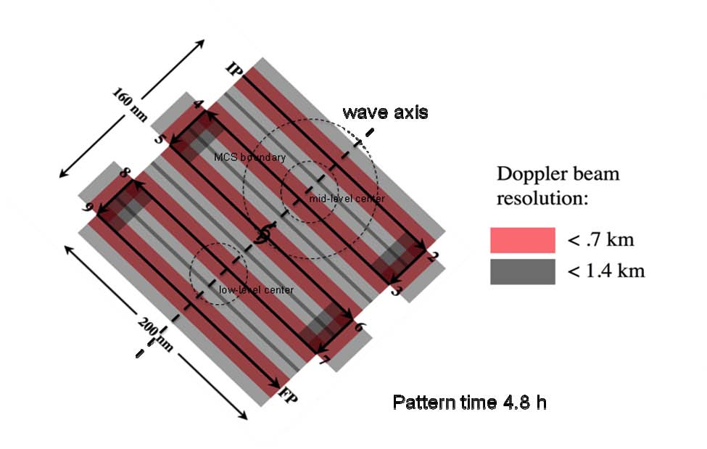
Figure 5-1: P-3 Pre-genesis early organization vortex survey pattern – Lawnmower pattern.

- Note 1: TAS calibration is required.
- Note 2. The pattern is flown with respect to the wave axis, typically inclined at 30-40° from N, or relative to circulation or vorticity centers.
- Note 3. Length of pattern (axis parallel to wave axis) should cover both low- and mid-level vortices, leg lengths range from 150 – 200 nm (275-375 km). Leg lengths and separation distance can vary, depending on storm size and ferry time.
- Note 4. Fly pattern at 12,000 ft (4 km) altitude, deploying dropwindsondes at all turn points and midway along long legs. If available, deploy AXBT’s coincident with all dropwindsondes.
- Note 5. Set airborne Doppler radar to scan F/AST on all legs.

Tropical Cyclogenesis Experiment

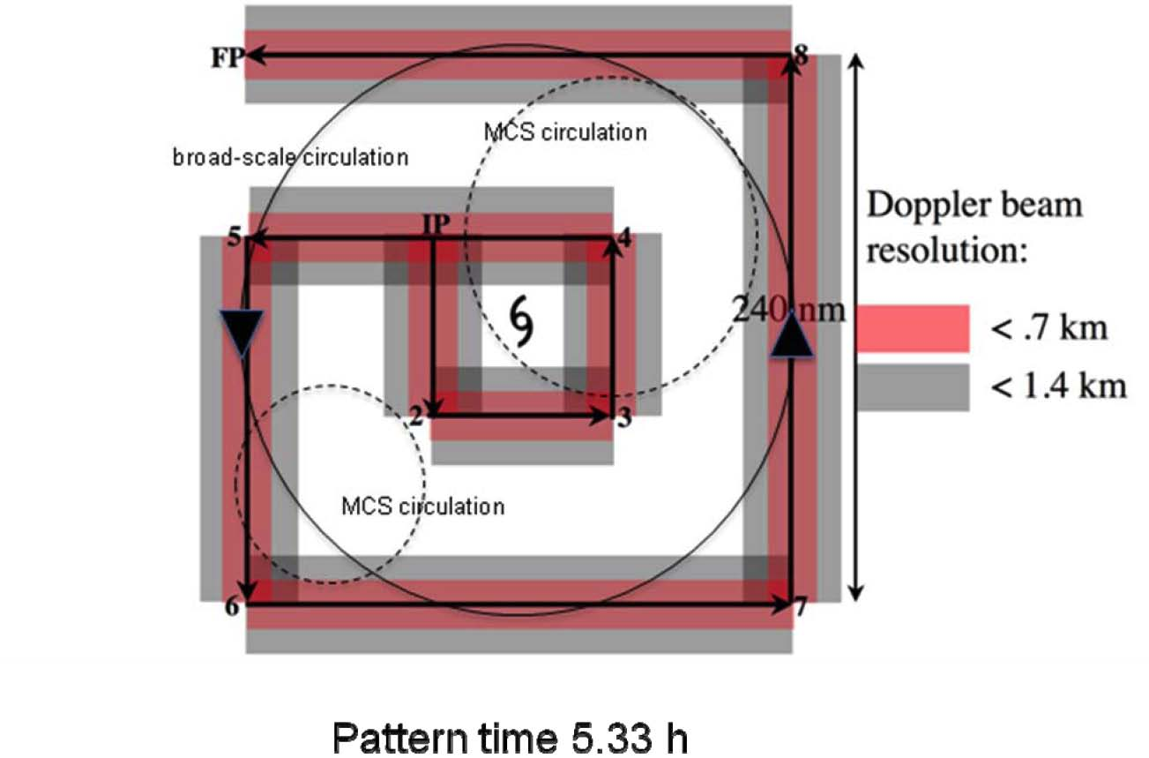
Figure 5-2: P-3 Pre-genesis late organization vortex survey pattern – Square-spiral pattern.

- Note 1. TAS calibration is required.
- Note 2. Release dropwindsondes at all numbered points, and at points of equivalent length along non-numbered legs, to form a grid of dropsondes of equal horizontal spacing. Releases at intermediate points can be omitted if dropwindsonde supply is insufficient. If available release AXBT’s at coincident locations to dropwindsondes.
- Note 3. The spacing between the outer spiral and inner box (nominally set to 60 nm (111 km)) can be increased or decreased depending on the size of the disturbance and ferry time.
- Note 4. Fly at 12,000 ft (4.0 km) altitude.
- Note 5. Set airborne Doppler radar to scan F/AST on all legs.

Tropical Cyclogenesis Experiment

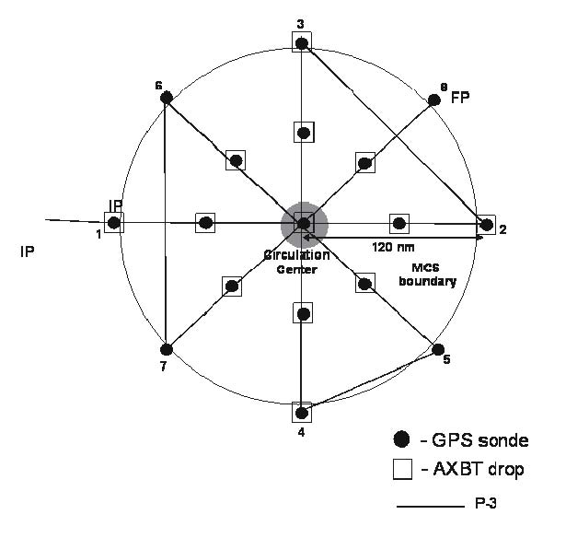
Pattern time: ~5.3 h
Figure 5-3: P-3 Post-genesis rotating figure-4 pattern.

- Note 1: TAS calibration is required.
- Note 2. The pattern may be entered along any compass heading.
- Note 3. Fly 1-2-3-4-5-6-7-8 at 12,000 ft altitude, 60-120 nm (111-225 km) leg length.
- Note 4 Set airborne Doppler radar to scan F/AST on all legs.

Tropical Cyclogenesis Experiment

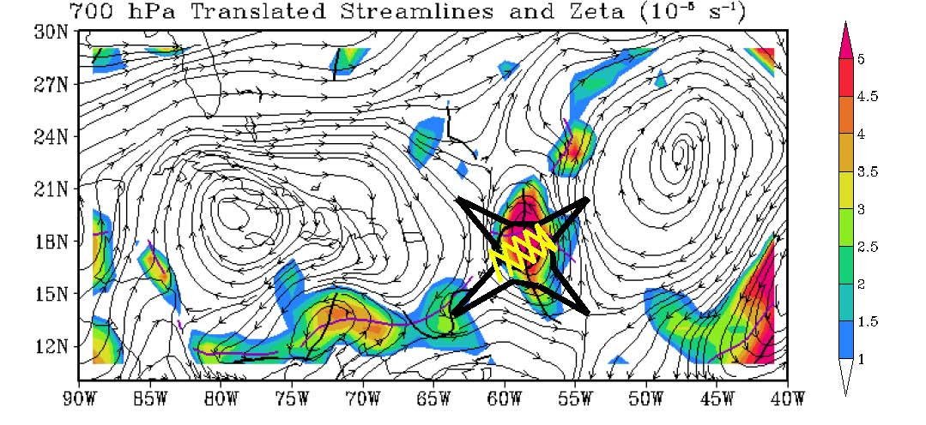
(a)

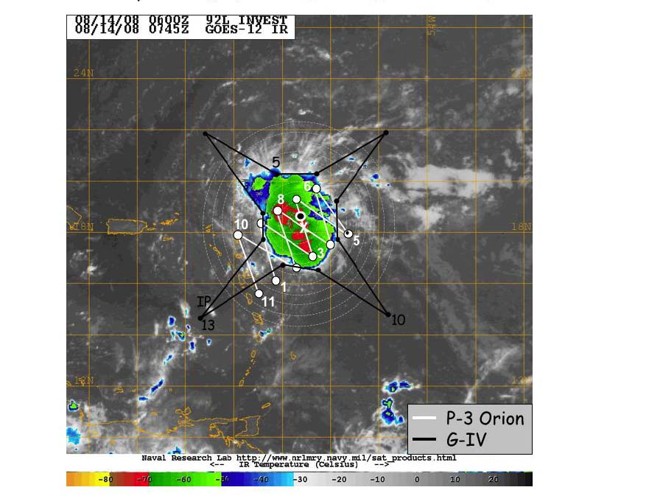
(b)

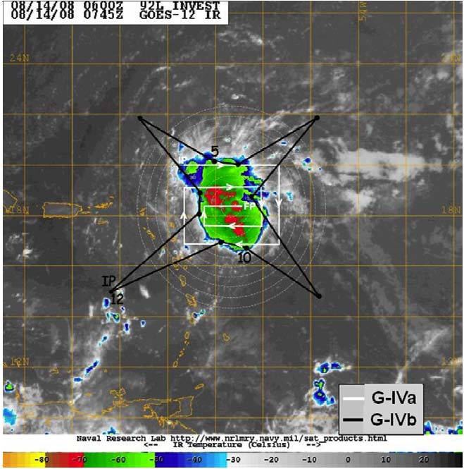

(c)

- Note 1: True airspeed calibration is required.
- Note 2. P-3 flown at 12 kft.
- Note 3. G-IV flown as close to cold cloud shield on inner radii as is deemed safe.
- Note 4. Set airborne Doppler radar to scan F/AST on all legs.
- Note 5: Release GPS drops from P-3s at all turn points and midpoints (when not overlapping with previous drop). Release G-IV drops at all turn points and midpoints of radial legs. For G-IV square-spiral shown in (c), release dropsondes in pattern equivalent to that done for P-3’s in Fig. 5-2.
- Note 6: In (c), if P-3 is flying concurrently either a lawnmower or square-spiral pattern, G-IV can fly either star (pattern G-IVa) or square-spiral (pattern G-IVb). If NSF G-V is not flying concurrently with G-IV, then G-IV flies white pattern G-IVa (square-spiral) indicated. If G-V is flying concurrently with G-IV, then G-IV flies black pattern G-IVb (star) indicated.

Figure 5-4: Combined P-3/G-IV flight tracks.

Tropical Cyclogenesis Experiment

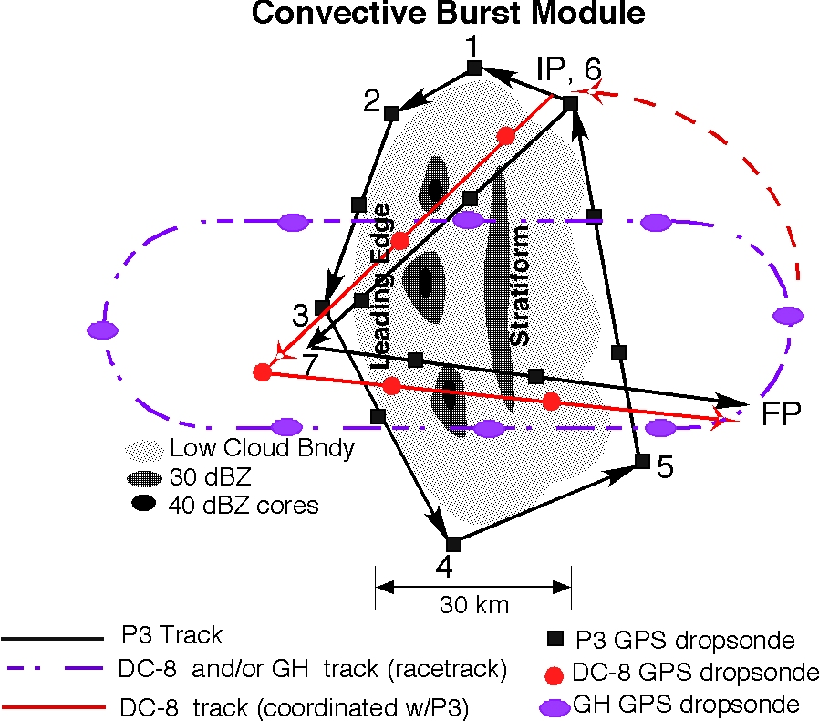

Figure 5-5: Convective burst module.

- Note 1: True airspeed calibration is required.
- Note 2. Circumnavigation (IP to point 6) by single P-3 at 14 kft.
- Note 3. Convective crossing (6-7-FP) at 12 kft.
- Note 4. Repeat circumnavigation (time permitting) at low altitude (200 ft in day, 1000 ft at night).
- Note 5. No GPS sondes for low-altitude option.
- Note 6. If possible, high-altitude aircraft (DC-8 or Global Hawk) flies racetrack pattern during P-3 circumnavigation, flies vertically aligned with P-3 during convective crossing.
- Note 7: Set airborne Doppler radar to scan F/AST on all legs.

6. Rapid Intensity Change Experiment

Primay IFEX Goal: 3 - Improve understanding of the physical processes important in intensity change for a TC at all stages of its lifecycle

Principal Investigator(s): John Kaplan, Robert Rogers
Motivation: While some improvements have been made in operational tropical cyclone intensity forecasting in recent years (DeMaria et al. 2007), predicting changes in tropical cyclone intensity (as defined by the 1-min. maximum sustained wind) remains problematic. Moreover, the operational prediction of rapid intensification (RI) has proven to be especially difficult (Kaplan et al. 2010) and given the significant impact of such episodes, has prompted the Tropical Prediction Center/National Hurricane Center (TPC/NHC) (NOAA 2008) to declare it as its top forecast priority. The difficulty of forecasting RI stems from a general lack of understanding of the physical mechanisms that are responsible for these rare events. Generally speaking researchers have attributed RI to a combination of inner-core, oceanic, and large-scale processes. The RI index presented in Kaplan et al. (2010), the best predictive scheme for RI to date, relies mainly on large-scale fields and broad characteristics of the vortex, such as environmental vertical wind shear and departure of the vortex from its empirical maximum potential intensity (which is itself largely derived from sea-surface temperature (SST)), as well as some characteristics of deep convection within the inner core, including the symmetry of inner-core convection around the storm center. This scheme is able to explain roughly 35% of the skill in RI forecasts in the Atlantic basin, with the remainder being attributable either to other processes not being accounted for in this methodology or constrained by predictability limits. The goal of this experiment is to collect datasets that can be utilized both to initialize 3-D numerical models and to improve our understanding of RI processes across multiple scales, with the overarching goal of improving our ability to predict the timing and magnitude of RI events.

Objective:

To employ both NOAA P-3 and G-IV aircraft to collect oceanic, kinematic, and thermodynamic observations both within the inner-core (i.e., radius < 120 nm) and in the surrounding large-scale environment (i.e., 120 nm < radius < 240 nm) for systems that have been identified as having the potential to undergo RI within 24-72 h. The SHIPS RI index will be the primary guidance that is used for selecting candidate systems for the short-term time periods (24-36 h) while both the RI index and 3-D numerical models will be used for the longer time ranges (i.e. beyond 36 h).

Hypotheses:

- By gathering observations that span spatial scales from 10s to 100s of kilometers it is possible to improve our understanding of the atmospheric and oceanic conditions that precede RI, particularly within the less observed inner-core region.

Characteristics of the tropical cyclone inner core, both on the vortex- and convective-scale, contribute a non-negligible amount to explaining the variance in the prediction of RI.

- The aforementioned multi-scale RAPX data sets can be used both to initialize and evaluate numerical model forecasts made for episodes of RI and that successful completion of these tasks will lead to improved numerical/statistical model predictions of RI.

Mission Description:

The P-3 aircraft will dispense AXBTs and GPS dropsondes and collect Doppler radar data while flying a rotating figure-4 pattern (see sample pattern shown in Fig. 6-1) in the inner-core with leg lengths of ~50-100 nm at the maximum safe altitude (~8k-12k feet) for avoiding graupel. The AXBTs and GPS dropsondes should be dispensed on each leg with a spacing of ~15-20 nm to provide adequate coverage for deducing the radial variations in kinematic and thermodynamic storm properties. The P-3 may also fly a convective burst module similar to that flown for the tropical cyclone genesis experiment if the opportunity to conduct such a flight pattern presents itself.

The G-IV should fly the environmental pattern shown in Fig. 6-2 at an altitude of ~ 42-45 K ft dispensing dropsondes at radii of 120, 180, and 240 nm to measure the thermodynamics and kinematic fields in the near storm environment. These particularly radii were chosen since collecting data in this region is crucial for computing the vertical shear and upper-level divergence both of which have been shown to be strongly correlated with RI. The radii of the innermost ring of G-IV drops shown in Fig. 6-2 can be adjusted outward if necessitated by safety considerations. However, the radii of the other rings of drops should then also be adjusted to maintain the specified spacing.

As noted above, this experiment requires that both the P-3 and G-IV be utilized. In addition, it is highly desirable that the P-3 aircraft fly a rotating figure-4 pattern (see Fig. 6-1) in the inner-core while the G-IV simultaneously flies the environmental surveillance pattern shown in Fig. 6-2 every 12 h. Although this mission can still be conducted if the G-IV aircraft flies a synoptic surveillance pattern instead of the one shown in Fig. 6-2, such a flight pattern should only be flown in the event that the G-IV has been tasked by the NHC to conduct an operational synoptic surveillance mission and thus would otherwise be unavailable for use in conducting research type missions. Furthermore, if either the P-3 or G-IV aircraft cannot fly every 12 h the experiment can still be conducted provided that the gap between missions for any one of the two aircraft does not exceed 24 h. Finally, when possible this experiment may also make use of the NASA DC-8 and Global Hawk aircraft that will be employed as part of the GRIP (Genesis and Rapid Intensification Processes) experiment.

Global Hawk Synoptic and Inner-core Module: From August 15 to September 30, NASA will be flying the high-altitude Global Hawk (GH) UAS as part of their Genesis and Rapid Intensification Processes experiment (GRIP). The GH will be based at NASA Dryden at Edwards AFB, California, has an endurance of up to 30 hours, and cruises at altitudes ranging from 60-65 kft with an airspeed of about 340 kt. Because of its long endurance, it is anticipated that the GH will fly a series of modules per mission with each individual module either sampling the synoptic environment, near environment, or a convective area of a tropical system of interest.

It is unknown whether or not the GH can safely overfly the deep convection of the eyewall of a mature hurricane. A module could be flown with the GH that samples both the inner region and the near environment of a mature hurricane without crossing over the eye and eyewall region itself.

An example of this type of module for the GH in the Gulf of Mexico is in Fig. 6-3. The pattern resembles a “butterfly or Alpha” pattern but the radial legs toward or away from the eye do not cross the eyewall and eye. Instead, the GH heads towards the eye to a radius as close to the eyewall as the pilots are comfortable with. Then, the GH turns radially outward away from the storm center at a heading 45� clockwise from the inbound direction. This pattern of inbound and outbound legs is repeated until the storm has been completely circumnavigated and/ or the desired azimuthal resolution is reached.

The module as drawn would take about 8 hours to complete from the location of the first drop to the last. The distance and number of the radial legs can be altered for each particular flight mission depending on storm location and the priority of any other modules that might be planned. Additional dropsondes can easily be inserted into the module as long as these drops are coordinated with operational and research aircraft that may be flying at lower altitudes beneath the GH.

Analysis Strategy: This experiment seeks to perform a multi-scale analysis of the conditions both before and during RI. Specifically, we will use GFS, GPS dropsonde, and ocean buoy observations to analyze the changes in energy transfer at the ocean-atmosphere interface during the time period of the experiment. Also, changes in the inner-core kinematic and thermodynamic structure will be examined using NOAA P-3 Doppler radar, flight-level, and GPS dropsonde data within the inner-core region (i.e., radius <120 nm). Inner-core analyses will include an analysis of the symmetric and asymmetric vortex structure, vortex tilt, and inner-core vertical shear derived from airborne Doppler and dropsonde data and statistics of vertical velocity, vorticity, and reflectivity from airborne Doppler. Finally, an analysis of the near-storm large-scale environment (i.e., 120 nm < radius < 240 nm) will be conducted using the high-resolution GFS analyses that contain the assimilated GPS dropsonde data deployed from NOAA G-IV aircraft. The overarching hypothesis of this analysis strategy is that by performing similar analyses for multiple RAPX data sets collected during both RI and non-RI events it will be possible to determine the conditions that are triggers for RI and to evaluate numerical model performance during such events.

Fig. 6-1. Sample rotated figure-4 flight pattern for RAPX mission. The red shading denotes locations where vertical spacing of Doppler beam < 0.7 km, grey shading where vertical spacing < 1.4 km. GPS dropsondes should be released at all turn points (past the turn after the aircraft has leveled), at midpoints of inbound/outbound legs, and at center point between IP/2 and 5/6. If available, release AXBT’s coincident with dropsondes at turn points and center points. Note that the above in-storm P-3 flight pattern requires about 3-4 hours to complete.

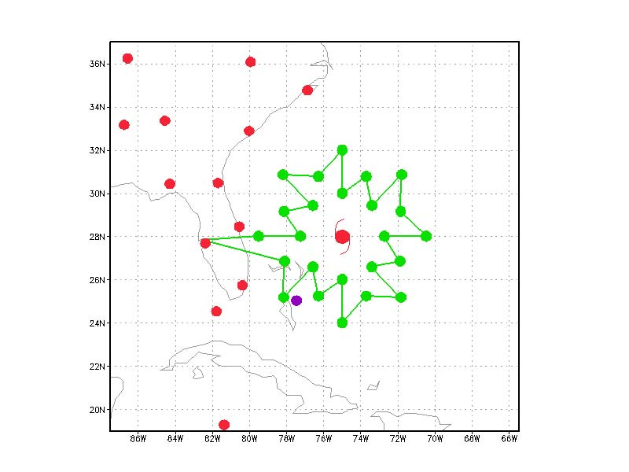
Fig. 6-2. A sample G-IV flight pattern for the RAPX mission. The green dots denote the desired dropsonde locations at 120, 180, and 240 nm radius from the storm center. Note that the end points of each leg can be rounded slightly as required for aircraft flight considerations. The flight pattern shown in Fig. 2 (excluding ferry time to and from the storm) requires about 6 hours to complete.

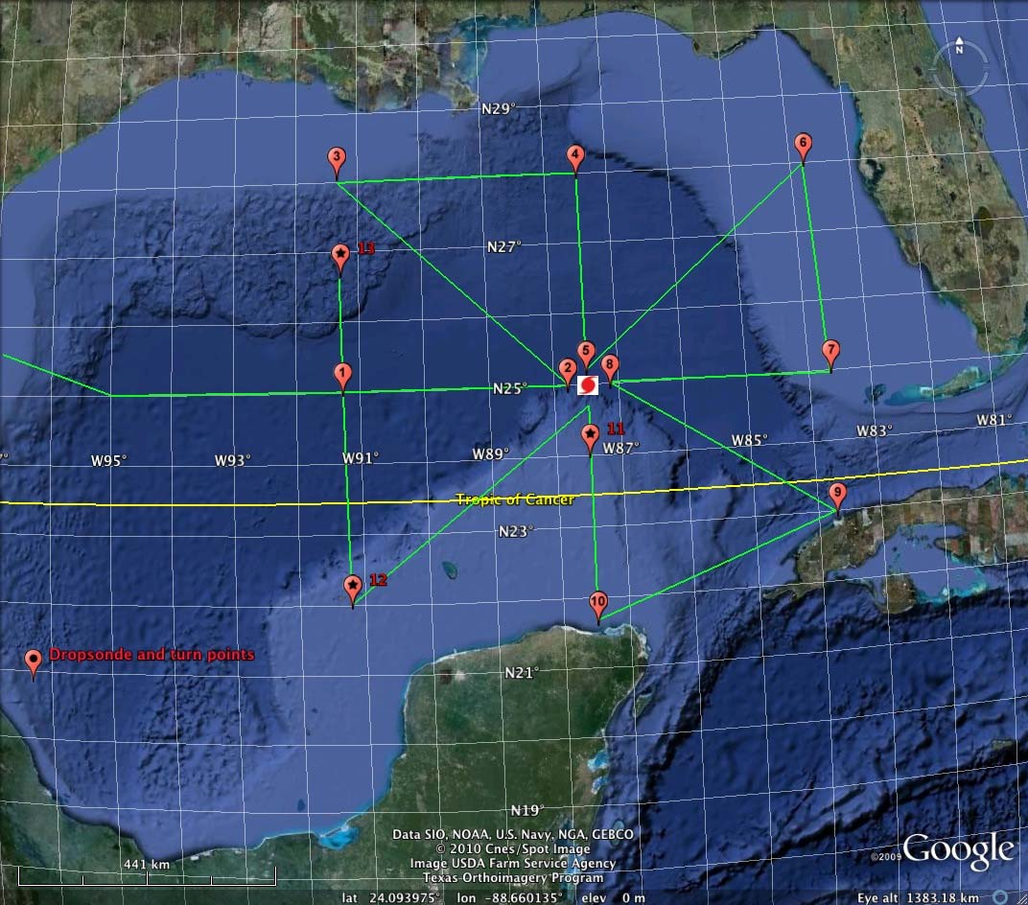

Fig. 6-3. A sample synoptic-core, RI module of the NASA GH UAS for a mature hurricane in the central Gulf of Mexico. Note that the radial legs do not cross the storm center but turn at some safe distance from the eye (points 2,5,8,11). The leg length and number of radial legs of this module could be changed for each particular mission. Close coordination of the location of the GH within this module with all other research and operational aircraft is required, especially if additional dropsondes are planned to be released.

7. TC-Ocean Interaction Experiment

Primay IFEX Goal: 3 - Improve understanding of the physical processes important in intensity change for a TC at all stages of its lifecycle

Principal Investigator(s): Eric Uhlhorn, Rick Lumpkin (PhOD), Nick Shay (U. Miami/RSMAS)

Significance and Goals
This program broadly addresses the role of the ocean and air-sea interaction in controlling TC intensity by making detailed measurements of these processes in storms during the 2010 season. Specific science goals are in two categories:

Goal: To observe and improve our understanding of the upper-ocean response to the near-surface wind structure during TC passages. Specific objectives are:
- The oceanic response of the Loop Current (LC) to TC forcing; and,
- Influence of the ocean response on the atmospheric boundary layer and intensity.

In addition, these ocean datasets fulfill needs for initializing and evaluating ocean components of coupled TC forecast systems.

Rationale

Ocean effects on storm intensity. Upper ocean properties and dynamics undoubtedly play a key role in determining TC intensity. Modeling studies show that the effect of the ocean varies widely depending on storm size and speed and the preexisting ocean temperature and density structure. The overriding goal of these studies is to provide data on TC-ocean interaction with enough detail to rigorously test coupled TC models, specifically:
- Measure the two-dimensional SST cooling, air temperature, humidity and wind fields beneath the storm and thereby deduce the effect of the ocean cooling on ocean enthalpy flux to the storm.
- Measure the three-dimensional temperature, salinity and velocity structure of the ocean beneath the storm and use this to deduce the mechanisms and rates of ocean cooling.
- Conduct the above measurements at several points along the storm evolution therefore investigating the role of pre-existing ocean variability.
- Use these data to test the accuracy of the oceanic components coupled models.

Ocean boundary layer and air-sea flux parameterizations. TC intensity is highly sensitive to air-sea fluxes. Recent improvement in flux parameterizations has lead to significant improvements in the accuracy of TC simulations. These parameterizations, however, are based on a relatively small number of direct flux measurements. The overriding goal of these studies is to make additional flux measurements under a sufficiently wide range of conditions to improve flux parameterizations, specifically:
- Measure the air-sea fluxes of enthalpy and momentum using ocean-side budget and covariance measurements and thereby verify and improve parameterizations of these fluxes.
- Measure the air-sea fluxes of oxygen and nitrogen using ocean-side budget and covariance measurements and use these to verify newly developed gas flux parameterizations.
- Measure profiles of ocean boundary layer turbulence, its energy, dissipation rate and skewness and use these to investigate the unique properties of hurricane boundary layers.
- Conduct the above flux and turbulence measurements in all four quadrants of a TC so as investigate a wide range of wind and wave conditions.

The variability of the Gulf of Mexico Loop Current system and associated eddies have been shown to exert an influence on TC intensity. This has particular relevance for forecasting landfalling hurricanes, as many

TCs in the Gulf of Mexico make landfall on the U.S. coastline. To help better understand the LC variability and improve predictions for coupled model forecasts, NOAA is partnering with the Department of Interior

’

s Minerals Management Service (MMS) and the University of Miami to obtain measurements in this rarely-observed region. MMS has recently installed a field of moorings in the central Gulf of Mexico, which will provide a long record of LC structural variability, including during TC events. In coordination with these observations, upper-ocean temperature and salinity fields in the vicinity of the LC will be sampled using expendable ocean profilers (see Fig. 7-1).

Pre- and post-storm expendable profiler surveys

Flight description
Feature-dependent survey. Each survey consists of deploying 60-80 expendable probes, with take-off and recovery at KMCF. Pre-storm missions are to be flown one to three days prior to the TC’s passage near the mooring array in the LC (Fig. 7-1) . Post-storm missions are to be flown one to three days after storm passage, over the same area as the pre-storm survey. Since the number of deployed expendables exceeds the number of external sonobuoy launch tubes, profilers must be launched via the free-fall chute inside the cabin. Therefore the flight is conducted un-pressurized at a safe altitude. In-storm missions, when the TC is passing directly over the observation region, will typically be coordinated with other operational or research missions (e.g. Doppler Winds missions). These flights will require 10-20 AXBTs deployed for measuring sea surface temperatures within the storm.

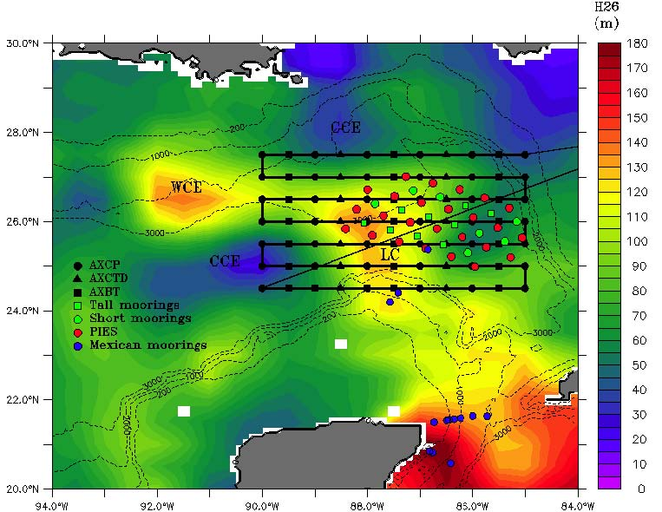

Track-dependent survey. For situations that arise in which a TC is forecast to travel outside of the immediate Loop Current region, a pre- and post-storm ocean survey focused on the official track forecast is necessary. The pre-storm mission consists of deploying AXBTs on a regularly-spaced grid, considering the uncertainty associated with the track forecast. A follow-on post-storm mission would then be executed in the same general area as the pre-storm grid, possibly adjusting for the actual storm motion. Figure 7-2 shows a scenario for a pre-storm survey, centered on the 48 hour forecast position. This sampling strategy covers the historical “cone of uncertainty” for this forecast period.

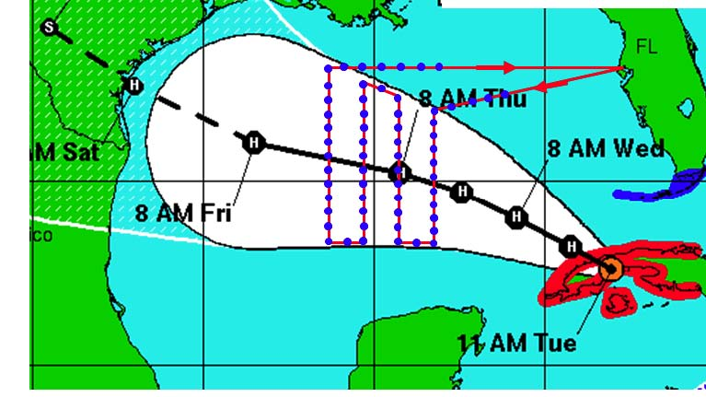
Figure 7-2: Track-dependent AXBT ocean suvey. As for the Loop Current survey, a total of 60-80 probes would be deployed on a grid (blue dots).

Coordinated float/drifter deployment overflights

Measurements will be made using arrays of profiling and Lagrangian floats and drifters deployed by AFRC WC-130J aircraft in a manner similar to that used in the 2003 and 2004 CBLAST program. Additional deployments have since refined the instruments and the deployment strategies. MiniMet drifters will measure SST, surface pressure and wind speed and direction. Thermistor chain Autonomous Drifting Ocean Station (ADOS) drifters add ocean temperature measurements to 150m. All drifter data is reported in real time through the Global Telecommunications System (GTS). Flux Lagrangian floats will measure temperature, salinity, oxygen and nitrogen profiles to 200m, boundary layer evolution and covariance fluxes of most of these quantities, wind speed and scalar surface wave spectra. E-M Lagrangian floats will measure temperature, salinity and velocity profiles to 200m. Profile data will be reported in real time on GTS.

Substantial resources for this work will be funded by external sources. The HRD contribution consists of coordination with the operational components of the NHC and the 53rd AFRC squadron and P-3 survey flights over the array with SFMR and SRA wave measurements and dropwindsondes. If the deployments occur in the Gulf of Mexico, Loop Current area, this work will be coordinated with P-3 deployments of AXBTs and AXCPs to obtain a more complete picture of the ocean response to storms in this complex region.

Main Mission description
P-3 flights will be conducted in collaboration with operational float and drifter deployments by WC-130J aircraft operated by the AFRES Command (AFRC) 53rd Weather Reconnaissance Squadron. The P-3 surveys will provide information on the storm and sea-surface structure over the float and drifter array.

Coordination and Communications
Alerts - Alerts of possible deployments will be sent to the 53rd AWRO up to 5 days before deployment, with a copy to CARCAH, in order to help with preparations. Rick Lumpkin (PhOD) will be the primary point of contact for coordination with the 53rd WRS and CARCAH.

Flights

Coordinated float/drifter deployments would nominally consist of 2 flights, the first deployment mission by AFRC WC-130J and the second overflight by NOAA WP-3D. An option for follow-on missions would depend upon available resources.

Day 1- WC-130J Float and drifter array deployment- Figure 7-3 shows the nominal deployment pattern for the float and drifter array. It consists of two lines, A and B, set across the storm path with 8 and 4 elements respectively. The line length is chosen to be long enough to span the storm and anticipate the errors in forecast track. The element spacing is chosen to be approximately the RMW. The Lagrangian floats and thermistor chain drifters (ADOS) are deployed near the center of the array to maximize their likelihood of seeing the maximum wind speeds and ocean response. The Minimet drifters are deployed in the outer regions of the storm to obtain a full section of storm pressure and wind speeds. The drifter array is skewed one element to the right of the track in order to sample the stronger ocean response on the right side.

Day 2. P-3 In-storm mission- Figure 7-4 shows the nominal P-3 flight path and dropwindsonde locations during the storm passage over the float and drifter array. The survey should ideally be timed so that it occurs as the storm is passing over the drifter array.

The survey includes legs that follow the elements of float/drifter line ‘A’ at the start and near the end. The survey anticipates that the floats and drifters will have moved from their initial position since deployment and will move relative to the storm during the survey. Waypoints 1-6 and 13-18 will therefore be determined from the real-time positions of the array elements. Each line uses 10 dropwindsondes, one at each end of the line; and two at each of the 4 floats, the double deployments are done to increase the odds of getting a 10m data.

The rest of the survey consists of 8 radial lines from the storm center. Dropwindsondes are deployed at the eye, at half Rmax, at Rmax, at twice Rmax and at the end of the line, for a total of 36 releases. AXBTs are deployed from the sonobuoy launch tubes at the eye, at Rmax and at 2 Rmax. This AXBT array is focused at the storm core where the strongest air-sea fluxes occur; the buoy array will fill in the SST field in the outer parts of the storm. In this particular example, the final two radials have been moved after the second float survey to avoid upwind transits. For other float drift patterns, this order might be reversed.

It is highly desirable that this survey be combined with an SRA surface wave survey because high quality surface wave measurements are essential to properly interpret and parameterize the air-sea fluxes and boundary layer dynamics, and so that intercomparisons between the float wave measurements and the SRA wave measurements can be made.

Extended Mission Description
If the storm remains strong and its track remains over water, a second or possibly third oceanographic array may be deployed, particularly if the predicted track lies over a warm ocean feature predicted to cause storm intensification (Fig. 7-5). The extended arrays will consist entirely of thermistor chain and minimet drifters, with 7 elements in a single line. As with the main mission, the spacing and length of the line will be set by the size of the storm and the uncertainty in the forecast track.

Mission timing and coordination will be similar to that described above. P-3 overflights would be highly desirable.

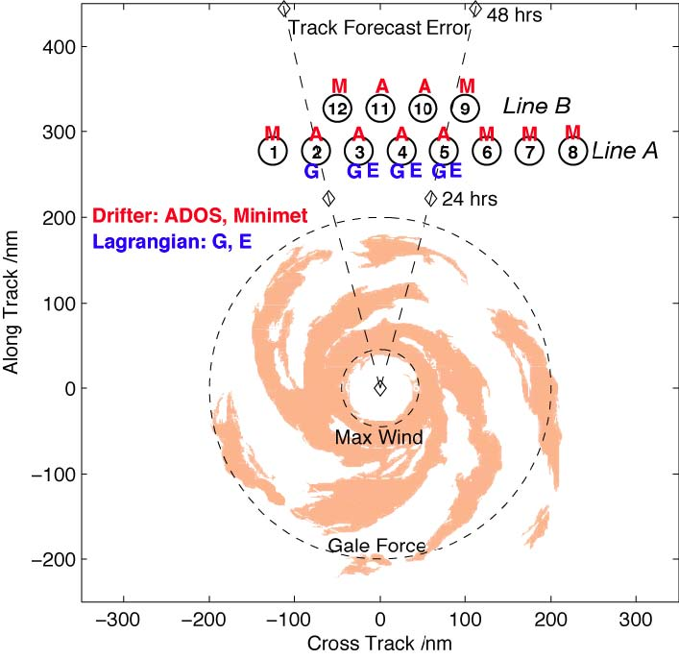
Figure 7-3: Float and drifter array deployed by AFRC WC-130J aircraft. The array is deployed ahead of the storm with the exact array location and spacing determined by the storm speed, size and the uncertainty in the storm track. The array consists of a mix of ADOS thermistor chain (A) and minimet (M) drifters and gas (G) and EM (E) Lagrangian floats. Three items are deployed at locations 3, 4 and 5, two items at location 3 and one item elsewhere.

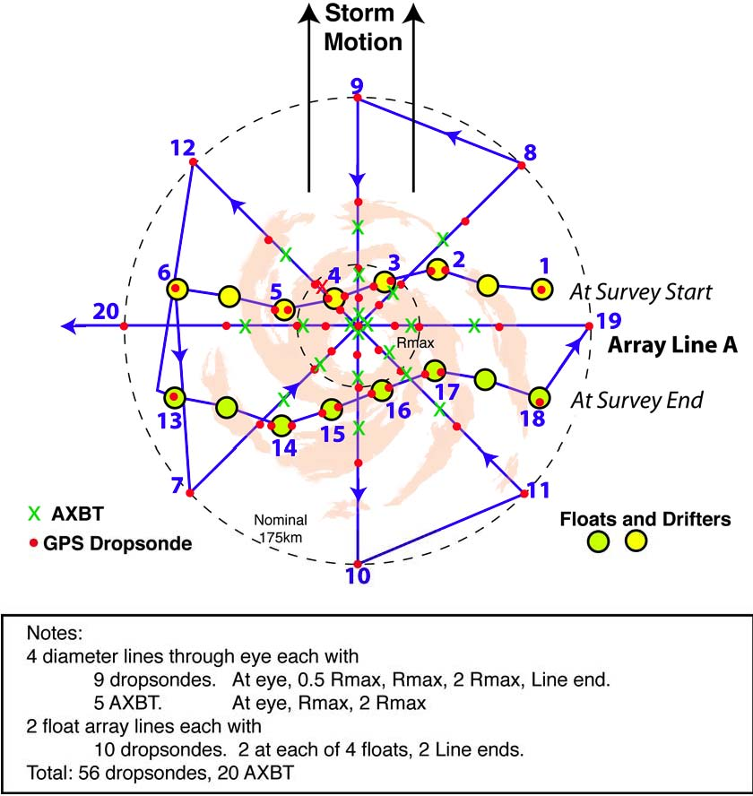

Figure 7-4: P-3 pattern over float and drifter array. The array has been distorted since its deployment on the previous day and moves relative to the storm during the survey. The pattern includes two legs along the array (waypoints 1-6 and 13-18) and an 8 radial line survey. Dropwindsondes are deployed along all legs, with double deployments at the floats. AXBTs are deployed in the storm core.

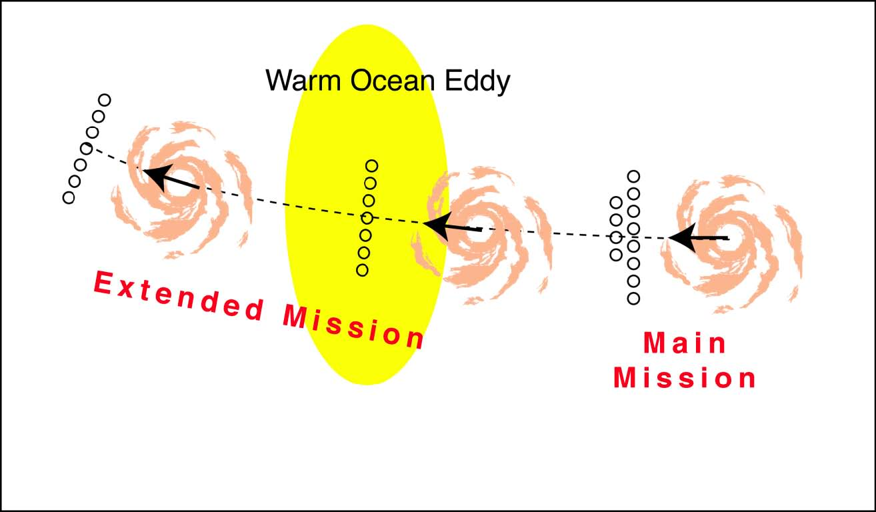

Figure 7-5: Extended Mission. Two additional drifter arrays will be deployed along the storm track.

8. Saharan Air Layer experiment

Primay IFEX Goal: 3 - Improve understanding of the physical processes important in intensity change for a TC at all stages of its lifecycle

Principal Investigator(s): Jason Dunion
INTRODUCTION
Saharan Air Layer Experiment: This is a multi-option, multi-aircraft experiment which uses GPS dropsondes and flight-level data from the NOAA G-IV (flying at ~175-200 hPa/~45,000-41,000 ft) and NOAA WP-3D (flying at ~500-700 hPa/19,000-10,000 ft) to examine the thermodynamic and kinematic structure of the Saharan Air Layer (SAL) and its potential impact on tropical cyclone (TC) genesis and intensity change. The GPS dropwindsonde drop points will be selected using real-time GOES SAL tracking imagery from UW-CIMSS and mosaics of microwave-derived total precipitable water from the Naval Research Laboratory and the UW-CIMSS MIMIC product. Specific effort will be made to gather atmospheric information within the SAL as well as regions of high moisture gradients across its boundaries and the region of its embedded mid-level easterly jet. The goals of this experiment are to better understand and predict how the SAL’s dry air, mid-level easterly jet, and suspended mineral dust affect Atlantic TC intensity change and to assess how well these components of the SAL are being represented in forecast models.

Program Significance: The SAL has been investigated fairly extensively during the past several decades, buts its role in influencing Atlantic TCs has not been thoroughly examined. The SAL is characterized by a well-mixed layer that originates over the arid regions of the Sahara and often extends up to ~500 hPa (~19,000 ft) over the African continent. This air mass is extremely warm and dry, with temperatures that are markedly warmer (~0.5-5.0oC in the central/western North Atlantic and ~5-10oC in the eastern North Atlantic) than a typical moist tropical sounding. Additionally, the RH (mixing ratio) in the SAL is ~45-55% (~25-35% RH, ~1.5-3.5 g kg-1) drier than a typical moist tropical sounding from 500-700 hPa. The SAL is often associated with a 20-50 kt mid-level easterly jet centered near 600-800 hPa (~14,500-6,500 ft) and concentrated along its southern boundary.
SAL outbreaks typically move westward off the western coast of North Africa every 3-5 days during the summer months. There are several characteristics of these frequent outbreaks that can act to suppress Atlantic TC formation:

1) The SAL contains dry, stable air that can diminish local convection by promoting convectively driven downdrafts in the TC environment;

2) The SAL contains a mid-level easterly jet that can significantly increase the local vertical wind shear. The low-level circulations of TCs under the influence of this jet tend to race out ahead of their mid and upper-level convection, decoupling the storm and weakening it;

3)

Mineral dust
suspended within the SAL absorbs solar energy and subsequently releases longwave infrared energy. These thermal emissions act to warm the SAL and can re-enforce the tropical inversion that already exists in the tropical North Atlantic. This warming helps to stabilize the environment and also limits vertical mixing through the SAL, allowing it to maintain its distinctive low humidity for extended periods of time (several days) and over long distances (1000s of km). Recent studies also suggest that mineral dust may impact the

formation of clouds in both the ambient tropical and tropical cyclone environments. Data from previous studies have indicated that the particle size of the SAL

’

s suspended mineral typically ranges from 0.4 - 40

�m;

Objectives: The main objectives of SALEX are to:
- Better understand how the SAL’s dry air, mid-level easterly jet, and suspended mineral dust affect Atlantic TC intensity change;
- Include the moisture information from the GPS dropwindsondes in operational parallel runs of the NOAA Global Forecast System (GFS) model. The impact of this data on the GFS (and GFDL) initial/forecast humidity fields and its forecasts of TC track and intensity will be assessed;
- Investigate the representation of the SAL’s temperature structure, low- to mid-level dry air, and embedded easterly jet in the GFS, GFDL, and HWRF-X models compared to GPS dropsonde data;
- Investigate the relationship between vertical distributions of dust detected by the DWL and temperature profiles/anomalies captured by collocated GPS dropsonde (pending P-3 DWL availability);

Links to IFEX: This experiment supports the following NOAA IFEX goals:
- Goal 1: Collect observations that span the TC lifecycle in a variety of environments;
- Goal 3: Improve our understanding of the physical processes important in intensity change for a TC at all stages of its lifecycle;

Mission Description: The NOAA G-IV (flying at ~175-200 hPa/~45,000-41,000 ft) and NOAA WP-3D (flying at ~500-700 hPa/~19,000-10,000 ft) GPS dropwindsonde drop points will be based on a flight pattern selected using information from the UW-CIMSS/HRD GOES SAL tracking product, mosaics of microwave-derived TPW from NRL Monterey, and the UW-CIMSS MIMIC TPW product. Specific effort will be made to gather atmospheric information within the SAL, the transitional environment (regions with high gradients of humidity) across its boundaries, its embedded mid-level easterly jet, and the immediate surrounding moist tropical environment. When possible, SALEX missions will be coordinated with the HRD Tropical Cyclone Genesis Experiment (GenEx). This coordination will involve the WP-3D and/or G-IV and be executed on a case-by-case basis. Additionally, HRD’s Saharan Dust Microphysics Module and/or Arc Cloud Module should be conducted during SALEX should opportunities present. In the event that the P-3 portion of this experiment is concurrent with an operationally-tasked Tail Doppler Radar (TDR) mission, the operational pattern will preclude any of the SALEX patterns described below. However, supplemental GPS dropsonde data may still be requested along the TDR flight track to support SALEX objectives. It is anticipate that any SALEX missions flown in 2010 will involve coordination with aircraft flying under the NASA Genesis and Rapid Intensification Processes (GRIP) experiment (e.g. DC-8, WB-57 and Global Hawk) and the NSF PRE-Depression Investigation of Cloud-systems in the Tropics (PREDICT) experiment (G-V). Coordination will be handled on a case-by-case basis and will depend on the specific scientific goals of each agency. Several SAL/TC interaction scenarios are candidates for SALEX missions:

Option 1:

Single TC located along the southern edge of the SAL (Fig. 8-1). Depending on the proximity of these two features, the SAL

’

s dry air may be wrapping into the TC

’

s low-level circulation (western semicircle).

G-IV: The G-IV IP will be in west of the TC (preferably west of the SAL’s leading edge) and the initial portion of the 1st leg (IP-2) will focus a GPS dropwindsonde sequence across the high gradient region of humidity at the SAL’s leading edge. The spokes of this pattern (IP-2/12-FP, 3-5, 6-8, and 9-11) will include sampling of the environment between ~200-400 nm from the center and will be adjusted according to the storm size. The inner-most portion of the track will be roughly defined by convective areas that are below the flight level (GOES and Meteosat IR brightness temperature values warmer than ~-55oC). The tangential legs at ~200 nm will observe the variability of possible dry air and shear that has penetrated close to the inner core (2-3, 5-6, 8-9 and 11-12). These inner tangential legs should be positioned as close to the outer edge of the inner core convection as safety permits. This will help maximize tail Doppler radar coverage of the storm’s inner core convection. The region east of the storm along the southern edge of the SAL is a favored location for the SAL’s mid-level easterly jet. The region will be sampled to observe the moisture gradients and variability of the mid-level easterly jet across this portion of the SAL (4-5-6).

WP-3D: The WP-3D IP will be in the SW quadrant of the TC and the initial portion of the 1st leg (IP-2) will focus on sampling the ambient moist tropical environment south of the TC. The 2nd leg (2-3) will include sampling the ambient moist tropical environment east of the TC as well as focusing a GPS dropwindsonde sequence across the SAL’s southern boundary to capture gradients of humidity and wind shear (associated with the SAL’s mid-level easterly jet). The 3rd leg (3-4) will include a GPS dropwindsonde sequence that will be focused along the dry air inflow region on the west semicircle of the TC. This drop sequence will focus on sampling the intrusion of low humidity SAL air into the TC circulation and how the SAL’s vertical structure and moisture content modify as it advects closer to the TC inner core. The final leg (4-FP) will include a penetration of the TC center of circulation followed by GPS dropwindsonde sequences targeting the SAL west of the TC. The final GPS dropwindsonde sequence will sample the SAL’s leading edge (“rooster tail”) west of the TC. Given the emphasis on P-3 operationally-tasked TDR missions in 2010, it is anticipated that the TDR rotated figure 4 pattern will typically supersede the Fig. 8-1 P-3 pattern. SALEX objectives could still be met with this TDR pattern, though slightly longer legs (105-120 nm) would be desirable.

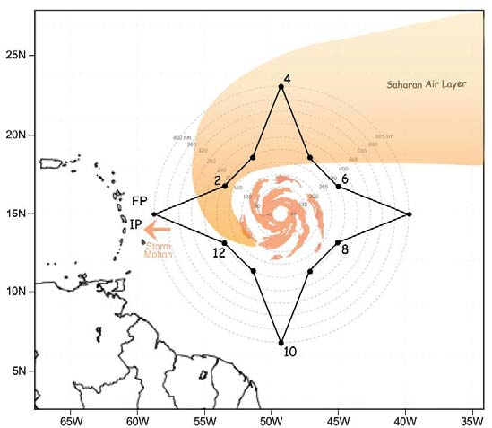

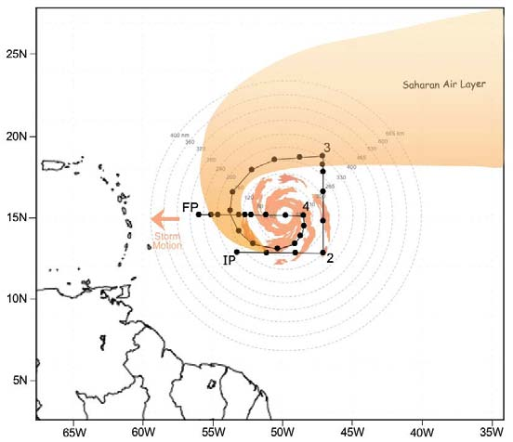

Fig. 8-1: Sample (top) G-IV and (bottom) WP-3D flight tracks for a TC positioned along the southern edge of the SAL

- Note 1: During the ferry to the IP, the G-IV should climb to ~200 hPa/41,000 ft as soon as possible and climb as feasible to maintain the highest altitude for the duration of the pattern. The WP-3D Orion should climb to the pre-determined flight-level (e.g. ~10,000-19,000 ft) as soon as possible.
- Note 2: In order to capture the SAL’s horizontal/vertical structure, particular attention should be paid to regions of high moisture gradients across its boundaries (G-IV: IP-2, 2-3, and 4-5-6; WP-3D: 2-3, and 4-FP) and possible penetration of dry air and vertical wind shear toward the inner core (G-IV: IP-2, 3-5, 6-8, 9-11 and 12-FP).
- Note 3: The SAL’s mid-level easterly jet (~20-50 kt at 600-800 hPa/14,500-6,500 ft) may be evident from GPS dropwindsondes dropped near the SAL’s southern boundary (G-IV: 2-3-4 and 4-5-6; WP-3D: 2-3 and 3-4).

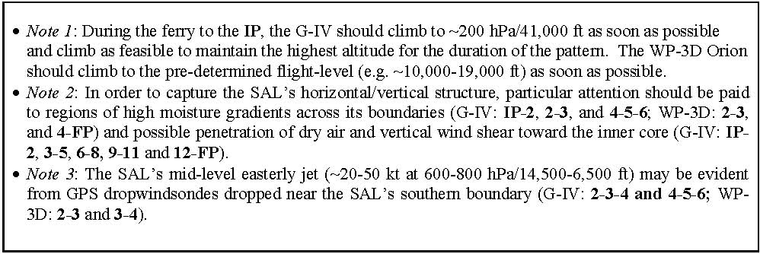

Option 2: Single TC is embedded within the SAL and intensifies upon emerging. These systems are often candidates for rapid intensification and should be coordinated with HRD’s Rapid Intensification Experiment (RAPX) if possible.

G-IV: The G-IV IP will be southwest of the TC. The first few legs (IP-2) will include a GPS dropwindsonde transect across the northern boundary of the SAL. This dropwindsonde sequence will focus on sampling the large humidity gradients across the northern edge of the SAL. The next several legs of the flight pattern (2-3-4-5-6-7-8) will intermittently sample the moist tropical environment out ahead of the TC and north of the SAL. The next few legs will include a GPS dropwindsonde transect across the northern boundary of the SAL northeast of the TC (7-8), intermittent GPS dropwindsondes within the SAL (8-9), and a GPS dropwindsonde transect across the southern boundary of the SAL (including the SAL’s mid-level easterly jet) southeast of the TC (9-10). The last few legs will largely sample the SAL environment from which the storm is moving away from (10-11-12-FP). The spokes of this pattern (IP-2/12-FP, 3-5, 6-8, and 9-11) will include sampling of the environment between ~200-400 nm from the center and will be adjusted according to the storm size. The inner-most portion of the track will be roughly defined by convective areas that are below the flight level (GOES and Meteosat IR brightness temperature values warmer than ~-55oC). The tangential legs at ~200 nm will observe the variability of possible dry air and shear that has penetrated close to the inner core (2-3, 5-6, 8-9 and 11-12). These inner tangential legs should be positioned as close to the outer edge of the inner core convection as safety permits. This will help maximize tail Doppler radar coverage of the storm’s inner core convection.

WP-3D: The WP-3D IP will be southwest of the TC. The 1st leg (IP-2) will include a GPS dropwindsonde transect across the northern boundary of the SAL. This dropwindsonde sequence will focus on sampling the large humidity gradients across the northern edge of the SAL. The 2nd leg (2-3) of the flight pattern will sample the boundary between moist tropical air north of the TC center and the SAL to the south and will include a penetration of the TC center of circulation. Particular attention will be focused on sampling dry SAL air near the TC inner core. The 3rd leg (3-4) will include a GPS dropwindsonde transect across the northern boundary of the SAL to sample the humidity gradients at the SAL’s northern boundary. The 4th leg (4-FP) will sample the boundary between moist tropical air north of the TC center and the SAL to the south and will include a penetration of the TC center of circulation. Particular attention will be focused on sampling dry SAL air near the TC inner core. Given the emphasis on P-3 operationally-tasked TDR missions in 2010, it is anticipated that the TDR rotated figure 4 pattern will typically supersede the Fig. 8-2 P-3 pattern. SALEX objectives could still be met with this TDR pattern, though slightly longer legs (105-120 nm) would be desirable.

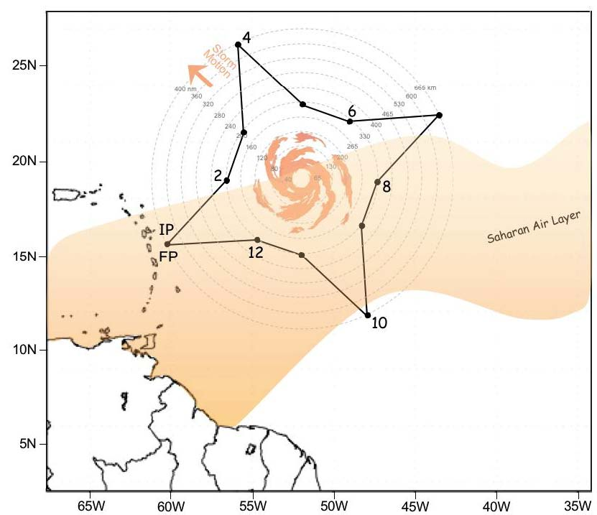

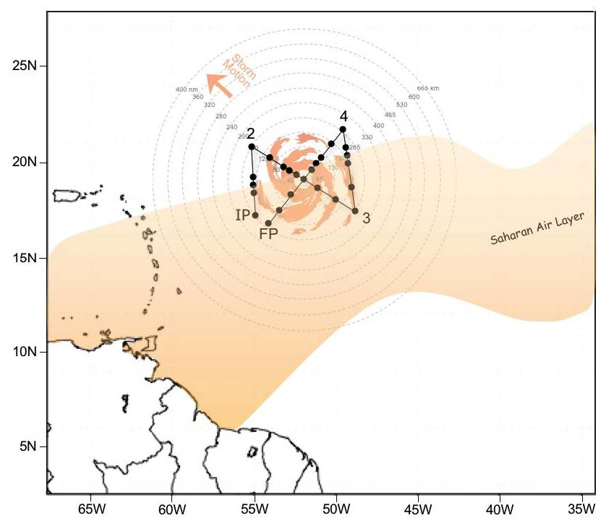

Fig. 8-2: Sample (top) G-IV and (bottom) WP-3D flight tracks for a TC emerging from the SAL.

- Note 1: During the ferry to the IP, the G-IV should climb to ~200 hPa/41,000 ft as soon as possible and climb as feasible to maintain the highest altitude for the duration of the pattern. The WP-3D Orion should climb to the pre-determined flight-level (e.g. ~10,000-19,000 ft) as soon as possible.
- Note 2: The TC may undergo a period of rapid intensification as it emerges from the SAL.
- Note 3: In order to capture the SAL’s horizontal/vertical structure, particular attention should be paid to regions of high moisture gradients across its boundaries (G-IV: IP-2-3, 7-8 and 9-10-11; WP-3D: IP-2 and 3-4).
- Note 4: The SAL’s mid-level easterly jet (~20-50 kt at 600-800 hPa/14,500-6,500 ft) may be evident from GPS dropwindsondes dropped near the SAL’s southern boundary (G-IV: 8-9-10-11-12).

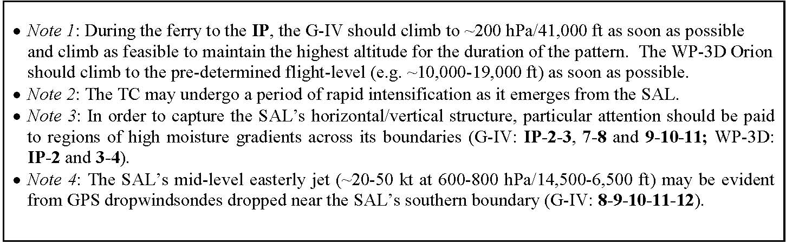

Option 3:

Single TC located along the leading edge of the SAL. These systems are often struggle to intensify as they are overtaken by the SAL surge, but do occasionally separate from the SAL and intensify. These systems are often characterized by their low-level circulations racing out ahead (west) of their mid-level convection.

G-IV: The G-IV IP will be west of the TC. The first two legs (IP-2-3) will include intermittent GPS dropwindsonde sampling of the moist tropical environment out ahead of the TC and west of the SAL. The 3rd (3-4) leg will sample the moist tropical environment north of the TC and west of the SAL followed by a GPS dropwindsonde transect across the leading edge of the SAL (north of the TC). The next several legs of the flight pattern (4-5-6-7-8-9) will intermittently sample the SAL with specific focus on sampling the gradients associated SAL’s mid-level easterly jet (typical located along the southern edge of the SAL). The 8th and 9th legs (8-9-10) will include intermittent GPS dropwindsonde sampling of the SAL, followed by a transect across the SAL’s southwest leading edge. The last few legs (9-10-11-12-FP) will include intermittent GPS dropwindsonde sampling of the moist tropical environment out ahead of the TC and west of the SAL. The spokes of this pattern (IP-2/12-FP, 3-5, 6-8, and 9-11) will include sampling of the environment between ~200-400 nm from the center and will be adjusted according to the storm size. The inner-most portion of the track will be roughly defined by convective areas that are below the flight level (GOES and Meteosat IR brightness temperature values warmer than ~-55oC). The tangential legs at ~200 nm will observe the variability of possible dry air and shear that has penetrated close to the inner core (2-3, 5-6, 8-9 and 11-12). These inner tangential legs should be positioned as close to the outer edge of the inner core convection as safety permits. This will help maximize tail Doppler radar coverage of the storm’s inner core convection.

WP-3D: The WP-3D IP will be west of the TC. The 1st leg (IP-2) will include intermittent GPS dropwindsonde sampling of the moist tropical environment out ahead of the TC and west of the SAL. The 2nd leg (2-3) of the flight pattern will sample the boundary between moist tropical air west of the TC center and the SAL to the east and will include a penetration of the TC center of circulation. Particular attention will be focused on sampling dry SAL air near the TC inner core. The 3rd leg (3-4) will include intermittent GPS dropwindsonde sampling within the SAL with specific focus on sampling the gradients associated SAL’s mid-level easterly jet (typical located along the southern edge of the SAL). The 4th leg (4-FP) will sample the boundary between the SAL to the east of the TC center and the moist tropical air to the west and will include a penetration of the TC center of circulation. Particular attention will be focused on sampling dry SAL air near the TC inner core. Given the emphasis on P-3 operationally-tasked TDR missions in 2010, it is anticipated that the TDR rotated figure 4 pattern will typically supersede the Fig. 8-3 P-3 pattern. SALEX objectives could still be met with this TDR pattern, though slightly longer legs (105-120 nm) would be desirable.

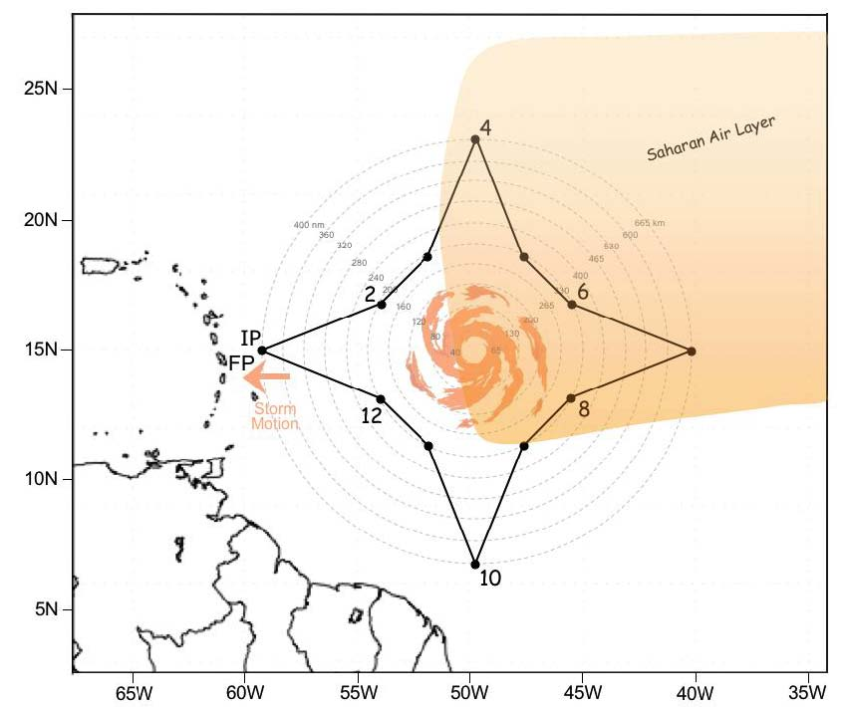

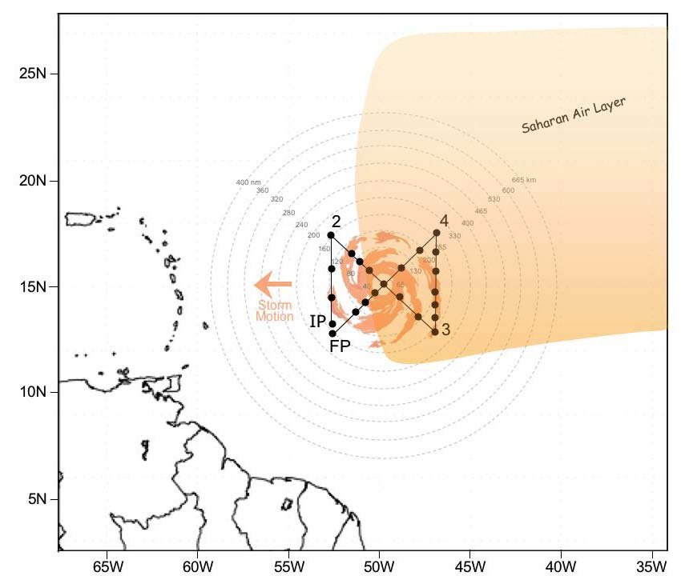

Fig. 8-3: Sample (top) G-IV and (bottom) WP-3D flight tracks for a TC along the leading edge of the SAL.

- Note 1: During the ferry to the IP, the G-IV should climb to ~200 hPa/41,000 ft as soon as possible and climb as feasible to maintain the highest altitude for the duration of the pattern. The WP-3D Orion should climb to the pre-determined flight-level (e.g. ~10,000-19,000 ft) as soon as possible.
- Note 2: The TC will likely struggle to intensify as it is overtaken by the SAL. Slow intensification is possible if the TC is able to separate from the SAL.
- Note 3: In order to capture the SAL’s horizontal/vertical structure, particular attention should be paid to regions of high moisture gradients across its boundaries (G-IV: 2-3-4 and 8-9-10; WP-3D: 2-3 and 4-FP).
- Note 4: The SAL’s mid-level easterly jet (~20-50 kt at 600-800 hPa/14,500-6,500 ft) may be evident from GPS dropwindsondes dropped near the SAL’s southern boundary (G-IV: 5-6-7-8-9; WP-3D: 2-3 and 3-4).

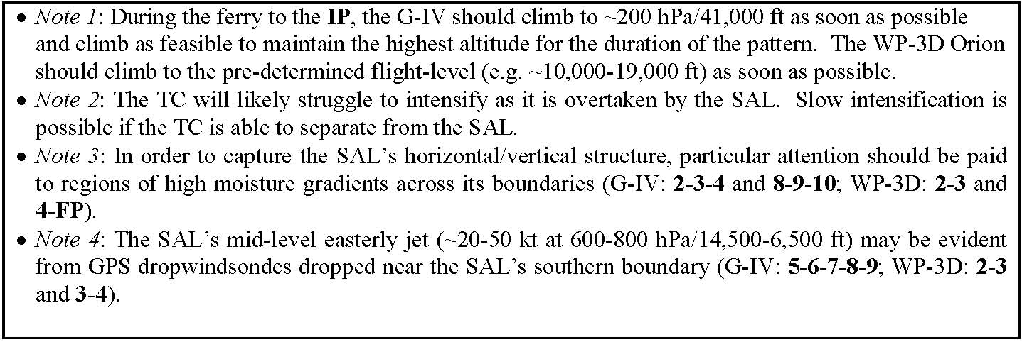

Option 4: Single TC embedded within the SAL throughout most or all of its lifecycle. These systems struggle to intensify and are often characterized by their low-level circulations racing out ahead (west) of their mid-level convection. Depending on the proximity of these features, the SAL’s dry air may be wrapping into the TC’s low-level circulation (western semicircle).

G-IV: The IP will be west of the TC and preferably west of the SAL. The first four legs (IP-2-3-4-5) will include GPS dropwindsonde transects across the western and northern boundaries of the SAL. These dropwindsonde sequences will focus on sampling the large humidity gradients across the SAL boundaries. These scenarios (TC embedded within the SAL) are typically cases where the TC is under the influence of a strong SAL easterly jet. The next several legs of the flight pattern (4-5-6-7-8) will intermittently sample the SAL environment northeast and east of the storm as well as the SAL’s mid-level easterly jet (typical located along the southern edge of the SAL). The last several legs (7-8-9-10-11-12-FP) will sample the moist tropical environment south and west of the SAL. The spokes of this pattern (IP-2/12-FP, 2-5, 6-8, and 9-11) will include sampling of the environment between ~200-400 nm from the center and will be adjusted according to the storm size. The inner-most portion of the track will be roughly defined by convective areas that are below the flight level (GOES and Meteosat IR brightness temperature values warmer than ~-55oC). The tangential legs at ~200 nm will observe the variability of possible dry air and shear that has penetrated close to the inner core (5-6, 8-9 and 11-12). These inner tangential legs should be positioned as close to the outer edge of the inner core convection as safety permits. This will help maximize tail Doppler radar coverage of the storm’s inner core convection.

WP-3D: The IP will be NW of the TC and preferably north of the SAL. The 1st leg (IP-2) will include a GPS dropwindsonde transect across the northern boundary of the SAL and will focus on sampling the large humidity gradients across the SAL. The 2nd leg (2-3) of the flight pattern will intermittently sample the moist tropical environment south of the SAL and will include a GPS dropwindsonde transect across the southern boundary of the SAL as well as the SAL’s mid-level easterly jet (typical located along the southern edge of the SAL). The 3rd (3-4) and 4th (4-5) legs will include a GPS dropwindsonde sequence that will be focused along the dry air inflow region on the west semicircle of the TC. This drop sequence will sample the intrusion of low humidity SAL air into the TC circulation and help to define how the SAL’s vertical structure and moisture content modify as it advects closer to the TC inner core. The final leg (5-FP) will sample the boundary between moist tropical air west of the TC center and the SAL to the east and will include a penetration of the TC center of circulation. Particular attention will be focused on sampling dry SAL air near the TC inner core. Given the emphasis on P-3 operationally-tasked TDR missions in 2010, it is anticipated that the TDR rotated figure 4 pattern will typically supersede the Fig. 8-4 P-3 pattern. SALEX objectives could still be met with this TDR pattern, though slightly longer legs (105-120 nm) would be desirable.

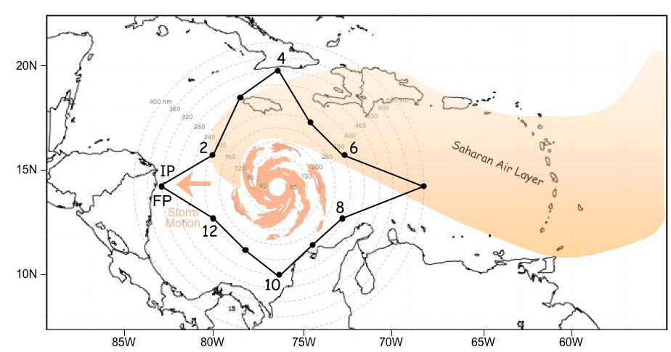

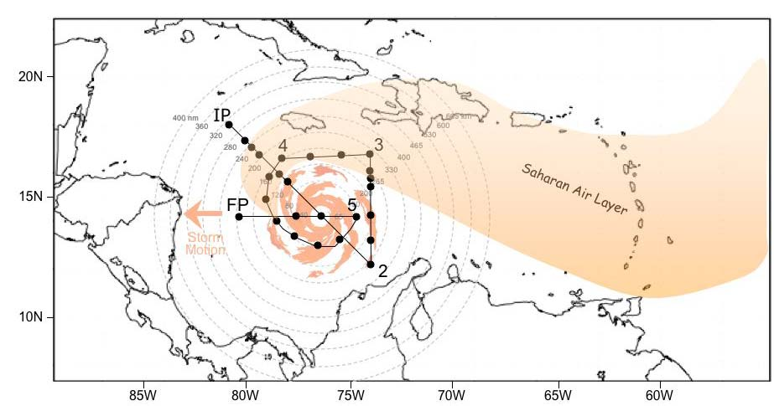

Fig. 8-4: Sample (top) G-IV and (bottom) WP-3D flight track for a TC embedded in the SAL for most or all of its lifecycle.

- Note 1: During the ferry to the IP, the G-IV should climb to ~200 hPa/41,000 ft as soon as possible and climb as feasible to maintain the highest altitude for the duration of the pattern. The WP-3D Orion should climb to the pre-determined flight-level (e.g. ~10,000-19,000 ft) as soon as possible.
- Note 2: In order to capture the SAL structure, particular attention should be paid to regions of high moisture gradients across its boundaries (G-IV: IP-2-3-4-5 and 7-8; WP-3D: IP-2, 2-3 and 5-FP).
- Note 3: The TC’s low-level circulation may race ahead of its mid-level convection due to the influence of the SAL’s mid-level easterly jet.
- Note 4: The SAL’s mid-level easterly jet (~20-50 kt at 600-800 hPa/14,500-6,500 ft) may be evident from GPS dropwindsondes dropped near the SAL’s southern boundary (G-IV: IP-2; WP-3D: 2-3).

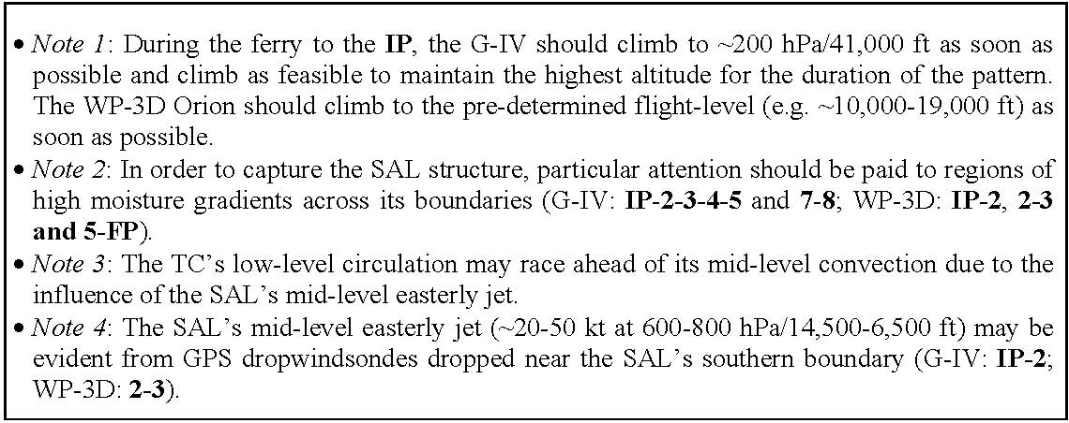

9. Tropical Cyclone Landfall and Inland Decay Experiment

Primay IFEX Goal: 3 - Improve understanding of the physical processes important in intensity change for a TC at all stages of its lifecycle

Principal Investigator(s): Peter Dodge, John Kaplan

Program Significance: The lifecycle of a TC often ends when it makes landfall and decays as it moves inland. During a hurricane threat, an average of 300 nm (550 km) of coastline is placed under a hurricane warning, which costs about $50 million in preparation per event. The size of the warned area depends on the extent of hurricane and tropical storm-force wind speeds at the surface, evacuation lead-times, and the forecast of the storm track. Research has helped reduce uncertainties in the track and landfall forecasts, and now one of the goals of IFEX is to improve the accuracy of the surface wind fields in TCs, especially near and after landfall. Improvements in diagnosing surface wind fields could decrease the uncertainty of the size of the hurricane warning area thereby reducing the cost of preparing for a landfalling hurricane.

There are still uncertainties in deriving surface wind estimates from flight-level and SFMR wind speeds collected near the coast. Changing bathymetry could change the breaking wave field, which could change both the roughness length at higher wind speeds as well as changing the microwave emissions. Evaluation of these effects may lead to adjustments to the operational surface wind speed algorithms. Data collected at the coast will also help to refine the Kaplan/DeMaria inland decay model that has been developed as part of a recently completed Joint Hurricane Testbed (JHT) project. Airborne Doppler radar data will be also be transmitted to NCEP as part of another completed JHT project to assimilate radar data into the HWRF model.

Analysis of Doppler radar, GPS dropwindsonde, SFMR, flight-level and SRA or AWRAP data collected during hurricane flights can help achieve the IFEX goals for the 2010 Hurricane Field Program. A major goal is to capture the lifecycle of a TC and while landfall is usually at the end of the lifecycle the same data collection strategies developed for mature hurricanes over the open ocean can also be applied at landfall. Subsets of the data collected can be transmitted to NHC and to EMC, for assimilation into HWRF. The Doppler and GPS dropwindsonde data can be analyzed to derive three-dimensional windfields to compare with output from the HWRF and data from the SRA can be compared to HWRF wave fields. In addition to shear and heat flux from the ocean, hurricanes at landfall experience other conditions that may affect intensity change. These include change in ocean wave action in shallow waters, change in surface roughness, drier and cooler inflow from the land, and topography. Radar, dropwindsonde, and SFMR data can help define those conditions. Decay over land is also important and data collected during and shortly after landfall should help refine both operational statistical decay models (such as the Kaplan/DeMaria model) and 3-dimensional numerical models like HWRF.

HRD developed a real-time surface wind analysis system to aid NHC in the preparation of warnings and advisories in TCs. The surface wind analyses are now used for post-storm damage assessment by emergency management officials and to validate and calibrate the Kaplan/DeMaria decay model. These wind analyses could also be used to initialize the operational storm surge model in real time.

As a TC approaches the coast, surface marine wind observations are normally only available in real time from National Data Buoy Center moored buoys, Coastal-Marine Automated Network (C-

MAN) platforms, and a few ships. Surface wind estimates must therefore be based primarily on aircraft measurements. Low-level (<5,000 ft [1.5 km] altitude) NOAA and AFRES aircraft flight-level wind speeds are adjusted to estimate surface wind speeds. These adjusted wind speeds, along with C-SCAT and SFMR wind estimates, are combined with actual surface observations to produce surface wind analyses. These surface wind analyses were initially completed after the landfall of Hurricane Hugo in South Carolina and of Andrew in South Florida in support of post-landfall damage surveys conducted by FEMA. In recent years, these analyses have been produced in real time for operational use by the NHC for many of the TCs that have affected the Western Atlantic basin, including such notable landfalling storms as Opal (1995), Fran (1996), Georges (1998), Bret and Floyd (1999), Isidore (2003) and Frances, Ivan and Jeanne (2004), and Dennis, Katrina, Rita and Wilma (2005 ).

Dual-Doppler analysis provides a complete description of the wind field in the core. Recently the analysis techniques have been streamlined so real-time wind analyses can be computed aboard the aircraft and windfields at selected levels transmitted from the aircraft to NHC and NMC. These windfields are also quite useful for post-storm analysis. An observational study of Hurricane Norbert (1984), using a PDD analysis of airborne radar data to estimate the kinematic wind field, found radial inflow at the front of the storm at low levels that switched to outflow at higher levels, indicative of the strong shear in the storm environment. Another study used PDD data collected in Hurricane Hugo near landfall to compare the vertical variation of wind speeds over water and land. The profiles showed that the strongest wind speeds are often not measured directly by reconnaissance aircraft.

Recent GPS dropwindsonde data from near and inside the flight-level radius of maximum wind speeds (RMW) in strong hurricanes have shown remarkable variations of the wind with height. A common feature is a wind speed maximum at 300-500 m altitude. Theoretical and numerical modeling of the hurricane boundary layer suggests that the low-level jets are common features. The height of the jet varies by storm quadrant, and modeling indicates that this variation can be enhanced as a hurricane crosses land.

While collection of dual-Doppler radar data by aircraft alone requires two P-3 aircraft flying in well-coordinated patterns, time series of dual-Doppler data sets have been collected by flying a single P-3 toward or away from a ground-based Doppler radar. In that pattern, the aircraft Doppler radar rays are approximately orthogonal to the ground-based Doppler radar rays, yielding true Dual-Doppler coverage. Starting in 1997 the Atlantic and Gulf coasts were covered by a network of Doppler radars (Weather Surveillance Radar 88 Doppler [WSR-88D]) deployed by the National Weather Service (NWS), Department of Defense, and Federal Aviation Administration (Fig C-5 in the Appendix). Each radar transmits the base data (Level II) in near real time to a central site. These data are subsequently archived at the National Climatic Data Center. In precipitation or severe weather mode the radars collect volume scans every 5-6 min.

If a significant TC (major hurricane) moves within 215 nm (440 km) of the coast of the Eastern or Southern United States, then (resources permitting) a P-3 will obtain Doppler radar data to be combined with data from the closest WSR-88D radars in dual-Doppler analyses. The tail radar is tilted to point 20 degrees forward and aft from the track during successive sweeps (the fore-aft scanning technique [F/AST]). These analyses could resolve phenomena with time scales <10 min, the time spanned by two WSR-88D volume scans. This time series of dual-Doppler analyses will be used to describe the storm core wind field and its evolution. The flight pattern is designed to obtain dual-Doppler analyses at intervals of 10-20 min in the core. The Doppler data will be augmented by deploying dropwindsondes near the coast, where knowledge of the boundary-layer structure is crucial for determining what happens to the wind field as a strong storm moves inland. Dropwindsondes will also be deployed in the eyewall in different quadrants of the hurricane. To augment the core analyses, dual-Doppler data can also be collected in the outer portions of the storm, beyond the range of the WSR-88D, because the alternating forward and aft scans in F/AST mode intersect at 40 degrees, sufficient for dual-Doppler synthesis of wind observations.

Objectives:

Collect NOAA P-3 Doppler, flight-level, and SFMR surface wind data both within the inner-core (radius<120 nm) and near storm (120< radius < 240) environment to help improve and validate real-time and post-storm surface wind estimates in tropical cyclones.

Document the thermodynamic and kinematic changes in storm structure during and after landfall and improve our understanding of the factors that modulate changes in tropical cyclone intensity near the time of landfall.

Hypotheses:
It is possible to improve real-time surface wind estimates for landfalling tropical cyclones by obtaining in-situ inner-core and near storm wind data collected utilizing NOAA P-3 aircraft.

The above landfall datasets, in combination with high-resolution surface wind measurements collected by land based collection teams, can be used to validate statistical and 3-D numerical model landfall surface wind forecasts.

Our understanding and ability to forecast changes in the structure and intensity of landfalling tropical cyclones can be enhanced utilizing the high-resolution kinematic and thermodynamic data sets collected during the aforementioned landfall research missions.

The miniature supercells and/or tornadic cells exhibit many basic kinematic, thermodynamic, and dynamic structures as those found in severe thunderstorms across the Great Plains. Traditional environmental parameters (such as CAPE and vertical shear) may be used to distinguish those sectors of the storm most supportive of supercell development and thus narrow the scope of any severe weather watches.

Mission Description: This is a multi-option, single-aircraft experiment designed to study the changes in TC surface wind structure near and after landfall. It has several modules that could also be incorporated into operational surveillance or reconnaissance missions. It is designed for one or two single-aircraft missions with a P-3 when a hurricane moves within 215 nm (400 km) of the U.S. coastline. The first of these 2 flights will typically consist of the real-time module followed by SFMR and/or Coastal Wind Profile modules. A second flight could complete the post-landfall module. If the storm either moves parallel to the coastline or moves slowly inland and resources permit, it may be repeated with a second flight. While the storm location relative to the coastline will dictate which combination of these modules will be flown, the real-time module will generally precede all of the others.

This experiment should only be flown in a major hurricane, In addition, specific landfall flights will only be requested if the mobile observing systems are also deployed. These additional observations are especially important to document the inland decay of a major hurricane.

The aircraft must have working lower fuselage and tail radars. The HRD workstation should be on board, so radar and GPS dropwindsonde data can be analyzed and transmitted to NHC. The SFMR should be operated, to provide estimates of wind speed at the surface. If the AWRAP or C-SCAT is on the aircraft then it should also be operated to provide another estimate of the surface wind speeds. If the SRA is working it also should collect wave and sweep heights to characterize the storm surge and breaking wave field near the coast If the scanning LIDAR is available, then it should be operated to obtain wind profiles in the cear air regions, especially in the offshore flow..
If some of the portable Doppler radars (Shared Mobile Atmospheric Research and Teaching Radar [SMART-R] and/or Doppler on Wheels [DOW]), portable profilers and portable wind towers are deployed between ~65 and 130 km inland in the onshore flow regime as depicted in Fig. 9-1, this will provide valuable data for the inland decay model. If possible, one of the DOWs should be positioned relative to the nearest WSR-88D such that the dual-Doppler lobes cover the largest area of onshore flow possible. In the schematic shown in Fig. 9-1, one of the DOWs is positioned north-west of the Melbourne WSR-88D so that one dual-Doppler lobe is over the coastal waters and the other covers the inland region. The profiler is positioned in the inland dual-Doppler lobe to provide independent observations of the boundary layer to anchor the dual-Doppler analysis.

All modules support real-time and post-storm surface wind analyses. The flight patterns will depend on the location and strength of the storm relative to surface observing platforms and coastal radars. The first two modules could be easily incorporated into a tasked operational mission. The other two modules are suited to research missions, where the patterns are not constrained by fix or gale-force wind radii requirements. Note that pattern timing could be adjusted to coordinate with the NASA WB-57 flights to collect SFMR and other data to compare with measurements from the HIRAD instrument.

Real-time module: The real-time module combines passes over marine surface platforms with one or more figure-4 patterns in the core of the hurricane (Fig. 9-1.) The aircraft flies at or below 5,000 ft (1.5 km) , so that flight-level wind speeds can be adjusted to 30 ft (10 m) to combine with measurements from marine surface platforms. Flight-level and dropwindsonde data obtained near the platforms will be used to validate the adjustment method. Note that if the storm is outside of WSR-88D Doppler range then the figure-4 pattern could be repeated before returning home.

The landfall flight pattern should take advantage of buoys or C-MAN sites nearby, if those platforms are expected to experience wind speeds > 25 ms-1. The aircraft descends at the initial point and begins a low-level figure-4 pattern, possibly modifying the legs to fly over the buoys (Fig. 9-1). The radar will be in F/AST mode. If time permits the aircraft would make one more pass through the eye and then fly the dual-Doppler option. In this example, the pattern would be completed in about 2.5 h. Dropwindsondes would be deployed near the buoys or C-MAN sites, and additional dropwindsondes will be deployed at or just inside the flight-level RMW.

Note that the optimal volume scans for this pattern will be obtained when the storm is 32-80 nm (60-150 km) from the radar, because beyond 80 nm (150 km) the lowest WSR-88D scan will be above 5,000 ft (1.5 km) which is too high to resolve the low-level wind field. Within 32 nm (60 km) the volume scan will be incomplete, because the WSR-88D does not scan above 19.5 degrees. It is

essential that these passes be flown as straight as possible, because turns to fix the eye will degrade the Doppler radar coverage.

Analysis Strategy” Flight level, Doppler r radar, dropsonde and SFMR data transmitted in real time will be ingested into the H*WIND archive, where the observations are standardized to average 1 minute data at a standard height of 10 m in an open exposure. These data, in addition to other surface observations will be combined into analyses of surface windspeed that will be provided to forecasters, The quality controlled data will also be available for assimilation into models such as HWRF.
The analyses can also be used to validate surface winds in model outputt fields, as explained in more detail in module 3.

Coastal Survey module: When the hurricane is making landfall, this module will provide information about the boundary layer in the onshore and offshore flow regimes. Figure 9-2 shows an example for a hurricane making landfall near Melbourne, Florida. On the first coastal pass the P-3 would fly parallel 10-15 km offshore to obtain SFMR surface wind speeds (1-2 in Fig. 9-2). The track should be adjusted so that the SFMR footprint is out of the surf zone. The second pass should as close to the coast as safety permits, to sample the boundary layer transitions at the coast in onshore and offshore flow (3-4 in Fig. 9-2). The first pass should be at 5,000 ft (1.5 km) or less, and the aircraft could climb to higher altitudes for the second pass. On both of these passes the aircraft should fly to 150 km or the radius of gale-force wind speeds and release dropwindsondes at the RMW and at intervals of 12.5, 25, 50, 75 and 100 or 125 km on either side of the storm track, to sample both onshore and offshore flow regimes. Finally, to better sample the adjustment of the off shore flow from land to ocean a short leg would be flown from the coast spiraling towards the storm center. Three to four dropwindsondes would be deployed quite near the coast, followed by 3-4 dropwindsondes spaced every 20-30 km along the trajectory. The Doppler radar will be in F/AST mode, to provide wind estimates on either side of the aircraft track. This module could be flown when the hurricane is making landfall or after the storm moves inland. The pattern could be flown in ~2 h.
Analysis Strategy: In addition to the data processing described in modules 1 and 3 , the Doppler radar swath data will be edited and synthesized into windfields . The winds wil be compared with dropsondes and SFMR, AWRAP and/or LIDAR data to characterize the differences between the onshore and offshore flow.

Post Landfall Module: This module is designed to collect kinematic and thermodynamic data ~1-2 h prior to and up to 6 h after a hurricane makes landfall. It is essential that ground-based measurements are obtained in conjunction with those that are being made by aircraft, since the primary goal is to determine the kinematic and thermodynamic changes that occur after a hurricane makes landfall throughout the depth of the lower troposphere.

The P-3 will fly a coastal survey pattern followed by a figure-4 pattern over land (Fig. 9-3) with ~ 150-km legs at an altitude of ~15,000 ft (5 km). The P-3 tail radar should be in F/AST mode. These data will aid in rainfall estimation and will help document the changes in vortex and rain band structure over land that are crucial to understanding the environment that supports tornado and mesovortex development.

Over land, available portable wind towers, mesonet stations, profilers and DOWs should be deployed along the path of the landfalling hurricane to identify the changes in storm structure as the

hurricane moves inland. The wind towers and mesonet stations will obtain high-resolution surface wind, temperature, pressure, relative humidity, and perhaps rainfall measurements. If available, a profiler could be placed at the center of each line of mesonet stations. The profilers and RASS sounder will provide wind and temperature measurements within the lowest 3 and 1 km, respectively. Rain gauges should be located at each profiler and DOW site to obtain high-resolution rainfall measurements, both for calibrating the radar rainfall algorithms and for documentation of storm rainfall.

The first set of towers and mesonet stations should be placed as close as possible to the coastline (<10 km) to enable accurate documentation of the surface wind field just after landfall. Other towers or mesonet stations should be placed ~65 and 135 km inland respectively; however, these distances will vary depending upon the intensity and speed of motion of the landfalling storm as well as safety considerations. The spacing between the mesonet stations located within each group should be ~30 nm (50 km) perpendicular to the track to maximize the likelihood that one of the mesonet stations will be located near the RMW of the landfalling storm.

If the inland profilers are mobile, it will be possible to follow severe weather producing rain bands if safety and logistical considerations allow. The DOWs should be placed roughly halfway between the two rear lines of mesonet and profiler stations. The DOWs, in combination with the profilers with RASS, will aid in documenting the changes in kinematic and thermodynamic structure of the hurricane after landfall. An accurate analysis of such changes is crucial to learning more about the development of mesovortices and/or tornadoes spawned by landfalling hurricanes. They will also help document the changes in wind speeds within the PBL of a landfalling hurricane. Finally, the radars will aid in the measurement of the rainfall associated with the landfalling hurricane.

Analysis Strategy: Wind measurements for all landfalling cases for which simultaneous measurements were obtained by both NOAA-P3 aircraft and land-based collection teams will be converted to a uniform averaging time (1-min.), height (10-m), and exposure (Z0=0.01 or 0.03 m) using the methodology of Powell et al. (2009). The Kaplan/DeMaria empirical decay model will then be run for each of these cases and the surface wind forecasts from this model will be compared to the standardized surface winds at the appropriate observation location and time. Similar comparisons will also be made using the 3-D (e.g. HWRF or HWRF-X) numerical model surface wind forecasts. However, before such comparisons are made, the 3-D numerical model predicted winds will first need to be converted to open exposure or alternatively the observed surface winds will need to be standardized using the same exposure that was used in the 3-D model prediction at each surface observation location to enable a fair comparison to be made between the model predicted and observed wind.

Offshore Intense Convection Module: This module focuses on the collection of dual-Doppler radar and vertical profiles of the lower atmosphere near intense convective cells (> 35 dBZ on the LF radar) located in an offshore outer rain band (>150 km from the storm center) but embedded within the onshore flow. This module can be easily incorporated during either the real-time module, the coastal survey module, or the onshore wind profile module when a qualified outer rain band is encountered. Figure 9-4 shows an example flight pattern along the Carolina coast. In order to provide adequate estimates of low-level vertical shear and instability, the aircraft should fly this module at an altitude of 3000 m or higher. The Doppler radar should operate in F/AST mode to provide wind estimates on each side of the aircraft track. A minimum of 10 GPS sondes should be deployed. The first flight leg should cross the target band ~20-25 km downwind of the intense convective cells and proceed until the aircraft is 25 km outside the rain band axis, deploying a GPS sonde at the band axis and end point. The aircraft then turns upwind and proceeds along a straight track parallel to the rain band axis, deploying GPS sondes every 20-25 km. This length of this leg can adjusted as needed, but should be a minimum of 75 km. When the aircraft is ~20-25 km upwind of the target cells, the aircraft turns and proceeds along a track orthogonal to the band axis until the aircraft is 25 km inside the rain band. GPS sondes should be deployed at the initial and endpoints of this leg as well as at the band axis. Finally, the aircraft turns downwind and proceeds along a straight path parallel to the rain band axis, deploying GPS sondes every 20-25 km. The end point of this final leg should be ~20-25 km downwind of the initial target cell to ensure adequate dual-Doppler radar coverage of all cells. From here other modules can be resumed. The total time to complete this module should not exceed 60 min, and in most case can be completed in less time.

Significance: As tropical cyclones move inland and weaken, tornadoes also become a significant threat to society and one of the most difficult forecast problems. Since 2004, over 650 tornadoes have been spawned by 26 tropical cyclones impacting the U.S. coastline, resulting in 24 deaths, over 300 injuries, and more than $400 million in damage. Many of these tornadoes are spawned by miniature supercells. Much of the forecast challenge is due to significant differences in structure, organization, and environment from the classic midlatitude supercell: the miniature supercells are shallower, weaker, shorter-lived, and less buoyant, but occur in a very moist, high-wind, high-rotation environment with more vertical wind shear. Furthermore, individual miniature supercells often occur in close proximity to one another along organized outer rain bands, whereas their midlatitude counterparts often occur in relative isolation. As a result, midlatitude conceptual models have shown very limited success when applied to tornado forecasting in tropical cyclones. Numerous studies have documented the onshore environmental conditions and evolution of miniature supercells associated with TC-tornado outbreaks, but little is known about the offshore environment and cell evolution just prior to tornado outbreaks. The goal of the Offshore Intense Convection module is to document the structure, evolution, and low-level environment of the stronger convective cells (>35 dBZ) located offshore in an outer rain band (>150 km from the TC center) that will soon move onshore and potentially spawn tornadoes. This goal is consistent with the three primary goals of the Intensity Forecasting Experiment (IFEX).

Note: This module’s flight pattern can be reversed depending either on the location of the intense cells relative to the aircraft’s initial approach vector or the need for flight safety. This module could also be easily incorporate into any tasked operational or research missions in which an outer rain band (>150 km from the storm center) with embedded intense convective cells (>35 dBZ on the LF radar) is encountered during ferry to or from the storm core. In other words, this module is not strictly limited to the Landfall and Inland Decay Experiment.

Analysis Strategy: The P-3 Doppler radar data will be carefully edited and then synthesized into a three-dimensional wind field. Dropsonde and flight-level data will be analyzed and combined with an available rawinsonde and surface (e.g. buoys, CMAN, etc.) observations to establish the thermodynamic environment of the targeted cells. Any available land-based radar will be used to augment the cell evolution documented by the airborne radars. The cell’s environments and structures will be compared with those of mid-latitude supercells.

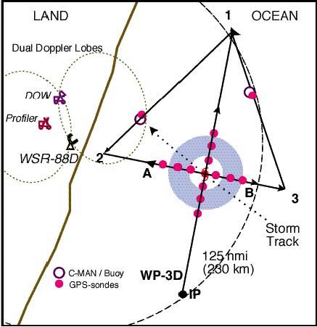

Figure 9-1: Real-time module.
- TAS calibration required. The legs through the eye may be flown along any compass heading along a radial from the ground-based radar. The IP is approximately 100 nm (185 km) from the storm center. Downwind legs may be adjusted to pass over buoys.
- P-3 should fly legs along the WSR-88D radials.
- Set airborne Doppler radar to F/AST on all legs. Aircraft should avoid penetration of intense reflectivity regions (particularly those over land).
- Wind center penetrations are optional.

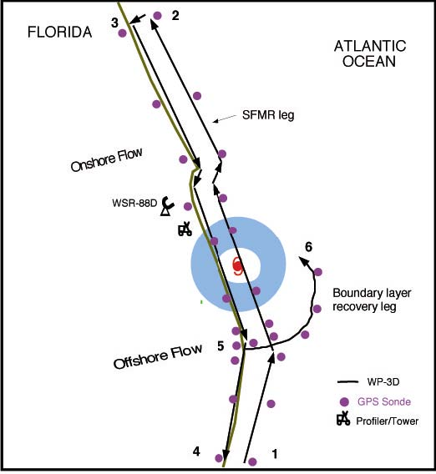

Figure 9-2: Coastal Survey pattern.

- First pass starts 150 km from center or at radius of gale-force wind speeds, whichever is closer. Pass from 1-2 should be 10-15 km offshore for optimum SFMR measurements. Release dropwindsondes at RMW, and 12.5, 25, 50, 75 and 100 or 125 km from RMW on either side of storm in legs 1-2 and 3-4. dropwindsondes should be deployed quickly at start of leg 5-6, and then every 10-15 km hereafter.
- Set airborne Doppler to scan in F/AST on all legs, with single PRF > 2400 and 20% tilt. Aircraft should avoid penetration of intense reflectivity regions (particularly those over land).

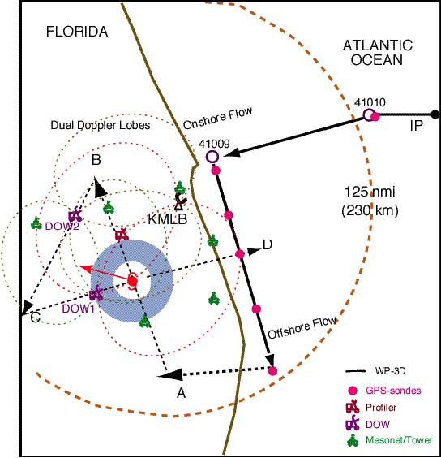

Figure 9-3: Post landfall module flight pattern.
- Coastal survey pattern (solid line) at ~10,000-15,000 ft (3-4 km) with dropwindsondes near buoys of opportunity and within 10-20 km of the shore in both the onshore and offshore flow
- Inland figure-4 pattern (dashed line) centered on the storm with leg lengths of ~80 nm (150 km) at an altitude of ~15,000 ft (5 km).
- P-3 should fly legs along the WSR-88D radials.
- Set airborne Doppler radar to F/AST on all legs.
- Aircraft should avoid penetration of intense reflectivity regions (particularly those over land).
- Wind center penetrations are optional.

Figure 9-4: Offshore Intense Convection pattern.

The IP should be a minimum of 150 km from the storm center. The first leg (IP-2) starts 25 km inside the rain band axis. Legs IP-2 and 3-4 should be ~20-25 km downwind and upwind of the target cells to ensure adequate Doppler coverage. Legs 2-3 and 4-IP should be 25 km inside and outside the rain band axis. The length of legs 2-3 and 4-IP can be adjusted but should be 75 km at minimum. Deploy dropwindsondes at the start or end points of each leg, at the band axis crossing points, and at ~20-25 km intervals along each leg parallel to the band. Aircraft altitude should be at 10,000 ft (3000 m) or higher. Set airborne Doppler to scan in F/AST mode on all legs. Aircraft should avoid penetration of intense reflectivity regions (particularly over land).

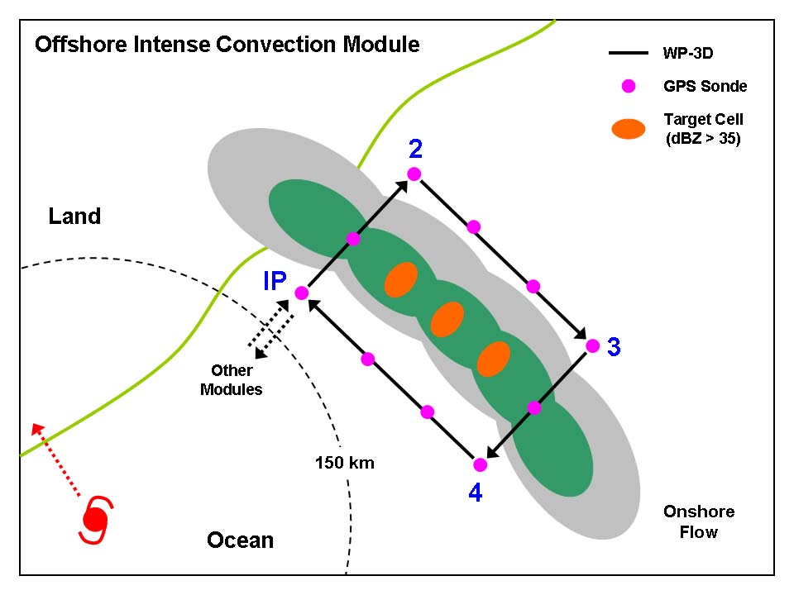

10. Tropical Cyclone/AEW Arc Cloud Module

Primay IFEX Goal: 3 - Improve understanding of the physical processes important in intensity change for a TC at all stages of its lifecycle

Principal Investigator(s): Jason Dunion
Program Significance: Arc clouds are common features in mid-latitude thunderstorms and mesoscale convective systems. They often denote the presence of a density current that forms when dry mid-level (~600-800 hPa) air has interacted with precipitation. The convectively-driven downdrafts that result reach the surface/near-surface and spread out from the convective core of the thunderstorm. Substantial arc clouds (i.e., >100 km in length and lasting for several hours) are also common features in the tropics (Figure 10-1), particularly on the periphery of African easterly waves (AEWs) and tropical cyclones (TCs). However, the physical processes responsible for such tropical arc clouds as well as their impacts on the short-term evolution of their parent disturbances are not well understood.

The mid-level moisture found in the moist tropical North Atlantic sounding described by Dunion (2009) is hypothesized to be insufficiently dry to generate extensive near-surface density currents around an African easterly wave (AEW) or tropical cyclone (TC). However, Dunion (2009) also described two additional air masses that are frequently found in the tropical North Atlantic and Caribbean during the summer months and could effectively initiate the formation of large arc clouds: (1) the Saharan Air Layer (SAL) and (2) mid-latitude dry air intrusions. Both of these air masses were found to contain substantially dry air (~50% less moisture than the moist tropical sounding) in the mid-levels that could support convectively-driven downdrafts and large density currents. Furthermore, outward-propagating arc clouds on the periphery of AEWs or TCs could be enhanced by near-surface super-gradient winds induced by the downward transport of high momentum air. Since most developing tropical disturbances in the North Atlantic are associated with a mid-level jet and/or mesoscale convective vortex near a state of gradient balance, any convectively-driven downdrafts would inject high momentum air into a near-surface environment that often contains a weaker horizontal pressure gradient. In such cases, density currents may be temporarily enhanced during local adjustments to gradient balance. Finally, tropical arc clouds may be further enhanced by outward-propagating gravity waves at mid levels that originate from the convective core of the tropical disturbance.

It is hypothesized that the processes leading to the formation of arc cloud events can significantly impact an AEW or TC (particularly smaller, less developed systems). Specifically, the cool, dry air associated with the convectively-driven downdrafts that form arc clouds can help stabilize the middle to lower troposphere and may even act to stabilize the boundary layer, thereby limiting subsequent convection. The arc clouds themselves may also act to disrupt the storm. As they race away from the convective core region, they create low-level outflow in the quadrant/semicircle of the AEW or TC in which they form. This outflow pattern counters the typical low-level inflow that is vital for TC formation and maintenance.

As arc clouds propagate away from the tropical disturbance, they visibly emerge from underneath the central dense overcast that can obscure them from visible an infrared satellite view. Therefore, when arc clouds are identified using satellites, they are often in the middle to later stages of their lifecycles. Hence, the mechanism of enhanced low-level outflow is likely occurring at the time of

satellite identification, while the mechanism of cooling/drying of the boundary layer has already occurred (though the effects may still be observable in the aircraft, GPS dropsonde and satellite data). This necessitates that the arc clouds be identified and sampled as early in their lifecycle as possible using available aircraft observations (e.g. flight-level, GPS dropsonde and Doppler radar data) and satellites (e.g. visible, infrared and microwave imagery).

Objectives: The main objectives of the TC/AEW Arc Cloud Module are to:
- Collect observations across arc cloud features on the periphery of AEWs or TCs using aircraft flight-level data and GPS dropsondes to improve our understanding of the physical processes responsible for their formation and evolution, as well as how these features may limit short-term intensification;

Links to IFEX: This experiment supports the following NOAA IFEX goals:
- Goal 1: Collect observations that span the TC lifecycle in a variety of environments;
- Goal 3: Improve our understanding of the physical processes important in intensity change for a TC at all stages of its lifecycle;

Mission Description: This multi-option research module is designed to utilize the WP-3D [flight-level (flying at multiple levels above 1500 feet) and GPS dropsonde data] or G-IV (GPS dropsonde data) aircraft. Although this module is not a standalone experiment, it could be included as a module within any of the following HRD research missions: Saharan Air Layer Experiment, TC Genesis Experiment, or TC Landfall and Inland Decay Experiment or as part of operational G-IV Synoptic Surveillance and NHC-EMC-HRD Tail Doppler Radar (TDR) missions. Total precipitable water (TPW) satellite imagery will be used to identify mid-level dry air (≤45 mm TPW) in the periphery of the AEW or TC. These areas of mid-level dry air will be favorable locations for arc cloud formation. Also, the 200-850 hPa shear vector may be an additional indicator of where and when arc clouds might form. When TPW imagery indicates the presence of mid-level dry air and the shear vector is indicating a shear direction toward the storm center (in that same quadrant or semicircle), arc cloud formation may be especially favorable. These targeted areas will be regions of preferred arc cloud formation and should be monitored closely using satellite imagery (preferably 1 km visible and 37 GHz microwave) during the mission. Depending on connection rates on the aircraft, supplemental communications via X-Chat with scientists on the ground would be desirable, especially given the unpredictability and rapid evolution of arc cloud features.

Option #1: G-IV aircraft
. Once an arc cloud feature has been identified, a GPS dropsonde sequence (preferably running perpendicular to the arc cloud) should be made between the convective area where the arc cloud originated to at least 20 nm beyond the leading edge of the arc cloud. Special attention should be paid to the transition zone across the leading edge of the arc cloud and to the environment adjacent to the convective core area where the arc cloud originated (behind the arc cloud). GPS dropsonde spacing should be ~20 nm and the transect can be made inbound (sampling in front of, across, and then behind the arc cloud) or outbound (sampling behind, across, and then ahead of the arc cloud) relative to the convective core region of the AEW/TC. In addition to the more common arc cloud that propagates away from the AEW/TC, a second arc cloud has occasionally been observed propagating in toward the AEW/TC. This second arc cloud appears to spawn from the same convective region as the outbound arc cloud and simply moves toward the AEW/TC instead of away from it. If a second inward propagating arc cloud is identified, the GPS dropsonde sequence should be extended to span the environments ahead of (relative to arc cloud

motion) both arc clouds. Figures 10-2 and 10-3 provide example G-IV flight patterns across arc cloud candidates. This option can be easily incorporated into pre-existing flight patterns with minimal additional time requirements.

Option #2: WP-3D aircraft: After an arc cloud feature has been identified, a multi-level flight pattern running perpendicular to the arc cloud should be initiated. The Doppler radar should operate in F/AST mode to permit sampling of the three-dimensional winds throughout any precipitating arc clouds. The initial pass should extend between the convection where the arc cloud originated to at least 20 km beyond the leading edge of the arc cloud. Flight altitude should be >3000 m to permit the deployment of multiple GPS dropsondes. Special attention should be paid to the transition zone across the leading edge of the arc cloud and to the environment adjacent to the convection where the arc cloud originated (behind the arc cloud). GPS dropsonde spacing should be ~20 km [reduced to ~10 km spacing closer (≤20 km) to the arc cloud] and the transect can be made inbound (sampling in front of, across, and then behind the arc cloud) or outbound (sampling behind, across, and then ahead of the arc cloud) relative to the convective core region of the AEW/TC. For the second pass, the aircraft should turn and descend to ~1000 m before proceeding back along the same transect extending from the originating convection to at least 20 km beyond the leading edge of the arc cloud. For the final pass, the aircraft should again turn and descend to ~500 m before again proceeding along a similar transect across the arc cloud. Flight altitudes for the second and final passes can be adjusted as needed for aircraft safety, but should sample as low as possible in order to capture any near-surface density current with the flight-level sensors. No dropsondes should be deployed on the second and final low-level passes. After the final low-level pass, the primary flight pattern can be resumed. The total time to complete this option should not exceed 60 min, and in most cases can be completed in less time. Figures 10-2, 10-3, and 10-4 show sample flight patterns for this multi-level option.

Note: If other experiment goals, time constraints, and/or aircraft safety would prevent the low-level passes, this option could be altered to include only the initial pass with the dropsonde deployment sequence at altitudes >3000 m.

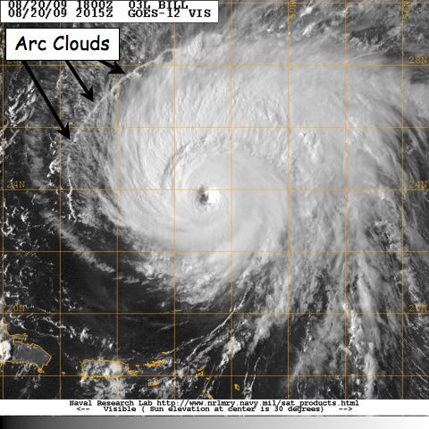
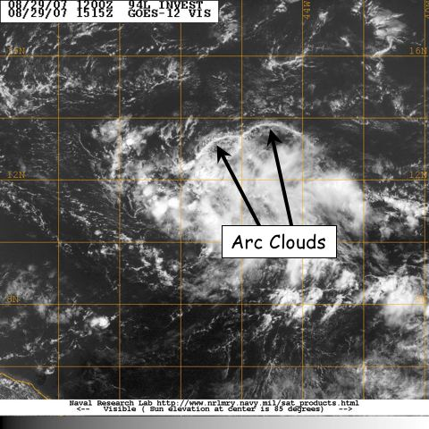

Figure 10-1:
GOES visible satellite imagery showing arc clouds racing away from the

convective cores of (left) 2009 Hurricane Bill and (right) 2007 Pre-Tropical Depression Felix.

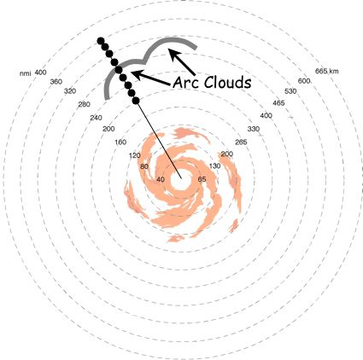

Figure 10-2: The G-IV (or WP-3D) flight track inbound or outbound to/from the TC/AEW. Azimuth and length of GPS dropsonde sequences during G-IV missions will be dictated by the pre-determined flight plan. For these cases, any G-IV flight legs that transect through the trailing and leading edges of the arc cloud are candidates for this module. When multiple arc clouds are present, the feature closest to the pre-determined flight track is desirable.

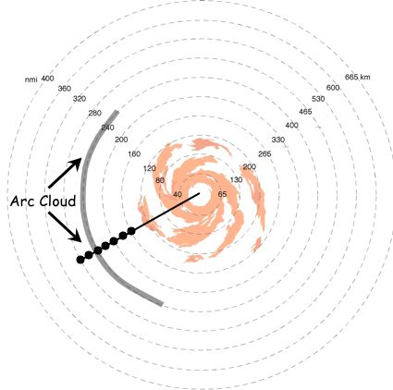

Figure 10-3: The G-IV (or WP-3D) flight track inbound or outbound to/from the TC/AEW. Azimuth and length of GPS dropsonde sequences during G-IV missions will be dictated by the pre-determined flight plan. For these cases, any G-IV flight legs that transect through the trailing and leading edges of the arc cloud are candidates for this module.

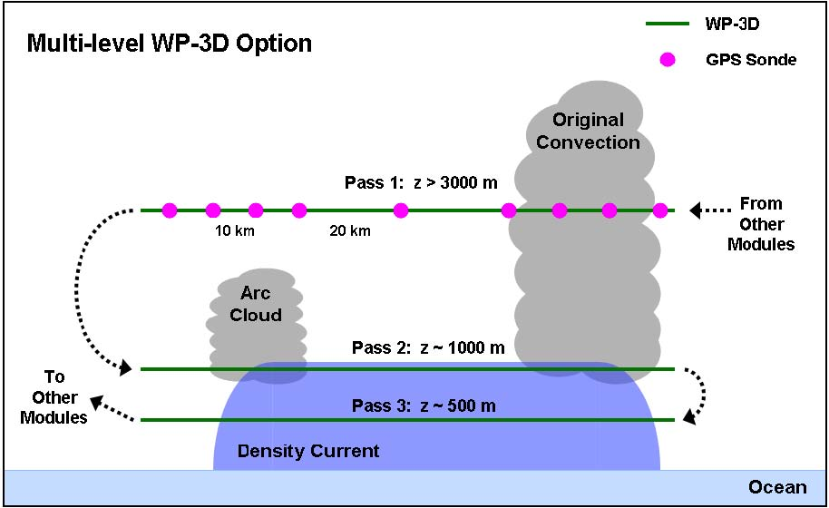

Figure 10-4: The WP-3D flight track for the multi-level option. Azimuth and length of initial midlevel pass with GPS dropsonde sequence will be dictated by the pre-determined flight plan. Lengths of the low-level passes should span much of the distance between the arc cloud and its initiating convection, while flight altitudes should be near the top and middle of any near-surface density currents (adjusting for safe aircraft operation as needed).

11. Hurricane Boundary Layer Entrainment Flux Module

Primay IFEX Goal: 3 - Improve understanding of the physical processes important in intensity change for a TC at all stages of its lifecycle

Principal Investigator(s): Jun Zhang and Gary Barnes (U. Hawaii)

Motivation and Background: Tropical cyclones interact with the ocean through the boundary layer, obtaining heat and moisture as the enriched fuel, and transferring momentum to the ocean in the form of currents and waves. An improved knowledge of mechanisms underlying air-sea exchange across the boundary layer is essential for interpreting physical, dynamical and thermodynamical processes, and hence for the development of models with realistic prognostic capabilities forecasting or simulating tropical cyclones. Unless model parameterizations of surface fluxes, vertical mixing and entrainment processes are complete and well founded, the models will have limited predictive capability under hurricane intensity change.

The equivalent potential temperature (θe) of the eyewall column has been directly related to the minimum sea-level pressure or intensity that a tropical cyclone achieves (Riehl and Malkus 1960, Emanuel 1986, Betts and Simpson 1987). The source of the air for the eyewall updraft is primarily the inflow layer that has its lower boundary at the sea surface. It is well established that the increase of θe is chiefly due to the flux of sensible and especially latent heat at the air-sea interface. However, the flux at the sea surface is but one part of the energy budget that determines the θe of the inflow, and ultimately the eyewall column. The fluxes through the top of the inflow layer, a result of convective scale motions or entrainment, can remove as much energy as was gained through the sea surface. In the right environmental conditions convective-scale downdrafts, merging at the surface to form a cooler, drier outflow in the subcloud layer, can reduce θe of the inflow layer and have a negative impact on TC intensity (Powell 1990b).

In contradistinction to this scenario there is evidence for situations, especially in the annulus adjacent to the eyewall, where the θe in the layer above the inflow can be warmer than that found in the inflow (Barnes 2008). This annulus is where surface wind speeds are increasing rapidly and where the stratiform rain and weakly subsiding air found in this region (Houze and Marks 1984) may serve to inhibit energy loss through the deeper troposphere by suppression of convective clouds. Radial-height cross-sections of θe from observations (e.g., Hawkins and Imbembo 1976, Jorgensen 1984, Wroe and Barnes 2003) and from numerical simulations (e.g., Rotunno and Emanuel 1987) reveal that θe increases substantially in this annulus adjacent to the eyewall. Entrainment of this warmer θe can result in an additional energy source to the inflow (Barnes and Powell 1995, Wroe and Barnes 2003). The overarching point is that the vertical profile of the total enthalpy flux divergence is what is required for the determination of the θe budget for the inflow, and the θe of the eyewall column.

Losses or gains through the top of the inflow have been argued to be an important but poorly measured component of the energy budget (Barnes and Powell 1995, Wroe and Barnes 2003). Recent flux measurements demonstrate that there is a downward sensible heat flux contributing to the energy content of the inflow (Zhang et al. 2008, 2009). Accurate determination of the fluxes at the top of the inflow layer, coupled with the change in the energy content within the inflow layer estimated with the GPS sondes, would allow us to determine the surface fluxes as a residual of the energy budget. The experiment is designed to estimate these fluxes directly by utilizing the GPS

sonde observations at 10 m, and the AXBT data. To date the challenging conditions found within a TC has prevented the community from accurately determining the surface fluxes so vital to hurricane thermodynamics. Accurate determination of the changes in the energy content of the inflow and of the losses or gains at the top of the inflow allows us to circumvent the problem of measuring the surface fluxes directly.

Objectives:
- Estimate the energy content of the inflow to the eyewall;
- Determine the sensible and latent fluxes through the top of the hurricane boundary layer;
- Determine the air-sea fluxes both as a residual to an energy budget and via the bulk aerodynamic formulae;
- Investigate the effect of turbulent transport processes near the top of the inflow layer on the hurricane intensity change.

Links to IFEX: This module supports the following NOAA IFEX goals:
- Goal 1: Collect observations that span the TC lifecycle in a variety of environments;
- Goal 3: Improve understanding of the physical processes important in intensity change for a TC at all stages of its lifecycle;

Module overview: This is a multi-option, single-aircraft module which is designed to directly measure momentum and enthalpy fluxes near the top of the inflow layer, as well as the energy of the inflow layer. This module can be included or linked with any of the following missions: Genesis experiment, or NHC-EMC-HRD Three-dimensional Doppler Winds Experiment missions, or Arc cloud experiment, or TC Landfall and Inland Decay Experiment, or Aerosonde Experiment. A combination of data sources from GPS sondes, AXBTs, high frequency turbulence sensors and Doppler radar on NOAA-43RF are applied to determine the quantities listed in the above objectives. Turbulence sensors need to be calibrated at the start of the field season as described in the turbulence calibration module. The stepped-descent module and the box module are also described below.

Turbulence Calibration Module (2-3 hours)
The calibration module only needs be executed on separate flights at beginning of the field season. The following maneuvers are requested for turbulence sensors calibration:
1). Dynamic Yaw--2 sets:
First set, vary sideslip angle (beta) by +/- 4 degrees. This maneuver requires 5 full sinusoids, with one consisting of left 4 degrees, back through center, right 4 degrees, back to center--one sinusoid. Second set, set angle variation, and perform faster roughly +/- 2.5 degree variation with 25 sec period.

2). Acceleration/Decceleration (AC/DC) run--1 set: Start at normal flight speed, slow to minimum sustainable flight speed, increase to maximum flight speed, slow minimum flight speed, return to normal speed. Try to maintain constant altitude (vary angle of attack).

3). Wind Circles: Two 360� standard rate turns: first clockwise, then counter-clockwise. We need 360� of data to be in a coordinated turn, so after the pilot enters the turn and it is coordinated, only then 'start the clock'.

4). Wind box: Straight and level box, 2 min on each side, standard rate 90

� turn on the corners. The box consists of 4 two-minute legs, with 90 degree standard rate turns after the completion of each leg. The box should be set up to fly one leg into, the next cross, the third out of, and the fourth cross wind direction. Indicated airspeed should be 210-220 kts.

5). Pitch (angle of attack) maneuvers--2 sets of 5: Five sinusoids with angle attack variations of +/-5 to 7 degrees. One complete sinusoid should have a period of 15 to 20 seconds. Upon completion of one set, fly straight and level roughly 2 minutes and begin second set.

All of these maneuvers should be aligned with the wind. The boxes should have legs parallel and perpendicular to the wind. The calibrations should be completed at the mean radar altitude where the measurements were conducted or roughly 1,000 ft (300 m). The maneuvers should be conducted in smooth air (as smooth as possible).

Stepped-descent module (40 minutes):
The module is flown between the eyewall and an outer rainband by NOAA-43, which is equipped with the turbulence sensors. It does not require any penetration of convective cells, the eyewall or convective rainbands. Preference is for a region that is either rain-free or stratiform rain only. For the simplest experiment 5 legs would be flown, each about 40 km or 5 minutes in duration (Fig. 11-1 and 11-2). The pattern would begin with a pass at 3 to 4 km altitude rapidly jettisoning 4 GPS sondes spaced approximately 10 km apart. During this pass 2-3 AXBT’s would also be deployed to determine the SST. Airborne radiometers (SFMR) would also provide an estimate of surface wind speeds, and if there are enough scatterers in the volume the Doppler radar can be used to determine mesoscale wind and divergence. The first leg (at ~ 3 km altitude) can be done in conjunction with the standard figure-4 patterns.

The GPS sondes are used to estimate the boundary layer height to the eyewall and the mean conditions of the boundary layer and the lower portion of the layer above. Because it is difficult to determine the height of the inflow layer at real time, the height of the maximum wind speed is defined to be top of the boundary layer, which is around 500 – 1000 m. The inflow layer top is expected to be 1-2 km in height.

We can use the dropsonde data at the end of outbound radar leg to diagnose the boundary layer height. Then we turn back into the storm to do the stair-step. The aircraft would descend to 600 m above the inflow top (about 2400 m) and fly toward the eyewall along an approximate radial. This leg will cover 40 km or require about 5 minutes. The aircraft will then turn and descend ~500 m and fly out-bound for 5 minutes. Two more legs will be completed, each another 500 m below the previous pass. The last pass will be 700 to 800 m above the sea. If the aircrew deems it safe a final pass could be flown 400 to 500 m above the sea. All legs will finish with a turn upwind to keep the legs nearly vertically aligned and in the same portion of the TC. Time to complete the module is about 40 min including descents and turns.

These five passes and the GPS sondes will allow for a determination of the sensible and latent heat fluxes (total enthalpy flux) as a function of height and radial distance adjacent to the eyewall or a convective rainband from the top of the inflow layer to 500 m altitude. The combination of the vertical profiles of equivalent potential temperature (
θ
e
) and the determination of the fluxes at the top of the inflow layer will allow an estimate of the air-sea fluxes as a residual and directly through the application of the bulk aerodynamic formulae applying AXBT, SFMR, and 10 m observations

obtained from the GPS sondes. The scheme will allow us to infer the magnitude of the transfer coefficients necessary to achieve energy balance, provide insight to the role of dissipative heating, and determine the role of entrainment of warmer

θ
e
through the top of the inflow layer.

Box Module (20-25 minutes):
If we wish to estimate divergence and there are too few scatterers to obtain this estimate from the Doppler radar we would like to execute a box pattern (Fig. 11-3) near the top of the inflow layer (1 – 2 km); this may add about 20-25 minutes to the module. This additional stage is beneficial, but not essential to estimate the fluxes or to complete the energy budget. It allows us to avoid constraining assumptions about the flow (we would have to assume no divergence due to the tangential wind component).

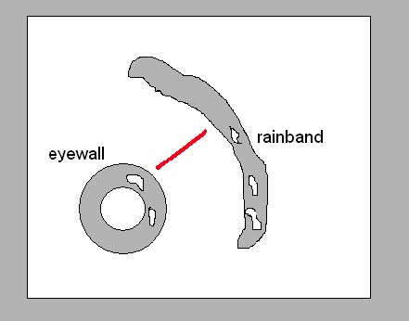 Fig. 11-1. Plan view of the preferred location for the stepped-descent module. Red line shows aircraft track. 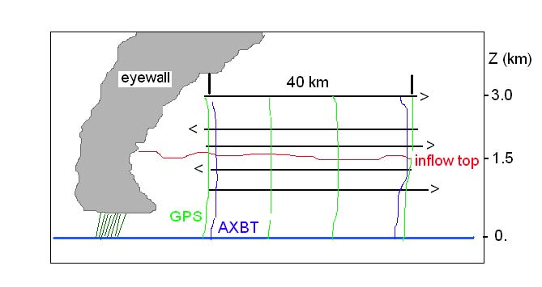 Fig. 11-2. Vertical cross-section of the stepped-descent module. 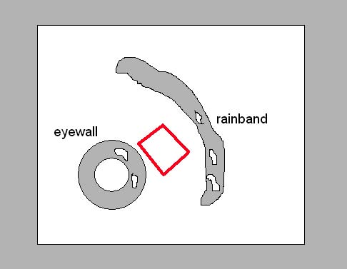 Fig. 11-3. Box module used to calculate divergence if no scatterers exist in the volume.

12. Aerosol/Cloud Droplet Measurement Module

Primay IFEX Goal: 3 - Improve understanding of the physical processes important in intensity change for a TC at all stages of its lifecycle

Principal Investigator(s): Robert Black

The sub-cloud aerosol determines the cloud base droplet concentration, which in turn controls the rate of precipitation formation. Recent work (Rosenfield et al, 2007) has shown that pollution aerosol might have a significant suppression effect on the hurricane intensity through the introduction of large quantities of aerosols in the form of cloud condensation nuclei (CCN). The mechanism Rosenfield et al propose for weakening a hurricane works by suppressing the warm rain process in the outer rain bands and eyewall.

In order to properly assess the likelihood of this scenario, it is necessary to determine the natural range and number concentrations of the sub-cloud aerosol in hurricanes that are far from land, unaffected by pollutants. These pristine oceanic aerosols are thought to be primarily sea-salt aerosol created by spray and ammonia salts with organic origins. The measurement of the sub-cloud and low-level cloud base aerosol and droplet spectra in the hurricane has not been heretofore possible. However, since the purchase of new droplet spectra probes, as well as a new cloud liquid water meter in 2009, this has finally become possible. In addition, it will be possible to obtain a new Droplet Measurement Technologies (DMT) dual-chamber CCN counter and a new fast-response hygrometer in time for hurricane season. These devices offer the ability to measure the concentration of the cloud - active parts of the aerosol. This information, along with accurate, fast-response hygrometer data will enable us to determine the fraction of the aerosol that is CCN.

While these new devices cannot determine the aerosol composition, they can determine the number concentration and activity spectra of these aerosols, and the new cloud droplet probe can measure the activated cloud base droplet spectra. This latter measurement is crucial to determining if the mechanism proposed by Rosenfield et al has any chance of operating. In order to do this, it will be necessary to fly the properly equipped WP-3D aircraft in the sub-cloud zone in several areas in various wind conditions, from benign trade wind to weak tropical storm strength through hurricane strength.

In the non-storm environment, it would be sufficient to fly in the sub-cloud layer at 1200' or a bit lower for 5 minutes, climbing 500', flying for another 5 minutes, then flying just above the trade-wind cumulus cloud base, to penetrate (non-precipitating) trade-wind Cu to obtain the low cloud droplet concentrations. In the Saharan Air layer (SAL) area, passes should also take place in the dry layer to determine the cloud-active proportion of the SAL aerosol. In a hurricane, such passes (Fig. 12-1) should take place in non-precipitating cloud both inside and outside the rain bands. The final pass through the low cloud base should take place in the nearest rain band. Outside the eyewall, passes like these should end with a pass just above the nearest cloud base altitude. Should there be a will, a radial penetration of the eyewall at 1.5 km radar altitude would be desired to obtain the low cloud number concentrations and water contents.

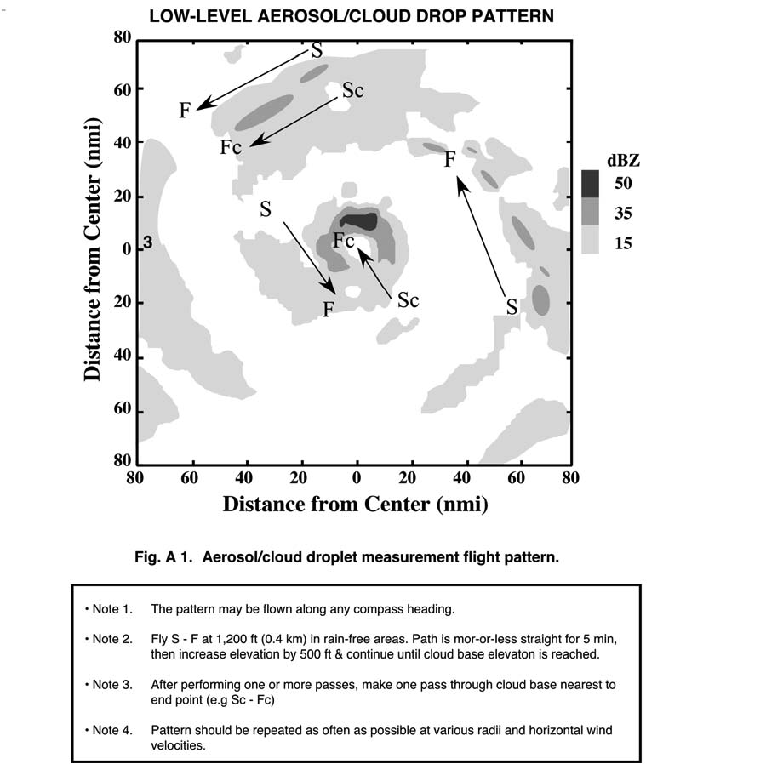

Supplemental: Operational Base Maps

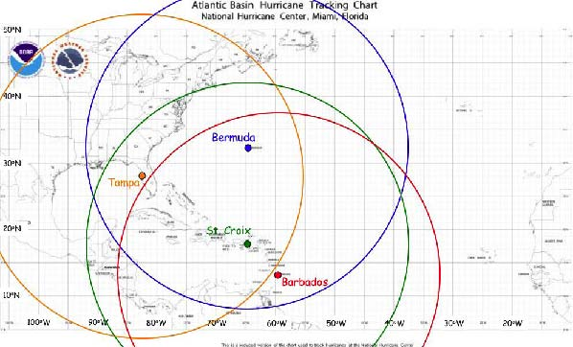

Map 1: Primary Atlantic operating bases and approximate operating ranges for the NOAA G-IV.

Supplemental: Operational Base Maps (continued)

Map 2: Primary Atlantic operating bases and approximate operating ranges for the NOAA P-3.
