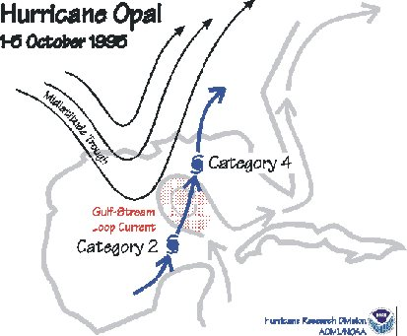
Figure 28. Hurricane Opal intensified rapidly under the influence of a “digging” mid-latitude trough as it careened northward across a warm eddy spun off from the Gulf Stream toward the U.S. coast.

