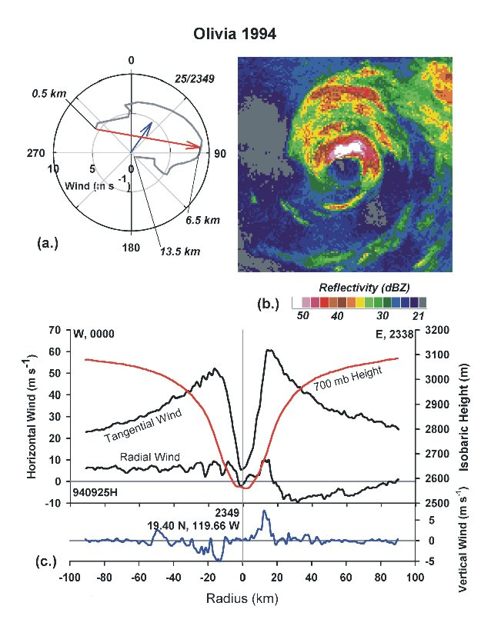
Figure 29. Eastern-Pacific Hurricane Olivia in westerly shear: (a) “environmental” hodograph; (b) radar reflectivity; and (c) flight-level wind and 700 mb height.

