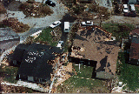
Figure 26. Widespread tornado damage in southern Miami-Dade County in the wake of Hurricane Andrew (1992).

