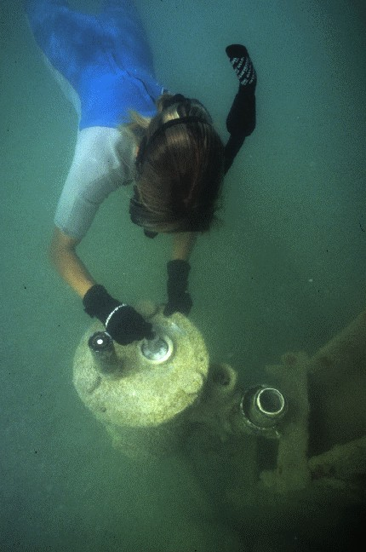
Figure 25. Underwater diver on sensors.

