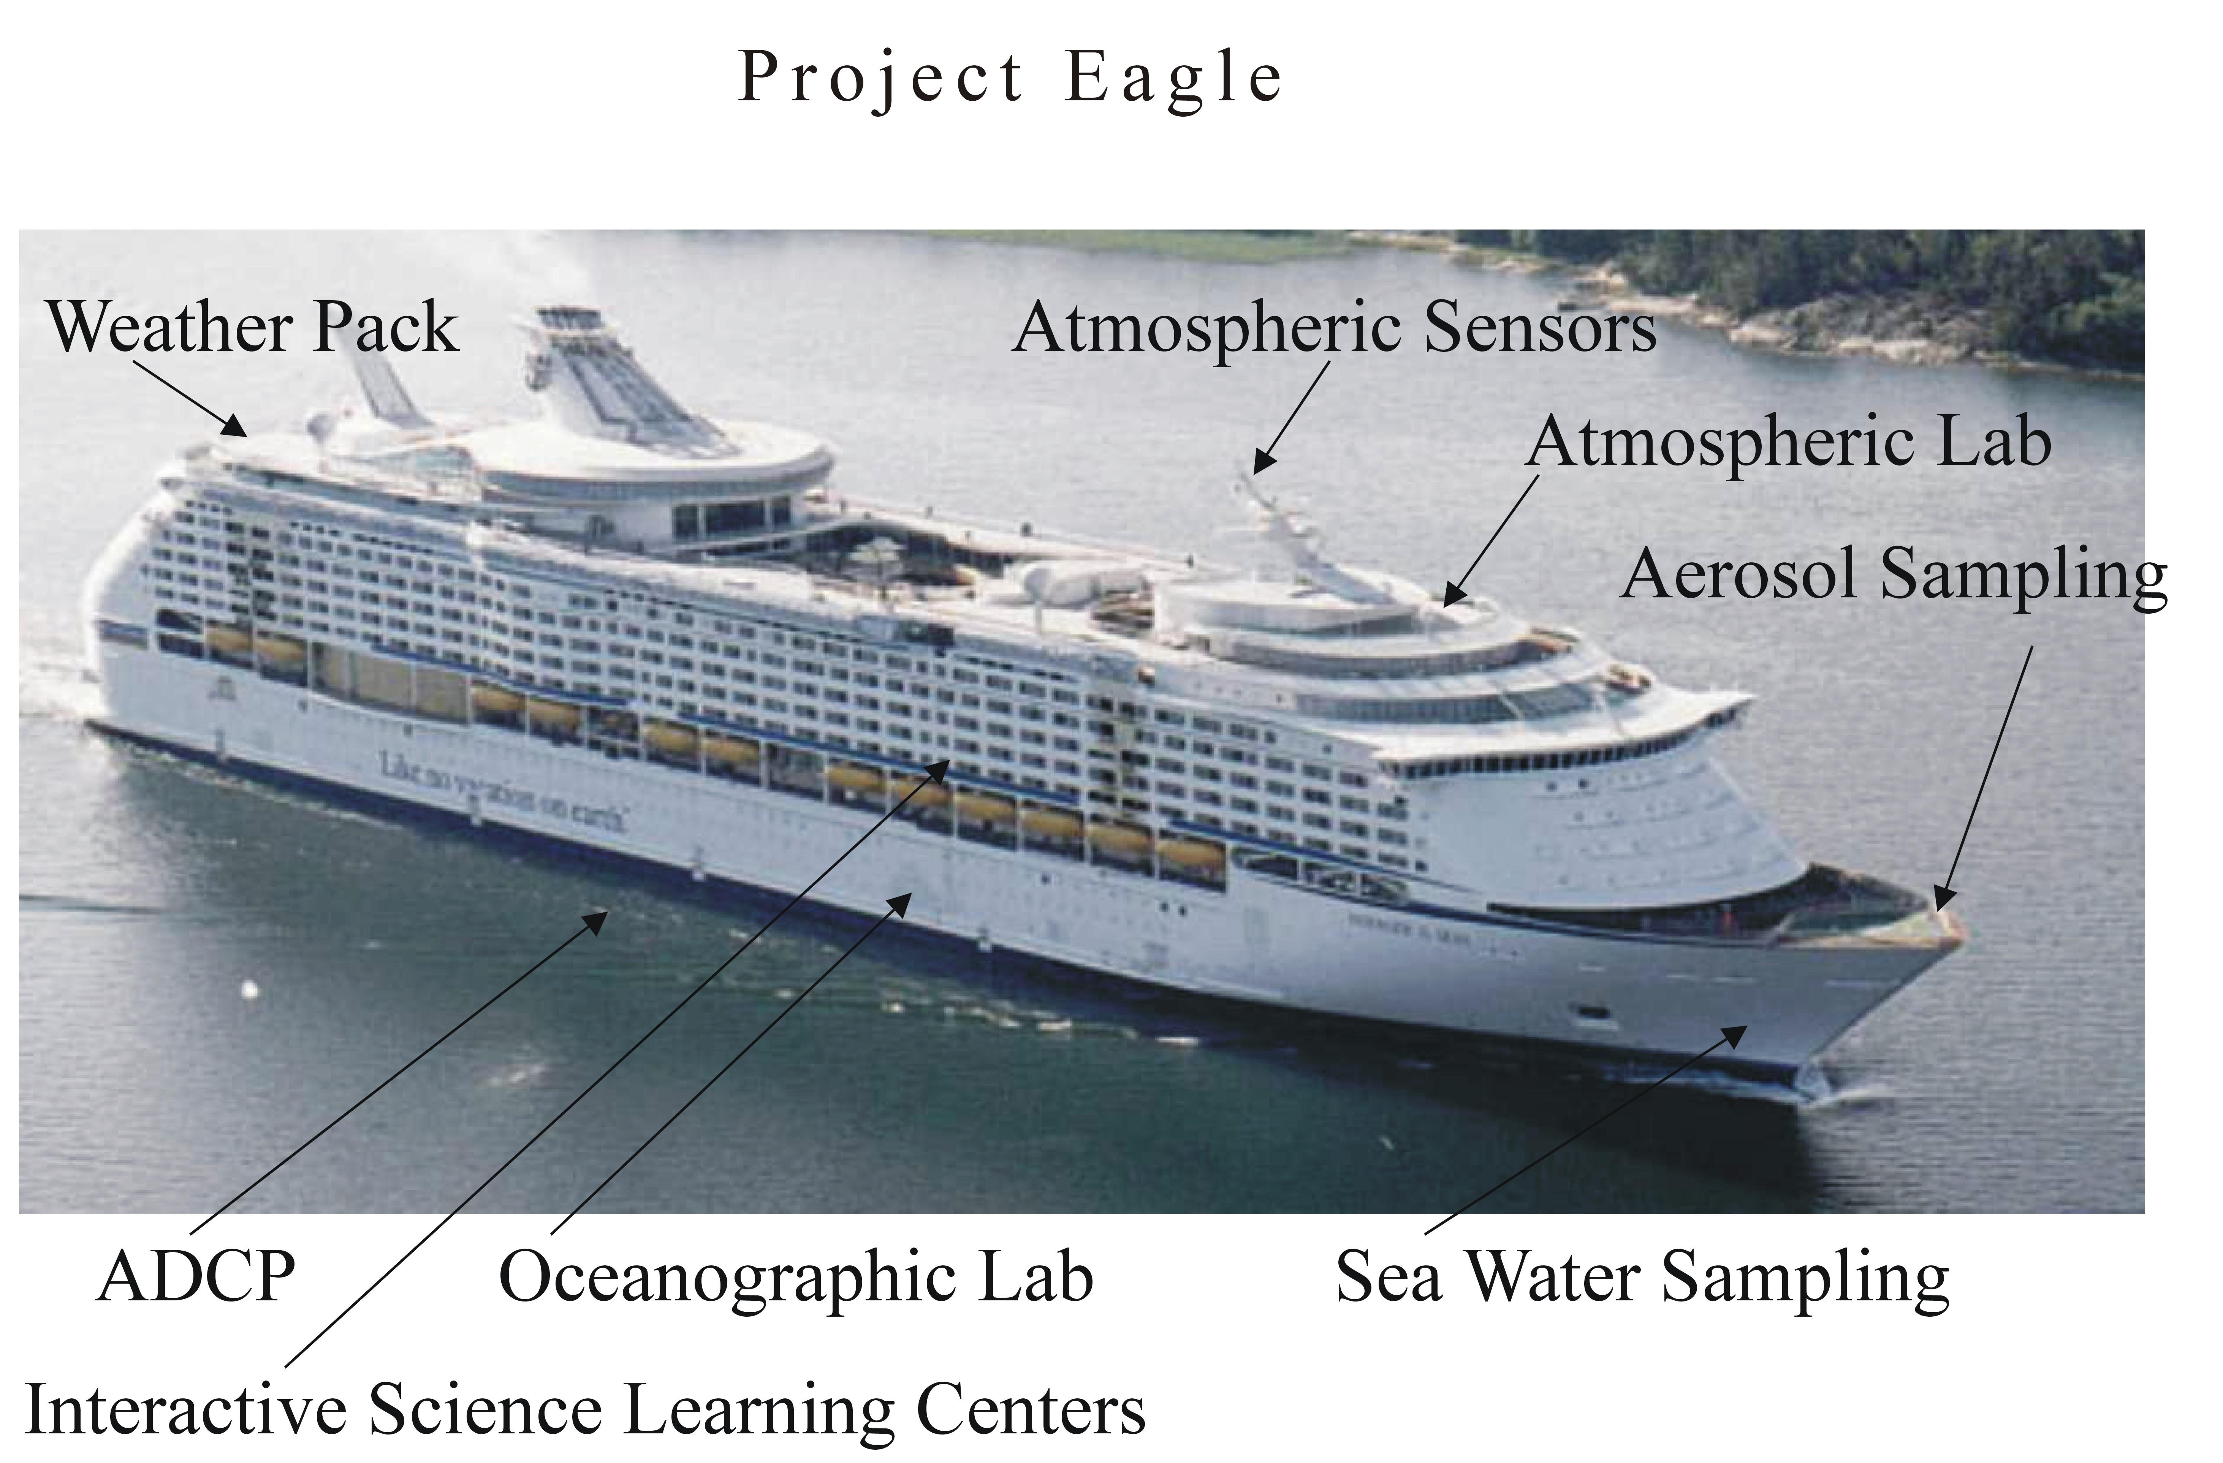
Figure 22. Location of laboratories, learning centers, and sensor/instrumentation aboard the Explorer of the Seas (Royal Caribbean Cruise Lines).

