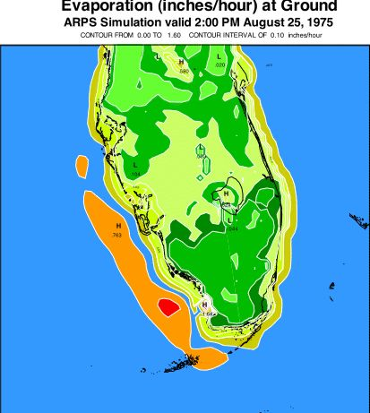
Figure 20. Evaporation valid at 2:00 p.m., August 25, 1975 from an ARPS mesoscale atmosphere model simulation over the Florida Area Cumulus Experiment (FACE) mesonet region. The evaporation pattern correlates well with the strongest divergent and initially driest surface wind fields, in the vicinity of the greatest surface-to-air temperature/humidity differences. Moisture was picked up by the atmospheric flow over Lake Okeechobee and by the organized offshore downdrafts associated with the west coast sea breeze circulation, while the Florida Everglades “muck” soil in the interior of the state tended to resist evaporation due to its high water retention and strong capillary forces. Thus, a significant north-south mesoscale gradient in evaporation was simulated across Florida Bay.

