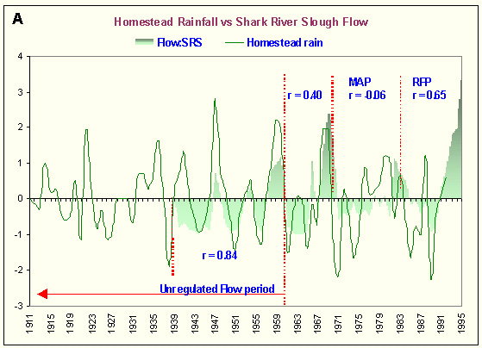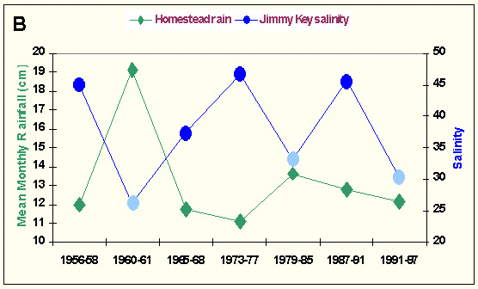
Figure 19. Natural and anthropogenic influences on overland freshwater flow and historical Florida Bay salinity. Upper panel (A): Trend analysis (0 = average conditions) of historic Homestead rainfall and Shark River Slough flow (1911-1995) shows varying degrees of correlation for pre-management (0.84), construction period (0.40) through changing water management strategies (-0.06 for MAP = Monthly Allocation Plan; 0.65 for RFP = Rainfall Plan). Lower panel (B): A strong inverse correlation between long-term salinity changes at Jimmy Key, in central Florida Bay, and long-term rainfall patterns indicate a natural forcing function dominates.

