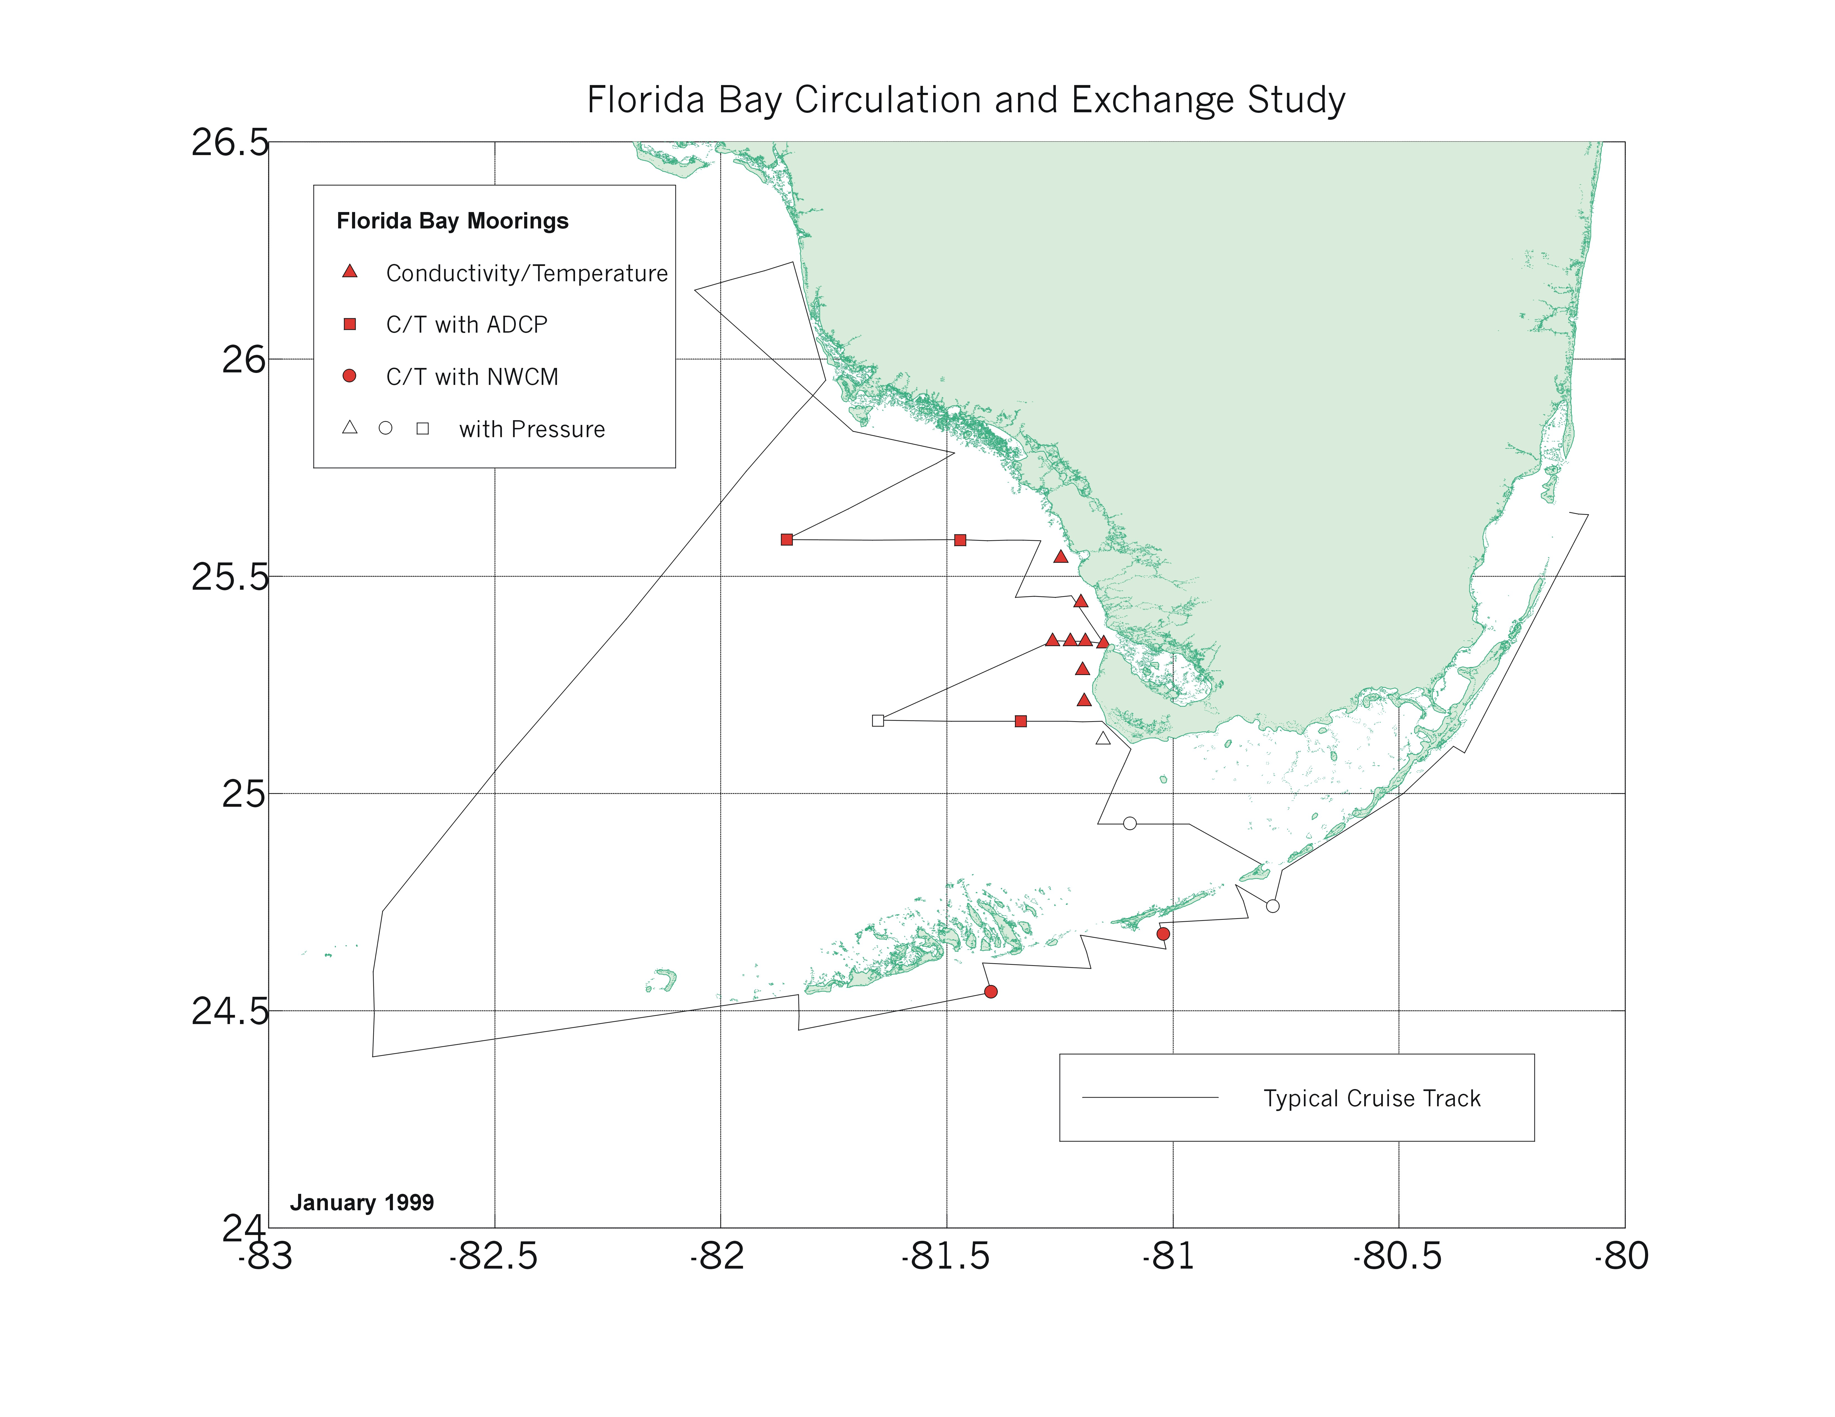
Figure 18. Map of physical fixed array plus cruise tracks.

