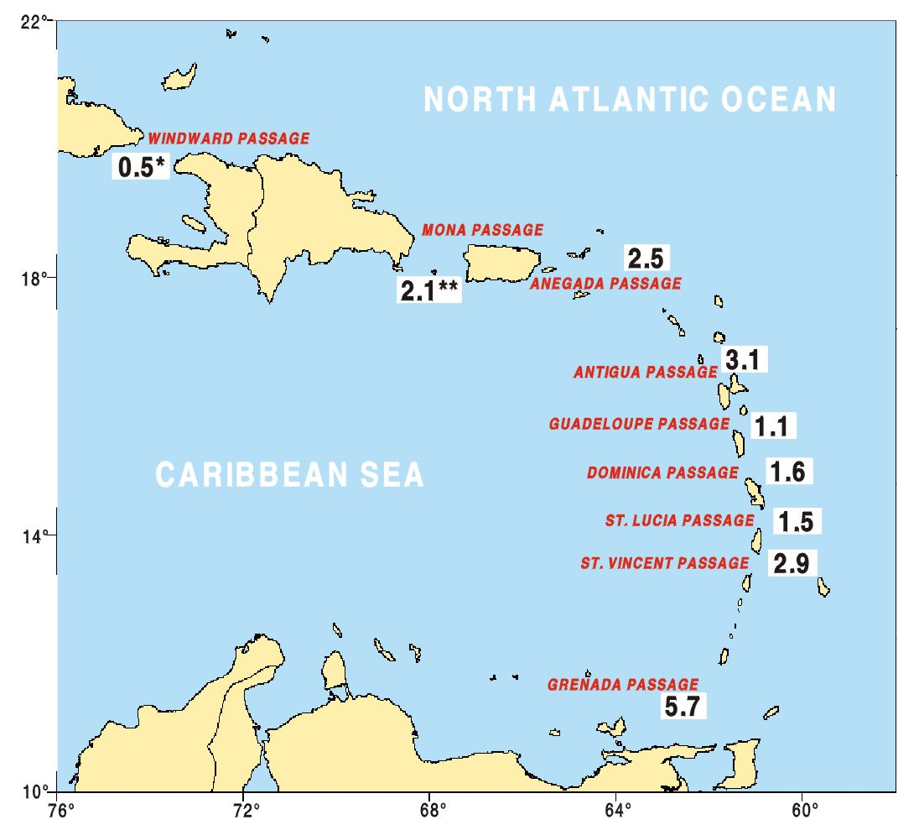
Figure 17. Direct measurements of transport in the Atlantic-Caribbean Passages from 1991-1998 have produced mean transports shown. Around 20 Sv of the approximately 32 Sv that flows through the Florida Straits enters the Caribbean south of the Virgin Islands, where southern hemisphere water masses dominate. A pilot program is underway (Caribbean Inflow Variability, with RSMAS and PMEL) to continuously measure the transport through the Grenada Passage via telephone cable and sea level to better understand the mesoscale transport variability and discern long-period changes in transport.

