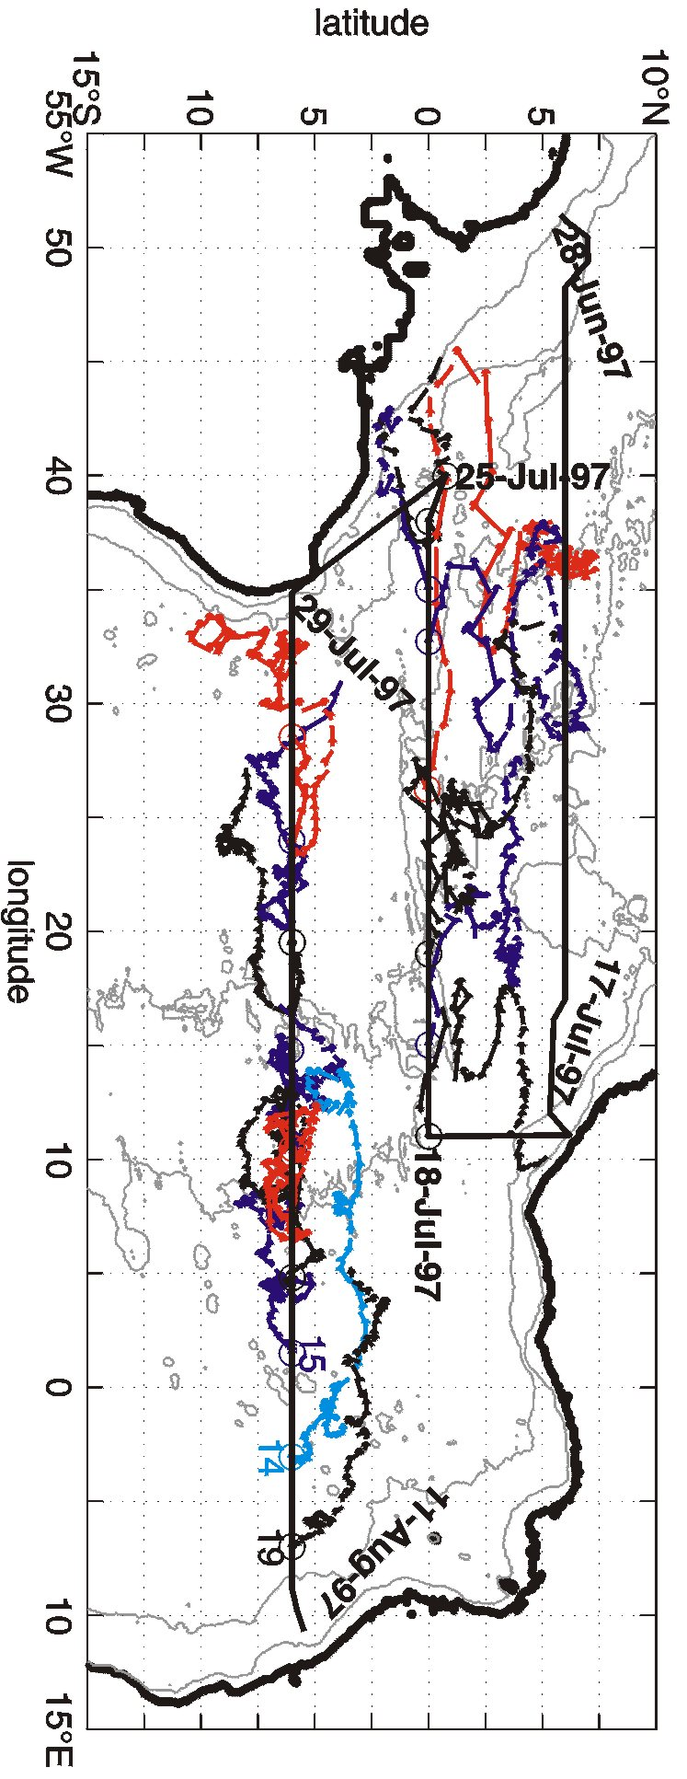
Figure 16. Trajectories of PALACE floats in the tropical Atlantic during the period July 1997 through November 1999 ballasted to drift at 1000 dbar and programmed to surface every 10 days to transmit in real time, via satellite, the profile obtained while rising to the surface. The instruments were deployed during the 1997 R/V Seward Johnson cruise (solid black lines). Each submerged trajectory segment is shown as a line starting at a dot. The trajectories reveal three regions of different flow characteristics. The equatorial band is characterized by high velocities (long trajectory segments), with a mean speed between 1°S and 3°N of about 10 cm/s. Further north, 3-8°N, and further south, 2-8°S, the speed is about half as large (shorter trajectory segments). Another difference between the high and the low energy regimes is that, in the latter, some of the PALACE floats tend to stay a long time in a small area, e.g., the three red trajectories are more than two years long. The one near 5°S, 10°W does not reveal much displacement, whereas the trajectories at and north of the equator cover large distances. Several zonal currents can be identified in the trajectories. These are the westward Equatorial Intermediate Current between about 1°S and 1°N, the Northern Intermediate Countercurrent in 2-3°N west of 25°W and at about 1°N further east, as well as the central branch of the intermediate South Equatorial Current between 2°S and 4°S (black and light blue trajectories starting at 6°S, 0-10°E). The flow pattern between 4°S and 8°S does not show persistent zonal currents over longer periods of time; instead, typical periods are shorter than four months.

