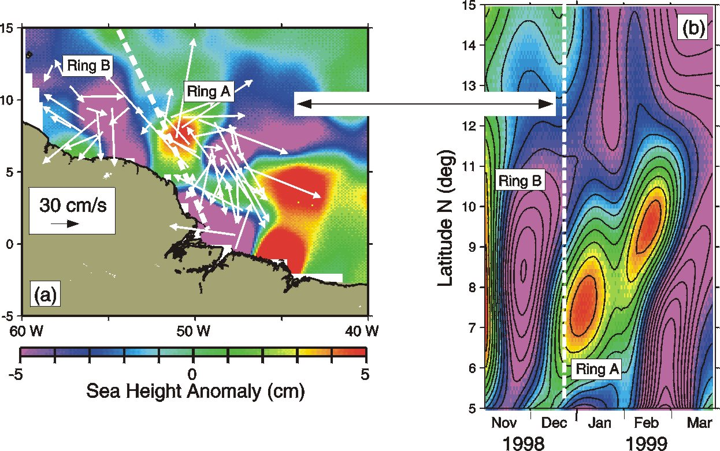
Figure 15. The North Brazil Current is responsible for a large part of the cross-equatorial transport of waters from the South Atlantic into the North Atlantic basin. This current retroflects to the east 2 degrees north of the equator, shedding warm rings which ultimately reach the Windward Islands and the Caribbean Sea. From TOPEX/Poseidon-derived sea height, this figure shows the conditions for December 10-20, 1998: (a) Regions of higher sea height anomalies (yellows and reds) are associated with warm anticyclonic features. There is a warm ring (Ring A) at approximately 7.5N, and the North Brazil Current retroflection at approximately 5N. The acoustic Doppler current profiler-derived velocity vector field at 150 m depth is superimposed and shows that west of Ring A there is an anticyclonic feature, with no surface signature, undetected by altimetry. The dotted white line shows the TOPEX/Poseidon groundtrack d311. (b) A space-time diagram of the TOPEX/Poseidon-derived sea height anomaly field for groundtrack d311 shows Ring A and a second ring that crosses this groundtrack during February 1999. Although altimetry represents a very useful tool to detect these warm features, the need for continuous hydrographic surveys is clearly shown in this example.

