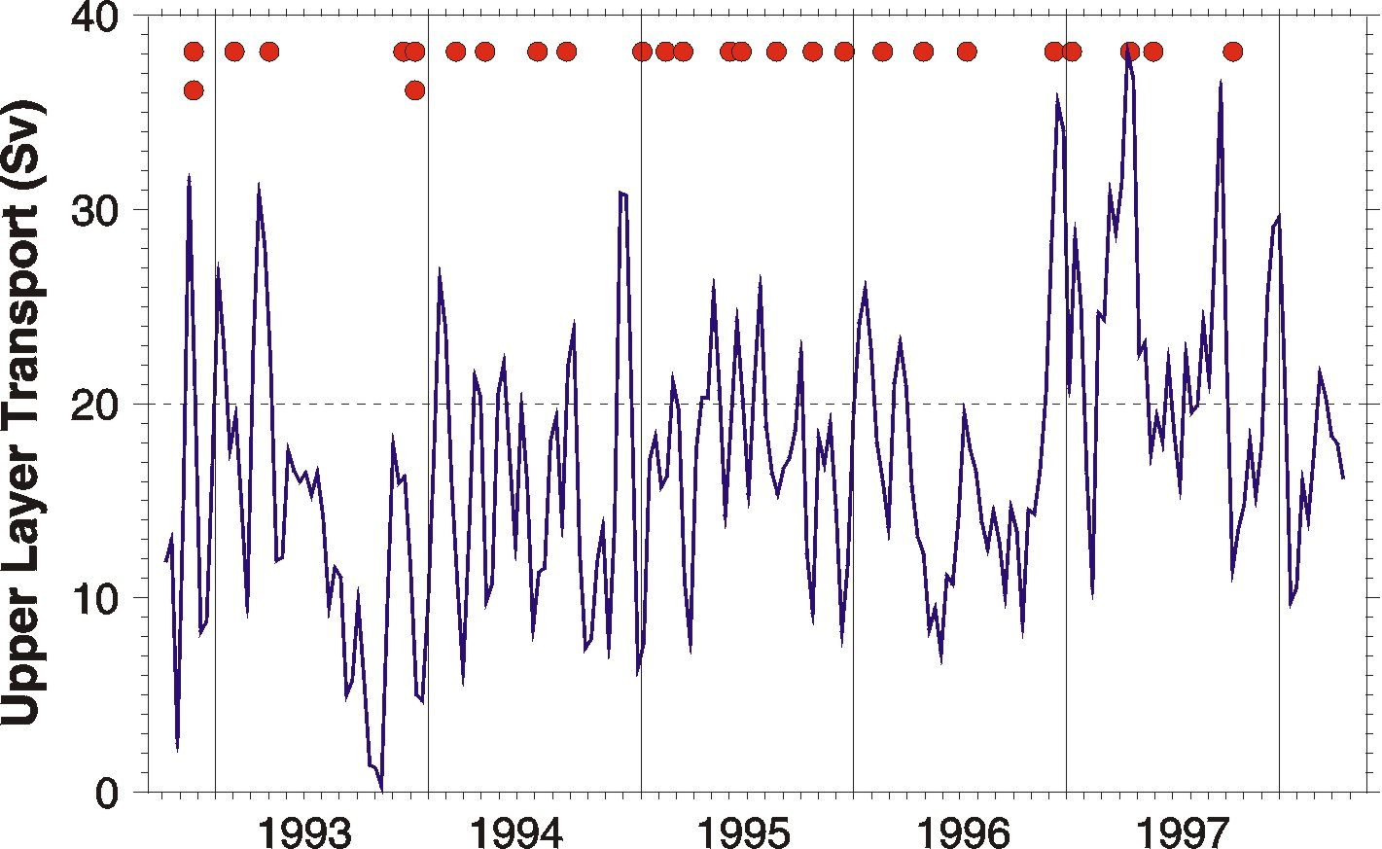
Figure 14. Another area that requires special attention because of its role in the thermohaline circulation is the southern tip of South Africa where exchange between the Indian and Atlantic Oceans takes place. One of the key questions still to be answered is how much heat and salt is transferred from the Indian to the Atlantic Ocean and what are the processes involved in this exchange. This figure shows the time series of the upper layer, westward baroclinic mass transport from the Indian to the Atlantic Ocean (solid line), and times when Agulhas rings were shed (circles). The transport was calculated using a combination of hydrographic and altimeter data and a simple model that relates the sea height anomaly with the depth of the upper layer. A strong interannual variability is observed. During 1997, the average transport of the Agulhas Current was significantly higher (23 Sv) than the long term mean (15.7 Sv). In spite of the high transport in 1997, the number of rings shed at the retroflection (4) was smaller than the other years (4 to 7), but each one of the rings transported twice the average volume of mass and heat. Variability of the strength of the retroflection and number and size of the eddies shed have a direct implication on the thermohaline circulation. Further observational and theoretical studies are needed to fully understand the process and its role in the global climate.

