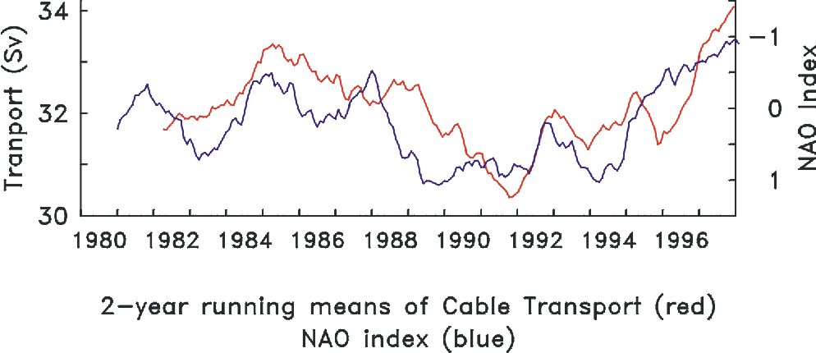
Figure 13. Florida Current transports are measured from West Palm Beach, Florida to the Bahamas via a submerged submarine cable. Voltage differences are measured at either end of the cable coupled with simple electromagnetic theory that says charged particles (water) moving through earth’s magnetic field will create a current (voltage) which gives a measure of how fast the water is moving through the Straits of Florida. Measurements taken since 1982 show a high correlation (0.9) with the NAO Index. The NAO is a measure of variability in atmospheric surface pressure difference between Portugal and Iceland which has been shown to be correlated with the climate of the continental United States and hurricane formation. Continued measurements of Florida Current transport may help unravel the mystery of coupling between the ocean and atmosphere at decadal time scales.

