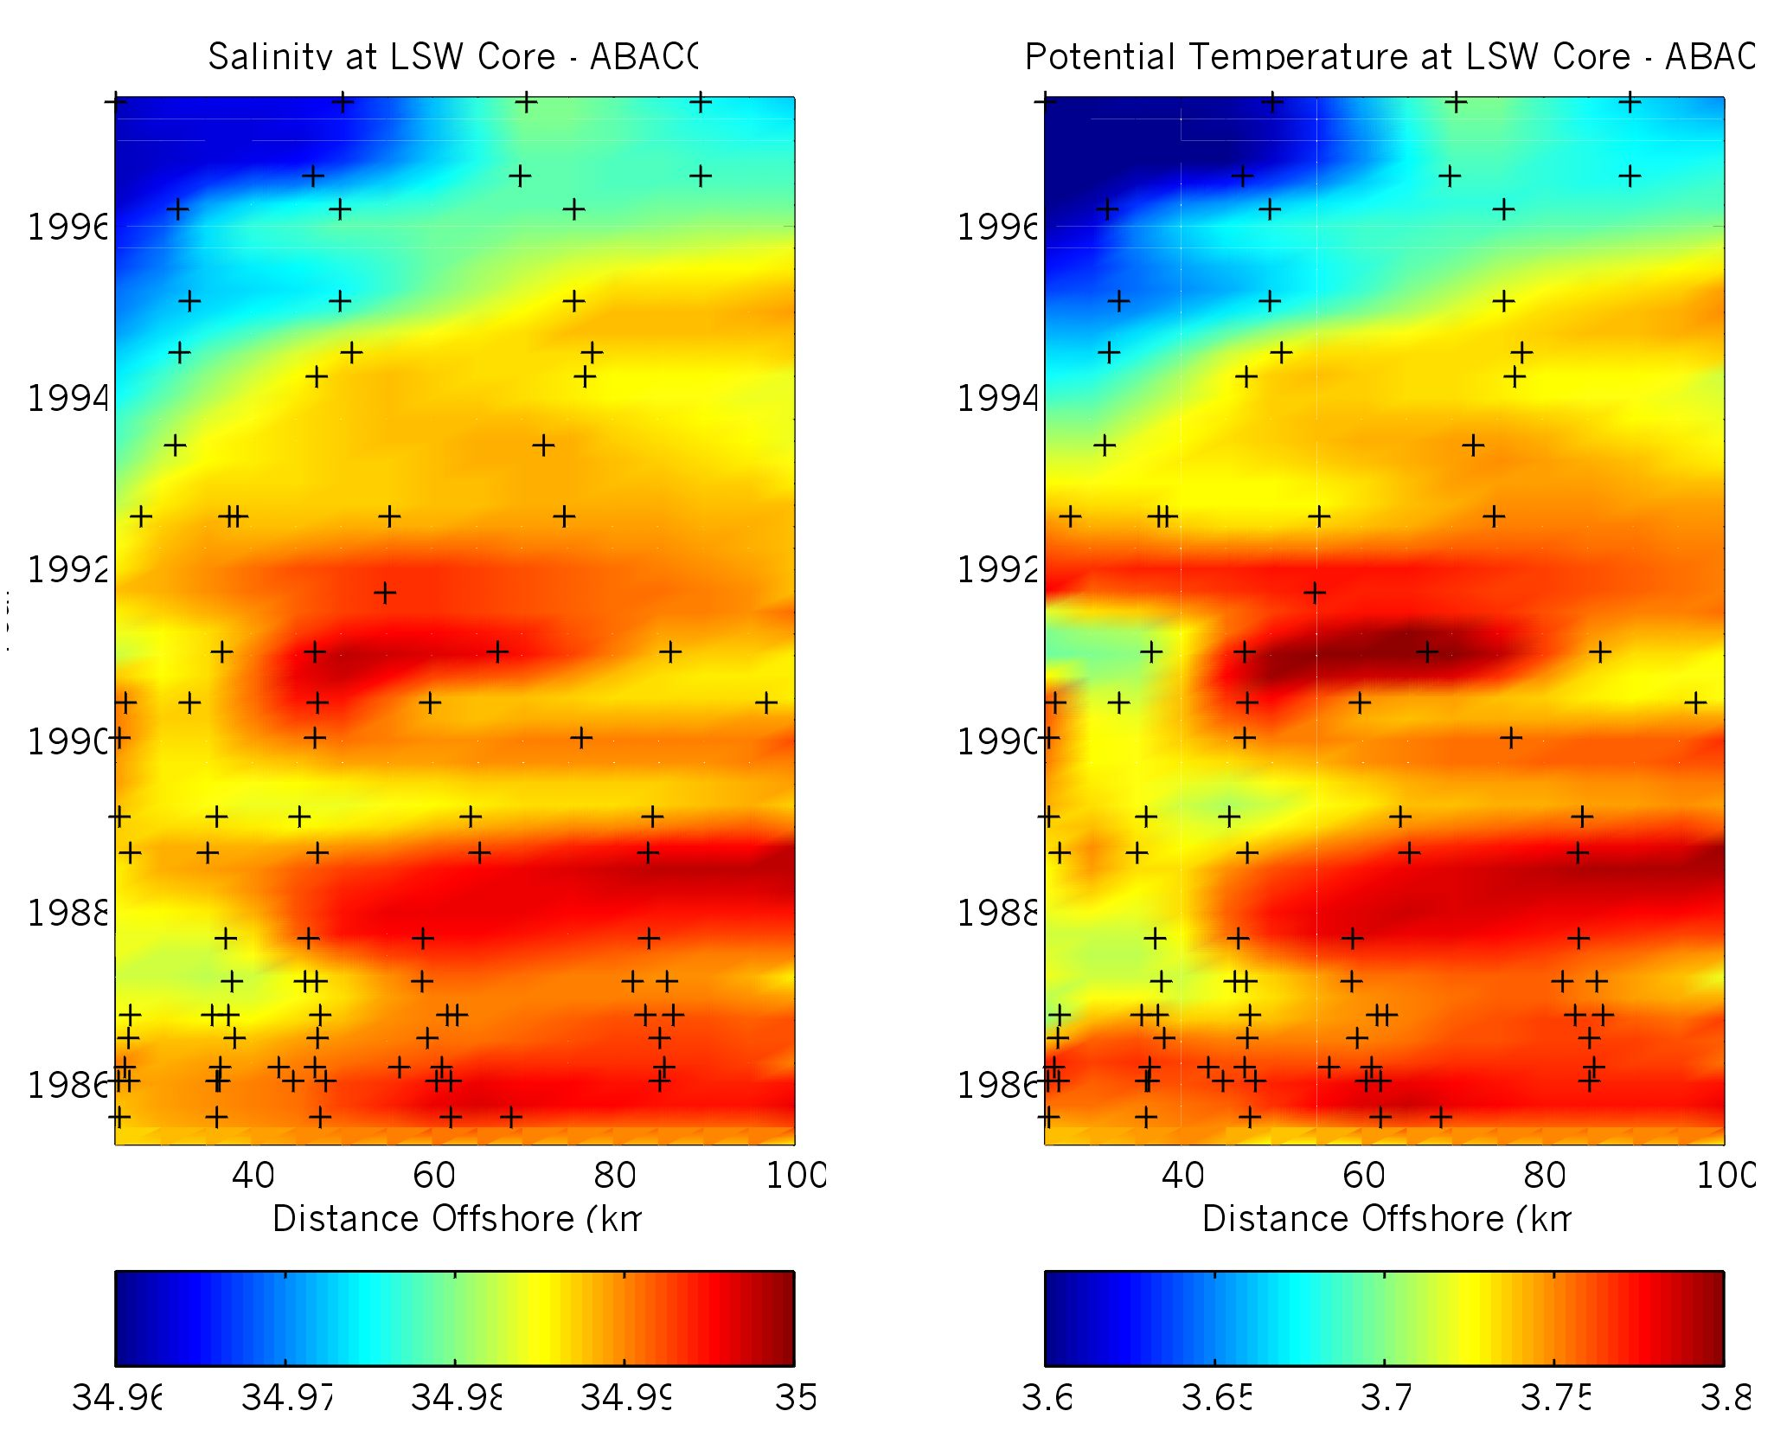
Figure 12. Time series of temperature and salinity at the depth of Labrador Sea Water obtained from data collected east of Abaco Island, the Bahamas (26.5N). Crosses represent station positions. The section is taken across the axis of the Deep Western Boundary Current. The Deep Western Boundary Current transports Labrador Sea Water from its source region in the Labrador Sea to south of the equator and is an important component of the global meridional overturning circulation. Prior to 1993, temperature and salinity characteristics were relatively uniform. After 1993, temperature and salinity began decreasing dramatically, beginning at the boundary and then extending offshore. This change in water mass characteristics indicates the arrival of Labrador Sea Water formed some 10 years earlier, indicating that the Deep Western Boundary Current advects waters from the Labrador Sea at faster rates than previously thought. These findings have important implications in studies of the ocean’s ability to uptake atmospheric gases such as carbon dioxide.

