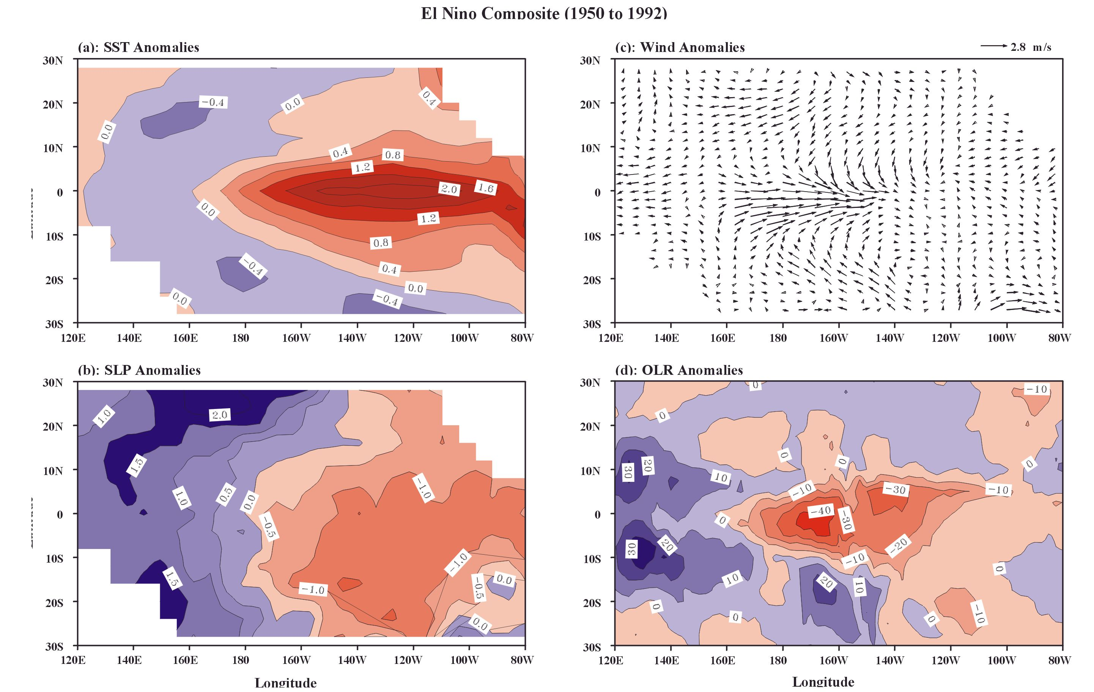
Figure 8. The El Niño composite of (a) SST anomalies, (b) SLP anomalies, (c) surface wind anomalies, and (d) OLR anomalies (Wang et al., 1999). El Niño displays western Pacific anomaly patterns in addition to eastern Pacific anomaly patterns. During the peak phase of El Niño, warm SST and low SLP anomalies in the equatorial eastern Pacific and low OLR anomalies in the equatorial central Pacific are accompanied by cold SST and high SLP anomalies in the off-equatorial western Pacific and high OLR anomalies in the off-equatorial far western Pacific. Also, while the zonal wind anomalies over the equatorial central Pacific are westerly, those over the equatorial far western Pacific are easterly. AOML is studying these neglected western Pacific relationships and is consolidating them into a unified theoretical model that combines them with the postulated mechanisms of other ENSO scientist

